Formal Definitions and Prediction Formulas
This document provides the mathematical formalisations that underpin the methods described in Chapter 3. It is intended as a supplement to the main text, making each algorithm fully reproducible from the thesis alone.

1. Two-Decision Decomposition of Forecasting Error
All models in this thesis operate on linearly detrended residuals. The total forecasting error on original-scale production decomposes into two independent decisions:

Definition 1.1 — Linear detrending
r_t = y_t − (α̂ + β̂ · t)

where y_t is observed production in year t, α̂ and β̂ are OLS estimates of intercept
and slope estimated exclusively on the training fold of each walk-forward scenario,
and r_t is the detrended residual. Predictions ŷ_t are obtained by re-adding the
projected trend: ŷ_t = r̂_t + (α̂ + β̂ · t).

Decision 1 — Trend modelling: How accurately does the training-period trend extrapolate to unseen test years? This decision is entirely determined by the linearity and stationarity of the production trend. It is measured by Naive_Median MAE: the error incurred when predicting every test year is exactly on trend (r̂_t = 0 for all test years).

Decision 2 — Climate signal extraction: Can a rule-based model predict detrended residuals r_t better than zero? This decision is measured by the gap between a model's weighted MAE and the Naive_Median weighted MAE. A negative gap indicates the model adds value beyond the trend baseline; a positive gap indicates it adds noise.

Definition 1.2 — Weighted MAE and the Decision 2 gap
Weighted MAE = Σ_s n_s · MAE_s / Σ_s n_s

where n_s is the number of test observations in scenario s and MAE_s is the mean
absolute error on those observations. The scenario-size weighting gives more influence
to earlier scenarios with larger test sets.

Decision 2 gap = Weighted MAE(model) − Weighted MAE(Naive_Median)

A negative gap is evidence that climate features carry predictive signal beyond the trend.

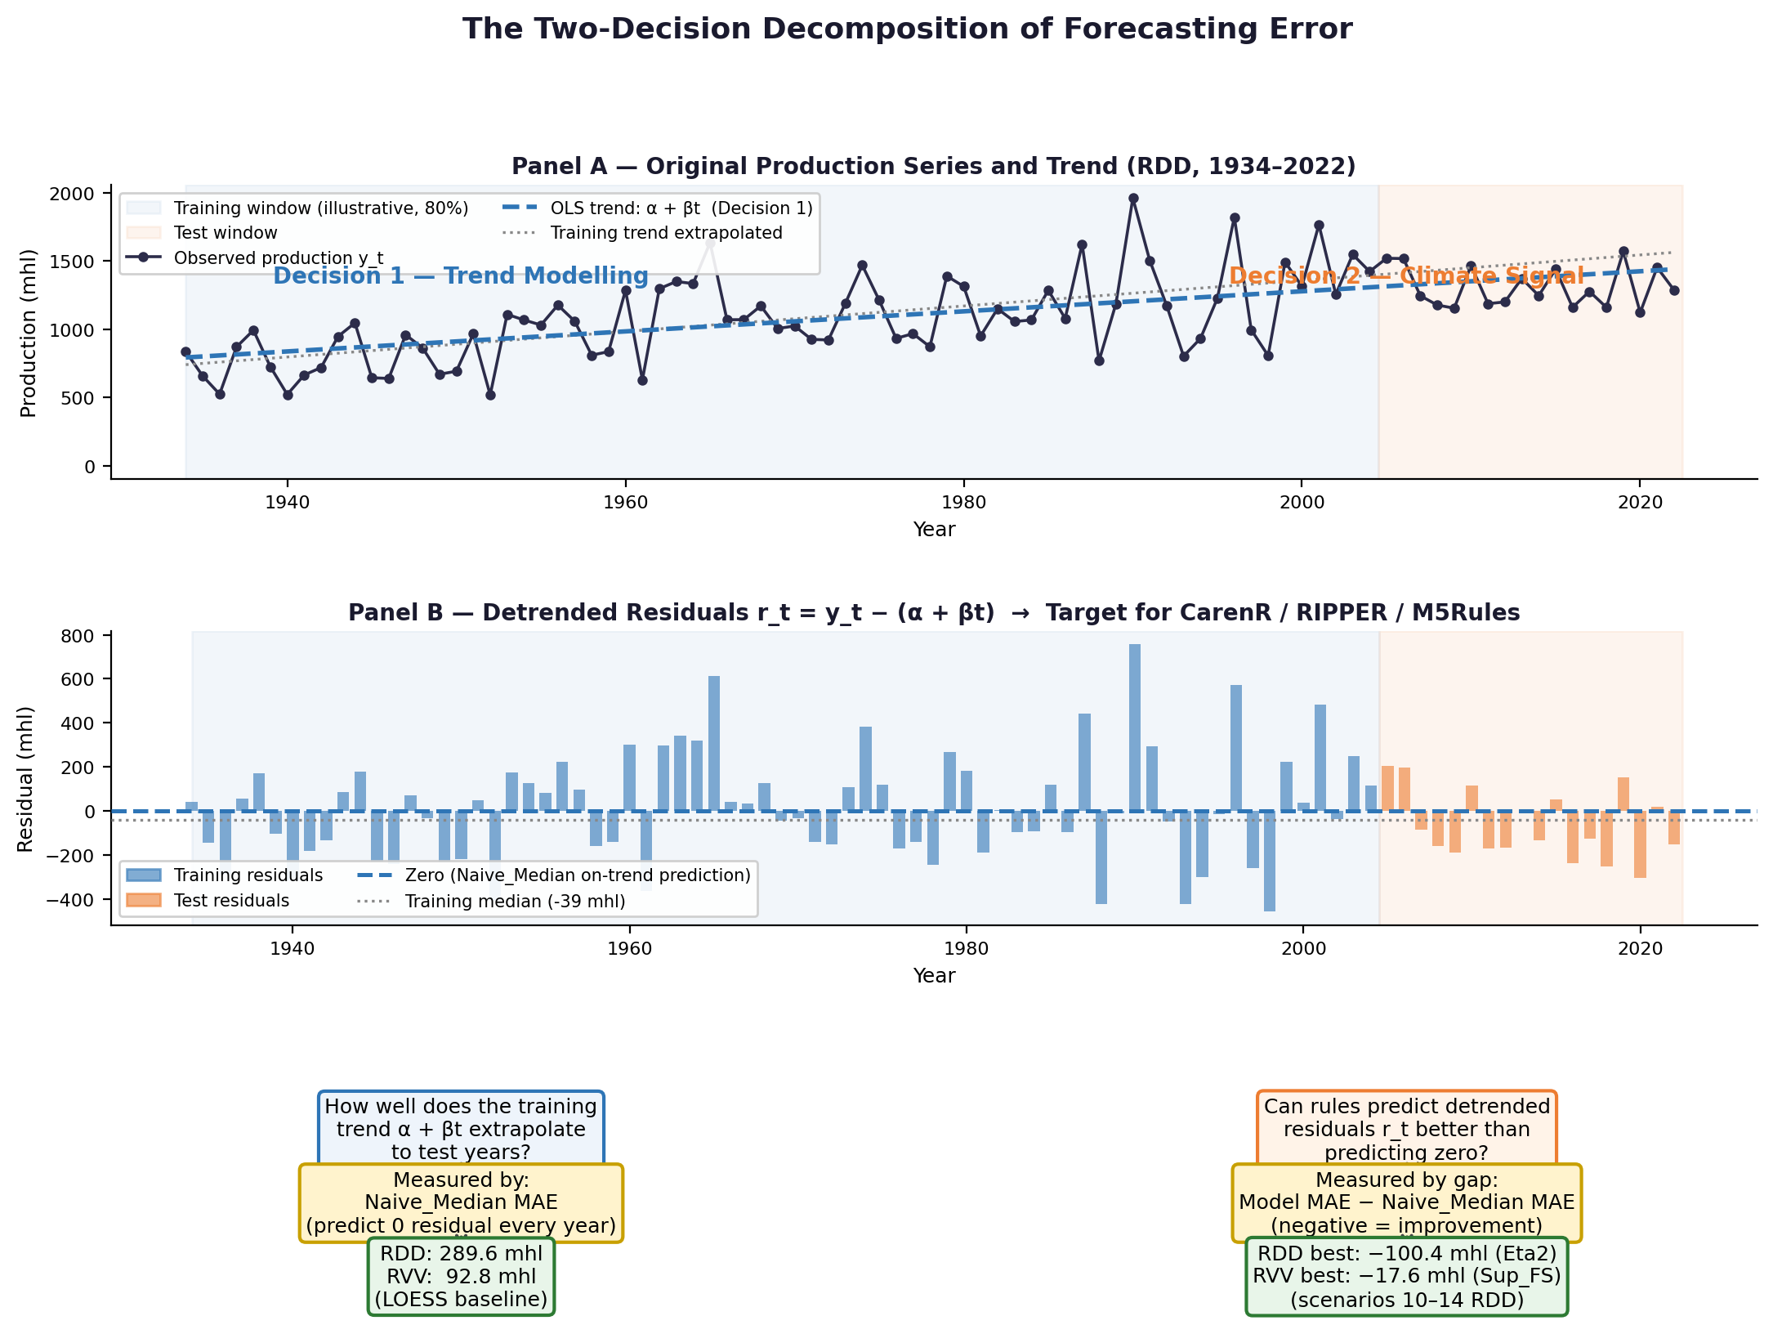
Figure — The two-decision decomposition. Panel A: original RDD production series with OLS trend. Panel B: detrended residuals r_t (blue = training, orange = test). Panels C–D: Decision 1 (trend quality, measured by Naive_Median MAE) and Decision 2 (climate signal, measured by the model-vs-baseline MAE gap).

2. Distributional Subgroup Discovery — Formal Problem Statement
CarenR solves a distributional subgroup discovery problem. Informally, it searches for conjunctions of discretised feature conditions that define a subset of training observations whose production distribution differs significantly from the global distribution.

Definition 2.1 — Distributional subgroup discovery (CarenR)
Let D = {(x_i, r_i) : i = 1, ..., N} be the training set, where x_i ∈ {1,2,3,4}^p is the
vector of discretised feature bins for year i and r_i is the detrended production residual.

A rule is an itemset I = {(f_1, b_1), ..., (f_k, b_k)}, a conjunction of (feature, bin) pairs.
The subgroup induced by I is:

S(I) = { i ∈ D : x_i[f_j] = b_j for all j = 1, ..., k }

CarenR retains rule I if and only if:

(1) KS(F_{S(I)}, F_D) is statistically significant (two-sample KS test)
(2) supp(I) = |S(I)| / N ≥ min_sup = 0.20

where F_{S(I)} is the empirical CDF of residuals in the subgroup, F_D is the empirical CDF
of residuals in the full training set, and the KS statistic is:

D = max_x | F_{S(I)}(x) − F_D(x) |

The output is the set R = {I : conditions (1) and (2) both hold}, along with for each retained rule its support supp(I), KS statistic D, p-value, and subgroup median.

3. CarenR Prediction Formulas
For a test observation x_new, let R_fired ⊆ R be the subset of retained rules that fire — that is, all conditions of the rule are satisfied by x_new. Let p(I) denote the subgroup median residual for rule I, computed on training observations only:
p(I) = median{ r_i : i ∈ S(I) ∩ D_train }

When no rules fire (R_fired = ∅), all variants fall back to the training median:
r̂ = median{ r_i : i ∈ D_train } [fallback — equivalent to Naive_Median]

3.1 MEDIAN (base variant — CarenR_Dist)
When R_fired contains exactly one rule, the prediction is its subgroup median. When multiple rules fire, the support-weighted formula (3.2) applies even for the base variant because strategy 'C' (support-weighted) is the default aggregation:
r̂ = p(I*) where I* = argmax_{I ∈ R_fired} supp(I)
(single highest-support rule when exactly one fires; weighted average otherwise — see §3.2)

3.2 SUP-weighted (CarenR_Dist_Sup and FS/Eta variants)
Each firing rule is weighted by its support fraction — the proportion of training observations it covers. Rules covering more of the training distribution contribute more:
r̂ = Σ_{I ∈ R_fired} supp(I) · p(I) / Σ_{I ∈ R_fired} supp(I)
supp(I) = |S(I)| / N, the fraction of training observations matching rule I.

3.3 CONF-weighted (CarenR_Dist_Conf)
Each firing rule is weighted by the negative log of its KS p-value — rules with stronger statistical evidence for distributional shift receive higher weight:
r̂ = Σ_{I ∈ R_fired} w(I) · p(I) / Σ_{I ∈ R_fired} w(I)
w(I) = −log( p-value_KS(I) )
A smaller KS p-value (stronger evidence of distributional shift) ⟹ larger weight. The −log transform prevents any single highly-significant rule from dominating through extreme weight ratios.

3.4 THRESHOLD (CarenR_Dist_Thresh / Sup_Thresh)
Instead of predicting the subgroup median directly, threshold variants predict only the sign of the median residual — whether production will be above or below trend — and map this to a fixed magnitude. This reduces sensitivity to outlier subgroups:
r̂ = sign( p(I*) ) · |median{ r_i : i ∈ D_train, r_i > 0 }| if p(I*) > 0
r̂ = sign( p(I*) ) · |median{ r_i : i ∈ D_train, r_i < 0 }| if p(I*) < 0

4. RIPPER — FOIL Information Gain
RIPPER grows each rule by greedily adding conditions that maximise the FOIL information gain (Quinlan, 1990; Cohen, 1995). For a rule R and a candidate condition c, the FOIL gain measures the increase in information content when c is added to R:

Definition 4.1 — FOIL gain
Let p = number of positive (target class) examples covered by rule R before adding c
Let n = number of negative (other class) examples covered by rule R before adding c
Let p' = positive examples covered by R ∧ c (after adding condition c)
Let n' = negative examples covered by R ∧ c

FOIL gain(c) = p' · [ log_2( p' / (p' + n') ) − log_2( p / (p + n) ) ]

The p' multiplier rewards conditions that maintain high coverage of positives while
improving purity. The bracketed term is the increase in log-odds of a positive example
being covered, analogous to information gain in decision tree learning.

RIPPER adds the condition c* = argmax FOIL gain(c) at each step, stopping when no condition improves gain or when a stopping criterion based on the Minimum Description Length (MDL) principle is met. With n ≈ 27–30 observations per class in this thesis, FOIL gain estimates have high variance, which is the primary reason for RIPPER's limited performance relative to CarenR on small datasets.

5. M5Rules — Standard Deviation Reduction
M5Rules selects splits by maximising the standard deviation reduction (SDR), the regression analogue of information gain. For a split of training set T into subsets T_L and T_R:

Definition 5.1 — Standard deviation reduction
SDR(T, split) = sd(T) − |T_L|/|T| · sd(T_L) − |T_R|/|T| · sd(T_R)

where sd(·) is the standard deviation of the target variable in the subset. The split
that maximises SDR is selected at each node. M5Rules requires each child node to contain
at least a minimum number of observations (default: 4); with N = 80–89 this limits the
tree to at most 3–4 splits before the minimum-leaf criterion is violated, which is why
M5Rules typically collapses to a single global linear regression on these datasets.

After tree construction, each leaf fits an OLS linear regression model and applies a smoothing procedure that interpolates between the leaf model and progressively coarser ancestor models. The smoothed prediction for leaf L with n_L observations is:
ŷ = (n_L · ŷ_L + k · ŷ_parent) / (n_L + k)
where ŷ_L is the leaf model prediction, ŷ_parent is the smoothed prediction from the parent node, and k is a smoothing constant (default k = 15 in Weka's M5Rules). This smoothing reduces overfitting in leaves with few observations, but also pulls predictions towards the global model when subgroup samples are small.

