Market Data Feed Ingestion System
Low-Latency Delivery, Book Building, Colo Infrastructure, Gap Recovery, and Monitoring
Review Draft
Senior interview framing
The design intentionally separates ultra-low-latency delivery from correctness-heavy book construction, replay, and analytics. The hot path is kept small and deterministic; the reliable path is replayable, auditable, and recovery-oriented.

1. Executive Summary
Goal: ingest heterogeneous exchange market data protocols, deliver minimum-latency normalized or raw events to trading clients, and simultaneously support durable book building, recovery, replay, and analytics without coupling slow work to the hot path.
- Use exchange-specific feed handlers behind common protocol, sequence, recovery, and normalization interfaces.
- Run a dual-path architecture: hot path for trading clients, reliable path for raw journaling, book building, snapshots, and replay.
- Deploy in exchange colocation with redundant A/B feeds, physically diverse cross-connects, low-latency switches, PTP time sync, and NUMA-aware servers.
- On packet gaps, degrade explicitly: detect, contain by channel/instrument, fill from backup line, request retransmission, mark stale if needed, and keep unaffected flows live.
- Monitor not only liveness but data quality: sequence gaps, A/B divergence, recovery latency, clock drift, NIC drops, publisher lag, book staleness, and client delivery health.

2. Requirements and Design Principles
Area | Requirement | Design Response
Heterogeneous protocols | Exchanges use binary multicast, TCP recovery, FIX, snapshots, and proprietary schemas. | Adapter per exchange; common normalized event model; preserve raw packets for exact replay.
Low-latency clients | Trading systems need deterministic microsecond to low millisecond delivery. | Minimal decode, sequence health, compact binary publish, shared memory or multicast, no durable storage dependency on hot path.
Book building | Risk/UI/research need correct and replayable books, not necessarily the lowest latency. | Reliable event log, ordered per-instrument workers, snapshot generation, replay/resync support.
Unreliable networks | Packet loss, out-of-order arrival, and feed divergence are expected. | A/B arbitration, bounded gap buffer, retransmission, stale markers, and channel-level containment.
Operations | Need proof of correctness and latency attribution. | Hardware timestamping, PTP monitoring, p99/p99.9 latency, gap/recovery metrics, and data-quality alerts.

3. Architecture Overview
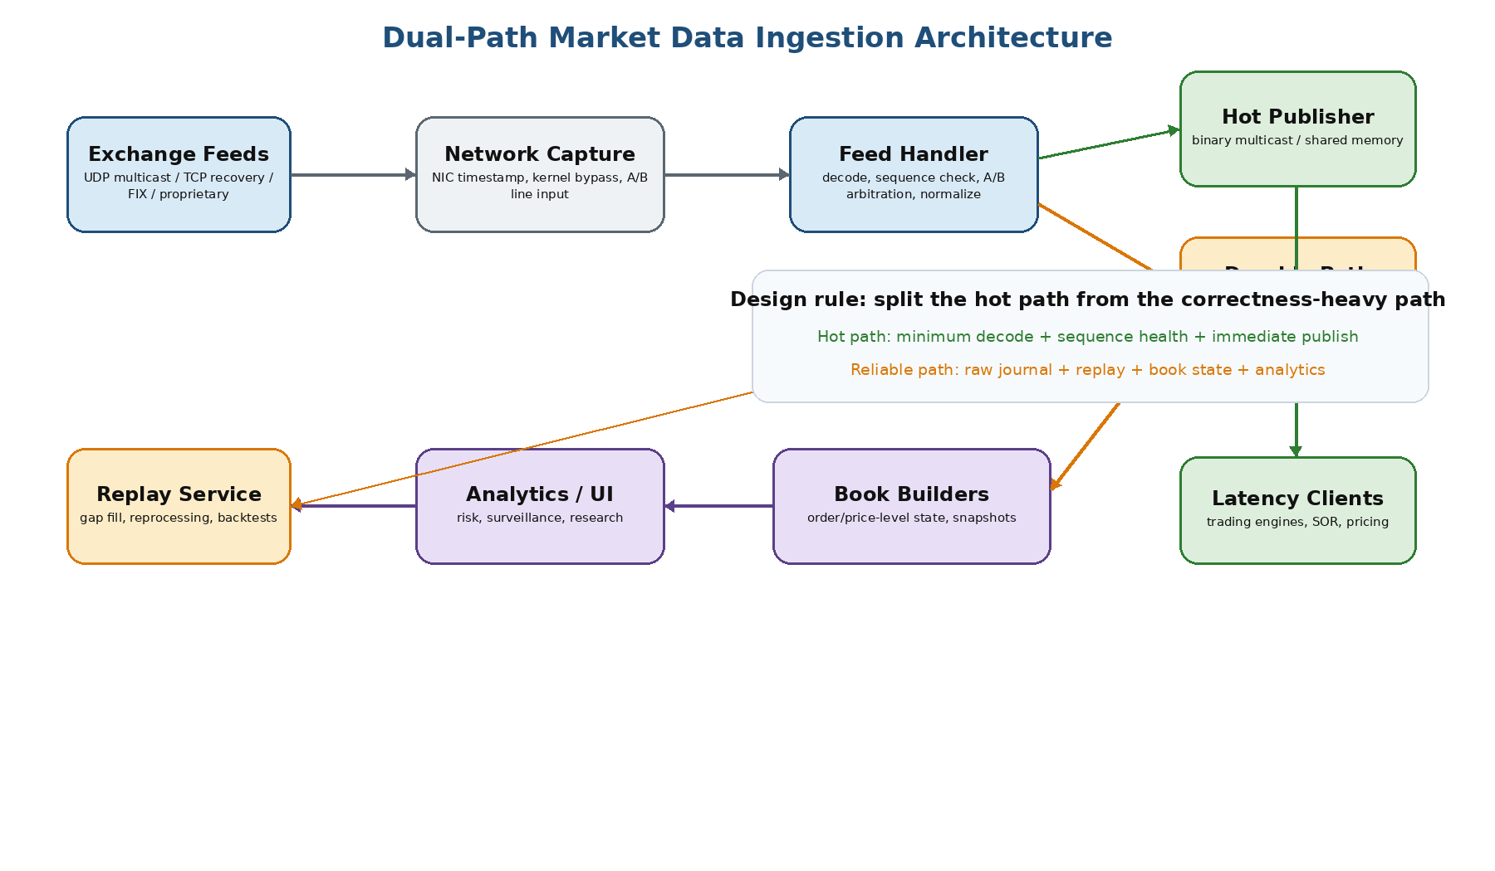
Figure 1. Dual-path architecture: latency-sensitive publishing is separated from durable storage, book construction, and replay.
- The hot path does only what is required to safely publish: receive, timestamp, decode, sequence-check, minimally normalize, and fan out.
- The reliable path persists raw packets and normalized events so decoder bugs, book bugs, or recovery issues can be replayed and corrected.
- Kafka-like infrastructure can be useful after the durable path, but should not sit on the critical trading publish path.
- Clients may subscribe to raw exchange-native data, lightly normalized binary events, or higher-level book snapshots depending on their SLA.
Exchange -> NIC timestamp -> FeedHandler -> SequenceTracker -> Publisher -> Trading Clients
\-> RawJournal -> Replay -> BookBuilder -> Snapshots / Analytics

4. Colocation Infrastructure for Minimum Latency
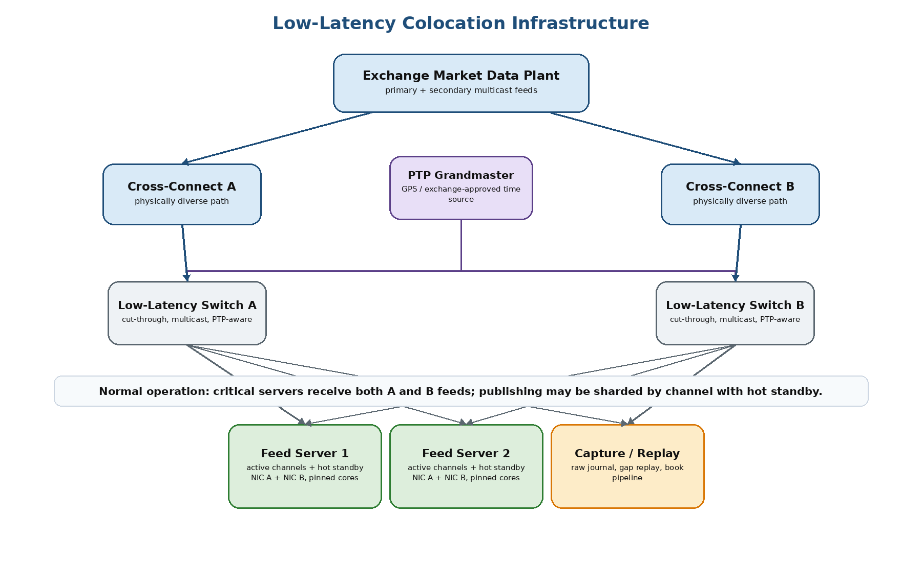
Figure 2. Critical colo servers receive both A and B feeds in normal operation; publishing can be split by channel with hot standby.

4.1 Physical and Network Setup
- Place latency-critical servers in the exchange colo or nearest market data distribution point.
- Use redundant cross-connects for Feed A and Feed B, ideally physically diverse through separate switch paths and NIC ports.
- Use low-latency, cut-through switches with hardware multicast support and PTP boundary/transparent clock capabilities.
- Keep the hot path free of routers, firewalls, general-purpose load balancers, storage writes, or inspection appliances.
- Separate market data receive, client publish, storage/replication, management, and time-sync networks.

4.2 Server and OS Tuning
Optimization | Why it matters
CPU pinning and isolated cores | Prevents scheduler noise and keeps feed processing deterministic.
NUMA locality | Keeps NIC, receive thread, buffers, and publisher on the same socket.
Kernel bypass or busy polling | Reduces syscall/interrupt overhead and latency jitter.
Disable deep C-states and frequency scaling | Avoids wakeup and clock-rate jitter.
Bounded queues and preallocated buffers | Prevents GC/allocation spikes and memory blowups during bursts.
No synchronous logging in hot path | Avoids disk or I/O stalls directly affecting trading delivery.

5. Time Synchronization
Preferred model: GPS or exchange-approved clock source -> PTP grandmaster -> PTP-aware switches -> PTP-capable NIC hardware clocks -> feed handler timestamps.
- Use PTP hardware timestamping for latency-sensitive systems; NTP is acceptable only for non-critical management and reporting hosts.
- Record exchange timestamp, NIC hardware receive timestamp, software receive timestamp, publish timestamp, and optionally client receive timestamp.
- Alert on PTP unlock, clock offset above threshold, grandmaster changes, NIC timestamp failures, and clock steps.
- Good timestamping turns latency from a guess into a measurable path: exchange-to-NIC, NIC-to-handler, handler-to-publisher, and publisher-to-client.
Timestamp | Purpose
exchange_timestamp | Helps estimate exchange-to-colo transit and exchange-side event ordering when provided.
nic_hardware_receive_timestamp | Best local ingress timestamp; avoids application scheduling noise.
software_receive_timestamp | Measures NIC-to-application and polling overhead.
publish_timestamp | Measures handler-to-client fanout latency.
client_receive_timestamp | Optional end-to-end validation for important clients.

6. Packet Gap Handling and Live Trading Safety
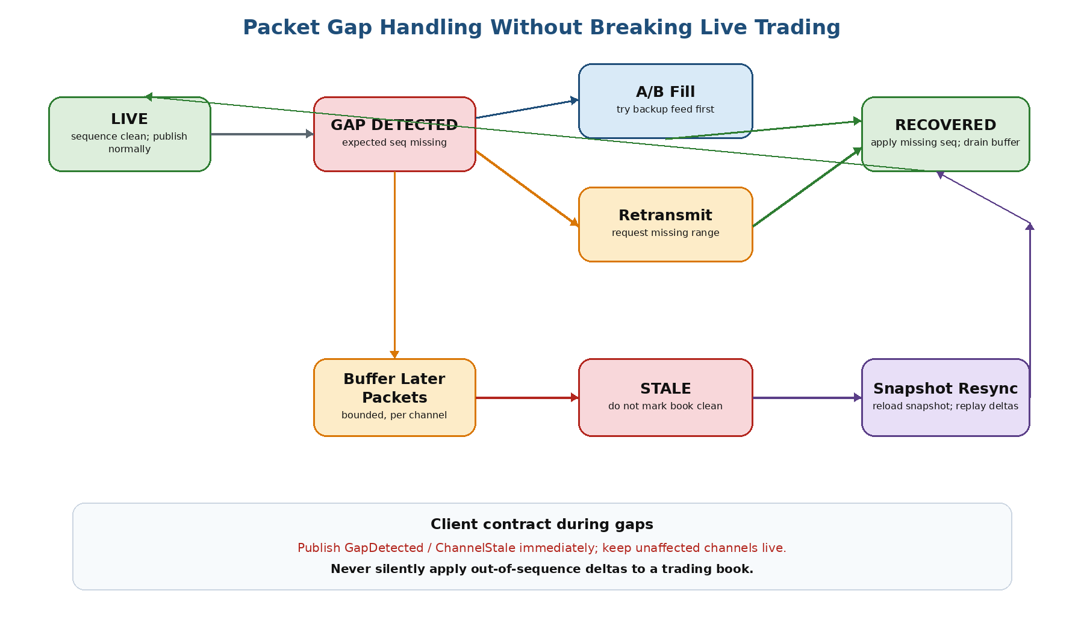
Figure 3. Packet gaps are contained and signaled instead of silently corrupting live trading state.
Non-negotiable safety rule
Never silently apply out-of-sequence deltas to a trading book and publish the book as clean. Missing one cancel, modify, or execution can make the book wrong.

6.1 Gap Handling Flow
- Detect the gap using venue/channel sequence numbers.
- Temporarily buffer later packets in a bounded per-channel gap buffer.
- Try to fill the missing sequence from the redundant A/B line.
- If both lines missed it, request retransmission from the exchange recovery channel.
- If recovery succeeds, apply missing messages in order, drain the buffer, and mark the channel live again.
- If recovery fails or exceeds policy, mark affected channel/instruments stale and start snapshot resync.
- Keep unrelated venues, channels, and instruments running.

6.2 Client Contract During Gaps
Mode | Behavior | Best For
Strict clean feed | Pause affected channel, publish GapDetected/ChannelStale, recover, then replay in order. | Book builders, risk, consumers that require gap-free state.
Fast feed with markers | Publish sequence numbers and explicit gap/stale markers; sophisticated clients enforce their own policy. | Trading engines that build local books and can make venue-specific decisions.
Snapshot resync mode | Discard stale book, reload snapshot, replay deltas from snapshot sequence, mark live after validation. | Longer recovery failures, book corruption, or recovery-channel outages.

7. Failover and Data Consistency Across Colo Servers

7.1 Feed-Level Failover
- Subscribe to Feed A and Feed B concurrently; do not leave the secondary line idle.
- Deduplicate by sequence number and publish the first valid copy of each sequence when operating in lowest-latency mode.
- Use the slower or backup line to fill packet loss before going to retransmission.
- Track A/B divergence, packet loss, and arrival skew as first-class metrics.

7.2 Server-Level Failover
Pattern | Normal Data View | Trade-off
Full hot-hot receive | Critical servers receive the same logical A/B feed data; arrival times and packet loss may differ. | Fastest failover; higher bandwidth and CPU cost.
Sharded active-active | Servers own different venue/channel/instrument ranges. | Scales better; failover requires backup subscriptions or spare capacity.
Full receive, sharded publish | Multiple servers receive all raw data but publish different channel sets. | Good balance: capacity sharing plus warm failover.
Separate geographic colos | Eventually may replicate normalized data, but not identical low-latency arrival. | Useful for DR/analytics; not a substitute for local venue feed in latency-sensitive trading.
Direct answer: do different colo servers have the same data?
For hot standby low-latency servers, usually yes at the logical sequence level: both receive the same A/B exchange feeds in normal operation. They will not have identical packet timing, hardware timestamps, or packet-loss patterns. For sharded capacity servers, not necessarily; for different geographic colos, data may be replicated later but will not arrive with the same latency profile.

8. High-Level Object-Oriented Design
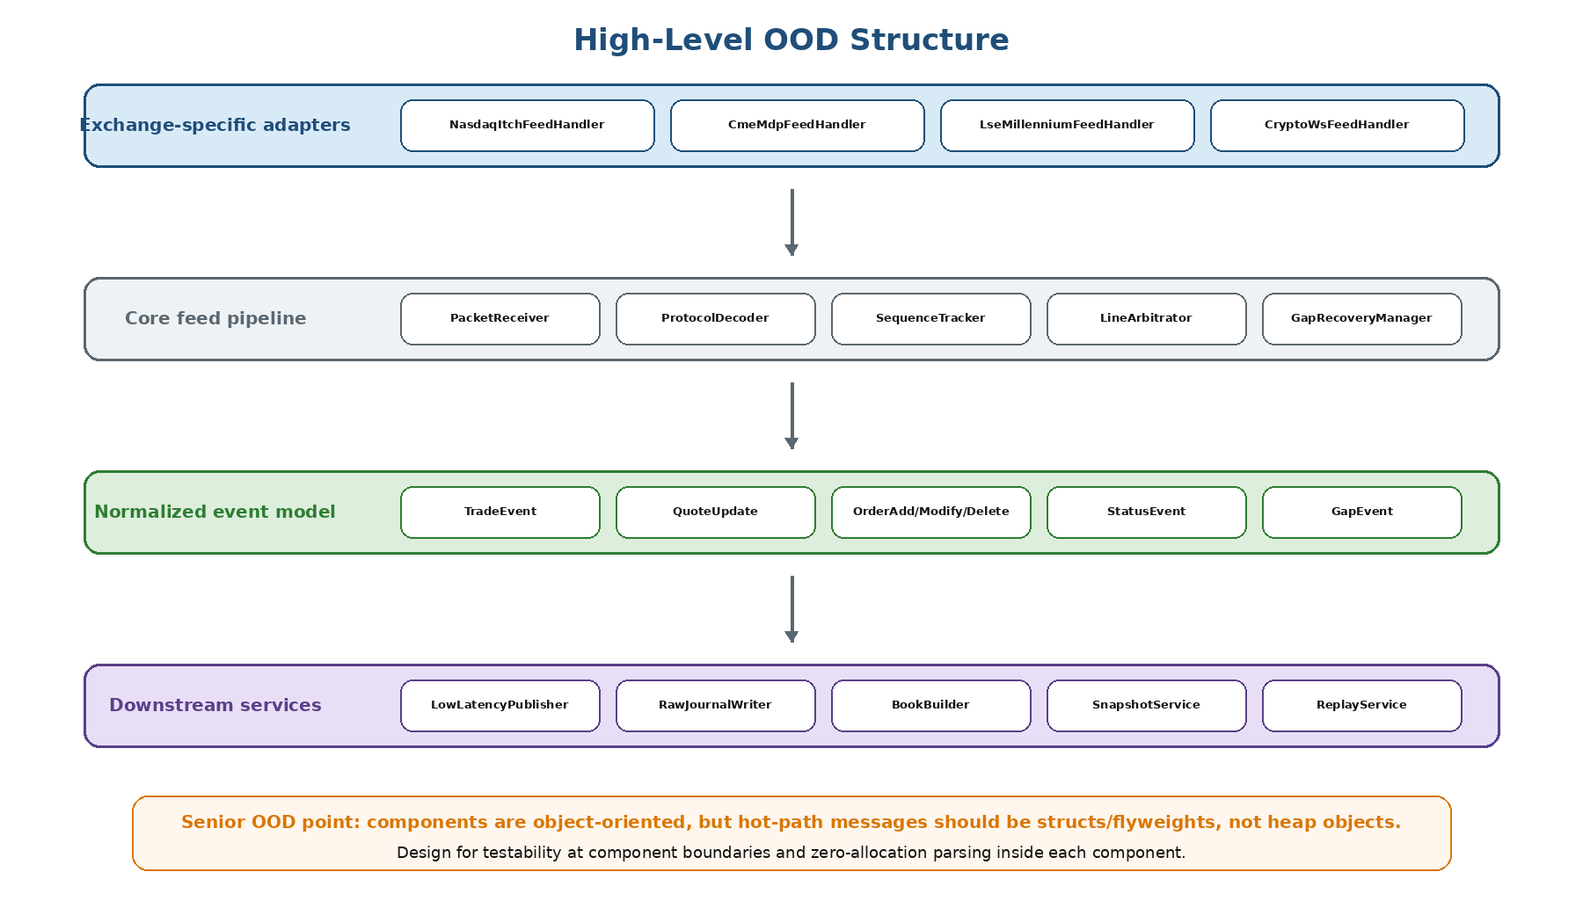
Figure 4. OOD component boundaries with low-allocation implementation inside hot-path components.
Component | Responsibility
ExchangeFeedHandler | Owns a venue/channel session and composes receiver, decoder, sequence tracker, recovery manager, normalizer, and publisher.
PacketReceiver | Reads packets from kernel bypass, busy-poll sockets, or standard sockets depending on SLA.
ProtocolDecoder | Converts exchange-specific binary/FIX/proprietary messages into decoded internal messages.
SequenceTracker | Validates ordering, detects duplicates, out-of-order packets, and gaps.
LineArbitrator | Merges A/B feeds, deduplicates, and fills gaps from the alternate line.
GapRecoveryManager | Requests retransmission and coordinates replay of recovered messages.
EventNormalizer | Converts decoded exchange messages into compact normalized events without losing fields needed for book replay.
LowLatencyPublisher | Publishes compact binary events to trading clients through shared memory, multicast, or low-latency transport.
RawJournalWriter | Persists original packets asynchronously for replay and audit.
BookBuilder | Applies ordered events per instrument/channel and manages live/stale/recovering state.
interface PacketReceiver { RawPacket receive(); }
interface ProtocolDecoder { DecodedMessage decode(RawPacket p); }
interface SequenceTracker { SequenceStatus check(long sequence); }
interface GapRecoveryManager { void recover(long fromSeq, long toSeq); }
interface EventNormalizer { NormalizedMarketEvent normalize(DecodedMessage m); }
interface EventPublisher { void publish(NormalizedMarketEvent e); }

9. Performance Optimizations
Hot Path | Avoid
Compact binary schemas or raw pass-through | JSON, text serialization, object-heavy conversion.
Preallocated buffers, flyweights, structs | Heap allocation per event and GC-sensitive object graphs.
Single-producer/single-consumer rings where possible | Locks, blocking queues, unbounded queues.
CPU/NIC/NUMA affinity | Cross-socket memory traffic and scheduler migration.
Bounded batching only within latency budget | Large batches that improve throughput but damage p99/p99.9 latency.
Explicit stale/gap status | Silent continuation after data loss.
- Optimize the hot path for p99 and p99.9 latency, not only average throughput.
- Optimize the book-building path for ordered correctness, replayability, and bounded lag.
- Optimize the historical path for compression, scan efficiency, and reprocessing cost.
- Do not let slow clients, durable writes, or recovery traffic block packet receive and trading publish loops.

10. Monitoring and Alerting
Category | Key Metrics / Alerts
Feed health | message rate, byte rate, heartbeat misses, sequence gaps, duplicates, out-of-order packets, A/B divergence.
Recovery | gap duration, retransmission requests, recovery success rate, recovery latency, unrecovered gaps, snapshot resync count.
Latency | NIC-to-decode, decode-to-normalize, normalize-to-publish, publish-to-client, p50/p95/p99/p99.9.
Book quality | book builder lag, stale books, crossed books, negative quantities, unknown order IDs, sequence mismatches.
Infrastructure | NIC drops, kernel drops, ring occupancy, CPU per pinned core, GC pauses if JVM, disk write latency, PTP offset.
Client delivery | per-client queue depth, disconnects, stale duration, slow-consumer drops, replay requests.
Operational target
At any moment, operators should be able to answer: which venue/channel is affected, which sequence is missing, whether A or B lost it, whether retransmission is pending, which clients were marked stale, and which systems remain live.

11. Senior Interview Closing Summary
The strongest design answer is not a single generic pipeline. Market data ingestion is a set of coordinated pipelines with different SLAs. The lowest-latency feed path must be short, deterministic, and explicitly sequence-aware. The reliable path must be durable, replayable, and correct enough to rebuild books after gaps, decoder changes, and operational incidents.
- Use hot-hot A/B feed receipt for critical colo servers and first-valid sequence arbitration for minimum latency.
- Use active/passive or active/active-with-fencing publishing depending on client deduplication capability.
- Make stale data impossible to miss: emit gap, stale, recovery, and publisher epoch messages.
- Do not corrupt live books: recover in order or mark stale and resync from snapshot.
- Design failure domains around venue/channel/instrument so one gap does not stop the entire trading plant.

12. Interview Checklist
Question | Strong Answer Signal
How do you handle heterogeneous protocols? | Exchange adapters behind common decode, sequence, recovery, and normalization interfaces.
How do you keep latency low? | Minimal hot path, kernel bypass/busy polling, pinned cores, NUMA locality, compact binary events, no blocking storage or slow clients.
How do you build books correctly? | Ordered per-instrument processing, raw/event logs, stale state, replay, snapshot resync.
What happens on packet loss? | A/B fill, bounded buffer, retransmission, stale markers, channel-level containment.
Do colo servers have the same data? | Critical hot standby servers usually receive the same logical A/B feed data; timing/loss differ; sharded servers may not.
How do you prove latency? | PTP hardware timestamps and latency breakdown from NIC receive through client delivery.
How do you avoid split-brain? | Publisher epoch, fencing, deterministic ownership, and sequence-based client deduplication.

