Jiaming Chen
CSE 446
HW3

1.1
<0,2,2> = w parallel to W
1.2
margin = sqrt(2^2+2^2) = sqrt(2)
1.3
sqrt(2) = 1/norm(W)
W = <0,2a,2a>
1/2 = 8a^2
1/16 = a^2
a = ¼

W = <0,1/2,1/2>
1.4
y1(W * Φ(x1) + w0) >= 1
y2(W * Φ(x2) + w0) >= 1
W*Φ(x1)+w0 <= -1
W*Φ(x2)+w0 >= 1
w0 <= -1
2+w0 >= 1
w0 = -1
1.5
f(x) = -1 + x/2 + x^2/2
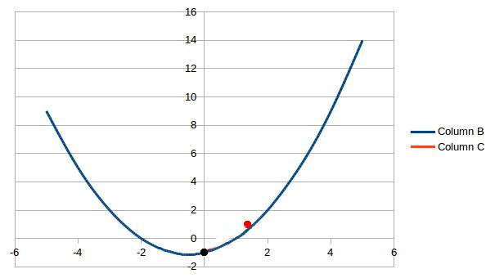

2.1.1
I will use DecisionTreeClassifier in the python sklearn library. For stump, I will set max_depth = 1; for depth two tree, I will set max_depth = 2.

2.1.2

TODO

2.2.1
Column A is for decision stump. The error converge toward 15%, and the best case is about 8% error. The error jumps up to 30 % at the beginning because the stump is a simple model, but we bagging quickly adjust it to give more accurate predictions.

2.2.2
Column B is for Depth 2 tree. It is almost the same as decision stump, converging toward 11% - 15%. And the best case is also around 8 %. The error doesn't jump as high at the beginning because depth two tree is more complicated, but in the long term, both stump and depth two have similar predictions.

2.2.3
In this experiment, I ran randint to sample from N numbers range from 0 to N-1, and used a set to record all the numbers. The uniqueness is calculated by size of set / N. In 100 iteration, the mean is 63.8% unique. The worst case is 53.5% unique, and the best case is 73.2% unique. The result is very close to the expected uniqueness 63.2%.

2.3.1
Column A is stump, B is Depth 2.

2.3.2
It is a tie because their predictions have similar accuracy. This result happens because the solution for the data set is not very complex, which can be represented easily by stump or depth two tree. Or we can see that depth two tree converges faster than stump at 0 to 6 iterations, which suggests depth two learner might be better if we have more complex data. But considering how quickly both classifier converge, there is no obvious reason to claim one to be better than another.

2.3.3

