Jiaming Chen
CSE 446
HW 2

Problem 1
1) Let P(B) be probability of Bronchitis, P(T) be probability of Tuberculosis
P(X) be probability of X-ray Shadow, P(D) be probability of Dyspnea
P(L) be probability of Lung Inflammation

P(B) = 1/2, Number of Bronchitis / Total Number of Samples
P(T) = 1/2, Number of Tuberculosis / Total Number of Samples
P(X|B) = 2/3, Number of X-ray Shadow / Total Number of Bronchitis
P(D|B) = 2/3, Number of Dyspnea / Total Number of Bronchitis
P(L|B) = 1, Number of Lung inflammation / Total Number of Bronchitis
P(X|T) 2/3, Number of X-ray Shadow / Total Number of Tuberculosis
P(D|T) = 1/3, Number of Dyspnea / Total Number of Tuberculosis
P(L|T) = 1/3, Number of Lung inflammation / Total Number of Tuberculosis

2) P(B|X,-D,L) = P(B)P(X|B)P(-D|B)P(L|B) = 1/2 * 2/3 * 1/3 * 1 = 1/9 => 60%
P(T|X,-D,L) = P(T)P(X|T)P(-D|T)P(L|T) = 1/2 * 2/3 * 2/3 * 1/3 = 2/27 => 40%

3) Yes. An overfitting situation in Naive Bayes is having 0/1 probability. P(-L|B) = 0,
which means no matter how likely Bronchitis is likely to occurs given the previous
evidence, multiplying by an outlier P(-L|B) would ruin everything.

Problem 2
1)
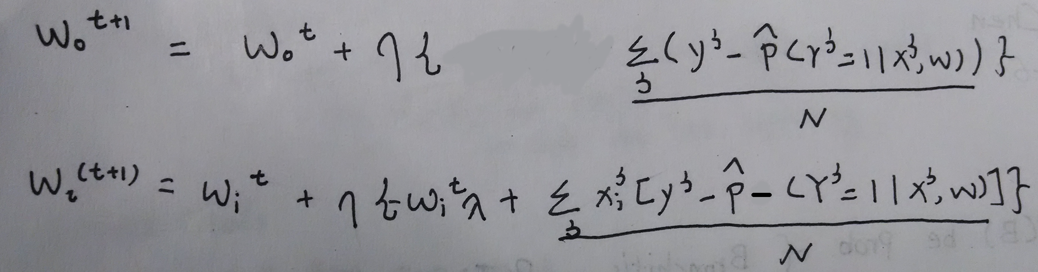

2)
a)

b)Accuracy 94.6%
3)
a)12

b)

c) 94.6%
4) l^2 norm = 1.01133 for lambda = 0
l^2 norm = 0.1334 for lambda = 0.3
lambda = 0.3 is preferred because the l^2 norm if smaller when lambda = 0.3 which is less likely to overfit the data compare to lambda = 0

Problem 3
1) For 0: Precision = 100%, Recall = .81%
For 1: Precision = 46.35% Recall = 100%

2) I used a accuracy upper bound of 99% and 80%, when the prediction reaches the upper bound, the loop will stop. However, the accuracy doesn't go higher than 50% in 1000 Iterations.

3) Based on observation, I don't see the prediction becomes better. Therefore, It probably doesn't converge. However, this is just a guess, we cannot tell for sure.

4)
 | Logistic Regression | Perceptron
RunTime | Faster because matrix algebra through all samples on the is fast | Slower because have to iterate through the samples one by one
Accuracy | More Accurate prediction | Less Accurate
Complexity if Implementation | Harder | Simple

Perceptron is my favorite because it is easy to understand and easy to implement.

