A Conditional Propellant Estimate for Shipboard Booster Recovery: Translational Optimization and Attitude Constraints
Team TBA, Problem A

Abstract
We estimate the propellant required to recover a first-stage booster that separates at 70 km altitude with a speed of 6,000 km/h and a dry mass of 130 t. The unspecified velocity direction, engine performance, aerodynamics, and landing hardware preclude a unique real-vehicle estimate. We therefore define a horizontal, wind-free reference scenario with spherical gravity, standard atmospheric density, variable mass, a constant drag coefficient of 0.5, and three virtual engines with a specific impulse of 320 s.
Direct multiple shooting yields a nominal candidate carrying 149.30 t of liquid oxygen and methane and consuming 147.84 t before reaching a center-of-gravity reference endpoint. The sequence comprises a 40 s coast, a three-engine entry burn, and a two-engine final burn. Independent integration gives a flight time of 217.75 s, a downrange distance of 206.35 km, a peak dynamic pressure of 47.01 kPa, and a reference descent speed of approximately 1.00 m/s. However, retaining this trajectory under the assumed high-pressure inflow constraint requires at least 24.8° of net thrust-to-body deflection at one instant. All nine deterministic perturbations fail the unchanged open-loop plan.
The 149 t value is consequently a reproducible translational benchmark, not a demonstrated safe-landing load or a global minimum. The analysis identifies the attitude, foot-contact, deck-coverage, and post-contact conditions that must be resolved before a complete recovery estimate can be justified.
Keywords: booster recovery; propellant estimation; trajectory optimization; attitude constraints; foot contact; numerical verification

1. Introduction

1.1 Motivation and problem context
Recovery requires the booster to withstand atmospheric entry, reach a fixed finite deck, approach with an acceptable body attitude, and remain stable during contact and engine shutdown. The problem specifies separation altitude and speed, dry mass, vehicle dimensions, and propellant species, while allowing the ship to be positioned conveniently [1]. It leaves the initial velocity direction, propulsion performance, aerodynamic coefficients, attitude-control capability, landing-gear properties, and allowable structural and thermal loads unspecified.
We therefore seek a conditional estimate: a propellant load for a stated reference model, together with an assessment of whether that trajectory can meet additional recovery requirements. This distinction allows a numerical answer without treating assumed hardware properties as established facts.

1.2 Research objectives and scope
The study separates trajectory generation from recovery feasibility. Model M0 describes variable-mass translation and provides a low-consumption candidate within a restricted strategy family. Model M1 denotes the coupled translation, rotation, actuator, and contact problem needed to assess recovery. This paper develops necessary conditions and governing relations for M1 but does not solve a complete M1 landing simulation.
Our objectives are as follows:
- Translational model: formulate M0 in a vertical great-circle plane and search a restricted burn sequence using direct multiple shooting.
- Numerical verification: check the nominal result with independently written coordinate formulations and integrators.
- Attitude assessment: determine whether the required thrust direction is compatible with assumed body-angle and deflection limits.
- Recovery assessment: distinguish the implemented M0 checks from the unresolved attitude, contact, deck, structural, and thermal requirements. The safety list comprises 18 classes and 19 records, with C13 split into C13a and C13b.
The principal numerical result is an approximately 149 t M0 candidate. Its reproducibility is assessed separately from its physical feasibility: neither a prescribed thrust direction nor a low center-of-gravity speed establishes safe foot contact.

1.3 Methodology overview
We first state the input assumptions and examine passive trajectories (Sections 2–3). We then formulate and solve the translational problem and independently verify its nominal result (Sections 4–7). Finally, we assess necessary attitude conditions and contact geometry, identify unresolved recovery requirements, and discuss their implications for the propellant estimate (Sections 8–11).

2. Assumptions, parameters, and notation

2.1 Evidence and modeling choices
We use G for quantities given in the problem, L for literature constants or reference models, H for chosen modeling assumptions, and U for quantities not established by the available information. H values define a numerical scenario; they are not hardware specifications or confidence limits. Table 1 collects the reference parameters and their evidence status.
Table 1. Reference parameters and evidence status.
Quantity | Reference value | Status | Basis
Separation altitude; speed | 70 km; 6,000 km/h | G | Problem statement [1]
Dry mass; height; diameter | 130 t; 65 m; 7.0 m | G | Problem statement [1]
Propellant species | Liquid oxygen and methane | G | Problem statement [1]
Earth radius; gravity parameter | R = 6371000 m; μ = 3.986004418×10¹⁴ m³/s² | L | Spherical approximation [3,4]
Density model | USSA 1976, geometric 0–70 km | L/H | Reference atmosphere [2]; domain chosen
Initial flight-path angle; wind | 0 degrees; zero | H | Unspecified by the problem
Engines; reference thrust | 3; 1 MN per engine | H | Virtual engine family
Steady throttle; specific impulse | 0.3–1.1; 320 s | H | Not a certified performance map
Ignition delay; response; slew | 0.5 s; 0.1 s; 1/s | H | Finite engine response
Reference area; drag coefficient | 38.4845 m²; 0.5 | G/H | Area derived from given diameter; C_D and zero lift assumed
Unusable fraction; usable reserve | 0.005 of initial load; 701.055 kg | H | Mass bookkeeping and nominal target
Pressure; force-budget limits | 50 kPa; 4 | H | Nominal safety screens
Deck half-width; edge margin | 20 m; 2 m | H | Static two-dimensional deck
CG-to-foot-plane; foot half-span | 32.5 m; 5 m | H | Assumed deployed geometry
TVC, inertia, aerodynamic moment, legs | Not established | U | Required for complete M1 safety
The propulsion system is a virtual three-engine model. Each engine has a reference thrust of 1 MN and a steady throttle range of 0.3–1.1. Two engines are used for the final burn as a scheduling choice, not as a proven optimum. At low speed, one engine cannot provide upward acceleration against even the dry weight because 1.1 MN < 130000 g₀ ≈ 1.275 MN. Two engines span 0.6–2.2 MN, with a dry-mass hovering throttle near 0.64. Three engines can also hover because their minimum combined thrust is 0.9 MN; their exclusion from the final burn is not a feasibility result.
The reference motion lies in a vertical great-circle plane over a spherical, non-rotating Earth. The atmosphere is stationary, and the ship remains fixed after its nominal location is selected. Horizontal separation gives vt,0 = 1666.667 m/s and vr,0 = 0. These are scenario assumptions; the specified speed alone does not determine them. An upward initial trajectory may leave the implemented 0–70 km atmospheric domain and would require that domain to be extended.

2.2 Notation
Table 2. Main notation.
Symbol | Meaning
h, φ | CG geometric height; Earth-centered position angle
v_{t}, v_{r}, V | Local tangential and radial velocities; speed
m, m_{d}, m_{p,0}, m_{use} | Total mass; dry mass; initial total propellant; usable mass
T, T_{i}, D, q | Net M0 thrust; engine thrust magnitudes; drag; dynamic pressure
β, θ, δ | Thrust direction; body direction; relative deflection
ψ, ω, I | Inertial body angle; body angular rate; transverse inertia
χ, θ_{d} | Opposite-relative-velocity direction; body tilt relative to deck
ℓ, b, A_{ref} | CG-to-foot distance; foot half-span; aerodynamic reference area
n_{Σ}, n_{proper} | Force-magnitude budget; net non-gravitational acceleration / g₀
All displayed force equations use SI units. One tonne, written t, is 1,000 kg. The optimizer internally scales altitude, velocity, mass, and thrust to km, km/s, t, and MN; the verification programs use SI variables and independent coordinate formulations.

2.3 Contributions and evidence boundaries
The study combines four elements:
- Input classification: the G/L/H/U labels distinguish problem data, literature references, scenario assumptions, and unresolved inputs.
- Traceable computation: the M0 candidate is accompanied by independent replay, coordinate comparisons, and a control-grid refinement study.
- A necessary attitude test: thrust and body-angle intervals identify incompatibilities that are invisible in a point-mass trajectory.
- An explicit recovery checklist: the 18 safety classes distinguish nominal M0 results from missing attitude, contact, structural, and thermal evidence. These are elements of the present analysis, not claims of new optimization algorithms or general safety theory.

3. Physical scales and preliminary diagnostics

3.1 Why gravity, curvature, atmosphere, and variable mass are retained
Several effects are significant at the stated scale. At separation, h₀/R = 0.0110 and g(h₀) = 9.61 m/s², compared with g(0) = 9.82 m/s². The curvature term V₀²/(R + h₀) ≈ 0.431 m/s² affects a trajectory extending roughly 200 km. Initial specific kinetic energy is 1.39 MJ/kg, while the gravitational potential decrease to sea level is about 0.680 MJ/kg. Gravity and curvature are therefore retained. A constant-mass approximation is also unsuitable when the candidate propellant load is comparable to the dry mass.
A passive diagnostic is useful before optimization. For a dry 130 t body, no thrust, horizontal separation, and the same reference area, integration to the spherical surface gives the results in Table 3. These dry-body calculations are explanatory baselines, not predictions for the heavier fueled candidate.
Table 3. Passive diagnostics for a dry 130 t body.
Dry-body diagnostic | Time (s) | Range (km) | Surface speed (m/s) | Peak q (kPa)
Vacuum | 123.3 | 204.7 | 2034 | 0.0
Atmosphere, C_D = 0.5 | 134.4 | 202.0 | 608 | 393.5
Atmosphere, C_D = 1.0 | 147.4 | 198.5 | 296 | 205.1
Both atmospheric cases reach the surface at hundreds of meters per second and exceed the assumed 50 kPa screening limit. Drag reduces the braking requirement but does not produce a soft landing. A sea-level terminal-speed estimate is insufficient because the body descends through changing density and may not approach its local terminal speed before impact.

3.2 What freedom to position the ship does and does not provide
For a vacuum central-force trajectory, specific angular momentum is conserved:
$$(R + h) v_{t} = (R + h_{0}) V_{0} (1)$$
The local tangential speed therefore increases to approximately 1,685 m/s at the surface in this vacuum diagnostic. Central gravity changes the velocity direction and its local components but exerts no torque about Earth’s center. Allowing a downrange ship avoids a return-to-launch-site requirement; it does not remove the horizontal-braking requirement. In the controlled trajectory, drag and appropriately directed thrust change the angular momentum.
The ship is placed once at the nominal controlled endpoint and is not moved in perturbation tests. The passive ranges of approximately 199–202 km need not match the controlled range of approximately 206 km, because thrust changes the flight path.

4. Variable-mass translational model

4.1 Environment and force closure
We use the lower-atmosphere formulation of the U.S. Standard Atmosphere 1976 [2]. Geometric height is converted to geopotential height by
$$H = \frac{R_{a} h}{R_{a} + h}, R_{a} = 6356766 m (2)$$
Within each geopotential layer, T_{a} = T_{b} + L_{b}(H − H_{b}). Pressure is obtained from the hydrostatic lapse-rate expression, or its exponential limit when L_{b} = 0, and ρ = p/(R_{air}T_{a}) with R_{air} = 8314.32/28.9644 J kg⁻¹K⁻¹. The geometric validity interval of this implementation is 0–70 km. The geopotential conversion radius is not substituted for the gravitational Earth radius.
The reference force laws are
$$g(h) = \frac{μ}{(R+h)^{2}}, q = \frac{1}{2}ρ V^{2}, D = q C_{D} A_{ref}, A_{ref} = \frac{π d^{2}}{4} (3)$$
The Earth constants are taken from [3,4]. The constant drag coefficient C_D = 0.5 and zero lift are assumptions, not a measured aerodynamic database. Drag depends on vehicle shape, orientation, and flow conditions [6]. Retropropulsion experiments also show configuration- and thrust-dependent flow [10]; their measured coefficients are not applied to this different booster.

4.2 Equations of motion and propellant accounting
With thrust angle β measured from the local upward radial direction, the equations are
$$\begin{aligned} \dot{h} = v_{r}, \\ {\dot{v}}_{t} = \frac{Tsinβ - D v_{t}/V}{m} - \frac{v_{r} v_{t}}{R+h}, \\ {\dot{v}}_{r} = \frac{Tcosβ - D v_{r}/V}{m} - \frac{μ}{(R+h)^{2}} + \frac{v_{t}^{2}}{R+h}, \\ \dot{m} = -\frac{T}{I_{sp} g_{0}}, \\ \dot{φ} = \frac{v_{t}}{R+h}. \end{aligned} (4)$$
The drag term is defined as zero at V = 0. All active M0 thrust vectors are parallel, so T is both their resultant magnitude and the sum of individual thrust magnitudes. The mass-flow relation uses constant specific impulse [5]. If a later model allows nonparallel engine vectors, translation must use their vector sum, while propellant flow depends on the sum of engine thrust magnitudes.
Initial total propellant includes oxidizer and methane. With an unusable fraction f_{un} = 0.005 of the initial load, the usable mass is
$$m_{use}(t) = m(t) - m_{d} - f_{un} m_{p,0}, m(0) = m_{d} + m_{p,0} (5)$$
The unusable fraction remains part of the vehicle mass but cannot be consumed. The usable reserve target is mres = 2.2×10⁶/(320 g₀) = 701.055 kg, corresponding to one second of maximum two-engine thrust. Optimization includes a further 10 kg buffer. This is a nominal bookkeeping requirement, not a demonstrated allowance for disturbances or emergency maneuvers.

4.3 Engine response
A point-mass solution must not exploit instantaneous full thrust. Ignition has a 0.5 s delay. After the delay, actual throttle follows a rate-limited first-order response with time constant 0.1 s and |u̇| ≤ 1 s⁻¹. For a full-throttle ignition command at time t_{c}, the modeled response is
$$u(t) = \left\{\begin{matrix} 0, & t - t_{c} ≤ 0.5, \\ t - t_{c} - 0.5, & 0.5 < t - t_{c} ≤ 1.5, \\ 1.1 - 0.1exp[-(t - t_{c} - 1.5)/0.1], & t - t_{c} > 1.5. \end{matrix}\right. (6)$$
During controlled burn segments, actual throttle is piecewise linear. The implied command ucmd = u + 0.1 u̇ is constrained to 0.3–1.1 at both ends of each segment, and the throttle slew limit is checked separately. Startup and shutdown may pass below 0.3 because the lower bound applies only to steady powered operation. Shutdown includes a rate-limited decrease followed by an exponential tail. No additional shutdown-command delay is assumed.

5. Restricted low-consumption trajectory search

5.1 Objective, strategy, and constraints
We minimize initial carried propellant,
$$min m_{p,0} = m_{0} - m_{d} (7)$$
The strategy family consists of an initial coast, a three-engine entry burn, an off command, a two-engine restart command five seconds later, and a final two-engine burn. The five-second interval separates commands; shutdown and restart dynamics prevent it from being a full zero-thrust interval. The landing pair ignites twice and the third engine once, within the assumed limit of three ignitions per engine.
Within each fixed initial ignition-time case, decision variables include m₀, entry shutdown time, final time, actual throttle nodes, and thrust-angle nodes. The searched cases use initial ignition times 0, 20, 40, 50, and 60 s. The 60 s run did not return a feasible solution from its tested initial guess. A separate continuously variable ignition-time search reached its iteration limit. Neither outcome proves physical infeasibility.
Optimization imposes sampled and RK-substep targets of q ≤ 47 kPa and nΣ ≤ 3.9, below the nominal replay thresholds of 50 kPa and 4. The force-magnitude budget and the corresponding proper-acceleration diagnostic are
$$n_{Σ} = \frac{∑_{i} |T_{i}| + |F_{aero}|}{m g_{0}}, n_{proper} = \frac{|∑_{i} T_{i} + F_{aero}|}{m g_{0}} ≤ n_{Σ} (8)$$
The quantities are coupled because the same drag D enters both q and nΣ. The latter bounds the magnitude of non-gravitational acceleration; it is not an independently established structural rating. Search bounds are m₀ ∈ [131, 400] t, tf ∈ [110, 450] s, h ∈ [32.5, 70000] m, and β ∈ [−90°, 90°]. Local thrust-direction slew is limited to 4.9°/s, and inertial thrust-direction slew is checked against 5°/s during replay.
The terminal target is a center-of-gravity reference state, not a foot-contact condition:
$$h_{f} = 32.5 m, v_{t,f} = 0, v_{r,f} = -1 m s^{-1}, β_{f} = 0, m_{use,f} ≥ m_{res} + 10 kg (9)$$
The optimization limits terminal vertical thrust to 0.95 times local weight. At the independently detected reference event, replay checks that vertical thrust does not exceed weight. Neither condition demonstrates stable support after actual contact.

5.2 Numerical method and independent acceptance
Direct multiple shooting is implemented with CasADi [7] and IPOPT [8]. Each powered phase is successively discretized into 80, 160, and 320 control intervals, with four RK4 substeps per interval. Coast steps are at most 0.5 s; startup uses 64 steps of 0.025 s; and the shutdown/restart transition uses 132 steps of 0.05 s with the actual response evaluated at the midpoint.
Solver convergence is followed by independent replay. Because some optimizer bounds are enforced only at control nodes or RK substeps, and not all path constraints are imposed during coast and startup, the complete schedule is reintegrated in SI Cartesian coordinates with DOP853, explicit control breakpoints, and a continuous reference-altitude event [9]. A 0.05 s sample spacing, maximum-step halving, and local peak refinement check the nominal path. An independently written SI polar model and RK45 provide additional comparisons. These checks establish numerical consistency for this candidate; they do not prove continuous-time constraint satisfaction analytically or global optimality.

6. Nominal trajectory and propellant result

6.1 Schedule comparison
Table 4. Accepted M0 schedule comparisons.
Initial ignition (s) | Intervals / phase | Initial load (t) | Consumed (t) | M0 screens
0 | 320 | 150.862 | 149.397 | Pass
20 | 80 | 150.022 | 148.559 | Pass
40 | 80 | 149.425 | 147.968 | Pass
50 | 80 | 151.043 | 149.576 | Pass
40 (selected) | 320 | 149.300 | 147.842 | Pass
The 40 s initial-coast case gives the lowest accepted load in the tested family. Preliminary 20, 40, and 50 s cases use 80 intervals per powered phase; the selected 40 s case and the immediate-ignition reference are evaluated at 320 intervals. The refined 40 s candidate carries 1.56 t less propellant than the immediate-ignition reference, a reduction of approximately 1.04%. The mixed-resolution preliminary comparison is not a converged ranking of every ignition time. Failed solver runs or fixed-load schedules do not establish a universal lower bound.
Table 5. Selected nominal event states.
Event | Time (s) | CG height (km) | v_t (m/s) | v_r (m/s)
Separation | 0.00 | 70.000 | 1666.67 | 0.00
Three-engine ignition command | 40.00 | 62.657 | 1668.10 | −367.28
Off command | 160.42 | 9.246 | 342.71 | −244.11
Two-engine restart command | 165.42 | 7.983 | 317.83 | −268.47
CG reference endpoint | 217.75 | 0.033 | 0.00 | −1.00
At the two-engine restart, substantial tangential and radial velocities remain, so the final burn is not a purely vertical braking maneuver. The ship is selected at the nominal surface-arc range. A geographical landing location would also require the separation location and heading.
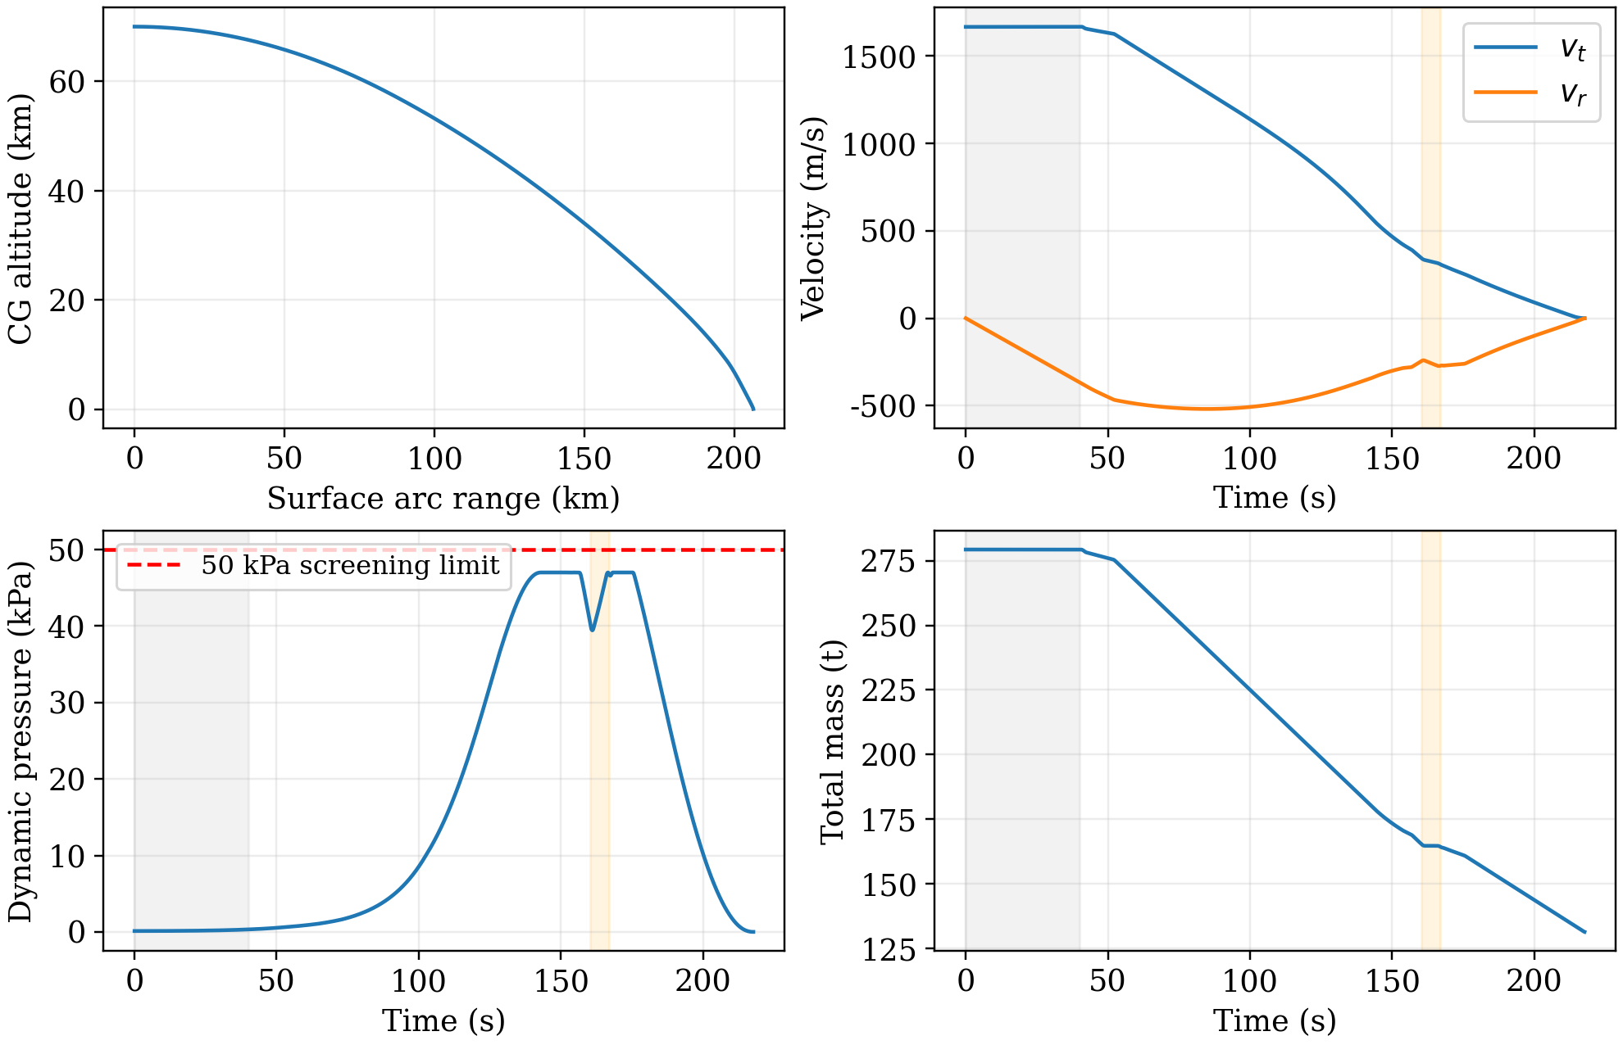
Figure 1. Nominal controlled trajectory from independent SI replay. Shading marks the initial coast and shutdown/restart transition. Altitude and velocity refer to the CG; the endpoint is not a simulated foot-contact event.
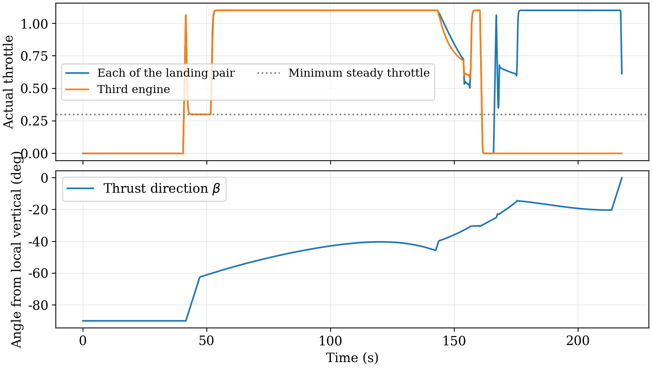
Figure 2. Actual throttle and required thrust angle. The landing pair shares a throttle trace; the third engine is separate. Passing below the dotted steady-throttle level during startup or shutdown is permitted by the response model. The angle is a required thrust direction; body attitude is not simulated.

6.2 Mass balance and characteristic thrust increment
Table 6. Nominal M0 results and interpretation.
Quantity | Nominal result | Interpretation
Initial total propellant | 149.30 t | Optimization objective, conditional
Consumed propellant | 147.84 t | To the CG reference event
Usable propellant remaining | 711.1 kg | Nominal target: 701.055 kg
Flight time | 217.75 s | CG-height event
Nominal ship range | 206.35 km | Selected once; surface arc
Reference radial velocity | −0.9999 m/s | Proxy interval: −2 to 0 m/s
Reference tangential velocity | < 10⁻⁴ m/s (magnitude) | CG proxy, not foot velocity
Peak dynamic pressure | 47.01 kPa | Nominal threshold: 50 kPa
Maximum force budget | 2.528 | Nominal threshold: 4
Reference vertical thrust / weight | 0.9502 | Not post-contact stability
Initial total mass is 279.30 t. With an assumed oxygen-to-methane mass ratio of 3.4, the 149.30 t load comprises approximately 115.37 t oxygen and 33.93 t methane. At the reference endpoint, about 1.458 t remains: 0.746 t unusable residue and 0.711 t usable reserve, with the difference attributable to rounding. The 147.84 t consumed mass is total propellant, not methane alone.
The mass-flow equation supplies a useful closure:
$$Δ v_{T} ≡ ∫_{0}^{t_{f}} \frac{T}{m} dt = I_{sp} g_{0} ln\frac{m_{0}}{m_{f}} ≈ 2.36 km s^{-1} (10)$$
This scalar characteristic velocity is the integral of thrust acceleration magnitude, not the net velocity change or passive impact speed. It incorporates the thrust expended along a changing flight path. Estimating it from an assumed impact speed and a near-dry-mass braking acceleration would neglect the coupled evolution of mass, gravity, drag, and thrust direction. The relatively large load is consistent with the candidate’s long powered descent under the imposed dynamic-pressure limit; it is not a universal minimum.

7. Numerical verification and perturbation response

7.1 Verification evidence
Table 7. Numerical verification evidence.
Check | Observed agreement | Scope
160 to 320 intervals | 0.018947% initial propellant change | Observed local refinement; not a proven discretization-error bound
Independent SI coordinates | 1.54×10⁻⁷ m/s radial endpoint difference | Cartesian versus independently written polar equations
DOP853 versus RK45 | 1.05×10⁻⁵ m/s radial endpoint difference | Different integrator families
Maximum-step halving | 3.30×10⁻⁷ m/s reference-speed difference | 0.1 to 0.05 s in original replay
Mass balance | 7.57×10⁻¹⁰ kg residual | Independent thrust/mass-flow integral
Engine response ODE | 1.12×10⁻⁹ maximum actual-throttle difference | Effective commands independently integrated
Analytic and coordinate limits | Rocket equation; quadratic drag; vacuum invariants; 200 random states | All implemented checks passed
Optimizer reproduction | Same state/control arrays and key times | From the delivered 160-interval guess
Refining from 160 to 320 intervals changes the initial propellant load by 0.0189%. This is evidence of local grid refinement, not a proven error bound. Re-solving the 320-interval problem from the archived 160-interval guess reproduces the reported mass, timing, and state/control nodes. The coordinate and integrator comparisons in Table 7 further support numerical reproducibility, but none tests global optimality or uncertainty in the assumed physics.
The replay input validator explicitly rejects out-of-range thrust angles, nonfinite throttle values, incorrect array shapes, and invalid timing. This is necessary because angles shifted by 2π can produce identical forces while violating raw control bounds. The nominal controls satisfy the strengthened validation checks.

7.2 Deterministic tests of the unchanged open-loop plan
Each test changes one parameter while keeping initial propellant, control history, and ship location fixed. Integration stops at the CG reference event, usable-propellant exhaustion, or the original planned final time. Controls are not extended beyond their defined interval. The reserve threshold keeps its nominal value. Changing Isp changes mass flow only in this test; it does not introduce an unprovided thrust-performance map.
Table 8. Deterministic perturbations of the fixed plan.
Single perturbation | Peak q (kPa) | Outcome of fixed plan | Screen
C_D: −10% | 52.38 | CG reference event: v_r = −80.87, v_t = 72.42 m/s | Fail
C_D: +10% | 44.98 | No CG reference event by planned end; CG height 560.1 m | Fail
I_sp: −1% | 46.16 | Usable propellant exhausted at CG height 299.9 m | Fail
I_sp: +1% | 48.21 | CG reference event: v_r = −53.96, v_t = 37.95 m/s | Fail
ρ: −5% | 47.09 | CG reference event: v_r = −56.69, v_t = 45.40 m/s | Fail
ρ: +5% | 48.26 | No CG reference event by planned end; CG height 302.1 m | Fail
v_t,0: −1 m/s | 46.95 | CG reference event: v_r = −11.54, v_t = 1.97 m/s | Fail
v_t,0: +1 m/s | 47.08 | No CG reference event by planned end; CG height 42.7 m | Fail
v_r,0: −1 m/s | 47.70 | CG reference event: v_r = −30.01, v_t = 15.27 m/s | Fail
None of the nine perturbed cases passes the original M0 acceptance checks. A 1 m/s reduction in initial tangential speed, approximately 0.06% of the nominal speed, gives an 11.5 m/s descent speed at the CG reference event. Reducing specific impulse by 1% exhausts usable propellant near 300 m altitude. These failures occur before complete attitude and foot-contact checks. The nominal reserve exceeds its 701 kg target by only about 10 kg; this bookkeeping margin does not establish robustness.
A case that has not reached the reference height by the planned end time may still admit a different controlled landing. The tests assess sensitivity of one fixed open-loop schedule, not the capability of a redesigned feedback controller. They are deterministic cases, so they provide neither a failure probability nor a confidence interval for propellant. Selected drag, specific-impulse, and initial-speed cases were repeated with RK45; event categories agree, and endpoint differences remain below 0.01 m in height and 0.01 m/s in velocity.

8. Attitude feasibility and the M1 extension

8.1 Separating thrust angle, body angle, and deflection
Let θ be the body angle from local vertical, β the required net-thrust angle, and δ the net thrust-to-body deflection. Then
$$β = θ + δ, ψ = θ + φ, ω = \dot{ψ}, \dot{θ} = ω - \frac{v_{t}}{R+h} (11)$$
The assumed high-pressure inflow limit requires the body axis to remain within 5° of the direction opposite relative velocity during descent at q ≥ 10 kPa. A separate late-descent limit requires body tilt within 5° when the lowest deployed-foot clearance is at most 200 m. First-contact limits are 2° body tilt and 0.5°/s angular rate relative to the deck. These constrain body motion, not merely the prescribed thrust direction.
At t ≈ 175.42 s, h ≈ 5.31 km, and q ≈ 47.0 kPa, the required thrust direction is β ≈ −14.34°, while the opposite-velocity direction is χ ≈ −44.12°. The body must lie in [−49.12°, −39.12°] under the inflow requirement. Consequently,
$$|δ| ≥ 24.78^{∘} at this instant (12)$$
This is a necessary instantaneous lower bound for retaining the M0 trajectory. A net deflection limit of 20° or less makes the inflow and thrust requirements incompatible at that instant. Near the ground, the analogous bound is approximately 15.28° using the local-deck approximation. These are trajectory-dependent requirements, not established actuator specifications.
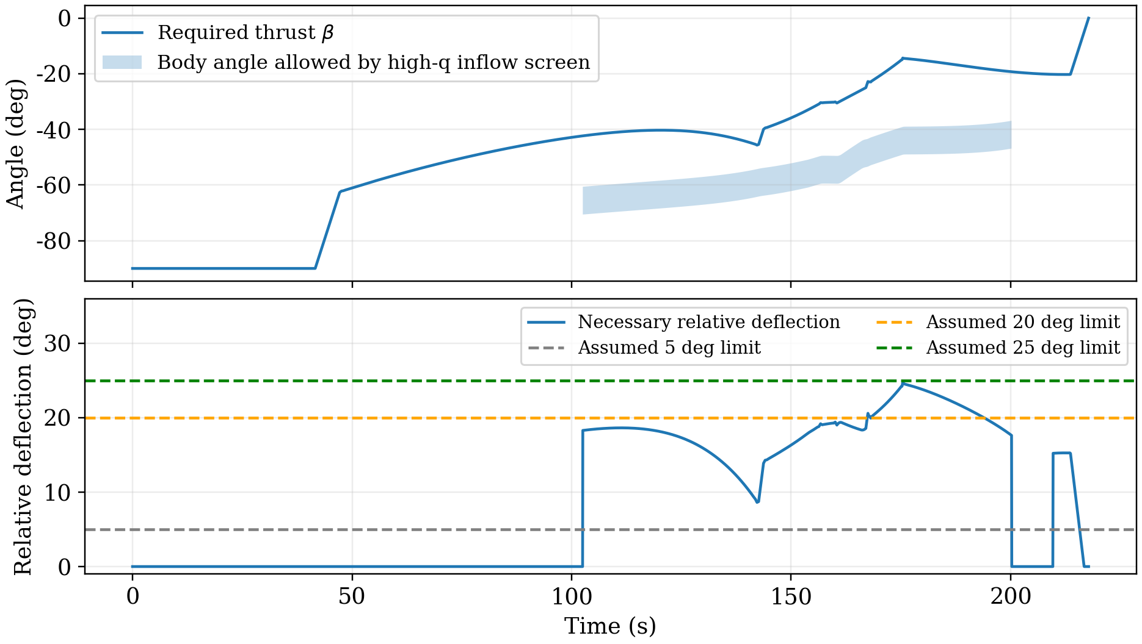
Figure 3. Required thrust and attitude-angle compatibility. The shaded interval is an allowed body-angle interval, not an allowed thrust interval. The lower panel is a sampled necessary relative-deflection bound; passing a 25-degree line does not demonstrate dynamic attitude feasibility.
For assumed net deflection limits of 3°, 5°, 10°, 15°, and 20°, the sampled angle intervals are incompatible at some instants. Limits of 25° and 30° remove this sampled instantaneous contradiction, but do not establish a continuous body trajectory with feasible torque, angular rate, or initial attitude.

8.2 Force and torque must be realized together
A rigid-body extension must add inertial angle ψ, angular rate ω, mass properties, and actuator dynamics. The following relation is only a local approximation with inertia held fixed:
$$\dot{ψ} = ω, I\dot{ω} = M_{T} + M_{a} + M_{ctrl} (13)$$
With clockwise angles as defined above, an engine mounted at −ℓ_{i}e_{b} + a_{i}e⟂ produces
$$M_{T,i} = -ℓ_{i} T_{i} sinδ_{i} - a_{i} T_{i} cosδ_{i} (14)$$
The moment sign follows from the clockwise angle convention. Aerodynamic moment may be represented by qArefL Cm or by an aerodynamic force applied at a pressure center; neither Cm nor that location is established here. A model with evolving mass distribution requires a consistent control-volume angular-momentum balance. Equation (13) must not be used as a complete variable-mass attitude equation by inserting an arbitrary I(t) and omitting the corresponding transport terms.
For scale, a uniform dry solid-cylinder surrogate gives I ≈ 4.62×10⁷ kg m². In a fixed-inertia, rest-to-rest maneuver with bounded net torque, the ideal bang-bang limit is t ≥ 2√(I|Δψ|/Mmax). A 90° turn in 5 s would require approximately 11.6 MN m without assisting torque. This is an illustrative requirement, not a measured inertia or a conclusion that such a turn occurs during the five-second command interval.
A coupled guidance and control model must allocate both force and moment among available engines, gimbals, differential thrust, and any reaction-control system. Thrust-vector control provides no torque at zero thrust, and aerodynamic controls cannot be assumed effective at low dynamic pressure. Reaction-control propellant must be counted if used. Translation and rotation must also use aerodynamic forces and moments consistent with the same body attitude and flow. The data required for this calculation are not yet established.

9. Foot contact, deck coverage, and post-contact safety

9.1 First contact and the non-supporting envelope
Use a local deck frame with CG coordinates (x_{c}, H_{c}) and body tilt θ_{d} relative to the deck normal. For the assumed deployed geometry, ℓ = 32.5 m and foot half-span b = 5 m. Let e_{b} = (sin θ_{d}, cos θ_{d}) and e⟂ = (cos θ_{d}, −sin θ_{d}). The feet are
$$r_{f,±} = r_{CG} - ℓ e_{b} ± b e_{perp}, h_{f,min} = H_{c} - ℓcosθ_{d} - b |sinθ_{d}| (15)$$
First contact is the earliest continuous zero of a deployed-foot clearance, provided that the non-supporting envelope has not touched first. For this geometry test, let s be distance along the body axis measured upward from the foot-plane center B, with the CG at s = ℓ. The main-cylinder proxy occupies s ∈ [2, 65] m with radius 3.5 m; both sides are sampled every 1 m and joined as a closed polygon. At foot contact and |θd| < 90°, its minimum clearance is 2 cos θd + (b − 3.5)|sin θd| > 0. The 2 m basal gap and 5 m deployed half-span are assumptions, not a measured layout. No conclusion follows for actual nozzles, protrusions, undeployed legs, or an inverted body.
At 2° tilt, the lowest foot contacts a flat deck when Hc ≈ 32.655 m, while the other foot is approximately 2b|sin 2°| = 0.349 m higher. Load transfer is therefore generally nonsimultaneous. Deployment timing, locking, intermediate geometry, and deployment loads require separate checks; the deployed-foot equations do not describe the stowed configuration.
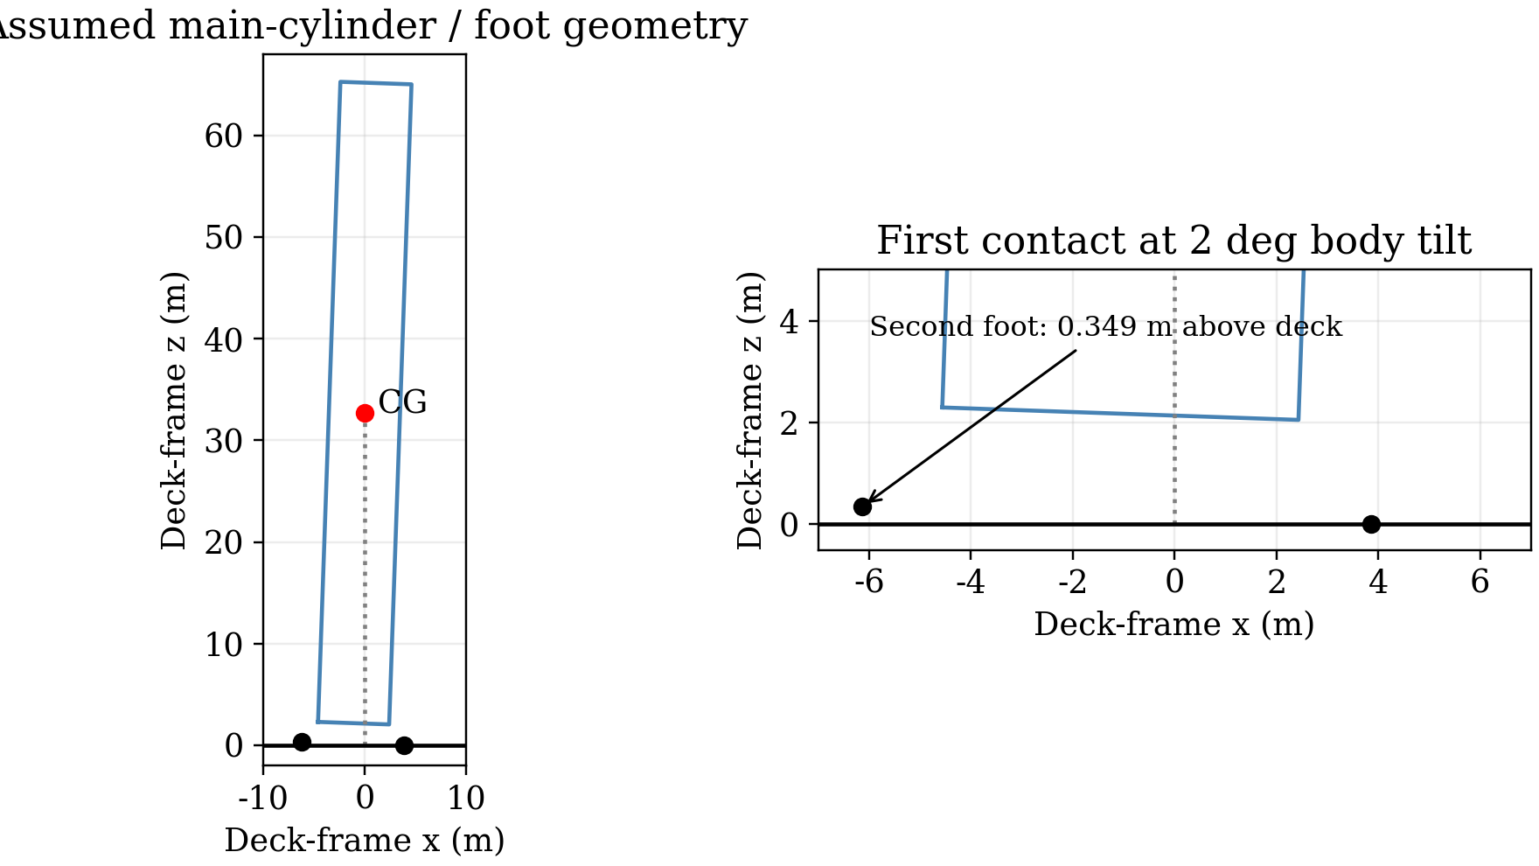
Figure 4. Assumed deployed geometry at first foot contact with 2-degree body tilt. The right panel resolves the approximately 0.349 m height difference. This is a kinematic construction, not a real landing-leg design or a contact simulation.
Contact geometry must be consistent with the spherical flight model. Away from the ship, clearance is measured relative to the spherical sea surface, not an infinite extension of the ship’s tangent plane. A polygonal envelope requires minimum-distance checks along segment interiors as well as vertices. Near the ship, the finite deck and hull geometry determine contact.

9.2 Contact velocities and target coverage
For a stationary nominal deck, the foot velocities are
$$\begin{aligned} v_{f,x,±} = v_{CG,x} - ℓωcosθ_{d} ∓ b ωsinθ_{d}, \\ v_{f,z,±} = v_{CG,z} + ℓωsinθ_{d} ∓ b ωcosθ_{d}. \end{aligned} (16)$$
For a moving deck, the local deck-point velocity must be subtracted. The assumed vertical interval [−2, 0] m/s and horizontal-speed limit of 0.5 m/s apply to feet actually in contact. For an upright body with CG velocity (0, −1) m/s, a body rate of 4.9°/s gives a foot horizontal speed of about 2.78 m/s; 0.5°/s gives about 0.284 m/s. These examples show why the CG velocity alone is insufficient. The M0 thrust-direction rate is not a body-rate history.
Let B be the foot-plane center. The target-error condition is |xB − xship| ≤ 5 m (C13a). The separate deck-coverage condition requires every foot to lie within 18 m of the deck center (C13b), leaving a 2 m margin to the assumed 20 m half-width. Selecting the nominal ship position does not demonstrate tracking accuracy, three-dimensional support, or performance on a moving deck.

9.3 Absorption, shutdown, and stability
At the reference mass of 131.46 t, vertical kinetic energy is approximately 65.7 kJ at 1 m/s and 263 kJ at 2 m/s. With no engine support and a total stopping stroke s, the minimum average total normal force is m[g + w²/(2s)], where w is the initial downward speed. Peak and single-leg forces may be larger, particularly when the feet contact at different times. Unknown leg stiffness, damping, stroke, friction, and ratings prevent these energy estimates from establishing contact feasibility.
A contact model must include unilateral normal forces, friction, a finite compression stroke, and finite deck coverage. A spring-damper approximation must represent a defined compliant component rather than allow unphysical penetration by the rigid vehicle. The assumed two-second post-contact window should be checked for sliding, overturning, support loads, and compression limits.
An upright rigid-body pivot model with zero thrust and no sliding gives a static tipping angle arctan(b/ℓ) ≈ 8.75° and a potential-energy barrier of approximately 493 kJ. Any dynamic use of that barrier must include initial rotational energy and external work. It does not establish stability for powered contact, compliant legs, or a moving deck; the 2° contact limit alone is likewise insufficient.
At the CG reference endpoint, upward thrust is approximately 0.950 times local weight. Static normal support would therefore be only about 0.050 times weight if other forces were absent, reducing the support available for friction. Under the same response model, an immediate off command produces a two-engine tail impulse of approximately 386 kN s and consumes about 123 kg. This excludes additional command delay and plume/deck interaction. Thrust and angular rate must evolve continuously through contact, rather than being reset to zero.

9.4 Structural and thermal limits
Dynamic pressure and the force budget do not determine structural or thermal capacity. Bending, stress, buckling, flexible response, and propellant slosh require load distributions and mass properties. The stagnation-point scaling q̇h ∝ √(ρ/Rn) V³ illustrates the separate sensitivity of heating to speed [11], but no applicable heating coefficient, effective engine-end radius, thermal protection, or allowable temperature and heat load is established. Retropropulsion further changes the flow [10]. Passing q < 50 kPa therefore does not establish structural integrity or reuse readiness.

10. Discussion and limitations

10.1 Interpretation of the results
The computation closes the propellant balance through the trajectory rather than applying the rocket equation to an assumed velocity budget. Independent integrations support the resulting nominal benchmark. The attitude analysis then identifies an incompatibility that numerical convergence cannot resolve: retaining the same translational path may require more net deflection than an assumed actuator can supply. A propellant estimate for complete recovery must therefore be based on a trajectory that passes both translational and rotational requirements.

10.2 Limitations and unresolved data
The main unresolved inputs are the initial flight-path angle; thrust and specific-impulse maps; consistent aerodynamic forces and moments; center-of-mass and inertia histories; actuator limits; landing-leg and deck properties; and structural and thermal capacities. The search covers one strategy family and a limited warm-start path, not a robust closed-loop landing problem. Other engine counts, ignition times, aerodynamic designs, or feedback policies may change the required load. Adding propellant alone cannot be assumed to cure the deficiencies because it also changes thrust-to-weight ratio and the trajectory.

10.3 A defensible completion path
A complete estimate requires a specified actuator and mass-property scenario, joint translation–rotation optimization, feedback guidance, fixed-ship disturbance tests, actual foot and envelope contact events, and post-contact support, structural, and thermal checks. Candidates should then be compared under the same requirements. The present 149 t benchmark is neither a demonstrated feasible upper bound nor a rigorous lower bound for that complete problem.

11. Conclusion

11.1 Main findings
Under the stated horizontal, wind-free, constant-drag, virtual-engine assumptions, the selected M0 candidate carries 149.30 t of total propellant and consumes 147.84 t before reaching a CG reference height of 32.5 m. The flight lasts 217.75 s, ends at a downrange distance of 206.35 km, and has a peak dynamic pressure of 47.01 kPa and a reference descent speed of approximately 1.00 m/s. Refining the control grid from 160 to 320 intervals changes the initial load by 0.0189%. The radial endpoint differences are approximately 1.54×10⁻⁷ m/s between coordinate implementations and 1.05×10⁻⁵ m/s between DOP853 and RK45.

11.2 Implications for recovery
These numerical checks support reproducibility, not complete recovery feasibility. Retaining the trajectory under the assumed high-pressure inflow constraint requires at least 24.8° net thrust-to-body deflection at one instant, and all nine deterministic perturbations fail the unchanged open-loop plan. Actual foot-contact and post-contact safety remain unverified. The defensible result is thus an approximately 149 t conditional benchmark and a set of unresolved recovery requirements, rather than a verified safe load or minimum-propellant solution.

References
[1] University Physics Competition. The 2026 University Physics Competition Problems, Problem A. https://university-physics-competition.com/2026-competition. Accessed 7 November 2026.
[2] NOAA, NASA, and U.S. Air Force. U.S. Standard Atmosphere, 1976. NOAA-S/T-76-1562; NASA-TM-X-74335, 1976. https://ntrs.nasa.gov/citations/19770009539.
[3] NASA NSSDC. Earth Fact Sheet. Volumetric mean Earth radius. https://nssdc.gsfc.nasa.gov/planetary/factsheet/earthfact.html. Accessed 7 November 2026.
[4] G. Petit and B. Luzum, eds. IERS Conventions (2010). IERS Technical Note 36, numerical standards, 2010. https://iers-conventions.obspm.fr/conventions/content/tn36.pdf.
[5] NASA Glenn Research Center. Specific Impulse. https://www1.grc.nasa.gov/beginners-guide-to-aeronautics/specific-impulse/. Accessed 7 November 2026.
[6] NASA Glenn Research Center. Drag Coefficient. https://www1.grc.nasa.gov/beginners-guide-to-aeronautics/drag-coefficient/. Accessed 7 November 2026.
[7] J. A. E. Andersson, J. Gillis, G. Horn, J. B. Rawlings, and M. Diehl. CasADi: A software framework for nonlinear optimization and optimal control. Mathematical Programming Computation, 11:1–36, 2019. https://doi.org/10.1007/s12532-018-0139-4.
[8] A. Wächter and L. T. Biegler. On the implementation of an interior-point filter line-search algorithm for large-scale nonlinear programming. Mathematical Programming, 106:25–57, 2006. https://doi.org/10.1007/s10107-004-0559-y.
[9] SciPy developers. solve_ivp: Initial-value problem solvers. SciPy documentation. https://docs.scipy.org/doc/scipy/reference/generated/scipy.integrate.solve_ivp.html. Accessed 7 November 2026; computations used SciPy 1.17.0.
[10] A. Marwege, D. Kirchheck, J. Klevanski, and A. Gülhan. Hypersonic retro propulsion for reusable launch vehicles tested in the H2K wind tunnel. CEAS Space Journal, 14:473–499, 2022. https://doi.org/10.1007/s12567-022-00457-w; author-institution record: https://elib.dlr.de/188153/.
[11] K. Sutton and R. A. Graves, Jr. A General Stagnation-Point Convective Heating Equation for Arbitrary Gas Mixtures. NASA-TR-R-376, 1971. https://ntrs.nasa.gov/citations/19720003329.
[12] University Physics Competition. Contest Rules, solution papers and generative AI provisions. https://university-physics-competition.com/contest-rules. Accessed 7 November 2026.

Appendix A. Computational traceability and reproduction
The computational records distinguish model assumptions, numerical verification, and unresolved recovery requirements. Archived high-precision values support reproduction; the main physical conclusions use rounded values appropriate to the assumed inputs. Numerical tolerances are not uncertainty bounds for a real vehicle.
The archived records include the 320-interval controls, independent Cartesian and polar replays, analytic-limit and engine-response checks, the 160/320 grid comparison, optimizer reproduction, nine perturbations, and the attitude/geometry diagnostics. These are existing calculation records; the present textual revision adds no new trajectory or M1 simulation. Relevant archived results must accompany any distributed reproduction package.
The optimizer uses CasADi 3.7.2 with IPOPT, NumPy 2.3.5, and ordinary Python execution. Verification uses SciPy 1.17.0. The nominal acceptance threshold for reference velocity is −2 ≤ v_{r} ≤ 0 m/s and |v_{t}| ≤ 0.5 m/s; mass, pressure, force budget, steady commands, throttle slew, and inertial thrust-direction rate are also checked. A continuous CG-height event is deliberately labeled as a proxy. Full M1 and support dynamics have no pass flag.
The reproduction sequence is:
- Check the lower-atmosphere implementation against layer-boundary and reference-density values; reject invalid controls before integration.
- Solve the chosen initial-ignition case with 80, 160, and 320 intervals per powered phase, warm-starting only within this declared strategy family.
- Replay actual engine response and mass flow at every control breakpoint, independently detect the CG reference event, and refine pressure/load peaks.
- Cross-check coordinates, vacuum invariants, the ideal rocket equation, quadratic-drag decay, and an independently integrated actuator response.
- Keep controls, initial carried mass, and nominal ship fixed for each one-parameter perturbation; terminate on first applicable event rather than burning unusable residue.
- Evaluate attitude interval intersections and deployed-foot/envelope geometry without labeling these necessary checks as a solved rigid-body landing.
Section 8 gives a locally fixed-inertia attitude relation and necessary angle tests, not a completed attitude history. Center-of-mass, inertia, aerodynamic-moment, actuator, deployment, leg, deck, and heat-shield inputs remain unresolved. They must be specified before the benchmark can be extended to a complete recovery calculation.

Appendix B. Safety criteria and evidence boundaries
The checklist has 18 classes and 19 records: C13a addresses target error and C13b addresses support coverage. Unless otherwise stated, numerical limits are assumed study targets. A nominal M0 pass refers only to the implemented subset and reference scenario.
Table 9. Safety criteria and current evidence boundaries.
ID | Criterion | Evidence status | Boundary / target
C01 | Mass and flow | Nominal M0 pass | Nonnegative usable mass; thrust-flow accounting
C02 | Data/model domain | Partial | Height-domain checks pass; real aero applicability unverified
C03 | Engine and actuator limits | Partial | M0 engine response checked; torque/gimbal authority unknown
C04 | Dynamic pressure | Nominal M0 pass | Peak 47.0 kPa; limit 50 kPa (H)
C05 | Proper acceleration | Derived diagnostic pass | Implied by C06 under the same limit
C06 | Force budget | Nominal M0 pass | Maximum 2.528; limit 4 (H)
C07 | High-q inflow attitude | Necessary angle test: incompatible if net deflection ≤20° | At most 20-degree net deflection cannot retain original trajectory
C08 | Late verticalization | Necessary angle test: approximately 15.28° required | About 15.28-degree relative authority required near ground
C09 | Near-vertical stopping screen | Not verified / limited domain | Not mechanically applicable to a strongly horizontal restart
C10 | Foot / envelope first contact | Geometry defined; not verified | Actual pose, deployment, and protrusions missing
C11 | Foot vertical speed | CG proxy only | Required contact-foot interval: −2 to 0 m/s (H)
C12 | Foot horizontal speed | CG proxy only | Contact-foot magnitude at most 0.5 m/s (H)
C13a | Foot-center target error | Not verified | At most 5 m (H); nominal ship selection is insufficient
C13b | All-foot deck coverage | Not verified | Every foot inside 18 m half-span (H)
C14 | Contact body tilt | Not verified | At most 2 degrees relative to deck (H)
C15 | Contact body angular rate | Not verified | At most 0.5 degrees/s relative to deck (H)
C16 | Usable reserve | Nominal M0 pass; not robust | 711 kg versus 701 kg target (H)
C17 | Structure and heating | Not verified | No certified stress, temperature, heat-load, or TPS limits
C18 | Stable post-contact support | Not verified | At least 2 s; leg/friction/capacity inputs unknown

Report on the Use of AI
Draft disclosure status: incomplete; this manuscript is not submission-ready.
ChatGPT, through a Codex workspace assistant, was used for modeling support, code preparation, numerical checking, manuscript drafting, and editorial revision. The contest rules require a Report on the Use of AI identifying the system and providing exact queries and complete outputs [12]. The exact underlying model release has not been verified and is not stated.
Verified prompts include the initial drafting request, “写出最终论文初版”, and the present editorial request, “着重看文字 核定并修改文章”.
These prompts are quoted in their original wording. Earlier work also involved model construction, trajectory search, verification, and attitude/contact analysis. The complete records of those interactions and this revision must be appended from the actual session history; the two prompts above are not a complete disclosure.
This manuscript and its calculation records do not constitute a verbatim transcript of all AI interactions. The exact prompts and full outputs must be assembled from verified records rather than reconstructed or summarized. The current disclosure remains incomplete. The team must review the physics, calculations, references, and AI-generated text before submission; no final submission compliance is claimed.

