<http://www.55188.com/viewthread.php?tid=3891445&highlight=###>

N:=21;M:=6;M1:=20;

TR1:=EMA(MAX(MAX(HIGH-LOW,ABS(HIGH-REF(CLOSE,1))),ABS(REF(CLOSE,1)-LOW)),N);

HD :=HIGH-REF(HIGH,1);

LD :=REF(LOW,1)-LOW;

DMP:=EMA(IF(HD>0 AND HD>LD,HD,0),N);

DMM:=EMA(IF(LD>0 AND LD>HD,LD,0),N);

PDI:= DMP\*100/TR1;

MDI:= DMM\*100/TR1;

ADX: EMA((PDI-MDI)/(MDI+PDI)\*100,M)\*2;

ADXR:EMA(ADX,M);

ADMA:EMA(ADX,M1);

OMD:(ADX-2\*ADMA+ADXR)/2, COLORSTICK;

DRAWBAND(ADX,RGB(155,50,50),ADXR,RGB(0,100,50));

STICKLINE(OMD>REF(OMD,1) AND OMD>0,0,OMD,1,0),COLORRED;

STICKLINE(OMD>REF(OMD,1) AND OMD<0,0,OMD,1,0),COLORGREEN;

STICKLINE(OMD<REF(OMD,1),0,OMD,1,0),COLORCBCBC0;

STICKLINE(OMD>=0 OR OMD<=0,0,0,50,1),COLORWHITE;

ADX1:ADX,COLORRED;

ADXR1:ADXR,COLORGREEN;

ADMA1:ADMA;

强:IF(ADX1>=ADXR1,ADX1,DRAWNULL),COLORRED,LINETHICK3;

买入:IF(OMD>0 AND OMD-REF(OMD,1)>0,30,0);

{OMD;}

110;

0;

-110;

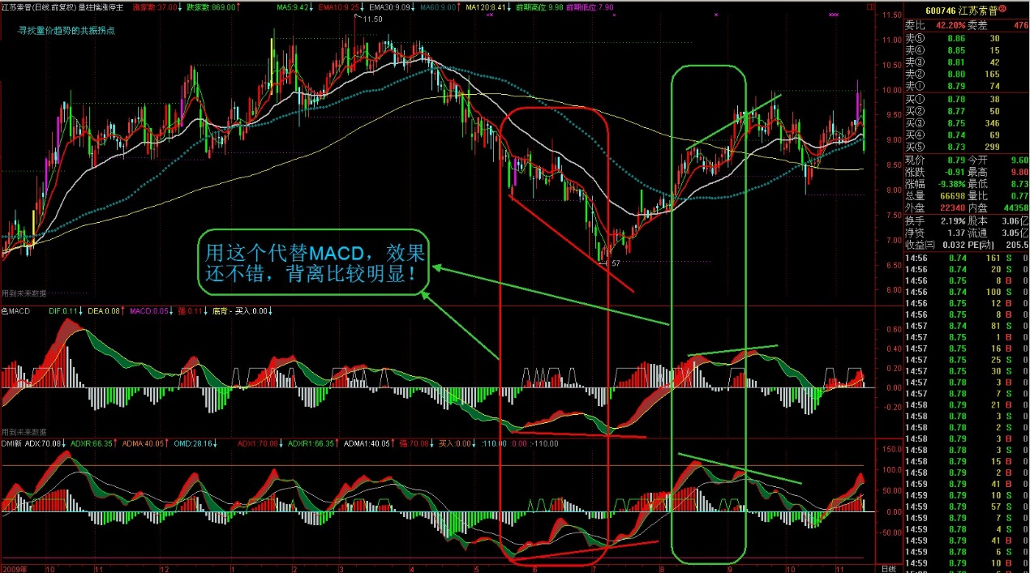

{DMI新编}  
N:=21;M:=6;M1:=20;  
TR1:=EMA(MAX(MAX(HIGH-LOW,ABS(HIGH-REF(CLOSE,1))),ABS(REF(CLOSE,1)-LOW)),N);  
HD :=HIGH-REF(HIGH,1);  
LD :=REF(LOW,1)-LOW;  
DMP:=EMA(IF(HD>0 AND HD>LD,HD,0),N);  
DMM:=EMA(IF(LD>0 AND LD>HD,LD,0),N);  
PDI:= DMP\*100/TR1;  
MDI:= DMM\*100/TR1;  
ADX: EMA((PDI-MDI)/(MDI+PDI)\*100,M)\*2;  
ADXR:EMA(ADX,M);  
ADMA:EMA(ADX,M1);  
OMD:(ADX-2\*ADMA+ADXR)/2, COLORSTICK;  
DRAWBAND(ADX,RGB(155,50,50),ADXR,RGB(0,100,50));  
STICKLINE(OMD>REF(OMD,1) AND OMD>0,0,OMD,1,0),COLORRED;  
STICKLINE(OMD>REF(OMD,1) AND OMD<0,0,OMD,1,0),COLORGREEN;  
STICKLINE(OMD<REF(OMD,1),0,OMD,1,0),COLORCBCBC0;  
STICKLINE(OMD>=0 OR OMD<=0,0,0,50,1),COLORWHITE;  
ADX1:ADX,COLORRED;  
ADXR1:ADXR,COLORGREEN;  
ADMA1:ADMA;  
强:IF(ADX1>=ADXR1,ADX1,DRAWNULL),COLORRED,LINETHICK3;  
买入:IF(OMD>0 AND OMD-REF(OMD,1)>0,30,0);  
{OMD;}  
110;  
0;  
-110;  
  
[ 本帖最后由 阿强理想2008 于 2010-11-13 10:40 编辑 ]\