http://www.55188.com/viewthread.php?tid=7845762&extra=&highlight=&page=4

<http://www.55188.com/thread-8156497-1-4.html###>

**补充资料**

我的原来的公式是:

参数名        缺省            最小         最大         步长  
                 N1             5                 2              120           1  
                 N2             20                2             250           1

LC:=REF(CLOSE,1);  
RSI1:SMA(MAX(CLOSE-LC,0),N1,1)/SMA(ABS(CLOSE-LC),N1,1)*100;  
RSI2:SMA(MAX(CLOSE-LC,0),N2,1)/SMA(ABS(CLOSE-LC),N2,1)*100;  
准备逃顶:(RSI1-RSI2)>=30;  
STICKLINE(准备逃顶,RSI1,RSI2,0.8,0);  
准备抄底:(RSI2-RSI1)>=30;  
STICKLINE(准备抄底,RSI1,RSI2,0.8,0),COLORRED;  
50;  
  希望在此基础上,能加上当股价创新高的时候,而RSI1没有创新高,就能产生一根RSI1两个高点的画线,并显示"顶背离";相反,当股价创新低,而RSI1并没有创新低,这时,就在两个低点划一根线,并显示"底背离"  
(有图片为例:下面指标中白色的线为RSI1,我手工画了背离线,是红色的和黄色的)

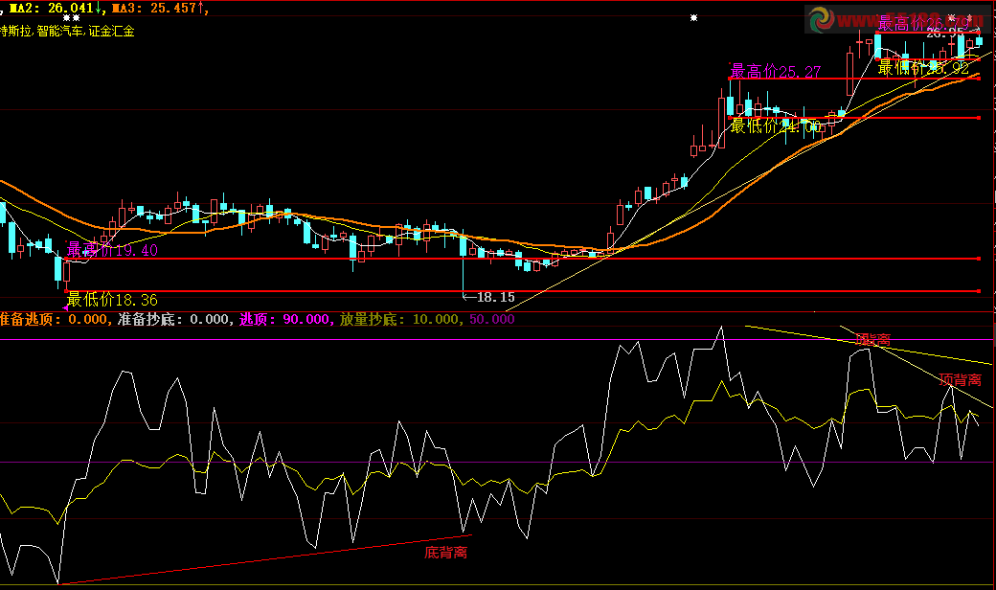

N=5;

LC:=REF(CLOSE,1);  
RSI1:SMA(MAX(CLOSE-LC,0),N1,1)/SMA(ABS(CLOSE-LC),N1,1)*100;  
RSI2:SMA(MAX(CLOSE-LC,0),N2,1)/SMA(ABS(CLOSE-LC),N2,1)*100;  
准备逃顶:(RSI1-RSI2)>=30;  
STICKLINE(准备逃顶,RSI1,RSI2,0.8,0);  
准备抄底:(RSI2-RSI1)>=30;  
STICKLINE(准备抄底,RSI1,RSI2,0.8,0),COLORRED;  
50;  
AA:=REF(RSI1,N)=HHV(RSI1,2*N+1);  
BB:=BACKSET(AA,N+1);  
CC:=FILTER(BB,N) AND RSI1=HHV(RSI1,N+1);  
A1:=BARSLAST(REF(CC,1));  
顶背离:=REF(CLOSE,A1+1)<CLOSE AND REF(RSI1,A1+1)>RSI1 AND CC,COLORRED,LINETHICK2;  
DRAWLINE(CC,RSI1,FILTER(顶背离>0,5),RSI1,0),COLORRED,LINETHICK2;  
AA2:=REF(RSI1,N)=LLV(RSI1,2*N+1);  
BB2:=BACKSET(AA2,N+1);  
CC2:=FILTER(BB2,N) AND RSI1=LLV(RSI1,N+1);  
A2:=BARSLAST(REF(CC2,1));  
底背离:=REF(CLOSE,A2+1)>CLOSE AND REF(RSI1,A2+1)<RSI1 AND CC2,COLORYELLOW,LINETHICK2;  
DRAWLINE(CC2,RSI1,FILTER(底背离>0,5),RSI1,0),COLORYELLOW,LINETHICK2;

这是我加了个顶提示的；LC:=REF(CLOSE,1);  
RSI1:SMA(MAX(CLOSE-LC,0),N1,1)/SMA(ABS(CLOSE-LC),N1,1)*100;  
RSI2:SMA(MAX(CLOSE-LC,0),N2,1)/SMA(ABS(CLOSE-LC),N2,1)*100;  
准备逃顶:(RSI1-RSI2)>=30;  
STICKLINE(准备逃顶,RSI1,RSI2,0.8,0);  
准备抄底:(RSI2-RSI1)>=30;  
STICKLINE(准备抄底,RSI1,RSI2,0.8,0),COLORRED;  
50;  
AA:=REF(RSI1,N)=HHV(RSI1,2*N+1);  
BB:=BACKSET(AA,N+1);  
CC:=FILTER(BB,N) AND RSI1=HHV(RSI1,N+1);  
A1:=BARSLAST(REF(CC,1));  
顶背离:=REF(CLOSE,A1+1)<CLOSE AND REF(RSI1,A1+1)>RSI1 AND CC,COLORRED,LINETHICK2;  
DRAWLINE(CC,RSI1,FILTER(顶背离>0,5),RSI1,0),COLORRED,LINETHICK2;  
AA2:=REF(RSI1,N)=LLV(RSI1,2*N+1);  
BB2:=BACKSET(AA2,N+1);  
CC2:=FILTER(BB2,N) AND RSI1=LLV(RSI1,N+1);  
A2:=BARSLAST(REF(CC2,1));  
底背离:=REF(CLOSE,A2+1)>CLOSE AND REF(RSI1,A2+1)<RSI1 AND CC2,COLORYELLOW,LINETHICK2;  
DRAWLINE(CC2,RSI1,FILTER(底背离>0,5),RSI1,0),COLORYELLOW,LINETHICK2;  
VAR1:=1;    
VAR2:=1/WINNER(CLOSE);    
VAR3:=MA(CLOSE,13);    
VAR4:=100-ABS((CLOSE-VAR3)/VAR3*100);    
VAR5:=MA(WINNER(CLOSE*0.95)*100,3)*VAR1,COLORMAGENTA;    
VARD:=VAR5>VAR4;  
STICKLINE(VARD,RSI1,RSI2,0.8,0),COLORRED;