**求助吸筹进场选股公式。谢谢各位理想的老师。**

<http://www.55188.com/viewthread.php?tid=8222386&page=1###>

M:=55;  
N:=34;  
LC:=REF(CLOSE,1);  
RSI:=((SMA(MAX((CLOSE - LC),0),3,1) / SMA(ABS((CLOSE - LC)),3,1)) * 100);  
FF:=EMA(CLOSE,3);  
MA15:=EMA(CLOSE,21);  
VAR1:=IF(YEAR>=2038 AND MONTH>=1,0,1);  
VAR2:=REF(LOW,1)*VAR1;  
VAR3:=SMA(ABS(LOW-VAR2),3,1)/SMA(MAX(LOW-VAR2,0),3,1)*100*VAR1;  
VAR4:=EMA(IF(CLOSE*1.3,VAR3*10,VAR3/10),3)*VAR1;  
VAR5:=LLV(LOW,30)*VAR1;  
VAR6:=HHV(VAR4,30)*VAR1;  
VAR7:=IF(MA(CLOSE,58),1,0)*VAR1;  
VAR8:=EMA(IF(LOW<=VAR5,(VAR4+VAR6*2)/2,0),3)/618*VAR7*VAR1;  
主力吸筹:IF(VAR8>100,100,VAR8)*VAR1,COLORMAGENTA;  
庄家吸筹:STICKLINE(主力吸筹>-150,0,主力吸筹,1,0),COLORYELLOW;  
散户: 100*(HHV(HIGH,M)-CLOSE)/(HHV(HIGH,M)-LLV(LOW,M)),COLORGREEN,LINETHICK2;  
RSV:=(CLOSE-LLV(LOW,N))/(HHV(HIGH,N)-LLV(LOW,N))*100;  
K:=SMA(RSV,3,1);  
D:=SMA(K,3,1);  
J:=3*K-2*D;  
庄家:EMA(J,6),COLORRED,LINETHICK2;  
DRAWTEXT(CROSS(庄家,散户) ,庄家,'←进场')COLORRED;  
换手:SUM(VOL,1)/CAPITAL*100,COLORMAGENTA,NODRAW;  
涨家:INDEXADV,COLOR0066FF,NODRAW;  
跌家:INDEXDEC,COLOR99FF99,NODRAW;

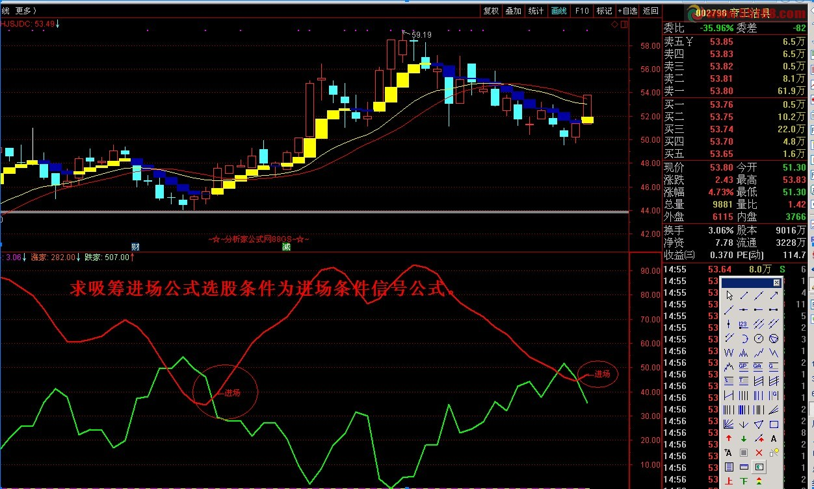

{选股}

M:=55;  
N:=34;  
散户:= 100*(HHV(HIGH,M)-CLOSE)/(HHV(HIGH,M)-LLV(LOW,M));  
RSV:=(CLOSE-LLV(LOW,N))/(HHV(HIGH,N)-LLV(LOW,N))*100;  
K:=SMA(RSV,3,1);  
D:=SMA(K,3,1);  
J:=3*K-2*D;  
庄家:=EMA(J,6);  
CROSS(庄家,散户);