## 涨停板分类主图（源码 主图 通达信 贴图）

在这里 我把选股源码放出来 需要的直接粘贴  
涨停:=BETWEEN(CLOSE/REF(CLOSE,1),1.0984,1.110) AND C=H AND C>O;  
{蓝心板}  
R1:=(C>REF(C,1) AND C>REF(C,2));R2:=(REF(R1,1) AND C<=REF(C,1) AND C>=REF(C,2));R3:=(REF(R2,1) AND C>=REF(C,1) AND C<=REF(C,2));  
R4:=(REF(R3,1) AND C<=REF(C,1) AND C>=REF(C,2));R5:=(REF(R4,1) AND C>=REF(C,1) AND C<=REF(C,2));R6:=(REF(R5,1) AND C<=REF(C,1) AND C>=REF(C,2));  
R7:=(REF(R6,1) AND C>=REF(C,1) AND C<=REF(C,2));R8:=(REF(R7,1) AND C<=REF(C,1) AND C>=REF(C,2));R9:=(REF(R8,1) AND C>=REF(C,1) AND C<=REF(C,2));  
RA:=(REF(R9,1) AND C<=REF(C,1) AND C>=REF(C,2));RB:=(REF(RA,1) AND C>=REF(C,1) AND C<=REF(C,2));RC:=(REF(RB,1) AND C<=REF(C,1) AND C>=REF(C,2));  
RD:=(C<REF(C,1) AND C<REF(C,2));RE:=(REF(RD,1) AND C>=REF(C,1) AND C<=REF(C,2));RF:=(REF(RE,1) AND C<=REF(C,1) AND C>=REF(C,2));  
R10:=(REF(RF,1) AND C>=REF(C,1) AND C<=REF(C,2));R11:=(REF(R10,1) AND C<=REF(C,1) AND C>=REF(C,2));R12:=(REF(R11,1) AND C>=REF(C,1) AND C<=REF(C,2));  
R13:=(REF(R12,1) AND C<=REF(C,1) AND C>=REF(C,2));R14:=(REF(R13,1) AND C>=REF(C,1) AND C<=REF(C,2));R15:=(REF(R14,1) AND C<=REF(C,1) AND C>=REF(C,2));  
R16:=(REF(R15,1) AND C>=REF(C,1) AND C<=REF(C,2));R17:=(REF(R16,1) AND C<=REF(C,1) AND C>=REF(C,2));  
R18:=(REF(R17,1) AND C>=REF(C,1) AND C<=REF(C,2));R19:=((REF(RD OR RE OR RF OR R10 OR R11 OR R12 OR R13  
OR R14 OR R15 OR R16 OR R17 OR R18,1)) AND R1);  
R1A:=((REF(R1 OR R2 OR R3 OR R4 OR R5 OR R6 OR R7 OR R8 OR R9 OR RA OR RB OR RC,1)) AND RD);  
蓝心板:=REF(RD OR RE OR RF OR R10 OR R11 OR R12 OR R13 OR R14 OR R15 OR R16 OR R17 OR R18,1);  
{绿心板}  
RSV9:=(C-LLV(LOW,9))/(HHV(HIGH,9)-LLV(LOW,9))*100; K1:=SMA(RSV9,3,1);  
DK1:=K1-REF(K1,1);出手就赢:=IF(DK1>7 AND REF(DK1,1)<0 AND (DK1-REF(DK1,1))>9,50,0);  
绿心板:=(出手就赢=50 OR REF("KDJ.J",1)<0) AND "KDJ.J">0;  
红心板:=蓝心板 AND 绿心板;  
  
空心过滤:=IF((蓝心板 OR 绿心板),DRAWNULL,涨停) AND SUM(涨停,2)=1;  
蓝心过滤:=IF((绿心板),DRAWNULL,蓝心板);  
  
DF:=(C-REF(C,1))/REF(C,1)*100<-4.94;AO:=BARSLAST(DF);                    
突破箱体:=CROSS(C,REF(O,AO));  
  
{近期高位}  
近1:=REF(C,10)=HHV(C,2*10+1); 近2:=FILTER(近1,10); 近3:=BACKSET(近2,10+1); 近4:=FILTER(近3,10);近期压力:=REF(C,BARSLAST(近4));  
突破近压:=CROSS(C,近期压力);  
{长期高位}  
长1:=REF(C,60)=HHV(C,2*60+1); 长2:=FILTER(长1,60); 长3:=BACKSET(长2,60+1); 长4:=FILTER(长3,60);  长期压力:=REF(C,BARSLAST(长4));  
突破长压:=CROSS(C,长期压力);  
  
选红心板:红心板;  
选蓝心板:蓝心过滤;  
选空心板:空心过滤;  
选突破近压:突破近压;  
选突破长压:突破长压;  
另外 突破箱体可以分为2天突破 3天突破等 源码分别为  
V型反转2:=EXIST(DF,2) AND 突破箱体;  
V型反转3:=EXIST(DF,3) AND 突破箱体;  
  
只需要把数值改到几 就是几天

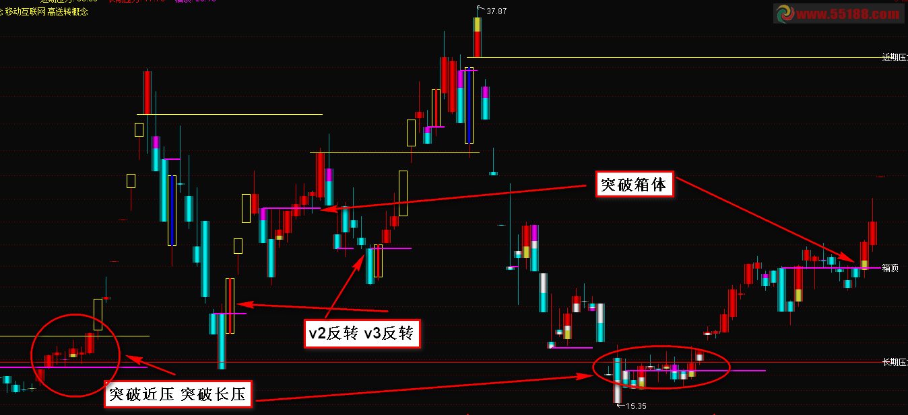

{涨停板分类主图}

涨停:=BETWEEN(CLOSE/REF(CLOSE,1),1.0984,1.110) AND C=H AND C>O;

{蓝心板}

R1:=(C>REF(C,1) AND C>REF(C,2));R2:=(REF(R1,1) AND C<=REF(C,1) AND C>=REF(C,2));R3:=(REF(R2,1) AND C>=REF(C,1) AND C<=REF(C,2));

R4:=(REF(R3,1) AND C<=REF(C,1) AND C>=REF(C,2));R5:=(REF(R4,1) AND C>=REF(C,1) AND C<=REF(C,2));R6:=(REF(R5,1) AND C<=REF(C,1) AND C>=REF(C,2));

R7:=(REF(R6,1) AND C>=REF(C,1) AND C<=REF(C,2));R8:=(REF(R7,1) AND C<=REF(C,1) AND C>=REF(C,2));R9:=(REF(R8,1) AND C>=REF(C,1) AND C<=REF(C,2));

RA:=(REF(R9,1) AND C<=REF(C,1) AND C>=REF(C,2));RB:=(REF(RA,1) AND C>=REF(C,1) AND C<=REF(C,2));RC:=(REF(RB,1) AND C<=REF(C,1) AND C>=REF(C,2));

RD:=(C<REF(C,1) AND C<REF(C,2));RE:=(REF(RD,1) AND C>=REF(C,1) AND C<=REF(C,2));RF:=(REF(RE,1) AND C<=REF(C,1) AND C>=REF(C,2));

R10:=(REF(RF,1) AND C>=REF(C,1) AND C<=REF(C,2));R11:=(REF(R10,1) AND C<=REF(C,1) AND C>=REF(C,2));R12:=(REF(R11,1) AND C>=REF(C,1) AND C<=REF(C,2));

R13:=(REF(R12,1) AND C<=REF(C,1) AND C>=REF(C,2));R14:=(REF(R13,1) AND C>=REF(C,1) AND C<=REF(C,2));R15:=(REF(R14,1) AND C<=REF(C,1) AND C>=REF(C,2));

R16:=(REF(R15,1) AND C>=REF(C,1) AND C<=REF(C,2));R17:=(REF(R16,1) AND C<=REF(C,1) AND C>=REF(C,2));

R18:=(REF(R17,1) AND C>=REF(C,1) AND C<=REF(C,2));R19:=((REF(RD OR RE OR RF OR R10 OR R11 OR R12 OR R13

OR R14 OR R15 OR R16 OR R17 OR R18,1)) AND R1);

R1A:=((REF(R1 OR R2 OR R3 OR R4 OR R5 OR R6 OR R7 OR R8 OR R9 OR RA OR RB OR RC,1)) AND RD);

蓝心板:=REF(RD OR RE OR RF OR R10 OR R11 OR R12 OR R13 OR R14 OR R15 OR R16 OR R17 OR R18,1);

{绿心板}

RSV9:=(C-LLV(LOW,9))/(HHV(HIGH,9)-LLV(LOW,9))*100; K1:=SMA(RSV9,3,1);

DK1:=K1-REF(K1,1);出手就赢:=IF(DK1>7 AND REF(DK1,1)<0 AND (DK1-REF(DK1,1))>9,50,0);

绿心板:=(出手就赢=50 OR REF("KDJ.J",1)<0) AND "KDJ.J">0;

红心板:=蓝心板 AND 绿心板;

红色持股:=R1 OR R2 OR R3 OR R4 OR R5 OR R6 OR R7 OR R8 OR R9 OR RA OR RB OR RC;

短进:=R19;

青色观望:=RD OR RE OR RF OR R10 OR R11 OR R12 OR R13 OR R14 OR R15 OR R16 OR R17 OR R18;

急速超跌:=(C-MA(C,34))/MA(C,34)*100<-14;品红离场:=R1A;

STICKLINE(C>=O,L,H,0,0),COLOR0000CC;STICKLINE(C<O,L,H,0,0),COLOR999900;STICKLINE(1,C,O,3.5,0),COLOR858500;

STICKLINE(C>=O,C,O,3.5,0),COLOR0000E5;STICKLINE(红色持股,C,O,2.8,0),COLOR000055;STICKLINE(红色持股,C,O,2,0),COLOR000088;

STICKLINE(红色持股,C,O,1.5,0),COLOR0000AA;STICKLINE(红色持股,C,O,1,0),COLOR0000CC;STICKLINE(红色持股,C,O,0.5,0),COLOR0000EE;

STICKLINE(青色观望,C,O,2.8,0),COLOR555500;STICKLINE(青色观望,C,O,2,0),COLOR888800;STICKLINE(青色观望,C,O,1.5,0),COLORAAAA00;

STICKLINE(青色观望,C,O,1,0),COLORCCCC00;STICKLINE(青色观望,C,O,0.5,0),COLOREEEE00;CO:=(C-O);

绿心过滤:=IF((蓝心板),DRAWNULL,绿心板);蓝心过滤:=IF((绿心板),DRAWNULL,蓝心板);

STICKLINE(急速超跌,O,C-CO/2,2.8,0),COLOR555555;STICKLINE(急速超跌,O,C-CO/2,2,0),COLOR888888;STICKLINE(急速超跌,O,C-CO/2,1.5,0),COLORAAAAAA;

STICKLINE(急速超跌,O,C-CO/2,1,0),COLORCCCCCC;STICKLINE(急速超跌,O,C-CO/2,0.5,0),COLOREEEEEE;STICKLINE(短进,O,O+CO/3,2.8,0),COLOR335555;

STICKLINE(短进,O,O+CO/3,2,0),COLOR338888;STICKLINE(短进,O,O+CO/3,1.5,0),COLOR33AAAA;STICKLINE(短进,O,O+CO/3,1,0),COLOR33CCCC;

STICKLINE(品红离场,O,O+CO/3,2.8,0),COLOR550055;STICKLINE(品红离场,O,O+CO/3,2,0),COLOR880088;STICKLINE(品红离场,O,O+CO/3,1.5,0),COLORAA00AA;

STICKLINE(品红离场,O,O+CO/3,1,0),COLORCC00CC;STICKLINE(品红离场,O,O+CO/3,0.5,0),COLOREE00EE;STICKLINE(涨停,O,C,3.6,1),COLORYELLOW;

STICKLINE(涨停 AND 蓝心过滤,O,C,0.4,0),COLORBLUE;STICKLINE(涨停 AND 绿心过滤,O,C,0.4,0),COLORGREEN;STICKLINE(涨停 AND 红心板,O,C,0.4,0),COLORRED;

{均线}

EXPMA5:EXPMA(C,5),COLORWHITE LINETHICK2;

EXPMA13:EXPMA(C,13),COLORMAGENTA LINETHICK2;

{近期高位}

AB1:=REF(C,10)=HHV(C,2*10+1); BB1:=FILTER(AB1,10); CB1:=BACKSET(BB1,10+1); HBD:=FILTER(CB1,10);

近期压力:REF(C,BARSLAST(HBD)) NODRAW,COLORYELLOW;

STICKLINE(C,近期压力,近期压力,10,0),COLORYELLOW ;DRAWTEXT(ISLASTBAR,近期压力,' 近期压力');

{长期高位}

AS1:=REF(C,60)=HHV(C,2*60+1); AS2:=FILTER(AS1,60); AS3:=BACKSET(AS2,60+1); AS4:=FILTER(AS3,60);

长期压力:REF(C,BARSLAST(AS4)) NODRAW COLORRED;

STICKLINE(C,长期压力,长期压力,10,0),COLORRED;DRAWTEXT(ISLASTBAR,长期压力,' 长期压力');

{箱体}

跌幅:=(C-REF(C,1))/REF(C,1)*100<-4.94;

箱顶:DRAWLINE(跌幅,O,REF(跌幅,1),REF(O,1),1),COLORMAGENTA LINETHICK2;

DRAWTEXT(ISLASTBAR,箱顶,' 箱顶');

{概念}

Z11:=STRCAT(HYBLOCK,' ');

Z21:=STRCAT(Z11,DYBLOCK);

Z31:=STRCAT(Z21,' ');

DRAWTEXT_FIX(ISLASTBAR,0,0,0,STRCAT(Z31,GNBLOCK)),COLORYELLOW;

DRAWTEXT_FIX(ISLASTBAR,0,0.08,0,STRCAT(Z31,FGBLOCK)),COLORYELLOW;

{}

DRAWTEXT((涨停) AND FINANCE(52),C,' 融资'),COLORGREEN;