Statistical Methods in AI
Assignment-4
wandb Dashboard link: https://wandb.ai/iiithyderabad12/smai-a4-q2-colorization
- Approach and Architecture: To address the multi-task learning problem, I implemented a single Convolutional Neural Network (CNN) with a shared backbone and two separate, task-specific heads.
- Shared Backbone: The backbone consists of two convolutional blocks, designed to extract hierarchical features from the 28×28 input images.
  - Block 1: A Conv2d layer (1 input channel, 32 output channels) followed by BatchNorm2d, ReLU, activation, and MaxPool2d (reducing spatial dimensions to 14 ×14).
  - Block 2: A Conv2d layer (32 input channels, 64 output channels) followed by BatchNorm2d, ReLU, and MaxPool2d (reducing dimensions to 7 ×7 ).
  - Dropout was applied after each pooling layer to prevent overfitting.
- Task-Specific Heads: The flattened output from the backbone ( 64 ×7×7=3136 features) is fed into two parallel heads:
  - Classification Head: An FC layer ( 3136 → 28) with ReLU, followed by a dropout layer and a final FC layer (128 →10) to produce the class logits.
  - Regression Head: A simpler FC layer (3136 → 64) with ReLU, followed by a final FC layer ( 64 → 1) to output the scalar "ink" value
- Hyperparameters and experiments: I conducted 5 distinct experiments to analyze the effect of the loss weights λ 1 and λ 2. The base hyperparameters, kept constant across these runs, were:
- Optimizer: adamw
- Learning Rate: 1e-3
- Batch Size: 128
- Epochs: 15
- Dropout Rate: 0.25
- λ Configurations :
  - λ1 constant and varied the other,as both the losser differ in magnitude notion, so their comparison numerically doesn’t make sense
- Results and Model Selection: From the 10 runs, I identified the best-performing models for each task based on their validation metrics.
  - Model with Highest Validation Accuracy - 93.4%
- - batch_size:32
- - dropout_rate:0.14244136820543785
- - epochs:25
- - filters1:32
- - filters2:128
- - lambda_1:1
- - lambda_2:14.680943002214374
- - learning_rate:0.00013924162602581272
- - optimizer:"adam"

- Best Regression Model: Valid RMSE - 0.01603931
- - batch_size:128
- - dropout_rate:0.1316434064300546
- - epochs:25
- - filters1:32
- - filters2:128
- - lambda_1:1
- - lambda_2:16.139271969747398
- - learning_rate:0.00013094505889394483
- - optimizer:"sgd"

- Discussion: The experiments clearly demonstrated the trade-off inherent in multi-task learning, controlled by the λ weights. As expected, prioritizing classification produced the best classifier, achieving the highest validation accuracy of 93.4%. The optimizer's focus on minimizing the cross-entropy loss pushed the shared backbone to learn features highly discriminative for the 10 classes, succeeding at its primary goal. And, although prioritizing regression should give better (lower) validation RMSE, it was the balanced model that did it, which might be due to influence of classification as well on RMSE. It is possible that the classification task acted as a regularizer for regression based on ink density, preventing overfitting. This is a good example of tradeoffs where the relationship is a non-zero sum game, and a balanced approach is good on both facets.
- Feature Map Visualizations and Interpretation: Block 1 describes the outline of the object very well as can be seen in the feature maps. This is the low-level edge detection. Block 2 focuses on the higher-order features like corners, edges, and textures inside the item, which are basically the niche features of the objects. Each channel focuses on a different feature.
Validation Losses and Accuracy (across 10 runs)
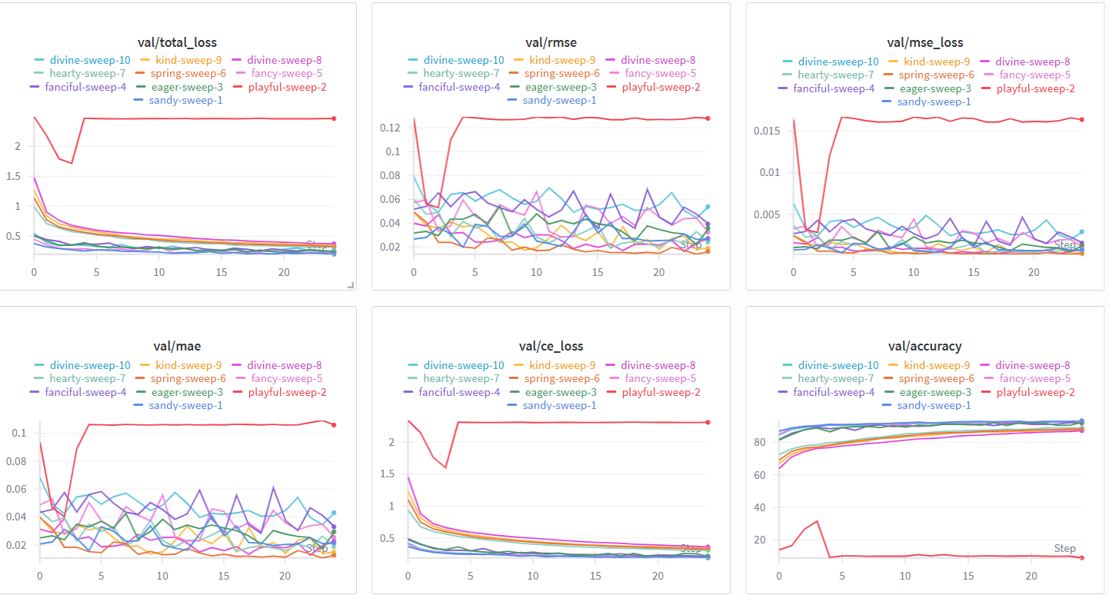

Visualizations
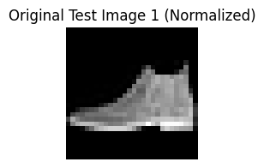
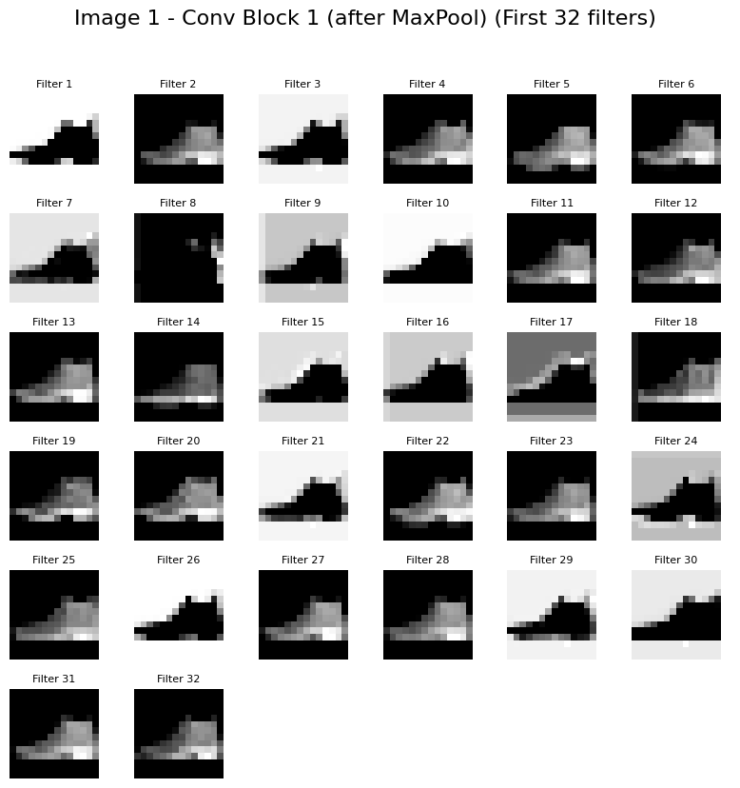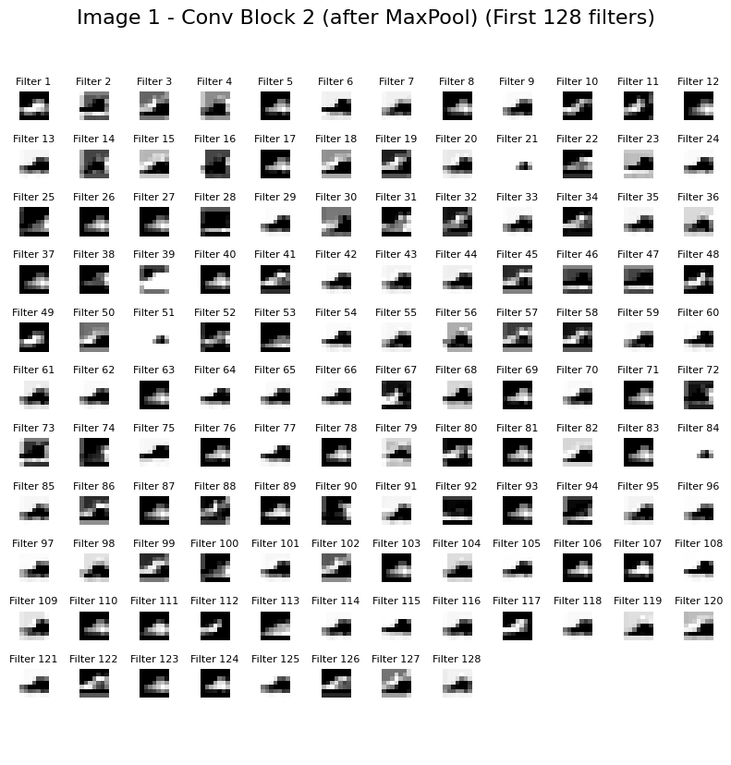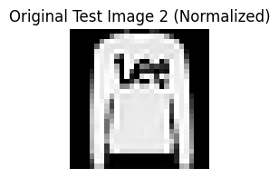
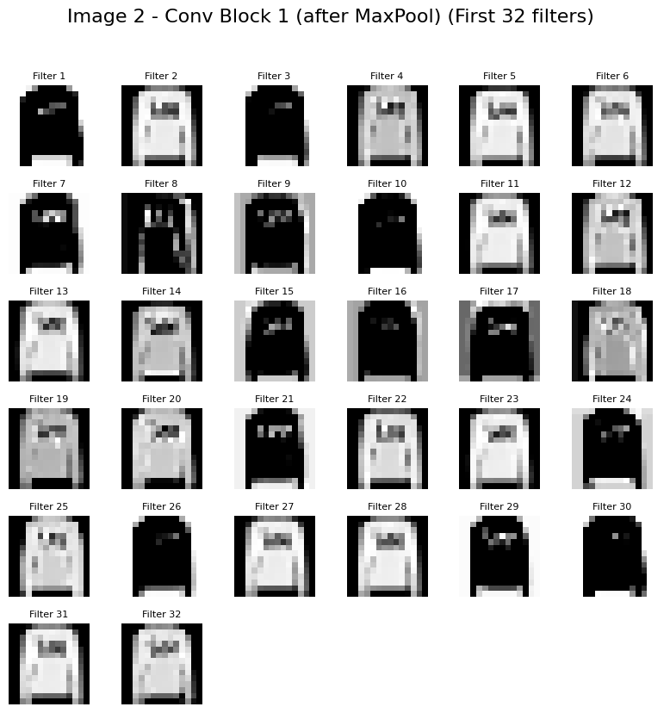
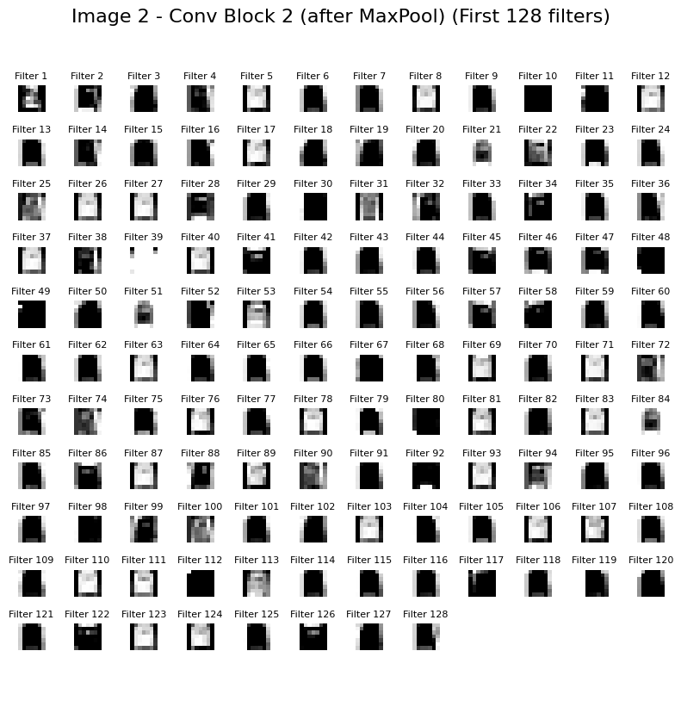
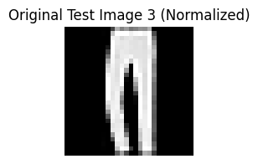
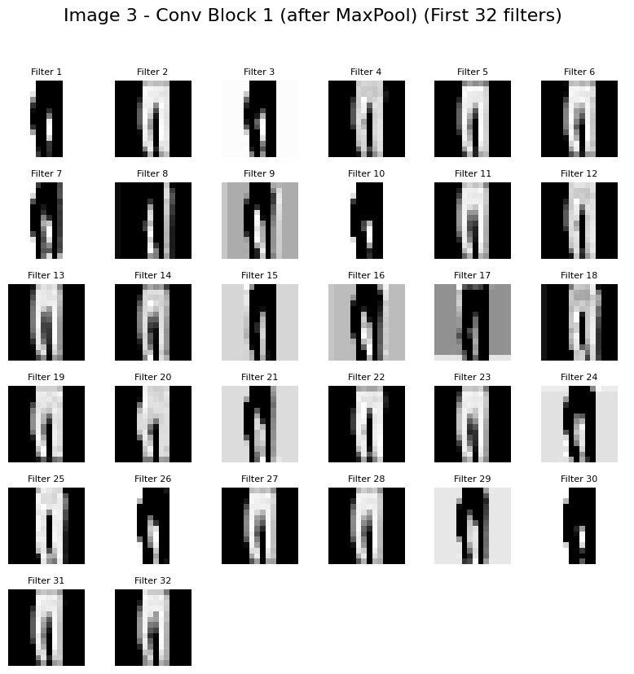
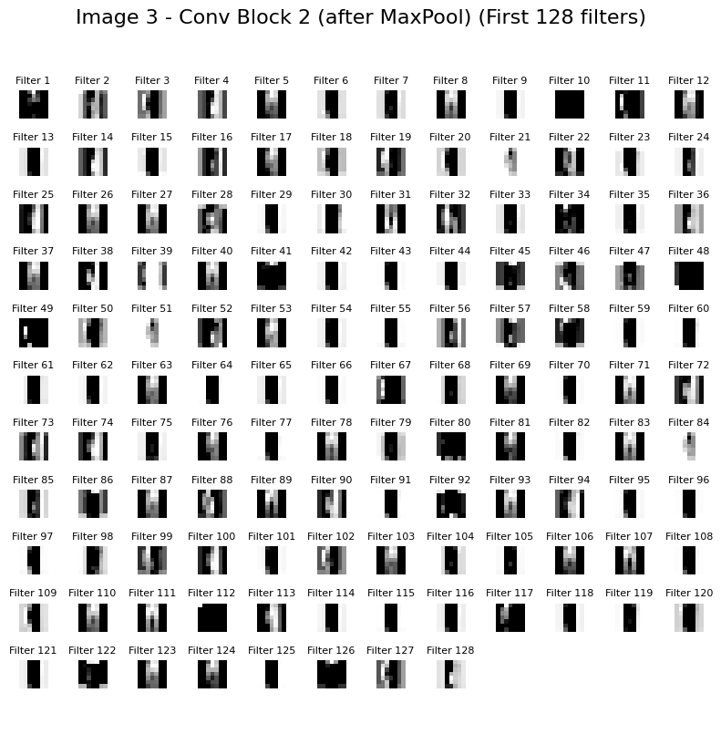
The first layers learns the actual shape, while the second sequential block learns the edge and minute detials.

