Boundary Administrator Profile Page, DBInterface

Controller Administrator Profile Controller

Entity User, User Role

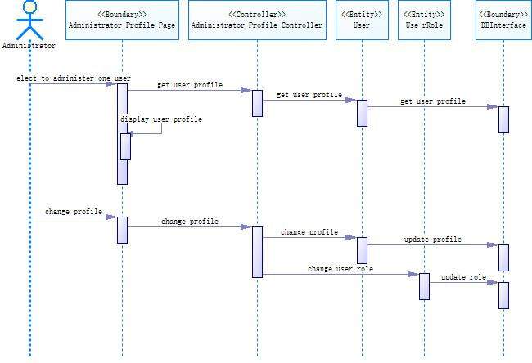

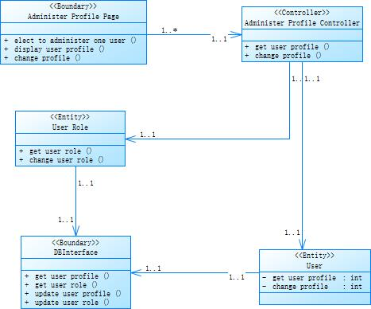

Administer Profile Page views/admin.ejs

Administer Profile Controller controllers/administrator_profile/admin.js

User models/user.js

User Role models/userRole.js

DBInterface db/db.js