Step1: generate a file containing 5000 integers and split it into five sub-input files, each containing 1000 integers.
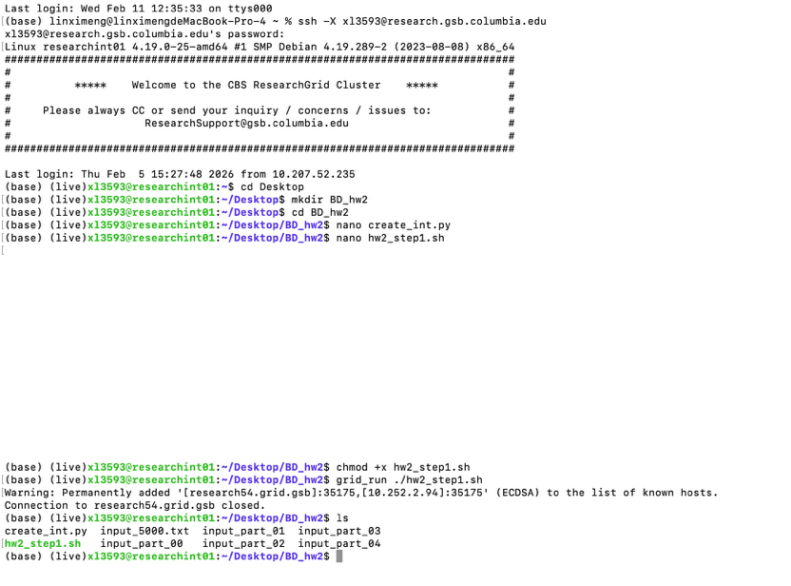
create_int.py:
import random

file = 'input_5000.txt'

with open(file, 'w') as f:
for _ in range(5000):
num = random.randint(0, 10000)
f.write(f"{num}\n")
hw2_step1.sh
#!/bin/bash
set -e
python create_int.py
split -l 1000 -d input_5000.txt input_part_

