Part 1:
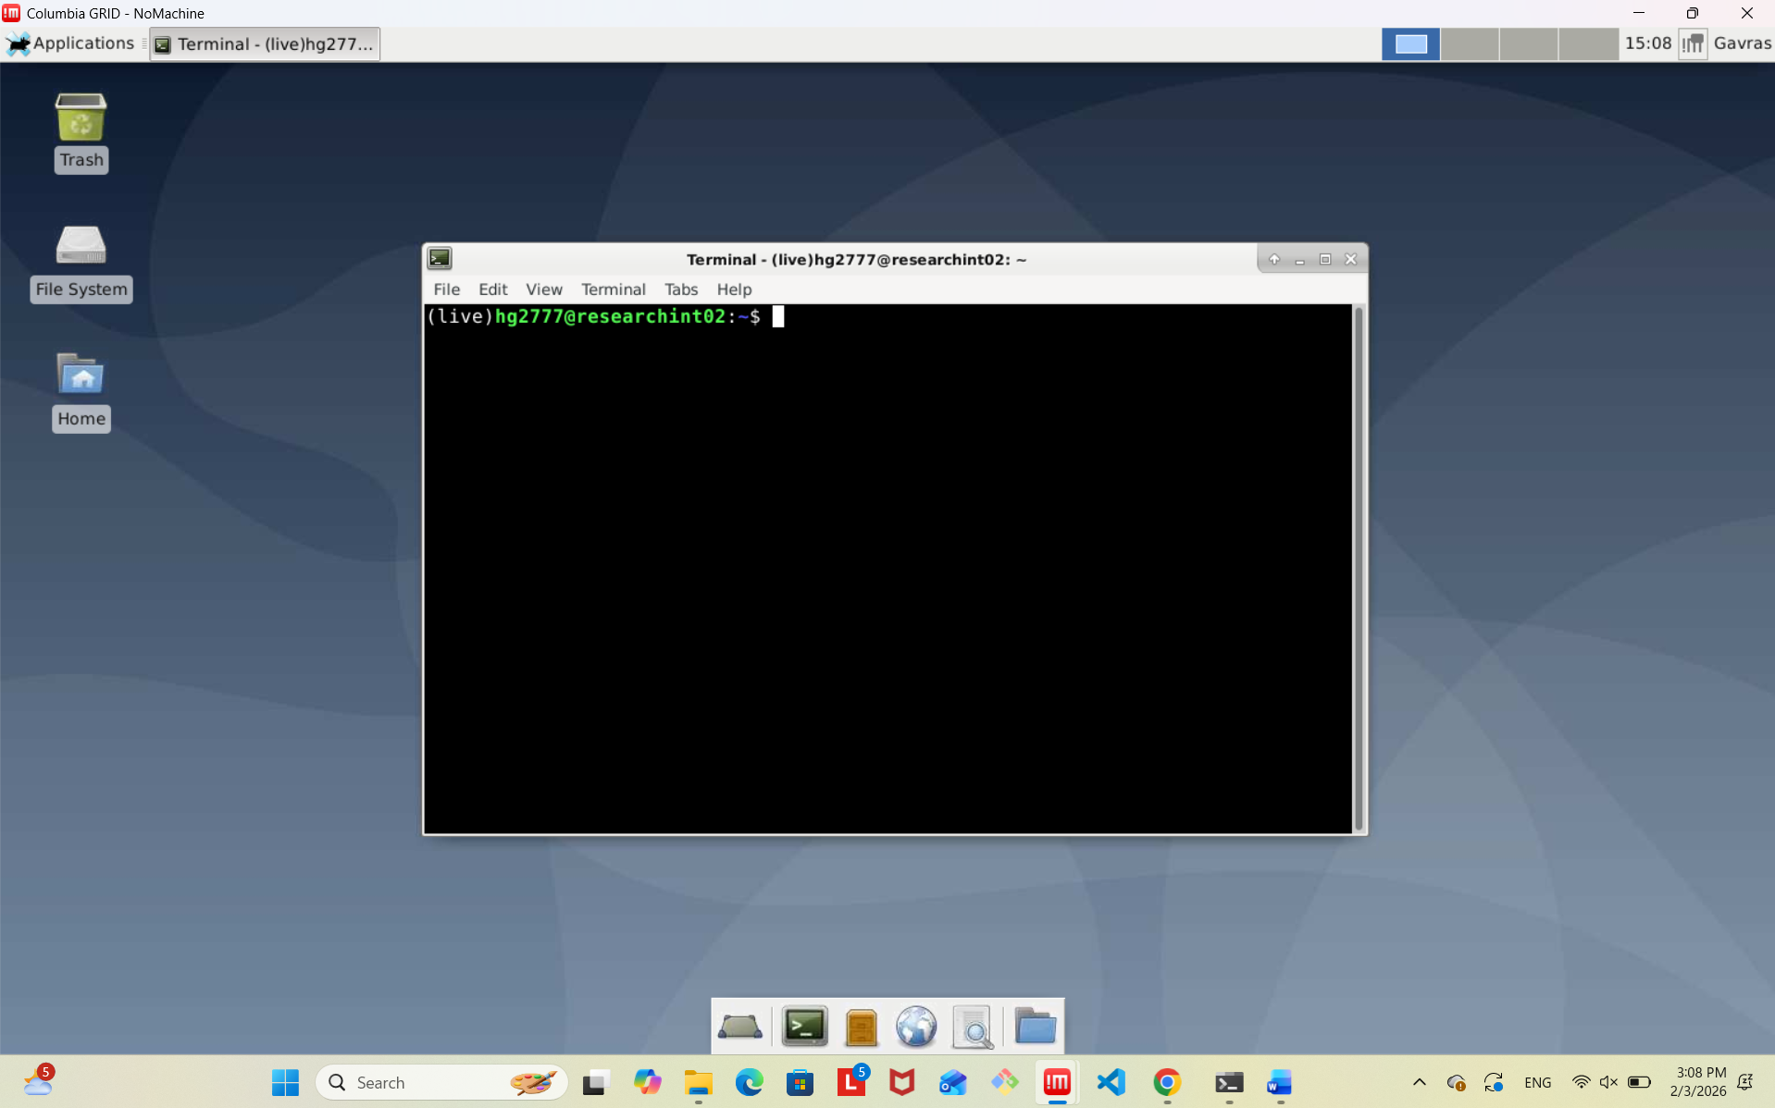
Part 2:
Script:
#!/apps/anaconda3/bin/python
import numpy as np
int_list = list()
with open('problem_set_integers.txt', 'r') as f:
for line in f:
int_list.append(int(line.strip()))
print(f'Count is {len(int_list)}')
print(f'Sum is {np.sum(int_list)}')
print(f'Average is {np.mean(int_list)}')
print(f'Standard deviation is {np.std(int_list)}')

Output:
(live)hg2777@researchint02:~/Documents$ grid_run ./Part2_sol.py
Warning: Permanently added '[research25.grid.gsb]:34023,[10.252.2.65]:34023' (ECDSA) to the list of known hosts.
Count is 1000
Sum is 515290743
Average is 515290.743
Standard deviation is 284501.16369194863
Connection to research25.grid.gsb closed.

Screenshot:
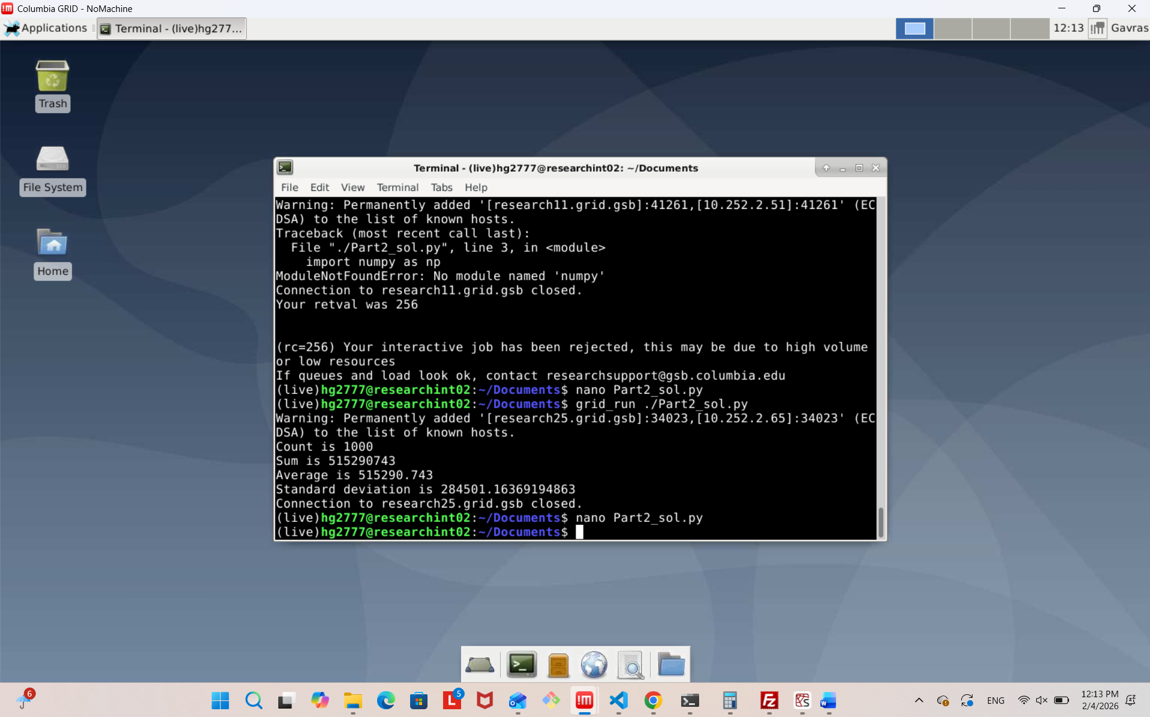

Part 3:
