Platform x86 CoRE

Ansible Case study on DSAnalyzer testing

Abstract

The purpose of this document is to provide the details of the DSAnalyzer testing on Ansible environment

Document Details

|  |  |
| --- | --- |
| Author: |  |
| Date: |  |
| Document Reference: | NA |
| Previous Document Reference: |  |
| Document Type: |  |
| Document keywords: | Ansible, gitlab, Plays |
| File Reference: |  |
| Issue: |  |
| Review Period: |  |
| Template Version: |  |
| Authorizer: |  |

Table of Contents

1 Steps involved in testing DSAnalyzer v1.1.0 on Ansible 6

2 Trouble shooting steps of ansible 14

3 Document Administration 15

3.1 Feedback 15

3.1.1 Naming Conventions of Documents 15

3.2 Attachments 15

Appendix A Abbreviations and Acronyms 16

Table of Tables

Table 1 - Mailing List Table 15

Table of Figures

Figure 1 - Ansible Package 7

Figure 2 - Package in Default Browser 7

Figure 3 - Projects in Gitlab 8

Figure 4 – Repository of DSAnalyzer in Gitlab 8

Figure 5 – New Projects in Ansible 9

Figure 6 - Inventory with groups and hosts 9

Figure 7 - Credentials 10

Figure 8 - Creating new Job Template 10

Figure 9 - Extra variables in Job template 11

Figure 10 - Updating Resolv.conf file 12

Figure 11 - Updating interfaces file 12

Figure 12 - Updating krb5.conf file 13

Figure 13 - Starting Template 13

Figure 14 - Job Template 14

Amendment History

|  |  |  |  |
| --- | --- | --- | --- |
| Issue | Date | Author | Notes |
|  |  |  |  |
|  |  |  |  |
|  |  |  |  |

Approval Schedule

|  |  |  |  |
| --- | --- | --- | --- |
| Name | Organization | Function | Approval Date |
| Patrick Tse | Cloud & Platform Services – Platform x86 CoRE | Manager |  |

Contributors

|  |  |
| --- | --- |
| Name | Position |
|  |  |

References

1. This is a sample reference, Sample Corporation

Typestyle Conventions

The following typestyle conventions are used within this document:

* **Black bold text** is used to designate:
* client tools
* Dialog titles and Dialog sections
* names of buttons, options, check boxes, menus, fields
* file and folder paths
* Active Directory paths
* A reference to a table heading
* **Dark red bold text** is used to designate implementation specific information. When dark red bold text is used, it must not be entered or followed literally, but must be replaced or reference made to the implementation specific information.
* “Text enclosed with double-quotes” is used to designate informational text as it is worded on a dialog box, message box or table body
* *Italic text* is used as emphasis
* “*Italic text enclosed with double-quotes*” is used to designate text as it is worded in a referenced document
* <Angled brackets> are used to define parameters. Parameters must not be entered literally but must be replaced with the required information. A parameter will be defined in the Section it is used.
* ALL CAPITALS is used to designate keyboard keys. When a key combination, or key and mouse combination is required this is designated by the plus sign (+), which is included between the key, and key and mouse combination; e.g. CTRL+ALT+DELETE, CTRL+CLICK.
* An arrow (**🡪**) is used to indicate navigation of sequential menus or hierarchical trees.

Highlighting Statements

|  |  |
| --- | --- |
| 🖆 | Note |
|  | Supporting information to the preceding paragraph(s). |

|  |  |
| --- | --- |
| ❓ | Section Applicability |
|  | Immediately succeeds a Section Heading and provides information on the Section’s applicability depending upon the requirements. In addition, “(Applicability)”, without the quotes, is included in the Section Heading Text to highlight in the Table of Contents that the Section is optional and therefore, its applicability needs to be determined. |

|  |  |
| --- | --- |
| 🛈 | Important |
|  | Supporting information that is important to the preceding paragraph(s). |

|  |  |
| --- | --- |
| ✓ | Recommended Practice |
|  | Includes a summary of the recommended practice and setting(s) where applicable, based upon Vendor and DXC guidelines. |

# Steps involved in testing DSAnalyzer v1.1.0 on Ansible

**Step 1:**

Create the plays to run the DSAnalyzer v1.1.0

Below is the Screenshot of the Ansible package of DSAnalyzer v1.1.0

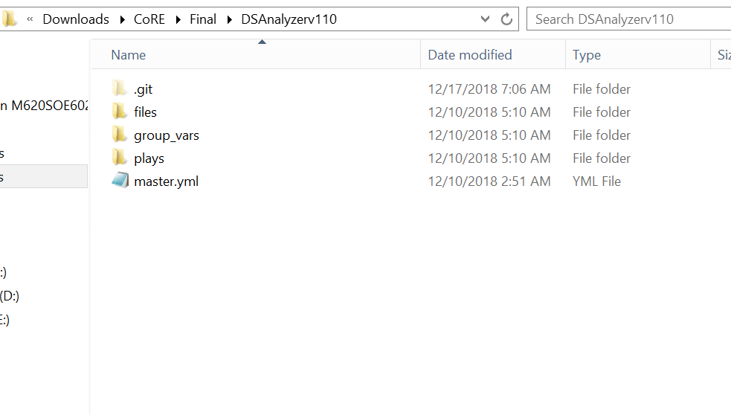

Figure 1 - Ansible Package

**Step 2:**

Copy DSAnalyzer V1.1.0 package on the default browser (path C:\inetpub\wwwroot)

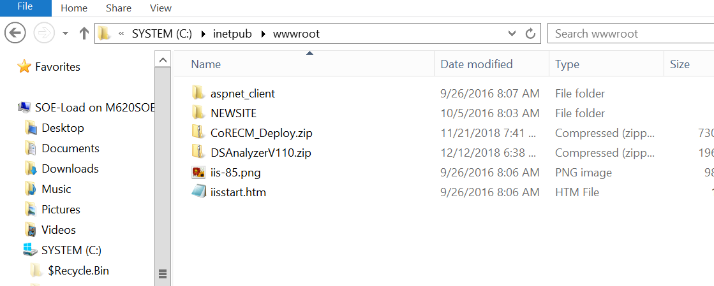

Figure 2 - Package in Default Browser

**Step 3:**

Create the projects in the GITLAB and push the code to the master.

Whenever we make the changes to the code we must push the code to master and sync the project in the ansible tower.

Note: Better to create the projects in the respective groups

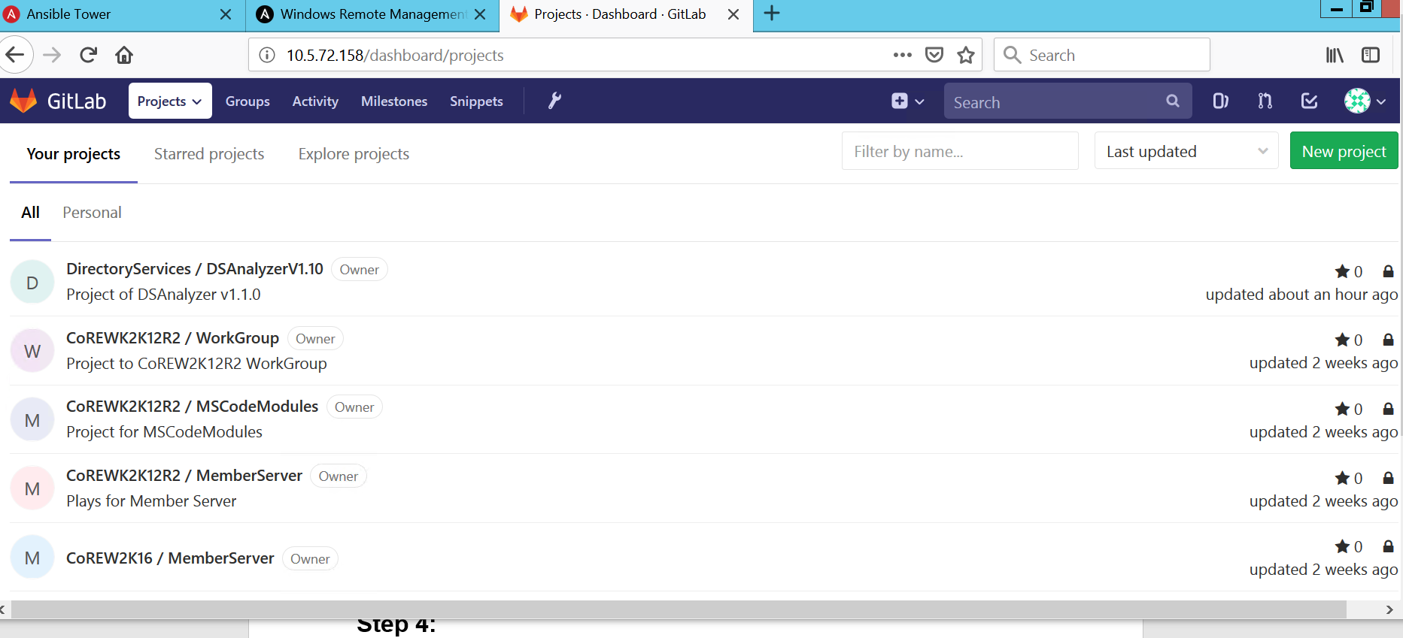

Figure 3 - Projects in Gitlab

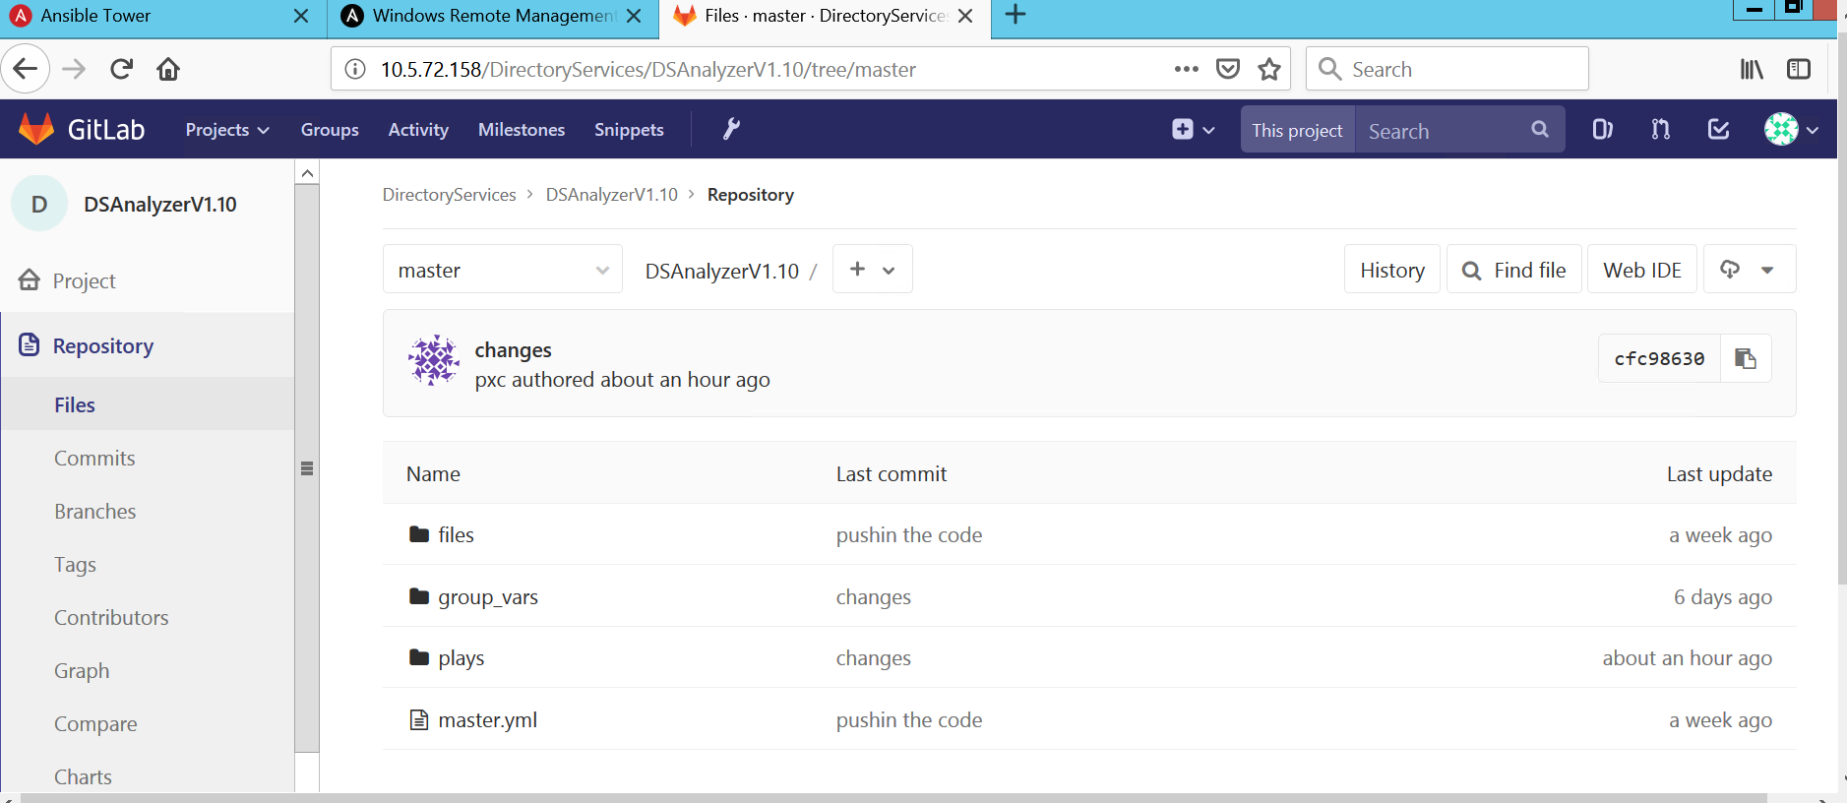

Figure 4 – Repository of DSAnalyzer in Gitlab

**Step 4:**

Create the projects in the ansible tower. While creating New project select SCM type as Git and provide the URL of the project created in the Gitlab and respective credentials of the gitlab

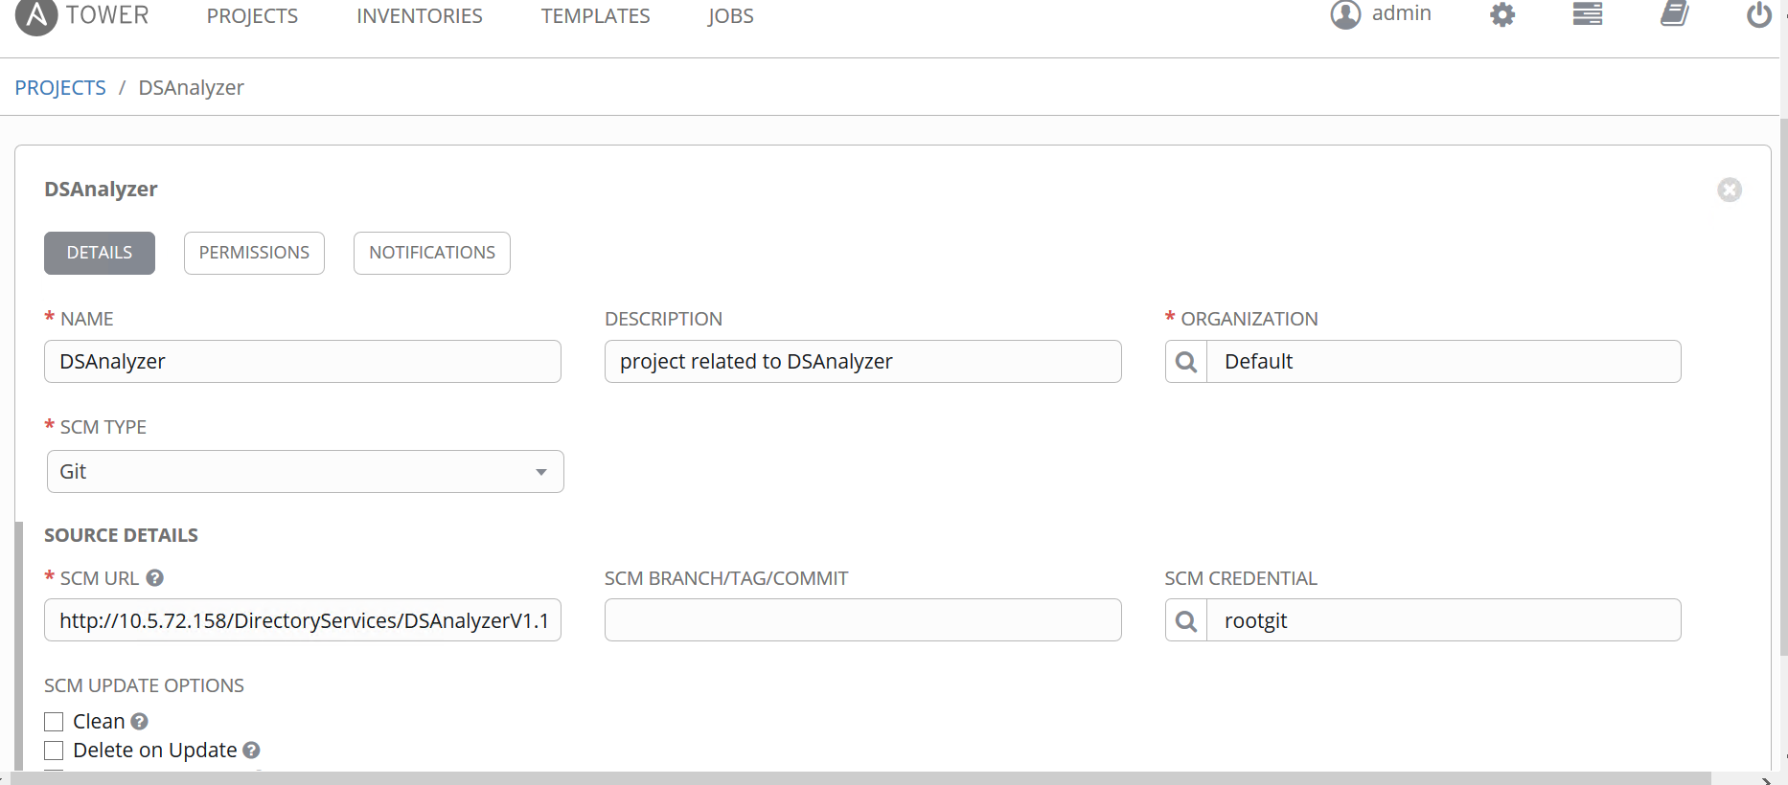

Figure 5 – New Projects in Ansible

**Step 5:**

* Create the new inventory or use the existing Inventory
* Create groups (DSAnalyzer) in the inventory and add the hosts in the groups.
* As the host is Member server add with in the following way hostname.domainname, if it is a workgroup add with IP address of the server.

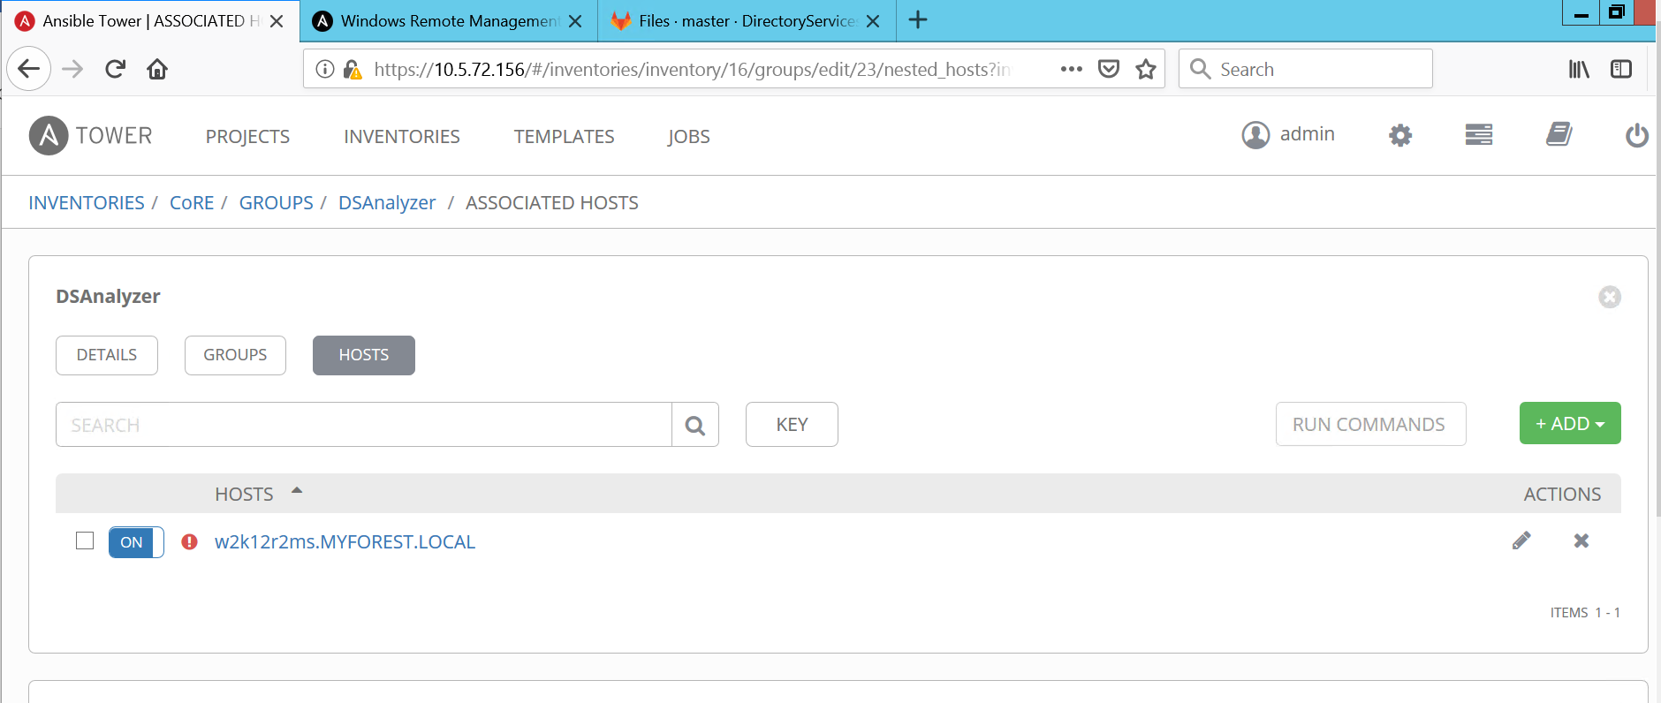

Figure 6 - Inventory with groups and hosts

**Step 6:**

Update the Domain Credentials in the Ansible credentials.

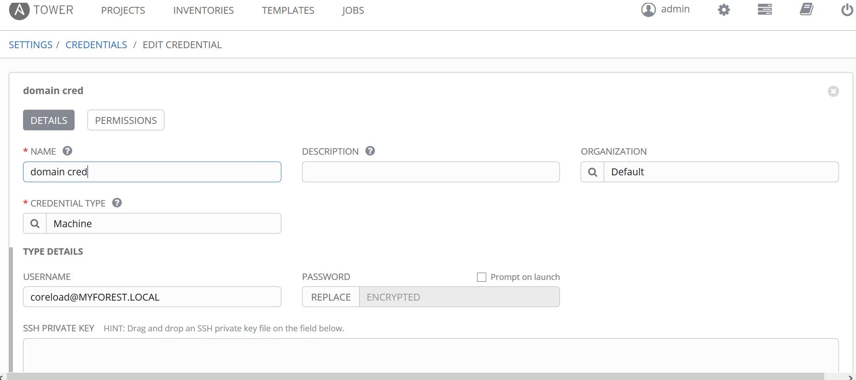

Figure 7 - Credentials

**Step 7:**

Now create the job template:

* Provide the inventory
* Provide Project as DSAnalyzer
* Playbook as master.yml
* Select the Credentials:
* As it is a member server add the Domain Credentials
* Limit the group to the Corresponding group (DSAnalyzer)

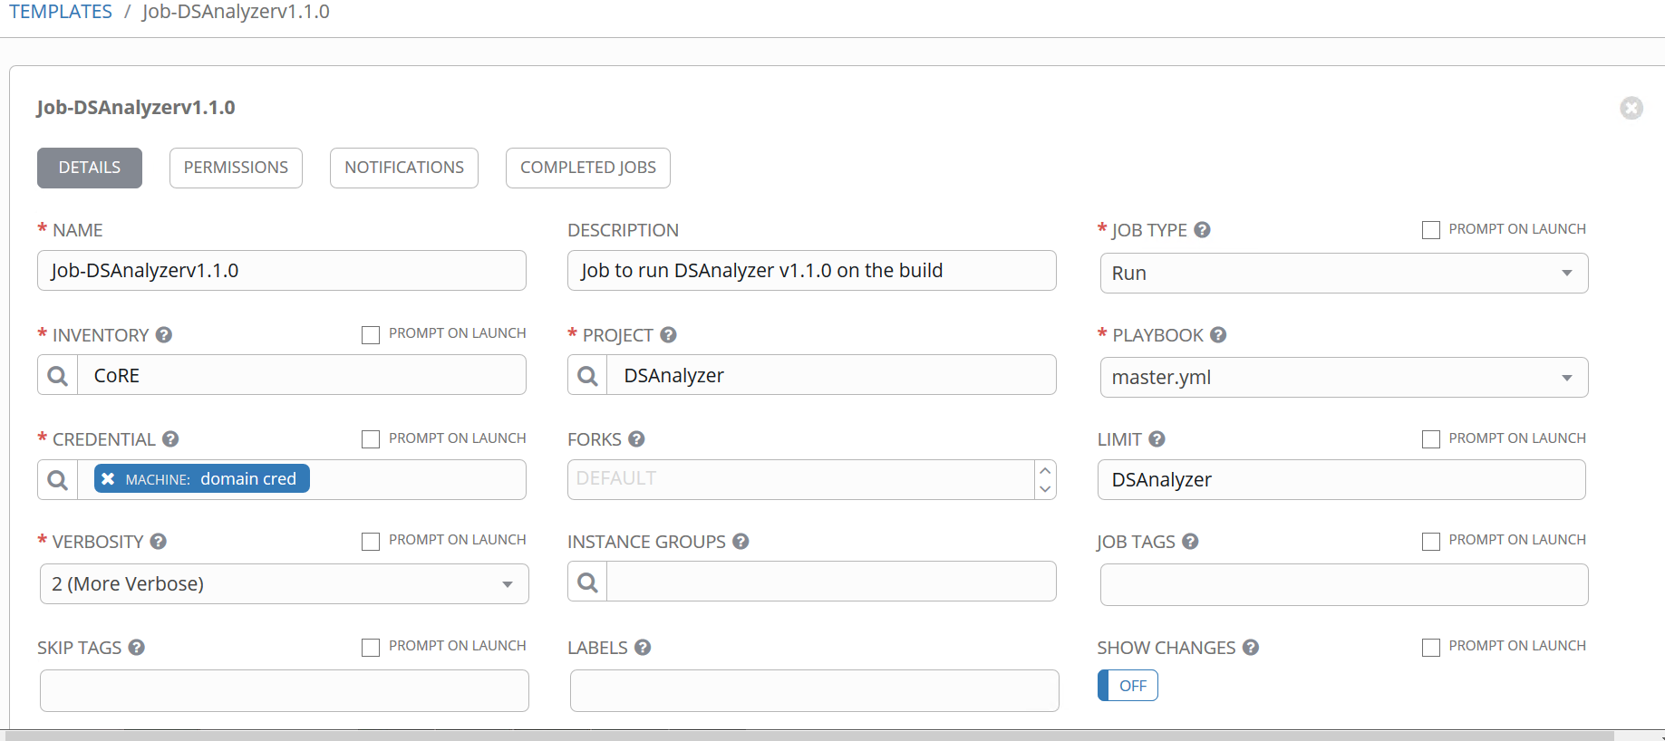Figure 8 - Creating new Job Template

* Increase the verbose level for clear logging
* In extra variables provide the port no. text

ansible_winrm_operation_timeout_sec: 120

ansible_winrm_read_timeout_sec: 150

ansible_connection: winrm

ansible_winrm_server_cert_validation: ignore

ansible_ssh_port: 5986

ansible_winrm_kerberos_delegation: true

* Save the job template

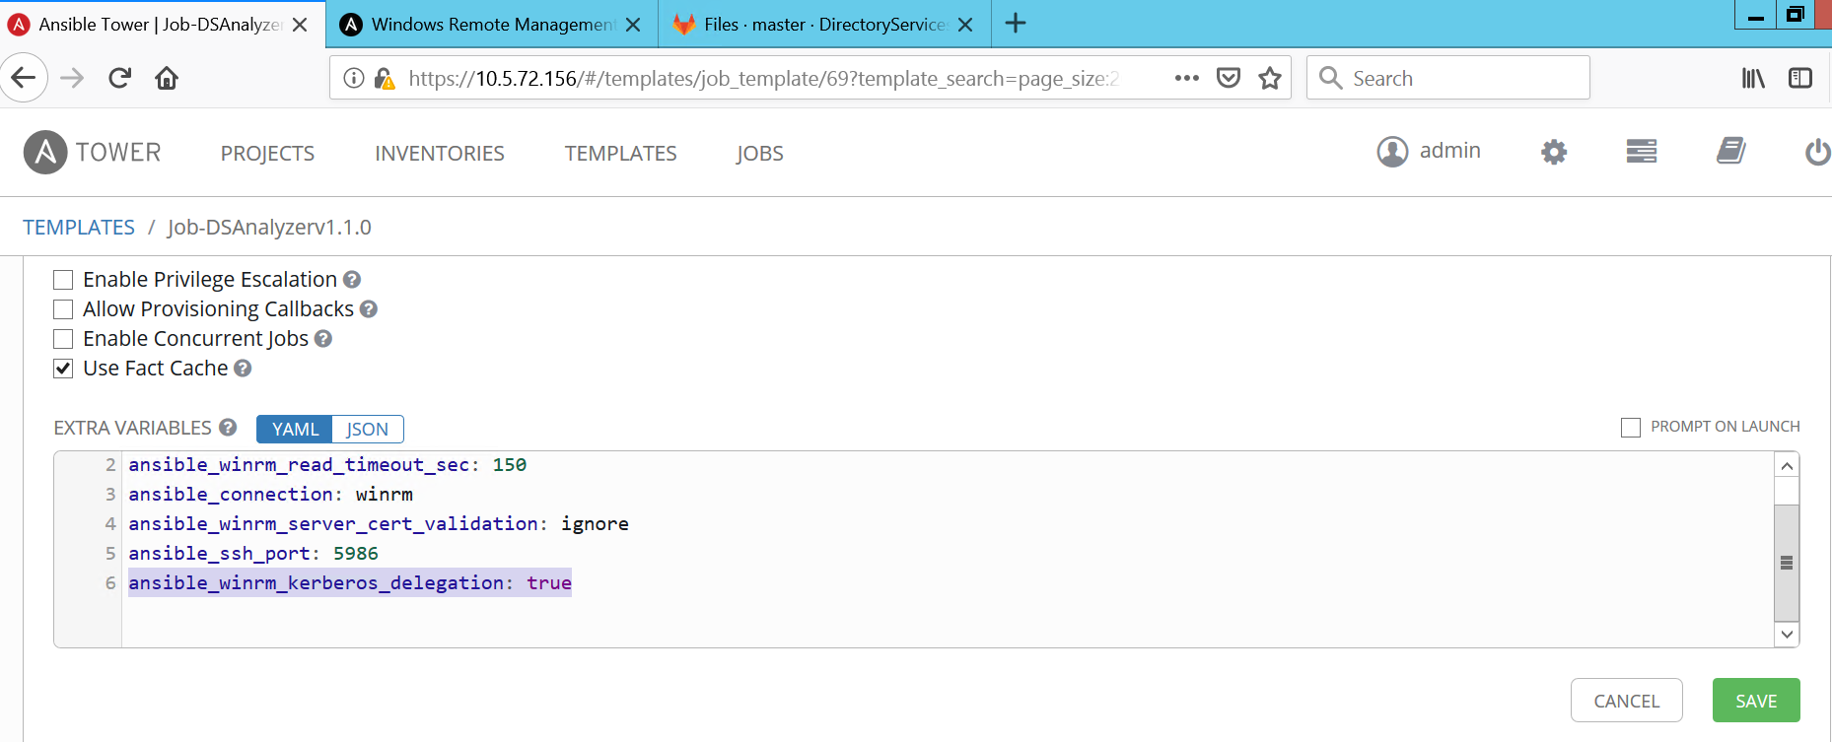

Figure 9 - Extra variables in Job template

**Step 8:**

Create the servers for the scan.

Run the Ansible scripts of member server on the Server.

Note: If the Member Server didn’t work, run ansible script of Work Group with subject parameter as hostname.

**Step 9:**

Update the ansible domain with your domain name.

Enter to the Ansible tower using putty.exe, provide the credentials and edit the following files with the domain information like DNS and name of the Domain.

Update the resolv.conf file with the Ip of the Domain.

Command to update the Resolv.conf file:

**Sudo vi /etc/resolv.conf**

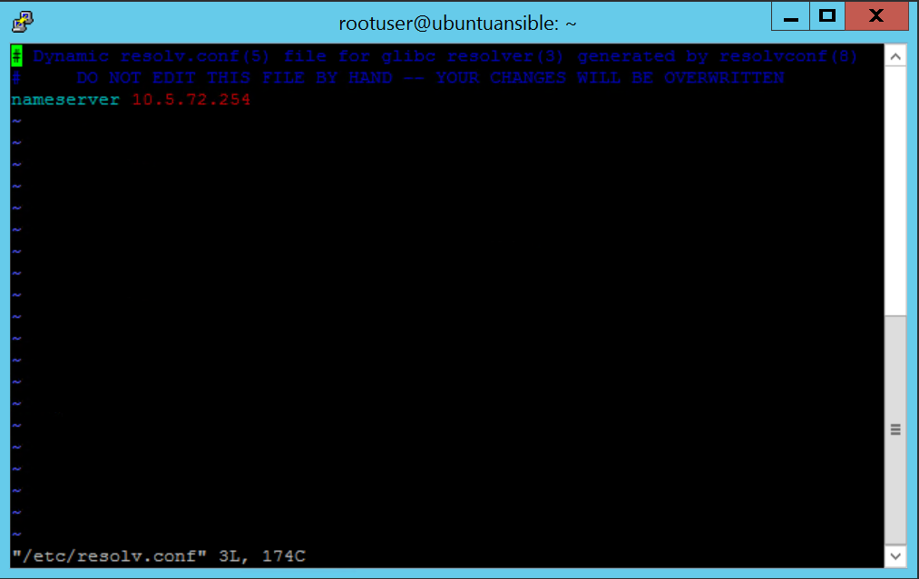

Figure 10 - Updating Resolv.conf file

We should also update the network\interfaces file with the DNS IP information

Command to update the file is:

**Sudo vi /etc/network/interfaces**

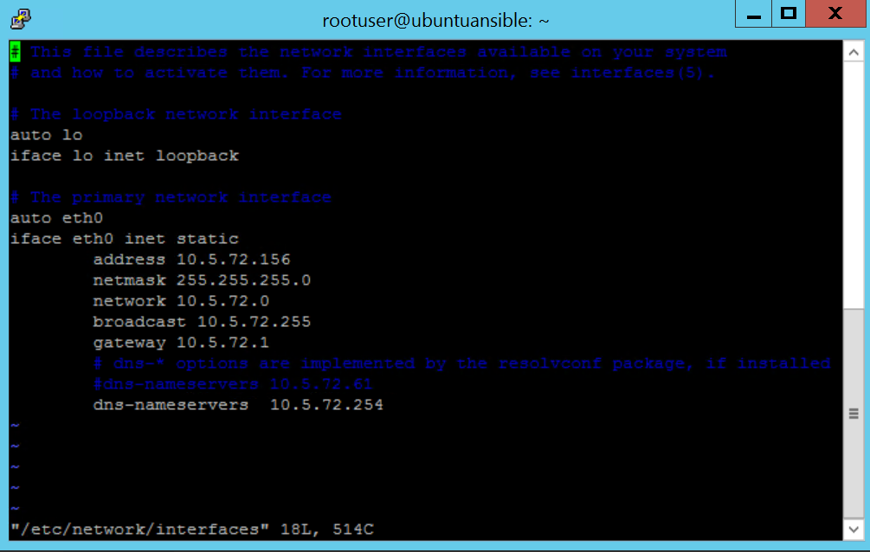

Figure 11 - Updating interfaces file

Update the krb5.conf file with the domain name.

Command to update the file is:

**Sudo vi /etc/krb5.conf**

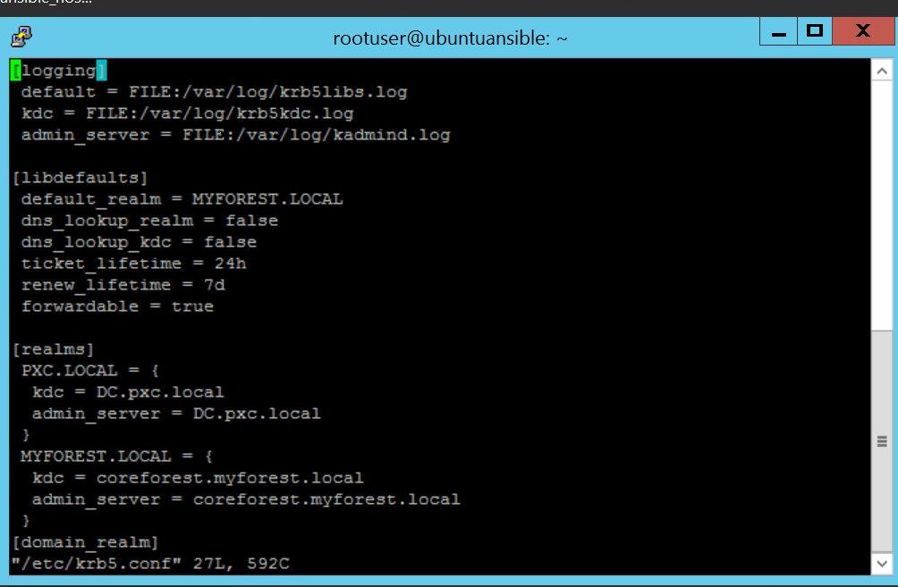

Figure 12 - Updating krb5.conf file

**Step 10:**

Start the Job Template.

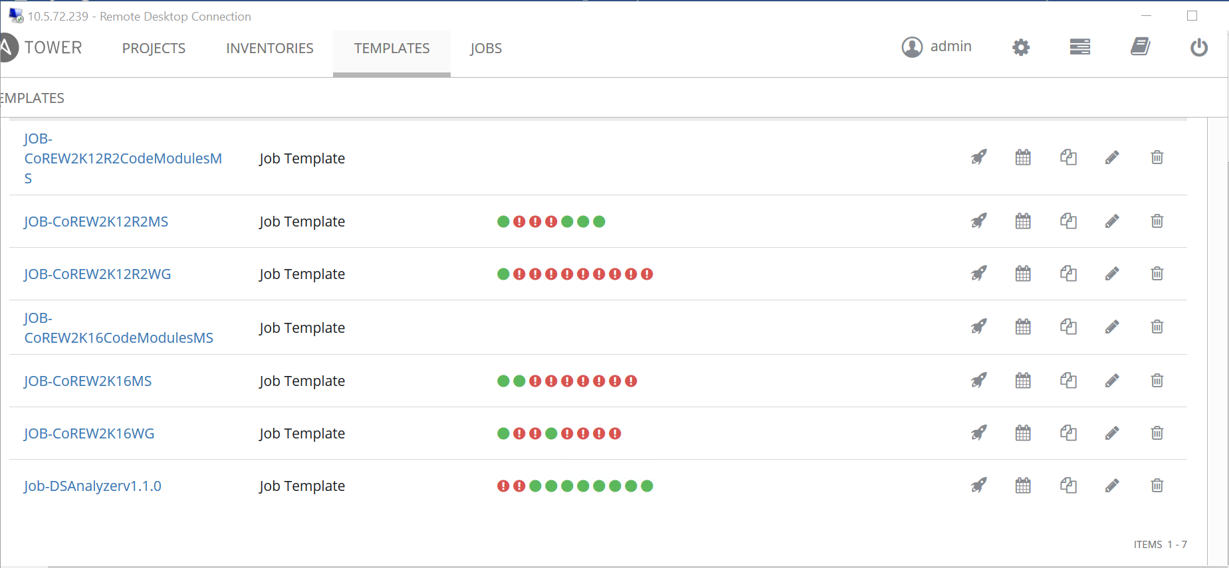

Figure 13 - Starting Template

**Step 11:**

Once the template is started the plays start executing. The template will fail if the paly or serer has issues and it goes successful if it has no issues with both plays and Server.

The following shows the state of play if it is successful.

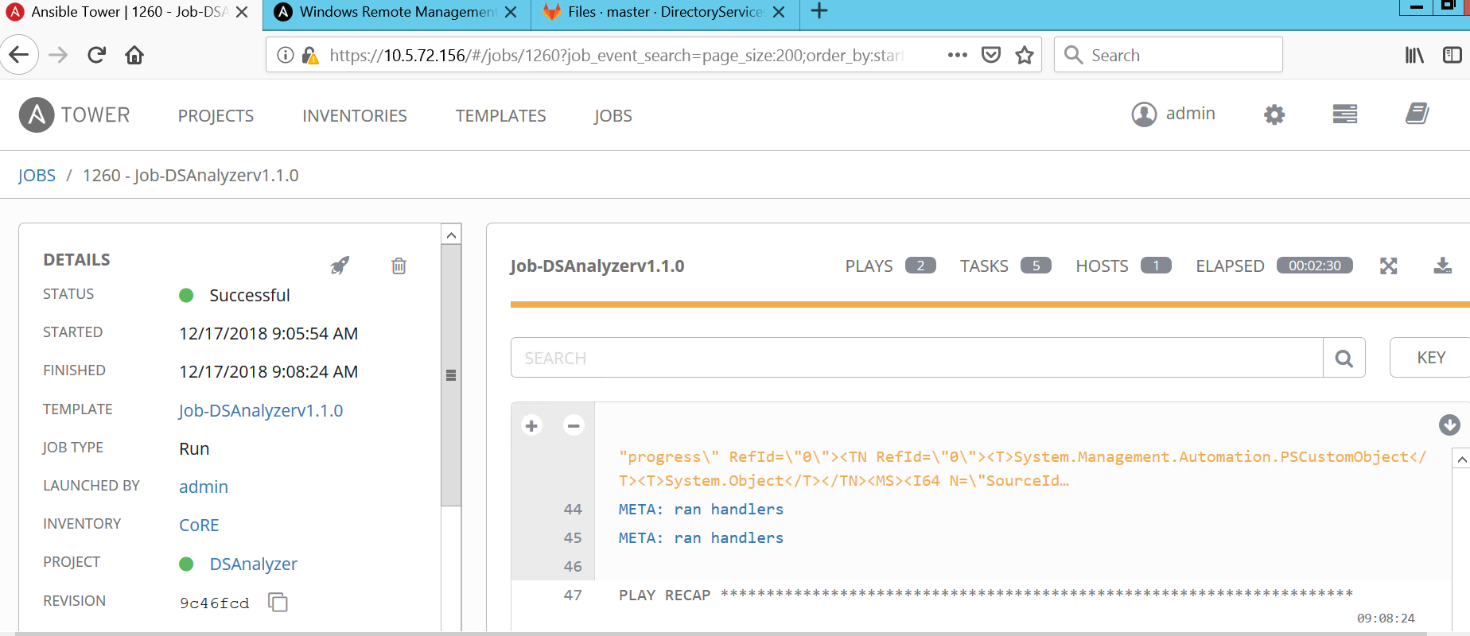

Figure 14 - Job Template

# Trouble shooting steps of ansible

**Method 1:**

Login to the DNS server and delete the duplicates in the DNS server.

**Method 2:**

Check whether the WinRM connection is working fine.Command to check the connection is

**$skipcn = New-PSSessionOption -SkipCACheck -SkipCNCheck; New-PSSession -ComputerName w2k12r2ms -Credential Get-Credential -UseSSL -SessionOption $skipcn**

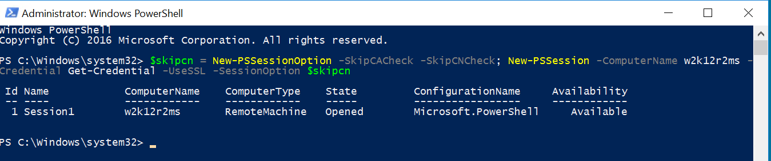

Figure 15 - WinRM connection

**Method 3:**

Check whether the Job Template and VM are on the same time Zone. If not set it to the same time zone.

**Method 4:**

If the job fails at deploying the DSAnanlyzer, see if the Unzip file is corrupted.

**Method 5:**

If the host is not reachable to the domain check the domain configuration in the Ansible tower. Login

to the ansible tower using putty.exe and check the following files

**/etc/network/interfaces**

**/etc/krb5.conf**

**/etc/resolv.conf**

**Method 6:**

Make sure that this Kerberos is added in the extra variables to avoid the double-Hop authentication issue

**ansible_winrm_kerberos_delegation: true**

# Document Administration

## Feedback

The information contained in this document is not region specific. Any customizations or variants of this publication that occur at the regional/account level are not under the management of this team.

General or technical feedback/updates/errors/suggestions regarding this publication can be submitted by emailing the responsible team listed in **Table 1**. This feedback will then be assessed, in terms of criticality, for addition to either the current version of the document or as part of the next review cycle.

|  |  |
| --- | --- |
| PxC Mailing List | Core Technology Areas of Responsibilities |
| [Platform x86 CoRE](mailto:Platform_x86_CoRE@dxc.com) | DXC Global Active Directory Standards, strategic initiatives, best practices, recommendations and process. |

Table 1 - Mailing List Table

### Naming Conventions of Documents

Global Directory Engineering has changed the document naming convention to be applied to its documents. Thus, documents created with a prefix of GDE or WPS or PWS will be renamed with a PxC (Platform x86 CoRE) prefix as they get reviewed or new ones are created. To ensure that access to previously published documents is still possible, whenever a previous document with GDE-x-icy or WPS-x-icy or PWS-x-icy document has been updated, the previous document reference will also be listed in the **Document Details** section of the new or updated document. All updates and new documents published by Platform x86 CoRE will use the new naming convention of PxC-x-icy.

## Attachments

Where a file has been attached in this document with a ZIP extension, it will contain other file formats. These formats may require specific Microsoft viewers to display the contents of the file properly. These viewers are freely distributed by Microsoft and can be found at <http://office.microsoft.com/en-us/downloads/HA010449811033.aspx>.

1. Abbreviations and Acronyms

| Abbreviation/Acronym | Definition |
| --- | --- |
| AD | Active Directory |
| AD DS | Active Directory Domain Services |
| ACL | Access Control List |
| BDC | Backup Domain Controller |
| CPS | Cloud & Platform Services |
| DC or DC(s) or DCs | Domain Controller or Domain Controllers |
| DNS | Domain Name System |
| e.g. | Exempli Gratia (Latin: for example,) |
| EMEA | Europe, Middle East and Africa |
| FQDN | Fully Qualified Domain Name |
| Gab | Gigabyte |
| GCARS | Global Change Activity Request System |
| GDE | Global Directory Engineering |
| GIS | Global Infrastructure Services |
| GOS | Global Outsourcing Services |
| GUI | Graphical User Interface |
| i.e. | Id Est. (Latin: that is) |
| IP | Internet Protocol |
| LAN | Local Area Network |
| Mb | Megabyte |
| MS | Microsoft |
| MSDE | Microsoft SQL Server Desktop Engine |
| NIC | Network Interface Card |
| NT | New Technology (Microsoft abbreviation) |
| OS | Operating System |
| PDC | Primary Domain Controller |
| PDS | Platform Development Studio |
| PWS | Platform x86 SOE |
| PxC | Platform x86 CoRE |
| SBC | Server Based Computing |
| SID | Security Identifier |
| SOE | Standard Operating Environment |
| SP | Service Pack |
| SQL | Structured Query Language |
| TCP | Transmission Control Protocol |
| UDP | User Datagram Protocol |
| VPN | Virtual Private Network |
| WAAS | Wide Area Application Services |
| WAN | Wide Area Network |
| WAFS | Wide Area File Services |
| WPS | Windows Platform Solutions |
| XP | experience (Microsoft abbreviation) |