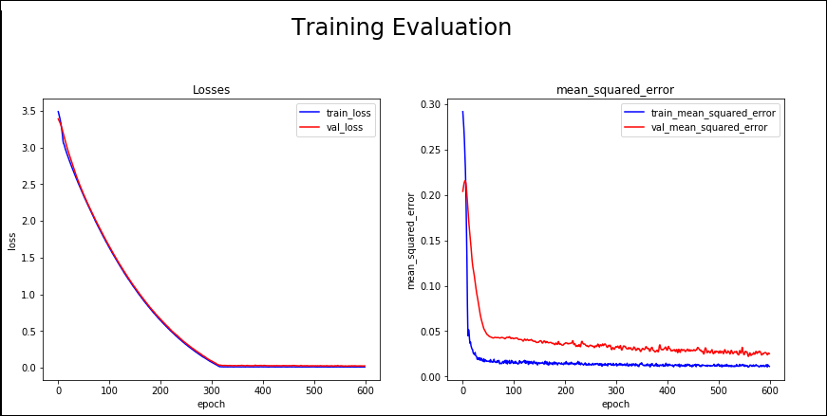

Day Prediction (Step): 1

sqrt mean_squared_error: 8.580250742091128

mean_squared_error: 73.62070279715535

mean_absolute_error: 6.771365681100396 R Squared: [0.86526094]

Adjusted R Squared: [0.86379638]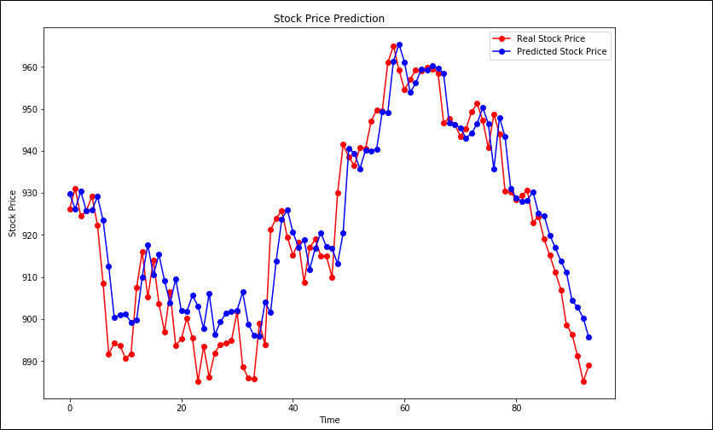

[04:29:39] WARNING: C:/Jenkins/workspace/xgboost-win64_release_0.90/src/objective/regression_obj.cu:152: reg:linear is now deprecated in favor of reg:squarederror.

Day Prediction (Step): 1

sqrt mean_squared_error: 9.111952143346889

mean_squared_error: 83.02767186264396

mean_absolute_error: 7.065098019863692

R Squared: [0.8480445]

Adjusted R Squared: [0.84121504]

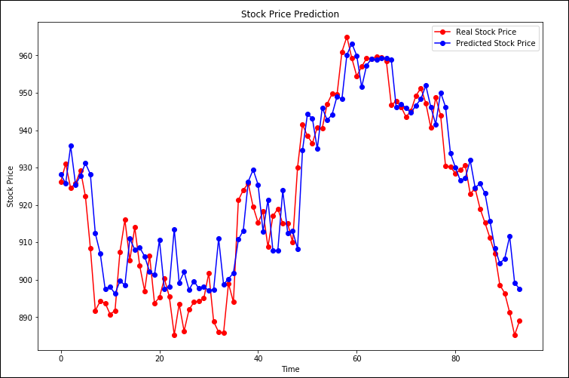

ZSH, ZSK, ZSN [[896.5144]] [[903.54254]] [[911.1345]]

ZSH, ZSK, ZSN [[886.80817]] [[893.8363]] [[901.4283]]

**Final Dec-03 1- Step**

ZSH, ZSK, ZSN [[894.68036]] [[901.7085]] [[909.3005]]

**Dec – 04 2 Step**

ZSH, ZSK, ZSN [[886.42413]] [[893.4523]] [[901.04425]]

**Dec – 05 3 Step**

ZSH, ZSK, ZSN [[894.70074]] [[901.7289]] [[909.32086]]

**Dec – 06 4 Step**

ZSH, ZSK, ZSN [[900.9229]] [[907.95105]] [[915.543]]

**Dec – 07 5 Step**

ZSH, ZSK, ZSN [[903.9528]] [[910.98096]] [[918.57294]]

jupyter nbconvert 5DaysPredictions.ipynb --to slides --post serve   
--SlidesExporter.reveal_theme=serif   
--SlidesExporter.reveal_scroll=True   
--SlidesExporter.reveal_transition=none

--TemplateExporter.exclude_input=True