TIRCIS Software

GeneProcess - DN to Radiance

Process Summary :

The processing of a scan file to radiance is a several step process.

If necessary, calculate the frame to frame offset for the scan file. Each point in the scene needs to move entirely through the interferometer. The frame to frame offsets describe the motion of the target relative to the imaging system.

Using the frame to frame offsets resample the input data to integer offsets, that is to say the first frame has the target at row1, the second resampled frame has the target at row 2 and so on through the 240 rows of the interferometer. The data are then arranged so that the processing program can quickly access a 320 sample by 240 frame which represents 320 targets going from interferometer position 1 to 240. The resulting array then becomes 320 x number of good lines x 240 interferometer samples.

Hot and cold blackbodies are flattened, 320 x 240 x 100 frames to a 320 x 240 frame.

Beginning at line 1 and going to the end of the resampled array, extract the 320 x 240 resampled interferogram. Each column of the frame, blackbody included is extracted using the same parameters as in the wavecal, starting and ending row and whether the extracted segment makes up the start or end of the mirrored profile. These profiles are then zero-meaned, apodized and FFT’d. Along with the corresponding Planck function, these profiles are entered into an equation to convert to radiance at each FFT bin.

Input requirements

* 2 blackbody acquisitions with known blackbody temperatures. 100 frame, 320 sample by 240 line, short integer files acquired by TIRCIS instrument. Ideally the temperatures of these blackbodies should bracket the temperatures encountered in the scene to be imaged
* Wavecal output file . (ASCII file relates bin to wavenumber to wavelength)
* Scan file, must have relative motion of target moving across the interferometer.
* An ASCII file listing the following information…
* Work directory startrow endrow leftFlag constantOffsetFlag xoffset yoffset
* ASCII 3 column wavelength file (relates bin to wavenumber to wavelength)
* Hot blackbody, hot blackbody temperature
* Cold blackbody, cold blackbody temperature
* ScanFile
* Output File Prefix

e.g. file listing

/home/harold/workdir/sucki/dhdata

0 38 233 0 1 0. -0.87 ; nwavefiles startsamp endsamp leftflag constoffset xoff yoff

/home/harold/workdir/sucki/2013_07_01/mywaves_07_0.txt

scan_BB70_130718_110234.img, 70.

scan_BB30_130718_105641.img, 30.

scan_scan2_DH_130718_110815.img

/home/harold/workdir/sucki/dhdata/proc

Program Operation

* Double click the Tircis_process icon. This opens both the main window as well as an opening control dialog entitle Tircis_Proc_start
* On the Tircis_Proc_start dialog, browse to the “Process File”. This is the ASCII file described above.
* On the Tircis_Proc_start dialog, click the “Calculate” radio button if you wish to have the program calculate the frame to frame offsets.
* On the Tircis_Proc_start dialog, if the “Fixed” button is selected, enter the X and Y offsets (note that the Y offset is the direction of motion through the interferometer.
* Click the GO button. This starts processing as you will then see the grayed boxes turn first yellow as that process is ongoing and green once it completes. The program will create several intermediate files as listed below. These files are accompanied by a .hdr ENVI header file.

*_stacked

Resampled frames to allow for interferogram processing of entire image.

*_spec

Hyperspectral radiance image with wavelengths clipped less than 8 microns and greater than 14 microns.

*_temp

Hyperspectral blackbody temperature image with wavelengths clipped less than 8 microns and greater than 14 microns.

*_emiss

Apparent emissivity image with wavelengths clipped less than 8 microns and greater than 14 microns.

Tab Display Operations

The GUI has several tab widgets which will allow you to view various products in the processing flow.

* Input Images Tab

Presents view the cold and hot black bodies as well as the scan image. A slider will allow for the selection of any frame and allow you to view the motion of the scene through the interferometer. See Figure 3 below.

* Wavelengths Tab

Presents plots of Wavelength vs. Pixel and Wavenumber vs. Pixel

* Resample Tab

Display of slices of the stacked cube with y being the number of scan lines and x being the interferometer dimension. Features should appear as horizontal bands. Tilting of the bands suggests that an adjustment of the offsets might be necessary. A profile plot shows the horizontal profile through the stacked image and hence is the resampled interferogram, i.e. the interferogram of a target in the scenen. A slider allows for selection of the column in the original frame to be modified for image display as well as profile to display. Also, the offsets used for resampling (if in calculated mode) can be displayed in the bottom plot window. See Figure 4 below.

* Radiance Tab

Display of radiance image, fills in as being calculated. Display band can be selected via combo box in upper right corner of tab. Clicking in display window will show the spectrum at that location in upper right plot window. Apparent emissivity at that point is displayed in the lower right.

* Temperature and Emissivity Tab

Same operations and displays as the radiance tab, except that temperature in Degrees C is displayed instead of radiance. By selecting the Emissivity/Temperature radio boxes the display can be toggled between the two products. The band for display can be changed via the combo box in the upper right corner of the tab. See Figure 5 below.

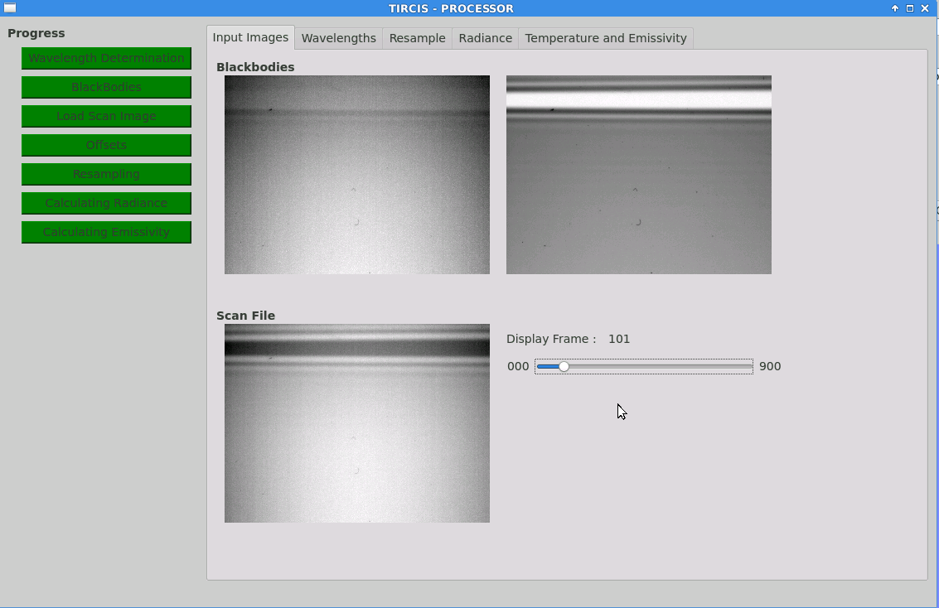

Figure 3. Tircis_process main window with the input images tab selected. Cold and hot blackbodies are shown at the top of the window and the scan image is shown at the bottom. The slider to the right of the scan display controls the frame being viewed.

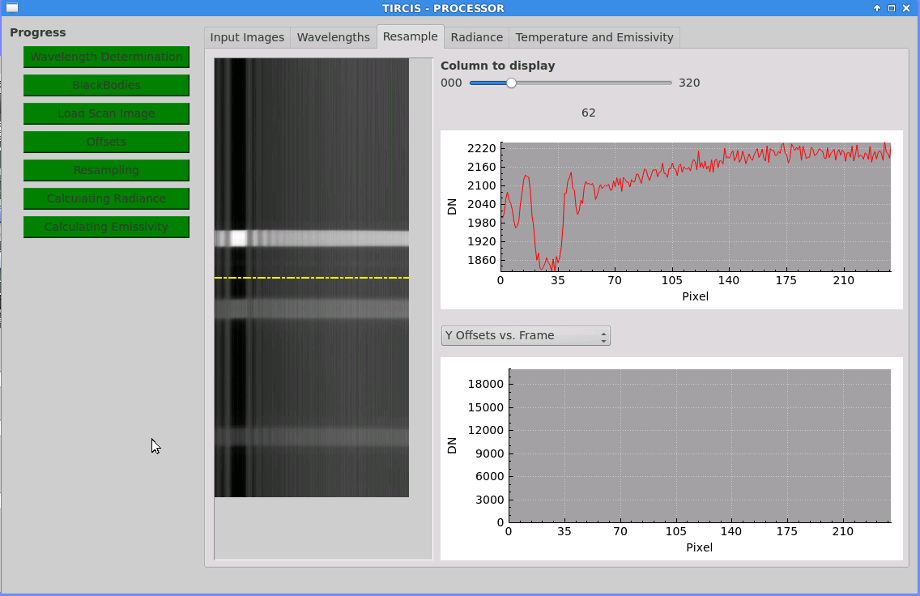

Figure 4. Tircis_process main window with the Resample tab selected. Note the horizontal bands which result from an accurate offset determination and proper resampling to form the interferograms. Interferogram for the selected row (yellow line which can be dragged up or down) is shown in the upper plot window.

Figure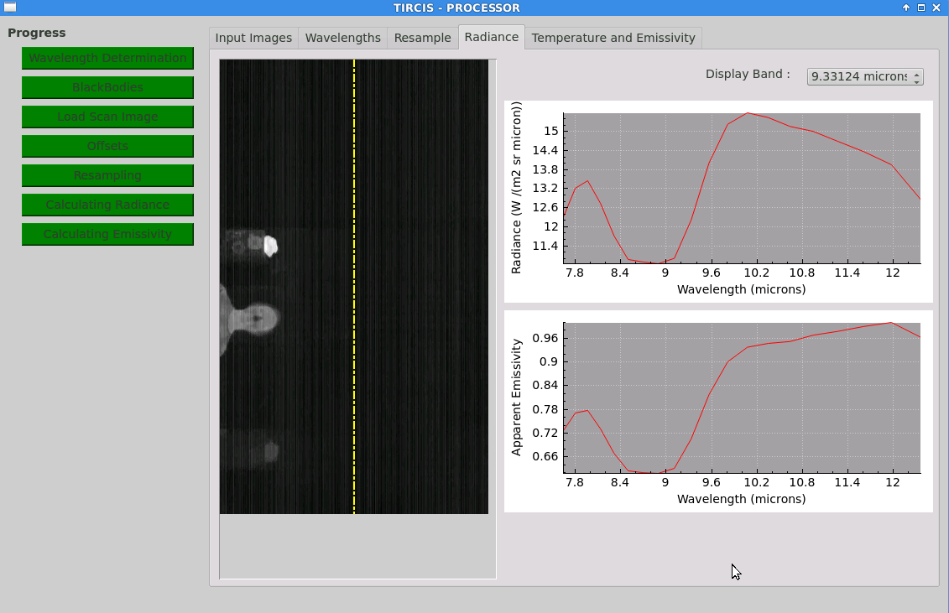

Figure 5. Tircis_process main window with the radiance tab selected. Radiance of the 9.3 micron band is displayed and the spectrum of the quartz crystal is displayed in radiance at top and in apparent emissivity in the bottom of the plot. Cursor clicking in the image window results in the radiance and apparent emissivity being plotted for that selected pixel.