TIRCIS Software :

Wavelength Calibrator - *wavecal*

**Process Summary**:

Wavelength calibration is performed by analyzing two or more wavelength calibration files. An emission source is imaged through a narrow bandpass filter. The more filters and the wider spread of the wavelengths of the filters will give a better quality calibration. The files are then flattened so that originally a 100 frame file is flatted to a single averaged frame and then a column is taken from each file for analysis.

A segment of the column is then extracted from the profile, which is then mirrored on either its left

or right side to form the profile which is then zero-meaned, apodized and FFT'd. The peak magnitude for each of the

FFT results is found, and then a fitting of wavenumber (known from the filter) to bin of the FFT peak location. This fitting yields polynomial coefficients (first degree polynomial here). These coefficients are then used to generate the relationship between FFT bin to wavenumber and wavelength. A three column ASCII file is generated with bin number, wavenumber and wavelength in microns. This file is then used as vital input to convert scan files from DN to radiance.

**Input requirements**:

* 2 or more “wavecal” acquisitions: these are 100 frames of 320 sample x 240 lines with interferometer oriented in the y direction. (See figure 1 for example frame.)
* ASCII File listing the filenames of the above acquisitions. Each line of this file consists of an absolute path and the wavelength in microns, separated by a comma. See the file listing below.

Example file listing....

> more 2013_07_01/filelist.txt

/hbeta/harold/workdir/sucki/2013_07_01/scan_wl108_130701_104028.img, 10.8

/hbeta/harold/workdir/sucki/2013_07_01/scan_wl8712_130701_103443.img, 8.712

/hbeta/harold/workdir/sucki/2013_07_01/scan_wl975_130701_104304.img, 9.75

**Program Operation** :

* Double click on the wavecal.exe icon. The main window will open (See Figure 1 below).
* Select File->Read Wavecal File List. This will open a File Dialog box to allow the user to specify the ASCII wavecal file list.
* Click the output file Browse button. This will allow you to specify the name and path of the output ASCII file. This file gets written when either the Column or Full Calibration buttons are clicked. See below.
* After selecting the file, the average wavecal raw profiles are displayed. The reconstructed profile, FFT Magnitude and wavenumber vs. Pixel can also be selected for display in the plot window by clicking in the Plot Type Combo Box.
* At this point the starting row and ending row for profile extraction can be modified (default

of 39 and 233, respectively). Reconstructed profile is formed by taking the starting and ending row from a column in the wavecal file and mirroring it based upon the LeftFlag checkbox. It is this reconstructed profile that is zero-meaned, apodized and FFT'd to proceed from DN to radiance. If the left checkbox is selected, the reconstructed profile comprises the extracted segment then the mirrored segment. If not selected, the reconstructed profile is the mirrored extracted segment then the extracted segment. One should note the start and end rows as subsequent processing of scan files and blackbodies will be processed with these parameters.

* Select either Column Calibrate or Full Calibrate

A profile can be taken from a position in the array, or it can be taken by averaging all columns to get a single profile from the file. This profile is then used for the calibration. A three column output file is written to the specified output file, with the three columns corresponding to bin number, wave number, and wavelength in microns.

**Column Calibrate**

The profile display and the subsequent wavelength calibration is based on a single column from the file, that defined by the position of the dashed yellow bar in the image display. This bar can be dragged by the cursor to any column in the image.

**Full Calibrate**

By clicking on the full calibrate button, the mean of each row is calculated and that is used to generate a single profile for the file. This is then used to calculate the other profiles and the wavelength calibration file.

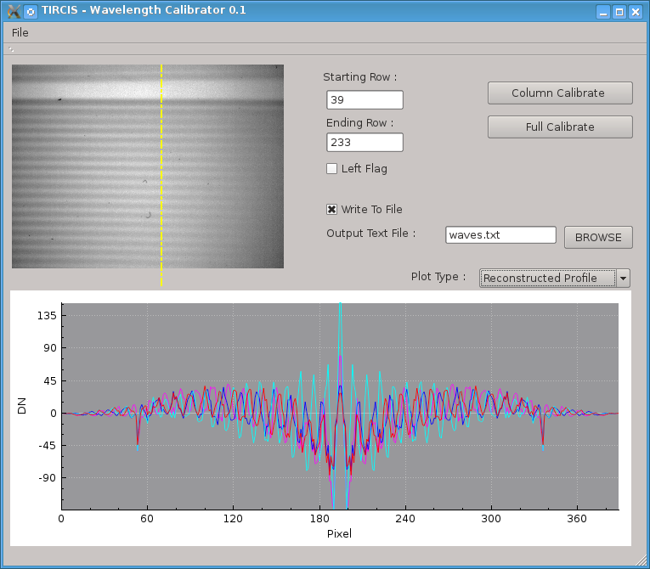

Figure 1. Main window of the TIRCIS Wavelength Calibrator package.