TIRCIS Software

Blackbody Analyzer *– bbanalyze*

Process Summary :

Given a wavelength file and three or more blackbody files, the program will use the hot and cold black body for radiance calibration. The remaining blackbody files will be converted from DN to radiance, and then will be plotted against the Planck blackbody radiance.

Each blackbody file is treated in the same manner, with the file flattened, then averaged in the sample direction to get a single profile. Using the start and end row the profile is extracted, mirrored, zero-meaned, apodized then FFT'd.Planck radiance arrays corresponding to the hot and cold bb temperatures are also calculated at the corresponding wavelengths (taken from the wavecal output file). Using these FFT arrays, (hot, cold, and unknown blackbodies) generate the radiance for each of the blackbody FFT profiles and compare to the Planck radiances. The program allows for the plotting of raw profiles, extracted mirrored profiles, FFT magnitude, and the radiance vs. Wavelength for each of the blackbody profiles, with Planck radiance overplotted.

Input Requirements :

* 3 or more blackbody acquisitions with known blackbody temperatures. 100 frame, 320 sample by 240 line, short integer files acquired by TIRCIS instrument.
* An ASCII file listing the blackbody acquisition filenames and the BB temp in Deg C separated by a comma. Note that the first and second files will be interpreted as the hot and cold blackbodies and will be used to derive the remaining blackbody radiances. Typical file will look like the example below...

>>> more radfiles

/hbeta/harold/workdir/sucki/dhdata/scan_BB70_130718_110234.img, 70

/hbeta/harold/workdir/sucki/dhdata/scan_BB40_130718_105825.img, 40

/hbeta/harold/workdir/sucki/dhdata/scan_BB50_130718_105939.img, 50

* Wavecal output file consisting of bin number, wavenumber, wavelength in microns.

Program Operation

* Double click on the bbanalyze.exe program icon. This opens the bbanalyze main graphical user interface.
* Select File->Read Radiance File List. Define the ASCII file giving the blackbody images and the temperature of the blackbodies.
* Select Configure->InputParameters. A dialog box will open with the hot and cold blackbodies and a text box to specify a wavelength file (created by the wavecal program). This also allows for the start and end row and the left flag (see description in wavecal) to guide profile extraction for processing. As soon as the ok button is selected, the dialog box is closed, and the hot blackbody and raw profiles from each of the blackbodies are displayed.
* The hot a cold black body flattened image display can be toggled by clicking on the hot or cold blackbody button.
* Using the combo box below the plot display, you can display the raw profile, the extracted, mirrored profile, the FFT magnitude, and the radiance versus wavelength. In this last case, the calculated radiance and the Planck blackbody radiance are displayed for each of the blackbodies. See Figure 2.

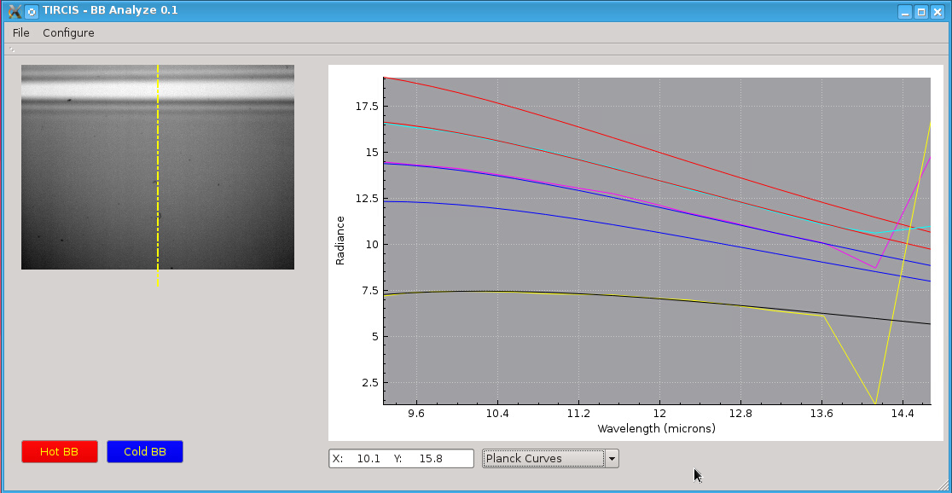

Figure 2. Main GUI window with hot blackbody and radiance vs wavelength (calculated and Planck radiance).