**Matzinger et al. DSSO-DSBSO Orbitrap/Iontrap MS3**

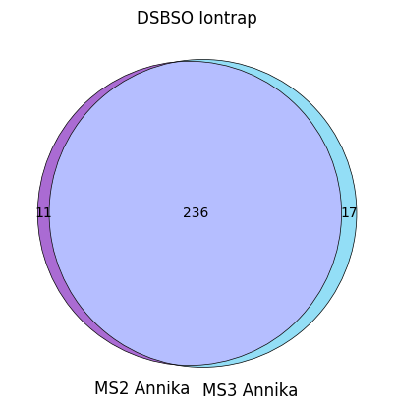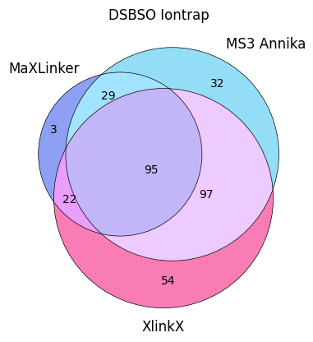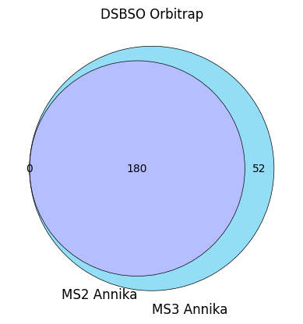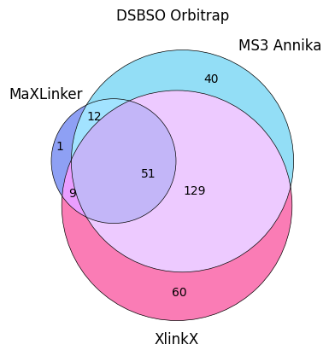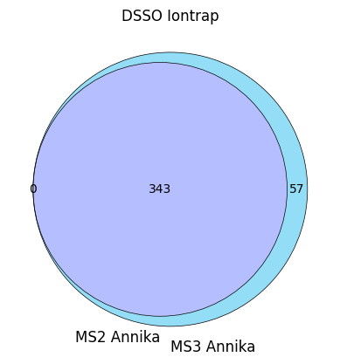

**PXD029252**

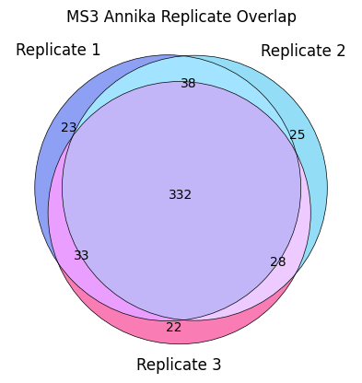

**PXD014337**

**PXD031114**

