**CS445 - Lab 1 Collaborative Git**

**[4 points] Exercise 1: Practice with all the local repository commands from the slides:**

1. git init



1. git status

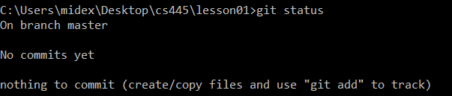

1. git diff



1. git add

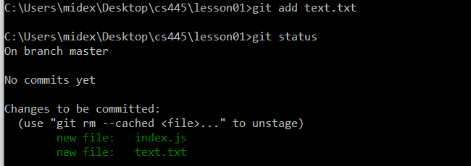

1. git commit

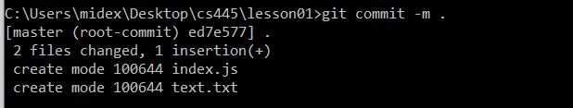

1. git commit –amend (updating the last commit)

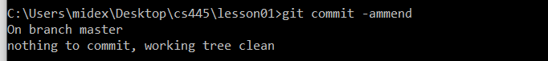

1. git log

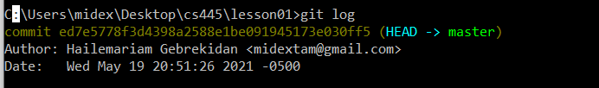

1. git show

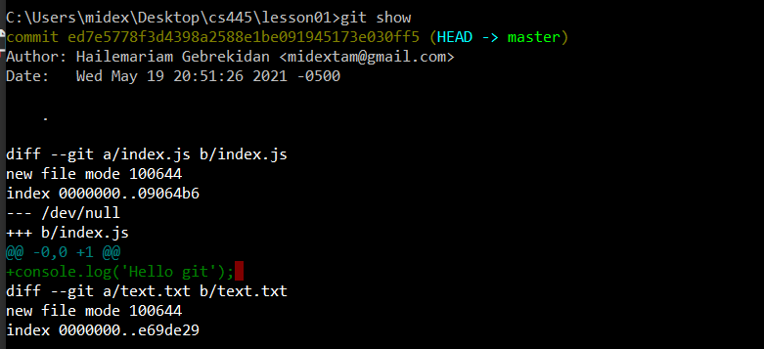

1. git tag



1. git restore

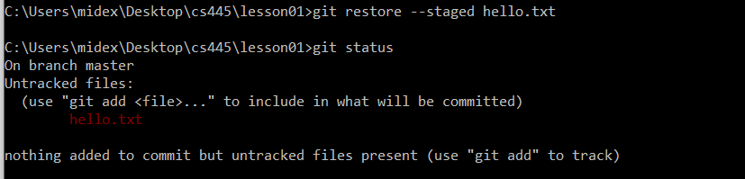

1. git branch



1. git checkout

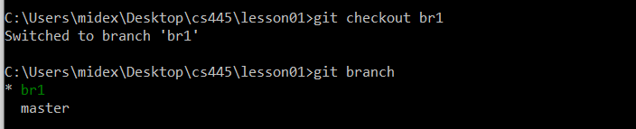

1. git merge



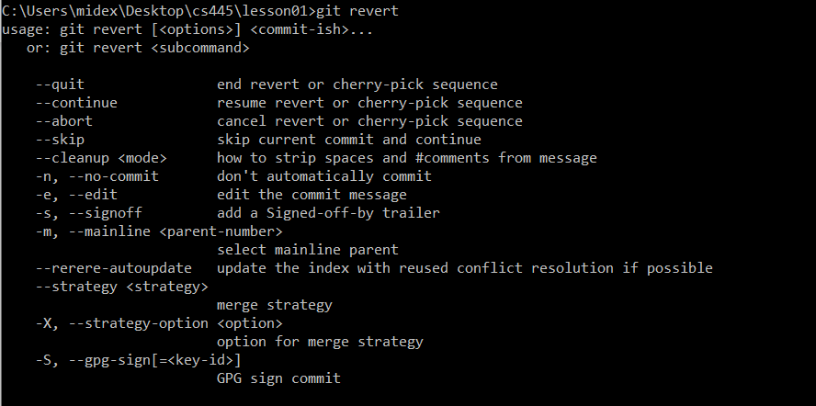

1. Undo changes from a certain commit git revert

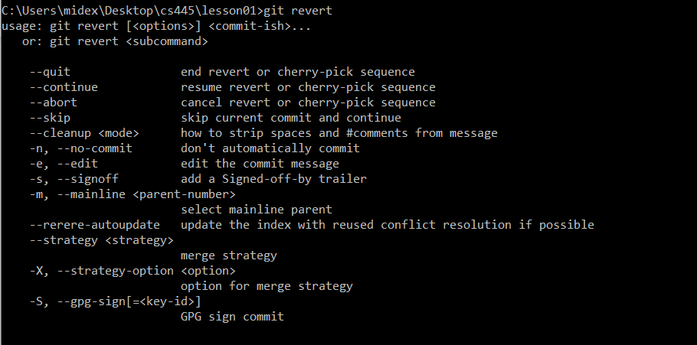

1. Erase commits with git reset



**[2 points] Exercise 2: Practice with all the remote repository commands from the slides:**

1. Create a remote repository

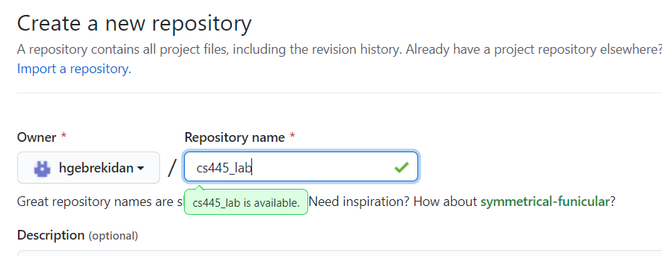

1. Create README.md

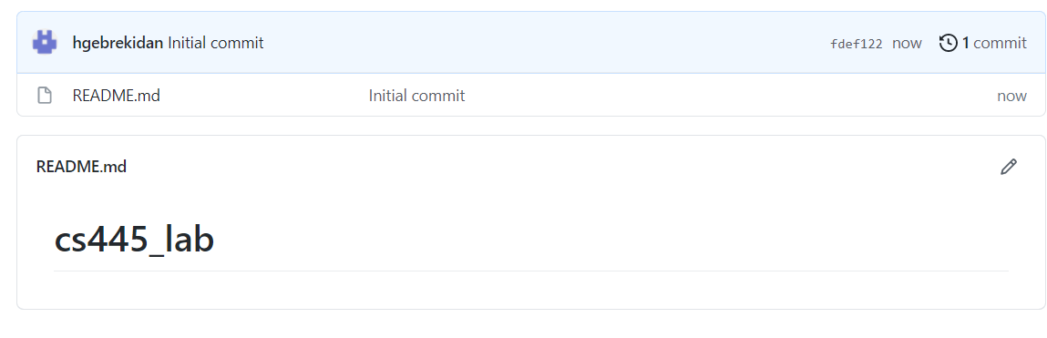

Add at least 5 markdown syntax (For example: Headers, Bold, Code, Unordered List, Links) [Cheatsheet](https://github.com/adam-p/markdown-here/wiki/Markdown-Cheatsheet" \t "_blank)

1. git remote

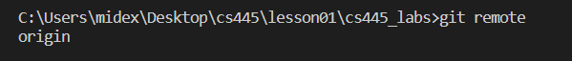

1. git clone

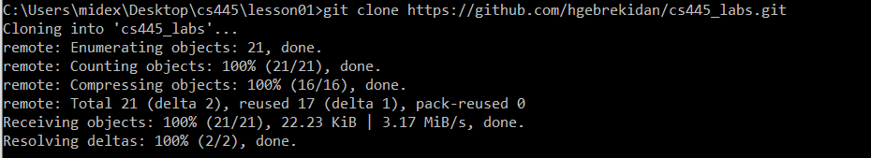

1. git push



1. git fetch

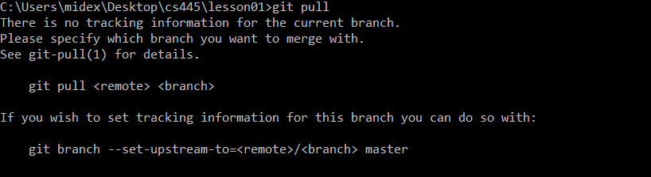

1. git pull



**[4 points] Exercise 3: Practice with all the third party repositories commands from the slides:**

Assume we are working with the following upstream: https://github.com/bellaxing/CS445-May2021-Lab1

1. Star the repository

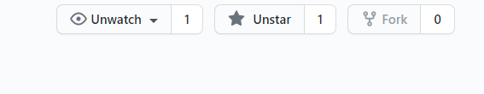

1. Watch the repository for any changes



1. Fork the repository

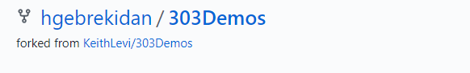

1. Clone your forked repository into your local machine

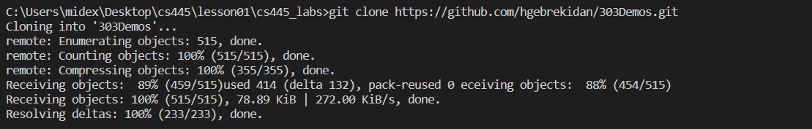

1. Create a new topic branch named using studentId-studentName, For example: 610001-JohnSmith



1. Checkout your new branch



1. Add a new file with your name, example: hello.js



1. Commit the changes

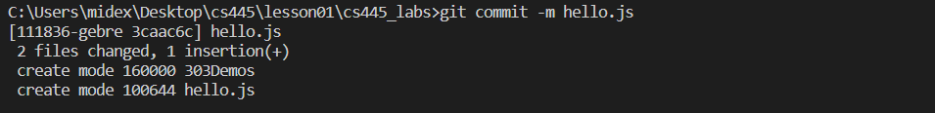

1. Merge your studentId-studentName branch with the main branch

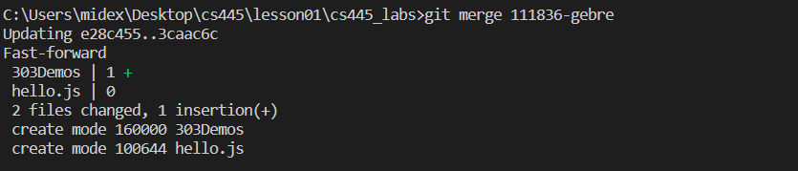

1. Push your changes to the remote repo

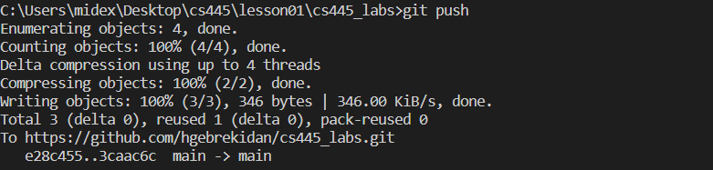

1. Create a new Pull Request to the upstream repo

