**What is GitHub? When was it created? Why? By who? What similar platforms exist? Why would you use such a platform?**

**ANSWER:**

GitHub is a Web-based Git repository hosting service. It offers all of the distributed revision control and source code management (SCM) functionality of Git as well as adding its own features. Unlike Git, which is strictly a command-line tool, GitHub provides a Web-based graphical interface and desktop as well as mobile integration. It also provides access control and several collaboration features such as bug tracking, feature requests, task management, and wikis for every project.

GitHub offers both plans for private repositories and free accounts,which are usually used to host open-source software projects.It was created in February 8, 2008; 7 years ago by Tom Perston-Werner, Chris Wanstrath,P J Hyett.

Other platforms include GITLAB, SVN, Bitbucket etc. The purpose of using a vcs is to keep track of code and issues. Differences between versions and different development stages.

Such platforms are used because, it's a social network that has completely changed the way we work. Having started as a developer's collaborative platform, GitHub is now the largest online storage space of collaborative works that exists in the world.

TUTORIAL:

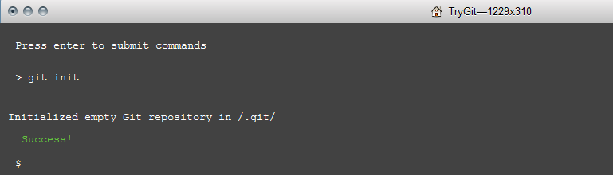

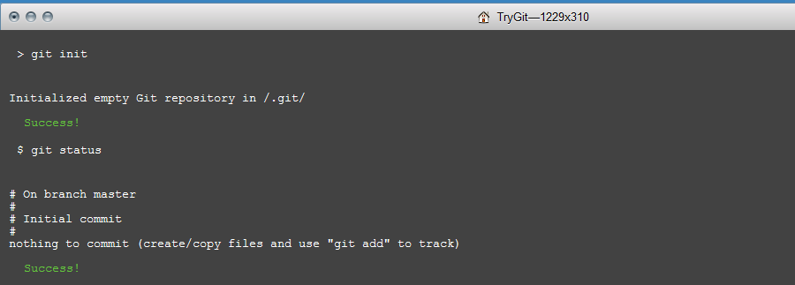

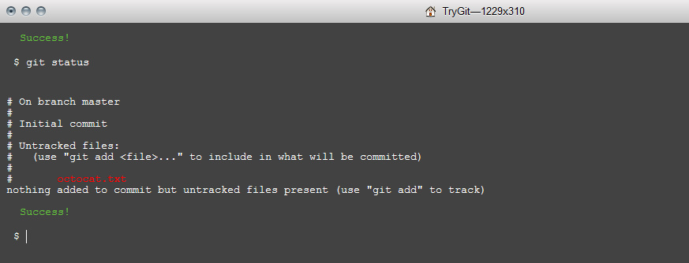

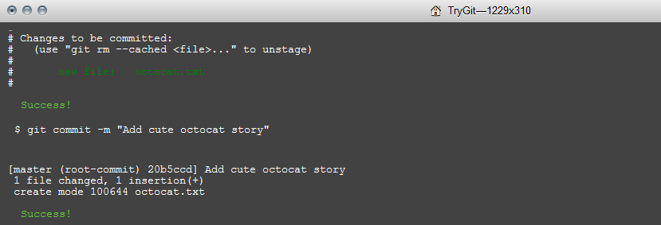

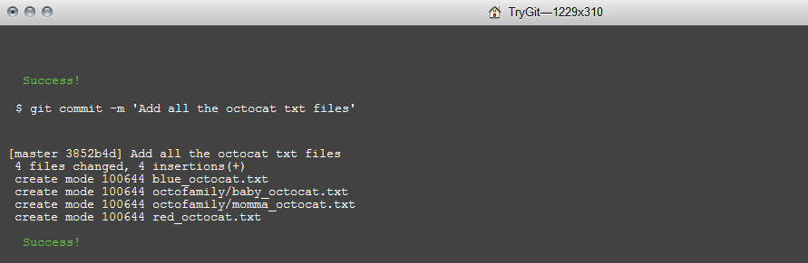

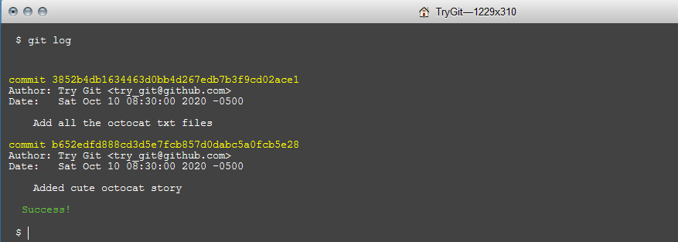

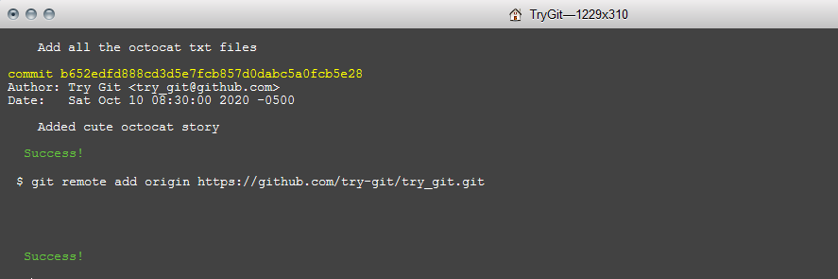

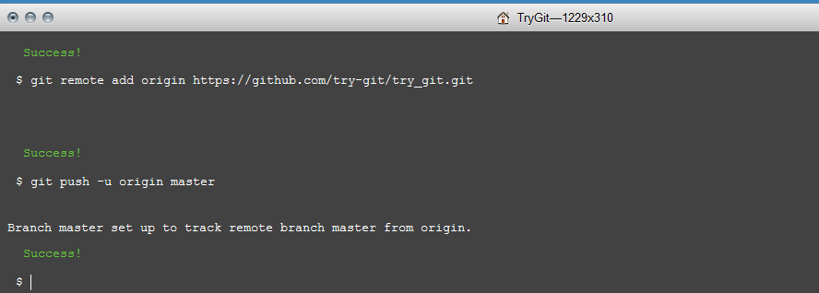

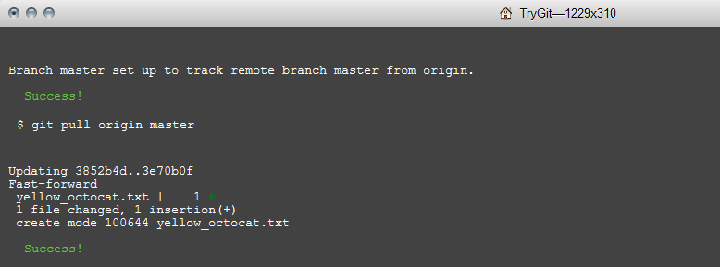

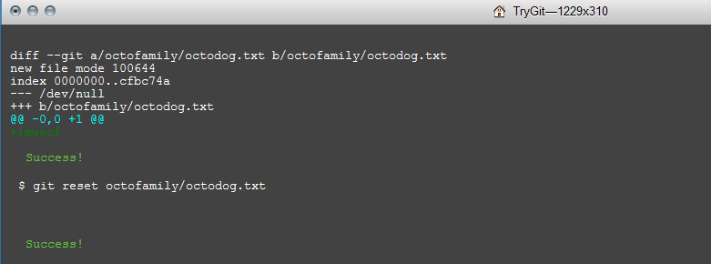

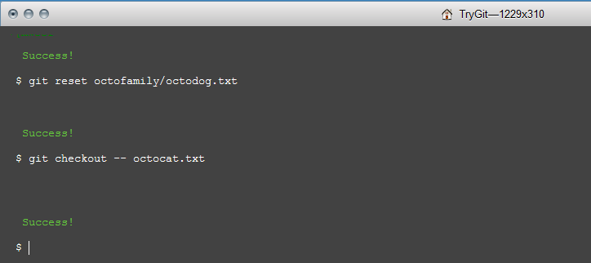

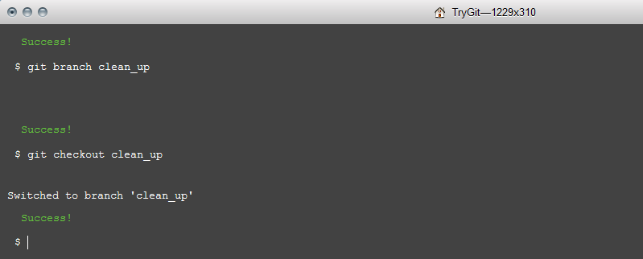

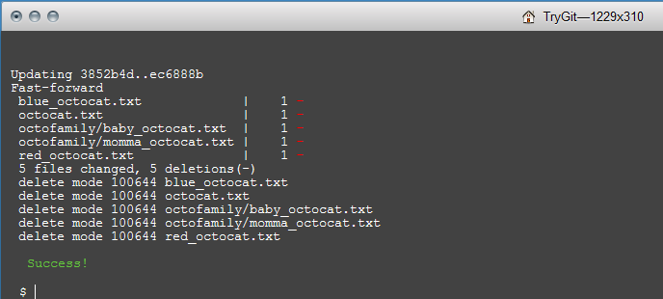

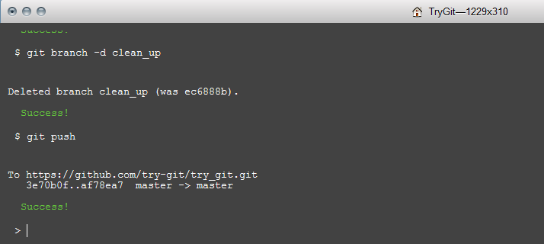

**Q.Define the following terms in the context of Git (2 lines maximum):**

* **Repository:** A space where all the files of a project, all its version, issues, commits reside.
* **Commit:** Recording changes made to the local changes.
* **Push:**  Updating remote repository for the changes made & committed in local repo.
* **Branch:** Different version of code/project in a repository.
* **Fork:** Copy of a repo in one’s account without making changes to original project.
* **Merge:** merging two different branchs or a forked repo once changes are finalized.
* **Clone:** Copying a repo on localhost/machine to grab a copy of code/project to use.
* **Pull:** Fetching and merging lastest commit from a remote repo.
* **Pull request**: Request to merge two branches or a frok and base branch.