###### Phase 1:

Start by creating a page that will display all of the cars that Frank has across all of his warehouses. Please sort the list according to _date_added_ asc. Below you will find a section with some sample data that you can use as for you application.

First Screen : All cars all display with few details on screen.

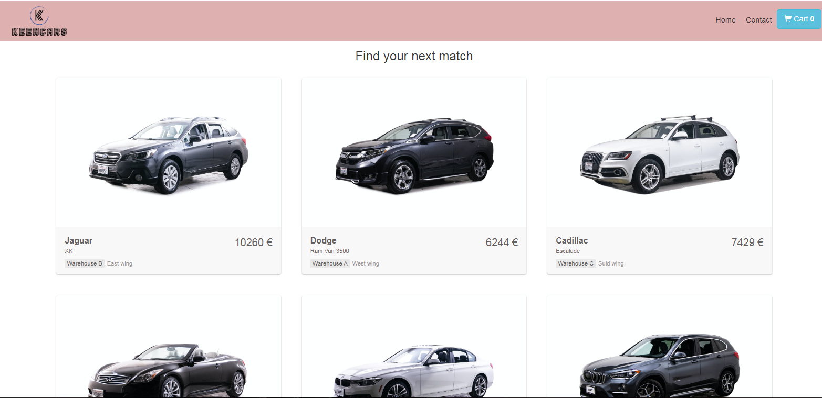

###### Phase 2:

Now, allowing the user to click on any of the cars (that are licensed = true) would make it a lot nicer. Once the user clicked on a car, we then show more details such as, the warehouse where it is stored and its location perhaps? It is up to you how detailed you want to make it.

Second Screen : Choose any specific Car. All Details will display.

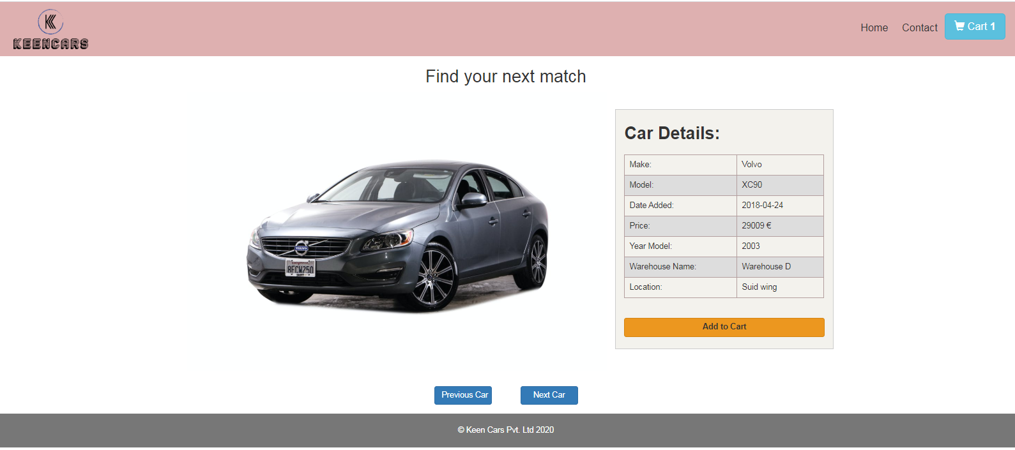

Add into Shopping cart and displaying the message as well.

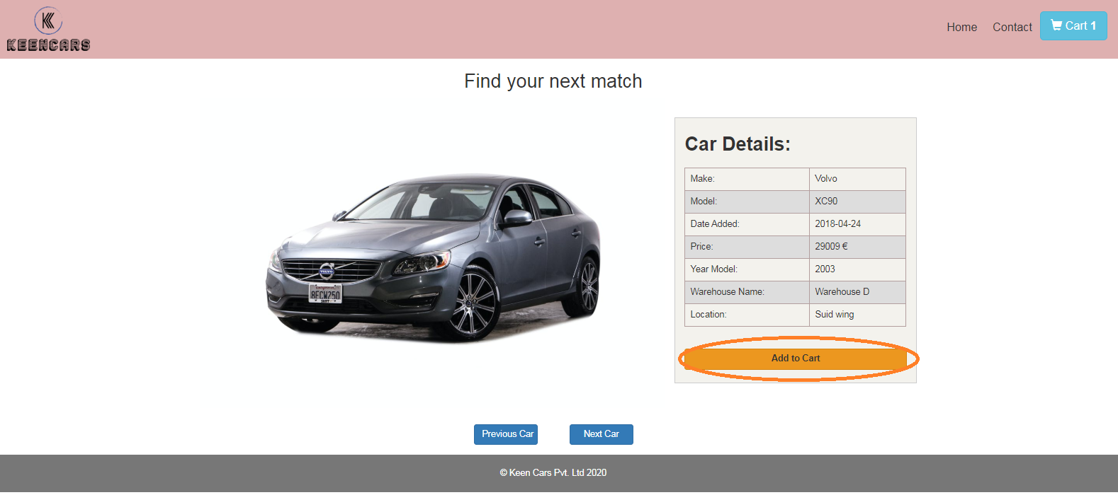

###### Phase 3:

Wow! Okay, we now have some good functionality! So lets take it one step further! Lets allow the user to add the car he is viewing to some sort of shopping cart so that he can easily checkout once he is done shopping. Oh, and perhaps we should show the user the total amount as well?

Last Screen : Display all the selected cars after clicking on carts. Also Carts showing the quantity of selected cars.

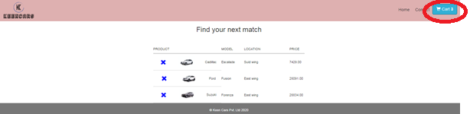

**Tools and Technologies**

* Technology: HTML, CSS, Angular-8
* Spring Boot , java-8 ,

#### This Projects covers all fundamentals of Angular and spring boot

* Multiple Modules
* Components, Template and DataBinding
* Form Validation
* HttpClient
* Animations
* Dependency Injection
* Routing & Navigation
* Service Workers
* Pipes
* JWT Token Generator
* Project exposés : post and Get mapping.

**Installation instruction**

Below all the frontend and backend instruction to run the application .

Request you to please first run the spring boot application to see the actual result on frontend.

Front-end

* git clone from github.
* reach the folder on terminal till angular-garage.
* run npm install
* run ng serve
* open the browser and hit the below url [http://localhost:4200](http://localhost:4200/)

Backend

* git clone from github.
* Open the project into IntellJ
* Run the SpringBootGarageApplication.you can also run using command
* Go to command termina.
* Reach til spring boot application folder (Spring_boot_Frank_Garage)
* Run this command (mvn spring-boot:run)