NOTE: This template is shareware downloaded from www.processimpact.com. All shareware payments are donated to the Norm Kerth Benefit Fund to help a consultant who is disabled with a brain injury. Please visit http://www.processimpact.com/norm_kerth.html to make a shareware payment ($10 suggested). Thank you!
eLearning versions of several popular Process Impact training seminars are available at www.processimpact.com/elearning.shtml, including “In Search of Excellent Requirements,” “Exploring User Requirements with Use Cases,” and “Writing High-Quality Requirements.” Single-user and corporate-wide site licenses are both available.
Vision and Scope Document
for
Web-store “365days”
Version 1.0 approved
Prepared by Komkova E. V.
08.11.2022
Table of Contents

Table of Contents ii
Revision History ii
1. Business Requirements 1
1.1. Background 1
1.2. Business Opportunity 1
1.3. Business Objectives and Success Criteria 1
1.4. Customer or Market Needs 1
1.5. Business Risks 1
2. Vision of the Solution 2
2.1. Vision Statement 2
2.2. Major Features 2
2.3. Assumptions and Dependencies 2
3. Scope and Limitations 2
3.1. Scope of Initial Release 2
3.2. Scope of Subsequent Releases 2
3.3. Limitations and Exclusions 3
4. Business Context 3
4.1. Stakeholder Profiles 3
4.2. Project Priorities 4
4.3. Operating Environment 4

Revision History

Name | Date | Reason For Changes | Version

Business Requirements

Background
The web-store “365days” is based on the sale of household appliances. There are 50 points of delivery of orders in the country. Each city or locality has several pick-up points. Using the web-application It will enable to simplify making the order, not to queue and not to discuss the characteristics of their preferences for the order in the shop. It will be a wide variety of household appliances.

Business Opportunity
Creating the web-application will serve a couple of goals:
- Reduction of rental and staff costs
- Providing a large range of products.
- The app works 24 hours a day
- Providing people with convenient way to use the web-applications.
- The ability to make an order from anywhere in the country
- The ability of delivery to any point of the country.
- The ability to pick up the order

Business Objectives and Success Criteria
The most important business objectives are:
BO-1 | Increase profit by 30% for six months
BO-2 | Increase count of clients to 15% for six months
BO-3 | Do active advertising to attract new clients
BO-4 | Online store owners can easily analyse almost every action of customers in an online store
Success criteria:
SC-1 | Offer related products
SC-2 | Expanding the range of products due to color, size, configuration and other characteristics.
SC-3 | Increase count of clients each two month to 5%
SC-4 | Advertising on billboards and web-sites
SC-5 | Gathered statistic gives data to analyze

Customer or Market Needs
Online shopping saves time. Customers do not need to queue at the checkout, get to the store. There is no pressure from sales consultants who impose their offer on the network. Product search is made as easy as possible. It is enough to enter a keyword, rather than explore the entire range of the store. It will make the process easier and comfortable. Using the web-application purchases are made around the clock. A person will not worry about the opening hours of the store.
Application will be developed on three platforms: android, iOS and Windows. There is also the web-site.

Business Risks
The major business risks, that we can face are:
- New web-application won’t be popular with customers, we expect it to be use.
- The web-application will difficult for users, we try to make to easy and understandable for users.
- It is a huge competition in the market, so we expand products more.
- Lack of tactile contact with the product. Therefore, we will give the opportunity to return the product if the buyer doesn’t like it and it wasn’t using.
- Malicious espionage, we implement a security system and protect data.
- Delays in delivery, we expect it not to be.

Vision of the Solution

Vision Statement
This is a web-app. It will be developed on three platforms: Android, iOS and Windows. There is also the website. Users will be able to make an order while they will be at home, will pay for it online by card or pay in cash. The possibility of delivery to the specified location or pickup will be arranged. This will allow people not to stand in line spending their time and waiting for. Application will comfortable for person.

Major Features
 | Feature | Priority | Description
F-01 | Restricted access | Must have | Only registered users must be able to log in to web-application and use it.
F-02 | make an order | Must have | Customers must be able to make an order.
F-03 | Cancel an order | Must have | Person who is authorized must be able to cancel the order.
F-04 | Add to cart | Must have | Allow the ability to gather multiple order units on one place and accumulate an all order.
F-05 | Payment by card | Must have | Allow the ability to pay order by user’s card. Funds for payment of the order are reserved on the user's account and transferred to the contractor only after confirmation of receipt of the order.
F-06 | Product catalog | Must have | Users can view catalog to make their choice.
F-07 | Choose location | Must have | Users must be able to choose a place to pick up their order.
F-08 | Use a loyalty card | Should have | A system of discounts, accumulative points for regular and new customers. Each authorized person must have a loyalty card to be able to receive a small gift.
F-09 | Generating reports | Should have | Admin should be able to get reports about work: count of new clients and count of well-selling products in day, daily revenue.
F-10 | Customer feedback | Could have | Users rate the application, can leave comments.
F-11 | Bonus system | TBD | Create system of bonus for regular customer. Client receives a certain number of bonuses for some number of spent rubles.

Assumptions and Dependencies
Major dependencies the project must rely upon for success are:
- Application development depends on the Operating System of the device.

Project assumptions are:
- User authorization via social networks will allow to get information about the user.

Scope and Limitations

Scope of Initial Release
Major features that will be included in the initial release of the project are user registration, make an order, payment by card. The benefit of the web-application is that it will allow people to make an order without standing in line in the shop and pick it up at a specified place. The web-application will be developed only for any device.

Scope of Subsequent Releases
Major features will be deferred to later releases are customer feedback, generating reports and bonus system. Customer feedback will help us learning user’s opinion and also allow to learn how to improve application for users. To attract new clients, should add new feature – bonus system.

Limitations and Exclusions
The major limitations:
- The web-application will be developed only for any device.
- Delivery is carried out only within the country.
- It will exist on Android, iOS and Widows.
- Only an authorized users can make an order.
- Only owner can view statistics.
- Payment of the order by card and in cash.

Business Context

Stakeholder Profiles
Stakeholder | Major Value  Его выгода | Major Interests  Основные фичи
Client | Saving time | Make an order, the ability to pay for an order online, choose the type of delivery, view the product catalog, add to cart.
Delivery staff | Get full delivery information | Delivery of the order to the specified location
Owner | Analyze data of the work. | Monitor and analyze customer getting statistical data.
Bank | Getting a percentage of transactions. | Order payment online.

Operating Environment

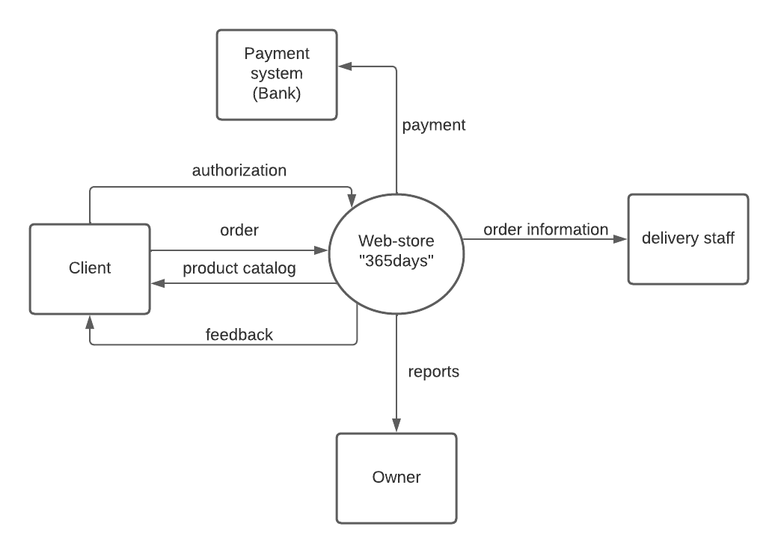
Figur 1 – Context diagram

