Often, we are assigned to a task that is full of ambiguity. As a student, we need to learn and adapt how to re-act in such scenario. After all, no one knows it all.

For the most part, it is “knowledge on–demand”. I know, we all keep too many cheat sheets for a particular task (scattered and outdated most of the time).

This is where Google/Bing/Baidu etc. come in. Why do you think each of the company worth so much?

Let’s learn some best practice from this video presentation:

<https://www.youtube.com/watch?v=R0DQfwc72PM>

Reflections:

* Do you have better tips/suggestions?
* …

Hands-On Practice Cases:

Please do an internet search on at least the following cases.

Case 1: <Your Often Search Terms> .pdf

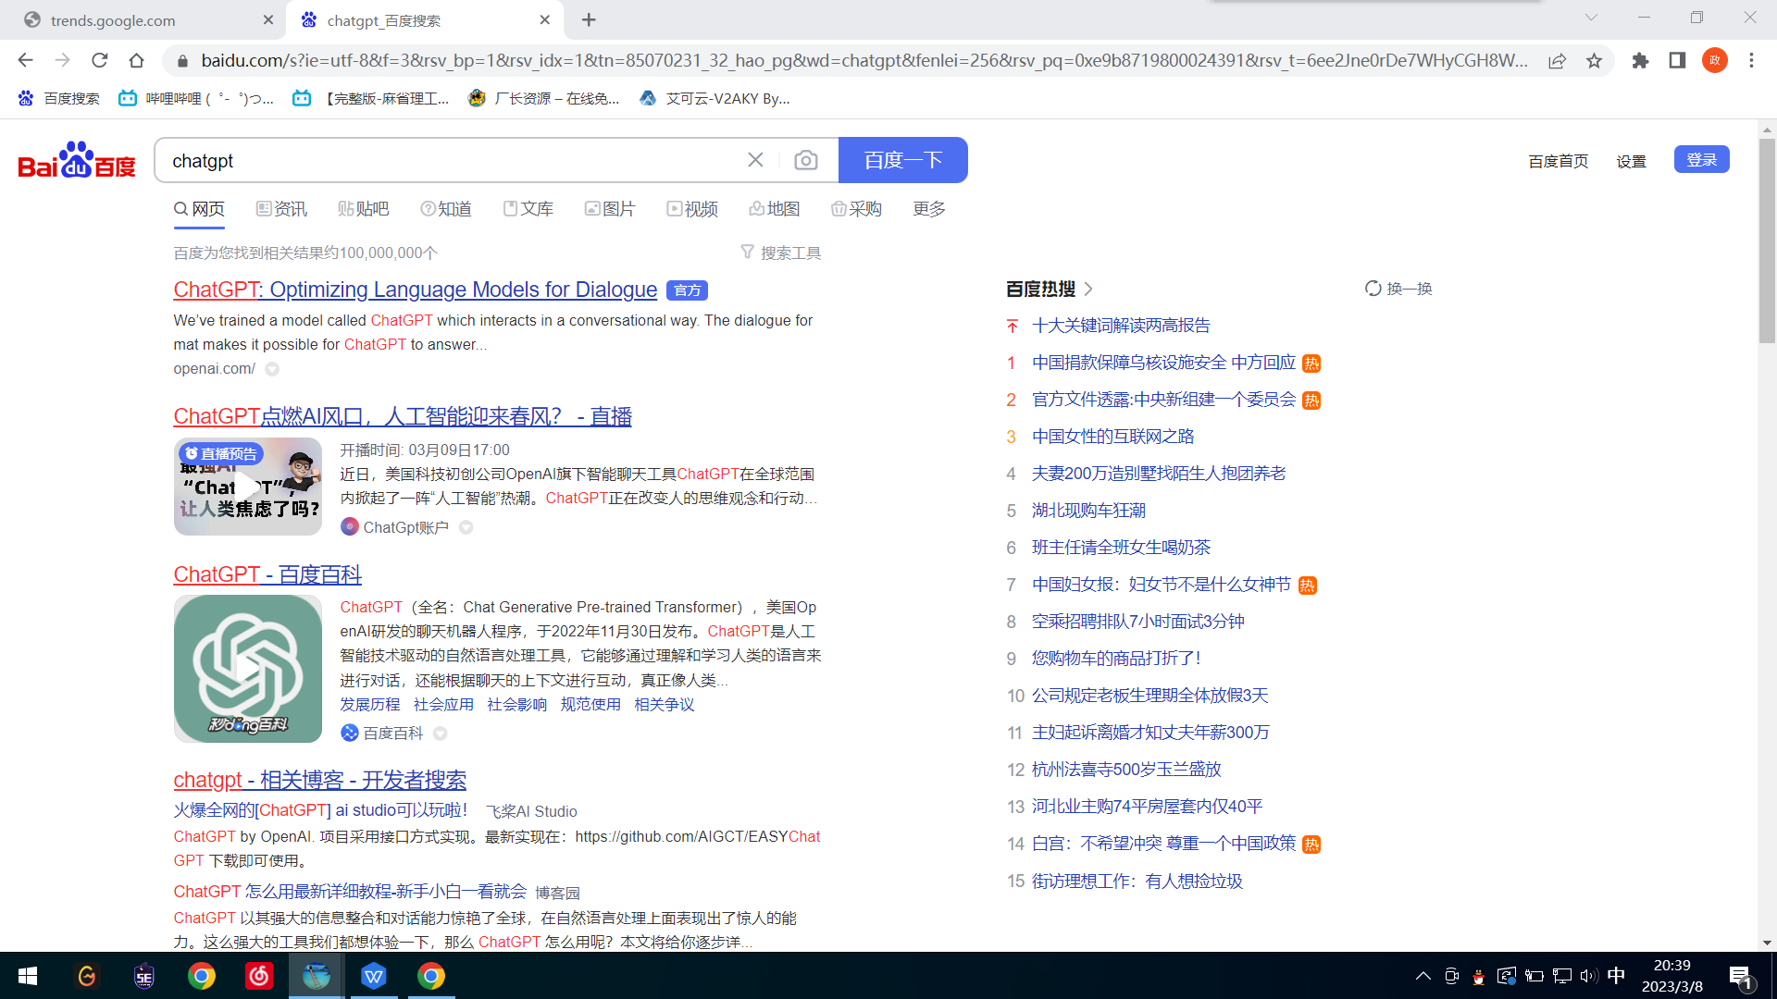

Case 2: “<Your Often Search Terms>”

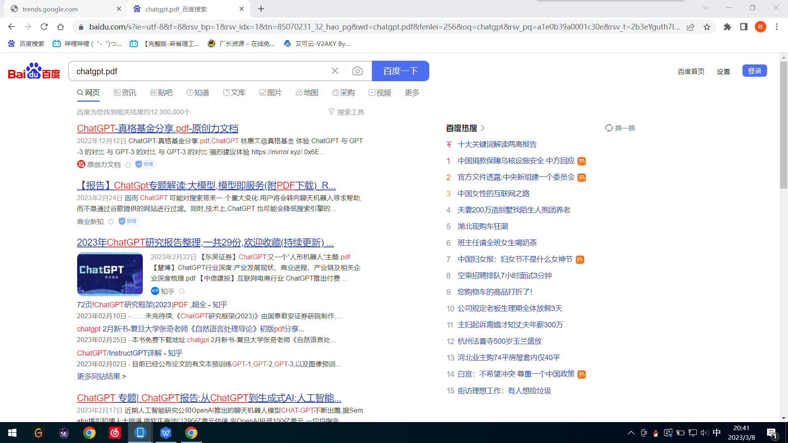

Case 3: <Your Often Search Terms> filetype:pdf

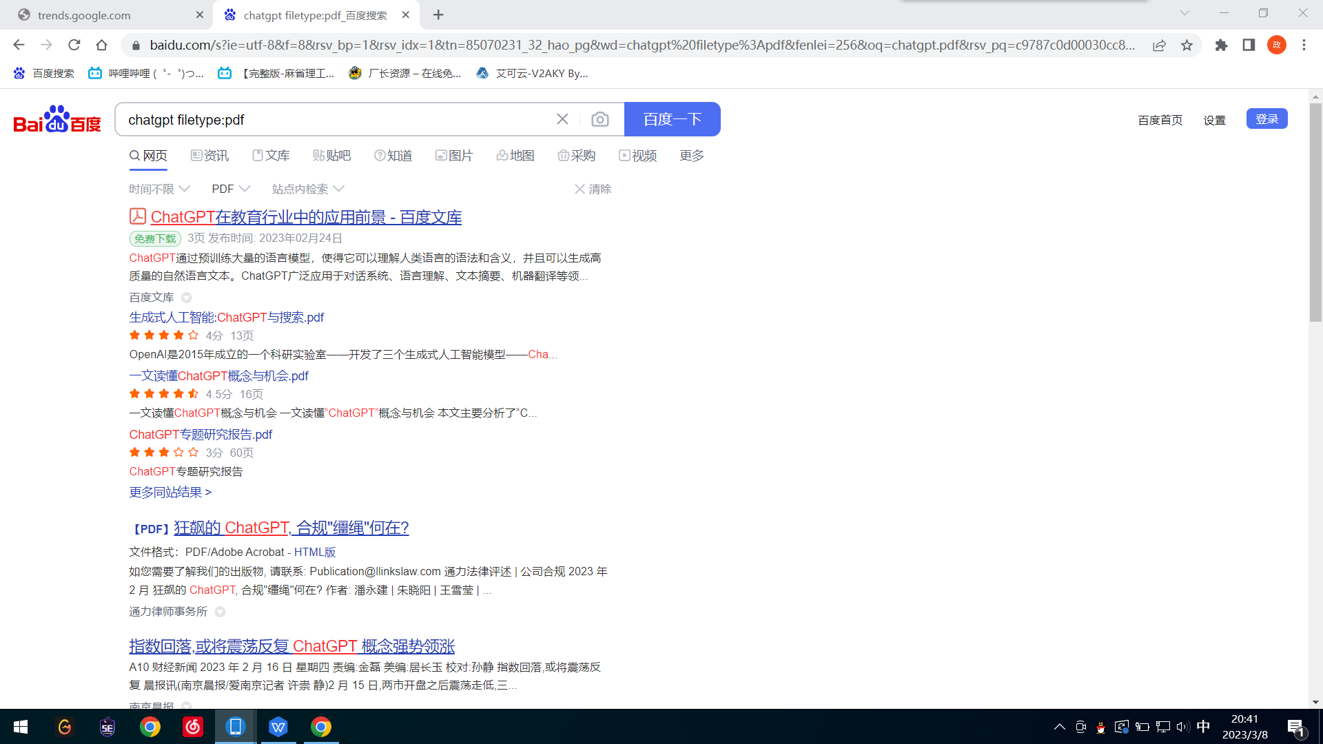

Case 4: <Your favorite photo search>

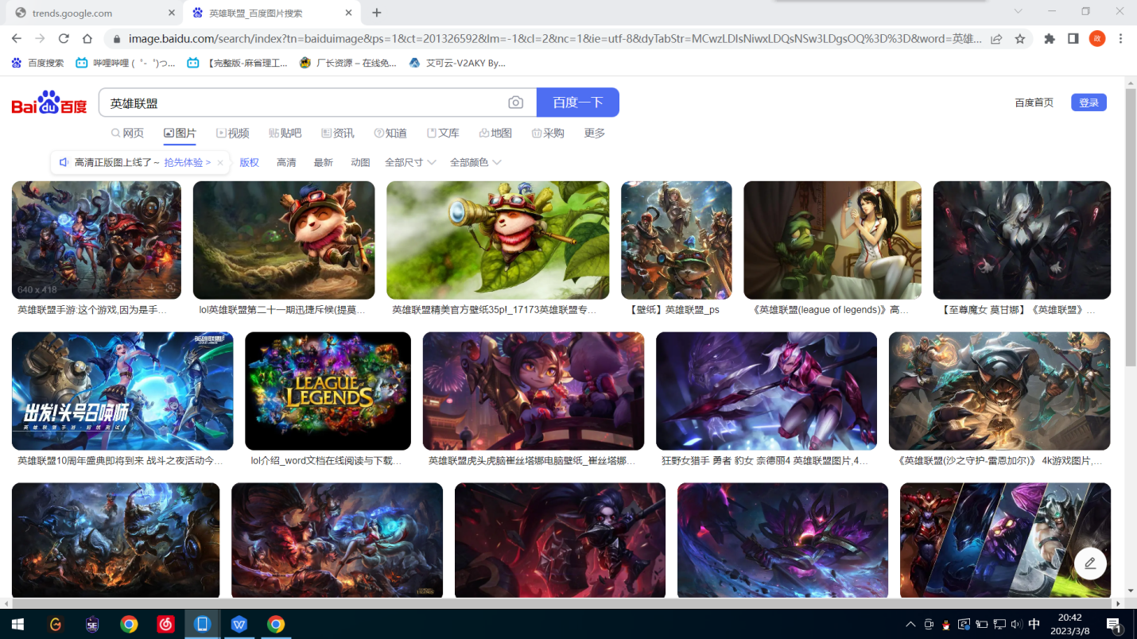

Execution Steps:

1. Per video presentation, which search tips you learn it for the 1st time, and which tips you know it already?
2. Open baidu.com and conduct the search as outline above.
3. Capture your session screen shots and pasted into this document.

Let’s explore this and share during class session. What are your observations and tips on searching for a general/specific topic?

Optimize search criteria

Search Logical Command

Exact match search

Special search command

(What is the world searching? I suggest this site: <https://trends.google.com/trends/?geo=US>)

Lab Results Submission:

Please submit your results to our course TA. The subject of the email should be: [Your StudentID, Assignment Subject]. e.g. [12345678, Lab_Internet_Search].