# Try It Yourself: Interpret a Histogram

## Excel Instructions

1. Open the countries.csv dataset in Excel.
2. Select the data.
3. Find the column header for gni_per_capita in Column N.
4. Select the data in Column N.
5. Insert a Histogram.
   1. With Column N highlighted, navigate to the Insert tab.
   2. Click on Insert Statistic Chart→Histogram.

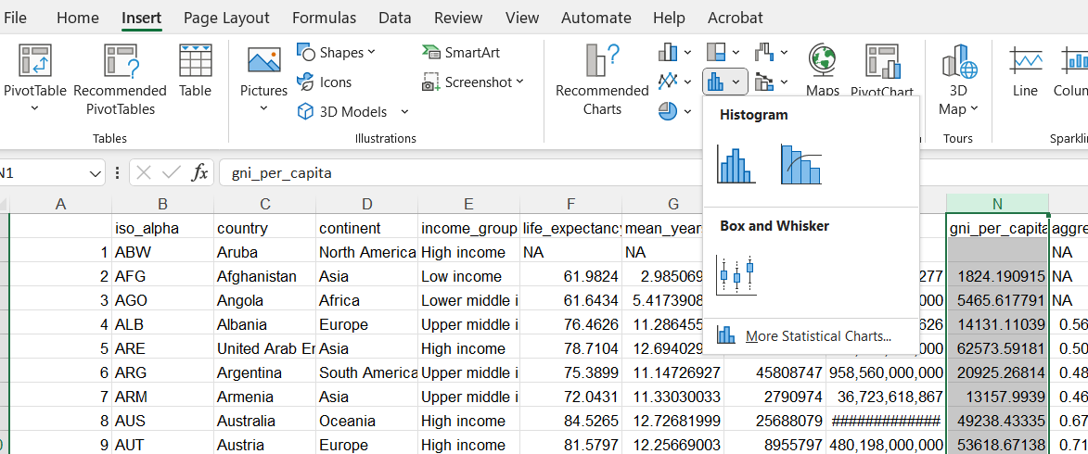

1. Adjust the histogram (optional).
   1. To adjust bin size, right click on the horizontal axis.
   2. Select Format Axis to modify bin width. Select “Bin width” and set it to 5000.
   3. Tick “Underflow bin” and set it to 5000.
   4. Add axis titles via Chart Design→Add Chart Element→Axis Titles.