**Pilger 10**

1. **Einrichten in eclispe**
   1. **Wildfly**

View Servers >

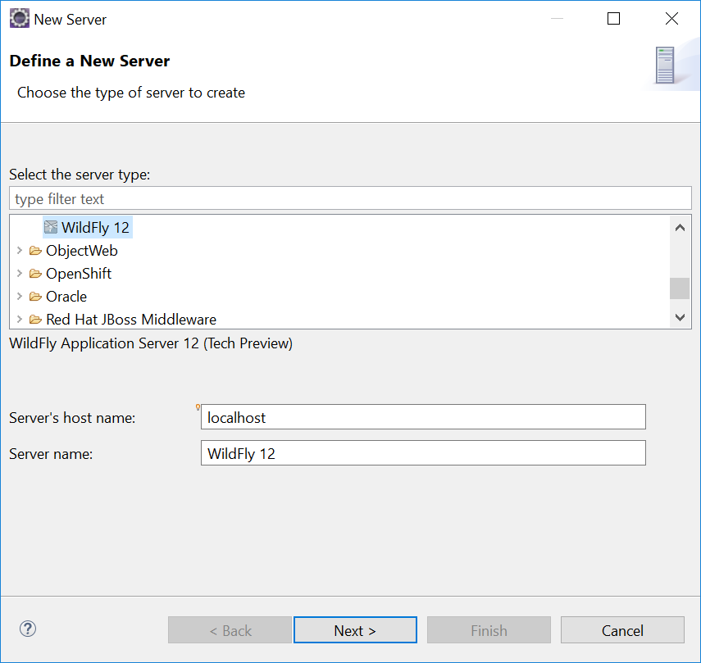

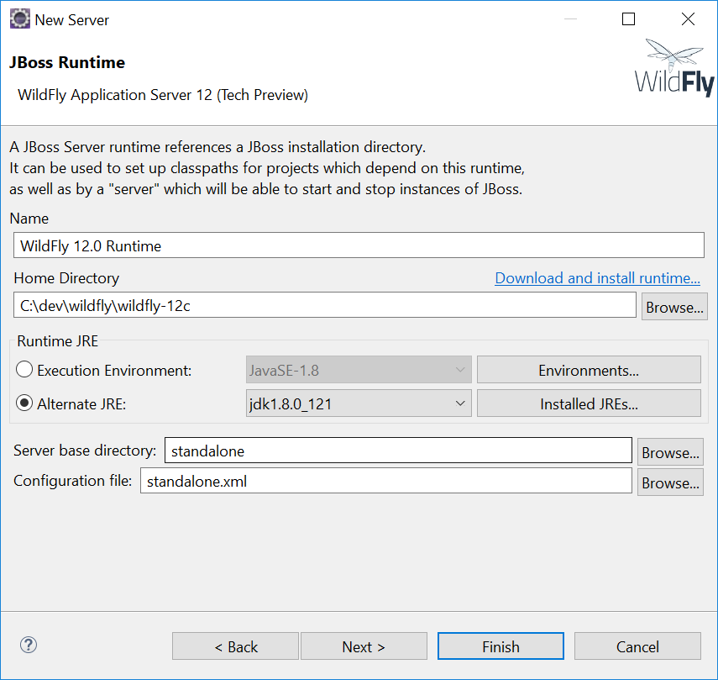

* 1. **Launch-Konfiguration**

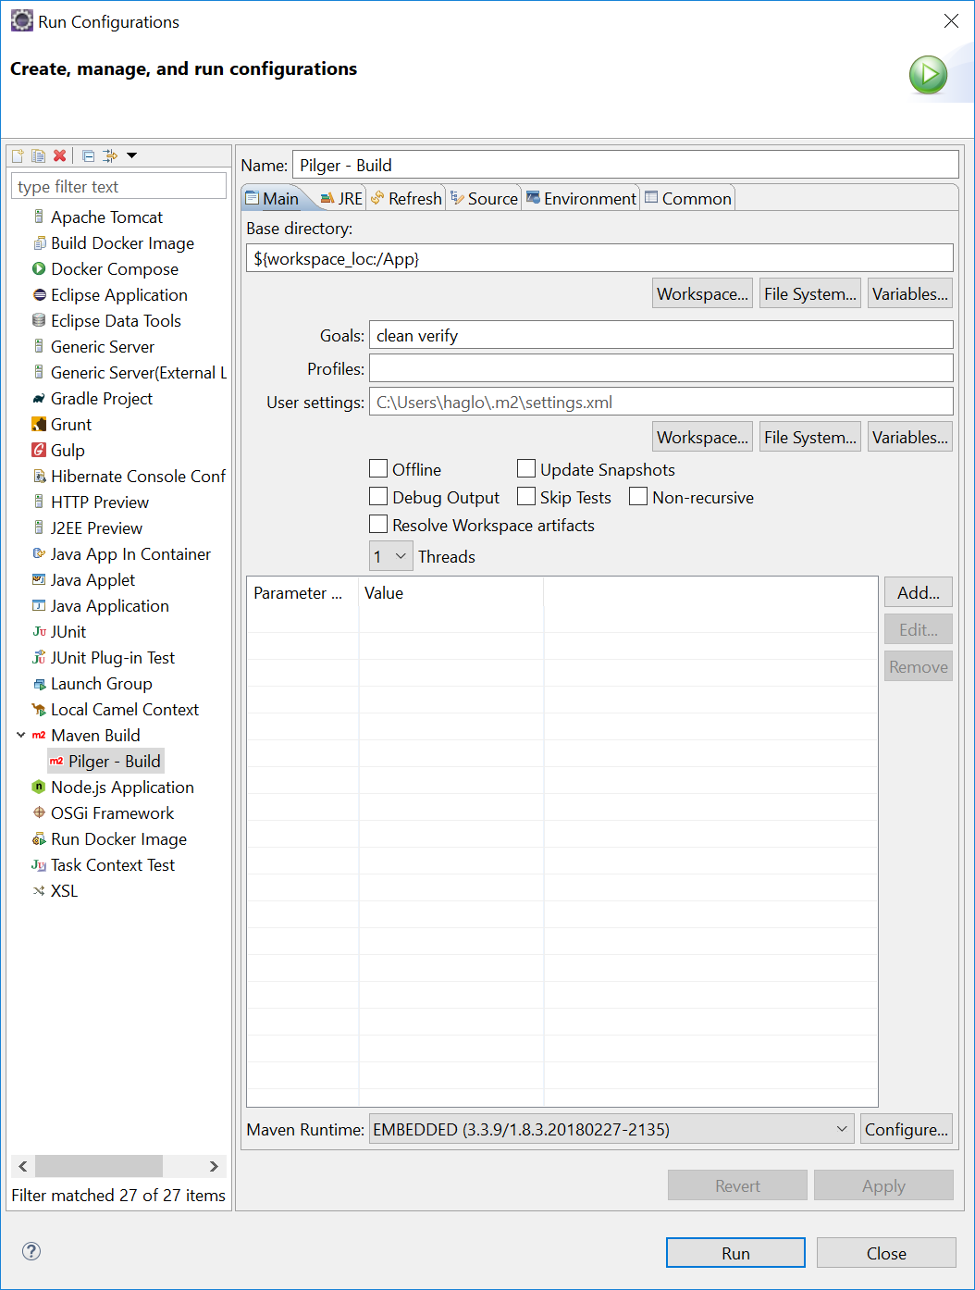

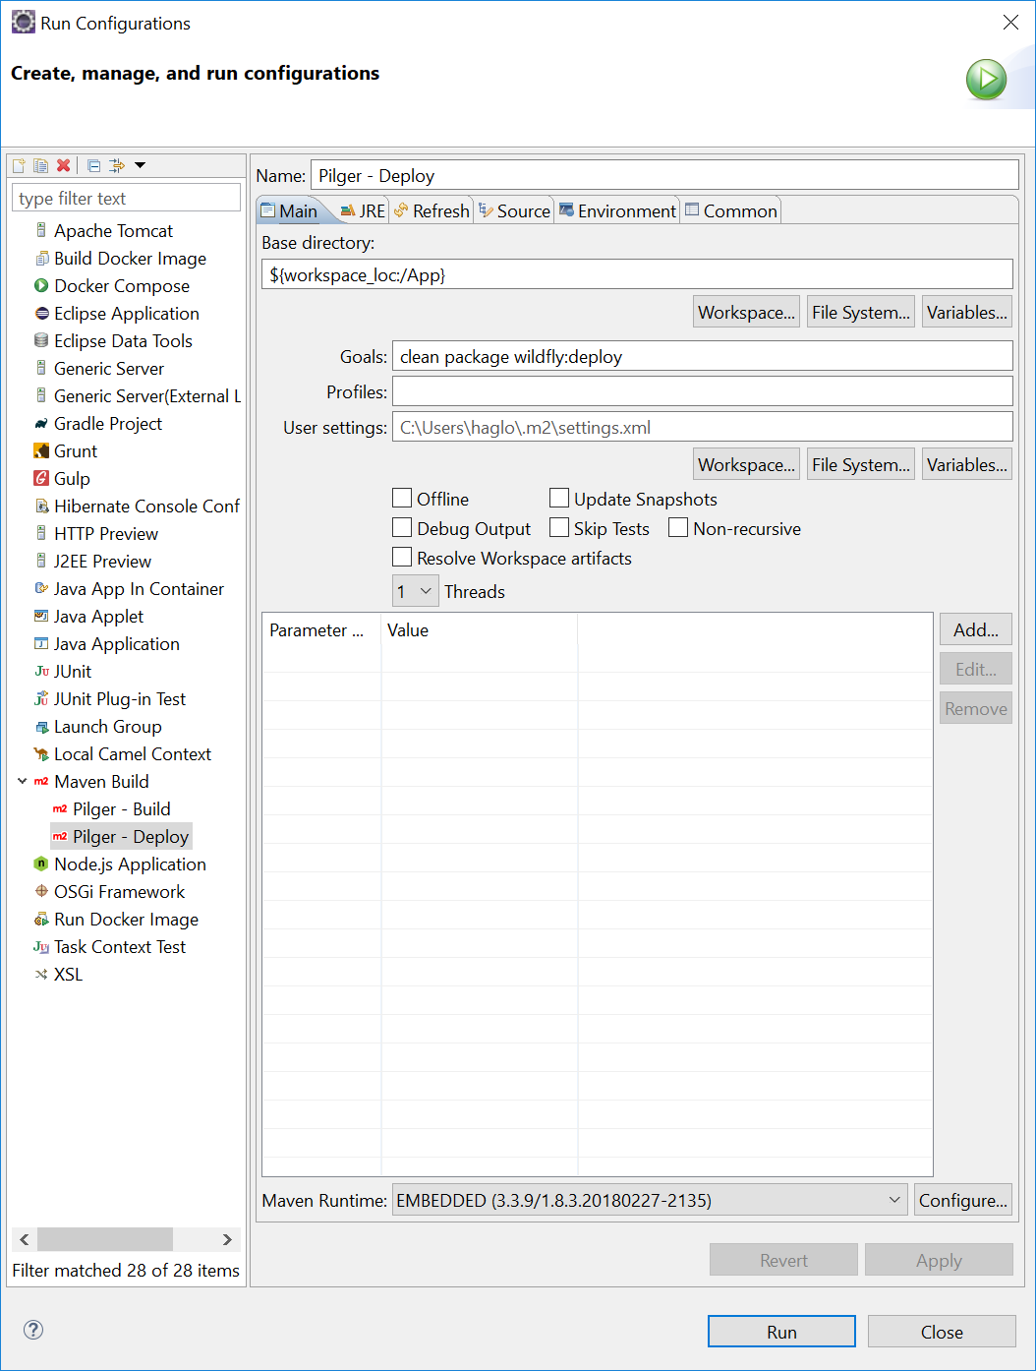

1. **Deployen**
2. Wildfly starten
3. Pilger – Build
4. Pilger – Deploy
5. http://localhost:8080/AppFrontend/