**Randomized Weather vs. Latitude Analysis**

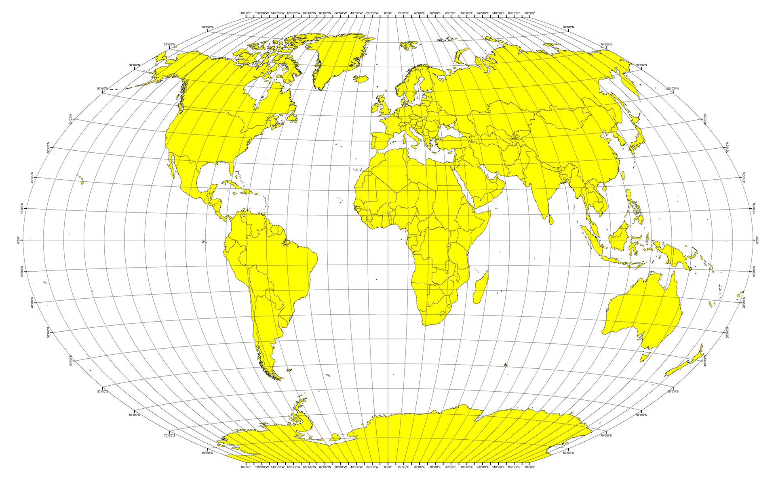

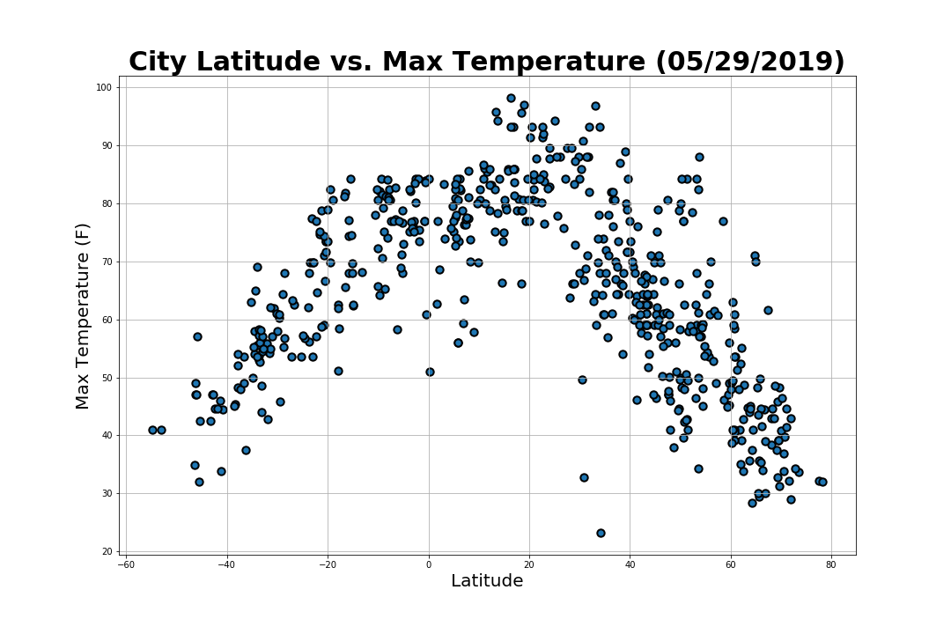

* Here, we can see a clear relationship between proximity to the equator and maximum temperature.
* It appears that the closer a city gets to the equator, the higher the max temperature gets.
* There is also a slight bias of cities above the equator (circa 20 degrees latitude) with a higher maximum temperature.
* Vice versa, the further a city gets form the equator, the lower the max temperature is.

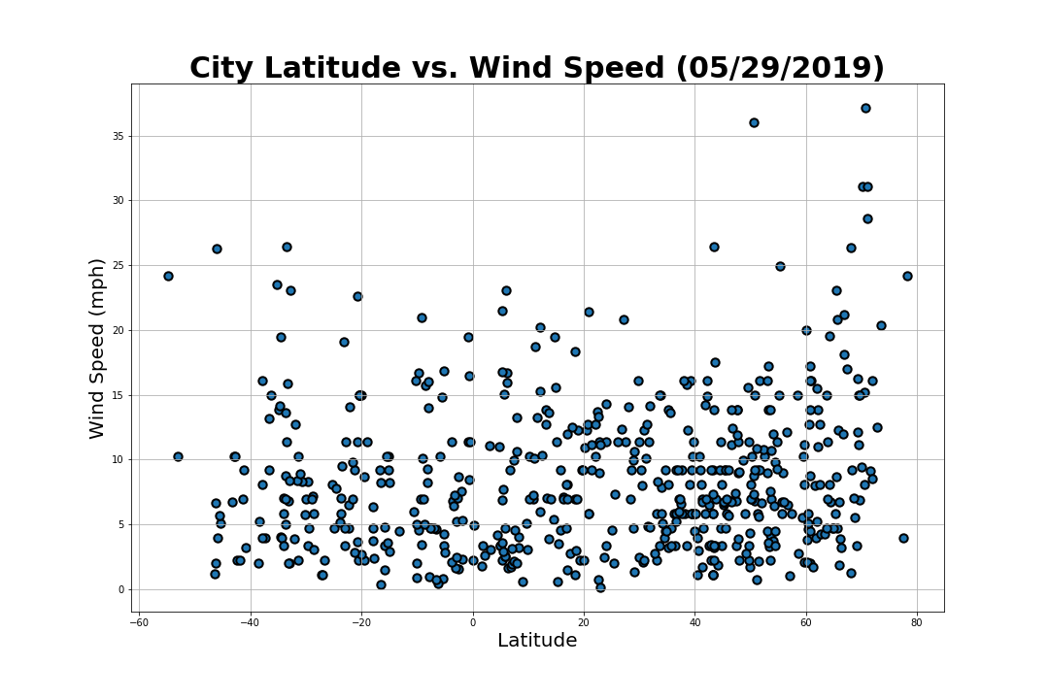

* There appears to be no strong relationship between city latitude and wind speed.
* It is noteworthy to mention, however, that the cities with the highest latitudes appear to have the biggest concentration outliers in terms of high wind speeds.

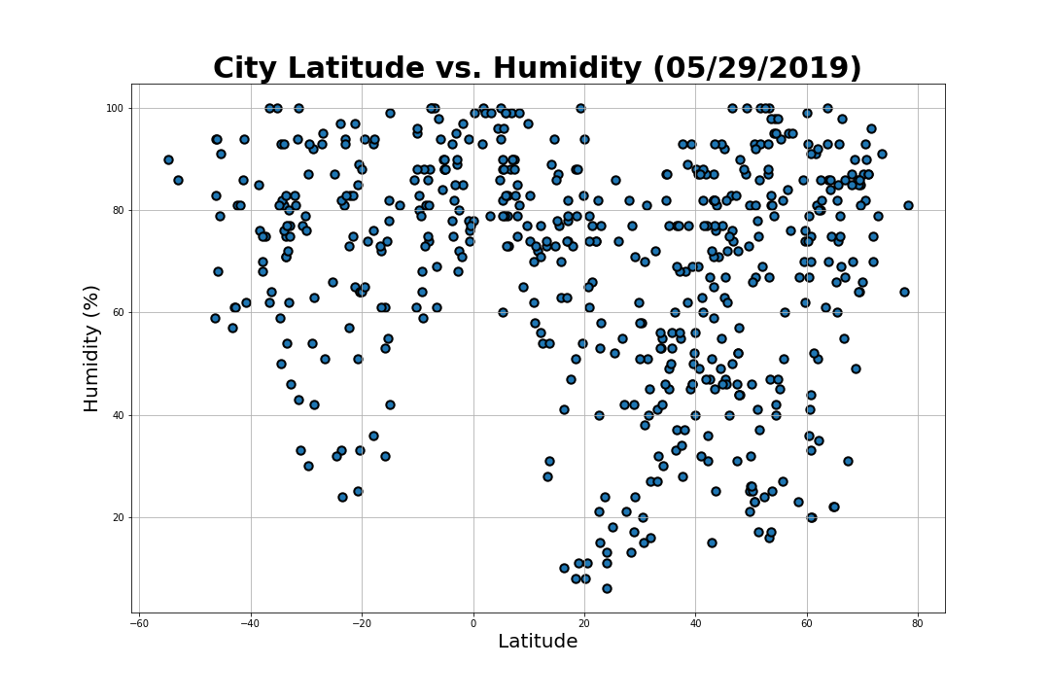

* With regard to city latitude vs humidity, there appears to be no strong relationship between the two factors.
* However, the cities with the lowest humidity percentages appear slightly to cluster around 20 degrees latitude.

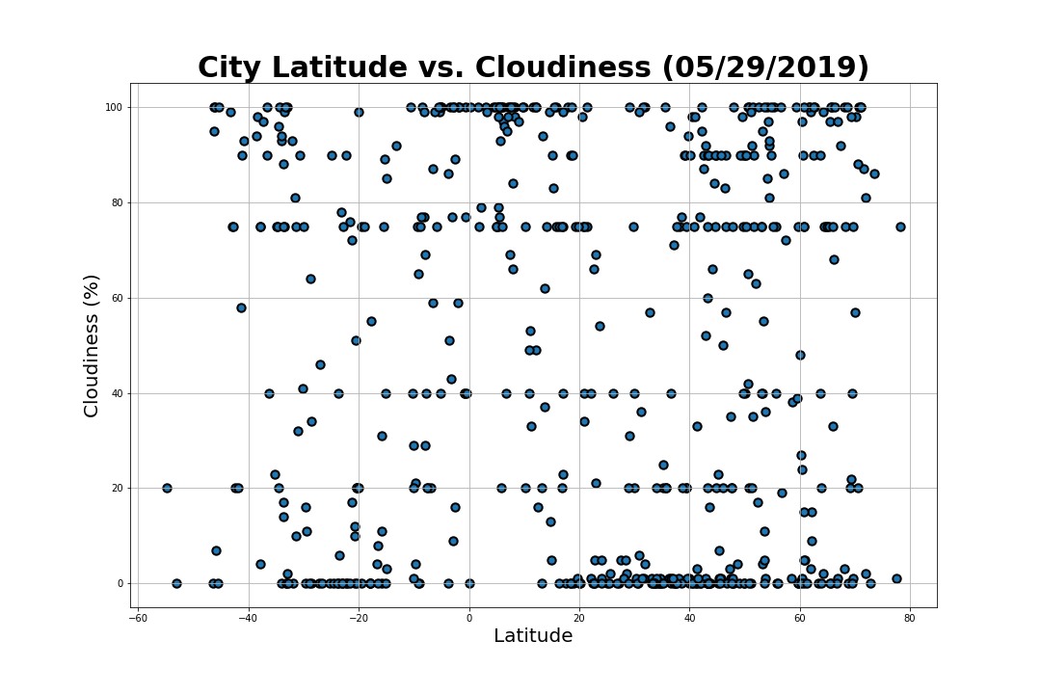

* Regarding city latitude vs. cloudiness, there appears to be no strong relationship between the two factors.
* There is, however, a noticeable distribution of cities with 0, 20, 40, ~75, and 100 percent cloudiness with the highest concentrations of the group being 0, ~75, and 100 percent cloudiness.
* This distribution appears to be independent of latitude.
* This could be due to human bias (i.e. bias toward round numbers) in the way they calculate the cloudiness percentages or just a natural phenomenon…

**Conclusions**

Given the overall data set, the only clear relationship between latitude and weather out of the four factors measured appear to be between latitude and max temperature. The closer a city is to the equator, the hotter, and the further away a city is from the equator, the colder. While there are some notable correlations in other factors of the data set, max temperature appears to be the most noteworthy argument for weather having strong correlations with latitude. For future considerations, it would be interesting to see how other weather factors relate to the latitude of a city.