**CSE-381: Systems 2**

**Exercise #8**

Max Points: 20

|  |
| --- |
| **Objective**: The objective of this exercise is to:   1. Review issues with passing references to local variables to threads    * Convert code to a multithreaded program that does not need synchronization 2. Understand the use of detached threads (a.k.a background threads)    * Understand the advantage of multithreaded web-server 3. Observe and fix race conditions in a multi-threaded program   **Submissions**:   1. This document saved as a PDF file and named muid.pdf (where muid is your unique ID, example: raodm.pdf) 2. The C++ program you modified as part of this exercise.   Fill in answers to all of the questions. For some of the questions you can simply copy-paste appropriate text from the terminal/output window into this document. You may discuss the questions with your instructor. |

|  |  |
| --- | --- |
| **Name:** | Ce Zhang |

|  |  |
| --- | --- |
| **☞** | **Wait for your instructor to cover the concept of background threads prior to proceeding with this exercise. The coverage will take about 15 minutes.** |

# Part #1: Incorrect to pass local variables to threads

*Estimated time: (4 × 5 minutes = 20 minutes)*

**Background**: In all programming languages, the scope (or lifetime) of local variables is limited – that is, once the scope ends, the local variable(s) are destroyed. Consequently, passing references to local variables to threads that operate beyond the scope of a local variable is incorrect and will cause program to abort with errors during runtime.

**Exercise**:

1. Study the spinUp method in the code fragment below. The spinUp method incorrectly passes reference to a local variable to threads:

|  |
| --- |
| using std::vector<std::thread> ThreadList;  **void** thrMain(**int** j, std::string &s) {  std::this_thread::sleep_for(2s); // Sleep 2 seconds  s.append("result " + std::to_string(j)); // Use reference  }  **void** spinUp() {  ThreadList thrList;  **for** (**int** i = 0; (i < 10); i++) {  std::string result = "";  thrList.push_back(std::thread(thrMain, i, **std::ref(result)**));  }  **for** (auto &t : thrList) {  t.join();  }  } |

In the space below, briefly describe (in your own words) why the spinUp method will not work correctly -- **ensure you highlight the difference between the 2 arguments passed to thrMain method**:

|  |
| --- |
| Two argument are passed by the thrmain method, and first is pass by value which is ok, but second one is passed by reference which will cause the conflict in the end of for loop. |

1. The source code below illustrates the minimal change (it is 1 line code change) to spinUp method that would enable passing a valid reference.

|  |
| --- |
| **void** spinUp() {  ThreadList thrList;  std::string result = "";  **for** (**int** i = 0; (i < 10); i++) {  thrList.push_back(std::thread(thrMain, std::ref(result)));  }  **for** (auto &t : thrList) {  t.join();  }  } |

In the space below, briefly describe (in your own words) how the above change to the spinUp method resolves the issue with invalid reference:

|  |
| --- |
| In this version, the result is determined out of for loop, to sum up, the scope of result is now the duration of sign up method waits for all thread to finish. The result variable will always remain. |

1. The revised version of spinUp method above suffers from a race condition. Briefly describe the race condition in the space below:

|  |
| --- |
| In this version, all threads get reference to the same result object and all thread will try to modify the same object which cause a race condition. |

1. To fix the source of race condition, revise the thrMain method by using a mutex. Show a revised version of the thrMain method that addresses the race condition (hint: use a std::mutex and a std::lock_guard) below:

|  |
| --- |
| **void** thrMain(**int** j, std::string &s) {    } |

# Part #2: Multithreading a web-server using detached threads

*Estimated time: 30 minutes*

**Background**: Web-servers often use multiple threads to process requests from users. Moreover, most web-browsers count on multithreaded servers to often use multiple concurrent connections to obtain data.

In a web-server, typically, no synchronization is required when processing multiple requests. Each request can take a varying amount of time to complete and hence, waiting (via join) to requests to complete is not efficient. The combination of the aforementioned two characteristics of this application makes it a good candidate for using detached threads (*a.k.a* background threads).

**Exercise**: Convert the supplied starter code for this exercise to operate using multiple threads via the following procedure:

1. Create a Miami University C++ Project in NetBeans called exercise8 on the Linux server used for this course. Download and scp the supplied exercise8_start_code.zip file to the NetBeans project directory for your exercise on the Linux server.
2. The supplied zip file contains several files for use by the web-server. From a terminal (doing it in a NetBeans terminal would make your life easier), unzip the files on the Linux server (the Zip file should be in your NetBeans project directory) as shown below:

|  |
| --- |
| $ cd ~/NetBeansProjects/exercise8  $ unzip exercise8_starter_code.zip |

1. Now add the starter code exercise8.cpp to your NetBeans project. This is essentially the solution to homework #5 with extension to also stream files, in addition to running programs. You can study this starter code in more detail later on.
2. Compile the starter code in NetBeans. It should compile fine if you have your project setup correctly.
3. Run the starter code from NetBeans. It will print the port number where the server is listening for connections.
4. In a Chrome web-browser on your local computer, open the Network tab in Developer tools (click on: BrowserMenu→More Tools→Developer Tools→Network). The Network tab enables you to observe interaction between a web-browser and your server.
5. In your web-browser access the following URL (you will need to change your port number appropriately) to observe the requests from your browser:

|  |
| --- |
| http://os1.csi.miamioh.edu:**4000**/cmd_list.html |

1. Copy-paste a screenshot of your browser’s Network tab below (replacing the sample image):

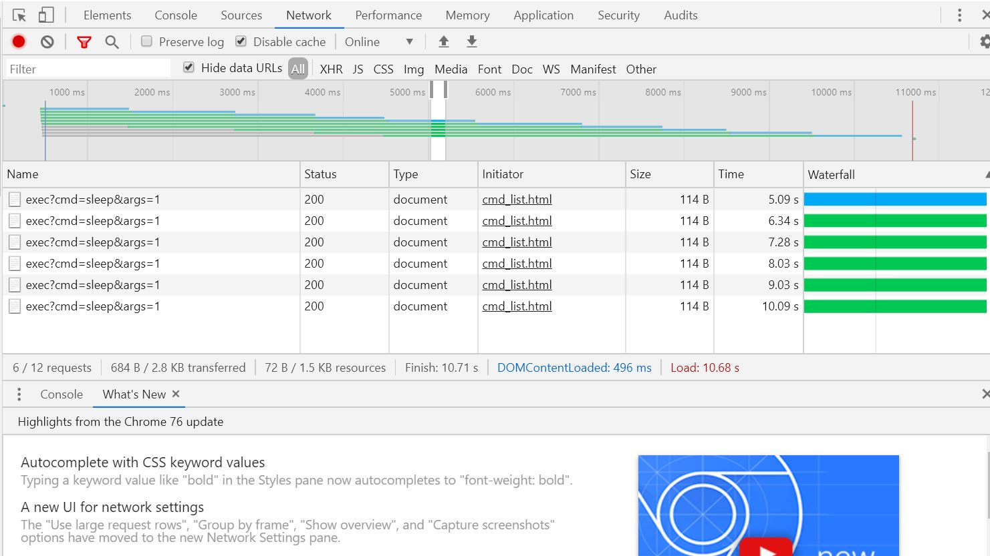

1. Using the information in the Network tab, indicate how much time took to "load" the page:

|  |
| --- |
| Time taken to Load the page (at bottom of Network tab):10.68s |

1. You will note that the web page takes about 10 seconds to load. Why do you think the web-page takes 10 seconds to load all of its contents?

|  |
| --- |
| The cmd_list.html has 10 invocations of one command that are run serially. Given 10 commands are running about 10s, and every one use about 1 second. |

1. A 10 second loading time is an eternity on the Internet these days. So, let us try to see how to use threads to make the site load faster. Using the example of detached threads from lecture slides, modify the runServer method to process each connection using a separate thread.

**Note**: Ensure you use std:shared_ptr and std::make_shared as shown in the lecture slides. Importantly, **ensure you understand why the use of local variable in client in the lecture slides does not cause a bad reference or a race condition**.

1. Once you have done some basic tests to ensure your server is operating correctly, revisit the following URL while recording requests in Chrome browser's Network tab (you have to press Shift while reloading the page to correctly reload the page):

|  |
| --- |
| http://os1.csi.miamioh.edu:**4000**/cmd_list.html |

1. Place a screenshot of the Network traffic in the tab below replacing the screenshot below:

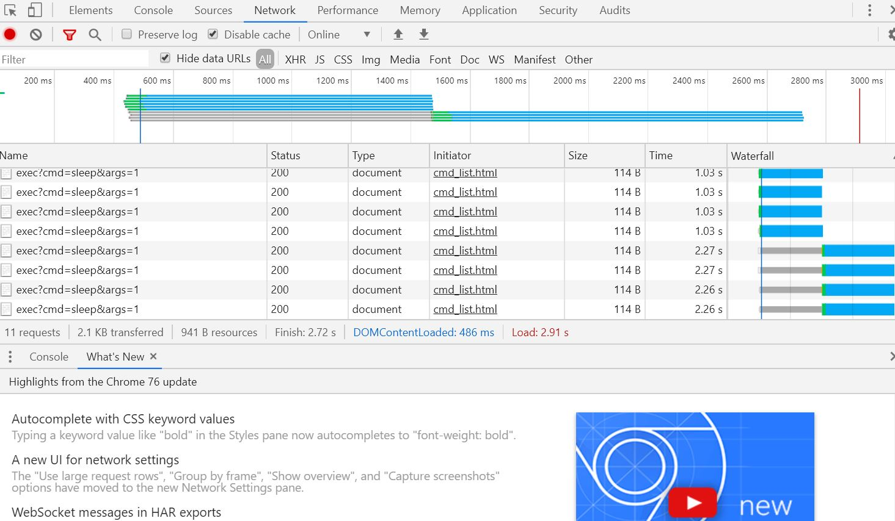

1. Using the information in the Network tab, indicate how much time took to "load" the page:

|  |  |
| --- | --- |
| Time taken to Load the page **with multiple threads**: | 2.91 s |

1. Using the information from step #8, briefly discuss the decrease in load time. Also mention how many concurrent threads do you think the browser used.

|  |
| --- |
| With multiple threads the load time decreased to 2.91seconds: a lot of time decrease. Itis because the web-browser used 6 concurrent requests that in the same process threads. |

# Part #3: Understanding capabilities of the web-server

*Estimated time: 15 minutes*

**Background**: The web-server developed in this exercise is versatile and can operate as a general-purpose web-server -- that is, it can be used to run any script (say, PHP, Python) or programs in other languages (Java) that use standard I/O. In fact, this is how almost all PHP and Python scripts are run by web-servers.

|  |  |
| --- | --- |
|  | It is important that you understand and appreciate the capabilities and sophistication that is already present in the programs you have created as part of this course. |

**Exercise:** Explore the capabilities of your web-server via the following procedure:

1. The starter code (zip file) already includes some files for testing.
2. Ensure your web-server is running. In your web-browser access the following URL (you will need to change your port number appropriately):

|  |
| --- |
| http://os1.csi.miamioh.edu:**4000**/exec.html |

1. Note how the web-server returned the contents of the file! This is a feature that has been added to the exercise8.cpp file supplied to you.
2. 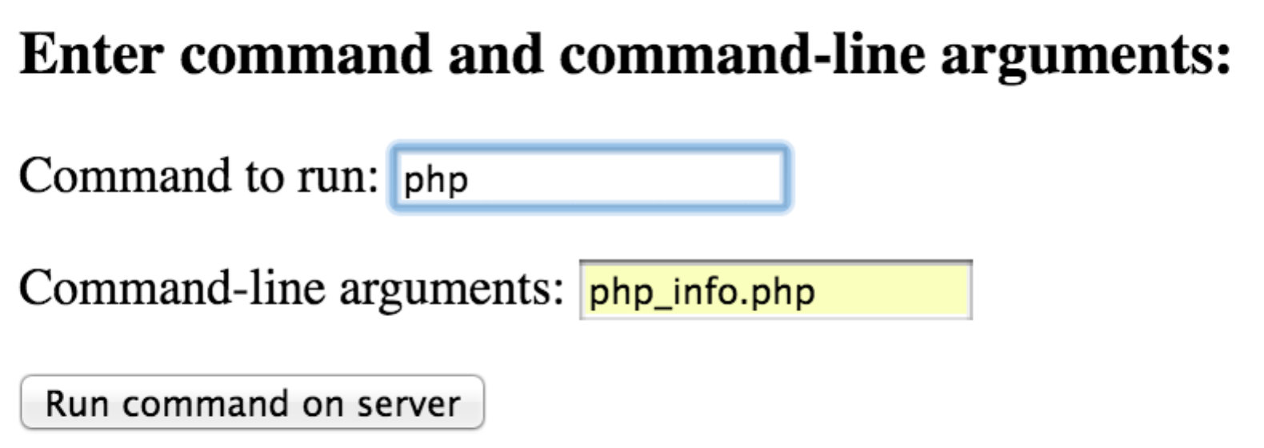In the web-form, use the command php and parameter php_info.php as shown in the adjacent image to have your web-server to use php program to run the php_info.php script. Your web-server will run the php program (it could run any php script for that matter, including Laravel applications) and show you the results.
3. Similarly, using the web-form, run the Java program using the following two steps:
   1. Compile the Java program using command & argument: javac java_test.java
   2. Run the Java program via command & argument: java java_test
4. Similarly, using the web-form, run a Python program using the following two steps:
   1. Run the Java program via command & argument: python intro.py
5. Building on the above experience, briefly (3 sentences) describe how you could use the web-server to serve as a "remote Linux terminal" (similar to a standard Linux terminal where the user can type 1-line command at the $ prompt)

|  |
| --- |
| The web-server is really good in that it can already execute any command. It can be easily converted to operate very similar to a Linux terminal by: one command line to the two separate input.it can be one command line which is like linux. And it can modify the server to process. |

# Part #4: Submit files

*Estimated time: < 5 minutes*

1. This document saved as a PDF file and named muid.pdf (where muid is your unique ID, example: raodm.pdf)
2. The C++ program you modified as part of this exercise.

Upload each file individually to Canvas. Do not upload archive files such as zip/7zip/rar/tar/gz etc. Ensure you click the Submit button on Canvas once you have uploaded all the necessary files.

# Part #5: Optional Part – Code Review

*Estimated time: 10 minutes*

Review the file processing features in exercise8.cpp while paying attention to the following methods:

1. Review the getMimeType method. This method returns a MIME type based on a file’s extension. You should be able to explain what MIME type is by now (of course, MIME types were covered in CSE-278 as well).
2. Next review the sendData method to see how it reads and streams contents of a given input stream is. This method is used to stream data from files and processes.
3. See how sendData method is used in the program in the following three cases:
   1. To send output from a process in the exec method. Review the exec method. Copy-paste the call to sendData method from exec method below:

|  |
| --- |
|  |

* 1. Review the send404 method that sends an HTTP error response back to the client. Copy-paste the call to sendData method from send404 method below:

|  |
| --- |
|  |

* 1. Next, review the serveClient method that process a client request. Copy-paste the call to sendData method from serveClient method below:

|  |
| --- |
|  |