Pre-requisite
The ArchiMate assessment is applicable to all practicing and aspiring architects within the STS practice.
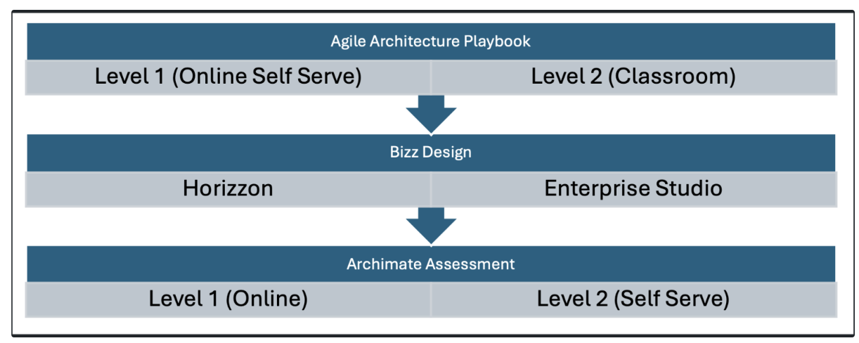

Assessment Scope
The assessment will focus on three key areas - Understand, Analyse and Apply. It will consist of following key areas of ArchiMate:

- Core Concepts
  - ArchiMate layers - Business, Application, Technology
  - Element Types - Active, Behaviour and Passive
  - Relationships - Structural, Dependency, Dynamic and specialisation
  - Viewpoint and modelling structure

- Extended Concepts
  - Extended layers - Motivation, Strategy, Implementation & Migration
  - Cross-layer dependencies
    - Alignment of business and lower layers
    - Alignment of application and technology layers
  - Relationships to other standards - TOGAF, EASE, UML

- Practical Modelling Skills
  - Create layered views using correct element types.
  - Mapping inter-layer dependencies (e.g. business service to application component)
  - Apply correct notation and relationship types
  - Visual clarity and consistency
  - Completeness of views

Assessment Format
The assessment will be two-step:

Stage 1: Multiple Choice Questions
The objective of this test is to assess theoretical understanding of the ArchiMate modelling language, structure and core concepts.
Duration - 45 minutes
Tool: MS Forms
There will be 43 questions focussing on understand and analyse areas.
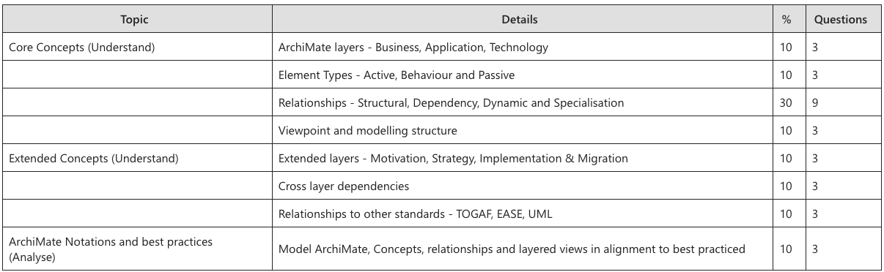

Stage 2 - Case Study based modelling task
The objective is to analyse candidates' ability to apply ArchiMate to model a real-world business scenario and recommend architecture using appropriate views for a target stakeholder.

Duration: Full day assessment.
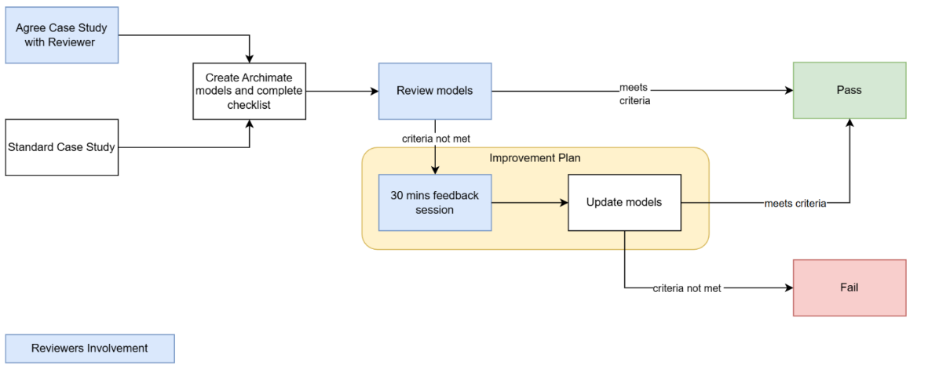

Example repo

https://github.com/ThomasRohde/archi-online

