# radsecproxy Configuration for the OpenRoaming

Rev. 20230520

## Introduction

This document explains the minimum configuration of radsecproxy for setting up a RadSec endpoint of the WBA OpenRoaming. This document aims to help operators obtain the first working environment but is not intended for providing official recommendations.

The following configuration examples assume to use v1.9.3 which is the latest as of this writing. The source package is available at <https://radsecproxy.github.io/> .

The Open Source Software (OSS) version of radsecproxy can be used to add RadSec transport and Dynamic Peer Discovery (DPD) features to existing RADIUS IdP/proxy software. In this document, we assume the network configuration shown in Fig.1. For simplicity, we assume that both radsecproxy and the RADIUS server are running on the same host.

Throughout the document, the locations of the configuration files are relative to the configuration directory of radsecproxy unless otherwise mentioned. It would be convenient to put all configuration files in /etc/radsecproxy or create a symbolic link to the ./etc directory at the radsecproxy installation path.

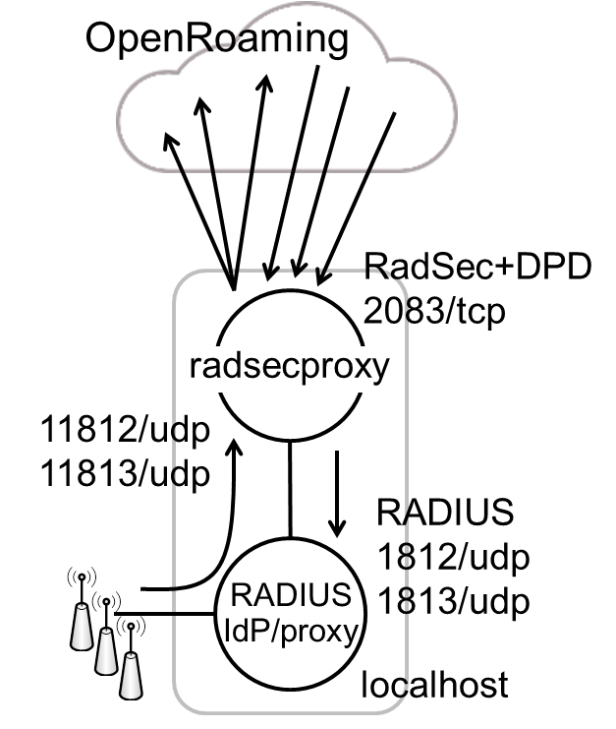

Fig.1 Using radsecproxy as a RadSec gateway for existing RADIUS IdP/proxy.

**See also:** [1] “PKI RadSec End Entity Deployment Guidelines” (WBA Members Only)

## Obtaining an OpenRoaming endpoint certificate and CA/I-CA certificates

Each operator directly connecting to the OpenRoaming network needs to receive an endpoint certificate package from a certificate issuer, i.e. a WBA agent or a broker. The package contains the following certificates.

1. A server (IdP) certificate, a client (ANP) certificate, or a combined (IdP+ANP) certificate.
2. Root CA certificate, normally named as WBA_OpenRoaming_Root.pem .
3. All I-CA (Intermediate CA) certificates, normally the issuer’s I-CA certificate and the policy certificate named as WBA_Policy_CA.pem .

These certificates should be in text format. In addition, the operator should retain the key file which was generated during the CSR creation [1] and its passphrase.

Suppose an operator “example.com” receives a certificate named as example.com.cer, which is a text file. The contents can be seen by a command line as follows.

$ openssl x509 -noout -text -in example.com.cer

A new certificate chain file can be created by simply concatenating the operator’s certificate and the I-CA certificates.

$ cat example.com.cer WBA_Issuing_CA.pem WBA_Policy_CA.pem > cert-chain.pem

The content of the file looks like:

-----BEGIN CERTIFICATE-----

<operator’s certificate>

-----END CERTIFICATE-----

-----BEGIN CERTIFICATE-----

<I-CA certificate WBA_Issuing_CA.pem>

-----END CERTIFICATE-----

-----BEGIN CERTIFICATE-----

<I-CA certificate WBA_Policy_CA.pem>

-----END CERTIFICATE-----

We assume that all certificate files and the key file are stored in the radsecproxy configuration directory, e.g., /etc/radsecproxy .

Note, if the certificate and chain have been issued using WBA’s Agent API, the responses may have been delivered to you using a JSON format. This means that the certificate and chain need to be reformatted back to a multi-line text format. Assuming your json certificate is in a file named “cert-json.pem”, this can be achieved using the awk command:

$ awk '{gsub(/\\n/,"\n")}1' cert-json.pem > cert-text.pem

## Configuring radsecproxy as OpenRoaming IdP (server) gateway

The only configuration file to be edited is radsecproxy.conf. By using the following configuration example, all requests from external OpenRoaming clients (ANPs) will be forwarded to the local RADIUS server which is listening on the standard ports 1812/udp (auth) and 1813/udp (acct).

ListenTLS *:2083

ListenUDP *:11812 # This UDP port is for local testing purposes only.

LogThreadId on

LogLevel 3

tls OR-certs {

CACertificateFile /etc/radsecproxy/WBA_OpenRoaming_Root.pem

CertificateFile /etc/radsecproxy/cert-chain.pem

CertificateKeyFile /etc/radsecproxy/<keyfile.key>

CertificateKeyPassword <passphrase>

TLSVersion TLS1_2: # Don’t miss the last colon (:).

}

client 0.0.0.0/0 {

type tls

tls OR-certs

secret radsec

CertificateNameCheck off

}

client [::]/0 {

type tls

tls OR-certs

secret radsec

CertificateNameCheck off

}

# This client block is for local testing only and may be removed on a production system.

client 127.0.0.1/32 {

type udp

secret testing123 # Adjust it to the local RADIUS server setting.

}

server localproxy {

type udp

host localhost

secret testing123 # Adjust it to the local RADIUS server setting.

statusServer on # Turn it on if RADIUS server supports it.

}

server localproxy-acct {

type udp

host localhost

port 1813

secret testing123 # Adjust it to the local RADIUS server setting.

statusServer on # Turn it on if RADIUS server supports it.

}

realm /@.*\.example\.com$/ { # Fix the regex accordingly to catch all your realms here.

server localproxy

accountingServer localproxy-acct

accountingResponse on

}

CertificateKeyPassword line can be omitted if the key file was generated without passphrase.

To test the functionality locally, try the following on the same host, using a test ID/PW pair.

$ radtest testID@example.com testPW localhost:11812 1 testing123

In addition, check that the TLS is configured correctly by using the openssl s_client command as follows from an external host.

$ openssl s_client -showcerts <ip address of FreeRADIUS server>:2083

Once the above tests have been successful, i.e., you have received Access-Accept, you may ask an ANP outside your own network to test the authentication over the RadSec transport. Alternatively, you may set up your own ANP on an external network for testing.

Note: Some RadSec products, e.g. Cisco Spaces Connector, require EAP and may block non-EAP communication. Please see also eaopl_test command for tests using EAP.

## Configuring radsecproxy as OpenRoaming ANP (client) gateway

The only configuration files to be edited are radsecproxy.conf and a new file naptr-openroaming.sh. By using the following configuration example, all requests from the local RADIUS proxy will be forwarded to external OpenRoaming servers (IdPs). Since the local RADIUS server is using the standard ports 1812/udp (auth) and 1813/udp (acct), shifted ports 11812/udp and 11813/udp are used in this example. The local RADIUS server needs to be configured accordingly.

[radsecproxy.conf]

ListenUDP *:11812

ListenUDP *:11813

LogThreadId on

LogLevel 3

tls OR-certs {

CACertificateFile /etc/radsecproxy/WBA_OpenRoaming_Root.pem

CertificateFile /etc/radsecproxy/cert-chain.pem

CertificateKeyFile /etc/radsecproxy/<keyfile.key>

CertificateKeyPassword <passphrase>

TLSVersion TLS1_2: # Don’t miss the last colon (:).

}

client 127.0.0.1/32 {

type udp

secret testing123 # Adjust it to the local RADIUS server setting.

}

server OR-dynamic {

type tls

tls OR-certs

secret radsec

certificateNameCheck off

dynamicLookupCommand /etc/radsecproxy/naptr-openroaming.sh

}

realm /@.+\..+$/ { # This realm block must be placed at the end if others exist.

server OR-dynamic

accountingServer OR-dynamic

accountingResponse on

}

CertificateKeyPassword line can be omitted if the key file was generated without passphrase.

New script file for the dynamic lookup, named naptr-openroaming.sh, can be created based on the example script for eduroam, tools/naptr-eduroam.sh, included in the radsecproxy source tree. The easiest way is to replace all “x-eduroam:radius.tls” with “aaa+auth:radius.tls.tcp”.

Please see also <https://github.com/wireless-broadband-alliance/openroaming-config> and “Pull requests”.

## Consideration on separating the IdP and ANP radsecproxy

Some operators may adopt the OpenRoaming settled model or work as an ANP for non-OpenRoaming operators. If this is the case, care must be taken in the proxy configurations.

It is recommended to separate inbound and outbound proxies by running two radsecproxy instances. If the proxies were combined, inbound requests would be transferred to other operators, allowing another operator to gain false authorization without a bilateral roaming agreement, intentionally or by mistake.

The secondary radsecproxy can be run as shown below.

# radsecproxy -c /etc/radsecproxy2.conf -i /var/run/radsecproxy2.pid

## Firewall configuration (informational)

Because there are many RadSec clients doing the DPD on the OpenRoaming network, the source addresses of these clients cannot be determined beforehand.

The RadSec endpoint of the OpenRoaming ANP needs to have port 2083/tcp open to any hosts.

For your information, if firewalld is used on a Linux distribution, the configuration file /etc/firewalld/zones/public.xml would need an additional rule:

<rule family="ipv4">

<source address="0.0.0.0/0"/>

<port port="2083" protocol="tcp"/>

<accept/>

</rule>

On Ubuntu use the command:

$ sudo ufw allow 2083

Rev. 20200817 Hideaki Goto, Cityroam/eduroam

Rev. 20200910 Hideaki Goto, Cityroam/eduroam

Rev. 20210108 Hideaki Goto, Cityroam/eduroam RadSec secret updated.

Rev. 20210409 Hideaki Goto, Cityroam/eduroam Removed ambiguities in client certificate handling.

Rev. 20210719 Hideaki Goto, Cityroam/eduroam Fixed accounting configuration. Updated firewalld rule example.

Rev. 20220107 Hideaki Goto, Cityroam/eduroam Revised for clarity. Added an explicit TLS version setting. Described a risk in IdP/ANP combined deployment.

Rev. 20220220 Hideaki Goto, Cityroam/eduroam Added some testing stuff.

Rev. 20230304 Hideaki Goto, Cityroam/eduroam Fixed a typo.

Rev. 20230421 Hideaki Goto, Cityroam/eduroam Fixed the issuer’s name.

Rev. 20230517 Mark Grayson, Cisco Added JSON to TEXT format command and openSSL test command.

Rev. 20230520 Hideaki Goto, Cityroam/eduroam (merge & clean-up)