# Abstract

Placeholder text.

# Introduction

## 2.1 Overview

Intensity measures (IM) provide a link between the ground-motion related probabilistic seismic hazard analysis and the structural-related response analysis. Although a variety of IMs are defined and utilized by the code and design process, a majority of them are adapted for traditional fixed based structures. Traditionally, the spectral acceleration at a period of or , the fundamental period of the structure, is used to build design spectrum and scale ground motions for dynamic analysis. However, it is desirable to adapt intensity measures for the stiffness of the structure being designed. For isolated structures whose effective period is significantly longer than conventional buildings, intensity measures adapted around shorter periods might perform sub-optimally.

Furthermore, although Heresi and Miranda (2020) studied intensity measures with a dispersion based on a power regression and analyzed the results with spatial correlation, it is desired to apply more advanced linear models to the study, such as logistic or probit models adapted to classification studies. This allows the prediction and inference of binary outcomes, such as isolated structure impact against the moat wall, or superstructure collapse. Additionally, the presence of the binary impact variable opens the door to studies on the interstory drift, on which power regressions can be applied in conjunction with conditioning on impact

In addition, a majority of previous studies tested intensity measures as a characterization of the ground motion on structure, such as a unique frame. Given a variety of structures and bearing designs, an extension to the intensity measure is proposed that would characterize the structure design as well as the ground motion intensity. By doing so, it is possible to observe many different combinations of superstructures, isolation designs, and ground motions and provide collapse predictions that take into account the ground motion intensity normalized by what the structure is designed for. Thus, the adapted intensity variable would be able to guide designers as to what level of amplification to the ground motion the structure should withstand in order to achieve targeted performance levels.

Paragraph about metrics:

Efficiency is an intensity measure’s ability to reduce uncertainty in predicting outcomes such as collapse or interstory drift.

Sufficiency is an IM’s ability to predict said outcomes while being independent of other seismic ground motion parameters (magnitude, distance to rupture, duration). Sufficiency is good because it allows the IM to be unconditional or biased with respect to other ground motion characteristics.

## 2.2 Literature review

Among intensity measures studied in previous research, many are built around certain a fixed period which could be modified to consider the higher effective period of isolated structures. Davalos and Miranda (2019) observed the effect of using the filtered incremental velocity () as an intensity measure that is based on observing small acceleration pulses in the ground motion. Since is period-dependent, meaning that its period parameter can be adapted less stiff isolated systems, the IM is easily manipulated to observe for a triple friction pendulum system. is also built on a ground motion’s incremental velocity, and its potential in predicting the impact of an isolated structure against a moat wall can be studied.

Eads (2015) investigated the performance of an average spectral acceleration ( over a range centered around a fixed period and found that for an appropriate period range, the IM is more efficient and sufficient in providing a collapse risk estimate. Since is period dependent, its center can be again modified to more accurately reflect the higher period of an isolated system.

Zengin and Abrahamson (2020) proposed using the instantaneous power, , as an IM that characterizes the maximum power that a ground motion’s velocity exerts on a structure and found it to be more accurate than at predicting maximum interstory drift and collapse response, especially in pulse-like and near-fault ground motions. The IM is also period dependent and, like , is also built upon a filtered velocity time series. Therefore, its effectiveness in predicting impact in isolated structures along with collapse is also of interest.

# Methodology

## 3.1 Overview

To facilitate a study of a diverse group of ground motions and structures, a database is generated starting from a uniformly random selection of building design input and ground motion amplitude parameters. The database consists of a spread of moment frames isolated with triple friction pendulum (TFP) bearings, designed to the input parameters, which are then subjected to full nonlinear dynamic analyses in OpenSees and evaluated for collapse, impact, and interstory drifts. Intensity measures are collected from the ground motions used in the nonlinear dynamic analyses and are nondimensionalized with variables to characterize the design of the structure as laid out in Section X.X. This forms a set of covariates and outcomes from which the regression and classification analyses are performed.

## 3.2 Database and model

To create the database, a set of inputs is generated from which the building design is automated and the ground motion is scaled. The structure designed is a three-story steel moment frame, isolated with triple friction pendulum bearings. The structure spans 3 bays in each direction. Figure 1 shows an elevation of the structure with dimensions.

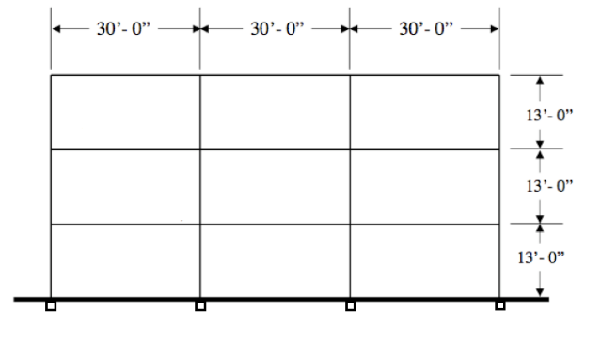

*Figure 1. Elevation view: isolated moment frame*

For the purpose of creating a space of input variables, Latin hypercube sampling with uniform distribution is utilized to generate design input combinations to ensure that an evenly distributed initial input set is achieved and to create a good representative of the variability across the design space.

A library of 68 ground motions is collected from events of magnitudes ranging from 6.0 to 8.0 and rupture radii from 0.0 km to 80.0 km. Vs,30 velocities are limited to a range from 200 m/s to 600 m/s in order to consistently represent the site profile with dense soil and soft rock.

Given a random and amplification factor, the ground motion is scaled over a range of interest is defined as , where is a typical average period for isolated structures, estimated as 3.0 seconds. The ground motions are scaled to the design spectrum (with amplification) using the spectral average as defined in Eads (2015),

where are the range coefficients from 0.2 to 1.5. To prevent excessive distortion of ground motion, no scale factor beyond 20 is used. The ground motion intensity measures as described in Section X.X are then collected.

The TFP bearing design is derived from the unidirectional multi-stage behavior of TFP bearings. A sample backbone curve for the force-displacement behavior of the TFP bearing is shown in Figure 3

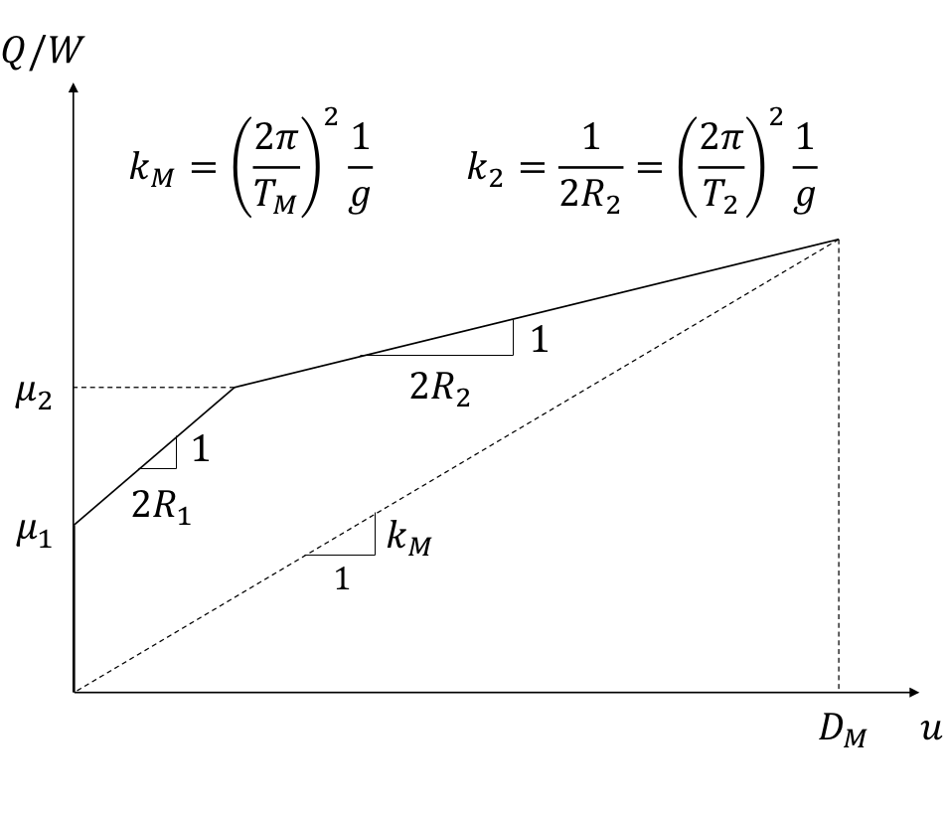

*Figure 3. Triple friction pendulum bearing backbone curve*

For simplicity, this study examines bearings with the outer sliding surfaces sharing the same friction coefficient and radius of curvature. Given two backbone parameters, the rest of the bearing parameters can be solved for: and are selected as inputs. From , the expected displacement is calculated given S1 from Becker & Mahin 2013, Fenz & Constantinou 2008,

where is the damping coefficient from ASCE 7-16, associated with the damping ratio . Starting with a guess of , is incremented until a physically realistic bearing design is reached. Amplification for torsion is not included as the analysis is conducted in 2D. However, the expected displacement is still amplified to represent variability in moat designs.

The superstructure is then designed following ASCE 7-16 Chapter 12 procedures, with maximum drift at at the MCER level. The random variable is introduced as a strength reduction factor in order to simulate the variability in structure strength, with the structure experiencing some yielding at the upper bound of due to inherent overstrength and remaining very elastic at the lower bound of . The lightest compact W-shapes are selected for the beams, and then the columns are selected to ensure a strong column weak beak mechanism.

At the end of the design procedure, the friction coefficients (), slider radii of curvature (), moat gap (), column sections, and beam sections have been selected.

The 2-D model is constructed in OpenSees. The frame elements are modeled using elastic beams and columns with plastic hinges at ends, implemented using a force-based beam column element and two-point Gauss-Radau integration over each hinge region is used to handle plasticity. Beam hinges are created with uniaxial section following a bilinear backbone curve to represent steel. Column hinges are created with fiber element. To simulate effects, a leaning column is used to carry the loads from the unmodeled gravity frames. A rigid diaphragm using elastic elements spans the layer above the isolators. The superstructure has 5% Rayleigh damping.

The bearings are modeled with triple friction pendulum elements using simple Coulomb friction. A moderate vertical stiffness is used as to not allow any excessive uplift or compression that would result in numerical instability. The moat wall is implemented using zero-length impact elements. The impact model uses a damped Hertz contact model with calibration parameters as used by Muthukumar & DesRoches (2006).

Ultimately, the database consists of 384 designs, each subjected to a ground motion as scaled above.

## 3.3 Intensity measures

To properly characterize the ground motion intensity in addition to the different isolated buildings, it is of interest to normalize the ground motion’s measure against building characteristics. To that end, two sets of variables are considered: the first to characterize the ground motion intensity, and the second to characterize the isolated building’s parameters.

For the ground motion, the considered variables are:

1. Peak ground acceleration

PGA is commonly used to represent the maximum force inducing acceleration that the ground motion subjects structures to. However, it is period-independent, and although it is present in a design spectrum, it is not a measure commonly used to design around.

1. Peak ground velocity  
   Similar to PGA, PGV measures the maximum velocity subjected from the ground motion and is also period-independent. However, it is of interest to determine whether or not a velocity-based measure more effectively predicts impact and collapse in a system where sliding behavior dominates.
2. Average spectral pseudo acceleration as defined in Eads (2015)  
   where N is the number of ordinates considered (spacing). A choice is ; however, for isolated structures, it is more desirable to use since the periods for isolated structures are already high. The choice of is then selected as a typical average period for isolated structure . This was previously chosen as 3.0 seconds, but can be lower based on the range of isolated structures considered. Moreover, this measure is period-dependent, which means that the centering can be chosen to be , the effective period of the isolated system, in order to model more closely the less stiff behavior in the sliding structure. The resulting average spectral pseudo acceleration based around the effective period is .
3. Spectral pseudo acceleration of a damped linear single degree of freedom (SDOF) model with a period equal to the effective period of the isolated structure  
   This is dependent on knowing the period of the structure, and is selected because isolated structures may be influenced by pulses with higher periods. Moreover, spectral pseudo accelerations are easily obtainable from a design spectrum.
4. Spectral pseudo acceleration of a damped linear SDOF model with a period equal to the post-sliding period of the isolated structure  
   This is dependent on knowing the post-sliding period of the structure, which can be calculated from the backbone curve of a bearing.
5. Maximum instantaneous power of the ground motion as defined by Zengin and Abrahamson (2020), with respect to the effective period of the isolated structure  
   The window of integration, is a function of , . This intensity is based around the velocity of a time series, filtered to remove energy at frequencies that are unlikely to excite the structure. A four-pole Butterworth bandpass filter for the range is applied to a velocity time series, and a trapezoidal integration scheme is used. has units of velocity-squared, and has been shown to effectively parameterize bursts of energy over a short time period, especially in near-fault ground motions.
6. Filtered incremental velocity, as defined by Davalos and Miranda (2019)  
   where are the local maxima and minima of , and   
   is the integrated velocity from the filtered acceleration of the ground motion. Davalos and Miranda (2020) further recommended for the filter to simply be a low-pass filter with the cut-off being fixed at 1 Hz. This is implemented with a Butterworth 2-pole low-pass filter. has period-dependency in the integration window and has units of velocity. It is aimed at parameterizing several peaks in the velocity from the time series.

For the building parameters, the considered parameters must be able to encompass and include effects of the superstructure, the general behavior of the isolation system, and the protection provided by the moat gap. It is also desired to use variables that are analogous to the intensity measure used for the ground motion.

To include these variables in a manner that is appropriately dimensionless, the following measure is proposed. Starting from the ASCE 7-16 Eq. 17.5-1 (maximum displacement capacity for an isolated system),

We seek to use for our amplified moat gap, which is the exact equation above, amplified with a random scalar from 1.0 to 2.25. We can then back calculate an amplified that the structure was designed for. This follows from the simple conversion that .

where is the amplified moat gap in the design. The unamplified spectral pseudo acceleration at which the structure is designed for is also considered

This is the spectral acceleration at the effective period of the bearing system, calculated from the value of the design spectrum that is accessed from site parameters. Both building-related spectral accelerations achieve the goal of including characteristics of the isolated structure, since it is derived from the effective period of the structure. Moreover, the superstructure is designed from the spectrum dictated by these spectral accelerations, and thus superstructure strength is indirectly tied to values. Lastly, the amplified variant of has the benefit of also accounting for the amplified moat gap that surrounds the frame. The values are spectral accelerations, through which normalization with the ground-motion spectral accelerations will be easily interpretable as a simple ratio.

Dimensionless variables can be formed from the combination of ground motion variables in the numerator and building variables in the denominator:

Be sure to explain how by proxy, the Sa(design) values account for the stiffness of the system and the moat gap. Give a good reason on the omitted combinations, such as why PGA wasn’t normalized by just S_M.

## 3.4 Logistic regression for collapse and impact

For this study, collapse is defined as any story exceeding the interstory drift limit of , and impact is defined as any case where the isolation layer displacement exceeds the isolation moat gap and a large axial force is observed in the isolation layer diaphragm.

A logistic model is considered for the classification problem of collapse and impact. Letting the outcome variable, either collapse or impact, be labeled as , with 1 being the event occurs, the logistic model distributes the variable as

Here, is the regression coefficient, which is fit using a maximum likelihood estimator (MLE) method. Once fit, the link function that dictates the probability of the event happening is

From the starting database of 384 points, a generalized linear model is fit using the logistic link function, repeated with 10-fold cross validation method, which reserves 10% of the points for testing. The fit built on the training set of points is then tested against the testing set, whereby classification for positive impact/collapse is assigned if . Upper and lower confidence intervals for the predictions are also recorded with

where is the standard error of the model. For the dataset, a no-information-rate (NIR) exists, which is the percent of correct predictions that would be achieved if the model blindly guesses the more accurate between collapse and no collapse. Assuming a Gaussian distribution, a p-value of the predicted model performing worse than the NIR is also recorded.

### 3.4.1 Efficiency

To quantify efficiency for any intensity measure, a form of dispersion is usually sought as the metric. Since the logistic regression lacks a dispersion in the form of a standard deviation from the fit, the deviance of the fitted model is reported as a proxy for dispersion

The deviance is defined as the difference in log likelihoods between the fitted model and a saturated model, which is a model that would perfectly fit the sample. To further characterize the goodness-of-fit of the model, McFadden’s pseudo is also reported, which is defined as

where is the log likelihood of the model fit with predictors (IMs), and is the log likelihood of the model with just the intercept and no predictors.

Also recorded but not presented: Hosmer-Lemeshow goodness of fit test (for which we used pseudo R^2) and overdispersion test. Be sure to explain how to interpret deviance in the results.

### 3.4.2 Efficiency when predicting collapse

Figure X shows the performance of each IM with respect to deviance for a logistic regression on collapse. For brevity, the IMs will be abbreviated to their numerator, and a subscript will indicate whether or not the denominator accounts for the moat gap amplification. It can be seen that along with has the lowest deviance and are the most efficient IMs in predicting collapse the isolated moment frame. shows the highest deviance and does not decrease deviance much from the null (show null deviance). It should also be noted that in predicting collapse, IMs that consider the amplification of the moat gap performs better than their unamplified counterpart. Moreover, Eads’ average spectral acceleration performs better when the effective period of the isolation system is used as the centering period, as opposed to centering about a fixed value of 3 seconds. Figure X also shows the goodness-of-fit measure, pseudo . The same trends are held here as with deviance.

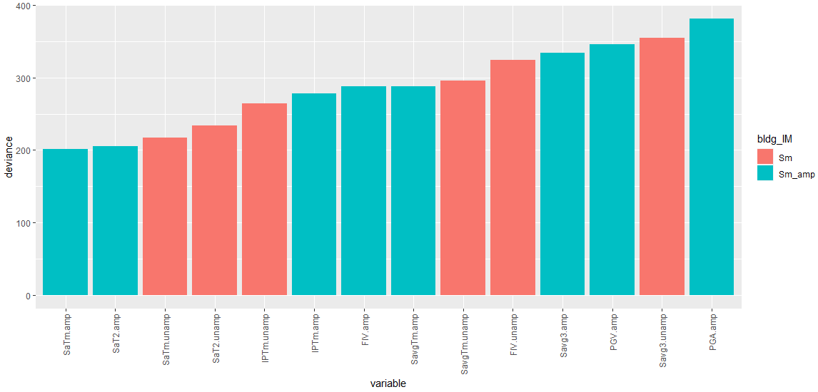

Figure X: Logistic regression for binary collapse, deviance

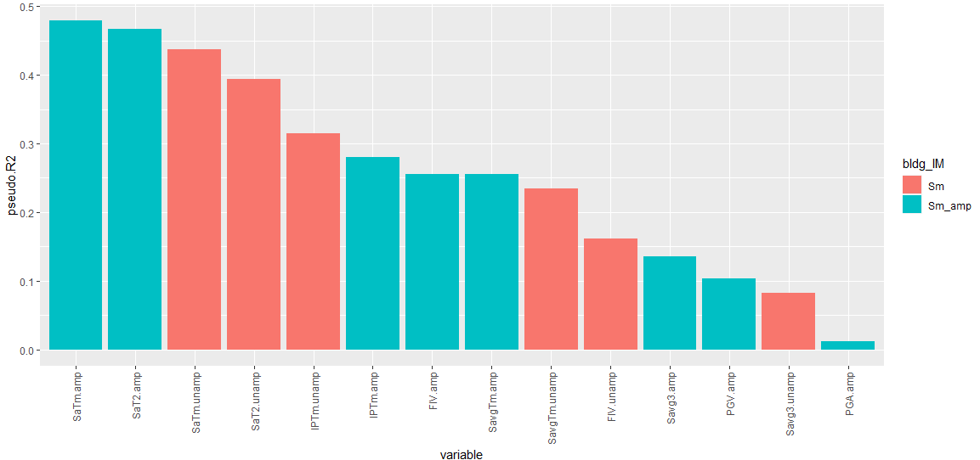

Figure X: Logistic regression for binary collapse, pseudo

In predicting against a test set, and predict the best, with mean accuracies close to 90%. It should also be noted that when testing for accuracy of prediction, the performance improvement by including the gap amplification in the IM is less visible with many of the unamplified IMs predicting at a higher mean accuracy than their amplified counterparts. Also plotted are the 95% confidence intervals for the prediction accuracy, and four IMs has 95% CIs that fall below the NIR of 68%: , , , and .

Although prediction accuracy functions fine as a baseline indicator of usability, it should be noted that the reported prediction accuracy only reflects the test against a limited set of points. Furthermore, the reported CIs for the study are often wide, and the ordering of the IMs could fall in a wide range of possibilities once uncertainty is considered.

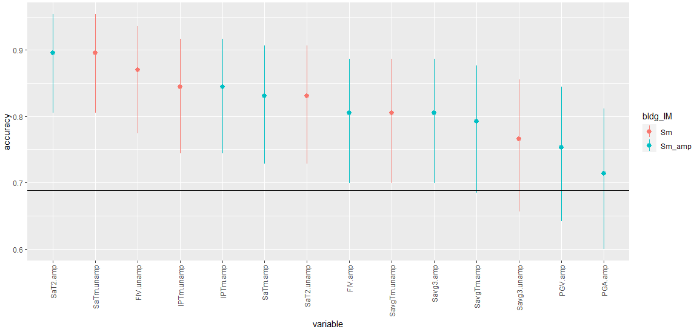

Figure X: Logistic regression for binary collapse, prediction accuracy

### 3.4.2 Efficiency when predicting impact

Examining the deviance in Figure X, all IMs that include the amplification of the moat gap perform better than their unamplified versions. This is foreseeable, considering that the moat gap is directly associated with the impact variable. In the study with impact, variables and perform more closely to the two and , contrasted with the collapse case, where even the unamplified and showed lower deviance than any other IMs. From the goodness-of-fit measure in Figure X, fits the data well enough to present a pseudo greater than 0.5.

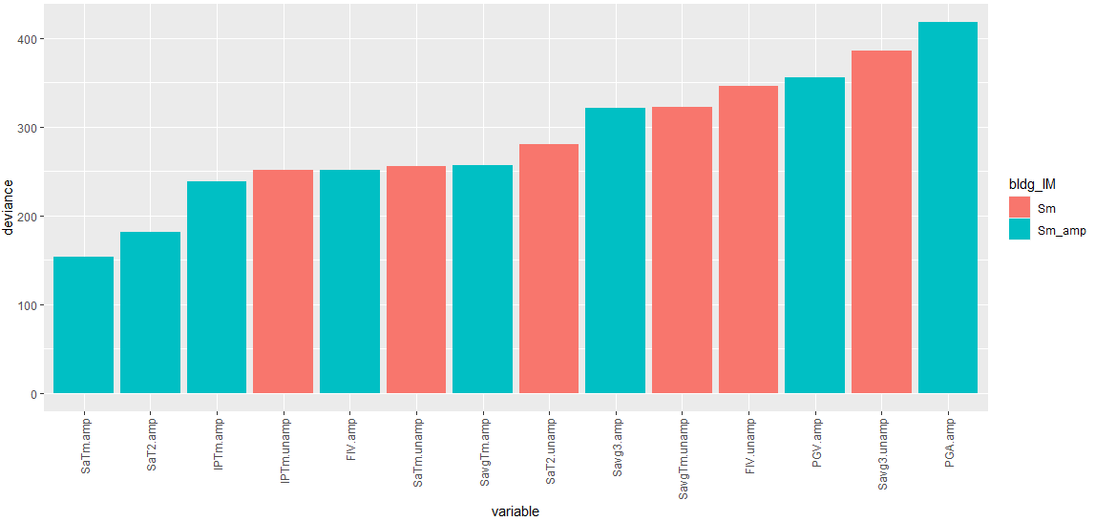

Figure X: Logistic regression for binary impact, deviance

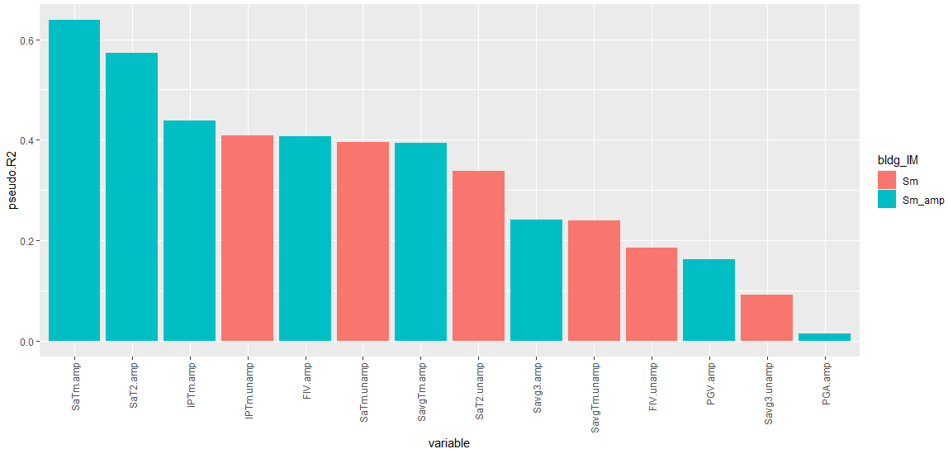

Figure X: Logistic regression for binary impact, pseudo

In predicting against a sample of test impact data, all IMs predict with accuracy confidence intervals staying above the no-information-rate. The highest predictor is the spectral acceleration measured at the post-sliding period of the structure, which plays the most direct role in the impact behavior that happens after the outer isolator begins moving.

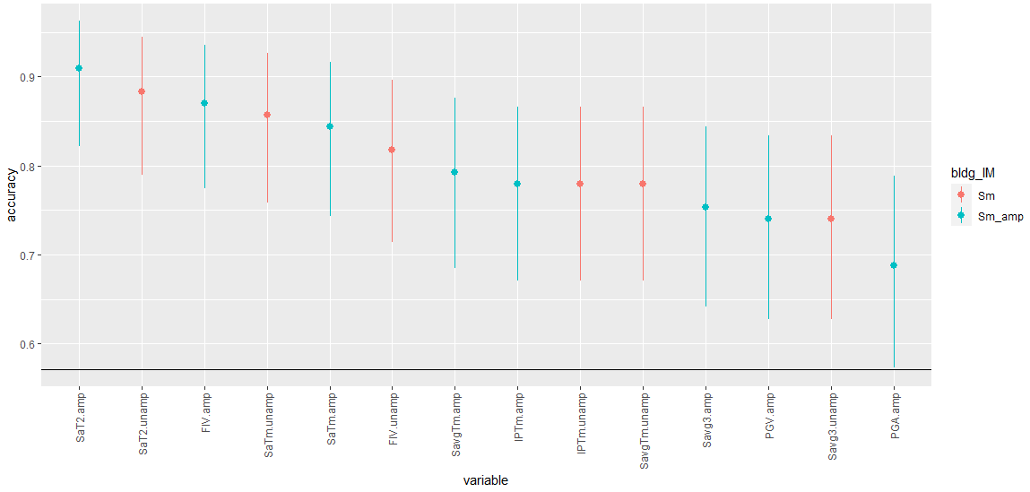

### 3.4.3 Efficiency when predicting collapse in conjunction with fixed base period

In addition to the IM, which considers the ground motion intensity, bearing stiffness, and moat gap overdesign, it is also possible to consider the effect of the superstructure stiffness in the regression if we model

The second term is the ratio between the stiffness of the equivalent superstructure on fixed base and the effective stiffness of the isolated system. To evaluate this model, the Akaike Information Criterion (AIC) is obtained. The AIC is a measure based on the deviance, but penalizes the model for having more variables.

Here, is the number of estimated parameters in the model, and a higher penalized AIC results from having more predictors. Additionally, within each regression, a Z-test is also performed to determine each predictors’ significance in its own study. Here, the model is tested against a null hypothesis that the predictor’s coefficient is equal to zero (having no effect), and a p-value representing the normally distributed probability that the null hypothesis is accepted is recorded. A smaller p-value would then correspond to the predictor being more significant.

A p-value obtained from the likelihood ratio test between two models can also be used to quantify the significance of the fixed-base period ratio. (more details?). Do we need another analysis of variance to determine significance or is the above enough?

In tandem with building stiffness, IM always more important than Tfb ratio. Tfb ratio always has pvalue less than IM, and even less than just the null intercept. AIC is better when we just do IM.

As a representative example, is chosen as the intensity measure for the study in conjunction with the fixed base period ratio. In predicting collapse, three logistic regression models are compared in Table X. In the studies that include the fixed base period ratio, the p-value for the ratio is significantly higher than the other predictors. Often, a p-value of 0.05 is set as the critical threshold for studies that seek 95% confidence, and the intensity measure along with the intercept value achieves these in studies that exclude the fixed base ratio in the regression. Moreover, when examining the Akaike Information Criterion, the model that achieves the lowest value is the regression on just the IM, indicating that although the inclusion of the fixed base ratio decreases the deviance, its addition further complicates the model and is penalized.

Table X: Z-test results and AIC for logistic regression of collapse against IM and TfbRatio

|  |  |  |  |  |  |
| --- | --- | --- | --- | --- | --- |
| **Model** | p-value for intercept | p-value for IM | p-value for Tfb | AIC | Residual deviance (null deviance = 386.04) |
| Collapse ~ IM | <2e-16 | <2e-16 | - | 221.13 | 217.13 |
| Collapse ~ Tfb | 0.0586 | - | 0.337 | 389.11 | 385.11 |
| Collapse ~ Tfb + IM | 7.93e-11 | <2e-16 | 0.337 | 222.2 | 216.20 |

### 3.4.4 Efficiency when predicting collapse in conjunction with building strength

Similarly, the same study can be carried out for the strength reduction factor, . Table X shows the comparison of the three logistic regressions below, drawing the same conclusions as with the fixed base period ratio.

Table X: Z-test results and AIC for logistic regression of collapse against IM and

|  |  |  |  |  |  |
| --- | --- | --- | --- | --- | --- |
| **Model** | p-value for intercept | p-value for IM | p-value for | AIC | Residual deviance (null deviance = 386.03) |
| Collapse ~ IM | <2e-16 | <2e-16 | - | 221.13 | 217.13 |
| Collapse ~ | 0.0237 | - | 0.760 | 389.94 | 385.94 |
| Collapse ~ + IM | 5.73e-16 | <2e-16 | 0.397 | 222.14 | 216.14 |

Need to do the same for impact or?

### 3.4.2 Sufficiency

Check for sufficiency against multiple parameters

## 3.5 Power regression for interstory drift ratio

### 3.5.1 Efficiency of full regression

For a continuous variable, a linear model can be fit as follows

where is a standard normally distributed variable, and the residual standard error is recorded as a measure of dispersion for the regression. Past studies have shown that engineering demand parameters, when conditioned on intensity measures, are log-normally distributed (Shome and Cornell 1999, Aslani and Miranda 2005). For isolated structures, since impact against the moat wall has a large effect (either cite this or show our own results) on drift ratios, the regression has to be modified as

with representing the binary impact variable. From this regression, the residual standard error and value and are measured as quantifiers of model dispersion and goodness-of-fit, respectively.

Is it worth including this? Most of the effect of the regression comes from the impact variable anyway.

Full regression:

Impact is an important predictor of drift

Residual se and R^2 : SaTm, SaT2, Sa_avgTm, IP, FIV all lead the way, perform comparably. Here though, unamp ratios work better than amp denominators. PGA, PGV, and Sa_Avg3 trail last.

### 3.5.2 Efficiency of intensity measures conditioned on impact

It is also possible to modify the regression such that the results are not regressed upon the impact variable, but rather conditioned. In that case, the regression performed is

This regression simply regresses drift on the intensity measure, restricting to the dataset filtered either by impacted experiments or non-impacted experiments exclusively. Additionally, with the same conditioning on impact, the regression can also be done in tandem with the fixed-base period ratio, and the likelihood ratio test can be again carried out to compare significance of models including and excluding the period ratio.

When conditioned on the system experiencing impact against the moat wall, the two spectral accelerations at critical periods, and , are the most efficient in having low residual standard errors. Of note is that when regressing against interstory drift ratio, measures that do not include the amplification of the moat gap are more efficient than their amplified counterparts. From the goodness-of-fit study, it can be seen that fits the data significantly better than other IMs. However, by conditioning on impact (and removing impact as a predictor), the overall goodness-of-fit is decreased. Needs null standard error to compare against.

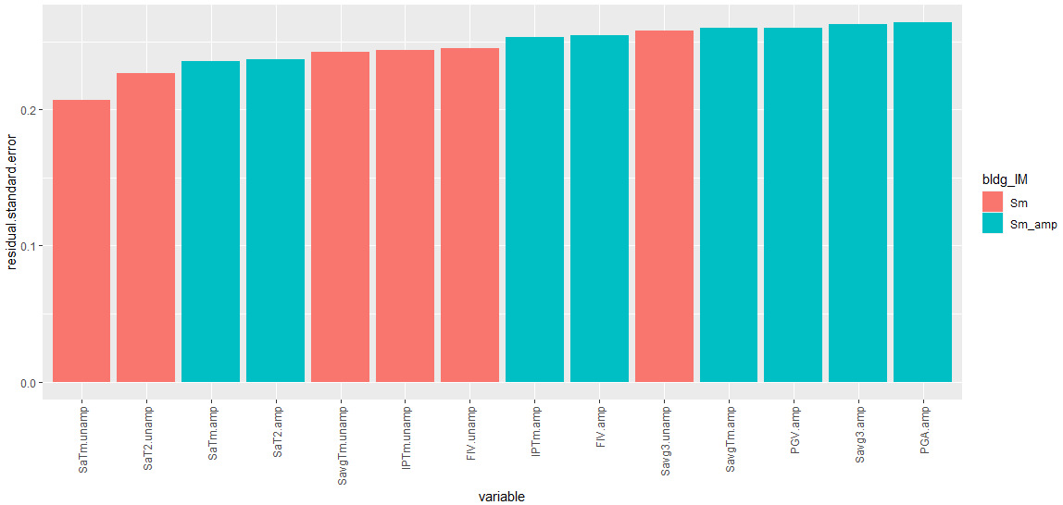

Figure X: Residual standard error from regression of interstory drift, conditioned on impact

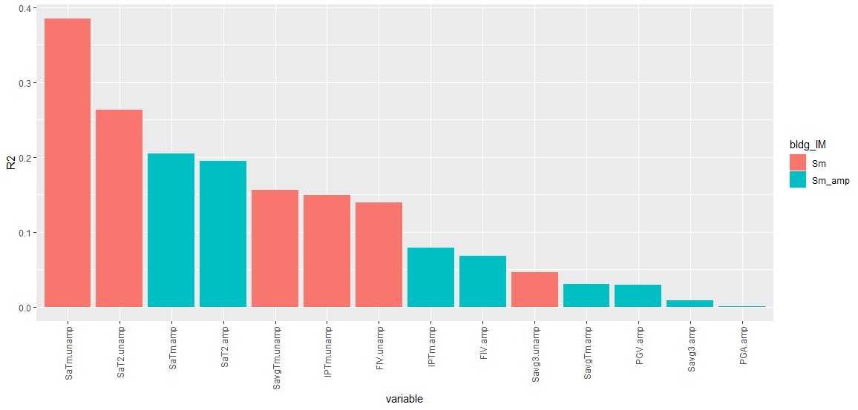

Figure X: from regression of interstory drift, conditioned on impact

### 3.5.3 Efficiency of intensity measures conditioned on no impact

Upon conditioning on cases where there has not been impact with the isolation moat wall, it is found that all unamplified IMs perform more efficiently than any amplified IM. It can be concluded that where impact has not occurred, there is no effect in the inclusion of the amplification of the moat gap as a predicting variable of interstory drift. The most efficient IM by both measures of dispersion and goodness-of-fit is , although all values in the study of unimpacted structures are significantly lower than that of the impacted structures, indicating that less of the drift can be predicted by the IM. Nevertheless, the general decrease in residual standard errors implies that the IMs are more efficient in predicting drift when impact has not occurred.

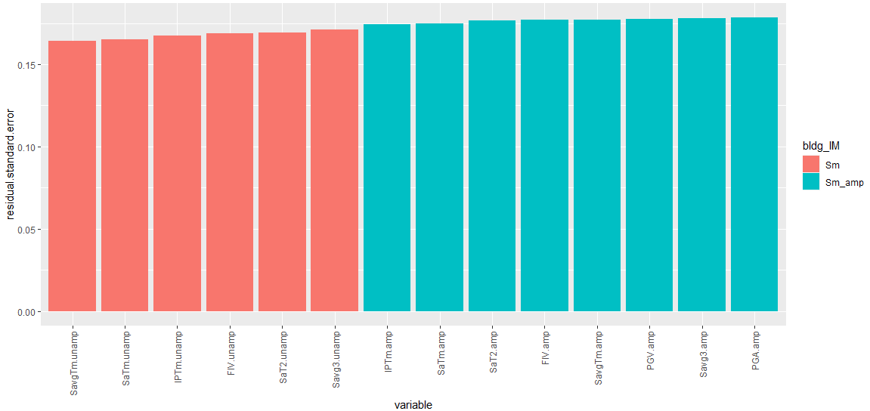

Figure X: Residual standard error from regression of interstory drift, conditioned on no impact

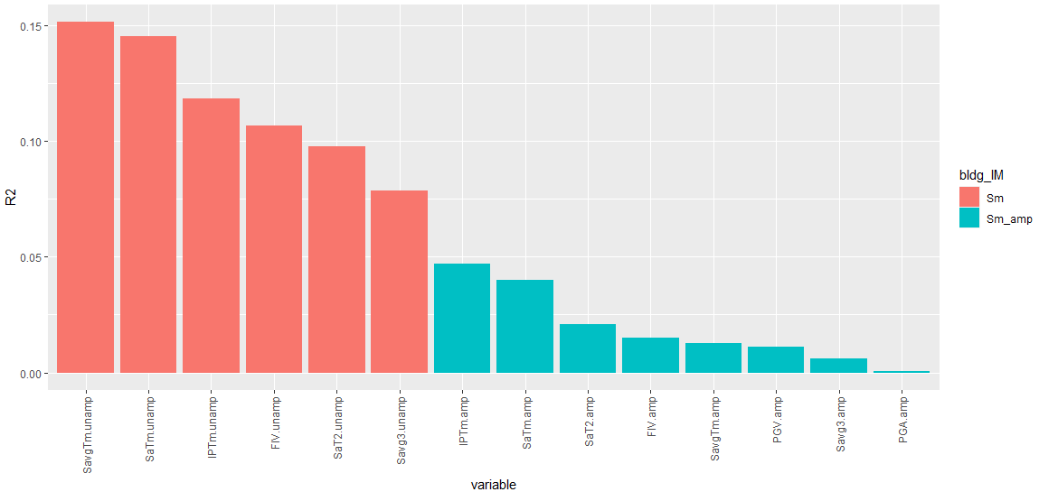

Figure X: from regression of interstory drift, conditioned on no impact

Figure X combines the two studies for presentation. Generally, the IMs show an improvement in efficiency when predicting in cases where impact has not occurred. However, the IMs perform better under impact when examining the correlation ().

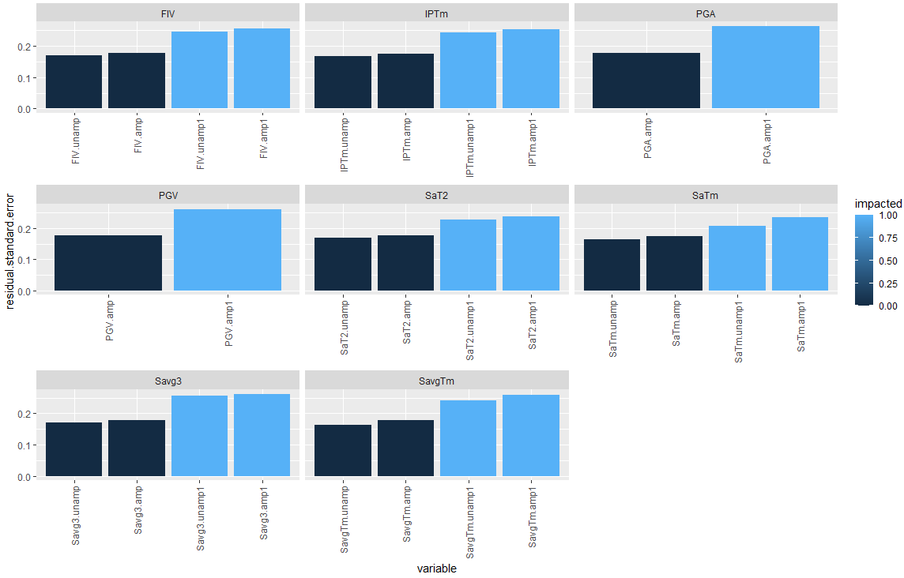

Figure X: Comparison of residual standard errors from power regression on interstory drift

### 3.5.4 Regression with fixed base period

The Z-test described in Section X.X.X is again utilized to evaluate the effect of the fixed base period ratio on the prediction of interstory drift. However, for a continuous variable, a Student’s t-test is used to evaluate the null hypothesis as opposed to the Z-test. Again, the data is conditioned to ensure that the impact variable does not act as a significant underlying predictor. When examining AIC, a smaller value (towards negative infinity) indicates a better model in comparison to other models in the study. Tables X and X records the t-test result, along with the AIC, for the IM conditioned for impact. When conditioned for impact happening, although the addition of the fixed-base ratio contributes to lowering the residual standard error, the best model according to the AIC is the regression on just the intensity measure. However, of note is when the study is conditioned for structures where impact has not occurred. First, by the decrease of residual standard error, it can be concluded that the regression study among all variables is more efficient than its impacted counterparts. We note that the inclusion of both the IM and the fixed base ratio contributes to the efficiency of the model. Furthermore, the p-value for the fixed base period ratio is notably smaller, indicating its significance as a predictor. When examining the AIC, the model that is best supported is the model that includes both the fixed base period of the structure and the IM in conjunction. Lastly, the coefficient of determination indicates that the model is much better explained when both variables are considered as predictors when impact has not occurred.

Table X: t-test results and AIC for logistic regression of collapse against IM and TfbRatio, conditioned for impact

|  |  |  |  |  |  |  |
| --- | --- | --- | --- | --- | --- | --- |
| **Model** | p-value for intercept | p-value for IM | p-value for Tfb | AIC | Residual standard error (null = 0.2632) | Multiple |
| Drift ~ IM | <2e-16 | <2e-16 | - | -50.50 | 0.2071 | 0.3847 |
| Drift ~ Tfb | 1.07e-11 | - | 0.702 | 34.33 | 0.2639 | 8.5e-3 |
| Drift ~ Tfb + IM | <2e-16 | <2e-16 | 0.532 | -48.91 | 0.2074 | 0.3861 |

Table X: t-test results and AIC for logistic regression of collapse against IM and TfbRatio, conditioned for no impact

|  |  |  |  |  |  |  |
| --- | --- | --- | --- | --- | --- | --- |
| **Model** | p-value for intercept | p-value for IM | p-value for Tfb | AIC | Residual standard error (null = 0.178) | Multiple |
| Drift ~ IM | <2e-16 | 1.22e-8 | - | -156.01 | 0.165 | 0.1454 |
| Drift ~ Tfb | <2e-16 | - | <2e-16 | -206.7 | 0.1462 | 0.3294 |
| Drift ~ Tfb + IM | <2e-16 | 3.57e-12 | <2e-16 | -253.9 | 0.1302 | 0.4700 |

Should we do the same for Ry?