Question for Peter

Hardy Griesbauer

03/11/2020

## Study background

The data were taken from a partial cutting silviculture trial established in 1992 near Prince George (EP1162). The study is set up as follows:

1. Nineteen 50m x 50m sites were harvested with three levels of basal area retention (treatments were randomly assigned to each site);
2. The three levels of basal area retention are as follows: (i) control (no harvest, around 30m2/hectare in 1992); (ii) 10m2/hectare residual basal area (relatively high level of partial harvest); (iii) 20m2/hectare residual basal area (relatively light level of partial harvest);
3. Each of the 19 sites has one 11.28m fixed-radius permanent sample plot established in the centre;
4. Data were collected at the 19 plots over 5 years: 1992, 1994, 1997, 2009 and 2019. Not all plots were measured at each period!

Below are the number of plots measured in each of the three treatment units and five years:

|  |  |  |  |  |  |
| --- | --- | --- | --- | --- | --- |
| Treatment | 1992 | 1994 | 1997 | 2009 | 2019 |
| TU:10 | 6 | 5 | 5 | 6 | 6 |
| TU:20 | 4 | 5 | 5 | 6 | 6 |
| TU:Control | 7 | 5 | 5 | 7 | 7 |

This table shows that in a given measurement year, data were collected in between 17-19 plots. Most plots were visited in all five measurement years.

Here is a screenshot of some of the stand-level data:

## Warning: `as.tibble()` is deprecated, use `as_tibble()` (but mind the new semantics).  
## This warning is displayed once per session.

## # A tibble: 10 x 7  
## Treatment Plot Year Volume Basal.Area SPH QMD  
## <chr> <fct> <fct> <dbl> <dbl> <dbl> <dbl>  
## 1 TU:10 13 1992 63.9 12.7 540 17.3  
## 2 TU:10 13 1994 78.5 14.7 560 18.3  
## 3 TU:10 13 1997 103. 18.7 720 18.2  
## 4 TU:10 13 2009 200. 30.1 960 20.0  
## 5 TU:10 13 2019 297. 40.6 980 23.0  
## 6 TU:10 14 1992 60.8 10.3 280 21.7  
## 7 TU:10 14 1994 76.0 12.3 320 22.2  
## 8 TU:10 14 1997 103. 15.5 400 22.2  
## 9 TU:10 14 2009 241. 28.2 500 26.8  
## 10 TU:10 14 2019 270. 34.7 580 27.6

Here is a plot of mean plot-level basal area trend over time: 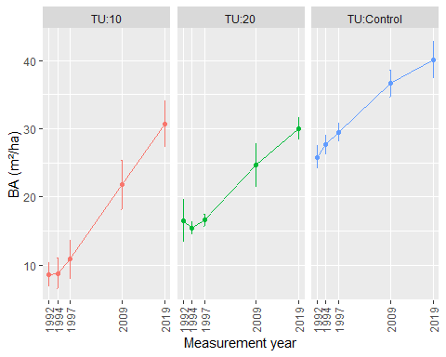

*Whiskers are standard error of the mean*

To me, it looks like the plots in TU:10 increased their basal area faster than plots in the other two units. This was the one of the study’s hypotheses (opening the stand up more will stimulate faster growth). To test that hypothesis, I would like to contrast the slope of the lines between treatments.

I believe I can do this in R with the following code:

fit.BA<-lmer(Basal.Area~Year*Treatment+(1|Plot),data=ep1162.dat)  
  
summary(fit.BA)

## Linear mixed model fit by REML ['lmerMod']  
## Formula: Basal.Area ~ Year * Treatment + (1 | Plot)  
## Data: ep1162.dat  
##   
## REML criterion at convergence: 441.1  
##   
## Scaled residuals:   
## Min 1Q Median 3Q Max   
## -3.10666 -0.51379 0.02721 0.54019 1.81417   
##   
## Random effects:  
## Groups Name Variance Std.Dev.  
## Plot (Intercept) 24.876 4.988   
## Residual 9.219 3.036   
## Number of obs: 85, groups: Plot, 19  
##   
## Fixed effects:  
## Estimate Std. Error t value  
## (Intercept) 23.3620 1.1972 19.514  
## Year1 -6.4341 0.6918 -9.301  
## Year2 -4.9271 0.7042 -6.997  
## Year3 -3.2283 0.7042 -4.584  
## Year4 4.3724 0.6401 6.831  
## Treatment1 -6.6907 1.7120 -3.908  
## Treatment2 -2.1826 1.7148 -1.273  
## Year1:Treatment1 -1.5916 0.9494 -1.676  
## Year2:Treatment1 -1.7014 0.9931 -1.713  
## Year3:Treatment1 -1.2907 0.9931 -1.300  
## Year4:Treatment1 0.7823 0.9124 0.857  
## Year1:Treatment2 1.5469 1.0573 1.463  
## Year2:Treatment2 0.6536 1.0020 0.652  
## Year3:Treatment2 0.0708 1.0020 0.071  
## Year4:Treatment2 -0.8264 0.9178 -0.900

##   
## Correlation matrix not shown by default, as p = 15 > 12.  
## Use print(x, correlation=TRUE) or  
## vcov(x) if you need it

## Contrasts between slopes

Using the emmeans package, I contrast the slopes as follows:

# emtrends(fit.BA, pairwise ~ Treatment, var = "Year")  
  
library(lmerTest)

##   
## Attaching package: 'lmerTest'

## The following object is masked from 'package:lme4':  
##   
## lmer

## The following object is masked from 'package:stats':  
##   
## step

anova(fit.BA, type="3")

## Analysis of Variance Table  
## Df Sum Sq Mean Sq F value  
## Year 4 3489.1 872.28 94.6158  
## Treatment 2 277.3 138.63 15.0369  
## Year:Treatment 8 200.8 25.10 2.7227

## Generate cell means

# joint_tests(fit.BA) #another way to see the ANOVA table for the overall tests  
  
cell.means <- emmeans(fit.BA, ~ Treatment*Year)  
  
cell.means

## Treatment Year emmean SE df lower.CL upper.CL  
## TU:10 1992 8.65 2.38 24.9 3.73 13.6  
## TU:20 1992 16.29 2.58 32.3 11.04 21.5  
## TU:Control 1992 25.85 2.21 24.9 21.30 30.4  
## TU:10 1994 10.04 2.47 27.9 4.99 15.1  
## TU:20 1994 16.91 2.47 27.9 11.85 22.0  
## TU:Control 1994 28.36 2.36 31.0 23.55 33.2  
## TU:10 1997 12.15 2.47 27.9 7.10 17.2  
## TU:20 1997 18.02 2.47 27.9 12.97 23.1  
## TU:Control 1997 30.23 2.36 31.0 25.42 35.0  
## TU:10 2009 21.83 2.38 24.9 16.92 26.7  
## TU:20 2009 24.73 2.38 24.9 19.81 29.6  
## TU:Control 2009 36.65 2.21 24.9 32.11 41.2  
## TU:10 2019 30.69 2.38 24.9 25.78 35.6  
## TU:20 2019 29.95 2.38 24.9 25.04 34.9  
## TU:Control 2019 40.10 2.21 24.9 35.55 44.6  
##   
## Degrees-of-freedom method: kenward-roger   
## Confidence level used: 0.95

plot(cell.means, by="Year")

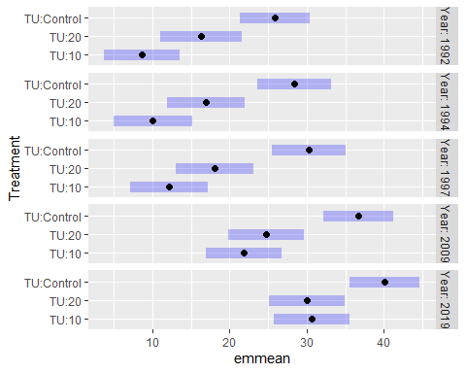

## Contrasts

This is the code with interaction=“consec”.

year.by.trt <- contrast(cell.means, interaction = "consec", by = NULL) #might need to change the by = option here.

Need a slight change in code so that all treatments are contrasted. Right now it’s only contrasting consecutive treatments. Let’s change the interaction to “pairwise”:

year.by.trt <- contrast(cell.means,interaction="pairwise") #might need to change the   
  
year.by.trt

## Treatment_pairwise Year_pairwise estimate SE df t.ratio p.value  
## TU:10 - TU:20 1992 - 1994 -0.784 2.83 54.8 -0.276 0.7833   
## TU:10 - TU:Control 1992 - 1994 1.113 2.61 54.5 0.427 0.6712   
## TU:20 - TU:Control 1992 - 1994 1.896 2.81 54.9 0.675 0.5022   
## TU:10 - TU:20 1992 - 1997 -1.777 2.83 54.8 -0.627 0.5333   
## TU:10 - TU:Control 1992 - 1997 0.874 2.61 54.5 0.335 0.7387   
## TU:20 - TU:Control 1992 - 1997 2.651 2.81 54.9 0.944 0.3492   
## TU:10 - TU:20 1992 - 2009 -4.747 2.67 54.3 -1.780 0.0806   
## TU:10 - TU:Control 1992 - 2009 -2.374 2.39 54.0 -0.994 0.3247   
## TU:20 - TU:Control 1992 - 2009 2.373 2.58 54.3 0.919 0.3623   
## TU:10 - TU:20 1992 - 2019 -8.385 2.67 54.3 -3.145 0.0027   
## TU:10 - TU:Control 1992 - 2019 -7.794 2.39 54.0 -3.263 0.0019   
## TU:20 - TU:Control 1992 - 2019 0.591 2.58 54.3 0.229 0.8199   
## TU:10 - TU:20 1994 - 1997 -0.993 2.72 54.0 -0.366 0.7159   
## TU:10 - TU:Control 1994 - 1997 -0.239 2.72 54.0 -0.088 0.9303   
## TU:20 - TU:Control 1994 - 1997 0.755 2.72 54.0 0.278 0.7821   
## TU:10 - TU:20 1994 - 2009 -3.964 2.64 54.4 -1.503 0.1386   
## TU:10 - TU:Control 1994 - 2009 -3.487 2.61 54.5 -1.338 0.1866   
## TU:20 - TU:Control 1994 - 2009 0.476 2.61 54.5 0.183 0.8557   
## TU:10 - TU:20 1994 - 2019 -7.601 2.64 54.4 -2.883 0.0056   
## TU:10 - TU:Control 1994 - 2019 -8.907 2.61 54.5 -3.416 0.0012   
## TU:20 - TU:Control 1994 - 2019 -1.306 2.61 54.5 -0.501 0.6186   
## TU:10 - TU:20 1997 - 2009 -2.970 2.64 54.4 -1.126 0.2650   
## TU:10 - TU:Control 1997 - 2009 -3.249 2.61 54.5 -1.246 0.2181   
## TU:20 - TU:Control 1997 - 2009 -0.278 2.61 54.5 -0.107 0.9154   
## TU:10 - TU:20 1997 - 2019 -6.608 2.64 54.4 -2.506 0.0152   
## TU:10 - TU:Control 1997 - 2019 -8.668 2.61 54.5 -3.325 0.0016   
## TU:20 - TU:Control 1997 - 2019 -2.061 2.61 54.5 -0.790 0.4329   
## TU:10 - TU:20 2009 - 2019 -3.638 2.48 54.0 -1.467 0.1481   
## TU:10 - TU:Control 2009 - 2019 -5.420 2.39 54.0 -2.269 0.0273   
## TU:20 - TU:Control 2009 - 2019 -1.782 2.39 54.0 -0.746 0.4589   
##   
## Degrees-of-freedom method: kenward-roger

## Test

test(year.by.trt, joint=TRUE)

## df1 df2 F.ratio p.value note  
## 8 54.33 2.72 0.0135 d   
##   
## d: df1 reduced due to linear dependence