Analyses of 27 years of stand structure development and basal area growth response to a range of initial basal area density levels, 1992-2019

Mike Jull and Hardy Griesbauer

29/03/2020

# Methods

## Analysis

### Tree-level growth responses

To test the hypothesis that tree-level growth response over the 1992-2019 period varied with interactions between (i) tree basal area at the time of treatment (1992); (ii) residual basal area; and (iii) species, we fit linear mixed effects models with log-transformed 1992-2019 basal area increment as the response variable, and treatment, species and log-transformed 1992 basal area as interacting fixed effects, and plot as a random intercept effect. We also fit a similar model with the 1992-2019 basal area increment expressed as a percentage of 1992 basal area. Plots of residuals and fit lines with orginal data were examined to evaluate model goodness of fit. Variance explained for each model are reported using the approach described in Nakagawa et al. (2013), as implemented in the MuMIn package for R (**???** later).

We also examined how basal area increment at the tree-level varied over the four measurement periods, by fitting a similar model as described above, with an additional fixed effect of measurement period. This allowed us to examine temporal changes in growth responses, including evaluating for a potential lag effect. We do note that because we did not measure increment before treatment, we cannot address questions regarding short-term growth declines associated with treatment.

## Stand structure and growth dynamics

### Changes in tree density over time

We qualitatively assessed changes in tree density over time through density diagrams that displayed tree density (stems per hectare) by diameter class, faceted by measurement period, species and treatment unit. The effects of tree density changes on basal area was also qualitatively evaluated by summarizing basal area per hectare by diameter class, species and treatment unit.

### Stand-level basal area and volume growth

#### Volume estimates

Tree volumes were estimated using species- and region-specific equations (Nigh 2016) based on tree height and DBH. We estimated tree heights by fitting a single diameter-height models developed with a linear mixed effects model, with log-transformed DBH as a fixed effect, and tree nested within plot as a random effect. Trees with broken tops were omitted from diameter-height models.

# Results

### Tree-level growth responses

A comparison of tree-level 1992-2019 basal area increment to tree size at the time of treatment showed that basal area increment over 27 years increased with tree size, and that this relationship varied between species and among treatment units (Appendix 1). A linear mixed effects model using 510 trees (70 spruce, 440 fir) confirmed that slopes and intercepts varied with species and residual basal area (p<0.001 for all interactions). This model explained 47.8 % variation (marginal R2) in diameter increment over the 27 years of the study, and showed that diameter increment increased with initial tree size, and increment was higher in the treatment units with basal area removed, compared to the control, and that spruce trees had higher basal area increment than fir (Figure 1). A similar model predicting basal area increment as a percentage of tree size at the time of treatment showed that smaller trees grew proportionally more than larger trees, with a strong negative exponential decrease with initial tree size (Appendix 2 and Figure 2), however, the model fit was relatively poorer, explaining 31.4 % of variation in % basal area increase.

To detect differences in growth rates over the 27-year period of this study, we compared growth rates between the four measurement periods, by species and treatment unit (Appendix 3). Growth rates were lowest in the three years immediately after treatment, and increased over the subsequent two measurement periods (1994-1997 and 1997-2009), before decreasing again in the last measurement period (2009-2019). This temporal pattern appeared consistent between species and among treatment units; as well, spruce trees had higher growth rates than fir over all periods and treatment units, and growth rates were higher in the high-removal treatment unit, compared to the low-removal treatment and control units. A linear mixed effects model with species, measurement year and treatment unit as fixed effects (not shown) explained 23.9% variation (marginal R2) in log-transformed basal area increment (m2 at breast height) over different periods (Figure 3).

### Tree density

Mean plot tree density by diameter class diagrams showed that across all treatment levels, subalpine fir comprised the majority of stems in the smaller diameter classes, both in the year after treatment, and in 2019 (Figure 4). The diameter class distribution of fir in all treatment units was negative exponential. Mean spruce density was lower than fir, with a relatively flatter diameter distribution. Within the high-removal treatment unit, fir density increased mostly in the smaller diameter classes between 1992 and 2019; in the low-removal treatment unit, fir density increased most in trees between 12.5 to 27.5cm DBH; and in the control treatment unit, fir density increased mostly in trees above 22.5cm DBH ( Figure 5). Spruce tree density increased less than fir, with the exception of an increase of over 250% in SPH in the smallest diameter class in the light-removal treatment unit.

## Stand-level changes

### Volume estimates

### Height-diameter models

Tree heights had a positive nonlinear relationship with diameter, for both species and across all time periods (Appendix 4). A comparison of height-diameter models showed that intercepts and slopes of log-transformed heights did not vary significantly (p<0.05) between species or time periods (not shown), therefore a single height-diameter linear mixed-effects model was developed using 870 tree height-diameter observations in the dataset, with log-transformed diameter as the fixed effect, and tree nested within plot as random effect. This model explained 86% of variation in log-transformed heights, with an intercept of 0.256 and slope coefficient of 0.814 * log(DBH). Residual and predicted vs actual height plots were assessed to ensure goodness of fit (Appendix 5). The model slightly overestimated tree heights in shorter trees, and underestimated tree heights in taller trees. This model was applied to predict heights in trees without height measurements, and tree-volume estimates generated as per Nigh (2016).

### Stand increment

Annual increment between the four periods differed between treatment units (Figure 7). In the high-removal treatment unit, annual basal area increment increased in each subsequent measurement period, with the highest mean plot values of 0.9m2 per hectare. In contrast, mean plot basal area annual increment was highest in the low-removal treatment unit during the 1994-1997 period, and decreased in subsequent periods. A similar pattern was observed in the control treamtent unit. Annual increment patterns in total and merchantable volumes were similar to basal area, with the exception of the high-removal treatment unit. Here, maximum annual volume increment was highest between 1997 and 2009, with a mean plot value of 8m3 per year per hectare; this increment decreased slightly from 2009-2019 period. In the control unit, volume increment from 2009-2019 was lower than from 1992-1994.

### Species composition over time

#### Volume and basal area

Fir basal area and volume exceeded that of spruce in both the control and light-removal treatment unit; these differences increased in each subsequent period after ca.1997 (Figure 8). From 1997-2019, fir basal area and volume increased faster than spruce in the light-removal and control units. The differences were not as clear in the high-removal treatment unit, as there was a lot of variation in spruce among plots. *we could test this for significance*

Among treatments, spruce volumes and basal were similar across the three treatment units, especially from 1997-2019. Spruce volume and basal area varied substantially among plots within the high-removal treatment unit. Fir basal area and volumes in the control unit exceeded other treatment units, with the largest difference between control and high-removal treatment unit.

#### Tree density

In the control and light-removal treatment unit, there were more fir trees than spruce across all time periods. The difference between fir and spruce density appeared to remain stable in the control unit over the period of this study. In the high-removal treatment unit, fir density began to noticeably exceed that of spruce starting ca.1997, although the variation in fir tree density among plots in this treatment was relatively high.

#### Quadratic mean diameter

Quadratic mean diameter in both fir and spruce remained relatively stable over all measurement periods in the control unit. In the low-removal treatment unit, spruce QMD exceeded that of fir across all periods, however, the differences between species apeared to be diminishing over time. In the high-removal treatment unit, spruce QMD increased over time, and both species had approximately similar mean QMD.

# Discussion

Here are the main results that emerge to me from our data:

1. All treatment units maintained a stand structure analagous to an uneven-aged stand (ie reverse-J diameter distribution). In the high-removal TU, most recruitment was into the smallest size class (pole), whereas recruitment was into larger size classes in the light-removal and control. This suggests that understory response may increase with level of change in the canopy.
2. High-level of basal area removal stimulated a stronger and more sustained growth response Basal area increment has higher in the high-removal treatment units compared to other two, and peaked ~20 years after treatment, compared to ~5 years in control/light-removal. What does this mean for stand development over the next 20-30 years?

* By 2019, the high-removal and light-removal TU converged in terms of volume and basal area. This seems remarkable to me, and perhaps runs counter to what we learned in silviculture II: *one will never recoup thinned volume!* Growth rates in the high-removal TU exceeded those in the light-removal; what does this mean for stand dynamics over the next 20 years? Will the high-removal TU actually exceed light-removal in terms of volume?
* Most basal area increases are from the larger trees, however, the smaller trees had stronger responses when considered as a % of initial tree size.

1. Partial cutting in this uneven-aged spruce-fir forest affected spruce-fir composition differently depending on harvest level

* Stand development after harvest showed that spruce volume, basal area, and QMD increased more in the high-removal treatment compared to the other two treatments. In many plots in the high-removal TU, spruce volumes exceeds control/light-removal spruce.
* High removal stimulated stronger growth responses in spruce trees, compared to fir. In the light-removal and control units, spruce basal area and volume changed much less over the 27 years of the trial, and in fact, have similar levels.
* Within a time period, spruce quadratic means diameters were inversely related to harvest level. QMD is highest in the control unit, and lowest in the high-removal treatment unit, suggesting that there are fewer but larger trees in the control, whereas recuitment into sapling class trees has been highest in high-removal TU. Does this suggest that spruce are well adapted to take advantage of canopy gaps?
* Would we see this response in even more removal, say down to 5m2 per hectare?
* An important note: fir stems per hectare were low in the high-removal TU until around 1997, and then increased more rapidly relative to other units from ca. 1997-2019.
* Note that Figure 3 and 7 are similar - Figure 3 shows predicted BAI from model, and 7 shows actual data. Recommend deleting Figure 3 and using 7, b/c prefer to use real data! Appendix three is similar to Figure 7 - just uses boxplots instead of mean/se. Recommend Figure 7 and delete Appendix 3.

1. What other results emerge from the data?

**Discussion structure from Mike below**

1. comparisons of findings to the related scientific literature
2. comparisons of findings to biological principles and current ecological understandings - e.g. do our results make sense based on our understandings of stand dynamics, or example?
3. discussion of findings that seem anomalous, counter-intuitive, or contrary to prevailing literature or theory, AND consideration of whether our results and data may be an advancement in the science.
4. future research directions
5. commentary and direction on our findings and current management practices relative to: (a) similar practices globally, (b) similar practices in similar Picea-Abies types elsewhere, and finally (c) practices in ESSF-SBS spruce fir types in BC.
6. Regarding commentary on BC management: Keep this squarely focused on what the scientific foundation of these types of practices SHOULD be, based on the scientific evidence (and comparative literature) we have assembled. We can then comment on current practices and standards and whether they do or do not meet these tests. We must acknowledge that management standards for silviculture incorporate multiple considerations including best available science, but also other factors (e.g. simplicity, enforceability, etc).
7. Extrapolation and interpretation of our results beyond the bounds of this particular study and study site: this is where the comparative literature and reference to established principles of stand dynamics and productivity will aid us - i.e. if our results are consistent with broad-based silvicultural and ecological understandings and principles, then we can have good confidence that our results are robust and sound for extrapolation of other similar stands and forest types.
8. Opportunities for modelling etc in future?

# Tables

##### page break

# Figures

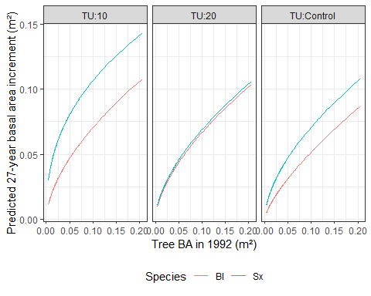

Figure 1: Predicted basal area (m2 at breast height) increment by tree basal area at time of treatment, species and treatment unit. Interactions between initial tree size, treatment unit and species were significant (p<0.001) in a linear model explaining 47.8% variation in basal area increment (not shown). Predictions are back-transformed to original response scale.

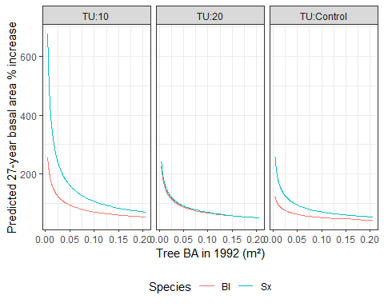

Figure 2: Predicted basal area (m2 at breast height) increment (cm), as a percentage of tree basal area at the time of treatment, by initial tree size. Interactions between initial tree size and (i) treatment unit and (ii) species factors were significant (p<0.001) in a linear model explaining 31.4% variation in basal area increment (not shown). Predictions are back-transformed to original response scale.

##### page break

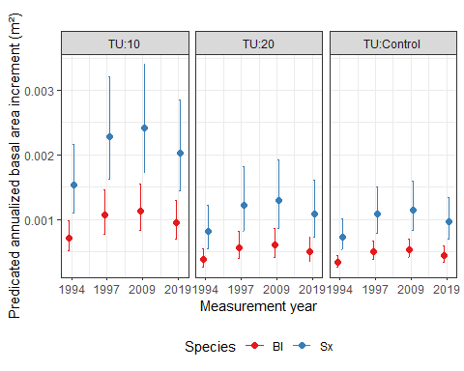

Figure 3: Predicted annualized basal area increment (m2 at breast height) over four periods from a linear mixed effects model explaining 23.9% variation in log-transformed basal area increment with period, treatment unit and species as fixed effects (p<0.001 for all fixed effects, now shown). Basal area increment are average for growing seasons within each period. For example, values at x-axis value of 1994 are mean for three growing seasons (between 1992 and 1994). Predictions are back-transformed to original response scale. Error bars represent 95% confidence intervals.

##### page break

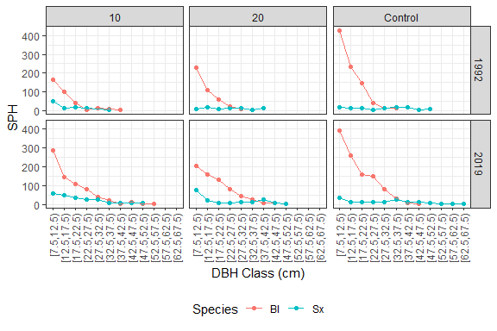

Figure 4: Mean density of stems per hectare (SPH) by diameter class and species, faceted by treatment unit and two measurement periods. Lowest value is included in each diameter class, highest value is not.

##### page break

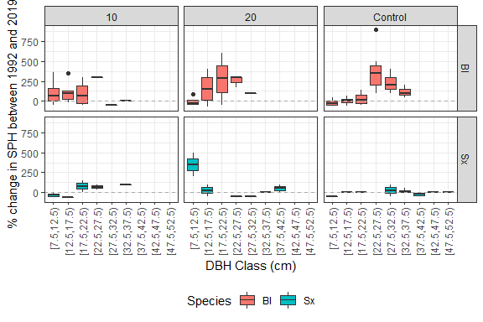

Figure 5: Percentage change between 1992 and 2019 in stems per hectare (SPH) by diameter class, faceted by treatment unit and species. Lowest value is included in each diameter class, highest value is not.

##### page break

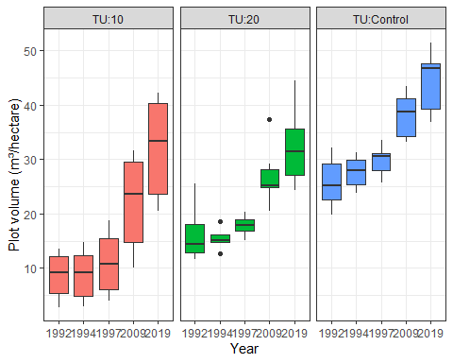

Figure 6: Variation in volume per plot (m³ per hectare) at five measurement years, faceted by treatment unit.

##### page break

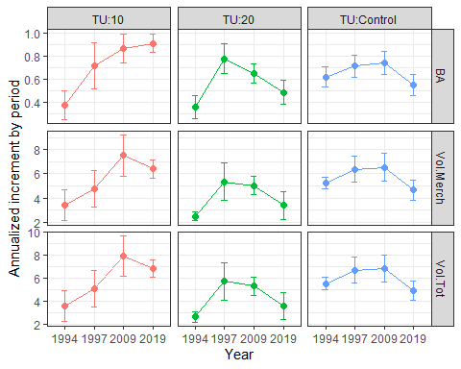

Figure 7: Mean annual increment per plot over four measurement periods. Top panel row shows basal area (BA), with units of m² per hectare. Middle panel row shows merchantable volume (Vol.Merch), and bottom panel row shows total volume (Vol.Tot). Volume units are m³ per hectare.

##### page break

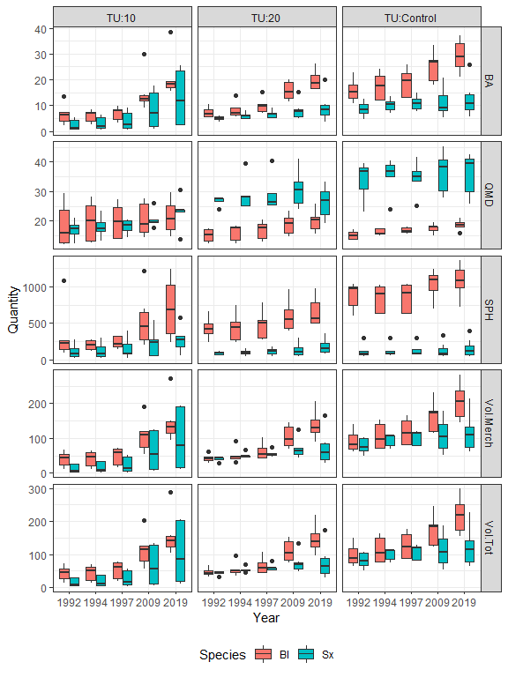

Figure 8: Among-plot variation in stand attributes, by species and faceted by treatment unit and attribute. Units are as follows: basal area (BA, m² per hectare); QMD (quadratic mean diameter,cm), trees per hectare (SPH, count), Merchantable volume (Vol.Merch, m³ per hectare); Total volume (Vol.Merch, m³ per hectare)

# Appendices

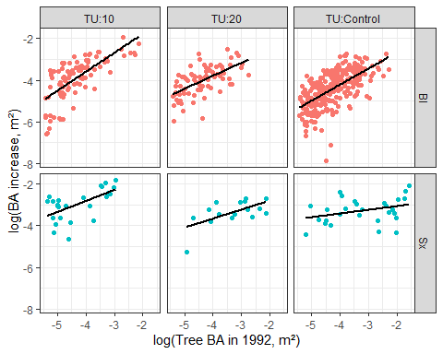

Appendix 1: Log-transformed basal area increment (m²) over 1992-2019 period by log-transformed tree size (basal area, m²) at the time of treatment, faceted by treatment unit and species. Both axes have been log-transformed. Linear regression lines added to emphasize slope.

##### page break

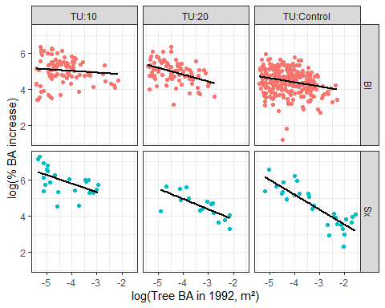

Appendix 2: Log-transformed basal area increment (m²), as a percentage of log-transformed initial tree size, over 1992-2019 period by tree size (basal area, m²) at the time of treatment, faceted by treatment unit and species. Both axes have been log-transformed. Linear regression lines added to emphasize slope.

##### page break

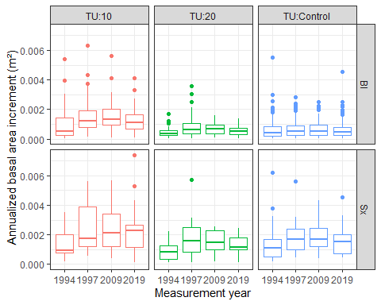

Appendix 3: Annualized basal area increment (m² at breast height) over four measurement periods. Boxplots show dispersion of mean growing season tree-level basal area increment within each period. Data are faceted by species and treatment unit.

##### page break

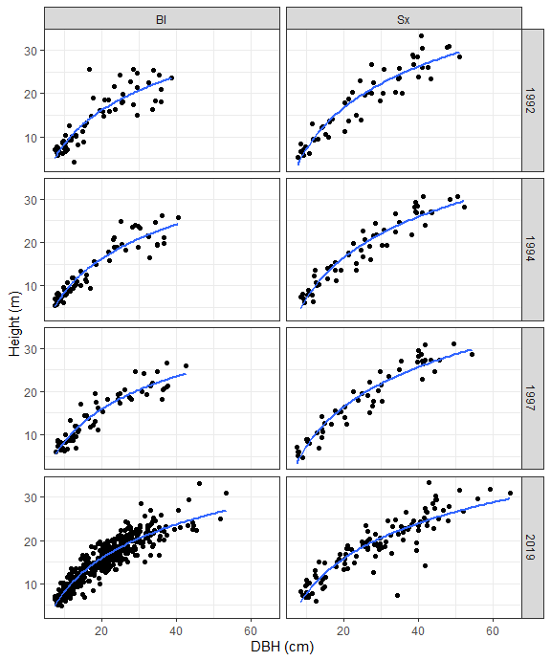

Appendix 4: Height and diameter comparisons for 870 tree measurements, faceted by species and measurement year.

##### page break

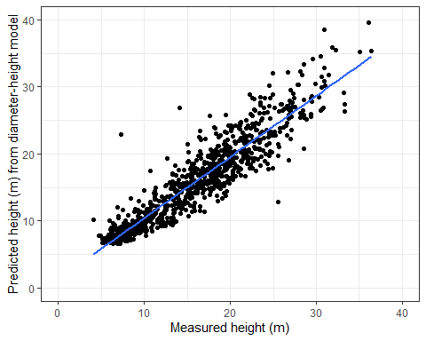

Appendix 5: Predicted height against measured height for 870 tree measurements. Outliers above the line may represent a tree with a broken top.

# References

Nakagawa, S., and Schielzeth, H. 2013. A general and simple method for obtaining R2 from generalized linear mixed-effects models. Methods in Ecology and Evolution **4**(2): 133–142. doi:[10.1111/j.2041-210x.2012.00261.x](https://doi.org/10.1111/j.2041-210x.2012.00261.x).

Nigh, G.D. 2016. Total and merchantable volume equations for common tree species in British Columbia by region and biogeoclimactic zone. BC Tech. Rep. 106. www. for. gov. bc. ca/hfd/pubs/Docs/Tr/Tr106. htm.