Manuscript_draft

Michael Jull and Hardy Griesbauer

10/12/2020

# To-do list

### Comments from Mike’s emails

we can put text below each comment to describe how it was addressed, and then delete comments for any issues once they are resolved.

#### Use of terminology

* The term “units” is used in several places, where it seems that you mean “treatments” (or treatment types, treatment unit).
* The use of the term “plot” or “plots” is used appropriately as far as I can see.
* The term “fir” is used to describe subalpine fir or ‘balsam’ in several parts of the text, including possibly figure and table captions. I know what species you are referring to, of course, but others, especially cursory readers, may misconstrue it. The colloquial use of ’fir" is spread across both Abies and Douglas-fir. “Balsam” as a term has well-documented ambiguities, and while Canadians tend to use balsam for Abies, Americans often call Abies “firs,” as in the various species of true fir. I would recommend using Abies as the shorthand descriptor in the text and captions for subalpine fir. It is a short word, and we have only 1 Abies species at this site. Also, my experience in the on-line-search literature world and with things like Google Scholar is that Abies is a much better and more diagnostic search word for this subject matter than fir or balsam. “Spruce-Abies” is very unambiguous as a descriptor for this forest type.
* Rate of change (increase, decrease) in vol, BA, and sph: In both in your stats tables and figure captions, and in the text narrative, ensure that what you are describing is clearly and accurately described as either: (a) the incremental change in values between two measurement periods, or (b) the difference in absolute value in certain parameters (e.g. standing volume) between two measurement periods, or between two treatments. Also, the annualized growth rate of something averaged over a measurement period (e.g. mean PBAI, like BA growth in m2/yr over a period) is different than the rate of change in a growth rate over time (e.g. is a growth rate increasing or decreasing). I got confused a few times on this issue.

### Commentary on sections and sub-sections

#### Section 3.1.1 BA increment from 1992 to 2019

* Great: Very clear and straightforward. i.e. - log-transformed treatment (initial BA) was a very statistically significant predictor of tree response across dbh classes for both Sx and Bl.
* Don’t know what all the random effects outputs are. I am sure they are meaningful, but I just dont know what they mean.
* Number of observations of 510: Should ensure it is clear that only trees > 7.5 cm dbh are counted.
* Would be good to define the dbh class limits somewhere. In Appendix 6 table, we describe the class mid-point.
* For Appendix 6, I assume that the null hypothesis for the ratio is = 1.

#### Section 3.1.2 Mortality

* I am thinking that mortality should / could be analysed as a frequency response - i.e. - expected vs actual distribution of mortality by size class and/or species. e.g. a Chi-squared or allied type of analysis. Null hypothesis is that mortality of stems is randomly distributed across different sizes and species of trees. H1 is that it is non-random.
* I’d suggest that we don’t compare total mortality (e.g # of stems) across treatment units, but rather frequency relative to initial number of stems (i.e. - at beginning of observation period). That way we normalize mortality rates relative to initial stem densities. Otherwise, results could be mis-leading - e.g. Control treatments could have more mortality in overall sph, simply because they have more initial stems.
* ACTION ITEM FOR ME: I need to check my original datasets and data sorting iterations to see how I handled mortality observations for the 1992 and 1994 plot remeasurements.
* Note for you: All of the mortality you’ve analysed and identified so far is mortality that is incremental following 92/94, so it is still solid analysis data, just with that qualification. I will clarify the 92/94 mortalilty observations for the Methods section; we did observe dead trees at these times, but these mortality pre-dated our treatments and/or first measurements. Anyway, probably not a big deal, but this needs examination and clarification to explain this. If necessary, I will quantify observations of dead trees observed on these years, because they are actually > 0.

Testing for density-dependence of mortality responses… some ideas or hypotheses.. Note that f (___) means “a function of”…

* MORT RATE of a size class = f (Sum of BA in that plot > than that size class). Would assume asymmetric competition where only bigger trees exert competition on smaller trees.
* MORT RATE of a size class = f ( Sum of BA in that plot that is either > or < that size class). Assumes symmetric competition where both big and small trees exert competition on their neighbors.

Caveats: (a) our plots and tree distributions might be too spatially variable to get a reliable test of these hypotheses, and (b) BA would be the BA at the beginning of a measurement period. And (c) a tree that died of suppression would probably show reduced growth rates prior to death; but trees that had abiotic damage and mortality - e.g. - snow or wind breakage - might not. Complicated stuff !!

#### 3.2.1 Estimating tree height from diameter

* Really solid stats and rationale for a single ht:dbh model. Great !
* What is really interesting and useful about this is that the ht:dbh relationship is seemingly statistically independent of treatment or, that is, initial density, A very useful simplifying assumption proven for future modellers of these stands. We should highlight this in either our results or discussion.

#### 3.2.2 Plot means

* See notes above about use of term “units” vs treatment (or similar).
* Clarify effects of treatment and/or species on growth rate vs standing vol / BA at each measurement period.
* A Figure 7b or equivalent could visually present changes in growth rate over time. (e.g. previous graphs we’ve developed)
* Under Observations, # 2 - the 2nd sentence needs work to edit and clarify.

#### 3.2.3 Stand attributes by diameter class

* We should define what we mean by the term inverse J or inverse J-shaped dbh distribution. Just for clarity.
* Should we quantitatively describe these distributions? Don’t have to, just asking the question.
* Is the merch limit for min merch tree size 18.5 cm dbh, or 17.5 cm dbh? I remember the latter from various cruises and cruise compilations.
* There are two Figure 2’s, one is for vol and one is for sph.
* Clarify in figures and text that sph is based on trees 7.5 cm dbh and greater. Increases in sph can be from ingress of trees growing from size classes below this limit.
* A suggestion: Have a table comparing total volume to merch volume by treatment, etc? Would be useful for some readers, and communicate MAI and volume growth rates too.

#### 3.2.4 Species composition

* First sentence: Clarify what you mean by “organized similarly.” Does this refer to frequency distribution ? What constitutes similarity?

#### Mortality

Last winter, as well as keeping reference copies of the initial “raw” dataset following data entry and related stuff, I kept copies each stage of data cleaning and prep (about 10 iterations).

We did have “dead tree” observations in the first ~ 2 year of monitoring. The key thing to see is : if I can determine is when the trees were dead, and/or when death was initiated, and why.  
Timing of tree death and observations of causal factors of tree death in these first two years will help inform our interpretation and data handling of these observations.

If trees were dead or moribund at the first “initial” observation or two (as soon after the logging as possible), this is – arguably - different than mortality that occurs over time in response to the basal area treatment and/or could be considered to be density- or treatment-dependent in some way.

The 1992 data was in mid-March really early after logging, and before snowmelt (in retrospect not a great idea but we had resources available before the end of the fiscal year at the time). The 1994 data was from when the plots were re-visited under snow-free conditions. We did a thinning and sanitation culling of trees in the treatment units and PSP’s in 1994 to remove logging-damaged trees and most deciduous, to bring the units and PSP’s down to their final treatment BA. 1994 remeasurements were completed after that.

A few plots, as you know, were established in 1994 not 1992.

Interpretive implications:

1. The very-early observed mortality may be a result of pre-existing stand conditions not the created, treatment-induced stand conditions. “stochastic” vs potentially treatment induced.
2. It can be argued that trees dead at time of treatment or very soon thereafter were never taking up growing space in the post-harvest stand, and therefore would not contribute to the initial “green” basal area going forward.
3. We do have 1992 data in most plots, but it was 1994 when the BA in each trmt unit and embedded PSP was finalized. 1994 is the most homogeneous start point for all PSP’s.

Regarding tree mortality in the period from 1992 to 1994 at Summit Lake EP 1162:

I reviewed our data regarding this, any relevant project records, and my own recollection of our monitoring of tree mortality during this period. Here is my train of thought, and what I have concluded on this topic:

1992 Observations and PSP establishment limitations

Trees that were dead at the time of the 1992 PSP establishment were not tagged or recorded. The rationale for this was that these trees were dead and therefore not taking up up growing space in the stands. Dead trees in 1992 would have been either snags / dead trees pre-existing the harvest, or trees fatally damaged or killed by logging activities (e.g. – trees with stems snapped and crowns broken off, no live limbs) or trees smashed to the ground by felled trees).

Summer 1994 sanitation treatment and Fall 1994 PSP Remeasurement

EP 1162 treatment units, including the PSP area contained therein, were assessed in Spring 1994 to review stand density / basal area, and stand condition, in order to:  
a) identify and mark-to-cut residual trees that were considered too badly scarred or damaged to constitute good growing stock for trial purposes, b) where needed, to lower the initial BA closer to the target level, c) to either fell or girdle birch trees, especially in the PSP’s themselves, but usually also within the TU as a whole, and d) to fell any dead, dangerous, and/or moribund trees within the treatment units and PSP’s. Generally most if not all of these trees felled in the sanitation felling were understory or subdominant trees, and occasionally a lower codominant tree. Tagged trees felled by the sanitation felling were documented on field sheets and our Excel datasets, so we can retrieve the species and size of these trees as needed. However, sanitation-felled trees included both live, moribund, and dead trees – generally all poorer quality or vigor though.

After felling, the felled trees were bucked to a 2 to 3 m length so as to lay these felled trees to as close to the ground as possibly, maximize decay, and minimize physical obstructions within the TU’s and PSP’s.

As a result of the sanitation felling, potentially some trees which died or were damaged between 1992 and Summer 1994 were felled without recording these mortality events and precise tree vigor beforehand. Some minor mortality occurred between 1992 and 94, but was obscured by the post-harvest sanitation treatment.

The 1994 Remeasurement occurred in Fall 1994, with a few plot remeasurements occurring in Winter 1994/95 (i.e. no intervening growing season).

For scientific rigour, we should not state that there was zero mortality between 1992 and 1994. Rather, I suggest, it is more accurate to state that data on tree mortalilty between 1992 and 1994 was not collected, and that the Summer 1994 sanitation felling treatment did not allow accurate documentation of tree mortality in this initial period on a retrospective basis.

We don’t, therefore, have data on mortality between 1992 and 1994, though my recollection is that it was minor in nature.

The difference in basal area between 1992 and 1994 is predominantly a product of the sanitation felling of some basal area, with minor natural mortality.

Mortality occurring between Fall 1994 and Fall 1997 remeasurements was captured accurately by these two sequential remeasurements.

“The difference in basal area between 1992 and 1994 is a result of basal area reductions through the sanitation felling of some stems and some minor natural mortality, combined with basal area increases through the growth of remaining live stems.”

A review of the various plots indicates that between 1992 and 1994, some PSP’s decreased in BA (as sanitation removals and minor mortality exceeded growth of live stems), while others increased in BA as tree growth exceeded BA removals.

* Is there any change in which sizes or size classes of trees die as stand volume increases? - e.g. is competition asymmetrical or symmetrical? Currently the y axis is total number of trees, I believe.
* Not sure if we have enough sample size of trees to look at species dynamics (Sx vs Bl).
* I am wondering if the same relationship that appears between volume and tree mortality, is mirrored in the relationship between BA and tree mortality. A bit more on this below…

Foresters (like me) do like to use BA per ha as a density measure for field planning and stand assessment because it seems to be broadly useful and is easily assessed via stand walkthroughs or plots. Sapwood BA is pretty well correlated with foliar biomass of the stand - a biological linkage. Tree BA is often correlated well with things like crown width.

I hadn’t thought alot previously about vol per ha as a density measurement, but it does have the characteristic of integrating not just BA, but also tree height, so it integrates tree growing space occupancy in both in horizontal dimensions (crown width and probably root spread) but also vertical. Vol ha theoretically provides more of a 3D measure of how the trees are occupying a given land area. The fact that volume is of commercial interest is a bonus. Key assumptions here: That trees are healthy and most importantly, crowns are health and growing relatively optimally relative to their growing space opportunities. Once crown vigor etc starts to decline with age, pests or pathogens, then the relationship could start to break down.

# Introduction

# Methods

This section will describe the methods we used for data analyses, not field data collection.

From our technical report submitted to FCI earlier:

Our data analyses and summaries examined the effects of the different levels of stand-level basal area density treatments on three main attributes of stand development following treatment. These include, in order:

1. Post-treatment stand basal area dynamics, including the rate and pattern of basal area re-growth and recovery over time following different levels of initial basal area density reductions;
2. Stand structural outcomes, including treatment influences on the overall abundance of trees (in sph) by diameter class, within the different treatment types, and;
3. Tree species composition outcomes, including treatment influences on the relative abundance and size class distributions of subalpine fir and hybrid white spruce within the different treatment types.

Analyses are grouped into three main categories (below). These are treated as separate categories in the Results section.

1. Tree-level responses to treatment;
2. Stand-level responses to treatment:

## Data analyses

### Tree-level growth responses

To test the hypothesis that tree-level radial growth response over the 1992-2019 period varied with interactions between (i) tree diameter at the time of treatment (1992); (ii) treatment; and (iii) species, we fit linear mixed effects models with log-transformed 1992-2019 diameter increment as the response variable, and treatment, species and log-transformed 1992 diameter as interacting fixed effects. To account for plot-level productivity differences, we included plot as a random intercept effect. Models were fit using the ‘lme4’ package for R [@]. We also fit a similar model with the 1992-2019 diameter increment expressed as a percentage of 1992 diameter. Plots of residuals and fit lines with orginal data were examined to evaluate model goodness of fit. Variance explained for each model are reported using the approach described in Nakagawa et al. (2013), as implemented in the MuMIn package for R (Barton 2009). Pairwise contrasts were performed using the ‘emmeans’ package for R [@] and Tukey HSD method of p value adjustment was used to control for multiplicity. We report all significant results at p<0.05.

### Stand-level growth and structure

#### Stand-level volume and basal area estimates

Total and merchantable volumes were estimated for trees using species- and region-specific equations (Nigh 2016) based on tree height and DBH. Consistent with forest management practices in British Columbia, we estimated volumes for trees meeting a minimum diameter utilization limit of 18.5cm DBH. For trees lacking a tree height measurement, we estimated height by fitting a single diameter-height model developed with a linear mixed effects model, with log-transformed DBH as a fixed effect, and tree nested within plot as random intercepts. Trees with broken tops were omitted from diameter-height models. We summed tree-level estimates of volume and basal area to generate stand-level estimates for each plot. To test the hypothesis that changes in stand attributes over 27 years varied by treatment, we fit separate linear models with stand total volume, basal area, and density as response variables, and the interaction between treatment and year as the independent variable.

#### Mortality

# Results

## Tree-level

### Basal area increment from 1992-2019

The tree-level basal area increment model indicated that interactions between log-transformed tree size, species and treatment explained 52.7% of the variation in log-transformed 1992-2019 tree-level BAI, and 37.8% of the variation in basal area increment as a percentage of tree size in 1992 (p<0.0001 for both, Table 1). Estimated marginal means from the model showed that between species and among treatments, basal area increment increased with tree size, meaning that larger trees increased basal area more than smaller trees (Figure 1), although smaller trees increased their size proportionally more than large trees (Figure 2). Species contrasts showed that spruce trees increased basal area significantly more than than fir in the high-removal and control treatment units, whereas basal growth between the two species was close to equal in the low-removal unit (Appendix 1). Within-species contrasts showed that spruce basal area increment in the high-removal unit exceeded spruce growth in both other units (Appendix 2), whereas fir basal area increment in the high- and low-removal units was higher than the control unit, and there were no significant differences between the two harvested units (Appendix 2).

## Stand-level analyses

### Tree height modeling

Tree heights had a positive nonlinear relationship with diameter, for both species and across all time periods (Appendix 3). We originally developed separate models for each species and time period, however, a comparison of height-diameter models showed that intercepts and slopes did not vary significantly (i.e., p>0.05) between species or time periods (not shown). Therefore, we developed a single height-diameter linear mixed-effects model using 870 tree height-diameter observations in the dataset. This model explained 86% of variation in log-transformed heights, with an intercept of 0.256 and slope coefficient of 0.814 * log-transformed DBH (not shown). Residual and predicted vs actual height plots were assessed to ensure goodness of fit (Appendix 4). Using this model, we generated height estimates for trees without height measurements, and then estimated tree total volume as per Nigh (2016).

### Plot means

### Rate of change from 1992 to 2019

All treatment units increased volume, basal area and stand density over the 1992-2019 period (Figure 3 and Appendix 5). Mean annual basal area and volume increment peaked during the 1997-2009 period in the two harvested treatments, and peaked in the 1994-1997 period in the control treatment unit (Figure 4). From 1992 to 2019, estimated marginal means of basal area increment in the low RBA unit exceeded marginal means in the high RBA and control unit by an estimated 8.4 and 7.8 m² per hectare, respectively (p<0.01 for both, Appendix 6).

The low RBA unit also significantly increased its stand density by an estimated 343 stems per hectare more than the control unit (p<0.001). The estimated rate of change in tree density did not differ significantly between the two harvested units. The rate of change in volume in trees over 18.5cm DBH was barely significant (p=0.049) between the two harvested units, and the difference was not significant between the control and harvested units.

### Stand attributes by year

By year, mean plot volume, basal area and stand density did not differ significantly between both harvested units (i.e., p>0.05, Appendix 7 and Figure 3). Contrasts between the high-removal and control treatment units showed that volume, basal area and stand density differences were highest and significant (i.e., p<0.05) in the 1992 measurement year, and these differences diminshed over each subsequent measurement year. In the 2019 measurement, volume and stand density were not significantly different between these two treatment units (i.e., p>0.05 for both). Contrasts between the low-removal and the control treatment units showed a similar trend with basal area and stand density; the control unit had significanly higher basal area and stand density means in 1992, but the difference between the units diminished over each subsequent measurement, becoming non-significant (i.e., p>0.05) in 2019. Plot means of volume did not differ significantly between the treatment units in any measurement year.

### Stand attributes by diameter class

Among treatments and throughout the stand development after treatment, the stands maintained a negative exponential (also referred to as ‘reverse-J’) diameter class distribution (Figure 5).  
Immediately after the partial harvest, the diameter class distribution of volume differed among treatments. In the 27 years since partial harvest, volume in all three treatment units was mostly concentrated in the 22.5-27.5cm DBH class, and mostly comprised of fir (Figure 6). Over both time periods shown in the figure and all three treatments, most of the spruce volume was concentrated in DBH classes spanning 37.5 to 47.5cm. Basal area trends were very similar to volume (not shown).

### Species composition

A comparison of proportional species composition by diameter class, treatment and year showed that fir and spruce volume proportion by diameter class varied similarly between the high RBA and control units (Figure 7). In 1992, the largest diameter classes were dominated by spruce, whereas fir was the dominant species in the smallest diameter classes. This pattern was also found for basal area and tree density (not shown). By 2019, the fir-spruce composition by distribution class was maintained in these two units, with small increases in spruce composition in the smallest diameter class.

In the low RBA, the species composition distribution by diameter class was different. Here, both fir and spruce maintained similar proportions across diameter classes smaller than 37.5cm DBH. Spruce formed the leading species in diameter classes above 37.5cm DBH, with the exception of the largest class.

## Mortality

A total of 95 trees (76 fir, 18 spruce, and 1 Douglas-fir) died in 17 plots from 1994 to 2019. The number of trees that died per plot from 1994 to 2019 increased significantly with plot basal area in 1994 (Figure 8, p < 0.0001). Similar linear models fitted separately for fir and spruce showed that fir mortality had a similar relationship to plot basal area, whereas spruce mortality did not (not shown). The diameter distribution of fir mortality followed a negative exponential distribution, with mortality concentrated in smaller diameter classes (Figure 9). Spruce mortality was concentrated in larger diameter classes. By treatment unit, the control unit had the highest mortality, whereas the high-removal treatment unit had the lowest mortality (Figure 10). The majority of mortality occured during the most recent measurement period of 2009-2019.

# Discussion

## Tree-level growth response to partial harvest

At the tree-level, our results suggest that while both hybrid white sruce and subalpine fir respond to thinning with faster radial growth, heavy thinning can elicit a stronger radial growth response in spruce, compared to fir. This coincides with our finding of proportionally higher spruce volume and basal area in the heavy thinning treatment in 2019, compared to the other treatments. Where thinning treatments in this region retain both species, removing a relatively high amount of the stand may favour spruce release. Other studies have shown that residual spruce growth responds favourably to heavy thinning. A 10-year analysis of white spruce growth underneath an aspen canopy found that a complete or high overstory removal resulted in immediate and significant spruce radial and height growth responses, compared to control and partial cutting treatments (Smith et al. 2016). In a 35-year old white spruce stand, diameter increment was maximized with the heaviest thinning intensity, however, the treatment thinning from below (Stiell 1970). Frank (1973) also showed that 70-year old white spruce basal increment increased with the amount of thinning. Competition for light is a key factor that limits white spruce growth, and opening up the stand to allow for increased light penetration may be a primary mechanism that enhances white spruce growth responses (Lieffers et al. 1999). High basal area removal may also increase air and soil temperatures, which can preferentially favour spruce growth responses compared to fir (Lajzerowicz et al. 2004).

Other comparative studies of spruce and fir growth rates present differing evidence regarding species differences in release potential to thinning. In mature Engelmann spruce (*Picea engelmannii*) – subalpine fir forests in western North America, understory spruce growth rates exceeded those of fir, allowing spruce to achieve canopy position faster, including after canopy gaps were created through disturbance (Antos et al. 2000, Andrus et al. 2018). In mature forest in central BC, spruce growth exceeded that of subalpine fir after age 80 (Eis and Craigdallie 1983). Because spruce tends to live longer than subalpine fir, higher growth rates at later ages may allow this species to become larger than fir. In contrast, thinning studies in spruce-fir forests in eastern North America report that balsam fir (*Abies balsamifera*) responds to release with faster height and diameter growth than co-occurring red spruce (*Picea rubens*) (Dumais and Prevost, 2007; Dumais et al. 2014, Messier et al. 1999). Although both species are similar in shade tolerance, firs are considered to be better adapted to low light conditions in the understory, allowing them to persist longer in undisturbed forest (Antos 2000) and potentially able to respond faster to changes in understory light (Dumais et al 2014, Messier et al. 1999). Other studies have found no difference in growth response between spruce and fir species after treatment (MCaughey and Smith1982). Our study also suggests that at lower levels of basal area removal, spruce and fir growth responses are similar.

In both species, post-treatment growth rates increased with the tree size at the time of treatment. This has been found in other studies as well. and is likely explained by the assymetric competition theory. Implications of this result are that growth increased from treatment will be concentrated in the larger tree size classes. If larger trees are able to increase their size faster than smaller trees and increase other metrics, such as crown size, to take advantage of increased growing space, then smaller trees will continue to experience competition and will not benefit as much from the thinning treatment. Forest managers should account for this size differential when planning thinning treatments. For example, a silviculture treatment that seeks to release a suppressed understorey may have to ensure that sufficient overstorey trees are removed to reduce assymetric competition after treatment.

## Management considerations

1. Both species responded with increased growth after partial harvest. High removal of basal area in these forests stimulated stronger spruce growth. This information can help silviculturists manipulate stand structure to preferentially …
2. Partial harvesting at both intensities delayed peak volume and basal area increment by approximately 10 years. Annual increment in the control unit declined faster over the last measurement period compared to previous periods, perhaps suggesting that the stand is becoming mature and losses due to mortality may substantially offset growth increment.

# Tables

Table 1: Summary of two mixed effects models of tree-level basal area increment

| Model | Fixed effects | | | | | | | | Random effects | | |
| --- | --- | --- | --- | --- | --- | --- | --- | --- | --- | --- | --- |
| Model | Term | Sum.Sq. | Mean.Sq. | Num.DF | Den.DF | Stat. | P value | R² | Group | Var. | St.Dev. |
| BAI | TU*Tree Size*Sp. | 171.56 | 28.59 | 6.00 | 76.19 | 69.62 | <0.00001 | 53 | Plot | 0.04 | 0.21 |
|  |  |  |  |  |  |  |  |  | Residual | 0.41 | 0.64 |
| BAI (%) | TU*Tree Size*Sp. | 61.85 | 10.31 | 6.00 | 76.19 | 25.10 | <0.00001 | 38 | Plot | 0.04 | 0.21 |
|  |  |  |  |  |  |  |  |  | Residual | 0.41 | 0.64 |

*The dependent variable in the first model (BAI) is tree basal area increment from 1992-2019. The dependent variable in the second model (BAI (%)) is basal area increment from 1992-2019 as a percentage of the tree’s basal area in 1992.*

Table 2: Output from three separate linear models testing the effect of the interaction between treatment and year on plot-level volume, basal area and density.

| Variable | Fixed effect | Sum sq. | Mean sq. | Num. DF | Den. DF | F value | p value |
| --- | --- | --- | --- | --- | --- | --- | --- |
| Volume | Treatment | 21307.4924 | 10653.74618 | 2 | 15.76347 | 7.33830 | 0.00559 |
| Year | 212868.1420 | 53217.03550 | 4 | 54.26783 | 36.65587 | 0.00000 |
| Trt*Year | 8889.2802 | 1111.16003 | 8 | 54.24833 | 0.76537 | 0.63439 |
| Basal area | Treatment | 287.1628 | 143.58142 | 2 | 15.80821 | 15.57412 | 0.00018 |
| Year | 3406.4763 | 851.61907 | 4 | 54.15210 | 92.37419 | 0.00000 |
| Trt*Year | 200.8116 | 25.10145 | 8 | 54.13842 | 2.72273 | 0.01344 |
| Stand density | Treatment | 256509.1431 | 128254.57153 | 2 | 15.69973 | 10.85007 | 0.00110 |
| Year | 1291513.9433 | 322878.48583 | 4 | 53.97516 | 27.31486 | 0.00000 |
| Trt*Year | 324226.3641 | 40528.29552 | 8 | 53.96395 | 3.42861 | 0.00294 |

*Trt, treatment; Sq., squares, Num., numerator; Den., denominator; DF, degrees of freedom*

# Figures

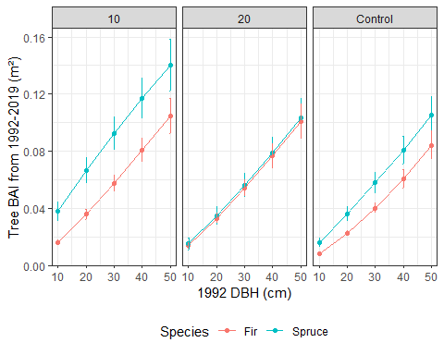

Figure 1: Estimated marginal means of spruce and fir basal area increment (m²) across five inital DBH classes and three treatments. Whiskers are standard error of the mean. Responses are back-transformed from the model. BAI, basal area increment

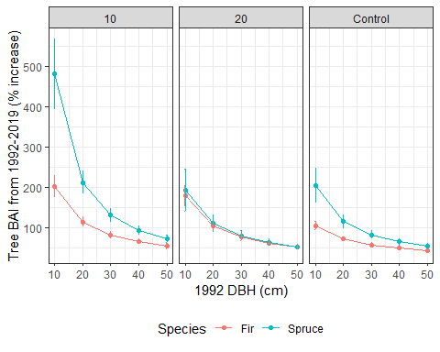

Figure 2: Estimated marginal means of spruce and fir basal area increment (expressed as a percentage increase relative to 1992 DBH) across five inital DBH classes and three treatments. Whiskers are standard error of the mean. Responses are back-transformed from the model. BAI, basal area increment

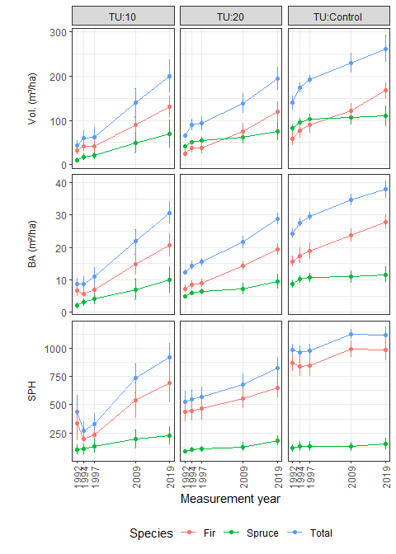

Figure 3: Mean plot live-tree attributes by treatment unit and year. Whiskers are one standard error of the mean. Vol., volume; BA, basal area; Tree dens., tree density

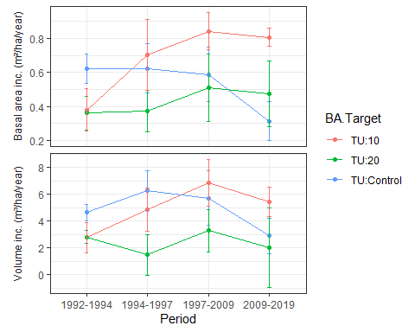

Figure 4: Mean plot annual increment over four measurement periods for basal area and volume, by treatment. Whiskers are one standard error of the mean. Inc, increment.

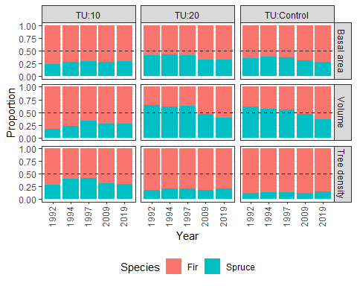

Figure 11: Mean proportion of spruce and fir basal area, volume, and tree density by treatment and year.

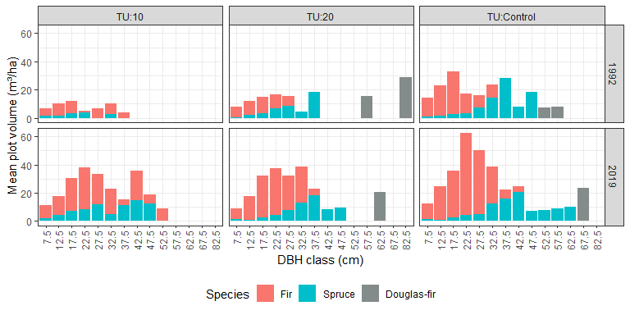

Figure 6: Diameter-class distribution of volume (m³/hectare) by species, treatment and year.Numbers identifying each diameter classes represent the lower size limit for that class. For example, trees in the 7.5cm DBH class are greater or equal to 7.5 and less than 12.5cm DBH.

*Note that in this figure, we show volume for all diameter classes. This is different than the stand-level estimate of volume, where we only estimate volume for trees that would be considered merchantable under conventional harvest in British Columbia (i.e., minimum 18.5cm DBH).*

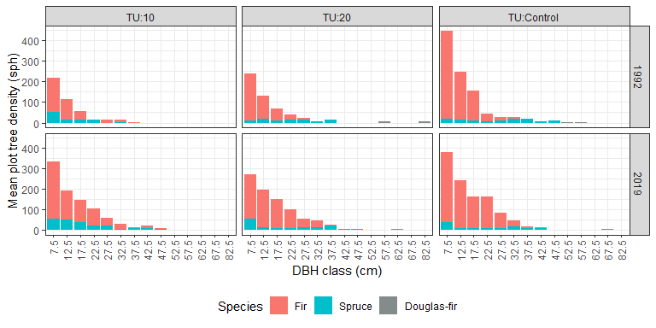

Figure 5: Diameter-class distribution of tree density (stems/hectare) by species, treatment and year.

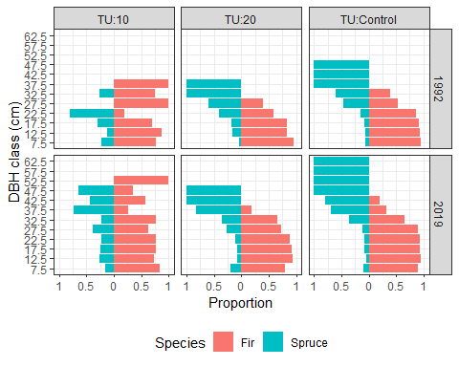

Figure 7: Spruce-fir volume proportional composition by diameter class, treatment and year.

*Note this figure is almost identical for compairsons of basal area, volume or tree density. For brevity, we only show basal area.*

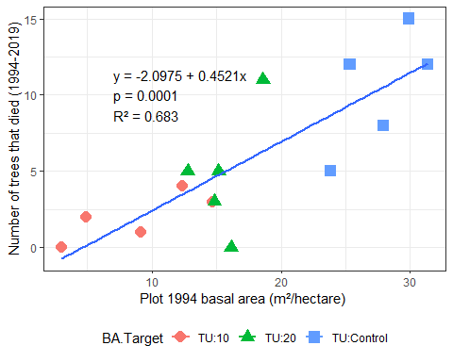

Figure 8: Total tree mortality over 1994-2019 period vs plot basal area in 1994. Plots are symbolized to show three treatment types.

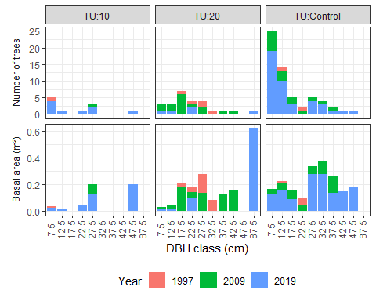

Figure 10: Total tree mortality recorded in plots from 1997-2019, presented as number of trees (top panel) and basal area (bottom panel). Numbers identifying each diameter classes represent the lower size limit for that class. For example, trees in the 7.5cm DBH class are greater or equal to 7.5 and less than 12.5cm DBH

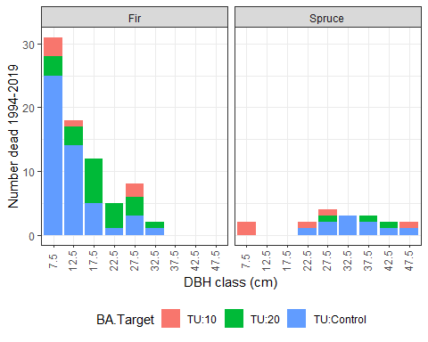

Figure 9: Fir and spruce mortality recorded in plots from 1997-2019, presented as number of trees, by diameter breast height class. Numbers identifying each diameter classes represent the lower size limit for that class. For example, trees in the 7.5cm DBH class are greater or equal to 7.5 and less than 12.5cm DBH.

# Appendices

Appendix 1: Contrasts between estimated marginal means of fir and spruce growth across treatment units and initial diameter classes. Ratio between predicted fir and growth is in ‘ratio’ column.

| contrast | BA.Target | df | t.ratio | p.value | DBH.1992 | ratio | SE |
| --- | --- | --- | --- | --- | --- | --- | --- |
| Fir / Spruce | 10 | 369.57 | -4.63 | 0.0000 | 10 | 0.42 | 0.08 |
| 20 | 0.54 | 0.07 |
| 30 | 0.62 | 0.06 |
| 40 | 0.69 | 0.06 |
| 50 | 0.75 | 0.05 |
| 20 | 502.32 | -0.28 | 0.7789 | 10 | 0.93 | 0.23 |
| 20 | 0.95 | 0.17 |
| 30 | 0.96 | 0.13 |
| 40 | 0.97 | 0.10 |
| 50 | 0.98 | 0.08 |
| Control | 498.90 | -3.42 | 0.0007 | 10 | 0.51 | 0.10 |
| 20 | 0.62 | 0.09 |
| 30 | 0.70 | 0.07 |
| 40 | 0.75 | 0.06 |
| 50 | 0.80 | 0.05 |

Appendix 2: Contrasts of predicted 1992-2019 tree growth among treatments within each species. Ratio of predicted growth between treatments is in ‘ratio’ column.

| Species | contrast | df | t.ratio | p.value | DBH.1992 | ratio | SE |
| --- | --- | --- | --- | --- | --- | --- | --- |
| Fir | 10 / 20 | 20.25 | 0.62 | 0.8135 | 10 | 1.12 | 0.21 |
| 20 | 1.09 | 0.15 |
| 30 | 1.07 | 0.11 |
| 40 | 1.05 | 0.09 |
| 50 | 1.04 | 0.07 |
| 10 / Control | 19.27 | 4.04 | 0.0019 | 10 | 1.93 | 0.32 |
| 20 | 1.60 | 0.19 |
| 30 | 1.43 | 0.13 |
| 40 | 1.33 | 0.09 |
| 50 | 1.25 | 0.07 |
| 20 / Control | 17.30 | 3.23 | 0.0129 | 10 | 1.72 | 0.29 |
| 20 | 1.47 | 0.18 |
| 30 | 1.34 | 0.12 |
| 40 | 1.26 | 0.09 |
| 50 | 1.20 | 0.07 |
| Spruce | 10 / 20 | 99.64 | 2.79 | 0.0171 | 10 | 2.50 | 0.82 |
| 20 | 1.92 | 0.45 |
| 30 | 1.65 | 0.30 |
| 40 | 1.48 | 0.21 |
| 50 | 1.36 | 0.15 |
| 10 / Control | 120.02 | 3.10 | 0.0067 | 10 | 2.37 | 0.66 |
| 20 | 1.85 | 0.37 |
| 30 | 1.60 | 0.24 |
| 40 | 1.45 | 0.17 |
| 50 | 1.34 | 0.12 |
| 20 / Control | 103.12 | -0.16 | 0.9859 | 10 | 0.95 | 0.32 |
| 20 | 0.96 | 0.23 |
| 30 | 0.97 | 0.18 |
| 40 | 0.98 | 0.14 |
| 50 | 0.98 | 0.11 |

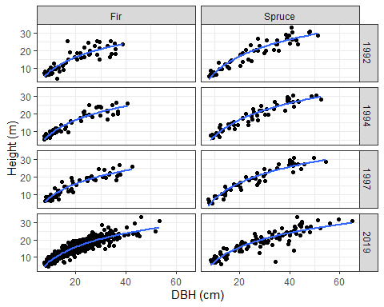

Appendix 3: Relationship between height (m) and diameter (cm) for trees with measured heights, by species and year.

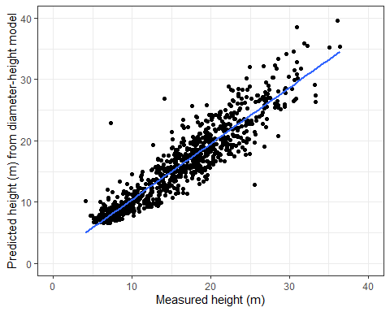

Appendix 4: Scatterplot of predicted height(m) vs actual height(m) from diameter-height model.

Appendix 5: Plot means of volume, basal area and stand density, by species, year and treatment.

| BA.Target | Year | Volume | BA | SPH | QMD |
| --- | --- | --- | --- | --- | --- |
| TU:10 | 1992 | 35.9 (12.2) | 8.6 (1.8) | 433 (141) | 17.4 (2.5) |
| TU:20 | 111 (32.6) | 16.5 (3.1) | 535 (91) | 20.3 (2.5) |
| TU:Control | 154.8 (16.2) | 25.8 (1.7) | 994 (56) | 18.2 (0.6) |
| TU:10 | 1994 | 47.5 (17.8) | 8.8 (2.2) | 324 (69) | 18.8 (2.7) |
| TU:20 | 102.8 (16.7) | 15.5 (0.9) | 548 (87) | 19.6 (1.7) |
| TU:Control | 173.9 (11.8) | 27.7 (1.4) | 964 (60) | 19.2 (0.3) |
| TU:10 | 1997 | 62 (21.9) | 10.9 (2.8) | 392 (90) | 18.7 (2.1) |
| TU:20 | 107.2 (18.9) | 16.6 (0.9) | 576 (86) | 19.8 (1.7) |
| TU:Control | 192.8 (8.8) | 29.5 (1.3) | 976 (60) | 19.7 (0.3) |
| TU:10 | 2009 | 139.6 (32.6) | 21.8 (3.6) | 733 (126) | 19.8 (1.9) |
| TU:20 | 184.8 (47.4) | 24.7 (3.1) | 687 (92) | 21.9 (2.1) |
| TU:Control | 253.6 (19.8) | 36.7 (2) | 1134 (51) | 20.3 (0.6) |
| TU:10 | 2019 | 199.3 (37.6) | 30.7 (3.5) | 913 (128) | 21.5 (2.1) |
| TU:20 | 207.2 (27.8) | 30 (1.6) | 830 (96) | 22 (1.6) |
| TU:Control | 285.5 (27.1) | 40.1 (2.8) | 1131 (73) | 21.3 (0.8) |

*Volume is m3/hectare, BA = basal area (m2/ha), SPH = stems per hectare, QMD = quadratic mean diameter (cm) at 1.3m height. Values in brackets are the standard error of the mean.*

Appendix 8: Plot means of mean annual volume, basal area and stand density increment, by species, period and treatment.

| BA.Target | Period | Volume | BA | SPH |
| --- | --- | --- | --- | --- |
| TU:10 | 1992-1994 (3) | 2.8 (1.2) | 0.4 (0.1) | 7 (2) |
| TU:20 | 2.8 (0.5) | 0.4 (0.1) | 13 (8) |
| TU:Control | 4.7 (0.6) | 0.6 (0.1) | 7 (2) |
| TU:10 | 1994-1997 (3) | 4.8 (1.6) | 0.7 (0.2) | 23 (9) |
| TU:20 | 1.5 (1.5) | 0.4 (0.1) | 9 (5) |
| TU:Control | 6.3 (1.5) | 0.6 (0.1) | 4 (2) |
| TU:10 | 1997-2009 (11) | 6.9 (1.7) | 0.8 (0.1) | 22 (4) |
| TU:20 | 3.3 (1.6) | 0.5 (0.2) | 13 (4) |
| TU:Control | 5.7 (2) | 0.6 (0.2) | 8 (4) |
| TU:10 | 2009-2019 (11) | 5.4 (1.1) | 0.8 (0.1) | 16 (10) |
| TU:20 | 2 (3) | 0.5 (0.2) | 13 (4) |
| TU:Control | 2.9 (1.3) | 0.3 (0.1) | 0 (3) |

*Volume is m3/hectare, BA = basal area (m2/ha), SPH = stems per hectare. Values in brackets in Period column are number of growing seasons in that period. Values in brackets in Volume, BA and SPH columns are the standard error of the mean.*

Appendix 7: Contrasts of stand attributes (volume, basal area and tree density) between treatments and by year. Contrasts are presented for five measurement years. SE, standard error, df, degrees freedom

| Contrast | Variable | Year | estimate | SE | df | t.ratio | p.value |
| --- | --- | --- | --- | --- | --- | --- | --- |
| TU:10 - TU:20 | Volume | 1992 | -74.98 | 38.56 | 34.53 | -1.94 | 0.14161 |
| 1994 | -72.26 | 38.24 | 33.59 | -1.89 | 0.15726 |
| 1997 | -62.15 | 38.24 | 33.59 | -1.63 | 0.24918 |
| 2009 | -45.15 | 36.55 | 29.27 | -1.24 | 0.44252 |
| 2019 | -7.84 | 36.55 | 29.27 | -0.21 | 0.97495 |
| Basal area | 1992 | -7.65 | 3.51 | 28.59 | -2.18 | 0.09233 |
| 1994 | -6.86 | 3.49 | 27.94 | -1.97 | 0.13919 |
| 1997 | -5.87 | 3.49 | 27.94 | -1.68 | 0.22959 |
| 2009 | -2.90 | 3.37 | 24.88 | -0.86 | 0.66991 |
| 2019 | 0.74 | 3.37 | 24.88 | 0.22 | 0.97395 |
| Stand density | 1992 | -75.60 | 136.51 | 26.05 | -0.55 | 0.84547 |
| 1994 | -113.12 | 135.78 | 25.54 | -0.83 | 0.68631 |
| 1997 | -73.12 | 135.78 | 25.54 | -0.54 | 0.85320 |
| 2009 | 46.67 | 131.90 | 23.06 | 0.35 | 0.93352 |
| 2019 | 83.33 | 131.90 | 23.06 | 0.63 | 0.80429 |
| TU:10 - TU:Control | Volume | 1992 | -118.94 | 35.22 | 29.27 | -3.38 | 0.00575 |
| 1994 | -124.18 | 37.56 | 35.52 | -3.31 | 0.00600 |
| 1997 | -128.51 | 37.56 | 35.52 | -3.42 | 0.00441 |
| 2009 | -113.99 | 35.22 | 29.27 | -3.24 | 0.00820 |
| 2019 | -86.15 | 35.22 | 29.27 | -2.45 | 0.05251 |
| Basal area | 1992 | -17.20 | 3.25 | 24.88 | -5.29 | 0.00005 |
| 1994 | -18.31 | 3.41 | 29.34 | -5.37 | 0.00003 |
| 1997 | -18.07 | 3.41 | 29.34 | -5.30 | 0.00003 |
| 2009 | -14.83 | 3.25 | 24.88 | -4.56 | 0.00033 |
| 2019 | -9.41 | 3.25 | 24.88 | -2.90 | 0.02050 |
| Stand density | 1992 | -560.95 | 127.10 | 23.06 | -4.41 | 0.00057 |
| 1994 | -621.78 | 132.51 | 26.68 | -4.69 | 0.00021 |
| 1997 | -565.78 | 132.51 | 26.68 | -4.27 | 0.00063 |
| 2009 | -400.95 | 127.10 | 23.06 | -3.15 | 0.01185 |
| 2019 | -218.10 | 127.10 | 23.06 | -1.72 | 0.22077 |
| TU:20 - TU:Control | Volume | 1992 | -43.96 | 37.30 | 34.93 | -1.18 | 0.47368 |
| 1994 | -51.91 | 37.57 | 35.53 | -1.38 | 0.36101 |
| 1997 | -66.36 | 37.57 | 35.53 | -1.77 | 0.19543 |
| 2009 | -68.84 | 35.22 | 29.27 | -1.95 | 0.14164 |
| 2019 | -78.31 | 35.22 | 29.27 | -2.22 | 0.08387 |
| Basal area | 1992 | -9.55 | 3.39 | 28.87 | -2.82 | 0.02294 |
| 1994 | -11.45 | 3.41 | 29.35 | -3.35 | 0.00606 |
| 1997 | -12.20 | 3.41 | 29.35 | -3.58 | 0.00343 |
| 2009 | -11.93 | 3.25 | 24.88 | -3.67 | 0.00319 |
| 2019 | -10.14 | 3.25 | 24.88 | -3.12 | 0.01209 |
| Stand density | 1992 | -485.36 | 131.88 | 26.28 | -3.68 | 0.00294 |
| 1994 | -508.66 | 132.53 | 26.69 | -3.84 | 0.00193 |
| 1997 | -492.66 | 132.53 | 26.69 | -3.72 | 0.00263 |
| 2009 | -447.62 | 127.10 | 23.06 | -3.52 | 0.00499 |
| 2019 | -301.43 | 127.10 | 23.06 | -2.37 | 0.06568 |

Appendix 6: Contrasts of 1992-2019 stand structure development over 1992-2019 between treatments. Contrasts are shown for three variables: volume, basal area and stand density.

| Variable | Treatment contrast | estimate | SE | df | t ratio | p value |
| --- | --- | --- | --- | --- | --- | --- |
| Volume | TU:10 - TU:20 | 67.133 | 33.445 | 54.436 | 2.007 | 0.04969 |
| TU:10 - TU:Control | 32.785 | 29.979 | 54.013 | 1.094 | 0.27899 |
| TU:20 - TU:Control | -34.348 | 32.395 | 54.464 | -1.060 | 0.29368 |
| Basal area | TU:10 - TU:20 | 8.385 | 2.666 | 54.298 | 3.145 | 0.00270 |
| TU:10 - TU:Control | 7.794 | 2.389 | 54.006 | 3.263 | 0.00192 |
| TU:20 - TU:Control | -0.591 | 2.583 | 54.318 | -0.229 | 0.81994 |
| Stand density | TU:10 - TU:20 | 158.930 | 95.492 | 54.240 | 1.664 | 0.10181 |
| TU:10 - TU:Control | 342.857 | 85.543 | 54.004 | 4.008 | 0.00019 |
| TU:20 - TU:Control | 183.927 | 92.498 | 54.256 | 1.988 | 0.05182 |

# References

Barton, K. 2009. MuMIn: multi-model inference. http://r-forge. r-project. org/projects/mumin/.

Lajzerowicz, C.C., Walters, M.B., Krasowski, M., and Massicotte, H.B. 2004. Light and temperature differentially colimit subalpine fir and Engelmann spruce seedling growth in partial-cut subalpine forests. Canadian Journal of Forest Research **34**(1): 249–260. doi:[10.1139/x03-198](https://doi.org/10.1139/x03-198).

Lieffers, V.J., Messier, C., Stadt, K.J., Gendron, F., and Comeau, P.G. 1999. Predicting and managing light in the understory of boreal forests. Canadian Journal of Forest Research **29**(6): 796–811. doi:[10.1139/x98-165](https://doi.org/10.1139/x98-165).

Nakagawa, S., and Schielzeth, H. 2013. A general and simple method for obtaining R2 from generalized linear mixed-effects models. Methods in Ecology and Evolution **4**(2): 133–142. doi:[10.1111/j.2041-210x.2012.00261.x](https://doi.org/10.1111/j.2041-210x.2012.00261.x).

Nigh, G.D. 2016. Total and merchantable volume equations for common tree species in British Columbia by region and biogeoclimactic zone. BC Tech. Rep. 106. www. for. gov. bc. ca/hfd/pubs/Docs/Tr/Tr106. htm.