Historical SAF planting analysis

Hardy Griesbauer

10/02/2020

## Historical analysis of SAF planting in northern BC

### Annual SAF planted by year in four regions

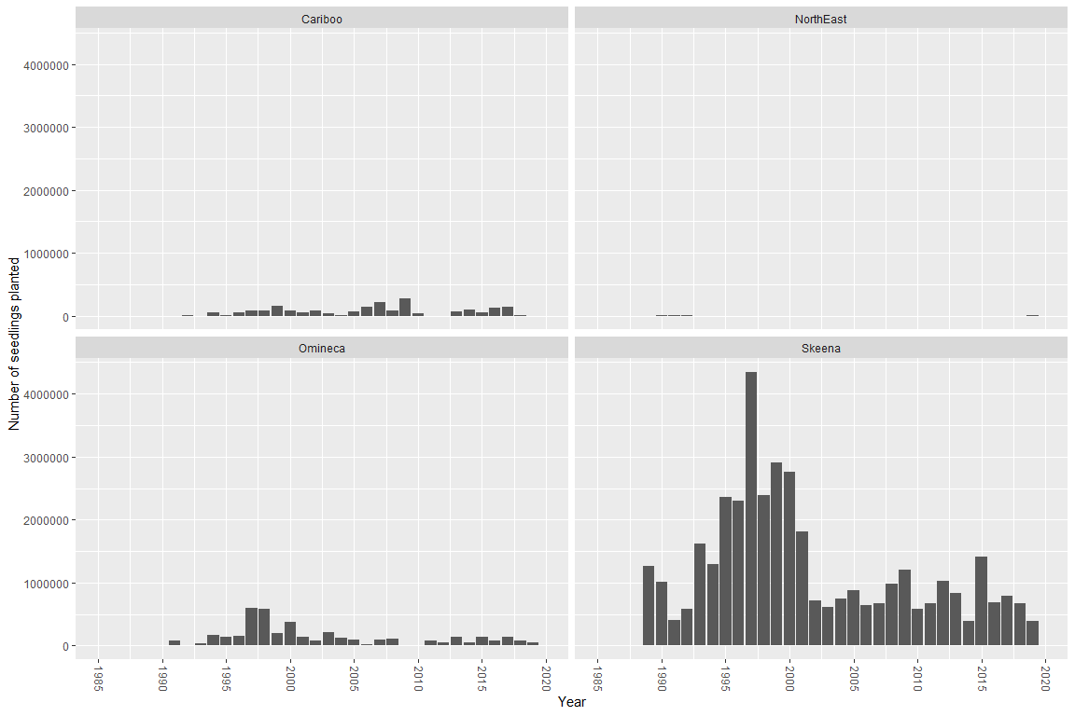

I kept the y-axis scaled the same for all regions to allow for better comparisons.

Figure shows that number of SAF planted in Skeena far exceeds number planted in other three regions.

Seems that SAF planting in all regions peaked between 1995 and 2000, and then dropped substantially around 2002.

We can zoom in on Omineca and Cariboo regions to see their numbers in more detail.

### Cariboo region

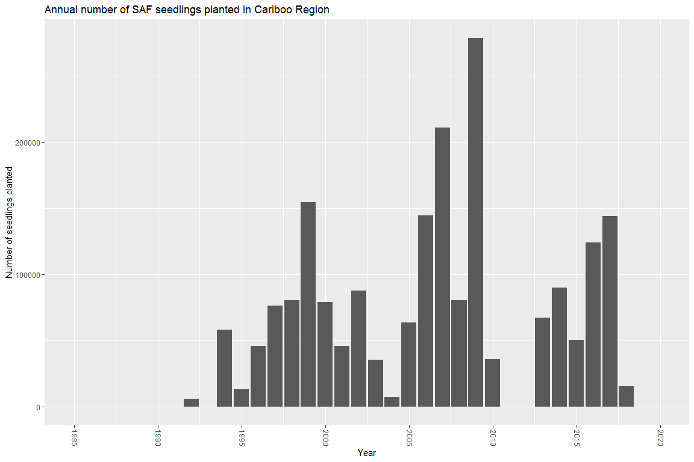

### Omineca Region

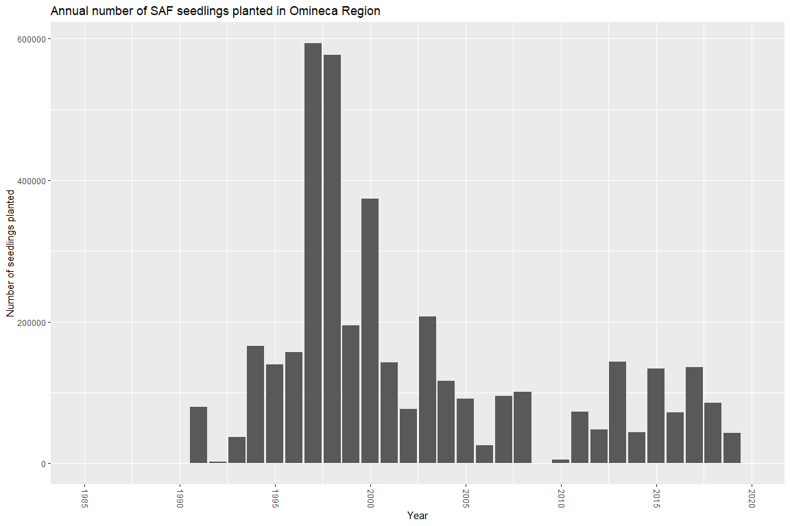

### Combined BA and BL planting in Skeena

Below is a figure showing annual planting in Skeena for both fir species (subalpine and amabalis).

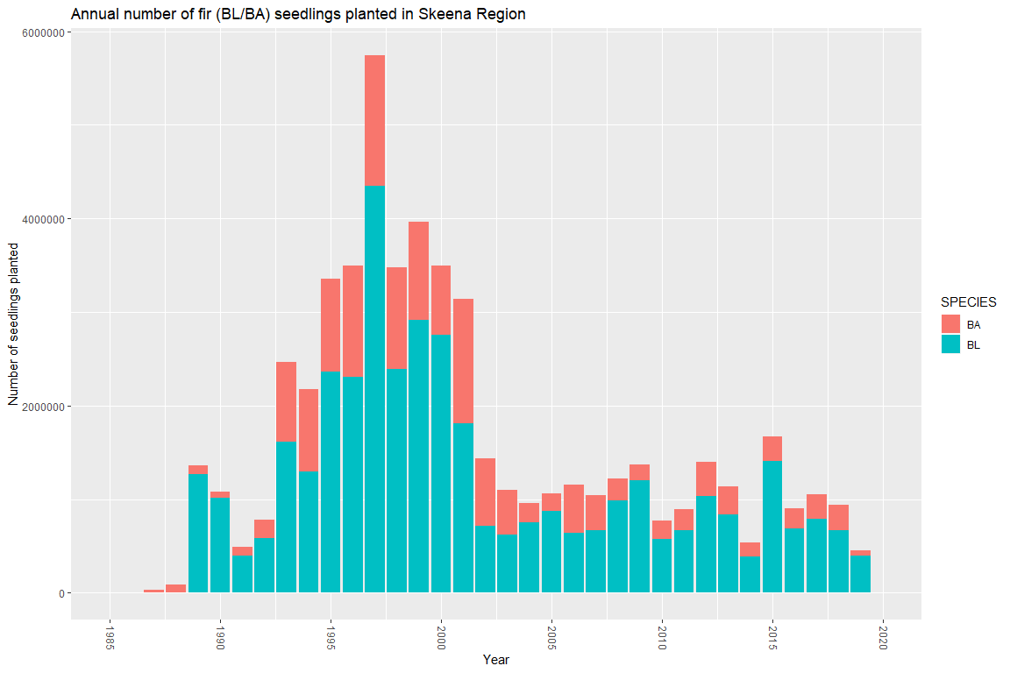

## Where are we planting SAF?

### Annual SAF planting by BGC unit categories

To show where SAF is being planted from an biogeoclimatic perspective, I created the following categories:

1. Wetbelt (ICH and SBSw/v subzones)
2. Sub-boreal/Boreal (SBS m/d subzones, BWBS); and
3. High-elevation (ESSF)
4. Coastal (CWH/MH)

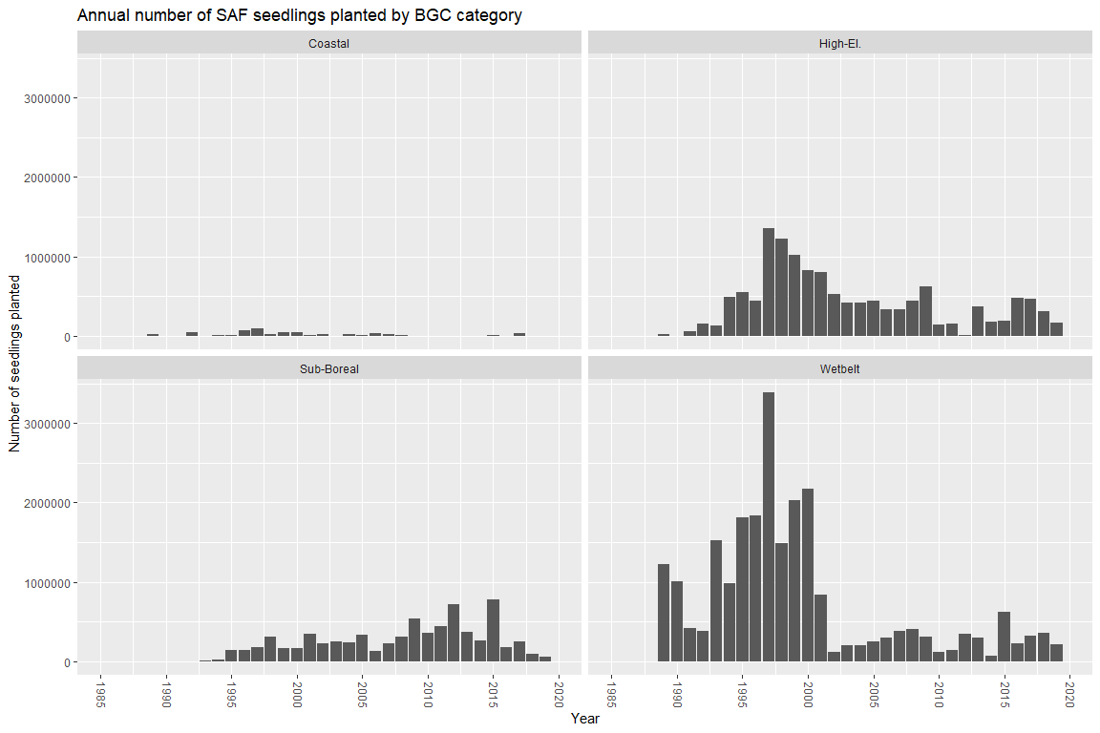

Most SAF seedlings in the 1990s were planted in wetbelt, but since ~2002 it look like equal amounts planted in sub-boreal, wetbelt and high-elevation units.

Just preliminary at this point. I can send the data itself for you to create your own figures, or could change the figures to suit the presentation. Whatever’s easier.

More to come!