Preliminary information on subalpine fir in the Omineca

Hardy Griesbauer

09/12/2019

### Some very preliminary historical data of SAF in the Omineca Region

Below are a few graphs from the RESULTS Species Monitoring planting, billed volume, and regenerated cover for SAF in the Omineca Region. These are just preliminary! I haven’t had a chance to closely examine the data yet for errors.

### File locations

All files and data are stored here: <https://github.com/hgriesbauer/treeSppROM>

### Data used for these analyses

I used the “Species Monitoring” datasets that were compiled using RESULTS data in February 2019. I used these datasets to produce many of the figures for my presentation on Douglas-fir at NSC 2019. For some reason, the link to the Species Monitoring website is broken. I will ask around to find the new URL so we can get more recent data (althought I imagine data current to February 2019 should suffice for now!).

### Subalpine fir planting in the Omineca Region

First, let’s look at historical planting of SAF.

romSpecies$plant %>%   
 filter(SPECIES_CATEGORY=="BL") %>%   
 group_by(DISTURBANCE_START_YEAR) %>% # Unfortunately, they only report disturbance year?   
 summarise(AREA=sum(SUMOFPRORATE_AREA)) %>% # summarize area planted  
 ggplot(aes(x=DISTURBANCE_START_YEAR,y=AREA))+ # start plotting call  
 geom_bar(stat="Identity")+ # Call for a bar plot  
 geom_smooth(method = "loess", se=F,span=0.3)+ # Add smoothed line  
 ylab("Prorated area (ha)")+ # Set y-axis label  
 xlab("Disturbance start year")+ # Set x-axis label  
 ggtitle(label="Area planted with SAF by disturbance year", subtitle = "Note that area is prorated")

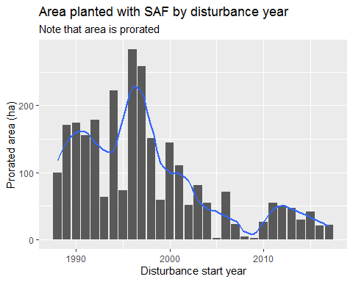

I believe prorated area = total polygon area * species %

### SAF billed volume by year

romSpecies$vol %>%   
 filter(SPECIES_CATEGORY=="BA") %>% # Filter for 'BA'   
 filter(BILLING_YEAR<2019) %>% # Remove 2019 from dataset, because year is incomplete  
 group_by(BILLING_YEAR) %>% # Unfortunately, they only report disturbance year?   
 summarise(VOL=sum(SPP_VOL)) %>% # summarize area planted  
 ggplot(aes(x=BILLING_YEAR,y=VOL))+ # start plotting call  
 geom_bar(stat="Identity")+ # Call for a bar plot  
 geom_smooth(method = "loess", se=F,span=0.3)+ # Add smoothed line  
 ylab("Volume (m^3)")+ # Set y-axis label  
 xlab("Billing year")+ # Set x-axis label  
 ggtitle(label="Billed SAF volume by billing year", subtitle = "Omineca Region")

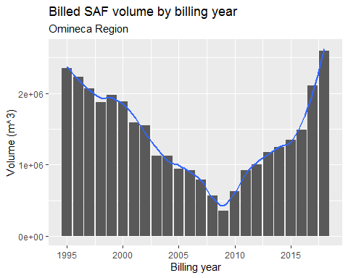

This graph seems strange, and tells me the data need to examined more closely. Could this perhaps reflect a shift from MPB salvage to other forest types ~ 2009? I will look into the actual Harvest Billing Dataset for more information. Would be good to look at annual reports too to see if they show a similar trend.

### Regenerated layer forest cover

The Species Monitoring datasets also have prorated areas for each species in regenerated areas, by BGC unit and Management Unit Type (TSA, TFL, TS Block, etc…). I wasn’t able to talk with someone about how this is calculated, but I assume it’s from silviculture labels? Without knowing how these data are generated, we probably don’t want to show them, but for interests’ sake, I produced one graph.

As an example, we can look at SAF area by Disturbance year:

romSpecies$regen %>%   
 filter(DESCRIPTION=="Balsam") %>% # Filter for 'BA'   
 filter(DISTURBANCE_START_YEAR<2019) %>% # Remove 2019 from dataset, because year is incomplete  
 group_by(DISTURBANCE_START_YEAR) %>% # Unfortunately, they only report disturbance year?   
 summarise(AREA=sum(SUMOFPRORATED_SPP_AREA)) %>% # summarize area regenerated  
 ggplot(aes(x=DISTURBANCE_START_YEAR,y=AREA))+ # start plotting call  
 geom_bar(stat="Identity")+ # Call for a bar plot  
 geom_smooth(method = "loess", se=F,span=0.3)+ # Add smoothed line  
 ylab("Prorated Area (ha)")+ # Set y-axis label  
 xlab("Disturbance year")+ # Set x-axis label  
 ggtitle(label="SAF prorated regenerated area by year", subtitle = "Across all BGC units, Omineca Region")+  
 xlim(1988,2018) # set same x axis limits as previous graphs

## Warning: Removed 2 rows containing missing values (geom_bar).

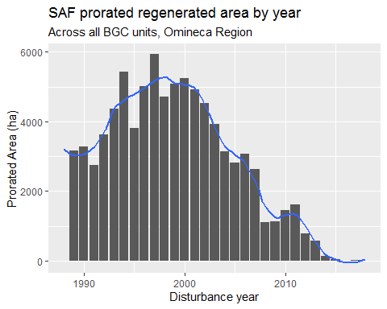

It looks like the dataset is missing data for years after around 2010. We see the same downward trend as planting and billed volume from ~1995 to 2010. There was likely an increase in Bl regenerated area after 2010, but the data are likely incomplete.

### Next steps

Look at actual harvest billing data Look at RESULTS planting dataset to get number of SAF planted per year Generate figures by BGC unit Other?