The Cost of Inaction
Adolescent Girls’ Education and Human Capital in Nepal
A policy analysis using the Nepal Living Standards Survey IV (2022/23)
Hernando Grueso, PhD
UNICEF
June 2026

Executive Summary
Nepal has made a great progress in getting girls into school. Today, adolescent girls are enrolled at higher rates than boys (40.2 per cent versus 34.8 per cent). Yet this progress in the classroom does not carry through to the labour market. Nearly half of adolescent girls aged 15–24 (46.8 per cent), are not in education, employment, or training (NEET), almost double the rate for boys (26.4 per cent). The gender gap in Nepal is no longer primarily a problem of school access, it is a problem of the transition from school to economic opportunity.
This analysis quantifies the economic cost of that lost transition. Using nationally representative microdata from the Nepal Living Standards Survey IV (NLSS IV, 2022/23) and a combination of econometrics and causal machine-learning, we estimate that Nepal forgoes approximately NPR 8.1 billion (about USD 61 million) in lifetime productivity for every single cohort of adolescent girls who do not complete secondary education. A new cohort reaches this stage every year, so this is a recurring annual loss, not a one-off. To place that figure in perspective, this is equivalent to roughly 9.4 per cent of Nepal’s annual health-sector budget, 7.6 per cent of the social security allowance budget, and 4.0 per cent of the education-sector budget.
Three policy insights stand out from these findings:
- Child marriage is the single most powerful driver of exclusion. Being currently married is associated with a 61-percentage-point fall in enrolment and a 42-point rise in NEET, larger than the combined association of poverty, caste, and disability. The share of girls who are married jumps from 10% at ages 15–18 to 56% at ages 19–24.
- Secondary education has a robust, stable effect on inclusion. Completing secondary school is associated with a 13.2-percentage-point reduction in the probability of being NEET, and this effect is stable across all seven provinces and all caste groups.
- The returns to schooling rise steeply with each level. Each additional year of schooling is associated with a 14.5 per cent average increase in earnings for girls, and these returns are convex, rising from about 8% at primary, to 27% at secondary, and 35% at higher secondary.
The policy implication is clear: Nepal’s next frontier is not only to get girls into school, but to keep them in school long enough for education to change their life trajectories. Investments need to reach girls before the post-18 transition, when the risks of marriage, dropout, and labour-market exclusion accelerate sharply. This means rewarding every additional year of schooling retained, with particular emphasis on secondary and higher secondary completion.
At the same time, education policy cannot be separated from child marriage prevention. Reducing child marriage is not only a protection objective, it is also central to education, employment, and economic growth. The findings show that marriage is one of the strongest predictors of girls’ exclusion from both school and work. Interventions that keep girls in school, delay marriage, support families, and expand adolescent girls’ aspirations should therefore be treated as mutually reinforcing components of the same investment agenda.
Finally, secondary education must be paired with credible pathways into economic opportunity. Girls need not only to complete school, but also to see a viable transition into skills, employment, entrepreneurship, and further learning. Without this, Nepal risks sustaining high levels of female enrolment while continuing to lose the economic returns of girls’ education.

1. Introduction and Motivation
Investing in girls’ education is among the most widely-evidenced development priorities in the world. The case is usually made in terms of rights and long-run social benefits. This report makes the case in the language of public finance: what does Nepal lose, in measurable economic terms, when adolescent girls do not complete secondary education and do not transition into productive economic activity?
The motivation is both moral and fiscal. Nepal’s Constitution guarantees education as a fundamental right, and the country has committed to the Sustainable Development Goals. But for a Ministry of Finance weighing competing claims on a constrained budget, the relevant question is concrete: is closing the gender gap in the school-to-work transition an expenditure, or an investment with a positive return? This analysis is designed to answer that question with defensible numbers.
This work follows the methodology of UNICEF’s cost-of-inaction analyses in other contexts —notably the Cost of Inaction: Girls’ Education in Afghanistan (2022) and Nepal’s own Cost of Inaction of Child Marriage (2014)— while adapting the approach to Nepal’s current data and using more recent causal-inference techniques.

2. Data
The analysis uses the Nepal Living Standards Survey IV (NLSS IV), 2022/23, produced by the National Statistics Office (NSO) of Nepal. The NLSS IV is a nationally representative, two-stage stratified household survey covering all seven provinces. It interviewed 46,870 individuals in 9,600 households.
The core analytical sample is 9,785 youth aged 15–24 (4,919 girls and 4,866 boys). For the econometric analyses we use the broader sample of 13,586 women aged 15–64. All estimates use the survey’s sampling weights and account for its complex design (primary sampling units and provincial strata).
Key variables include school enrolment and attainment (NLSS education module), employment and NEET status (defined using the ILO seven-day reference period), monthly wages, marital status, caste and ethnicity (grouped as Brahmin/Chhetri, Janajati, Dalit, and Religious/Linguistic minorities), disability status (Washington Group questions), wealth quintile, and province of residence.

3. Methodology and Key Assumptions

The analysis combines three methodological approaches designed to measure gaps, estimate the returns to education, and value lost earnings. Below is a summary of the key aspects of these methods, full technical details are included in the Annex.

3.1 Measuring the gaps
We first document the size and structure of the gender gap using descriptive statistics and a multivariate (linear probability) regression that isolates the independent association of each factor (marriage, caste, wealth, disability, geography) with enrolment and NEET status.

3.2 Estimating the effects of education
To estimate the effect of secondary education on the probability of being NEET, we use a causal forest (a machine-learning method for estimating causal effects, Wager and Athey 2018). This approach allows the effect of education to vary across individuals and groups, and provides a credible average treatment effect that is more robust than a simple correlation.

3.3 Valuing the lost earnings
To translate education into economic value, we estimate a Mincer wage equation, the standard tool in labour economics relating wages to years of schooling and experience. Because wages are observed only for women in paid employment (about 25% of working-age women), we test for selection bias using a Heckman selection model. The selection term is statistically significant but changes the estimated return by less than two percentage points, confirming that the wage estimates are robust (see Annex).

3.4 Key assumptions and limitations
Three assumptions are central to interpreting the cost-of-inaction figure, and we state them plainly so that the estimate is not over-read:
- Formal-sector focus. Wage returns are estimated on women in paid employment, who are a minority of all working-age women. The analysis captures the economic-productivity loss associated with formal labour-market engagement; it does not value unpaid or subsistence work.
- Labour-market entry. The break-even and cost figures assume that a girl who completes secondary education enters the labour market and earns the median wage. In reality not all will, so the figures describe potential economic value, not a guaranteed return.
- An upper bound, not a lower bound. Because the estimate assumes a girl who exits NEET earns the median wage immediately — with no friction from job search, childcare, mobility, or social norms — it should be read as an upper bound on what is realistically recoverable, not a floor.
We also use a deliberately conservative wage-return benchmark of 9 per cent per year of schooling (the International Labour Organization’s standard benchmark) for the headline cost calculation, rather than our own higher estimates. As the Annex shows, this 9 per cent figure sits below even the primary-school return we estimate, which makes the resulting cost a conservative one.

4. Findings

4.1 The gap is in the labour market, not the classroom
Girls in Nepal now enrol in school at higher rates than boys, but are far more likely to be excluded from both school and work as they reach adulthood. The female NEET rate of 46.8 per cent is nearly double the male rate, and the gap widens with age — from about 9 percentage points at ages 15–18 to almost 25 points at ages 19–24.
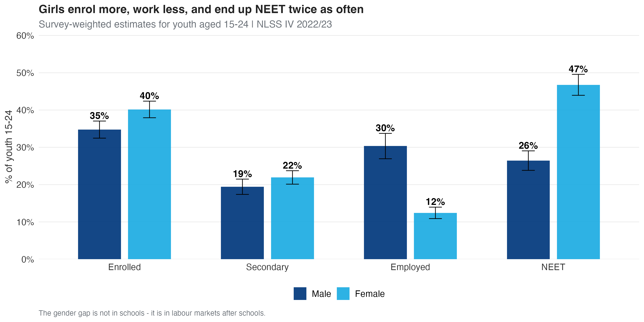
Figure 1. Enrolment, employment, and NEET by sex, youth aged 15–24. Source: Author’s calculations, NLSS IV 2022/23.
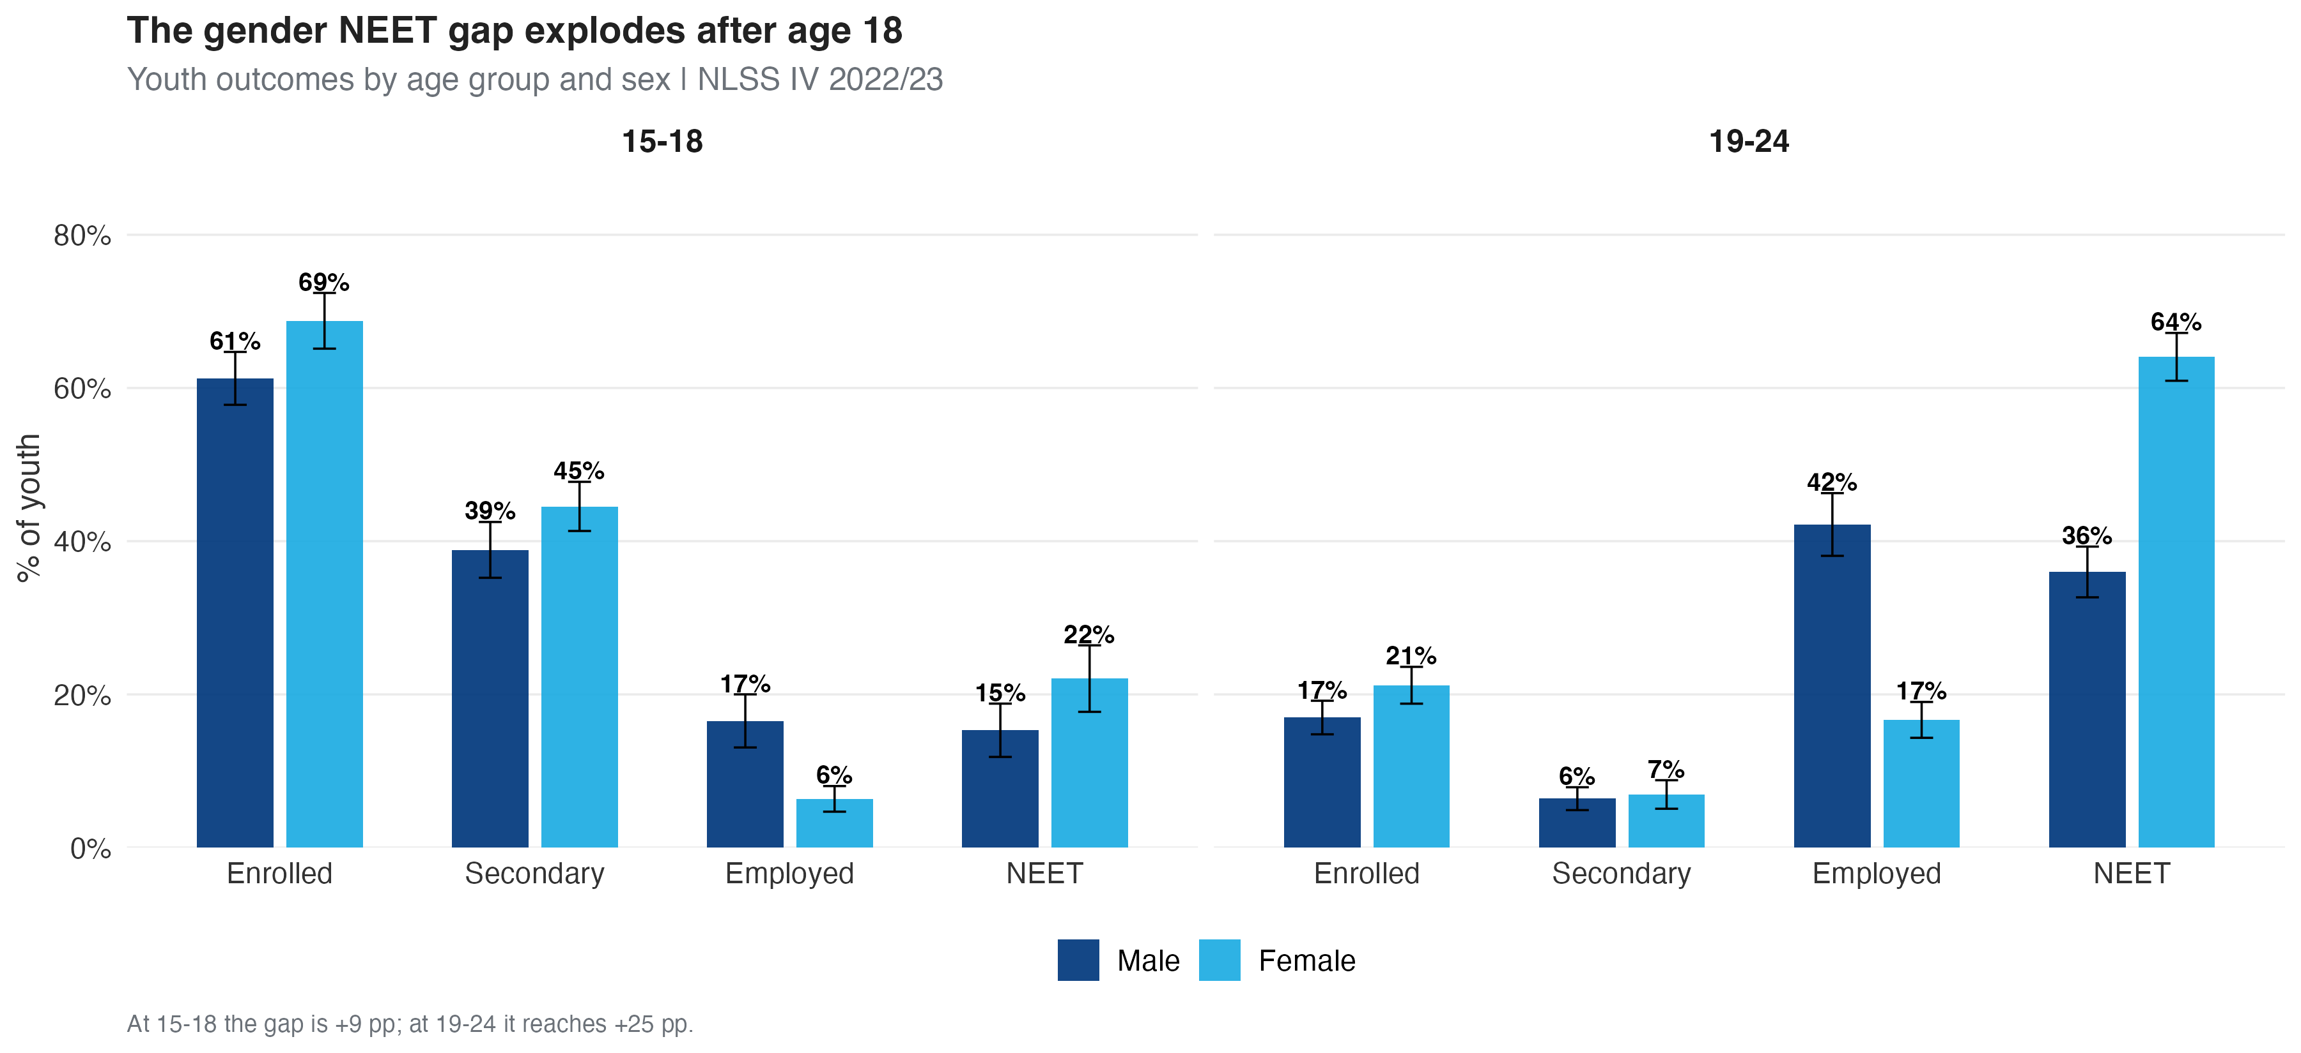
Figure 2. Youth outcomes by age group and sex. The NEET gap widens sharply after age 18. Source: Author’s calculations, NLSS IV 2022/23.

4.2 Child marriage is the strongest driver of exclusion
Among all the factors we examine, marital status has by far the largest association with girls’ exclusion. Being currently married is associated with a 61-percentage-point reduction in enrolment and a 42-point increase in NEET, after controlling for poverty, caste, geography, and disability. This pattern holds across every caste group.
Crucially, the prevalence of marriage changes dramatically across the adolescent years: 10 per cent of girls aged 15–18 are married, rising to 56 per cent by ages 19–24. The divergence in outcomes happens at this transition — which is why interventions need to reach girls before they reach it.
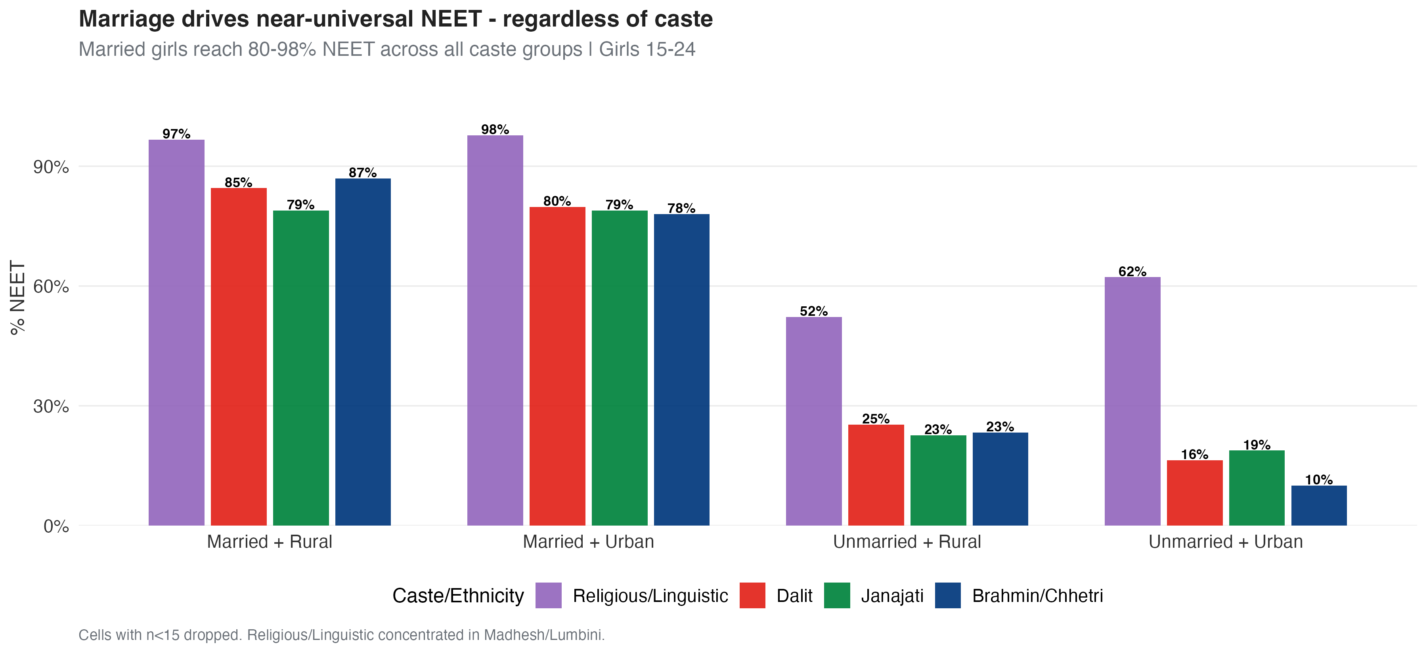
Figure 3. NEET rate by marital status and caste, girls 15–24. Marriage is associated with near-universal NEET across all groups. Source: Author’s calculations, NLSS IV 2022/23.
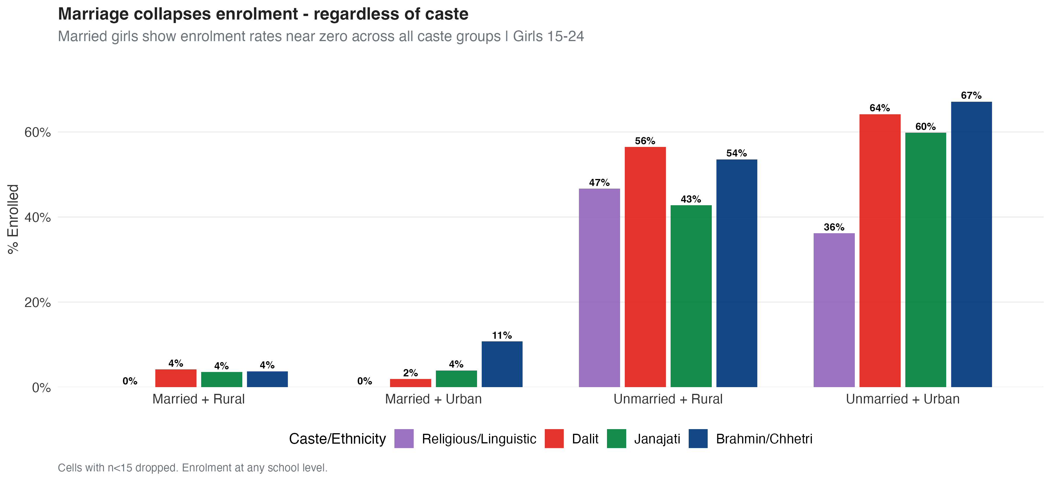
Figure 4. Enrolment by marital status and caste, girls 15–24. Source: Author’s calculations, NLSS IV 2022/23.

4.3 Education works — everywhere
The causal-forest analysis shows that completing secondary education is associated with a 13.2-percentage-point reduction in the probability of being NEET for women aged 15–64. This effect is remarkably stable: it holds across all seven provinces and all caste groups, indicating that education is a reliable lever for inclusion regardless of where a girl lives or which community she belongs to.
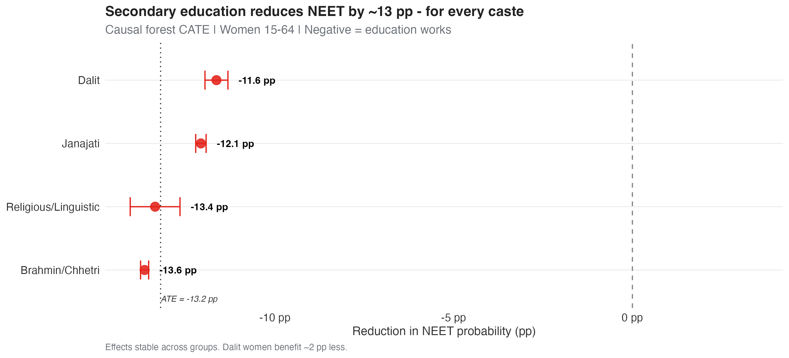
Figure 5. Estimated effect of secondary completion on NEET probability, by caste. Source: Author’s calculations, NLSS IV 2022/23.

4.4 The returns to schooling rise with each level
Each additional year of schooling is associated with a 14.5 per cent average increase in girls’ lifetime earnings. Critically, these returns are convex — they rise with the level of education, from roughly 8 per cent at primary, to 27 per cent at secondary, to 35 per cent at higher secondary. This means the economic loss from a girl leaving school is greatest precisely at the upper-secondary level, where Nepal’s gender gap in the school-to-work transition is widening.
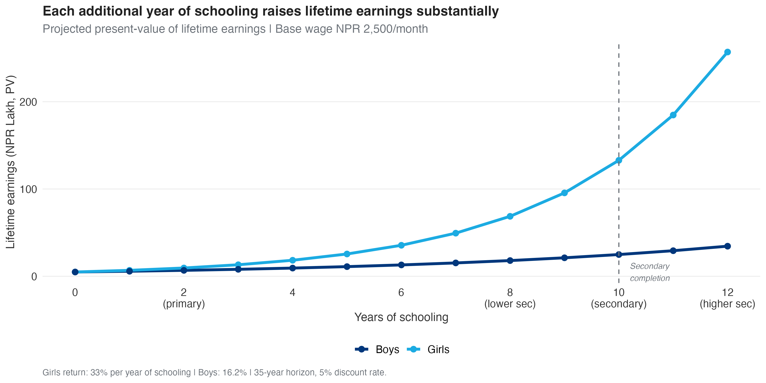
Figure 6. Projected lifetime earnings by years of schooling and sex. Source: Author’s calculations, NLSS IV 2022/23.

4.5 The cost of inaction
Combining the causal effect of education, the conservative wage return, and the size of the affected population (680,231 girls), we estimate that Nepal forgoes approximately NPR 8.1 billion (about USD 61 million) in lifetime productivity for each cohort of adolescent girls who do not complete secondary education.
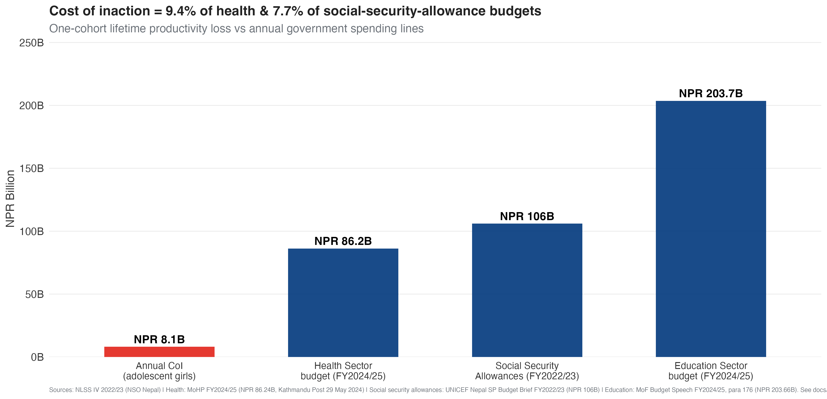
Figure 7. The annual cost of inaction compared with national budget lines. Sources: This analysis (NLSS IV 2022/23); health budget MoHP FY2024/25; social security allowances UNICEF Nepal FY2022/23; education budget MoF FY2024/25. See source notes.
This figure is equivalent to about 9.4 per cent of the annual health-sector budget, 7.6 per cent of the social security allowance budget, and 4.0 per cent of the education budget. It excludes the substantial non-market benefits of girls’ education — lower fertility, better child health, reduced adolescent pregnancy, and intergenerational gains — and so understates the true cost.

5. Policy Recommendations
The findings point to four priority areas for investment. They are complementary: education alone is necessary but not sufficient, because the binding constraints — marriage and the absence of economic opportunity — sit outside the classroom.
- Education — universal secondary completion with year-by-year retention. Because returns are convex, programmes should reward every year of schooling retained, with the largest gains concentrated at upper-secondary and tertiary level. Conditional support should target retention through the post-18 transition.
- Child marriage — treat prevention as an economic priority. Marriage is the single largest driver of girls’ exclusion, and its prevalence rises sharply after age 18. Enforcement of existing legislation, concentrated in the provinces with the widest gaps (Madhesh and Lumbini), should reach girls before the transition.
- Livelihoods — bridge programmes, vocational training, and economic opportunity. Because returns are concentrated in formal wage work, which absorbs only a minority of women, education must be paired with demand-side measures: skills bridges from school to work, vocational training, and second-chance pathways for those who have already left.
- Equity — close the gaps facing Dalit girls. Education alone leaves Dalit women with a residual labour-market disadvantage. Pair education investment with apprenticeships, targeted scholarships, and anti-discrimination measures.
Taken together, these investments are strongly cost-effective. Any secondary-completion programme costing less than the per-girl break-even — on the order of USD 90 in cumulative lifetime social spending — would yield a positive economic return in pure productivity terms, before counting the substantial health, fertility, and intergenerational benefits that this analysis does not monetise.

Annex: Technical Detail

A.1 The causal-forest estimate
The effect of secondary education on NEET status is estimated using a generalised random forest (Wager and Athey 2018) on the sample of women aged 15–64 (n = 13,586). The treatment is secondary completion; the outcome is NEET status; controls include age, marriage, caste, wealth, disability, and province. The estimated average treatment effect is a reduction of 13.2 percentage points in NEET probability, stable across provinces and caste groups. This design addresses selection on observable characteristics; it is not a randomised experiment, and residual unobserved confounding cannot be fully excluded.

A.2 The Mincer wage equation and Heckman selection model
Wage returns are estimated from a Mincer equation regressing log monthly wages on years of schooling (centred, with a quadratic term), experience, experience squared, and controls for rural residence, caste, and province, using survey weights and heteroskedasticity-robust (HC1) standard errors. The quadratic term captures the convexity of returns.
Because wages are observed only for the approximately 25 per cent of working-age women in paid employment, we test for sample-selection bias using a Heckman (1979) two-step model. The selection equation models the probability of being observed in the wage sample, with exclusion restrictions — the number of children under five in the household, the number of other adult women, household size, and wealth quintile — that plausibly affect labour-market participation but not the wage itself.
Result: the selection term is statistically significant (correlation ρ = 0.34; inverse Mills ratio p < 0.01), confirming positive selection into wage work. However, correcting for selection shifts the estimated return by less than two percentage points. The Mincer estimates are therefore robust to selection. This addresses only selection into observed wages; it is not a causal-identification claim for schooling, which rests on the causal-forest design above.
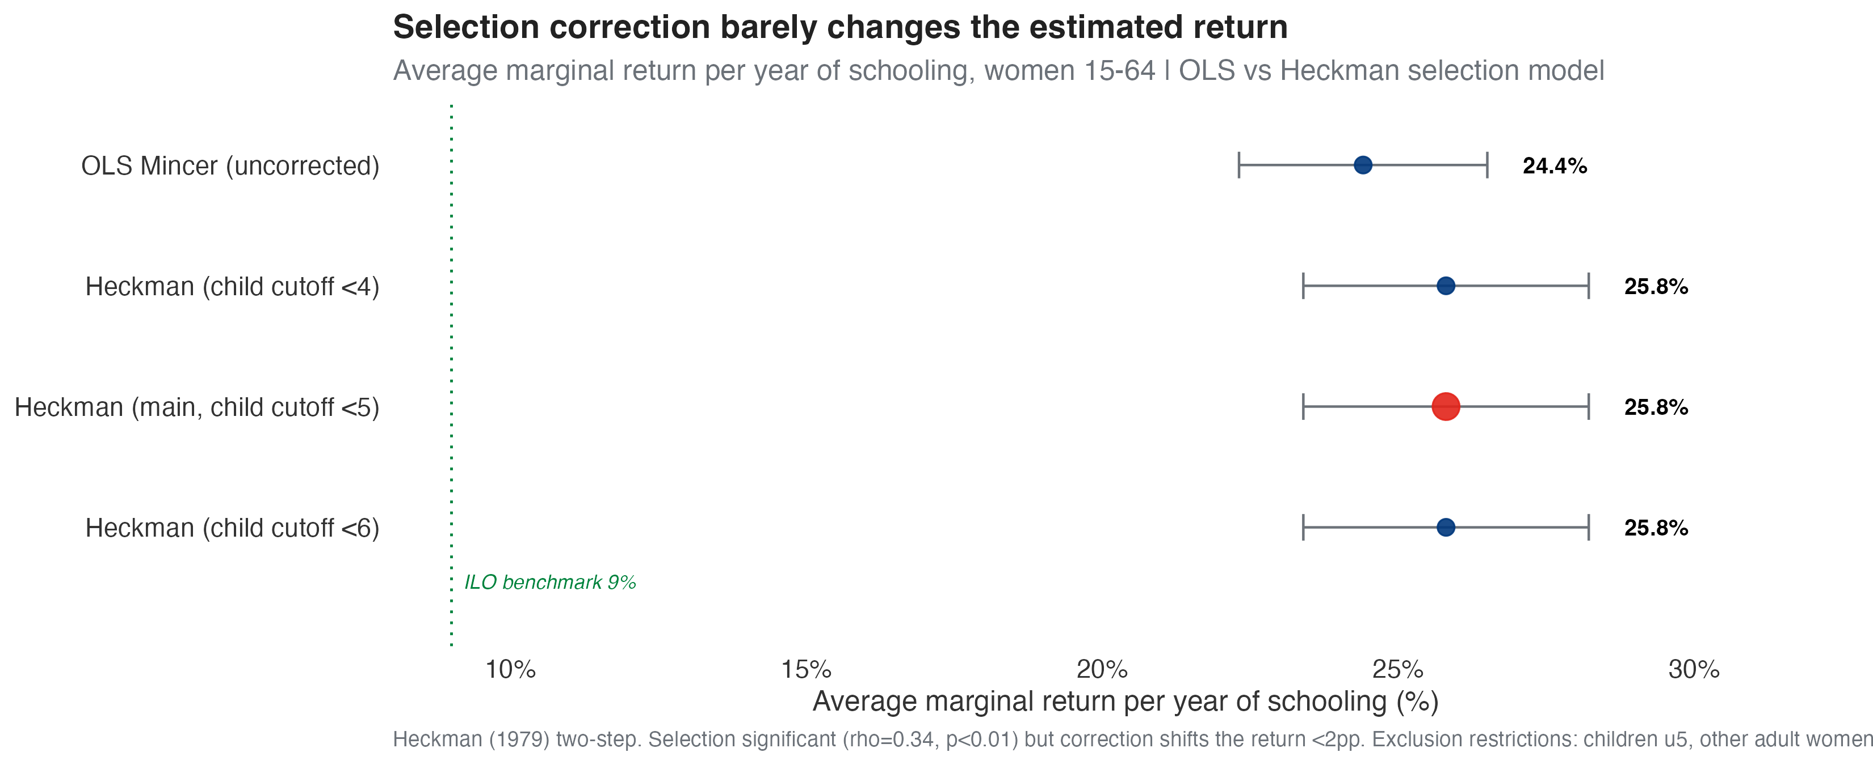
Figure A1. Average marginal return to schooling: OLS versus Heckman selection-corrected estimates, with robustness across exclusion-restriction definitions. Source: Author’s calculations, NLSS IV 2022/23.

A.3 The cost-of-inaction calculation
The cost of inaction combines four elements: (i) the causal effect of education on labour-market inclusion; (ii) a conservative 9 per cent per-year wage return (the ILO benchmark, below our own estimated returns); (iii) the median wage of women in salaried employment; and (iv) the affected population of 680,231 girls. Lifetime earnings are discounted at 5 per cent over a 35-year working horizon. The resulting figure of NPR 8.1 billion is the present value of lifetime productivity forgone by one cohort.

A.4 Sources for budget comparisons
Figure | Value (NPR) | Fiscal year | Source
Cost of inaction (one cohort) | 8.1 billion | — | This analysis, NLSS IV 2022/23 (NSO Nepal)
Health-sector budget (total MoHP) | 86.24 billion | 2024/25 | Ministry of Finance, reported by Kathmandu Post, 29 May 2024
Social security allowance budget | 106 billion | 2022/23 | UNICEF Nepal, Social Protection Budget Brief Update FY2022/23
Education-sector budget (MoEST) | 203.66 billion | 2024/25 | MoF Budget Speech FY2024/25, para 176
Full source links are maintained in the project documentation (docs/SOURCES_budget_figures.md).

A.5 References
Wager, S. and Athey, S. (2018). Estimation and Inference of Heterogeneous Treatment Effects using Random Forests. Journal of the American Statistical Association, 113(523).
Heckman, J. (1979). Sample Selection Bias as a Specification Error. Econometrica, 47(1).
UNICEF (2022). Cost of Inaction: Girls’ Education in Afghanistan. UNICEF.
UNICEF Nepal (2014). Cost of Inaction: Child Marriage in Nepal. UNICEF.
National Statistics Office of Nepal (2023). Nepal Living Standards Survey IV (2022/23).

