**1. What is Boolean?**

A Boolean value is either true or false.

Write down 3 different expression that results a Boolean type

12 < 66

100 >= 99 + 1

thay_giao != "tam duoc"

**2. What is a flow chart?**

A flow chart describes how computer executes condition against different statements in a conditional statement.

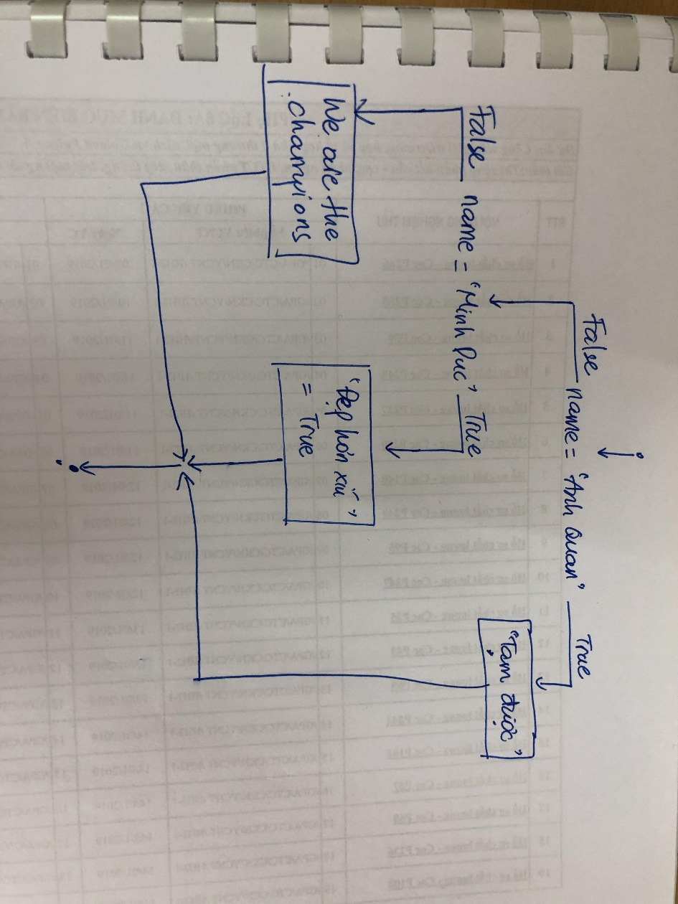

**3. What is nested conditional?**

If-statement within another if-statement

thao = input("bạn hãy điền 'xinh' hoặc 'hiền': ")

if thao == 'xinh':

    print("Chúc mừng, bạn rất có mắt thẩm mỹ!")

else:

    if thao == 'hiền':

        print("Ở hiền gặp lành nhé các bạn")

    else:

        print("Hãy luôn nghĩ tốt về người khác")