Open the solution explorer

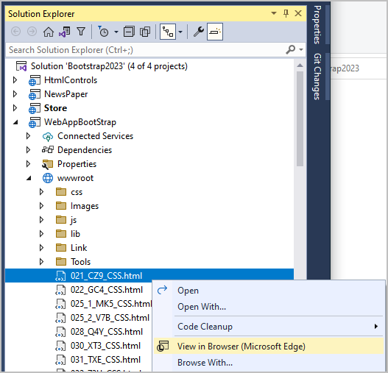

Right click any html file and choose view in browser.

Now when web page open in browser, you can edit HTML in visual studio and click save file. The changes will be immediately reflected in your browser in real time without restarting the app.