建立表

Create table student(

id varchar(255) primary key,

name varchar(255),

age int,

sex varchar(255)

);

Create table subject(

id varchar(255) primary key,

subject varchar(255),

teacher varchar(255),

description varchar(255)

);

Create table score(

id varchar(255) primary key,

student_id varchar(255),

subject_id varchar(255),

score double(5,2),

foreign key (student_id) references student(id),

foreign key (subject_id) references subject(id)

);

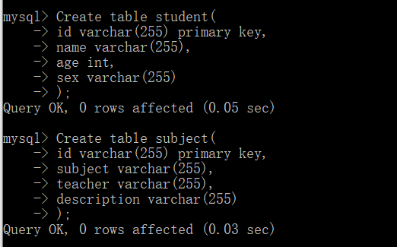

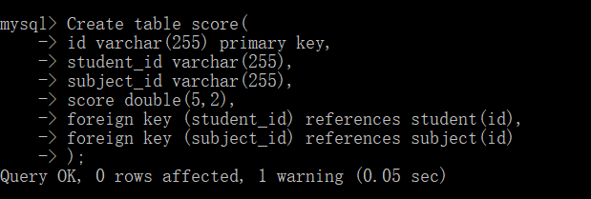

添加数据

Insert into student values(“001”,”zhangsan”,18,”male”);

Insert into student values(“002”,”lisi”,20,”female”);

Insert into subject values(“1001”,”Chinese”,”Mr.Wang”,”the exam is easy”);

Insert into subject values(“1002”,” math”,” Miss Liu”,” the exam is difficult”);

Insert into score values(“1”,”001”,”1001”,80);

Insert into score values(“2”,”002”,”1002”,60.00);

Insert into score values(“3”,”001”,”1001”,70.00);

Insert into score values(“4”,”002”,”1002”,60.50);

