Open Source Web SW report(March 09, 2021)

2019038071 황규현

1. Screen capture of your code in Notepad++ or Atom

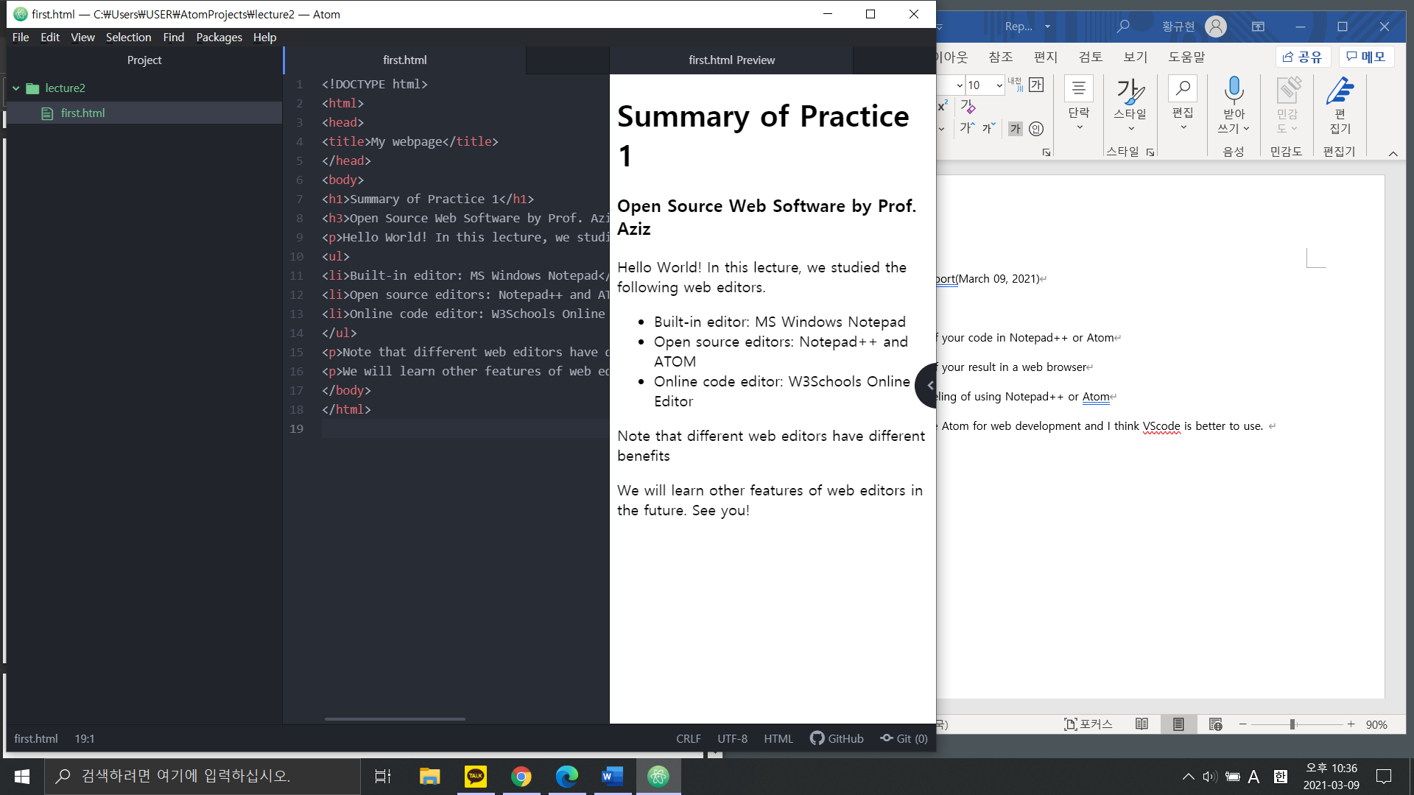

1. Screen capture of your result in a web browser

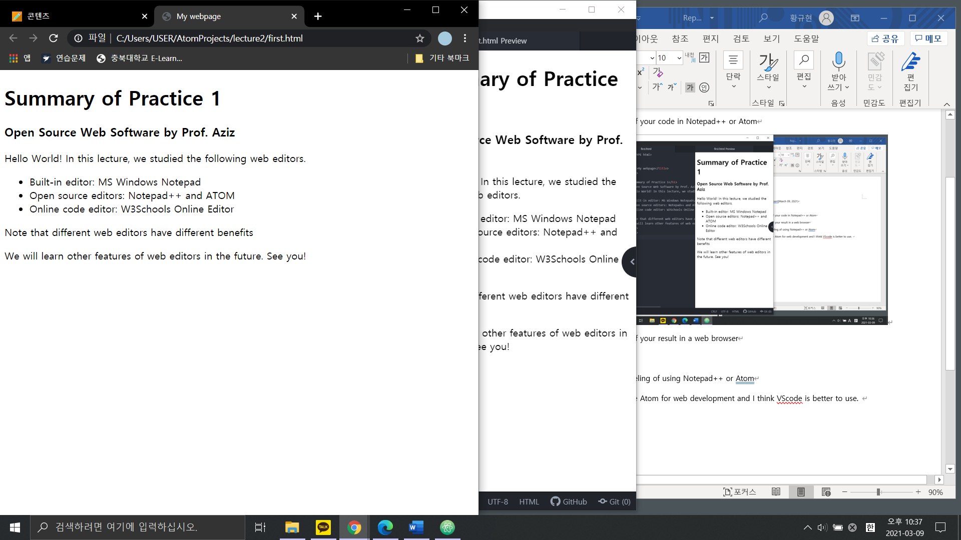

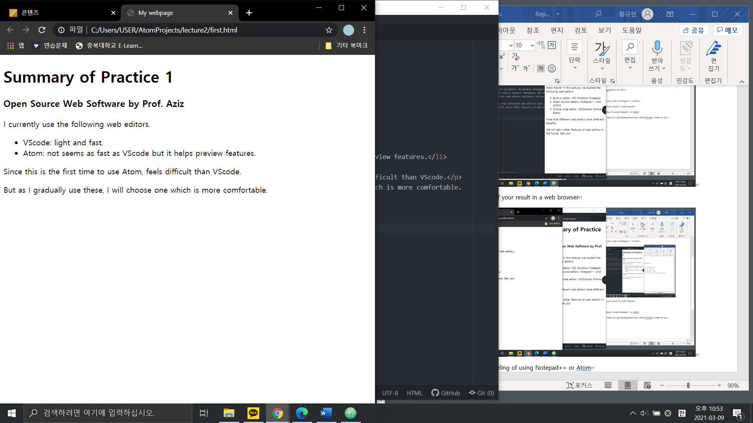

Changed the contents

1. Describe your feeling of using Notepad++ or Atom

I used VScode before Atom for web development. I didn’t feel inconvenient when I was using it, but after using Atom, Atom looks better. VScode is lighter and faster than Atom that I feel. However, Atom's preview-html function is convenient to see the html execution results without having to open a web browser. At first, I thought Atom was difficult, but I think it was just because I used it for the first time. I am planning to use both and choose an editor that fits me better.