Michael Rzepka (34) (SG-11)

Haritha Garikapati (14) (SG-11)

Wang Zhang (50) (SG-3)

Ran Chen (11) (SG-3)

Dr. Yugyung Lee

CS 551: Advance Software engineering

October 3, 2014

Project Plan

# Introduction

For Group 1, our project name is “Car Master”. It is a University of Missouri - Kansas City Software Engineering project training under the instruction of Dr. Yugyung Lee and her TA.

# Project Goal and Objectives

## Overall Goal

For the “Car Master” app, we offer multiple features for our users. They will be able to see their cars information, we will provide the nearest cars service store, and the nearest gas station based on the users location while give the lowest price and highest price. Also, the app will send the car recall records according to user’s car information, as well as the cars estimated value. The “Car Master” app provides convenience car service to the user.

## Specific Objectives

The primary objective of this app is to offer convenience service for a car owner. If user inputs the car’s basic information, the app can search all the information about the car. At the same time, when the user uses the app outside; through map direction, the user can find the nearest gas station with the price, car service store and so on. Users can check the recall information through the app, and be given an estimate on their cars value.

## Significance

The “Car Master” app offers information based on the user’s car. For some apps, they offer the map service or car service separately. However, for the “Car Master” app, we combine all the various services together to give our users a single unique experience. We offer the best service for the car owner.

# Related Work

For a related project, seGuRo Drive is a good example. That product focused on more general approach to travel (current weather, fuel gauge, directions, and a car locator), but it does give users any information about the car specifically. “Car Master” hopes to bridge this gap, allowing users to track all of their cars needs from a single application.

seGuRo Drive - <https://www.youtube.com/watch?v=sYptma7AnHU>

# Proposed System

## Requirement Specification

### Functional Requirements

Default categories should be provided to the user for easy sorting and searching. The interface should be visually comprehensible and intuitively navigable by the user while at the same time being comfortable within the screen size constraint of a small Android smartphone. Furthermore, users should be able to login, save preferences, and receive notifications.

### Non-functional Requirements

#### *Operational*

Using minimum Android SDK 9 Gingerbread and target SDK 17 should simplify development. Further simplification can be achieved by designing any web interfaces to support a minimum of HTML5, and CSS3.

#### *Performance*

We expect to provide the best mobile application performance possible by implementing an Android application. The application is ultimately a parser of results produced by Several APIs. The parsing of data should be very quick as the heavy processing will be previously accomplished through server-side bashing.

### Business / Technical Requirements

“Car Master” will be built on the Android Framework, as a device specific application. The embedded framework features will include a SQLite DB for data storage local to the device, GPS functionality to locate the devices current location, and support for calling multiple external web services.

### Business Process/Workflow analysis (UML Activity Diagram)

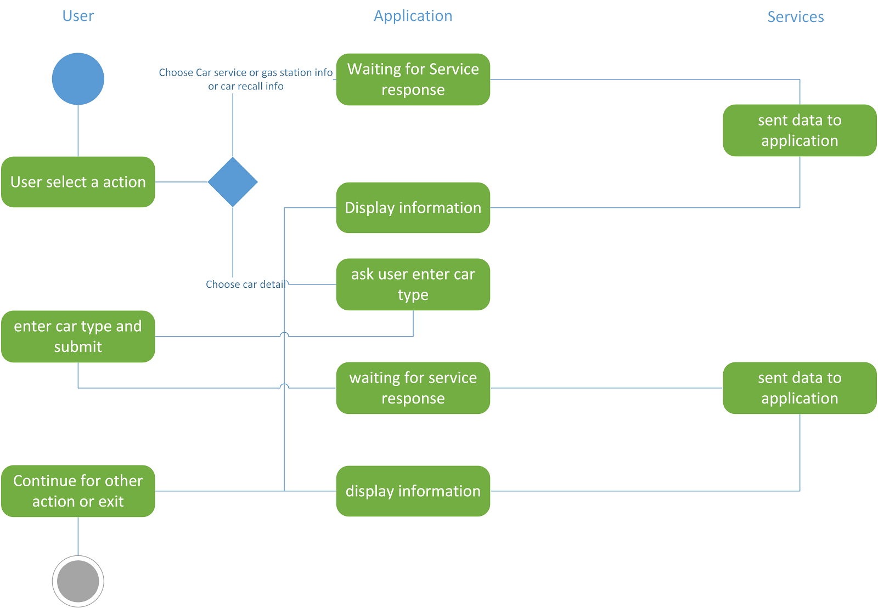

## Framework Specification

### System Architecture Diagram

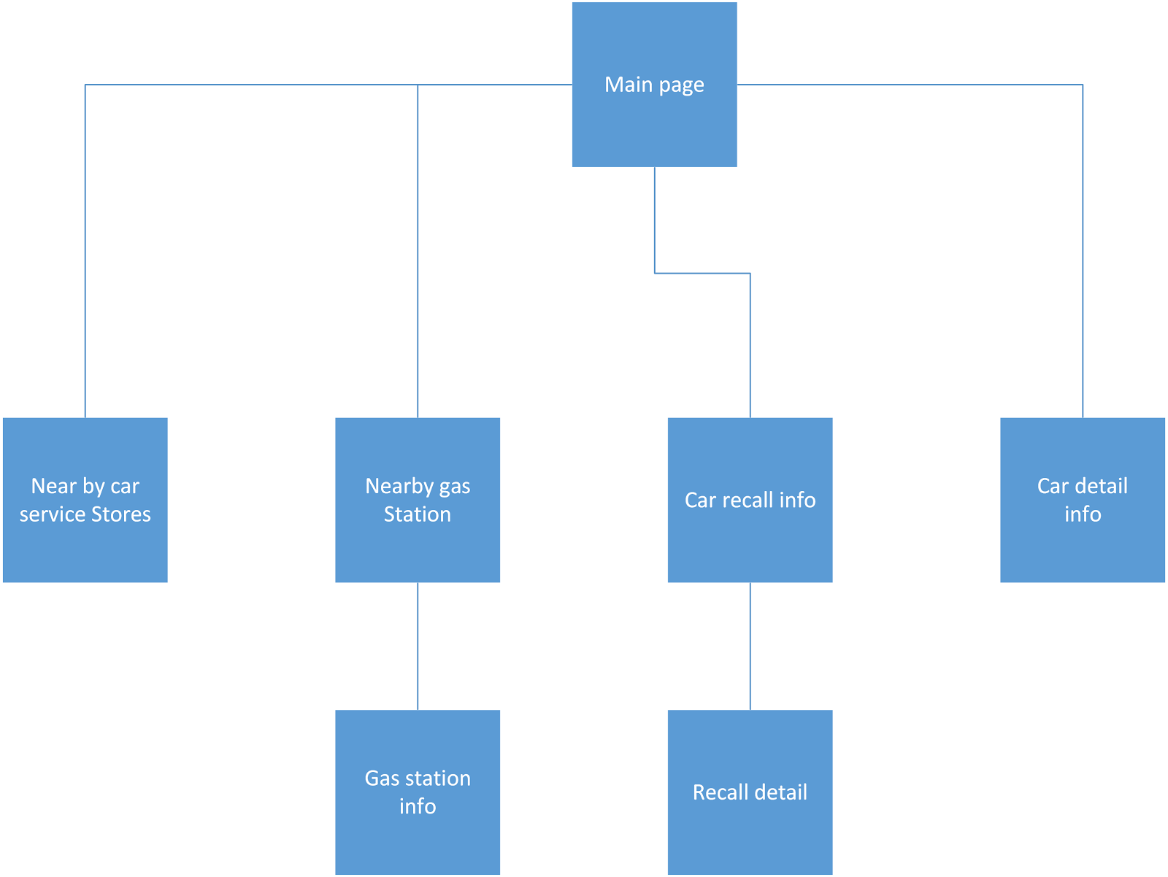

## System Specification

### Existing Services:

NHTSA car recall information

<http://api.usa.gov/recalls/search.json?organization=nhtsa>

Edmund’s Vehicle Pricing and Information Web Services

<http://developer.edmunds.com/api-documentation/vehicle/>

Car Information

<http://developer.edmunds.com/api-documentation/vehicle/spec_make/v2/>

Google Map

<https://developers.google.com/maps/>

Gas Station with price

<http://www.mygasfeed.com/keys/api>

### Class diagram

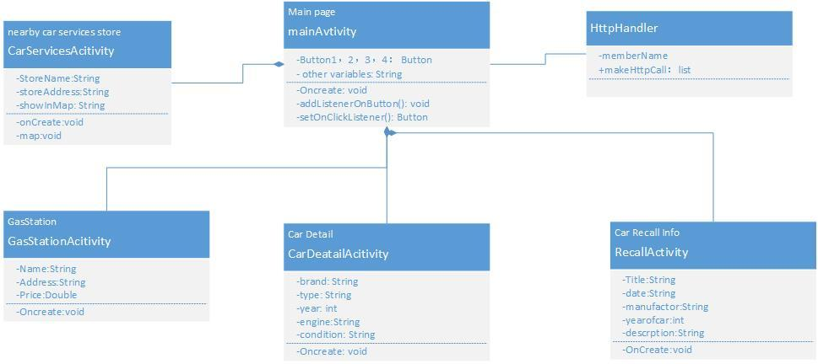

### Sequence diagram

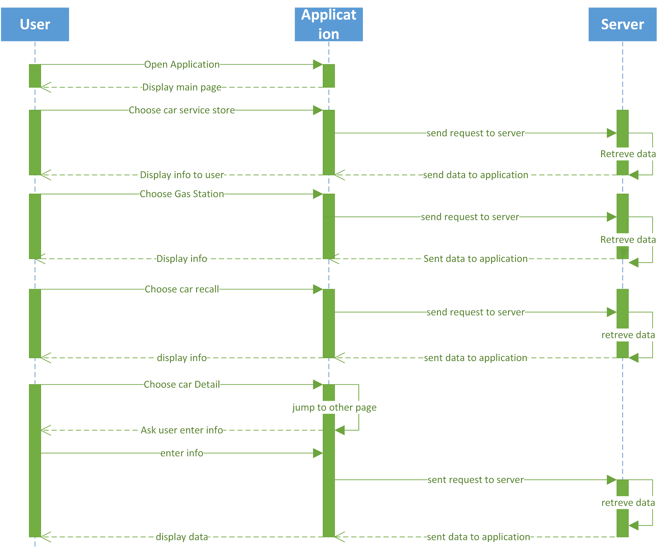

### Service Specification

Base on the APIs, we will display data as Json format, then we will parse information from APIs and as output we will display parse information through our application.

### Design of Mobile Client

Our project Application is Android based. For our app GUI, it contains five features. First one is car information, in this part, our application will display all the information about that car which are user entered. Second one is car recall information. In this part, our App will display car recall records based on what user enter.Third one is car value. our App will display a market value for user’s car. Four one is car services store, which is function that will display nearby car services stores based on user location. The last one is gas station. in this part, app will display the nearby gas station with prices. Also we may implement a user login function and registration function.

# Plan by Services (using ScrumDo)

## Schedule for the four different increments (for each increment, do the following tasks)

* Epic: Increment 1 - Requirement Gathering and Designing the application
  + separate the work for each people
  + Design Car value feature
  + Design Recall Feature
  + Design Nearby Services Feature
  + Design Car Information Feature
  + Design Dashboard
  + Design Login Page
* Epic: Increment 2- coding
  + Implement Car value feature
  + Implement Recall Feature
  + Implement Nearby Services Feature
  + Implement Car Information Feature
  + Implement Dashboard
  + Implement Login Page
* Epic: Increment 3 - coding
  + Test Car value feature
  + Test Recall Feature
  + Test Nearby Services Feature
  + Test Car Information Feature
  + Test Dashboard
  + Test Login Page
* Epic: Increment 4 - Refine GUI
  + Refine GUI for Car value feature
  + Refine GUI for Car Recall Feature
  + Refine GUI for Car Nearby Services Feature
  + Refine GUI for Car Car Information Feature
  + Refine GUI for Car Dashboard
  + Refine GUI for Car Login Page
* Epic: Final Project - Deploy the components and complete documentation.

### Stories (features): Scenario & Use case specification template

30 Stories have been developed to fit into each of the above iterations, based upon the features mentioned above for the application.

ScrumDo URL: <https://www.scrumdo.com/projects/project/2606/summary>

### 

## Project Timelines, Members, Task Responsibility

Michael Rzepka - Primary: Car Value Feature, Secondary: Dashboard and User Login

Wang Zhang - Primary: Car Recall Information, Secondary: Nearest gas station with price

Ran Chen - Primary : Car Information, Secondary: Interface of APP

Haritha: Extra Car Information, GUI

### Bibliography

*Recall Watch*. Computer Software. Google Play Store. Vers. 2.0.1. Stellar Computer Systems, 11 Jul. 2011. Web. 1 Jan. 2014. <<https://play.google.com/store/apps/details?id=com.stellarpc.feeds.recallwatch&hl=en>>

seGuRo Drive - <https://www.youtube.com/watch?v=sYptma7AnHU>