Disclaimer:
The answers below are not entirely precise and should not be relied upon for learning purposes. They are part of an exercise to improve my understanding, explanation skills, and problem-solving techniques. Thank you, Haim Levhar

What is the difference between a host and an end system? List several different types of end systems. Is a web server an end system?
A host is a specialized software that offers services to users for accessing the Internet. Examples of Internet services include email and web pages. End systems are the devices that communicate with these services. End devices encompass all electronic devices capable of connecting to remote networks, or what is commonly referred to as the "Internet."
Types of end systems include computers, smartphones, televisions, gaming consoles, thermostats, home security systems, and eyeglasses. This list expands as technology advances, opening new venues to enhance its capabilities.
A web server is certainly categorized as an end system due to its role in network communications.

Who's Controlling the Internet? Is the Internet damaging the environment? Can anyone shut down the Internet?
The Internet is controlled by ISPs (Internet Services Providers). Through ISPs, we can access the Internet via local cables or wireless connections. The Internet comprises interconnected networks, allowing end systems to communicate with one another. These systems can be interconnected using physical mediums such as wires or cables, which transmit signal waves to our home devices, enabling Internet connectivity, known as guided medium. Alternatively, wireless connections, known as unguided media, can also be utilized.
In my view, this approach of wireless connections does not harm the environment. In contrast, installing physical cables underground requires ground excavation, which can harm the environment. Therefore, this type of approach does have environmental consequences.
The Internet is governed by the Transmission Control Protocol and the Internet Protocol, collectively known as TCP/IP. In addition to the fact that the Internet comprises many interconnected networks, if someone prevents a particular end system from communicating with another, then he only disrupts one network among countless others. The only scenario that could cause the Internet to fail is severe congestion within the network.

What is a sneakernet? Explain the main characteristic of networking. Mention key design issues of a computer network.
The sneakernet is an informal term. for transferring electoral waves to devices with physical media. such as USB Flash drives, USB cards, hard disk drives, SD cards, etc.
The main characteristics of networking include transmitting and receiving data from one host/end system to another (the source and the destination). In order to send our packets (which contain bits of data) to a remote network, routers come into play. Routers send information from the Internet to personal devices such as computers, phones, and tablets, transferring the packets through communication links. These links can be either guided (e.g., cables) or unguided (e.g., wireless).
The design issues of computer networking can be:
Low transmission rate - transmission rate measured in bits/second. In some cases, the R[s] may have a higher transmission rate than the R[c]. Nevertheless, the transmission rate will be min(R[s], R[c]).
Nodal delays - In the process of sending packets from source to destination, there can be nodal delays there. Which is divided into multiple types of delays, including, processing delay, queuing delay, transmission delay, and propagation delay. I will discuss them in the later review questions.
Network-security - The network-security is how we, the network engineers, protect the online user from attacking his professional, social, and personal activities, by "bad guys" who want to use the online-user's sensitive information for themselves. These types of attackers are occasionally called "Hackers".

List four access technologies. Classify each one as home access, enterprise access, or wide-area wireless access.
I will be listing more than four access technologies and will classify them for their network access type as the following: DSL, cable, FTTH, Ethernet, Wi-Fi, 4G, and 5G.
Home Access Technologies - DSL (Digital Subscriber Line), cable, pair-twisted copper wire, optical fiber, FTTH (Fiber-To-The-Home).
Enterprise Access Technologies – Ethernet, Wi-Fi.
Wide-Area Wireless Access Technologies - 4G (Fourth-Generation), 5G (Fifth-Generation), An advanced and improved version of 4G.

Is the HFC (Hybrid-Fiber-Coax) transmission rate dedicated or shared among users? Are collisions possible in a downstream HFC channel? Why or why not?
The HFC characteristics are:
Transmission Rate - HFC's transmission rate is indeed shared among users through neighborhood junctions, leading to the neighborhood users.
Support Capacity - HFC supports between 500 to 5,000 homes due to the coaxial cable in the network.
Collisions in HFC Architecture: -
Collision-Free Downstream - collisions are not possible in a downstream HFC channel because the data transmission is managed by the cable operator.
Frequency Management - the operator allocates specific frequency bands for downstream traffic.
No Overlap or Interference - this prevents any overlap and interference between users' data, ensuring that collisions do not occur in the downstream channel.

What access network technologies would be most suitable for providing Internet access in rural areas?
I think the access network technology that is best suited in this case is the wide-area access network technology. Rural areas are found in remote places from the center with all the networks that are located there. This is the reason behind my choice because this type of network supports up to a few tens of kilometers of communication. In contrast to other access network technologies, such as Wi-Fi, which supports only up to a few tens of meters of communication.

Dial-up modems and DSL both use the telephone line (a twisted-pair copper cable) as their transmission medium. Why then is DSL much faster than dial-up access?
In order for a customer to get the service of a telecommunication company (e.g., access to the Internet), the service that the company provides must go to the modem and then to our router that connects us to the Internet. In a modem, the service of the company goes through the first communication link that connects to the modem and then this data is sent to the router. This can cause a slow transmission rate due to the interval in the middle of the process (i.e., the modem).
On the other hand, in DSL we have a direct connection between the company and the router. That is, there are no intervals during the process.

Do signals really travel faster in fiber optics?
Indeed, they do. The waves in fiber optics travel faster than regular cables used for communication due to their light speed in transferring signals.

What are some of the uses of fiber optic cabling in the business world?
Fiber optics are immune to electromagnetic interference, lose very little signal over distances up to 100 kilometers, and are extremely difficult to intercept. The use of fiber optics can vary from place to place. For the most part, fiber optics are used for telephone networks, computer networks, security, and cable television, and the list has grown over the years.

What principle does fiber optic work on?
Fiber optics is based on the principle of the speed of light. The medium conducts data with pulses of light, with each pulse representing a bit. The speed of light is measured at 300,000 km/sec.

HFC (Hybrid Fiber Coaxial) DSL (Digital Subscriber Line) and FTTH (Fiber-To-The-Home) are all used for residential access. For each of these technologies, provide a range of transmission rates and comment on whether the transmission rate is dedicated or shared.
DSL - In DSL, the downstream transmission rates are 24Mbs to 52Mbs and upstream rates of 3.5Mbs to 16Mbs. DSL is shared by definition.
HFC - In HFC, the downstream transmission rates are 40Mbs to 1.2Gbs and upstream rates of 30Mbs to 100Mbs. HFC is shared among the users.
FTTH - In FTTH, the downstream transmission rates are 100Mbs through 1Gbs and upstream rates of 20Mbs through 500Mbs. FTTH is dedicated to the user.

Describe the different wireless technologies you use during the day and their characteristics. If you have a choice between multiple technologies, why do you prefer one over another?
The wireless technologies I use during my day include Bluetooth and Wi-Fi.
Bluetooth - The most used wireless technology in my daily life. Also used primarily for listening to songs, podcasts, and YouTube videos. It provides pleasure and improvement through content consumption.
Wi-Fi - Used for Internet service on my smartphone and PC. It is essential for accessing online content before using Bluetooth.

Suppose that there is exactly one packet switch between a sending host and a receiving host. The transmission rates between the sending host and the switch and between the switch and the receiving host are R [1] and R [2], respectively. Assuming that the switch uses store-and-forward packet switching, what is the total end-to-end delay to send a packet of length L? (Ignore queuing, propagation, and processing delay.)
The end-to-end equation is: N(L/R). N is the number of routers that the packet passes through in order to reach the destination. L is the length of the packet (as mentioned above). The transmission rate of packet switching transferred from a sending host to a receiving host is determined by the communication link in the routing process with the minimum transmission rate. denoted as R = min (R [1], R [2]). Therefore, the total end-to-end delay in this case is: N(L / min(R[1], R[2])).

What are the three phases of circuit-switching? List the advantages and disadvantages of circuit-switching and packet-switching. What are the delays in packet-switching?
The three phases in the circuit-switching protocol are the establishment of a dedicated communication link between sender and receiver, the transfer of data, and the termination of the connection by ending the communication link.
The advantages of circuit-switching are no queuing delays due to the dedicated communication links. Disadvantages are high implementation costs and complexity compared to packet switching.
Advantages of packet-switching: enables more efficient sharing of transmission capacity than circuit-switching. Disadvantages: packet-switching is not suitable for real-time services due to its variable and unpredictable end-to-end delays (e.g., queuing delay).
Delays in packet switching, occasionally referred to as nodal delay, consist of four main components: processing delay, queuing delay, transmission delay, and propagation delay.

What is the difference between circuit-switching and packet-switching?
In circuit switching, in order to connect a host to another for transferring/receiving data to/from the other host, a communication link between them must be dedicated. This ensures exclusive access for the communicating hosts without interference. In contrast, packet switching involves queuing, allowing anyone in the queue to access the communication link, even during an ongoing conversation between two hosts.

Why is a content provider considering a different Internet entity today? How does a content provider connect to other ISPs? Why?
content providers sometimes created their own networks, with data centers interconnected to deliver services to their users. Content providers are the clients of the user ends. ISPs exist on a particular framework of various access ISPs linked to tier-1 ISPs (directly or indirectly).
A content provider connects to other ISPs either by connecting with them or by connecting with them at IXLs.
Because the payments for getting a connection to tier-1 ISP can be extremely expensive for the content provider, and if there is a more affordable way available, then why not?

What causes packet loss?
Queuing delay is the main reason for packet loss. Queuing delay occurs when the transmission rate on the communication link between the switch and the receiving host is lower than the transmission rate on the communication link between the switch and the sending host or any other. In this case, the packets sent are accumulated in the switch, waiting for their turn while packets continue to flow towards the switch from the back. At some point, the switch will reach its finite capacity and will reject any other packet coming towards it, causing packet loss. Even though there are protocols whose implementation varies, such as the TCP protocol, that re-transmits the packet to guarantee the complete transmission of the packets to the destination.

Suppose host A wants to send a large file to host B. The path from host A to host B has three links, of rates.
a. Assuming no other traffic in the network, what is the throughput for the file transfer? b. Suppose the file is 4 million bytes. Dividing the file size by the throughput, roughly how long will it take to transfer the file to host B? c. Repeat (a) and (b), but now with R [2] reduced to 100 Kbps.
A. The throughput T for a file transfer from host A to host B is T = min (R [1], R [2], R [3]).
B. Given a file size F of 4 million bytes and throughput T: Transfer time = 4,000,000 / min (R [1], R [2], R [3]).
C. Assuming that R [1] and R [3] have a greater transmission rate than 100Kbps (i.e., R [2]), the result is T = 100Kbps. for b: T = S/T = (4 * 10⁶ bytes) / (12,500 bytes per second) = 320 seconds.

Suppose end system A wants to send a large file to end system B. At a very high level, describe how the end system creates packets from the file. When one of these packets arrives at a router, what information in the packet does the router use to determine the link onto which the packet is forwarded? Why is packet switching on the Internet analogous to driving from one city to another and asking for directions along the way?
An end system A breaks the large file into chunks. It adds a header to each chunk that includes the destination IP address (end system B), thus generating multiple chunks, called packets. The packet switch uses the header with the destination IP address to determine the next communication link.
Packet switching is analogous to driving from one city to another and asking directions along the way because a router uses its own forwarding table to determine the outgoing link. Each router knows only the next hop, without having information about the entire route from a source to a destination. This is similar to people along the way who only know the next direction to take.

If two end systems are connected through multiple routers and the data-link level between them ensures reliable data delivery, is a transport protocol offering reliable data delivery between these two end systems necessary? Why?
Certainly, a transport protocol that offers reliable data delivery between two systems is necessary. The reason is that while the data-link level provides a reliable data delivery from the transmission node over one link to the receiving node, this reliability covers only part of the route. In contrast, a transport protocol ensures reliable data delivery from one end system to another across the entire route from source to destination.

What do encapsulation and de-encapsulation mean? Why are they needed in a layered protocol stack?
In encapsulation, the protocol stack adds supplementary information to the application-layer message to secure the message from untrustworthy sources and identify the destination. In de-encapsulation, the protocol stack of the receiving side removes the added supplementary information in the reverse order, restoring the original message sent by the sender.
Encapsulation and de-encapsulation are needed because they ensure secure, accurate message transmission between layers and destinations.

Which layers in the Internet protocol stack does a router process? Which layers do a link-layer switch process? Which layers does a host process?
A router processes the Internet protocol stack from layer 1 through layer 3: physical layer, link layer, and network layer.
A link-layer switch processes 1 and 2 layers: the physical layer and the link layer.
A host processes all the layers in the Internet protocol stack: physical layer, link layer, network layer, transport layer, and application layer.

Compare and contrast the different Ethernet standards (10BASE-T, 100BASE-T, 1000BASE-T, and 10GBASE-T) in terms of speed, cabling requirements, maximum distance, and use cases. Provide a detailed analysis of which standard would be most appropriate for various scenarios, such as a small office, a data center, and a long-distance connection.
10BASE-T: The speed, which is the maximum number of bits that can be transmitted over a cable using this Ethernet standard, is 10Mbps. The typical cable used in the 10BASE-T Ethernet standard is copper. The 10BASE-T Ethernet standard supports a maximum cable length of 100 meters. The 10BASE-T Ethernet standard, informally called '10Mbps' or more commonly 'Ethernet', is primarily used by networks without high-bandwidth requirements.
Table 2-1 summarizes common Ethernet standards along with their characteristics.
Informal Standard Name | Bandwidth Rate | Common Informal Name | Cable Type | Maximum Cable Length
100BASE | 100Mbps | Fast Ethernet | Copper | 100 meters
1000BASE-T | 1000Mbps | Gigabit Ethernet | Copper | 100 meters
10GBASE-T | 10Gbps | 10 Gig Ethernet | Copper | 100 meters

Note that there is another Ethernet standard, although different and more expensive than most of the Ethernet standards, it is still widely used today, especially for long-distance networks, informally called '1000BASE-LX'. The 1000BASE-LX Ethernet standard provides bandwidth of up to 1000Mbps, uses fiber optic cable, and supports up to 5000 meters (5 km) of cable length.

What is the meaning of AAA network security? What are the different methods of user authentication?
AAA (authentication, authorization, accounting) is a protocol designed to enhance security in communication between remote end systems. The initial method is Authentication, ensuring that a transmitted message arrives only to the destination and not to anyone else. The second method within the AAA protocol is Authorization, granting users permissions based on their privilege level. The final method of the protocol is Accounting, documenting the actions of authorized users to ensure traceability in case of issues.

Describe how a botnet can be created and how it can be used for a DDoS attack.
A botnet can be created by infecting hosts' devices with malware. These infected and compromised devices may also be enrolled in a network of thousands of similar devices. These devices are controlled by a malicious guy who leverages these devices for spam e-mail distribution and distributed denial-of-service attacks (DDoS).

What happens when you type a URL (uniform resource locator) in the web browser?
A URL serves as an identifier for an HTML base file and guides how to link to other HTML base files. URLs play a crucial role in locating resources on the web, such as videos, photos, web pages, documents, and more. Now, let's describe the sequence of steps that occur when a URL is entered into a browser. When a URL is typed into a web browser, the browser first identifies the protocol, which can be HTTP or HTTPS. HTTPS is designed to provide secure HTTP connections, but we'll discuss HTTPS later. After identifying the protocol, the browser moves to the domain name, which identifies a company's domain or other resources. To access a specific file on the company's server, after the domain name, add a path to the desired file. Next, let's discuss how the browser translates the website name to an IP address using DNS. DNS is a service that translates hostnames to IP addresses, allowing humans to use mnemonic names instead of hard-to-remember IP addresses. After DNS resolution, an HTTP request is sent and an HTTP response message is received from the server with the requested content. There are more details to mention, but these are the main steps. Now, let's briefly discuss what happens on the server side when a request is received. The HTTP request message header includes details such as the type of request (GET or POST), domain, date, and sender's address. Once the server analyzes the HTTP request message, it responds with an HTTP response message containing the requested entity body, which is then sent back to the client. That covers the basics. If there are minor errors, I understand—I'm just starting. For now, I'd like to keep my expression and wording intact.

What are the advantages of distributed processing?
The advantages of distributed processing include fault tolerance, as the system continues to operate even if some nodes have failed. Because we have another node in the system with its self-scalability. In contrast to a single-point server, once this single-point server fails, all the systems crash along with it. The second advantage is performance. The system has faster processing through parallel execution. And finally, we have reliability. Because of what I have mentioned before, the multiple points servers minimize the risk of a complete system failure. Therefore, when some server fails, you can continue to use the system and the data will still be sent across the network.

Design and describe an application-layer protocol to be used between an automatic teller machine and a bank's centralized computer. Your protocol should allow a user's card and password to be verified, the account balance (which is maintained at the centralized computer) to be queried, and an account withdrawal to be made (that is, money disbursed to the user). Your protocol entities should be able to handle the all-too-common case in which there is not enough money in the account to cover the withdrawal. Specify your protocol by listing messages exchanged and the action taken by the automatic teller machine or the bank's centralized computer on transmission and receipt of messages. Sketch the operation of your protocol for the case of a simple withdrawal with no errors, using a diagram similar to that in the following figure:
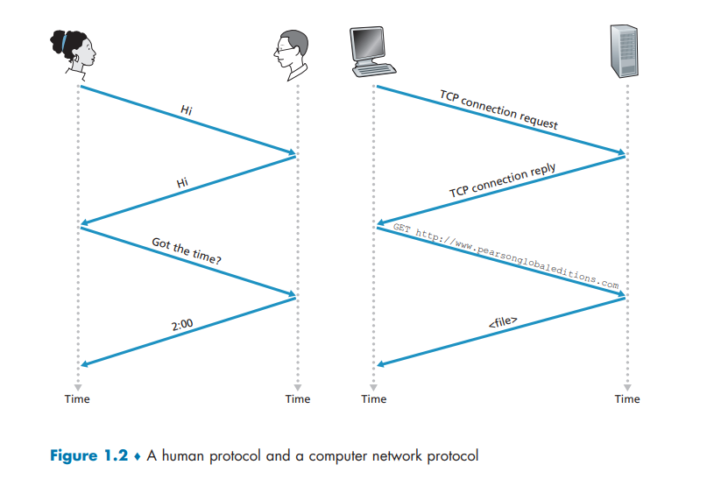
Explicitly state the assumptions made by your protocol about the underlying end-to-end transport service.

Solution.

CAP - Cash Authentication Protocol.
ATM - Automatic Teller Machine.
BCC - Bank Centralized Computer.
BAD - Bank Account Database.
AK - Authentication Key.
AB - Account Balance.
The basic requirements for the ATM are:
a. To allow a user's card information, in addition to his password, to be verified.
b. The user's account balance (Which is maintained at the centralized computer) to be queried.
c. An account withdrawal to be made (that is, money disbursed to the user).
The CAP has two key steps for verifying a user on the ATM:
1. When the user inserts his card & password information into the ATM software, the process of creating a CAP request message begins.
The ATM transmits this CAP request message with the AK set to 0 to BCC. We will refer to this type of message as `CAP req-mess'.
2. If indeed the user's data on the `CAP req-mess` matches an account in the BAD, `CAP res-mess` is created and sent over the connection to ATM, with the AK set to 1.

Transmission  Date | User Card  Information | user  Password | Authentication  Key

Figure 1.1 - Packet format of CAP message exchanges between ATM and BCC for verifying a user.



Diagram 1.1 - A simple diagram illustrating the operation of the CAP.

The second key stage in the CAP processing involves similar steps to those in the initial stage:
<-- Since I am currently at home and without a board available for designing the next two steps, I will leave a comment here. This comment's purpose is to remind me, when I see it while I'm in class, to continue with the CAP's design. -->
1.

Equation 1.1 provides a formula for the end-to-end delay for sending a single packet of length L over N links with the transmission rate R. Generalize this formula for sending P such packets back-to-back over the N links.
Solution.
The original formula:
N * (L/R)
In this original formula, N is the number of links from the source to the destination. A link is a direct connection between two entities through the route, such as the medium access that connects the source end system and the next packet switch, from one packet switch to another through the route, and the last packet switch to the destination end system. L is the packet's length in bits, assuming that all the packets have the same length. R is the transmission rate over the N links.
The modified formula:
(P+N) * (L/R)
In this modified formula, P represents the number of packets to be sent over the N links. This protocol uses the store-and-forward technique.

P = 2;
L = 10;
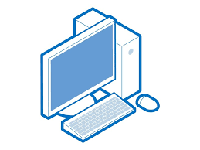 5 bps 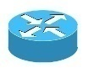 5 bps 5 bps
Source Destination

Figure 1.2 – A simple packet transmission example using the store-and-forward technique.

In the illustrated example, we want to send 2 packets with a length of 10 bits for each packet from the source end system to the destination end system. Thus, the values of the variables are:
L = 10; P = 2; R = 5; N = 3.
the end-to-end delay is (2+3) * (10/5), which is equal to 10. Therefore, the end-to-end delay = 10.

What are the common network issues and how to resolve them quickly?
There are many network issues. Some of them are negligible and can be fixed by re-configuration of the network's issue-causing components.
I will list four of the common network issues that I am currently familiar with below:
Low Bandwidth - The bandwidth is the number of bits per second (bps) that pass over the network. Note that the network administrator can't enforce this bandwidth for higher bps; if they do, delays and router buffer overflow will occur in the network, causing a ``congested network''. (a computer network topic that I will cover in the next section).
To resolve this issue, all you need to do is modify the bandwidth to higher bps to allow more packets to be sent per second, which is provided by the network's current vendor.
Congested network - Congestion means that the transmitted data exceeds the offered traffic load in certain medium access, causing packets ready to be sent to wait for the termination of the current on-the-way packets. Resolving this issue by deploying more medium access (Base stations in wireless networks and cables in wired networks) over the network to reduce the probability of the network becoming congested.
Outdated hardware – This occurs frequently in legacy networks with old and outdated hardware components. Annual scans are recommended for locating these outdated hardware components to be replaced by modern (Not required, but recommended) and compatible components for the network.
Router buffer overflow - This network issue causes transmitted packets to be delayed or dropped due to an overflow queue in a router's buffer. We can know if such a case would occur by evaluating the 'traffic intensity' value. If this value is closer to '0', then there is a low probability of router buffer overflow. Therefore, a tiny amount or even no packets will suffer delay or be dropped. In contrast, if the 'traffic intensity' value is closer to '1', it guarantees that transmitted packets will suffer from delay and dropping.

When should I use layered architecture?
You should use layered architecture when you have a complicated process with multiple tasks to perform, creating a complex system.
The layered architecture divides the complex system into multiple layers. Each layer provides different services required to complete the process. By using layered architecture for complex systems, you simplify it, making it easier to resolve issues when they appear in the complex system (after the layering stage).
Network designers generally attempt to deploy networks that don't have single points of failure, though they don't always succeed. Network topologies that employ redundancy are of much interest.
- Draw an example of a six-node network in which the failure of any single link does not disconnect the entire network. That is, any node can still reach any other node.
Solution:
For such a case in which a failure of some single link does not disconnect the entire network, and all the other nodes in it can still send messages to each other, the Ring topology would be an appropriate choice.
The characteristics of the ring topology include two communication links between a node and each of its neighbor nodes for all the nodes in the network.
When some single link fails, the network won't crash, since another link is connecting the two nodes where the link failure has occurred.

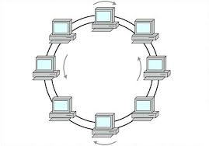

Figure 1.3 – A ring topology network.

- Draw an example of a six-node network in which the failure of some single link does not disconnect the entire network, but the failure of some single node does disconnect it.
Solution:
For the case in which the failure of some single node disconnects the entire network, the star topology type of network would be an appropriate choice.
The star topology is characterized by a main node that through it, other nodes can reach and send messages to each other. If this main node fails, the remaining nodes cannot communicate and send messages to each other. Note that from the main node to each of its neighbor nodes, two communication links have been placed to protect the network from the issue mentioned in section number 1.

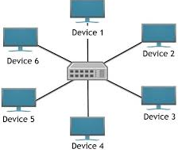
Figure 1.4 – A star topology network. Assume that there are two communication links between the main node and each of the other nodes.

- Draw an example of a six-node network in which the failure of some single link disconnects the entire network. Note that not all the examples above may have feasible solutions.
Solution:
To resolve this issue, the Line / Bus topology would be an appropriate choice.
This type of topology is characterized by connecting all the nodes in the network through a single link. That is, if this single link fails, it causes the entire network to crash. When the single link fails, the remaining nodes won't be able to communicate and send messages to each other, as there is no other way for them to communicate.

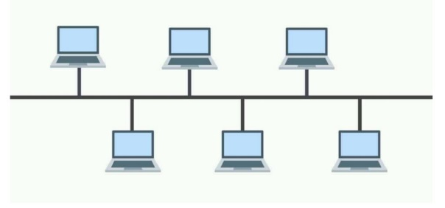
Figure 1.5 – A line/bus topology network. Assume that there are two communication links between the main link to each of the other nodes.

List one everyday example using a layered architecture.
Splitting the complicated process from when we wake up until the time we go to sleep into a multiple-layer activity stack. By modularizing the complicated process we encounter every day in our life, decisions, and actions can be made in each layer with a low probability of interrupting all of the other layers.

1 | Waking up | Falling asleep
2 | Eating breakfast | Eating dinner
3 | Driving to work | Returning from work
4 | Starting to work | Finishing to work
5 | Break start | Break end

Figure 1.6 – An everyday example using a layered architecture.

Early versions of TCP combined functions for forwarding and reliable delivery. How are these TCP variants located in the OSI protocol stack? Why were the forwarding functions later separated from TCP?
Initially, TCP was located in both the transport & network layers on the OSI protocol stack. When the forwarding functions were separated from TCP, it was removed from the network-layer protocols and is now located solely in the transport layer, since TCP provides the reliable delivery functions that are important for the transport layer.
The network layer provides the same forwarding services as TCP, it is generally unnecessary to duplicate the same services within the same layer, as a result, the forwarding functions were separated from TCP.

Explain how IP protects data on the network.
IP protects data on the network using the TCP protocol, which provides a reliable data transfer service. When communicating processes use TCP's reliable data transfer service, they can rely on TCP to deliver all data sent without error and in the proper order.

How does TCP provide reliability? Write down the names of services provided by TCP. Write the name of the well-known ports used by TCP.
TCP provides reliability using connection-oriented & reliable data transfer services.
Well-known ports that use TCP include electronic mail (SMTP), file transfer (FTP), and web pages (HTTP 1.1).

Do port addresses need to be unique? Why or why not? Why are port addresses shorter than IP addresses?
Certainly, port addresses do need to be unique for certain services. In recent years, there has been an increasing number of services deployed on the Internet. When a process runs on a client's end system wants to communicate with another process that supports a service (For instance, a Web service using HTTP 1.1), it sends a packet from its socket with the IP address of the requested web page (e.g., obtained through the DNS protocol, which provides the host-and-domain-names-into-IP-addresses translation service.) to the server's socket. The web server then performs demultiplexing on the received packet and responds with a response packet back to the appropriate client (using the client's IP address). The OS on the client's end system needs to demultiplex the response packet to its destination process. The OS performs this by using the port address located on the request packet, indicating the destination process for the response packet.
However, port addresses do not need to be unique for each process running on every end system around the globe.
Port addresses are shorter than IP addresses because they only identify specific processes within a device, whereas IP addresses identify entire devices on a network. This limited scope allows port addresses to be smaller in size.

Recall that TCP can be enhanced with TLS (Transport Layer Security) to provide process-to-process security services. Does TLS operate at the application layer or the transport layer? If an application developer wants TCP to be enhanced with TLS, what does the developer have to do?
Despite the TLS abbreviation containing a 'transport layer' segment, it can be confusing to decide that TLS operates at the transport layer since it contains words related to a transport layer. However, in reality, TLS operates on the application layer.
In order for an application developer to enhance TCP with TLS in their application, they need to use TLS code. This indicates to the application running on their end system that the packets to be transmitted use TCP / TLS. That is, it encrypts the outgoing packets. TLS provides a few important services such as data encryption/decryption, data integrity, and end-point authentication.

Referring to the following table:
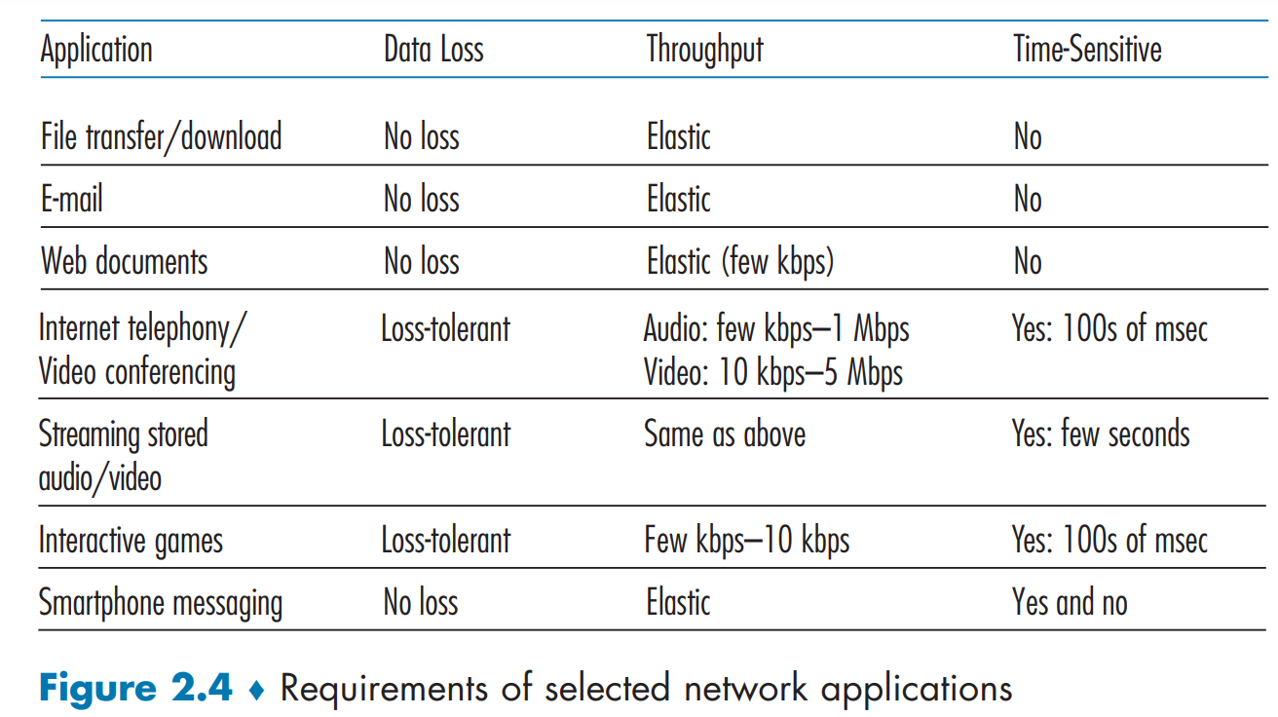
You can see from this table that none of the applications requires both no data loss and timing. Can you conceive an application that requires no data loss and is also highly time-sensitive?
To find an application that requires no data loss & timing, remote word processing (RWP) is compatible. When using an RWP application by the web browser, no data loss is a fundamental requirement as the writer/typist must see what he has typed in order to continue typing. RWP is also a time-sensitive application since the writer/typist must see instantaneously what he is typing in order to avoid and correct mistakes in the ongoing typing text.

List the four service classes that a transport-layer protocol can provide. For each of the service classes, indicate if either TCP or UDP (or both) provided such a service.
The 4 service classes that can be provided by a transport-layer protocol include reliable data transfer, timing, security, and throughput.
As shown in the table in Figure 1.7, TCP can provide reliable data transfer & security (obtained through the TLS protocol) services, but it cannot guarantee timing & throughput services. UDP, on the other hand, can provide timing & security (obtained through DTLS) services, but it cannot guarantee reliable data transfer and throughput services, which can lead to data loss or duplication.

Service Class | TCP | UDP
Reliable Data Transfer | Support, ensures data is delivered correctly and in order through error checking and retransmission mechanisms. | Not Support, does not guarantee delivery or order, as it is connectionless and unreliable.
Security | Support with SSL/TLS, which provides encryption and secure communication over the network. | Support with DTLS (Datagram Transport Layer Security), which adds encryption to UDP.
Timing | Not Support, prioritizes reliability over timing, making it unsuitable for real-time applications. | Support, suitable for real-time applications due to low latency and no retransmission delays.
Throughput | High but can be affected by congestion control and error correction mechanisms, resulting in variable throughput. | High and consistent due to minimal overhead, but no delivery guarantees can lead to data loss or duplication.

Figure 1.7 – TCP vs UDP comparison table.

Explain the response and status codes in HTTP.
HyperText Transfer Protocol (HTTP) is the web's application-layer protocol. Through HTTP, a web browser (which we will refer to as a 'client' from now on) and a web server can exchange messages with each other. When a client wants to access a certain web page, it sends an HTTP request message containing the URL address representing the location of the desired web page. The web server then receives this HTTP request message and responds with an HTTP response message whose entity body field contains the data of the requested web page. Note that the data transmitted from the web server consists of a base HTML file and HTTP objects (which can be a JPEG image, a JavaScript file, a CSS style sheet file, a video clip, etc.). Thus, the response in HTTP provides the client with the desired data. But what if the requested data does not exist? This is where status codes come in. The purpose of status codes in HTTP is to alert the client about certain issues encountered with the requested URL address. A few of the most common status codes are:
- 400 Bad Request: The web server cannot understand the request.
- 404 Not Found: The requested URL does not exist or has been removed/replaced.
- 500 HTTP Version Not Supported: The requested HTTP protocol version is not supported by the server.
These are common status codes today. However, as shown in Figure 1.8, there are more status codes in HTTP. You may want to take a look to discover additional types.
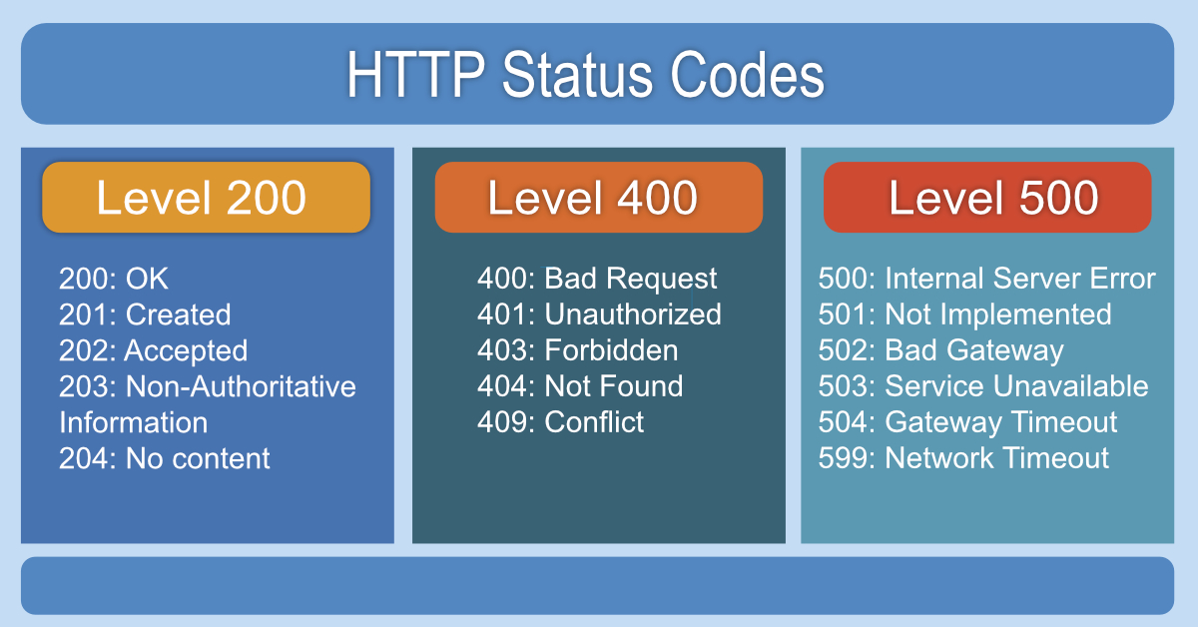
Figure 1.8 – HTTP status codes categorize responses: success (200), client errors (400), and server errors (500).

Are email addresses case-sensitive?
No, email addresses are not case-sensitive. Email forms with capital letters, such as EXAMPLE@gmail.com and example@gmail.com, refer to the same email address. Note that this rule solely applies to the phrase before the "@" sign.
What are the resolved limiting factors of the Simple Mail Transfer Protocol (SMTP)?
There are a large number of limiting factors of SMTP. However, I will introduce only the common cases encountered with these limiting factors.
- Limiting the attachment size – Attaching files, videos, images, documents, and so on is limited to only a few tens of megabytes. This limitation is unsuitable for the large-sized files being sent today.
- Limitation of header lines' length – The header lines and the data first have to be encoded to a 7-bit ASCII form before being sent as an email message to the sender's user agent, which in turn sends it to the sender's mail server. When the receiver's mail server receives an email message, it sends this message to the receiver's user agent, which decodes the message from the 7-bit ASCII form into its original form and sends the decoded message directly to the receiver. This may be the reason why SMTP restricts the attachment size.
How to check if an email address exists without sending an email?
The existence of an email address can be verified by an SMTP verification tool. Most email applications today, whether web-based or smartphone apps (such as Gmail), provide this verification automatically to their users.

What are different DNS zones?
The DNS architecture is divided into three different zones. The first zone contains the DNS root server, which is the main DNS server in the architecture, as clients begin with it when searching for a particular IP address. The second zone consists of Top-Level Domain (TLD) servers, which represent a full domain of all the IP addresses that contain their domain name. The third and final zone consists of Authoritative DNS servers, which are used by a company to manage a defined set of IP addresses.

What is a caching-only server?
A caching-only server is a server that stores web pages visited by the client for future reuse. This reduces the need for the server to request previously visited web pages from different web servers.

How does the DNS lookup process work?
The DNS lookup process begins when a client sends a request with a hostname for the DNS servers to locate and respond with the corresponding IP address, allowing the client to visit this IP address (in the form of a website).
There are three simple key steps from when the client requests a particular IP address until they receive the result.

Why do we use DNS?
Web-pages' addresses consist of a sequence of unrelated numbers, called IP addresses. As humans, our memory system was not designed to memorize sequences of random numbers; it was designed to use language instead. Thus, remembering web-pages' addresses would be extremely unmanageable if we had to use IP addresses as the only way to access those pages. For this reason, the DNS protocol was developed. The DNS protocol provides the translation service that resolves host and domain names into IP addresses. When we want to access a webpage, all we need to do is enter the page's hostname, and DNS will perform the translation process for us. To summarize, by using DNS, we can access desired web-pages more easily and efficiently.

What are the three architectures in peer-to-peer applications?
- A client-server architecture: In this architecture, a central server is used to connect different peers in the network, allowing them to communicate and send files to each other.
- A peer-to-peer (P2P) architecture: This architecture allows different peers to communicate and send files to each other without the need for a central server.
- A hybrid architecture: This type of architecture combines the characteristics of both the client-server and P2P architectures. In this setup, peers in the network can communicate with each other only after the central server has established a connection between them.

Summarize BitTorrent and the difference between peer, seed, and leecher
BitTorrent is a P2P protocol designed for file distribution among peers in a torrent (network of peers).
- Peer: A peer in a peer-to-peer (P2P) network is any node (computer or device) that participates in the network by both requesting and providing resources. In a P2P network, every peer can act as both a client and a server. This decentralized approach allows each peer to contribute to the network's overall resource pool, enhancing scalability and resource sharing.
- Seed: A seed is a peer that has a complete copy of the distributed file in the P2P network. Once a peer has downloaded the entire file, it becomes a seed.
- Leecher: A leecher is a peer that has only a part of the file being shared in the P2P network. A leecher obtains the remaining pieces of the distributed file by requesting them from both other leechers and seeds.

In section 2.7, the UDP server needed only one socket, whereas the TCP server needed two sockets. Why?
The UDP server needed only a single socket because UDP is a connectionless protocol. It identifies the client (source host) of the received packet by the source IP address field in that packet's header. It does not maintain a direct connection between itself and the client. To respond to the client, it uses the client's source IP address in the received packet as the client's destination IP address for the response packet. Therefore, the UDP server described needed only a single socket because, when it receives the packet, it remains disconnected from the client and then responds with a new connection between its socket and the client's socket. This socket is used for both receiving and sending messages. In contrast, TCP is a connection-oriented protocol. It establishes a TCP connection between itself and the client until one of them decides to disconnect. Thus, it needed two sockets: the first socket is used for receiving and sending back packets from and to the client, and the second socket is used for listening to incoming connections.

If the TCP server were to support N simultaneous connections, each from a different client host, how many sockets would the TCP server need?
For such a case, where the TCP server supports N simultaneous connections, the number of sockets needed for the TCP server would be: N + 1. N, as mentioned above, is the number of simultaneous connections from different client hosts. The additional socket is used by the TCP server to listen for incoming connections that want to establish a new TCP connection with it.

In the client-server application over TCP described in section 2.7, why must the server program be executed before the client program? For the client-server application over UDP, why may the client program be executed before the server program?
In order for a client to be able to communicate and send messages to a TCP server, a TCP connection must be established between them, a procedure called a "three-way handshake." This handshake procedure begins when a client sends a SYN message to a TCP server, indicating that the client wants to establish a connection. Therefore, the server program must be executed before the client program, because the client needs an active TCP server to send the SYN message to.
In contrast, when the client-server application operates over UDP, it uses the UDP server's IP address to reach it without needing to establish a direct connection first. Therefore, the client program can be executed before the server program in this case. The packet sent from the client indicates to the UDP server that it has arrived, and the client will wait until the UDP server is ready to receive it.

If TCP Round Trip Time (RTT) is currently 30 msec and the following acknowledgments come in 26, 32, & 24, respectively, what is the new RTT estimate? (Assume α = 9)
To calculate the new RTT estimate value, we use the Exponential Weighted Moving Average (EWMA) formula, which is shown in the form of a programming language statement below:
estimatedRTT = (1 - α) * estimatedRTT + α * sampleRTT
Given: estimatedRTT = 30; samplesRTTArray = {26, 32, 24}; α = 0.9
The first formula uses the given estimatedRTT value and the first element in the samplesRTTArray:
estimatedRTT = (1 – 0.9) * 30 + 0.9 * 26 estimatedRTT = 26.4 msec.
The second formula uses the new estimatedRTT value from the first formula and the middle element in the samplesRTTArray:
estimatedRTT = (1 – 0.9) * 26.4 + 0.9 * 32 estimatedRTT = 31.44 msec.
The third and final formula uses the new estimatedRTT value from the second formula and the last element in the samplesRTTArray:
estimatedRTT = (1 – 0.9) * 31.44 + 0.9 * 24 estimatedRTT = 24.744 msec.
Thus, the new RTT estimate value (represented as the estimatedRTT variable) after processing the three samples (26, 32, 24) is approximately 24.744 msec.
In an IPv4 packet, the value of the HLEN current packet (cp) is 1000 in binary. How many bytes of options are being carried by this packet?
To calculate the bytes of options in this packet, we use the following consideration:
- Each bit represents 4 bytes.
process:
- Multiply each bit by its index position in a binary approach.
- Add the results for each bit to a single result.
- Reduce the minimum HLEN for an IPv4 packet from the result.
- This result is equal to the bytes of options being carried by this packet.
Thus, in this case:
HLEN [cp] = 1000.
HLEN [cp] = 8*4 + 0 + 0 + 0.
HELN [cp] = 32 bytes.
HELN [cp] = 32 bytes – 20 bytes of minimum HELN.
HLEN [cp] = 12 bytes.
In an IPv4 packet with an HLEN value of 1000 in binary, the packet carries 12 bytes of options. This is determined by calculating the total header length (32 bytes) and subtracting the minimum header length (20 bytes).

The value of HLEN in an IPv4 datagram is 7. How many bytes options are present?
To find the number of bytes options presented in this IPv4 datagram, we use the following consideration:
- Each bit equals 4 bytes.
Process:
- Converting 7 from decimal form to a binary form.
- Multiply each bit by its index position in a binary approach.
- Add the results from all the bits into a single result.
- Reduce the minimum HLEN of an IPv4 datagram from the result.
- This result is equal to the number of bytes of options presented in this datagram.
Thus. In this case, 7 is converted to 0111 first. Then:
BytesOptions = 0111
BytesOptions = 0 + 4*4 + 4*2 + 4*1
BytesOptions = 28 bytes
BytesOptions = 28 bytes – 20 bytes of minimum HLEN
BytesOptions = 8 bytes
In an IPv4 datagram with HLEN value of 7, the datagram presents 8 bytes of options. This is determined by calculating the total HLEN (28 bytes) and subtracting the minimum HLEN (20 bytes).

Can the HLEN value in an IPv4 packet be less than 5 words? (A word is equal to 4 bytes.)
No, the HLEN value in an IPv4 packet cannot be less than 5 words. This HLEN value represents the number of bytes used by the packet. An IPv4 packet consists of essential fields necessary for networking, with each field having a different limitation on the number of bits it can use. The total number of bytes of an IPv4 packet is the result of combining all the fields into one, which is 160 bits. dividing 160 bits by 8 (byte) yields 20 bytes, and then dividing this by a "word" (4 bytes) equals 5 words. This is the minimum HLEN value for an IPv4 packet and exactly includes all the necessary fields to be used in the routing process by routers and packet switches for effective routing. Therefore, an IPv4 packet's HLEN value has to be greater or equal to 5 words.

A host is sending 100 datagrams to another host. If the identification number of the first datagram is 1024, what is the identification number of the last datagram (in IPv6)?
In this case, where the host is sending 100 datagrams, and the identification number of the first datagram to be sent is 1024, we use basic mathematics to calculate the last datagram's identification number. By adding 100 – 1 (a datagram that has been sent already) to 1024, which equals 1024 + 99, we get 1123. Therefore, the last datagram sent by the host will have the identification number field as 1123.

Explain the reason for the elimination of the checksum in the IPv6 header.
The checksum mechanism has been removed from the IPv6 header since the link and transport layers already perform checksumming on the ongoing packets. Therefore, the IPv6 designers felt that adding checksumming, even though the other layers perform it, would be unnecessary and could cause transmitted packets to be processed on routers more slowly, making it a costly operation in IPv6.

What are the three strategies used to handle the transmission from IPv4 to IPv6?
- Tunneling – the approach in IPv4 transition that has been widely adopted in practice involves tunneling. Tunneling is an IPv4 to IPv6 transition strategy that creates a new IPv6 datagram to carry the content of the old datagram (IPv4) in its payload field, and then sends this IPv6 datagram to the destination. The destination receives the content of the IPv4 datagram by extracting it from the payload field in the received IPv6 datagram. This encapsulation allows for IPv6-processing-only routers to be able to process and forward this datagram toward the destination.
- NAT – Network Address Translation (NAT) is a protocol used to convert private IP addresses into public IP addresses, primarily used by small organizations. The NAT protocol provides two types of translation services. The first type is a one-to-one translation service, which converts a single private IP address into a single public IP address. The second type is a many-to-one translation service, which converts multiple private IP addresses into a single public IP address. The NAT protocol also supports IPv4-to-IPv6 translation service, making it one of the three strategies.
- Dual stack – This is a strategy used to handle the case in which there is a need to translate an IPv4 address into an IPv6 address. Additional details are found in [RFC 4241].

What are the various DNS record types?
There are four types of records in DNS reply messages. The type of record controls the name and value fields in a Resource Record (RR) entry.
- When the type is "A," the name field contains a hostname, and the value field contains the corresponding IP address for this hostname.
- When the type is "NS," the name field contains a domain, and the value field contains the authoritative DNS server that knows how to obtain the IP addresses for the given hostnames in this domain.
- When the type is "CNAME," the value field contains the canonical name (the canonical name is the main, official name for something, used to avoid confusion and ensure clarity) for the alias name hostname in the name field.
- When the type is "MX," the name field contains a mail-server hostname, and the value field contains the canonical hostname for this mail server.
Note that the RRs also contain a Time-To-Live (TTL) field that determines when an RR should be removed from a cache. For more details about RRs, visit [RFC 1035]. (Mnemonic to remember the DNS record types: Aspire Now, Start Coding, Never Abandon Mission, Excel MaXimally.)

What is the difference between the MAIL FROM: in SMTP and FROM: in the mail message itself?
The MAIL FROM: section in SMTP is part of the SMTP handshaking process between a sender and a receiver, indicating that the sender wants to establish a connection to send their email messages. In contrast, the FROM: section indicates the sender of received messages after a connection has been successfully established.

Suppose that your department has a local DNS server for all computers in the department. You are an ordinary user (i.e., not a network/system administrator). Can you determine if an external website was likely accessed from a computer in the department a couple of seconds ago?
Generally, you cannot determine if an external website was accessed from a computer in your department if you are an ordinary user without authoritative access. However, if you have authoritative access to a network component that caches logs and DNS queries (in this case, the local DNS server), you will be able to determine whether an external website was accessed by a computer in your department by examining the cached logs.

Suppose Bob joins a BitTorrent torrent, but he does not want to upload any data to any other peers (he wants to be a so-called free-rider). Alice, who has been using BitTorrent, tells Bob that he cannot receive a complete copy of the file that is shared by the swarm. Is Alice correct or not? Why?
Alice is partially correct. On the one hand, Alice is correct because Bob does not share chunks with his neighboring nodes, causing him not to be in their top four unchoked peers. Therefore, Bob's requests for new chunks will not be responded to by his neighboring nodes, leaving him with only a part of the distributed file. On the other hand, even in such a case, Bob can still obtain a complete copy of the file that is shared by the swarm. Every 30 seconds, the neighboring nodes choose a random peer to be their optimistically unchoked peer, to which they send chunks and observe for reciprocation back from this peer. Thus, Bob can be chosen randomly by his neighboring nodes which allows him to obtain his remaining chunks of the distributed file. However, there is a low probability of obtaining a complete copy of a file in this approach, especially in large torrents.
Charlie claims that Alice is wrong, and he has even been using a collection of multiple computers (with distinct IP addresses) in the computer lab in his department to make his downloads faster by using some additional coordination scripting. What could his script have done?
The script he coded could be a script designed to turn his main computer, where he downloads the files, into the optimistically unchoked peer or one of the top four peers for all the computers in the collection. The coordination between the computers can be achieved by scripting the main computer (identified by its IP address) to be considered as the optimistically unchoked peer or one of the top four peers by the other computers in the collection in his department.

Install the Python programs TCPClient and UDPClient on one host and TCPServer and UDPServer on another host. A. Suppose you run TCPServer and try to connect using UDPClient. What happens? Why? B. Suppose you run UDPClient before you run UDPServer. What happens? Why?
A: When you try to connect to TCPServer using UDPClient, the UDPClient program's terminal will output an error message. This error message indicates that the protocol used by the sender program to which you were trying to connect it (TCPServer) is different from the protocol used by the requesting program (UDPClient).
B: Unlike TCP, the UDP protocol sends packets from a client to a sender without an initial handshaking procedure. This characteristic of the UDP protocol allows a client to send messages to a UDP server even when it has not been activated yet. However, even with this behavior in communication over UDP, if a UDP server is not active, the transmitted packet will be discarded.

Can you configure your browser to open multiple simultaneous connections to a website? What are the advantages and disadvantages of having a large number of simultaneous TCP connections?
In modern web browsers, an ordinary user can open multiple simultaneous connections to any website by simply clicking on the "+" keyboard located on the modern web browser's tab bar.
Having many concurrent TCP connections improves performance through parallel downloads, reduced latency, and better resource utilization. However, it also increases overhead, causes network congestion, and introduces security risks and scalability issues. Balancing the number of connections is essential to optimize benefits while minimizing drawbacks.

What is the Apache web server? How much does it cost? What functionality does it currently have? You may want to look at Wikipedia to answer this question.
Apache is a popular, free, cross-platform web server software that serves as an HTTP server that offers a vast array of features for websites.
Among these features are the Secure Socket Layer (SSL) and the Transport Layer Security (TLS) protocols. Apache also provides a set of design tools for the user interface on websites, accessible through a Graphical User Interface (GUI) tool.

What is a gateway? Can we set up a gateway that translates IP addresses, so we do not have to change all our internal addresses to an official network?
A gateway is a network component that connects the internal network to external networks, typically on the Internet.
Indeed, a gateway can be set up in the internal network to translate the internal addresses into external addresses, which can be made without needing to change the internal network to an official network. A gateway performs this translation service using the Network Address Translation (NAT) protocol, which translates private IP addresses (internal addresses) into public IP addresses (external addresses).

One of the header fields in an IP datagram is the Time-To-Live (TTL) field. Explain the need for this field.
One main concern when transmitting a packet is packet looping. Packet looping occurs when the path of a transmitted packet includes the source host, causing the packet to be in an infinite loop and making the destination host unable to receive that packet. To prevent packet looping, an IP datagram contains the TTL field. The TTL field represents how many hops (routers) a packet can pass. In each hop (a router that has processed this packet), the TTL field decrements by 1. When a router processing a packet detects that the TTL field has reached 0, it discards that packet.

How many bits does each of the following have? What base does each of them use? Ethernet mac address, UDP header's port number, TCP header's sequence number, IPv6's next header, IPv4 address, and IPv6 address.

Network Element | Number of Bits | Base Representation
Ethernet mac address | 48 bits | Hexadecimal
UDP header's port number | 16 bits | Decimal
TCP header's sequence number | 32 bits | Decimal
IPv6's next header | 8 bits | Decimal
IPv4 address | 32 bits | Dotted decimal
IPv6 address | 128 bits | Hexadecimal

Figure 1.8 – Bit Count and Base Representation of Network Elements.

True or false? Explain.
TCP connections are full duplex – True. Two hosts that communicate over TCP can send messages to each other simultaneously.
TCP has no option for selective acknowledgment – False. Initially, TCP did not support selective acknowledgment. However, it has been updated to support selective acknowledgment.
TCP connections are message streams – True. TCP uses message streams through sequence numbers.

What are the responsibilities of the transport layer?
The transport layer in the Internet architecture has several key responsibilities, which include:
- Multiplexing and Demultiplexing
- Flow Control
- Congestion Control
- Reliable Data Transfer
- Error Detection and Correction
The transport layer is responsible for ensuring efficient and reliable data transmission between systems.

Suppose a process in host C has a UDP socket with port number 6789. Suppose both host A and host B send a UDP segment to host C with destination port number 6789. Will both of these segments be directed to the same socket at host C? If so, how will the process at host C know that these two segments originated from two different hosts?
Indeed, the two UDP segments that host A and host B sent will be directed to the same socket at host C. A process at host C can distinguish the segments by examining the source port number and source IP address fields in each segment's packet header. This allows the process to determine that the segments originated from different hosts.

What is the difference between flow control and congestion control?
Flow control is a mechanism that restricts the number of packets a sender can send in a given time slot. This restriction prevents the case in which the receiver's buffer is overflowing. On the other hand, congestion control is a mechanism intended to prevent the network from becoming congested for better resource utilization and improved performance.

Suppose that a Web server runs in Host C on port 80. Suppose this Web server uses persistent connections and is currently receiving requests from two different Hosts, A and B. Are all of the requests being sent through the same socket at Host C? If they are being passed through different sockets, do both of the sockets have port 80? Discuss and explain.
A persistent connection is a dedicated TCP connection between a client and a web server, identified by four fields in the transmitted packets, which include: source port number, source IP address, destination port number, and destination IP address. In this case, the web server uses persistent connections, meaning a different and dedicated connection for each requesting client. Therefore, even though the requests from host A and host B are directed to the same port number (80) at host C, they will be passed through different sockets.

Suppose Client A requests a web page from Server S HTTP, and its socket is associated with port 33000.
- What are the source and destination ports for the segments sent from A to S?
The values of the source and destination port fields on the header in the segments sent from A to S are 33000 and 80, respectively. The 80 value is used because A requests the web pages using HTTP, identified by port number 80.
- What are the source and destination ports for the segments sent from S to A?
When S sends segments to A through HTTP, the source and destination port numbers are 80 and 33000, respectively.
- Can A contact to S using UDP as the transport layer?
The UDP protocol can be used as the transport protocol for communication between A and S. This can be used as their transport protocol because the HTTP protocol version used between A and S is an unsecured version (HTTPS is the secured version with S representing Security), making it compatible with the unsecured transport layer protocol, UDP.
- Can Client C request multiple resources in a single TCP connection?
By using a persistent connection between A and S, A can request multiple resources over a single TCP connection without the need to initiate a new TCP connection for each requested resource.

Consider the following Figure:
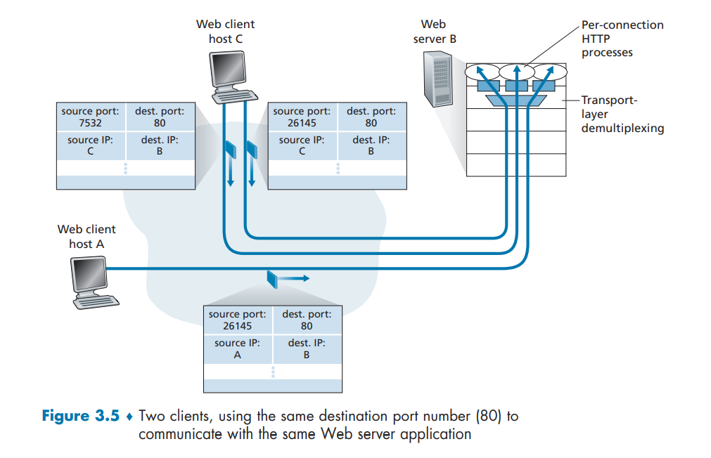

- Let us assume the following change: at B we want to access an FTP server from host A. What port number should be used to replace port 80?
Port 80 should be replaced with 21, with support for port 20. If host A wants to access to an FTP server instead of an HTTP server, the destination port number should be replaced from 80 to port 21, identifying an FTP service. Although the FTP protocol used another port number, 20, I mentioned port 21 because this port value is the most commonly used port number for FTP today.

- Would there be an error if the right process of C used port number 8080?
Port 8080 is an alternative port number for port 80. Hence, no error would occur.

- What are the source and destination port values in the segments flowing from the server back to the clients' processes?
The destination port value in these segments is the source port value, and the source port value is the destination port value from the segment sent by the client. Specifically, the source and destination port values sent from the server are the reversed from those in the received segment.

Why is it necessary for the server to use a special initial sequence number in the SYN-ACK message?
When the server receives a SYN message from the client, which is used by the client to establish a TCP connection between itself and the server, the server sends back a SYN-ACK message with the SYN flag set to 1, along with a random and special initial sequence number. This special initial sequence number determines if a client wants to continue with the connection establishment. If the client wants to proceed, it increments the received initial sequence number from the server by 1 and returns this sequence number value back to the server in a new segment. Otherwise, no segment is sent by the client.
The allocated resources and variables dedicated to the connection are released after approximately 1 to 2 minutes without a response from the client.

A layer-4 firewall (a device that can look at all protocol headers up to the transport layer) cannot:
- Block entire HTTP traffic during 8:00 PM and 6:00 AM.
This is an incorrect statement. A layer-4 firewall can filter incoming traffic by time and port numbers. Consequently, blocking HTTP traffic (identified by port 80 or 443 for secure connections) from 8:00 PM through 6:00 AM is possible for a layer-4 firewall.
- Block all ICMP traffic.
One of the main goals of the layer-4 firewall as a network component is to block ICMP (ping messages) traffic, as attackers at the time were sending enormous amounts of ICMP messages to the organization's network's server with the intent to crash it. Thus, a layer-4 firewall was developed to block ICMP traffic, making this statement about layer-4 firewalls to be incorrect.
- Stop incoming traffic from a specific IP address but allow outgoing traffic to the same IP address.
False. A layer-4 firewall is capable of stopping incoming traffic from specific IP addresses (often configured by the network administrator) while allowing outgoing traffic to be sent to this blocked IP addresses concurrently.
- Block TCP traffic from a specific user in a multi-user system between 8:00 PM and 6:00 AM.
This statement is correct. A layer-4 firewall cannot provide this functionality because it is incapable of identifying a user in a multi-user system without some user-identity information.

Consider the following statements about the functionality of an IP-based router.
- The router does not modify the IP packets during forwarding.
False. IP-based routers do modify IP packet values during forwarding. For instance, when an IP-based router receives an IP packet through an ongoing link, it decrements the TTL value by 1 and updates the forwarding table.
- It is not necessary for a router to implement any routing protocol.
This statement is absolutely correct. A router should not implement any routing protocol. However, a router should implement a routing protocol. Either the Link-State (LS) algorithm or the Centralized Routing (CR) algorithm is sufficient to forward an IP packet toward its destination.
- The router should reassemble IP fragments if the MTU of the outgoing link is larger than the size of the incoming IP packet.
This statement is incorrect because reassembly is typically done at the destination, not by intermediate routers during the forwarding process.

What is the key difference between forwarding and routing?
Forwarding is a function that routers use to forward a received packet based on their forwarding table.
Routing is a process computed by the network's routing algorithm to determine the best path for packets between a source and a destination.
The key difference between forwarding and routing is the information scale.
While forwarding is used in forwarding tables to send packets, every forwarding table is different because each router has limited information about the network architecture. It knows only the source incoming link and the appropriate outgoing link for a received packet, whereas routing knows the entire network architecture, allowing it to create forwarding tables for these routers. To summarize, forwarding is distinct from routing in that is a local action, whereas routing is a global process.

A router uses the following forwarding table:
Destination | Subnet Mask | Interface
144.16.0.0 | 255.255.0.0 | Eth0
144.16.64.0 | 255.255.224.0 | Eth1
144.16.68.0 | 255.255.255.0 | Eth2
144.16.68.64 | 255.255.255.224 | Eth3

A packet bearing a destination address 144.16.68.118 arrives at the router. On which interface will it be forwarded?
Eth3 is the closest match in the address range for a packet bearing 144.16.68.118 as its destination address. The other interfaces (Eth0, Eth1, and Eth2) can also be used to forward this packet for a case in which Eth3 fails.
Briefly explain the difference between the Control Plane and the Data Plane in the network layer. Is data traffic forwarding a User Plane function?
The Control Plane manages network decisions and routing, while the Data Plane handles the actual data transfer based on those decisions.
Data traffic forwarding is an important part of the User Plane (also called the 'Data Plane') because this forwarding function is essential for forwarding packets along a path from a source to a destination.

We said that a network layer's service model "defines the characteristics of the end-to-end transport of packets between sending and receiving hosts". What is the service model of the Internet's network layer? What guarantees are made by the Internet's service model regarding the host-to-host delivery of datagrams?
The service model of the Internet's network layer is best-effort service. Several of the most common services for the network layer that have been proposed by service models include guaranteed delivery of packets to their destination, guaranteed minimal bandwidth (e.g., 1 Gigabit per second), guaranteed reception of the packets in the order they were sent, guaranteed delivery with bounded delay (e.g., within 100 milliseconds), and security services. The best-effort service model guarantees none of these services.

How can the input ports in a high-speed router facilitate fast-forwarding decisions?
To help you understand this review question, I have clarified two key technical terms in it.
Forwarding Decisions– when a packet arrives at a router, the router decides to which outgoing link the packet needs to be forwarded to.
Input Ports – the links that connect a router to other network components (i.e., an end system, a link-layer switch, or another router), allowing it to receive and send incoming packets.
The input ports in a high-speed router use specialized hardware for parallel processing and fast lookups (obtained through lookup tables), enabling fast-forwarding decisions without CPU delays.

If a packet matches multiple entries in a router's forwarding table, which uses traditional destination-based forwarding, how does the router decide which entry to use to send the packet?
To determine which entry to use to send the packet, the router follows the longest prefix matching rule, which states "A packet that matches two or more entries in a router's forwarding table should be forwarded to the entry with the longest matching prefix of its destination address."

Why is a router required? What is inside a router? What are the types of routers? Does a router provide Wi-Fi?
The main function of a router is to forward datagrams toward their destination using lookup and forwarding tables.
A router is composed of software and hardware layers. The software layer routes and manages datagrams with a routing processor using the Control Plane's routing algorithms. The hardware layer consists of input ports, a switch fabric, and output ports. The software and hardware layers coordinate using a bus, which passes a copy of the forwarding tables to the switch fabric to locate the correct output port to which an arriving packet should be forwarded.
There are several types of routers: IP-based routers, modern routers that may not rely solely on the IP protocol, wired, wireless, and core routers. A router can also be used as a firewall for an organization's network.
Routers are widely served as Wi-Fi access points around the globe. Therefore, routers do provide Wi-Fi.

What is HOL blocking? Does it occur in input ports or output ports?
HOL (Head-Of-Line) blocking occurs when a packet that is being processed by the switch fabric requires a long time to process, causing the first packet in the queue to be blocked, which in turn causes other ready-to-process packets to wait and suffer from delays.
The HOL blocking phenomenon typically occurs at the input ports of a router.
Suppose host A sends host B a TCP segment encapsulated within an IP datagram. When host B receives the datagram, how does the network layer in host B know that it should pass the segment to TCP rather than UDP or some other upper-layer protocol?
The network layer in a host is able to pass the payload of a received datagram (that is, the encapsulated segment) to the appropriate transport protocol, whether it is TCP, UDP, or some other transport protocol, by checking the upper-layer protocol field of the datagram. In this case, in which host A has sent a TCP segment, host A sets the value of the upper-layer protocol field to 6, indicating to the network layer in host B that this segment should be passed to TCP rather than UDP or some other transport protocol.

What was the initial goal of CIDR? How does IPv6 solve the problem of IPv4 address exhaustion? Are there other advantages to IPv6 besides increased address space?
The initial goal of the Classless Inter-Domain Routing (CIDR) strategy was to provide flexibility to networks by allowing arbitrary address prefixes ranging from 1 through 32 bits. Instead of using the Classful Addressing scheme, which uses only 8, 16, and 24-bit prefixes that known as Class A, B, and C, respectively, an organization's network that uses the CIDR strategy can choose an arbitrary address prefix according to the number of hosts within it.
IPv6 solves the problem of IPv4 address exhaustion by increasing the number of bits used in an IP address from 32 to 128, allowing for 2 in power of 128 possible addresses (which is, of course, much greater than the 2 in power of 32 possible addresses in IPv4). IPv6 is represented in hexadecimal notation, consisting of 8 groups of four hexadecimal digits.
An example of an IPv6 address is: 2001:0DB8:85A3:0000:0000:8A2E:0370:7334
IPv6 has several additional key advantages besides increased address space, including improved security, the removal of the NAT protocol, and the simplification of routing headers.
There are more advantages than those listed above, but these are the major benefits of using IPv6 over IPv4.

When a large datagram is fragmented into multiple smaller datagrams, where are these smaller datagrams reassembled into a single larger datagram?
These smaller datagrams reassemble into a single larger datagram at the receiving host. More specifically, by the network layer in the received host.

Why hop limit field in an IPv6 datagram is used?
The hop limit field in an IPv6 datagram serves the same purpose as the Time-To-Live (TTL) field in an IPv4 datagram. Both fields are used to prevent packet looping by limiting the number of routers a packet can traverse before being discarded.

What are the differences between static IP and dynamic IP?
Static IP – the network administrator manually configures IP addresses for hosts in the network. The assigned IP addresses do not change during the period of time configured by the network administrator.
Dynamic IP – A DHCP server (Dynamic Host Configuration Protocol) is located on each subnet of a network, or it is directed by a router for subnets without a DHCP server. To obtain an IP address for a host in the subnet, the host performs a four-step procedure with the DHCP server, which consists of four messages exchanged between the host and the DHCP server: Discover, Offer, Request, and ACK messages. the host's assigned IP address changes as the host moves from one subnet to another.

Create a table that lists the important differences between a MAC address, an IPv4 address, and an IPv6 address.

Attribute | MAC address | IPv4 address | IPv6 address
Address Type | Mostly fixed (hardware) | Dynamic (software-assigned) | Dynamic (software-assigned)
Base Representation | Hexadecimal | Dotted-decimal | Hexadecimal
Number of bits | 48 bits | 32 bits | 128 bits
Assignment method | pre-assigned  (Embedded in hardware) | DHCP server of manually configuration | DHCP server of manually configuration
Nature | Physical | Logical | Logical

Figure 1.9 – A table listing characteristics of different types of computer addresses.
Visit a host that uses a DHCP server to obtain its IP address, network mask, default gateway, and its local DNS server. List the obtained values.
If you have a working PC and some free time, you can obtain all these values in a few simple steps.
The first step is to open a command prompt (CMD) window as an administrator on your PC. Next, enter and run the following command to release your IP address:
ipconfig /release
Then, to perform a four-step procedure with a nearby DHCP server in order to obtain a new IP address, network mask, default gateway, and local DNS server, enter and run the following command:
ipconfig /renew
After executing this command, you will see the new values displayed.
In my case, the new values are summarized in the following table:
Type | Value
IPv6 Address | 2001:4df7:1:3876:64b6:5ecf:3619:8a14
Temporary IPv6 Address | 2001:4df7:1:3876:3458:6e0c:a11b
Link-local IPv6 Address | fe80::4e2c:fd5:ab18:1a4f%11
IPv4 Address | 192.168.153.147
Subnet Mask | 255.255.255.0
Default Gateway | fe80::c14:e9ff:febd:49c2%11 , 192.168.153.205
DHCP Server | 192.168.153.205

Suppose there are four routers between a source host and a destination host. Ignoring fragmentation, an IP datagram sent from the source host to the destination host will travel over how many interfaces? How many forwarding tables will be indexed to move the datagram from the source to the destination?
The total number of interfaces an IP datagram sent from a source host to a destination host over a path that consists of four routers is ten. Generally, to calculate the total number of interfaces between the sending and receiving hosts, we use in a very simple formula, the Total Interfaces On Path (TIOP) formula: (N * 2) + 2.
In this formula, N represents the number of routers along the path. The additional integer value of 2 represents the sending and receiving interfaces of the hosts.
Four forwarding tables will be indexed to forward he IP datagram, one corresponding to each router along the path.
Suppose you purchase a wireless router and connect it to your cable modem. Also suppose that your ISP dynamically assigns your connected device (that is, your wireless router) one IP address. Also suppose that you have five PCs at home that use 802.11 to wirelessly connect to your wireless router. How are IP addresses assign to the five PCs? Does the wireless router use NAT? Why or why not?
To assign IP addresses for the five PCs, the wireless router uses the Network Address Translation (NAT) protocol. By using NAT in the wireless router, the wireless router can assign private IP addresses to the PCs in the home network, allowing the PCs to be hidden from external networks. If some PC wants to communicate with some other PC on an external network, the wireless router will convert the PC's private IP address into a public IP address. The responses to the public IP address will be forwarded to the wireless router, which will convert them into the original private IP address, and then send the data to the intended PC.
For instance, the wireless router might be assigned the IP address 10.0.0.1 /24 from its ISP. The router would then assign private IP addresses to the PCs in your home network, such as 10.0.0.1/24 for the first PC, 10.0.0.2/24 for the second, and so on.

What is a private IP address? Should a datagram with a private network address ever be present in the larger public Internet? Explain.
A private IP address is an IP address that is not visible to external networks. The internal network (that is, the network in which the private IP address resides) is the only network that knows about the existence of this IP address. Note that there may be many private IP addresses with the same value. However, each such IP address is located on a different network, and each network does not know that there are identical IP addresses on other networks. Therefore, this invisibility mechanism prevents networks from being confused with other networks' private IP addresses.
Clearly, a datagram with a private IP address as either the source host's or the destination host's should never be present on the vast public Internet. More specifically, as mentioned, there are many identical private IP addresses that exist concurrently on different networks. However, the invisibility mechanism prevents confusion between networks that have identical private IP addresses on other networks to their own private IP addresses. Therefore, this invisibility mechanism will be compromised if datagrams with private IP addresses are allowed to be present on the global and public Internet, causing routers in the Internet to have multiple entries for a single private IP address in their forwarding tables without a clear destination-based forwarding decision.

What is meant by a 'plug-and-play' and 'zeroconf' protocol?
The terms 'plug-and-play' and 'zeroconf' (zero-configuration) refer to the DHCP server's ability to connect a host to a network with minimal configuration effort from either the host or the network administrator.

What are the inside and outside NAT addresses?
NAT inside addresses are the private IP addresses of hosts on a network. The NAT outside addresses, however, are the corresponding translated public IP addresses of the hosts' private IP addresses, enabling them to communicate with other hosts on external networks, which are outside (i.e., external to) their internal network.

It has been said that when IPv6 tunnels through IPv4 routers, IPv6 treats the IPv4 tunnels as link-layer protocols. Do you agree with this statement? Why or why not?
Yes, I do agree with this statement. IPv6 can be seen as treating IPv4 tunnels as encapsulation layer (i.e., link layer) because the IPv4 tunnels provide a transport service similar to what a link-layer protocol does for native IPv6 packets.

Suppose that in a network, a machine X wishes to find the MAC address of another machine Y in its subnet. Explain the process X performs to achieve this MAC address.
In order for X to obtain Y's MAC address, X follows the following key steps:
- ARP Request - X creates an ARP request packet consisting of the IP addresses of X and Y, along with only X's MAC address (since X does not have Y's MAC address yet), and sends this ARP request packet in a broadcast frame to its subnet.
- ARP Reply – X's broadcast frame is sent to all the adapters on the subnet. The adapters each compare their IP address to the requested IP address in the received ARP request packet. Since Y is the only adapter that matches the requested IP address, only Y creates an ARP reply packet with its MAC address and sends it back to X.
- Update – X receives Y's ARP reply packet and updates its ARP table with Y's MAC address associated with Y's IP address, allowing X, which wished to communicate with Y, to do so.
Note that IP and MAC address associations typically expire after 30 minutes. Therefore, if hosts want to be able to communicate with each other after expiration, the ARP procedure would need to be performed again.
Consider the following questions:
- Is IPv6 backward compatible with IPv4?
No. IPv6 is not backward compatible with IPv4 because IPv6 has a larger address space than IPv4, making conversion of an IPv6 address into an IPv4 address problematic.
- Is it possible to have IPv4 and IPv6 addresses simultaneously?
Indeed, it is possible for a device to have both versions of IP addresses, which are IPv4 and IPv6, simultaneously. This configuration, called 'Dual Stack', enables the device to communicate with both IPv4-only and modern IPv6 devices.
- If the TTL field of a datagram has the value of 10, how many maximum routers can process this datagram?
The maximum number of routers that can process a datagram with an initial TTL value of 10 is ten, of course. Additionally, the datagram is also received by an 11th router. However, this 11th router discards the datagram because the TTL field has reached 0.
- If the value of the protocol field in a datagram is 17, which transport-layer protocol is used?
The transport-layer protocol used for a datagram with the protocol field containing the value 17 is UDP. To refer to TCP, the value 6 is entered into the protocol field.
- Suppose two IPv6 nodes want to interoperate using IPv6 datagrams, but they are connected to each other by intervening IPv4 routers. Then what is the best solution?
Nodes that interoperate using IPv6 datagrams over intervening IPv4 routers should use the tunneling technique, which was developed to allow IPv6 datagrams to be sent between sending and receiving hosts even if there are intervening IPv4-only routers.
- When you move the NIC cards from PC1 to PC2, does the MAC address get transferred as well?
Certainly. The MAC address will be transferred from PC1 to PC2 because PC's MAC address is inside a moveable hardware component called 'NIC card'. Thus, replacing PC1's NIC card with PC2's NIC card will result in the transfer of MAC addresses between PC1 and PC2.

Suppose computers P and Q have IP addresses 10.105.1.113 and 10.105.1.91, respectively. They also use the same subnet mask, denoted as N. Which of the values of N given below should not be used if P & Q are to belong to the same network?
255.255.255.0, 255.255.255.128, 255.255.255.192, 255.255.255.224.

- 255.255.255.0 as the N variable; the address range for hosts for this value of N extends from 10.105.1.0 through 10.105.1.255, with the first and last IP addresses reserved for the network and broadcast addresses, respectively. Thus, for P and Q to belong to the same network as .91 and .113, they are valid hosts because their IP addresses fall within the address range 10.105.1.0 - 10.105.1.255.
- 255.255.255.128 as the subnet mask; the address range for hosts for this value of N extends from 10.105.1.0 through 10.105.1.127, with the first and last IP addresses reserved for the network and broadcast addresses, respectively. Thus, for P and Q to belong to the same network as .91 and .113, they are valid hosts because their IP addresses fall within the address range 10.105.1.0 - 10.105.1.127.
- 255.255.255.192 represents N; the address range for hosts for this value of N extends from 10.105.1.0 through 10.105.1.63, with the first and last IP addresses reserved for the network and broadcast addresses, respectively. Thus, P and Q are invalid hosts because their IP addresses fall outside of the address range 10.105.1.0 - 10.105.1.63.
- 255.255.255.224 as the value of N; the address range for hosts for this value of N extends from 10.105.1.0 through 10.105.1.31, with the first and last IP addresses reserved for the network and broadcast addresses, respectively. Thus, P and Q are invalid hosts because their IP addresses fall outside of the address range 10.105.1.0 - 10.105.1.31.

If a class B network on the Internet has a subnet mask of 255.255.248.0, what is the maximum number of hosts per subnet?
To calculate the maximum number of hosts per subnet for a network with a subnet mask N (x.x.x.x), we perform the following key step:
- Convert N from a dotted-decimal notation into binary notation.
(If N is provided to you in binary notation already, this step is, clearly, unnecessary).
- Number the bits set to zero from the rightmost bit towards the first bit set to 1.
- Raise the integer 2 to the power of bits counted in step 2.
- Subtract two from the result, which accounts the reserved network and broadcast addresses.
- Display the result from the last step to obtain the maximum number of hosts allowed.

Hence, these key steps will be applied to the class B network with the subnet mask 255.255.248.0, as listed below:
- 255.255.248.0 is converted into binary notation: 11111111.11111111.11111000.00000000.
- After numbering the bits set to 0, there are 11 such bits overall.
- Raising 2 to the power of 11 results in 2048.
- Subtracting two from 2048 yields 2046.
Therefore, the class B network with the subnet mask 255.255.248.0 can support up to 2046 hosts per subnet.

What are the types of Network Address Translation (NAT)?
The NAT protocol offers two types of translation services.
- One-To-One Translation – NAT uses this type of translation to perform the standard translation of a private IP address into a public IP address.
- Many-To-One Translation – this type is used by NAT to translate multiple private IP addresses into a single public IP address.

Consider that a router interconnects three subnets: Subnet 1, Subnet 2, and Subnet 3. Suppose that all of the interfaces of in each of these three subnets are required to have the prefix 223.1.17/24. Also, suppose that Subnet 1 is required to support at least 60 interfaces, Subnet 2 is required to support at least 90 interfaces, and Subnet 3 is required to support at least 12 interfaces. Provide three network addresses (of the form a.b.c.d/x) that satisfy these constraints.
Since this task could be quite wordy if I had to write the solution only in words, I decided to simplify this complication and provide a picture of the solution below.

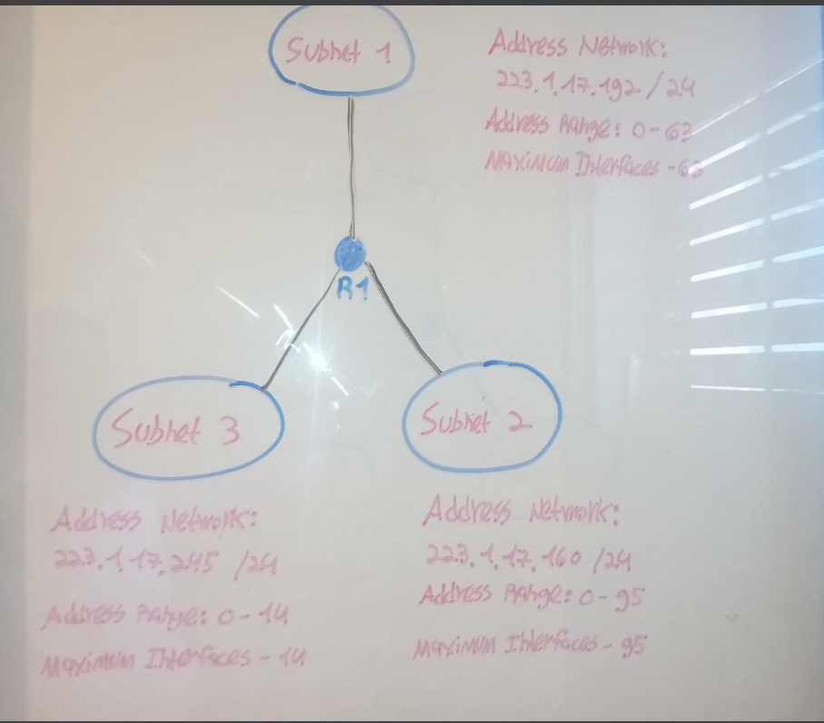
Figure 2.0 – A subnet diagram with network addressing.

Example forwarding tables that use the longest prefix matching are given below:
FT1:
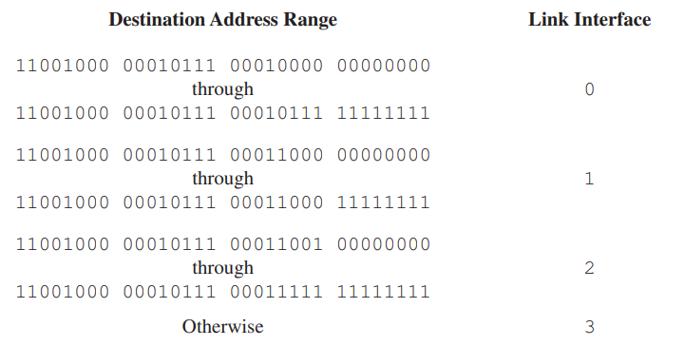
FT2:
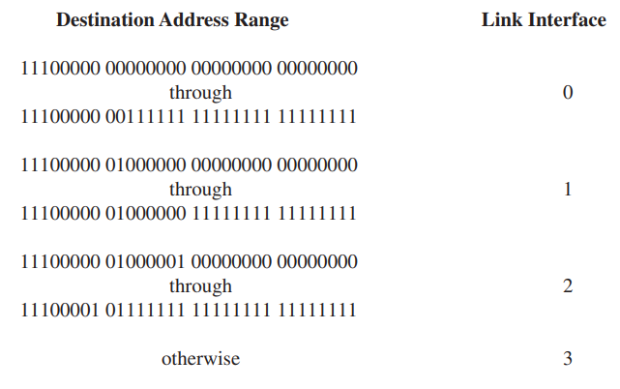
Rewrite these forwarding tables using the a.b.c.d/x notation instead of the binary notation.
The modified forwarding tables, which use the longest prefix matching based on the values in the destination address range attribute, represented in a.b.c.d/x notation, are shown below:
Destination Address Range | Link Interface
200.23.16.0/21 | 0
200.23.24.0/24 | 1
200.23.25.0/19 | 2
Default | 3
Forwarding Table 1.1 - Modified version of FT1.
Destination Address Range | Link Interface
224.0.0.0/10 | 0
224.64.0.0/16 | 1
224.65.0.0/9 | 2
Default | 3
Forwarding Table 1.2 - Modified version of FT2.

Consider the network setup shown below:
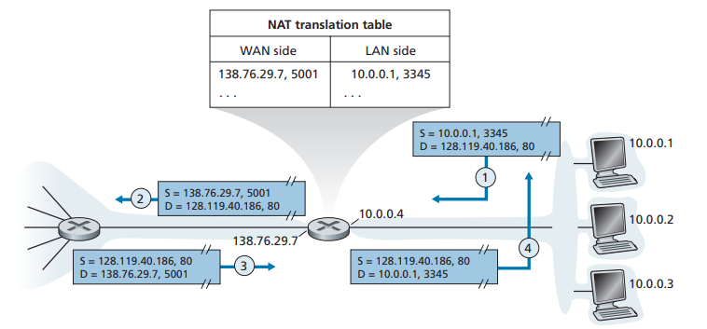
Suppose that the ISP instead assigns the router the IP address 24.34.101.225 and that the network address of the home network is 192.168.0.0/24. A. Assign addresses to all interfaces in the home network. B. Suppose each host has two ongoing TCP connections, all to port 80 at host 128.119.40.86. Provide the six corresponding entries in the NAT translation table.
- The address range for the network address 192.168.0.0/24 extends from 192.168.0.0 through 192.168.0.255, allowing up to 254 hosts in the network. We are asked to assign IP addresses to four interfaces, which are the interfaces of the three hosts in the home network, plus the interface of the router. Therefore, the first, second, and third hosts will be assigned the IP addresses 192.168.0.1, 192.168.0.2, and 192.168.0.3, respectively, and the router's interface will be assigned the next IP address, which is 192.168.0.4.
- The updated NAT translation table with the corresponding six entries is shown below:
WAN side | LAN side
24.34.101.225:4444 | 192.168.0.1:3333
24.34.101.225:4445 | 192.168.0.1:3334
24.34.101.225:4446 | 192.168.0.2:3335
24.34.101.225:4447 | 192.168.0.2:3336
24.34.101.225:4448 | 192.168.0.3:3337
24.34.101.225:4449 | 192.168.0.3:3338

the LAN-side column contains the hosts' IP addresses with a unique port number after the colon (:) for each ongoing TCP connection. The WAN-side column contains the corresponding public IP addresses and port numbers, allowing them to communicate on the public Internet.

What is meant by a control plane that is based on per-router control? In such a case, when we say the network control and data planes are implemented "monolithically", what do we mean?
A control plane that is based on per-router control means that the configuration and management of forwarding tables by the control plane are implemented within the router itself and not by a logically centralized control approach, such as the centralized routing approach used by SDN networks.
In such a case, where the per-router control approach is used, we should describe the network control and data planes as being implemented "monolithically". In simpler terms, it means "indivisible", as both the network control and data planes must be implemented as a whole.

What is meant by a control plane that is based on logically centralized control? In such cases, are the control plane and data plane implemented within the same device or in separate devices? Explain.
The opposite approach to the per-router control approach, where the control plane is separated from the data plane, is the logically centralized control approach. In this approach, the control plane is managed by a remote centralized controller (which can consist of several servers) that computes, maintains, and installs forwarding tables on the routers.
In this case, as mentioned, these control and data planes are not implemented within the same device, which improves network scalability and overall performance.

Summarize the link state routing algorithm.
The link state routing algorithm is characterized by having knowledge about each link throughout the entire network.

Two popular routing algorithms are Distance Vector (DV) and Link State (LS) routing. Which of the following are true?
- Count to infinity is a problem with DV and not LS routing: This statement is true because the DV routing algorithm is computed within individual nodes, which have partial knowledge about the links and other nodes in the network (expect of their neighbor nodes), making the count-to-infinity scenario commonplace in networks that use DV. In contrast, the LS routing algorithm cannot reach such a situation, as it is familiar with the entire network architecture, preventing count-to-infinity scenarios.
- In LS, the shortest path algorithm is run only at one node: This is a false statement because LS runs on multiple nodes, each having a complete topology database of the network.
- In DV, the shortest path algorithm is run only at one node: True. The DV routing algorithm runs only at one node.
- DV requires a lesser number of network messages than LS: This is generally considered true. DV requires fewer messages than LS, as it updates neighbors only.
To summarize, all the statements are proved to be true with the exception of the false statement, which is the second statement.

Briefly explain the difference between Distance Vector routing and Link State rouging.
Link State Routing; this type of routing requires each node in a network to have a complete map of the network, which includes the costs of directly attached links of all the nodes in the network. This information is distributed around the nodes by each node broadcasts the costs for its directly attached links. Count-to-Infinity scenarios cannot be on networks that use LS routing algorithms, whereas this problem is commonplace in networks that use DV routing algorithms. The following section describes DV routing in short.
Distance Vector Routing; in Distance Vector (DV) routing, each node knows and shares distance vectors only with its neighbor nodes. The least-cost paths for all of the other nodes are mostly calculated by an appropriate DV routing algorithm, such as OSPF.

How is a least-cost path calculated in a decentralized routing algorithm?
In a decentralized routing algorithm, the least-cost paths from a given node, x, to all of the destination nodes, N, are typically calculated by iterative process of exchanging messages with its neighbor nodes, and them in turn with their neighbor nodes, and so on until x has a set of least-cost paths for its destination nodes.
Why are intra-AS and inter-AS used on the Internet?
The Internet today consists of an enormous number of interconnected routers deployed in a wide variety of locations, with the number estimated to be in the hundreds of thousands of routers! Therefore, the management of routing protocols would be extremely complex, and each router would also require huge storage capacity if it were to store information about all the possible destinations on the Internet. To solve this problem, the Internet has been partitioned into Autonomous Systems (ASes), with each Autonomous System (AS) typically consisting of a manageable number of routers for a routing protocol. Thus, an intra-AS routing protocol operates within a single AS, acting as the only intra-AS routing protocol allowed to route traffic within the AS. An inter-AS routing protocol routes traffic from a source in one AS to a destination in another AS, enabling traffic transmission across multiple ASes.

What are the NEXT_HOP and AS_PATH attributes in BGP?
The NEXT_HOP attribute in BGP indicates the next router, or more precisely, the next link interface directly attached to a router to which the packet will be routed.
The AS_PATH attribute used in BGP contains a sequence of ASs with a network prefix at the end to which packets will traverse until reaching the destination network prefix.

Consider the following questions:
- What are the characteristics of OSPF?
The Open Shortest Path First (OSPF) protocol is an intra-AS routing protocol that is based on link-state routing. When OSPF is used by an AS, every router within the AS has a complete topology map of the AS, often in a hierarchical manner (as OSPF supports the hierarchical division of an AS into multiple areas), preventing count-to-infinity cases. OSPF determines the best path from a given source to a given destination by selecting the path with the lowest total cost (i.e., the path with the highest total link bandwidth) among multiple available paths.
- What are the benefits of dividing an autonomous system into various areas in OSPF and when is it required?
An autonomous system is typically divided into areas when the AS becomes too large for a single AS, thereby introducing the benefits of reduced overhead and improved overall performance. In OSPF, these smaller ASes are called 'areas', in which each area is identified by an area number, such as area0, area1, and so on. Similarly, an AS is identified on the Internet by a globally unique Autonomous System Number (ASN), similar to how interfaces connected to hosts and network components have IP addresses for unique identification on the Internet.
- What is the role of the topology map and routing tables in OSPF?
Routers in a network that uses OSPF have a topology map of the network, containing the link costs for all the links within the network. This topology map is used by routers to compute the least-cost path for a destination among multiple available paths. After a router selects the least-cost path to a destination, it saves this path in its routing table for future use.
- Why is OSPF called a loop-free protocol?
The OSPF protocol has a backbone area that is often called 'Area 0'. This backbone area is responsible for routing traffic from one area to another, preventing routing loops by structuring how traffic is exchanged between areas.

What is the default value of hello and dead intervals?
A hello message is sent from one router to its neighbor routers to advertise that it is still alive with an interval time between one hello message and another of typically 10 seconds. The default dead interval of 40 seconds. After a router hasn't received any hello message within this time, it removes the 'dead' (i.e., unresponsive) router.

What two types of ICMP messages are received at the sending host executing a Traceroute program?
To execute a Traceroute program, two main types of Internet Control Message Protocol (ICMP) messages must be received at the sending host (to which we will refer to as the 'source host'): one from routers that lie on the path between the source host and the destination host, and one from the destination host.
- The first type is the TTL expired ICMP message. This type of ICMP message causes routers along the path to send their names and their IP addresses, along with the header and the first 8 bytes of an arriving datagram from the source host, in which the TTL field has reached zero. The TTL expired ICMP message is used to identify the routers along the path.
- The second type is the unreachable destination port ICMP message. This ICMP message is sent only from the destination host's operating system back to the source host, indicating that there is no appropriate process running on the port number in the received datagram sent by the source host. This will mostly happen, as the source host's Traceroute program places an unlikely port number into the datagram to be sent to the destination host.

What is the incorrect command in the following router configuration? What needs to be changed to create a correct configuration?
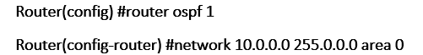

In this router configuration, the second configuration line contains an incorrect wildcard mask; it should be 0.0.0.255. The correct router configuration after this modification is:
Router(config) #router ospf 1
Router(config-router) #network 10.0.0.0 0.0.0.255 area 0

Consider the network shown below.
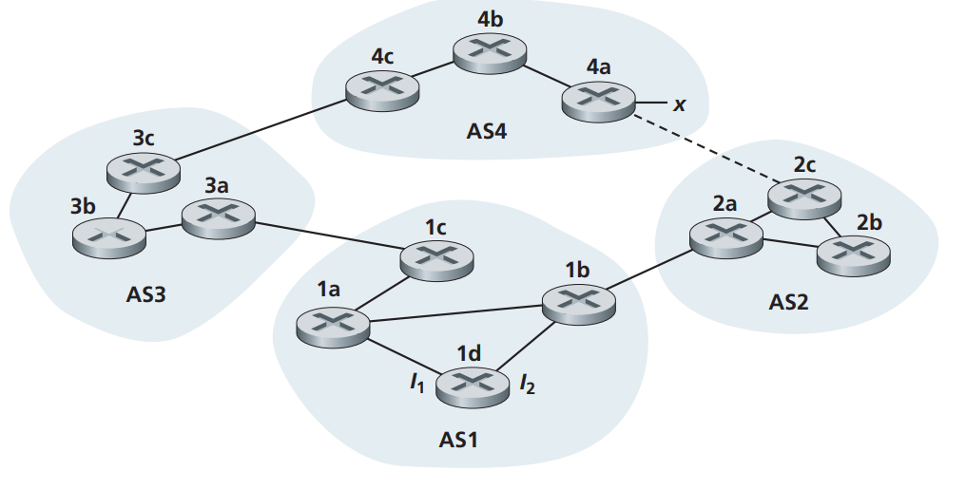
Suppose that AS3 and AS2 are running OSPF for their intra-AS routing protocol, and AS1 and AS4 are running RIP for their intra-AS routing protocol. Suppose eBGP and iBGP are used for the inter-AS routing protocol.
- Through which protocol does router 3c become familiar with the network prefix x?
Router 3c in AS3 becomes familiar with the destination network prefix x in AS4 by an external BGP (eBGP) connection with router 4c in AS4. An eBGP connection between two different AS-located routers (which are both of their AS border gateway routers) allows information to be exchanged between these two ASes.
- How does router 3a learn about the network prefix x?
Router 3d in AS3 learns about the existence of the network prefix x in AS4 by an internal BGP (iBGP) connection with router 3b within its AS, AS3, which in turn has an iBGP connection with router 3c, the border gateway router in AS3 that receives and routes information to and from remote network prefixes for all the routers within its AS through iBGP connections.
- Through which protocol does router 1c become familiar with the network prefix x?
Router 1c becomes familiar with the destination network prefix x by an eBGP connection, the same type of connection that router 3c has. However, router 1c's eBGP connection is not a direct connection with AS4, but rather receives and routes information to and from x through an intervening AS, AS3.
- How does router 1d learn about the network prefix x?
Router 1d learns about the existence of the network prefix x in AS4 by an iBGP connection.

In the following pairs of OSI protocol layer/sub-layer and its functionality, which pair is incorrect?
- Network layer and routing.
The routing process is handled by the control plane of the network layer, using routing protocols such as OSPF, RIP, and BGP. Based on this knowledge, this pair that relates the network layer with routing is correct.
- Transport layer and end-to-end communication.
The transport layer is responsible for several functions, some of which include guaranteed delivery, minimum-delay delivery, and reliable data delivery. These functions define the characteristics of the communication process between one end system and another. So, this pair that relates the transport layer with the functionality of end-to-end communication is correct.
- Medium access control sub-layer and channel sharing.
The medium access control sub-layer of the link layer has a central role in defining LANs, which are local shared channels. Therefore, this pair that relates the medium access control sub-layer with channel sharing is correct.
- Data-link layer and bit synchronization.
The bit synchronization mechanism is used by the physical layer in the Open Systems Interconnection (OSI) protocol stack. Therefore, this pair that relates the data-link layer with bit synchronization is incorrect.

What are the tasks performed by the link layer?
There are several types of tasks performed by the link layer. Some of them are more important than others, which are detailed below:
- Framing: Framing is an encapsulating process that is performed by the link layer, in which a network-layer datagram is encapsulated into a link-layer frame, along with various additional fields required for the link layer's services.
- Link access: This type of service from the link layer, which is provided by the MAC protocol, is necessary in networks with broadcast links. The MAC protocol controls the order for frames transmission in cases where multiple nodes send frames simultaneously on the broadcast link, ensuring that no collisions will be occurred.
- Reliable delivery: The link layer provides reliable delivery services by using error detection and correction techniques to detect corrupted or flipped bits in frames, similar to the services provided by transport layer protocols (e.g., TCP).

Mention one advantage and one disadvantage of using stop-and-wait flow control.
One advantage of using stop-and-wait flow control is that a packet sent by a source host is guaranteed to be received at the destination host through the use of ACK messages and packet retransmission mechanisms. One disadvantage is the poor utilization of the idle link while the sending host waits for an ACK message from the destination host.

Suppose nodes A, B, and C each attach to the same broadcast LAN (through their adapters). If A sends thousands of IP datagrams to B with each encapsulating frame addressed to B's MAC address, will C's adapter process these frames? If so, will C's adapter pass the IP datagrams in these frames to the network layer of C? How would your answers change if A sends frames with the MAC broadcast address?
The frames sent by A to B's MAC address will indeed be processed by C's adapter because these frames are on a broadcast LAN; therefore, all the nodes in the broadcast LAN will process these frames (In this case, only B and C).
However, C's adapter will not pass the IP datagrams to C's network layer and will discard these IP datagrams as soon as it notices that C's MAC address is different from the destination MAC address indicated on the received frames.
If A sends frames with the MAC broadcast address within its LAN, all the nodes' adapters in the LAN will process these frames and also pass the decapsulated frames, the IP datagrams, to the network layer of the nodes for further processing.

Consider the following questions regarding the ARP protocol and MAC addresses.
- Is it possible for the same MAC address o appear in the ARP tables of two ARP modules?
No, it is not possible to have the same MAC address in two ARP tables belonging to two different ARP modules. MAC addresses are globally unique addresses, and each ARP module responsible for a subnet owns a unique ARP table with unique MAC address entries within the subnet. However, in specific cases such as network virtualization or load balancing, the same MAC address may appear in multiple ARP tables, but these situations are exceptions rather than the norm.
- Why does an IP address need to be mapped to a MAC address, why cannot the MAC address itself be represented as an IP address?
MAC addresses were developed to provide the link layer with unique addresses to be used within a LAN. This decision was made because LANs are typically shared broadcast channels, causing each frame sent to a particular interface to be received by all the interfaces within the LAN. Therefore, if MAC addresses were represented as IP addresses, a node would be burdened and have to pass these frames to its network layer for further processing, increasing overhead and reducing performance even when the frames' destination address was not intended for it.
- How does ARP resolve an IP address to an Ethernet MAC address?
ARP resolves an IP address to a MAC address using ARP request and ARP reply packets exchanged between the requesting host and the destination host, respectively.
- Will a host update its ARP cache upon receiving any ARP request?
A host can update its ARP cache even when it receives an ARP request packet not intended for it. This is done by recording the source IP and MAC address fields of a received ARP request packet that was broadcasted on the LAN into its ARP cache.
- Which MAC address is an ARP request directed to?
The MAC address in an ARP request is that of the broadcast address of the LAN, which is forwarded by the link-layer switch to all the other nodes within the LAN.
- To which MAC address is an ARP reply directed?
The MAC address in an ARP reply is that of the requesting host, which is the host that sent the ARP request prompting the destination host to respond with this ARP reply.

