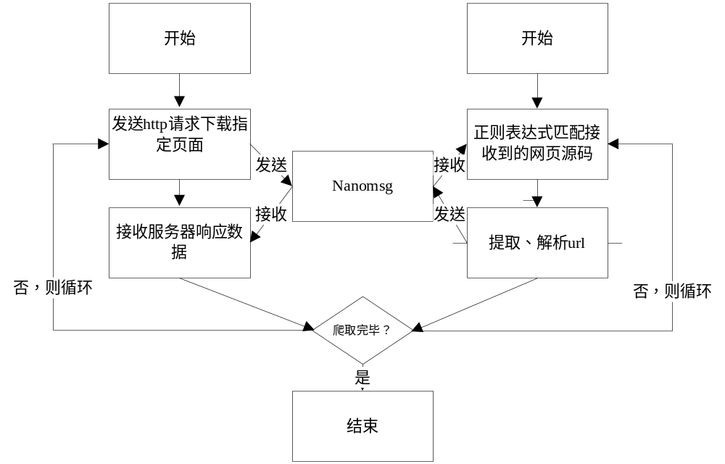

int analyze(char *bfbuf)

{

//FILE *fp = NULL;

size_t len; /* store error message length */

regex_t re; /* store compilned regular expression */

regmatch_t subs[SUBSLEN]; /* store matched string position */

char matched[BUFLEN]; /* store matched strings */

char errbuf[EBUFLEN]; /* store error message */

int err, i;

char *curpath=(char*)malloc(1024*sizeof(char));

//ulong slen=256*1024;

//char string[] = "AAAAabaaababAbAbCdCd123123 11(123){12} ";

//char pattern[] = "(\\([0-9]+\\))(\\{[0-9]+\\}{1})$ ";

char *recvbuf=(char*)malloc(100*1024*sizeof(char));

//char *srcbuf=(char*)malloc(256*1024*sizeof(char));

char *p=NULL;

//char pattern[] ="([/w-]+/.)+[/w-]+.([^a-z])(/[/w-: ./?%&=]*)?|[a-zA-Z/-/.][/w-]+.([^a-z])(/[/w-: ./?%&=]*)?";

//char pattern[] ="([http|https]://)?([/w-]+/.)+[/w-]+(/[/w- ./?%&amp;=]*)?";

//char pattern[] ="<a href=\"([^\"]+)\"[^>]*>[^<]+</a>";

char pattern[] ="<a [^>]*href=\"([^jh\"][^\"]*)\"";

//char pattern[] = "<a href.+?+\"";

//char pattern[] = "<a[^>]*?\s?href\s*?=\s*?['\"](?!javascript)(.+?)['\"](?:(?:\s*?)+?.*?)*?>";

//printf("String : %s\n ", string);

//printf("Pattern: \" %s \" \n", pattern);

/*if(NULL == (fp = fopen(FILE_PATH)))

{

printf("Open error\n");

return 0;

}*/

/* compile regular expression */

err = regcomp(&re, pattern, REG_EXTENDED);

if (err)

{

regerror(err, &re, errbuf, sizeof(errbuf));

fprintf(stderr, "error: regcomp: %s\n ", errbuf);

regfree(&re);

return 0;

}

//printf("Total has subexpression: %d\n ", re.re_nsub);

/* execute pattern match */

// regexec (regex_t *compiled, char *string, size_t nmatch, regmatch_t matchptr [], int eflags)

//fread(string,1,256*1024,fp);

//printf("before recv!\n");

recvbuf[0]='\0';

//recv_ipc(sockfd,recvbuf,1024*1024);

//printf("after recv!\n");

//printf("before file open!\n");

FILE *file1=fopen("./cra_send.dat","a+");

//printf("after file open!\n");

fread(recvbuf,sizeof(char),100*1024,file1);

//fclose(file1);

//printf("after file write!\n");

//printf("recvbuf:%s\n",recvbuf);

/*FILE *file=fopen("./test_ana.html","a");

if(ungzip(srcbuf,256*1024,file) != 1)

{

printf("uncompress failed!\n");

free(recvbuf);

free(srcbuf);

regfree(&re);

return 0;

}

free(recvbuf);

p=srcbuf;

printf("%s",p);

//int file = open("./test_ana.html", O_RDWR | O_APPEND | O_CREAT,S_IRWXU);

//fprintf(file,"%s",p);

fclose(file);*/

if(recvbuf[0] == '\0')

{

printf("recv failed!\n");

return 0;

}

//puts("before extract!");

if(!extract_curpath(recvbuf,curpath))

{

return 0;

}

//puts("after extract!");

FILE *file=fopen("./curpath.dat","a");

//fprintf(file,"curpath:%s\n",curpath);

fclose(file);

p=recvbuf;

if(!p)

{

return 0;

}

while(1)

{ //printf("while loop\n");

err = regexec(&re, p, (size_t)SUBSLEN, subs, 0);

if (err == REG_NOMATCH)

{

printf("Sorry, no match ...\n");

regfree(&re);

//free(recvbuf);

//free(curpath);

//if(recvbuf){puts("reg_nomatch before nn_freemsg");nn_freemsg(recvbuf);puts("reg_nomatch after nn_freemsg");}

return 0; //return value is boolean,not errno.

}

else if (err)

{

regerror(err, &re, errbuf, sizeof(errbuf));

printf("error: regexec: %s\n ", errbuf);

regfree(&re);

//puts("2");if(recvbuf){nn_freemsg(recvbuf);}

//free(recvbuf);

//free(curpath);

return 0;

}

//printf("%d\n",err);

static int matched_count=0;

matched_count++;

printf("matched_count:%d\n",matched_count);

printf("match begin: %d, end: %d, ",subs[1].rm_so, subs[1].rm_eo);

len = subs[1].rm_eo - subs[1].rm_so;

memcpy(matched, p + subs[1].rm_so, len);

matched[len] = '\0';

//printf("%s\n",matched);

puts("before analyzerUrl");

analyseUrl(bfbuf, curpath,matched);

puts("after analyzerUrl");

//extract(sockfd,matched,pus);

//send_ipc(matched);

//ipc_ana(matched,buf);

p+=subs[0].rm_eo;

if(*p=='\0')

{

break;

}

}

/*if no REG_NOMATCH and no error, then pattern matched

printf("\nOK, has matched ...\n\n");

for (i = 0; i<re.re_nsub; i++)

{

printf("subexpression %d begin: %d, end: %d, ", i,subs[i].rm_so, subs[i].rm_eo);

len = subs[i].rm_eo - subs[i].rm_so;

memcpy(matched, string + subs[i].rm_so, len);

matched[len] = '\0';

printf("match: %s\n ", matched);

} */

//if(recvbuf){nn_freemsg(recvbuf);}

//free(curpath);

//free(recvbuf);

regfree(&re);

return 1;

}

int crawler(int sockfd,char *url)

{

struct event *ev;

struct event_base *base=event_base_new();

evutil_socket_t fd;

struct sockaddr_in serv_socket;

struct timeval tv;

//int success=0;

//int arg[2];

args arg;

arg.sockfd=sockfd;

//arg.success=0;

arg.url=url;

tv.tv_sec=5;

tv.tv_usec=50*1000;

bzero(&serv_socket, sizeof(struct sockaddr_in));

serv_socket.sin_family = AF_INET;

serv_socket.sin_port = htons(80);

inet_pton(AF_INET, "10.108.106.179", &serv_socket.sin_addr);

fd = socket(AF_INET, SOCK_STREAM, 0);

int flag = connect(fd, (struct sockaddr *)&serv_socket, sizeof(serv_socket)); //建立和HTTP服务器的TCP链接

if(flag < 0)

{

printf("connect error!!! flag = %d\n", flag);

exit(1);

}

char * request = (char *) malloc (1024 * sizeof(char));

sprintf(request, "GET %s HTTP/1.1\r\nAccept: html/text\r\nHost: 10.108.106.179\r\nConnection: Close\r\n\r\n",url);//option: Accept-Encoding:gzip,deflate\r\n

int send = write(fd, request, strlen(request));

free(request);

ev=event_new(base,fd,EV_TIMEOUT|EV_READ|EV_PERSIST,cb_func,&arg);

event_add(ev,NULL);

event_base_loopexit(base,&tv);

event_base_dispatch(base);

//printf("after dispatch!\n");

//send_ipc(buf);

return 1;

}

