Game Design Document

Fill up the Following document

1. Write the title of your project.

Corona: The Task of Survival

1. What is the goal of the game?

The goal of the game is to reach the vaccine

1. Write a brief story of your game?

This game is based on the ongoing pandemic of corona virus in the

which the player has to escape the corona and reach the vaccine in

limited time .

1. Which are the playing characters of this game?

* Playing characters are the ones which respond to the user based on the input from the user
* Cars, monkeys, dinos, wizards etc, are the playing characters in the game.

|  |  |  |
| --- | --- | --- |
| Number | Character Name | What can this character do? |
| 1 | The survivor | This character has to escape corona and reach to the vaccine |
| 2 |  |  |
| 3 |  |  |
| 4 |  |  |
| 5 |  |  |
| 6 |  |  |
| 7 |  |  |
| 8 |  |  |

1. Which are the Non Playing Characters of this game?

* Non Playing characters are the ones which don't have an action or a behaviour when the user interacts with the game.
* Hurdles, stones, bananas, coins, etc are non playing characters in the game.

|  |  |  |
| --- | --- | --- |
| Number | Character Name | What can this character do? |
| 1 | Containment zone | A type of obstacle |
| 2 | Infected person | A type of obstacle |
| 3 | First aid kit | Can increase the health of the user by 50% |
| 4 | kadha | Can increase the health of the user by 25% |
| 5 |  |  |
| 6 |  |  |
| 7 |  |  |
| 8 |  |  |

Draw your imagination of this game. What does this game look like?

* Draw the game either on your computer or on paper,
* Add images of scenes of the game to show each of the playing and non-playing characters at least once.

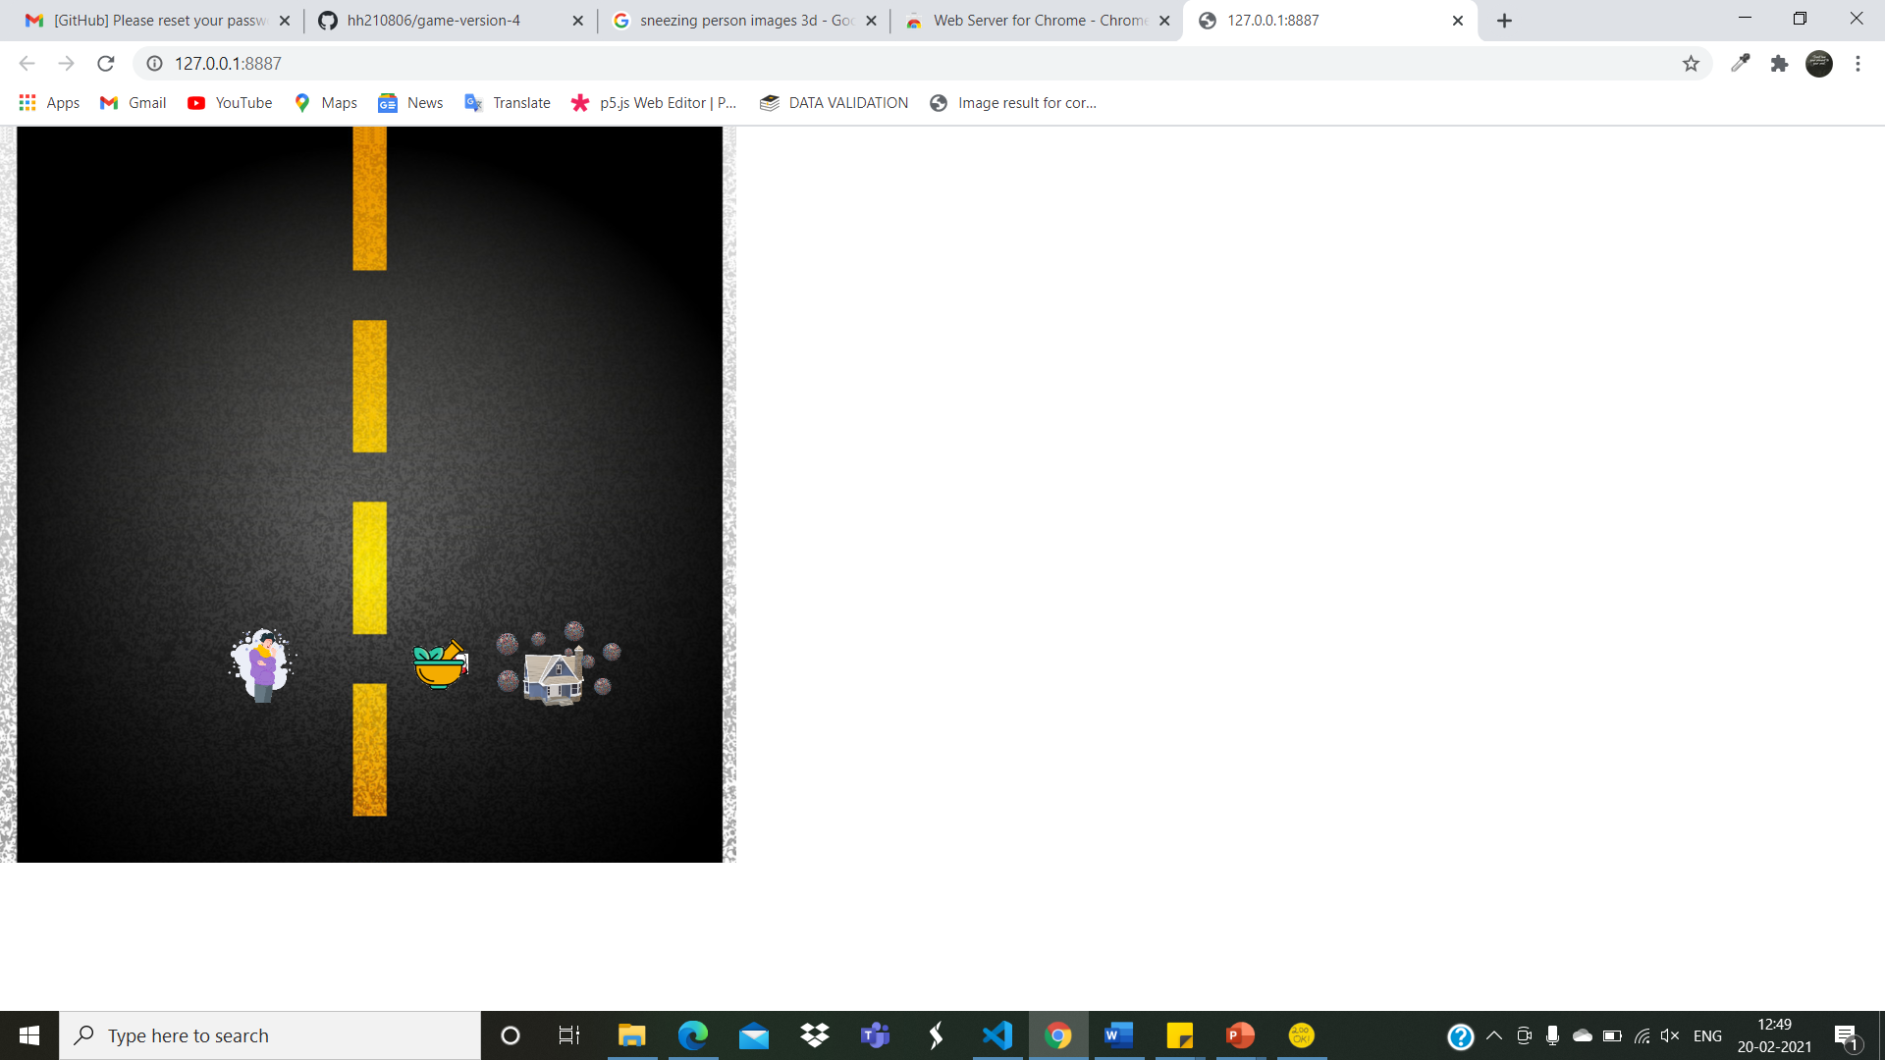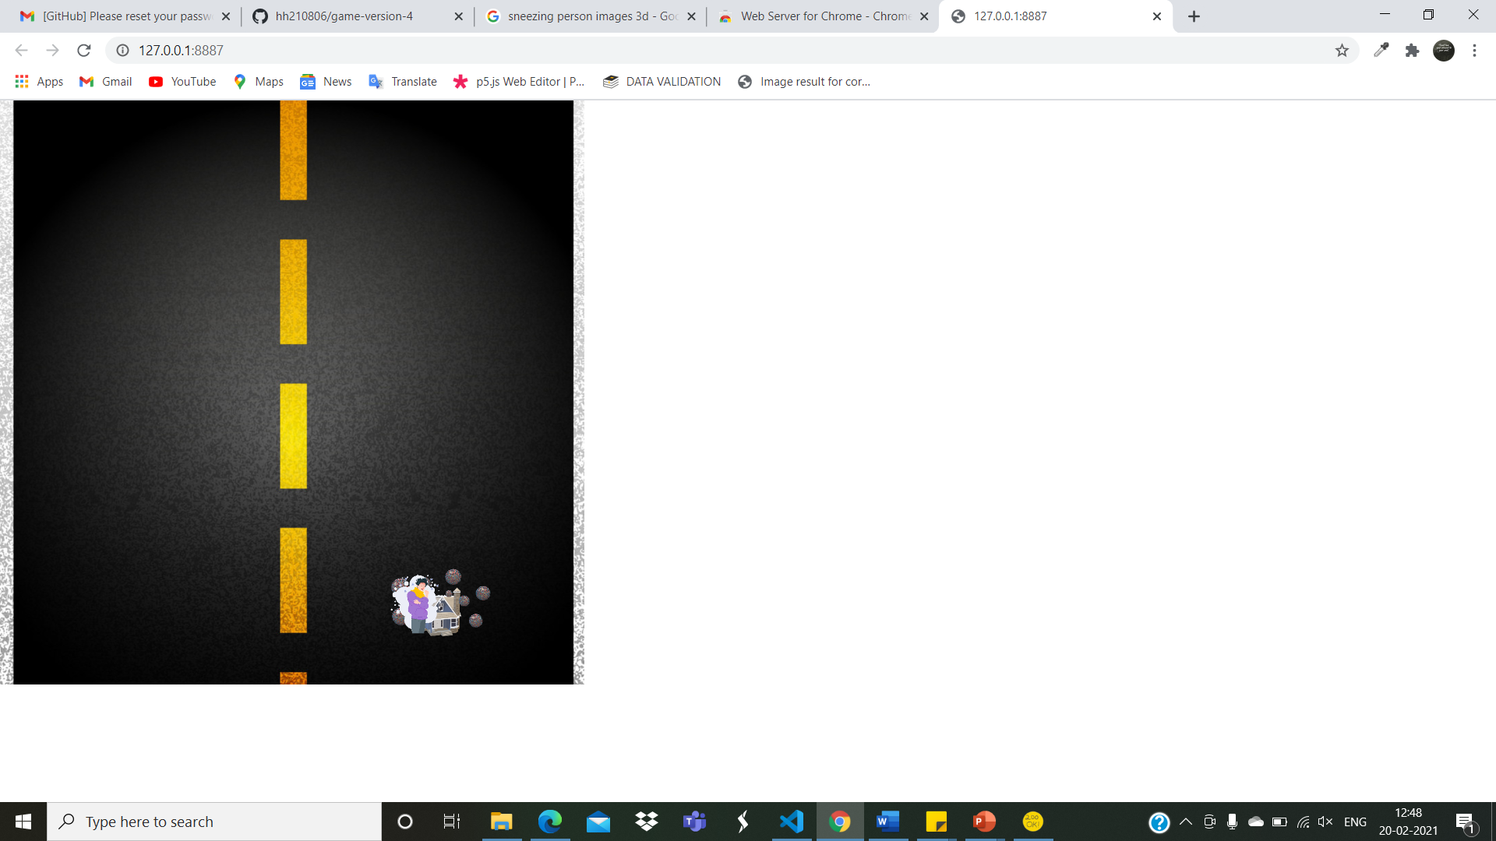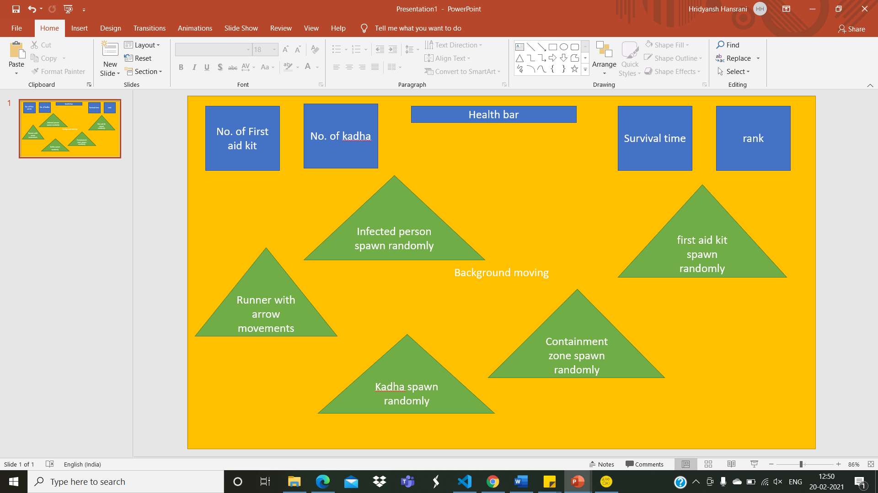

How do you plan to make your game engaging?

It is a interesting game based on ongoing pandemic.it has the things like first aid kit and kadha to increase the health and infected person and the containment zones to decrese the health of the player. Also this will give people the sense of how to deal with corona and the neccesary precautions that must be followed, but in a fun filled way. Also this game will be having a ranking system to appreciate the playing.