UNIVERSITY OF SCIENCE

FACULTY OF INFORMATION TECHNOLOGY



**SUBJECT**: COMPUTER GRAPHICS

**INVIDUAL LAB 03**

Name: **Phan Huy Hoàng**

ID: **19127409**

Class: **19CLC**

Year: **2021 – 2022**

Lecturers: **Pham Minh Hoang**

**Nguyen Manh Hung**

**HO CHI MINH CITY, November, 2021**

1. **Personal Information:**

* Name: Phan Huy Hoàng
* Student ID: 19127409
* Email: [phhoang19@clc.fitus.edu.vn](mailto:phhoang19@clc.fitus.edu.vn)

1. **Completeness**

|  |  |  |
| --- | --- | --- |
| **No** | **Requirements** | **Grade** |
| **1** | Implement an 2D affine transformation class on basis objects |  |
| a | Line segment, circle, ellipse, rectangle, polygon | 1 |
| b | Equilateral triangle, equilateral pentagon, equilateral hexagon | 1 |
| **2** | Manipulate on 2D objects |  |
| a | Move shapes by dragging mouse | 2 |
| b | Rotate shapes by dragging mouse on control points | 2 |
| c | Zoom shapes by dragging mouse on control points | 2 |
| **3** | Friendly interface, easy to use (refer to Paint or other popular graphic software) | 1 |
| **4** | Using OOP | 1 |
| **Sum** |  | 10 |
| **Completeness** |  | 10  (100%) |

1. **Guide user**

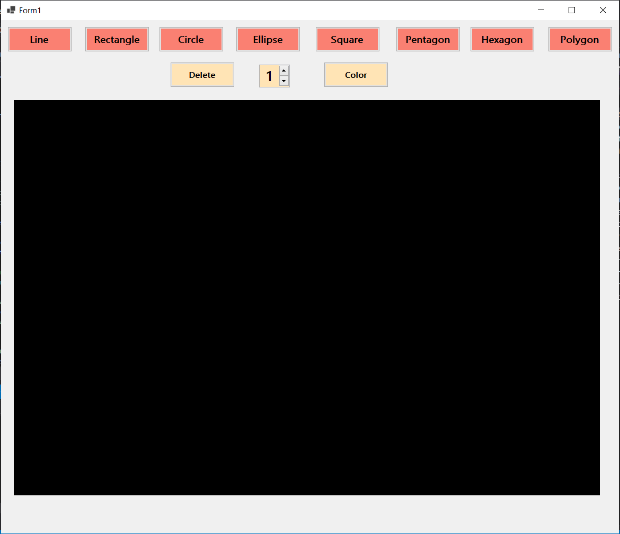

* The picture upper is the default application, first line buttons in red background are shape can draw. Below line is the function line, having delete function, change thickness function, and change color function.
* User can choose any shape to draw, and click to that shape to draw control points (highlight), after that user can choose any function (zoom, move, rotate) to use by click right mouse.
* The link below is the demo:

<https://drive.google.com/drive/folders/13IAopwsNLea5558LC5OHgUaKneadZ5pe?usp=sharing>