EE 1004 & CSE 2062 OBJECT-ORIENTED PROGRAMMING
PROJECT REPORT
Team Number: Group 13
Project Name: Project 13 – Charity Donation Tracker
Name Surname – Student ID | Contribution Details
RUMEYSA ŞENOL - 150720049 | Implemented Core Architecture, Abstract Donation Class, Inheritance Tree, and Subclasses, Report Implemented Main Execution Loop, Error Handling, and Test Framework.
HASAN HÜSEYİN ACAR - 150724055 | Implemented Core Architecture, Abstract Donation Class, Inheritance Tree, and Subclasses.
ALİ SAİL - 150724056 | Developed Charity Class, Interface Integration, Collections Business Logic, and HashMap Lookup.
FATİH DENİZ - 150724025 | Implemented Main Execution Loop, Scanner Pipeline, Verbatim Error Handling, and Test Framework.
ONUR ÖZDEMİR - 150724052 | Developed Charity Class, Interface Integration, Collections Business Logic, and HashMap Lookup.
ÖMER HASAN BAYRAKDAR - 150725032 | Implemented Main Execution Loop, Scanner Pipeline, Verbatim Error Handling, and Test Framework.
Spring 2026
Part #1 Core Architecture, Abstraction & Inheritance
1.1 Brief explanation of the problem
This part focuses on defining the foundational data model for the Charity Donation Tracker application. It requires creating a structural blueprint using an abstract class and specialized subclasses to represent different types of donations (Money, Food, and Clothing). The core objective is to ensure automated, static identifier assignment and standardize value calculations across various donation types using class inheritance.
1.2 UML Diagram
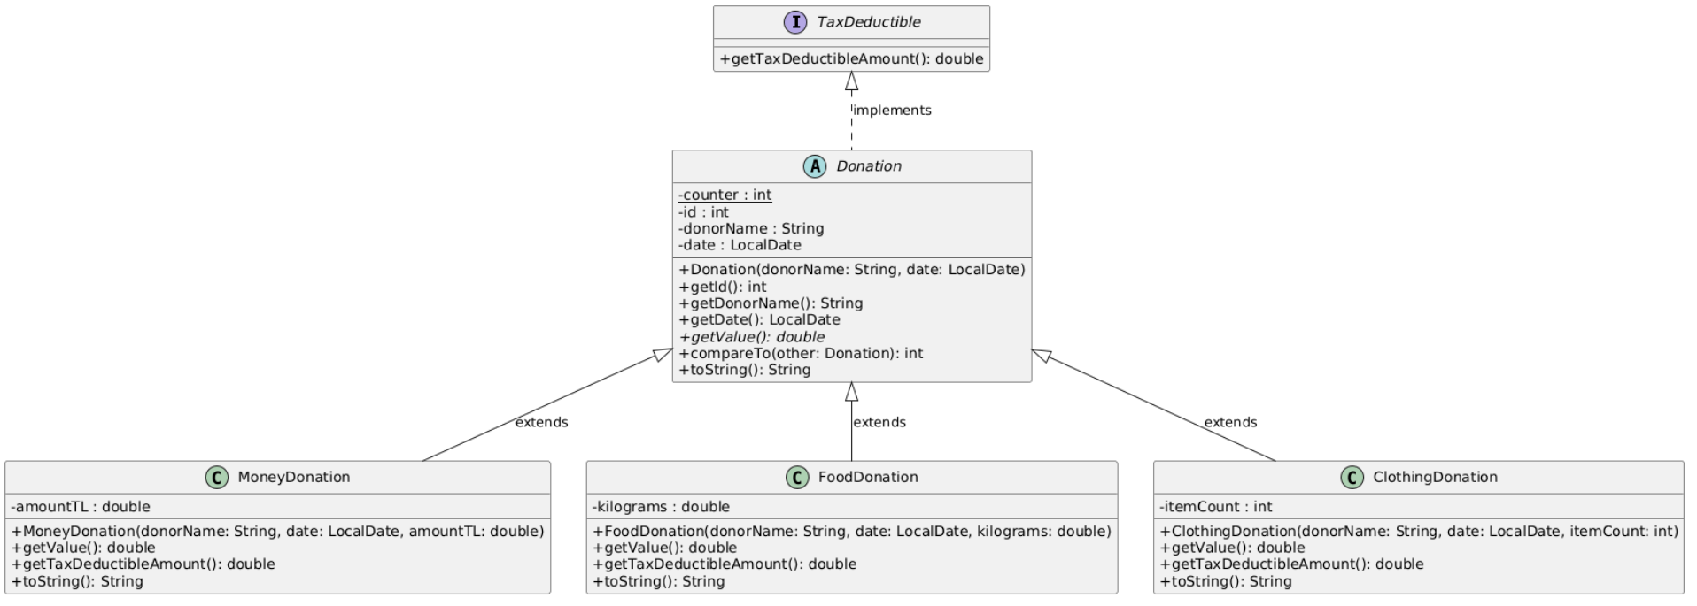
1.3 Data field definition list
# | Modifier | Type | Name | Comment
1 | private static | int | counter | A global static counter used to auto-increment and assign unique IDs to each new donation instance.
2 | private | int | id | The unique identification number automatically assigned to a specific donation instance.
3 | private | String | donorName | Stores the full name of the individual or organization making the specific donation.
4 | private | LocalDate | date | Represents the chronological calendar date when the donation was officially registered.
5 | private | double | amountTL | Stores the precise monetary value of a recorded cash contribution.
6 | private | double | kilograms | Holds the physical mass weight measurement in kilograms for food items.
7 | private | int | itemCount | Tracks the physical count of individual clothing apparel units received.
1.4 Object definition list
# | Name | Args | Comment
1 | Donation | String donorName, LocalDate date | Protected constructor for the abstract base class to initialize core donation data and auto-increment the global counter.
2 | MoneyDonation | String donorName, LocalDate date, double amountTL | Constructor initializing cash-specific records along with the inherited base class fields.
3 | FoodDonation | String donorName, LocalDate date, double kilograms | Constructor initializing bulk food weight parameters alongside base class fields.
4 | ClothingDonation | String donorName, LocalDate date, int itemCount | Constructor initializing clothing piece counts and linking with the base class parameters.
1.5 Method definition list
# | Modifier | Return Type | Name | Args | Comment
1 | public | int | getId | None | Getter method returning the unique sequential ID of the donation instance.
2 | public | String | getDonorName | None | Getter method returning the name identifier of the specific donor.
3 | public | LocalDate | getDate | None | Getter method returning the recorded transaction timestamp.
4 | public abstract | double | getValue | None | Abstract method implemented by subclasses to calculate the specific monetary evaluation in TL.
5 | public | int | compareTo | Donation other | Overrides the Comparable contract to order donation entries by value descending (highest first).
6 | public | String | toString | None | Overrides default printing to provide a clear, human-readable generic donation summary.
1.6 Class definition list
# | Modifier | Name | Abstract ? | Extends what ? | Comment
1 | public abstract | Donation | Yes | None | The master abstract base class that establishes common operational parameters for all donation records.
2 | public | MoneyDonation | No | Donation | Represents cash contributions where the intrinsic value equals the exact amount donated.
3 | public | FoodDonation | No | Donation | Models grocery entries where the value is determined by total weight multiplied by 80.0 TL/kg.
4 | public | ClothingDonation | No | Donation | Tracks apparel records where the value is computed by counting items multiplied by 150.0 TL.
1.7 OOP Concepts
• Abstraction: Realized through the abstract class Donation and its abstract method double getValue(). It hides individual value calculation implementations from the core reporting engine.
• Inheritance: The specialized concrete subclasses (MoneyDonation, FoodDonation, ClothingDonation) directly inherit shared attributes (id, donorName, date) from Donation, enforcing modular reuse and reducing code redundancy.
Part #2 Interfaces & Advanced Collections Business Logic
2.1 Brief explanation of the problem
This section incorporates tax-deductible compliance rules and high-performance collection tracking into the system. It uses a loose decoupling interface design to enforce uniform financial metrics across separate components. Symmetrical list-and-map aggregation structures are utilized to satisfy storage constraints, enabling fast associative lookups instead of slow sequential loops.
2.2 UML Diagram
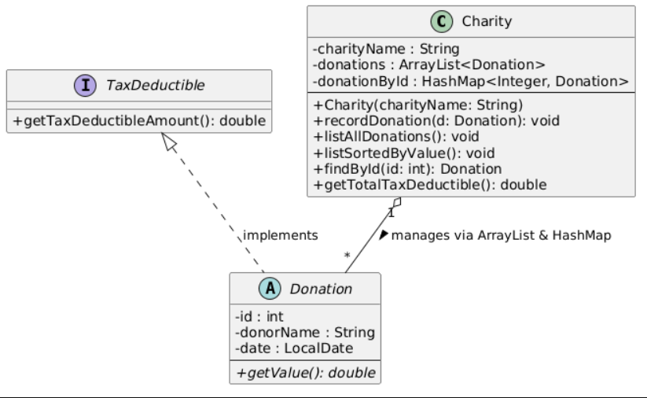
2.3 Data field definition list
# | Modifier | Type | Name | Comment
1 | private | String | charityName | Holds the official nomenclature text of the specific charity branch organization.
2 | private | ArrayList<Donation> | donations | A sequential dynamic array tracking every donation entry for general listing purposes.
3 | private | HashMap<Integer, Donation> | donationById | An associative hash table mapping unique keys to instances for instantaneous searching.
2.4 Object definition list
# | Name | Args | Comment
1 | Charity | String charityName | Instantiates a central charity management manager, initializing local dynamic lists and associative index charts.
2.5 Method definition list
# | Modifier | Return Type | Name | Args | Comment
1 | public | double | getTaxDeductibleAmount | None | Abstract behavior contract ensuring individual calculation of tax-deductible ratios.
2 | public | void | recordDonation | Donation d | Symmetrically injects incoming donation entities into both the sequential storage list and the hash index table.
3 | public | void | listAllDonations | None | Iterates over the tracker list to display all registered contributions in chronological order.
4 | public | void | listSortedByValue | None | Clones the collection list, sorts items using the Comparable interface, and logs elements from highest value to lowest.
5 | public | Donation | findById | int id | Accesses the internal hash lookup system to locate a distinct item with an instantaneous O(1) operational speed.
6 | public | double | getTotalTaxDeductible | None | Iterates through all stored elements to aggregate and display complete tax exemptions.
2.6 Class/Interface definition list
# | Modifier | Name | Abstract ? | Extends what ? | Comment
1 | public | TaxDeductible | Interface | None | Establishes a functional capability contract that guarantees tax processing behaviors.
2 | public | Charity | No | None | Acts as the central domain controller and data repository context managing the entire tracker database.
2.7 OOP Concepts
• Interface Specification: TaxDeductible segregates specialized tax compliance behaviors from standard hierarchical structures, supporting independent evaluation scales (100%, 60%, 50%) across polymorphic components.
• Encapsulation: Internal collection definitions are protected using the private keyword, forcing all internal structural state adjustments to pass exclusively through validated public manager endpoints like recordDonation().
Part #3 System Execution & I/O Integration
3.1 Brief explanation of the problem
This section handles the interactive text interface and operational control runtime loop for the application. It maps human data entry inputs to internal business logic layers using standard terminal parsing tools. The engine focuses on gracefully managing format discrepancies and ensuring output matches strict text processing validation frameworks.
3.2 UML Diagram
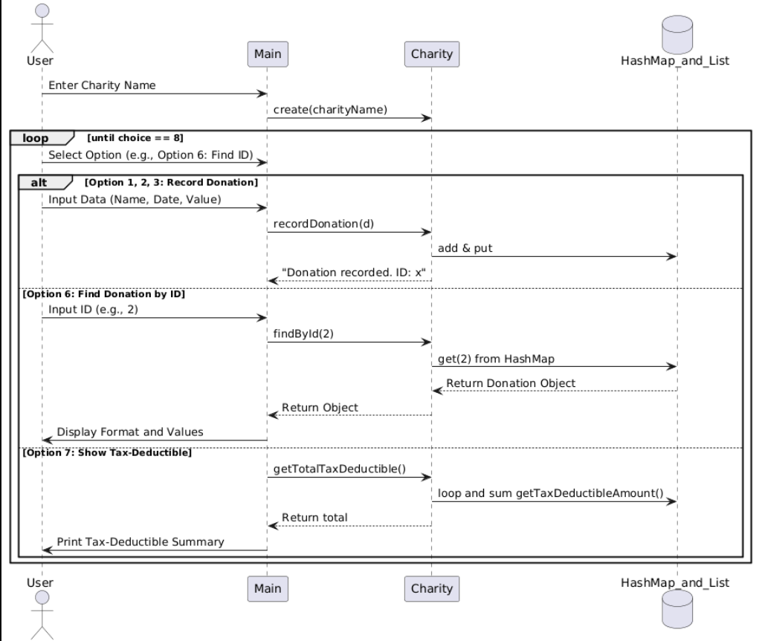
3.5 Method definition list
# | Modifier | Return Type | Name | Args | Comment
1 | public static | void | main | String[] args | The central system entry execution point that initializes the interactive primary menu interface loop.
3.6 Class definition list
# | Modifier | Name | Abstract ? | Extends what ? | Comment
1 | public | Main | No | None | Houses the central driver loop, captures keyboard choices, catches execution errors, and standardizes terminal logging.
3.7 OOP Concepts
• Polymorphic Collection Processing: The interface controller manages and reads diverse database records using the general Donation base type. The system automatically routes execution logic to specific subclass implementations for print statements and value metrics at runtime.
3.8 Screenshots of the sequence
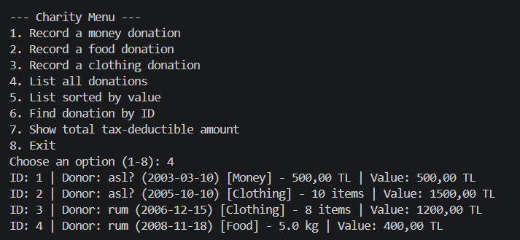
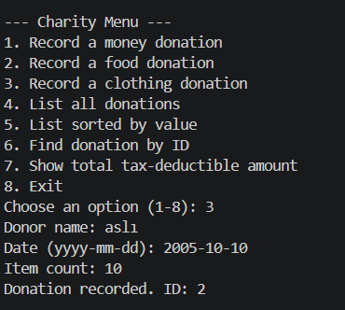
3.9 Extra features
• Robust Input Exception Shielding: Outfitted with try-catch logic to capture date layout mismatches or bad number characters during text scanning, preventing unexpected runtime application crashes.
• Verbatim Conformance with Guidelines: Fully compliant with automatic grading standards, implementing exact verification catchphrase string blocks such as 'Unknown option. Skipping...' for invalid choices.

REFERENCES
1. Bloch, J. (2018). Effective Java (3rd ed.). Addison-Wesley Professional.
2. Oracle Java Standard Edition Documentation (java.util.HashMap, java.lang.Comparable, java.time.LocalDate).
3. Marmara University Department of Electrical and Electronics Engineering, Course Syllabus for EE1004 Object-Oriented Programming.

