Online appendix: The Effect of Racial and Ethnic Attitudes on Asian Identity in the U.S

Data

Figure A.1. Examples of an Implicit Association Test
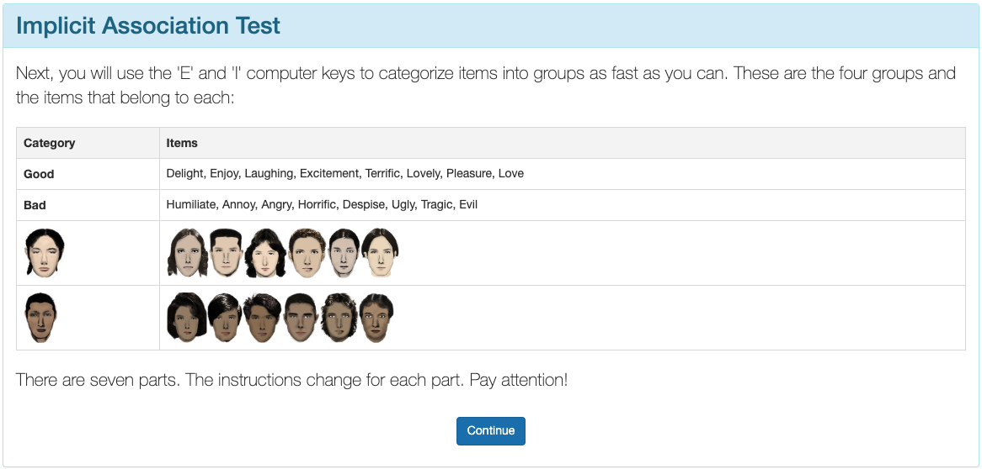
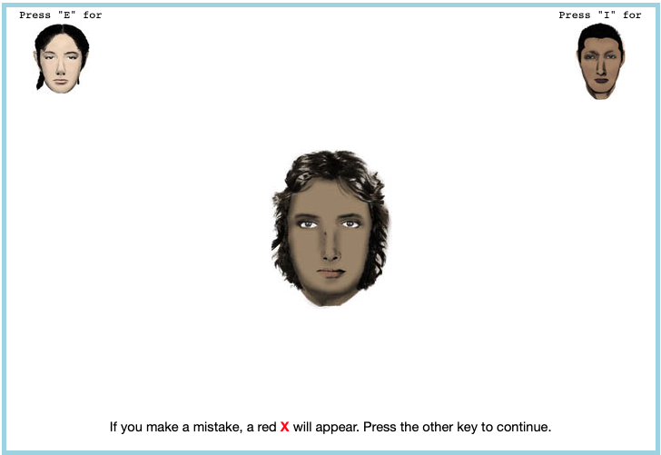


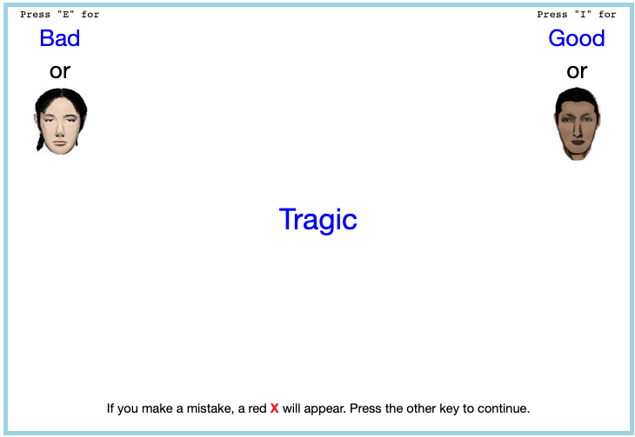
Here are a few examples of what a respondent would see on an implicit association test.

Figure A.2. Maps of State-level Association Test Bias Over Time Measure with Census Division Regional Boundaries
(a) State-level Bias in 2004
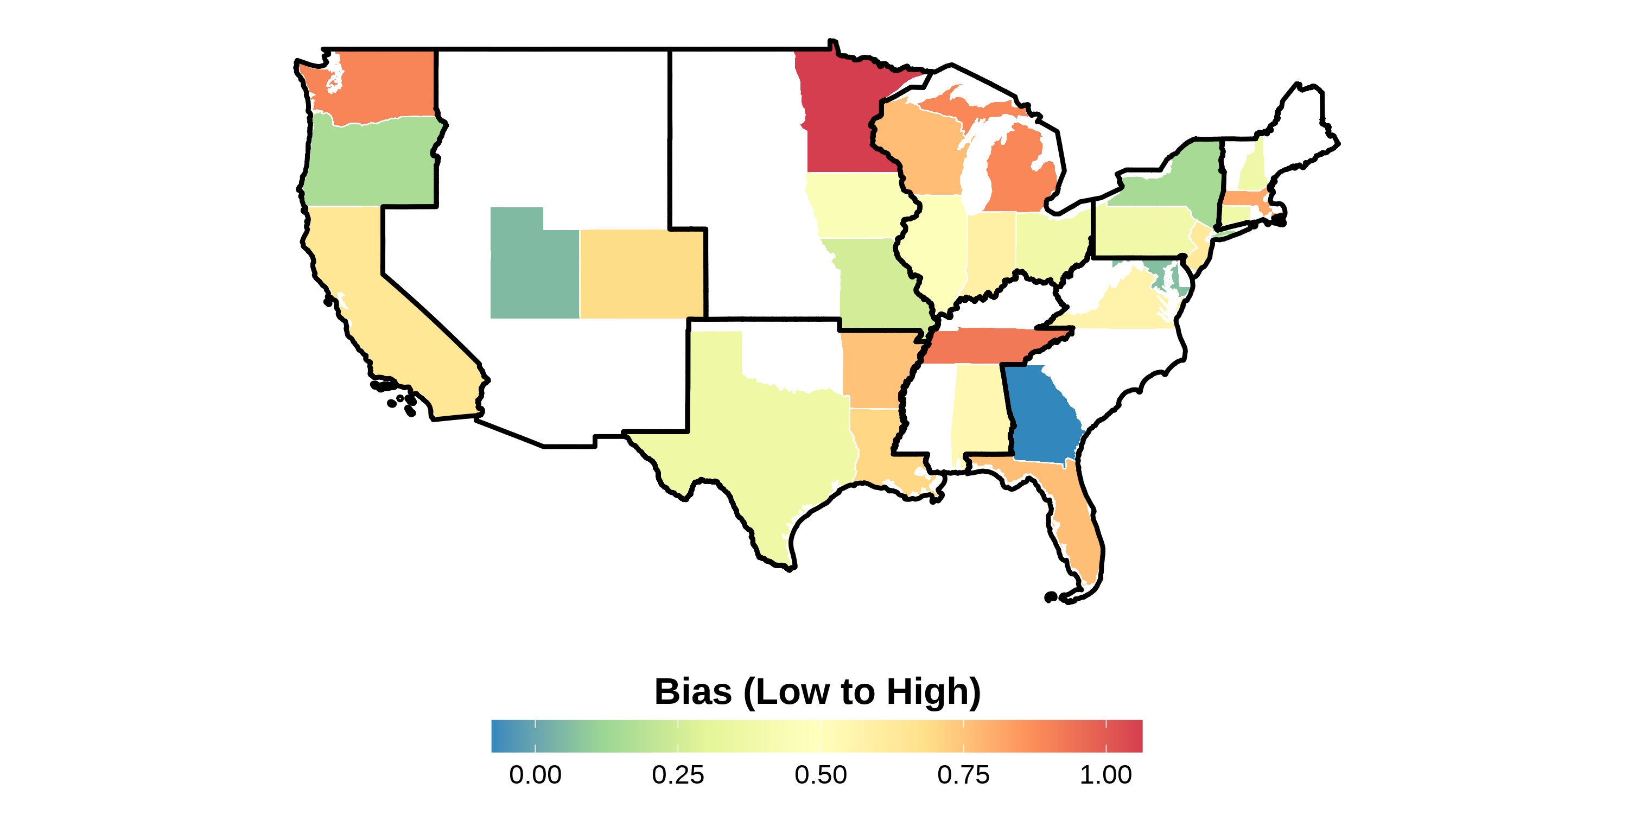
(b) State-level Bias in 2008
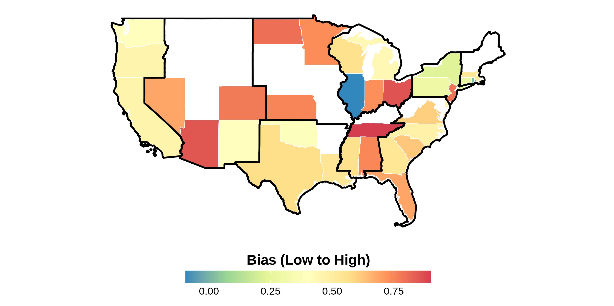
(c) State-level Bias in 2012
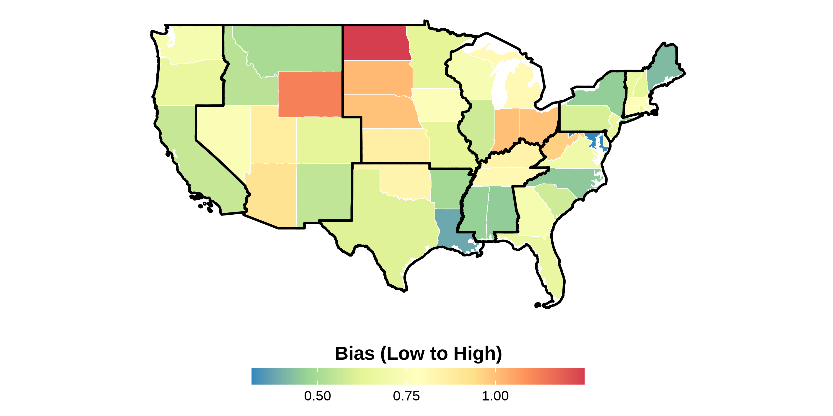
(d) State-level Bias in 2016
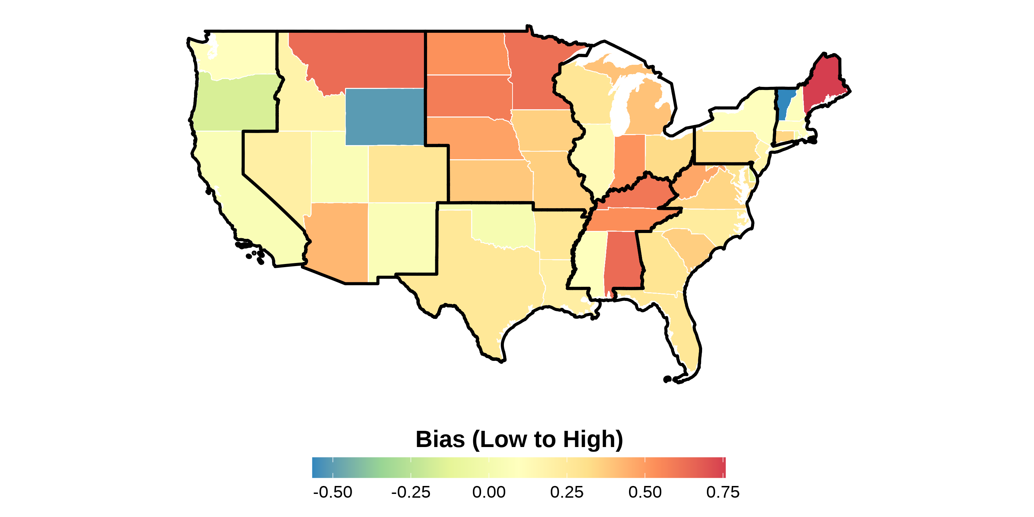
This figure shows the state-level bias index in different years in the sample. The index is measured in its own units, scaled in IAT -score units, and ranges from low to high bias; one index unit is about 2.4 standard deviations of the state-year distribution of the index. Bias index is constructed following Lubotsky & Wittenberg (2006). The data is from the 2004–2021 Harvard’s Project Implicit Association Test scores, American National Election Studies (ANES), and state-level hate crimes against Asians. Each panel presents state-level bias during a certain year. The boundaries in black represent the different Census divisions in the United States. Notice how there is a variation across states within a region.

Figure A.3. Maps of State-level Bias 2004–2021 Measure with Census Division Regional Boundaries
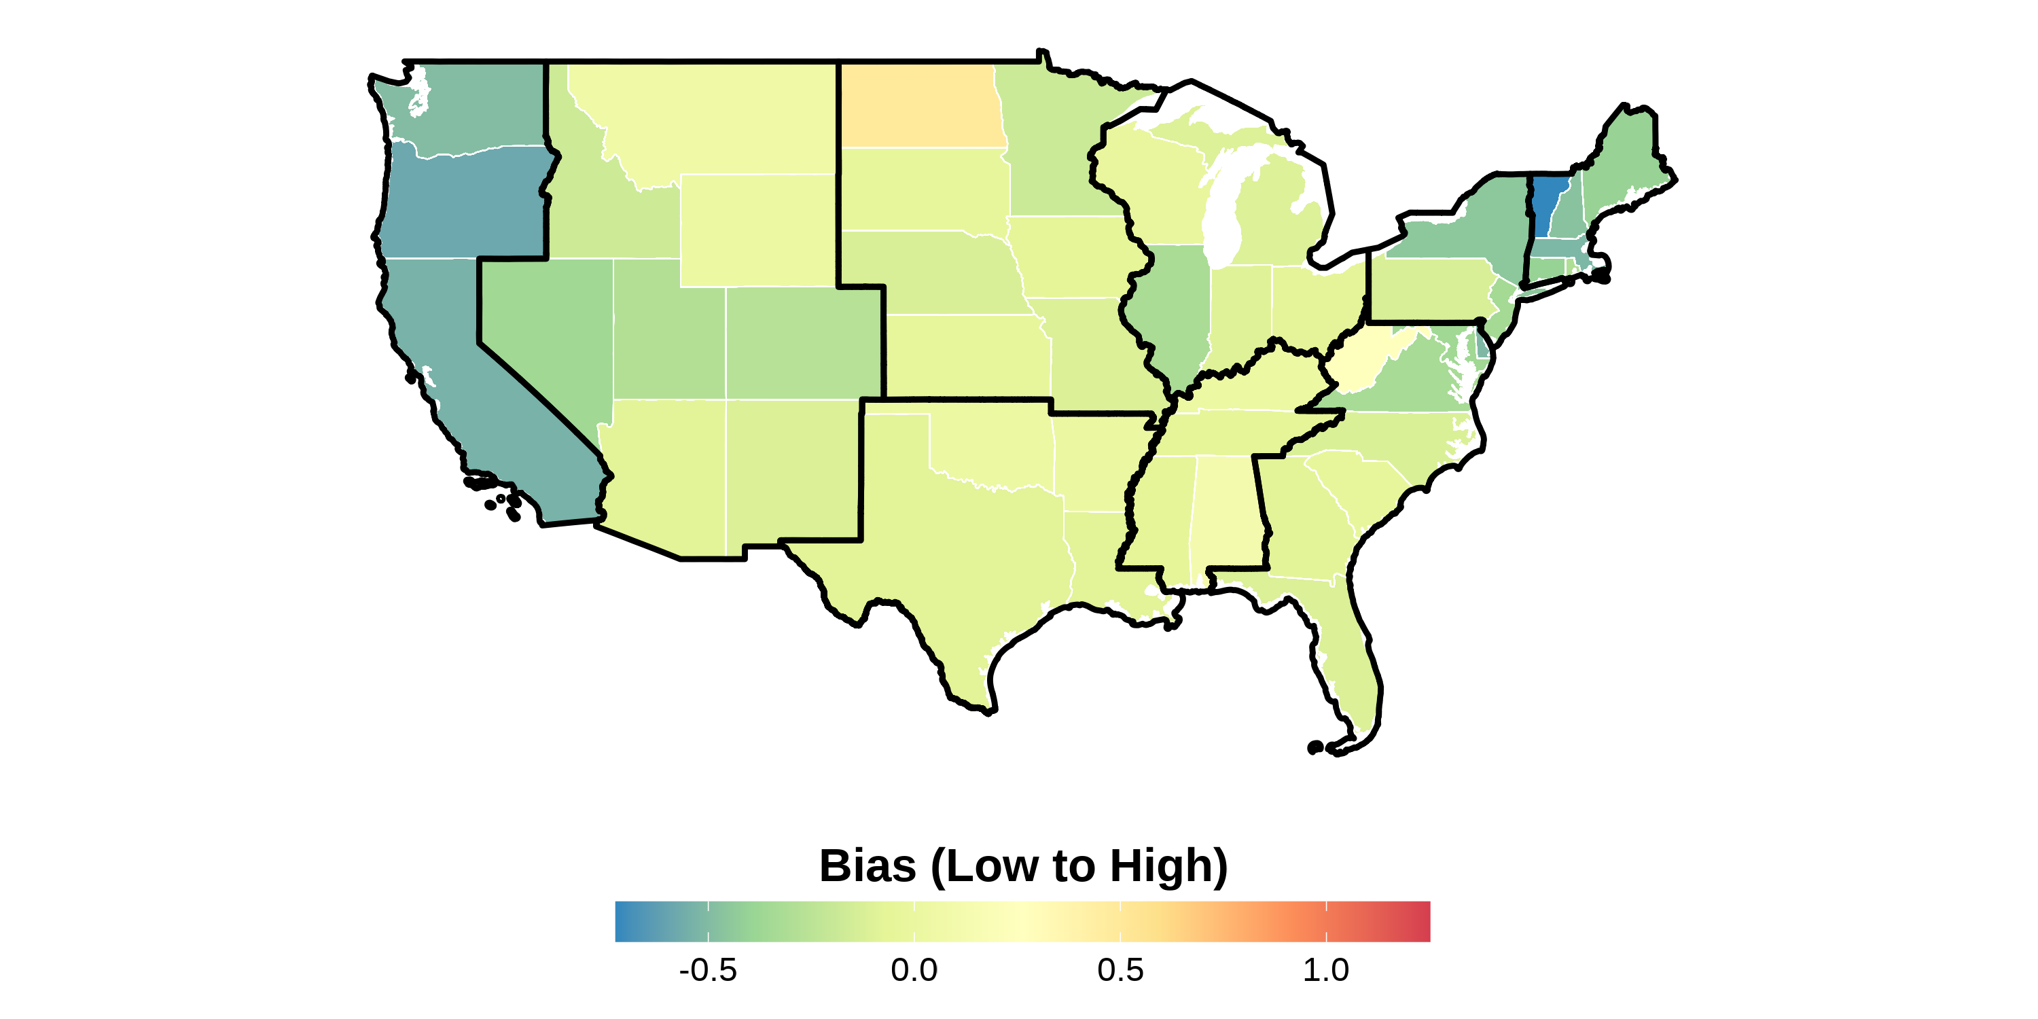
This figure shows the state-level bias index in the sample from 2004 to 2021. The index is measured in its own units, scaled in IAT -score units, and ranges from low to high bias; one index unit is about 2.4 standard deviations of the state-year distribution of the index. Bias index is constructed following Lubotsky & Wittenberg (2006). The data is from the 2004–2021 Harvard’s Project Implicit Association Test scores, American National Election Studies (ANES), and state-level hate crimes against Asians. The boundaries in black represent the different Census divisions in the United States. Notice how there is a variation across states within a region.

Figure A.4. Asian Racial Identity
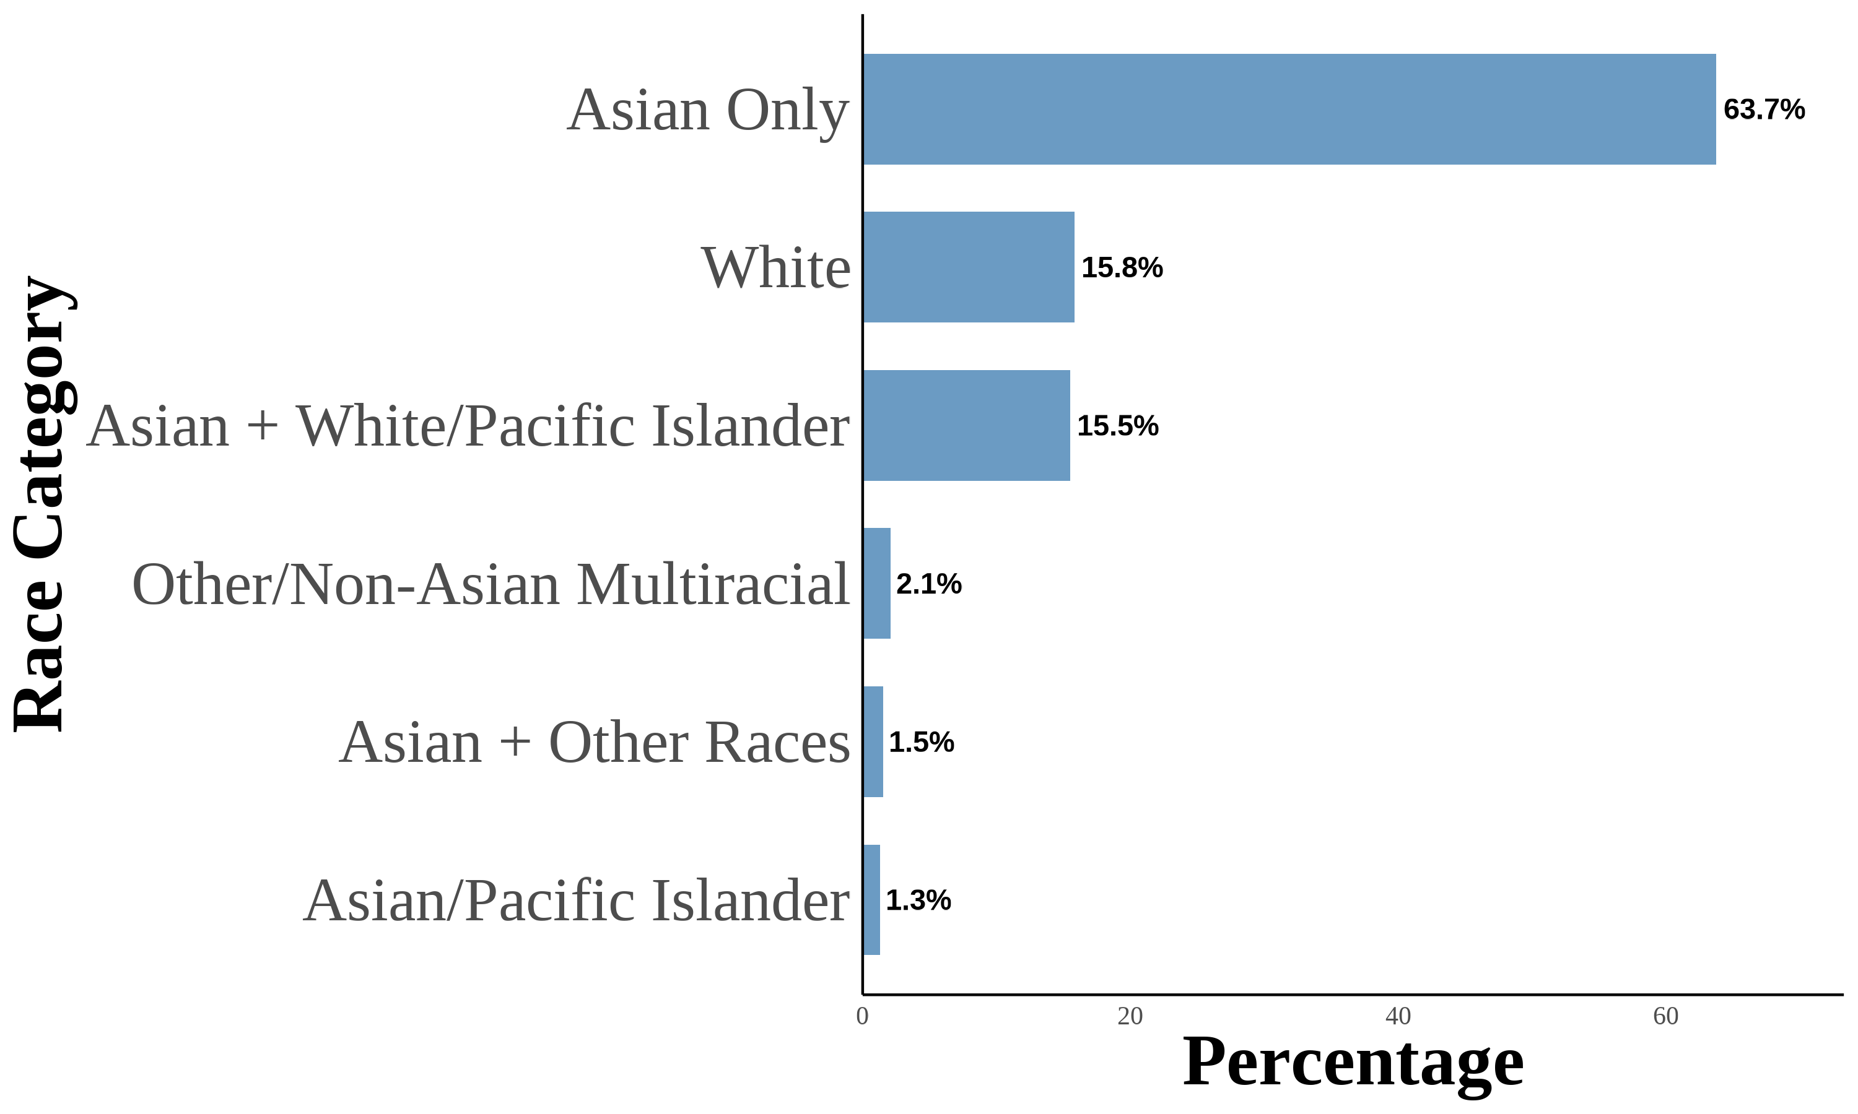
This figure shows the distribution of Asian racial identity among respondents. The data is aggregated from the 2004–2021 Current Population Survey (CPS). The sample includes first-, second-, and third-generation objectively Asian Americans. Following (F. M. Antman, Duncan, & Trejo, 2020; F. Antman, Duncan, & Trejo; 2016), I utilize birthplace information for individuals, parents, and grandparents to create objective Asian ancestry indicators.

Figure A.5. Asian Racial Identity: First Generation
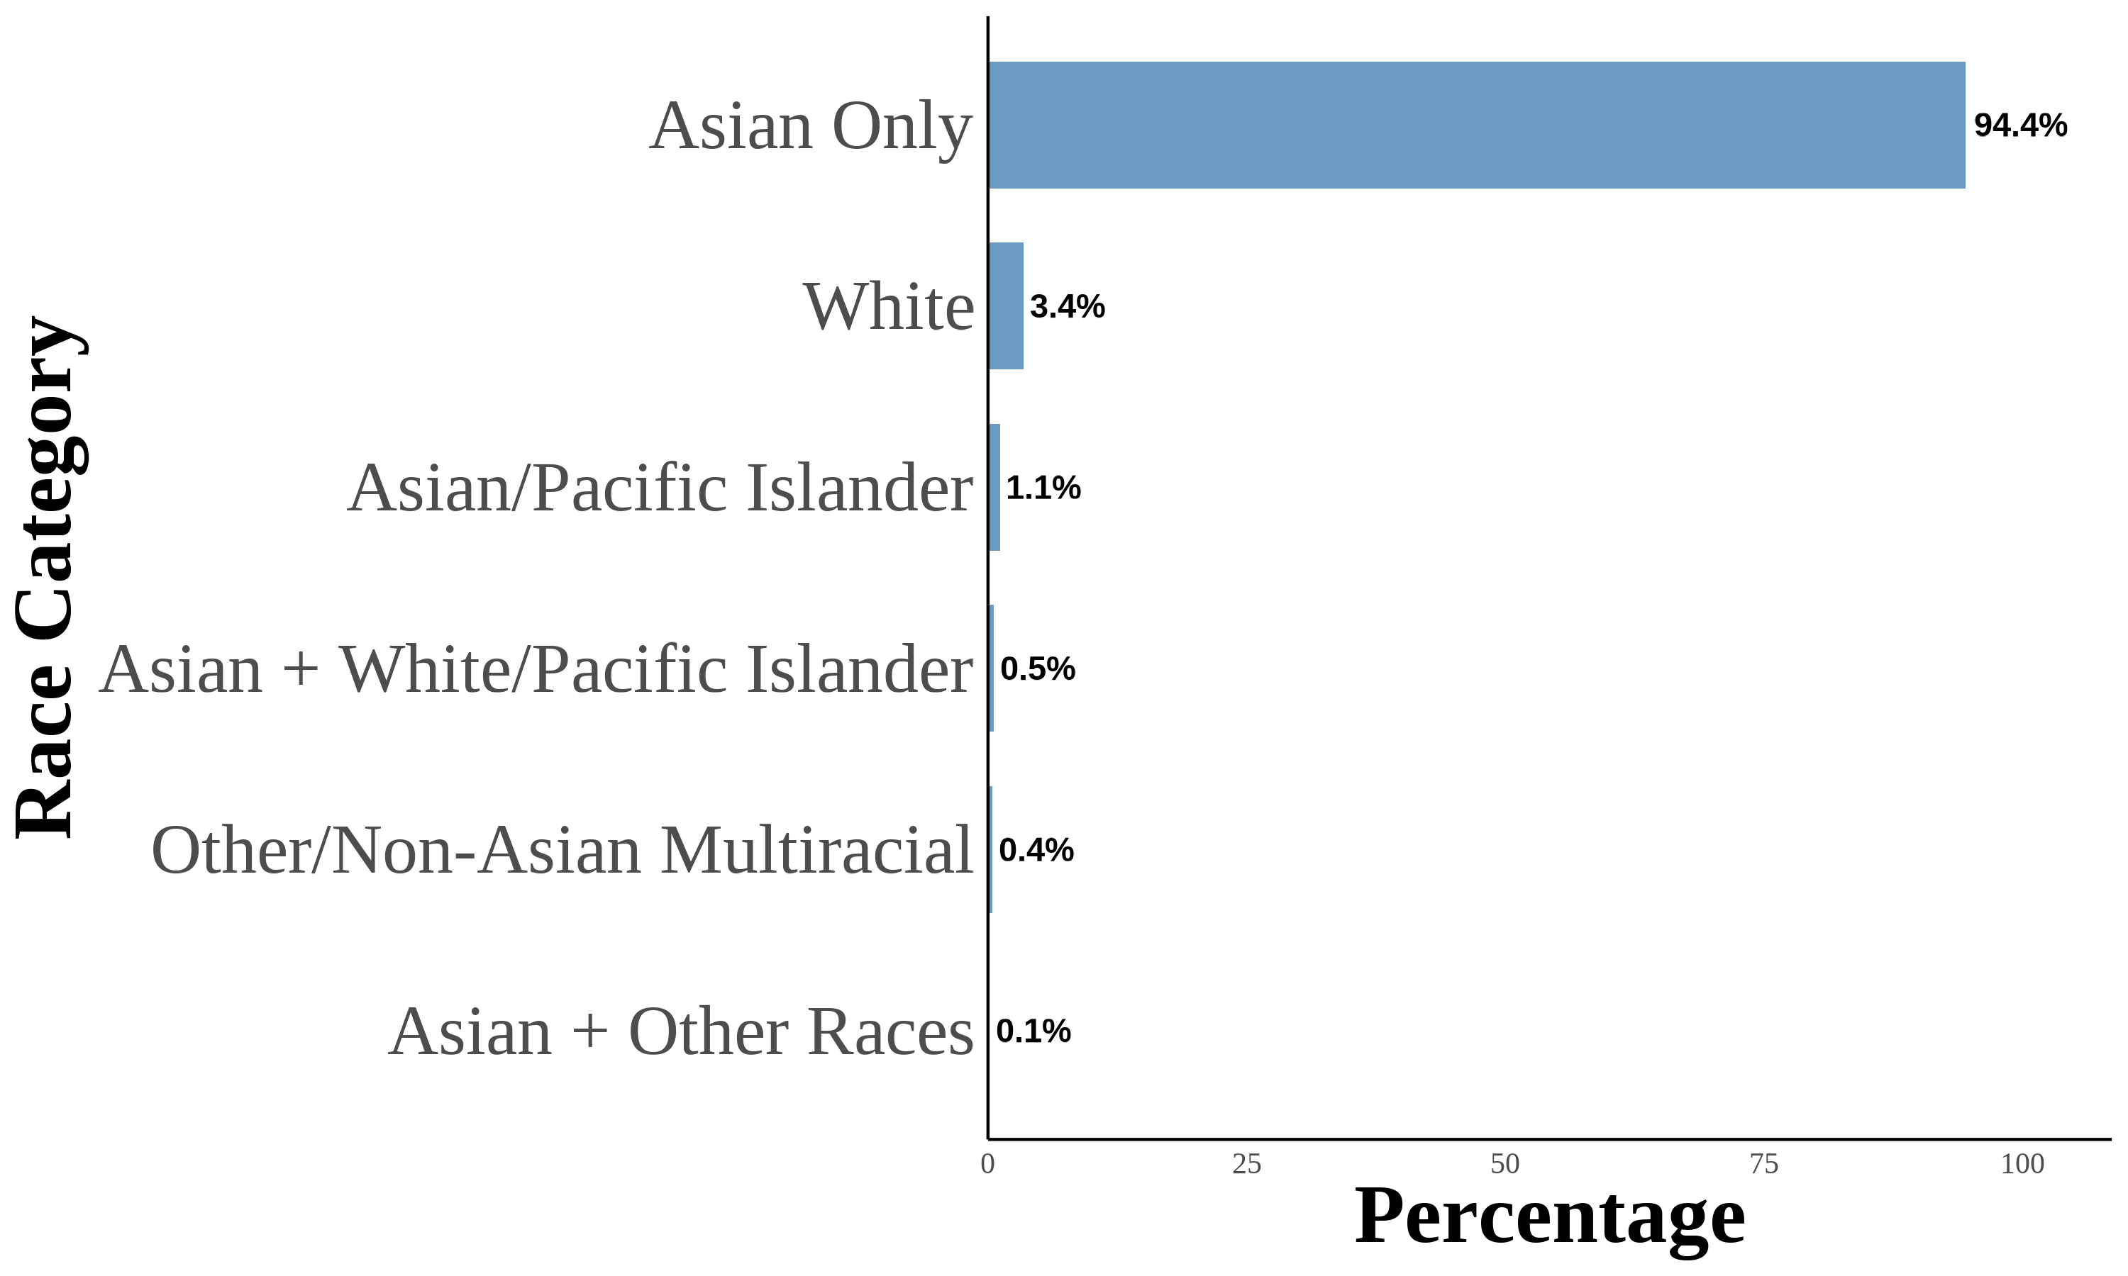
This figure shows the distribution of Asian racial identity among respondents. The data is aggregated from the 2004–2021 Current Population Survey (CPS). The sample includes first-generation objectively Asian Americans. Following (F. M. Antman et al., 2020; F. Antman et al.; 2016), I utilize birthplace information for individuals, parents, and grandparents to create objective Asian ancestry indicators. A first-generation Asian American is defined as an individual born in an Asian country and is not a US citizen born to US citizen parents abroad.

Figure A.6. Asian Racial Identity: Second Generation
(a) All Second Generation
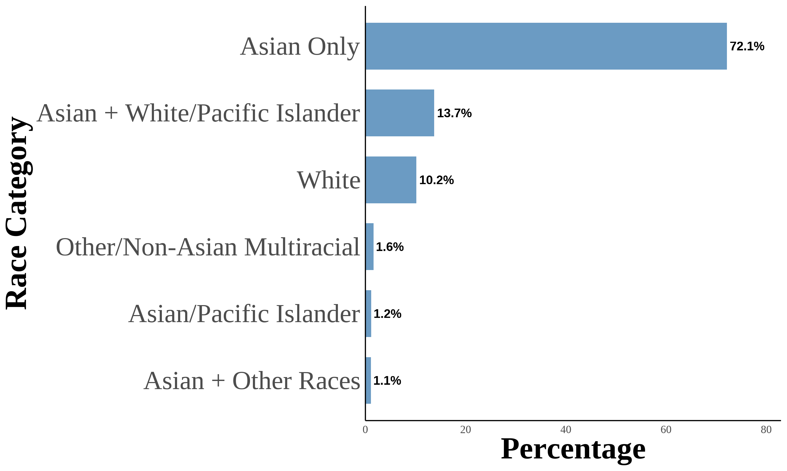
(b) Second Generation: Asian Fathers-Asian Mothers
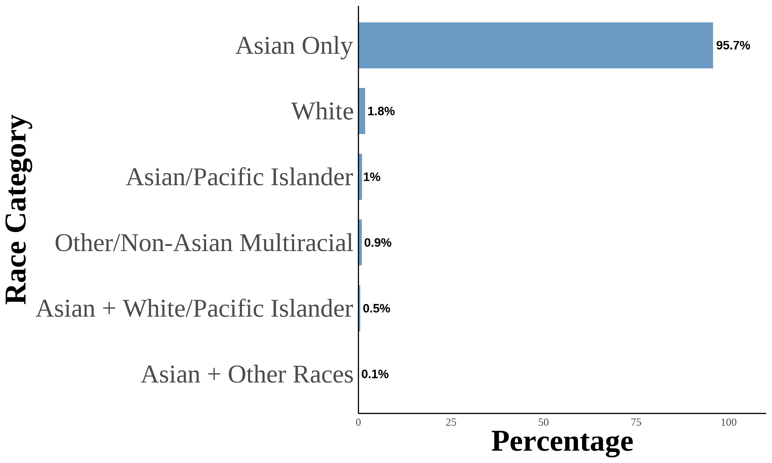
(c) Second Generation: Asian Fathers-White Mothers
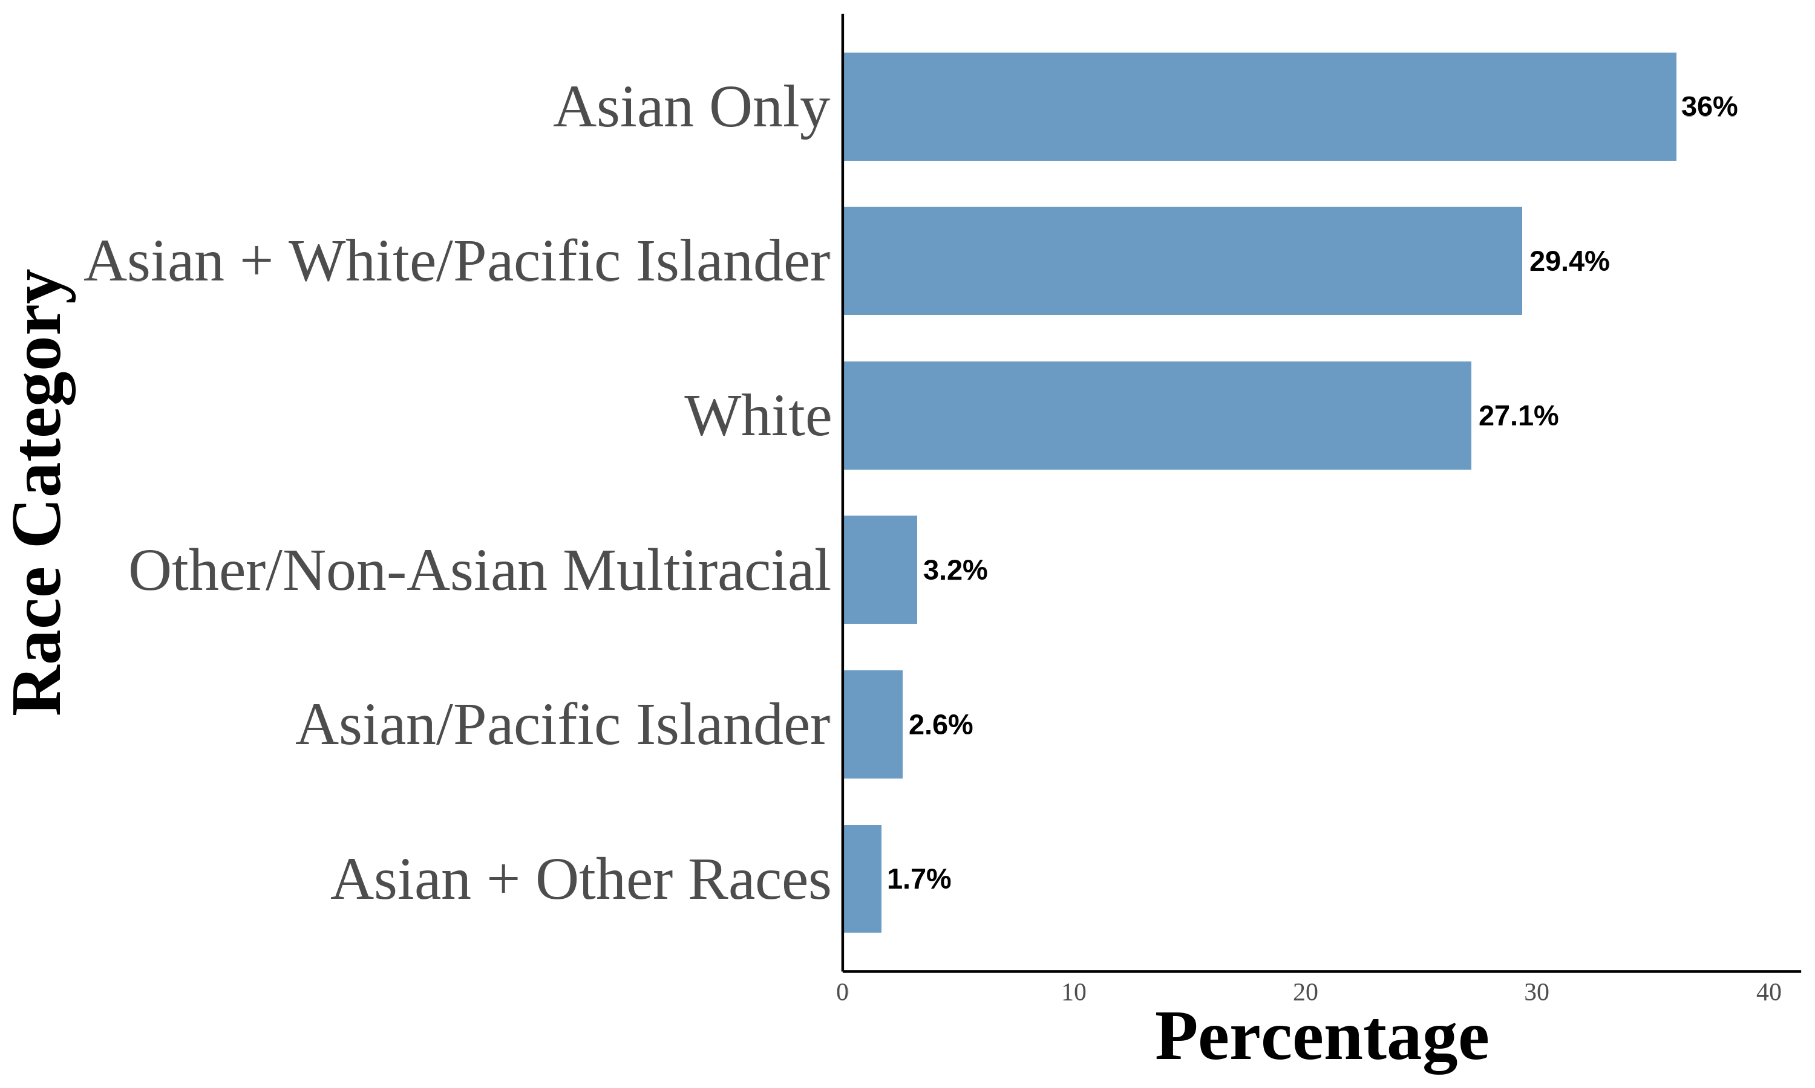
(d) Second Generation: White Fathers-Asian Mothers
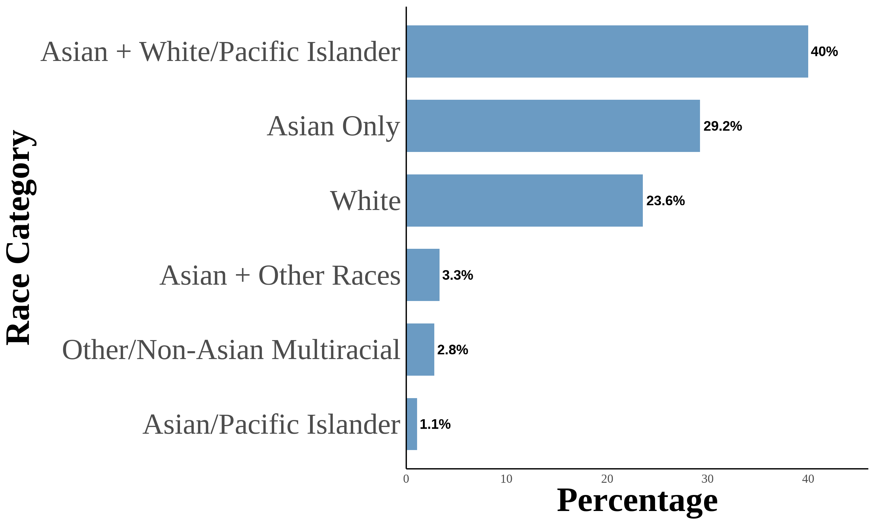
This figure shows the distribution of Asian racial identity among respondents. The data is aggregated from the 2004–2021 Current Population Survey (CPS). The sample includes second-generation objectively Asian Americans. Following (F. M. Antman et al., 2020; F. Antman et al.; 2016), I utilize birthplace information for individuals, parents, and grandparents to create objective Asian ancestry indicators. A second-generation Asian American is defined as a native-born individual with at least one parent born in an Asian country. The first panel is for second-generation Asian Americans. The second panel is for second-generation Asian Americans with both parents born in an Asian country. The third panel is for second-generation Asian Americans with an Asian father and a White mother. The fourth panel is for second-generation Asian Americans with a White father and an Asian mother.

Figure A.7. Asian Racial Identity: Third Generation
(a) All Third Generation
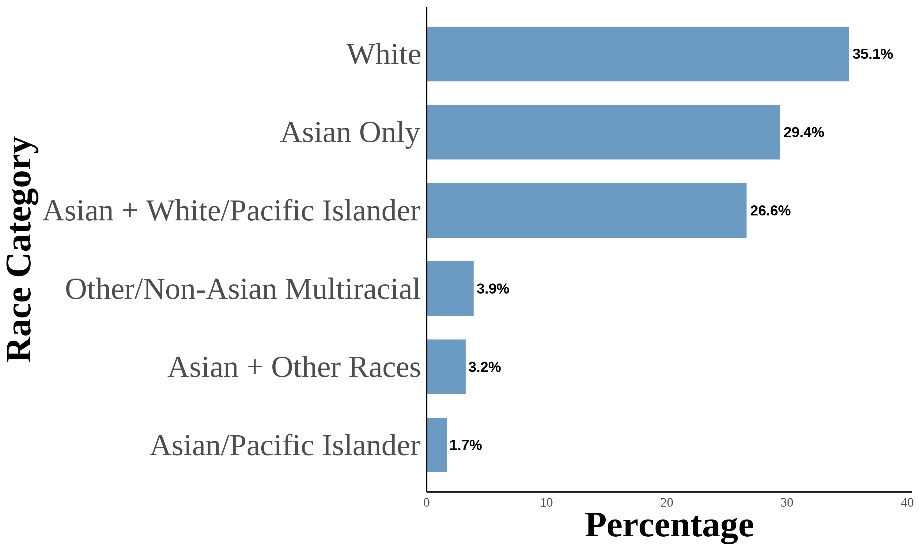
(b) Third Generation: One Asian Grandparent
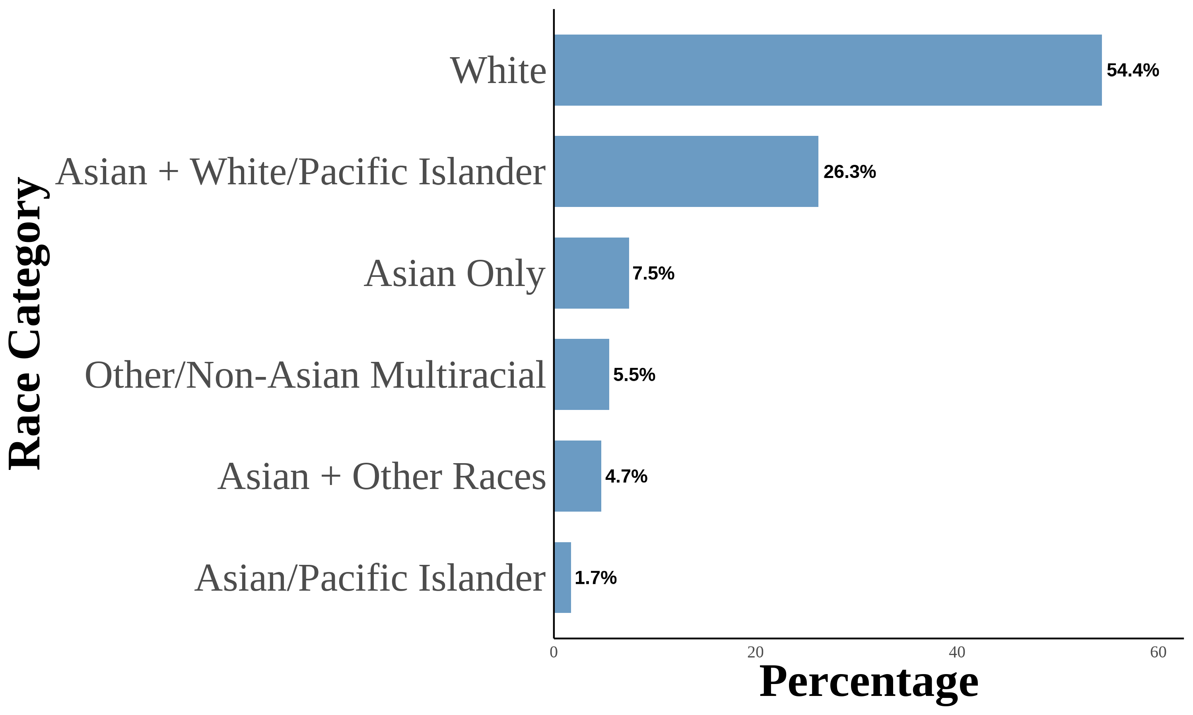
(c) Third Generation: Two Asian Grandparents
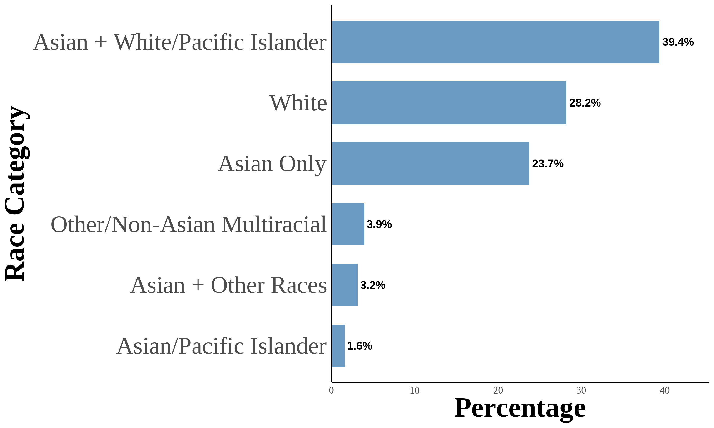
(d) Third Generation: Three Asian Grandparents
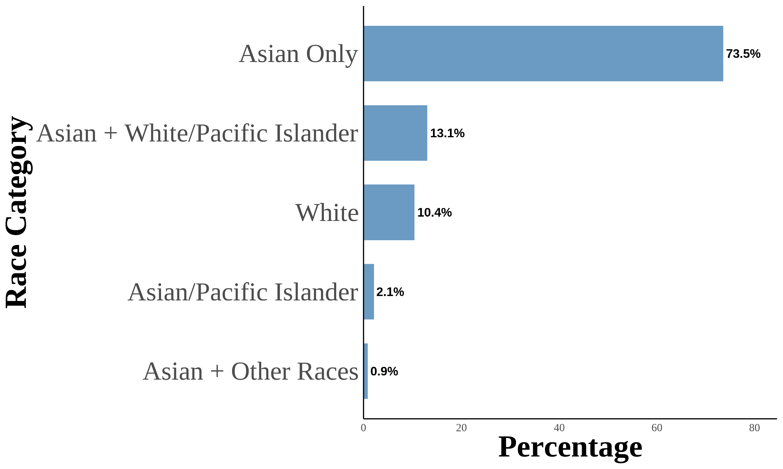
(e) Third Generation: Four Asian Grandparents
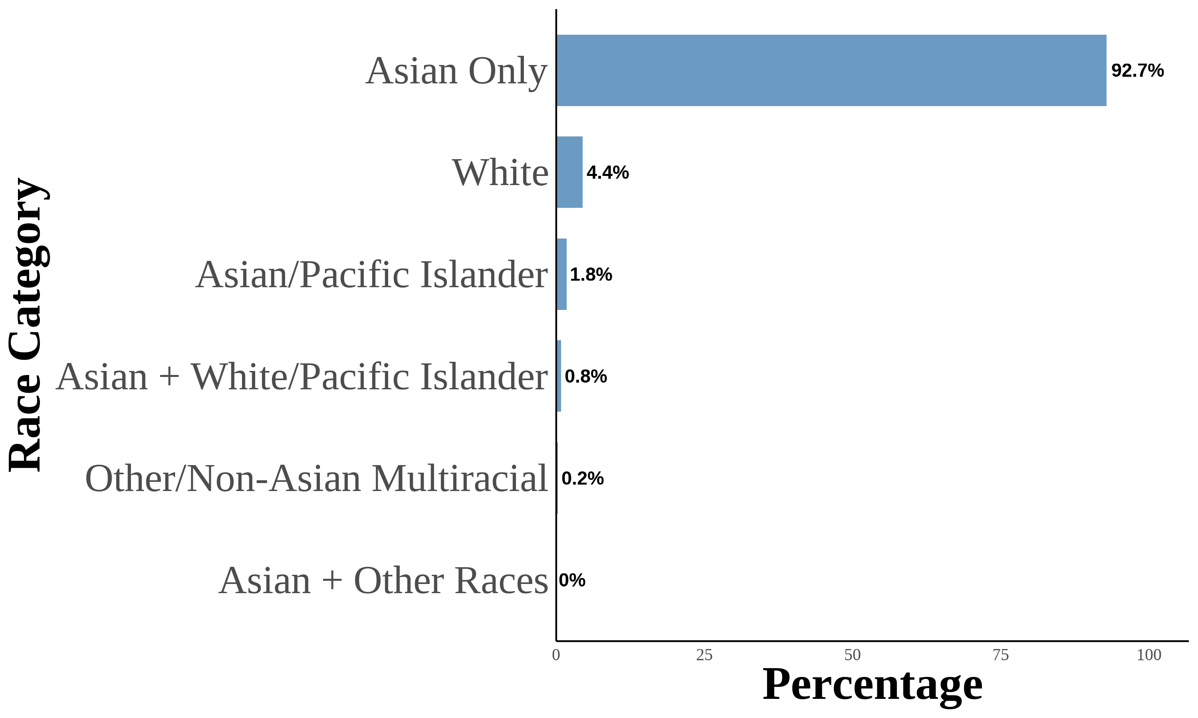
This figure shows the distribution of Asian racial identity among respondents. The data is aggregated from the 2004–2021 Current Population Survey (CPS). The sample includes second-generation objectively Asian Americans. Following (F. M. Antman et al., 2020; F. Antman et al.; 2016), I utilize birthplace information for individuals, parents, and grandparents to create objective Asian ancestry indicators. A third-generation Asian American is defined as a native-born individual with native-born parents and at least one grandparent born in an Asian country. The first panel is for third-generation Asian Americans. The second panel is for third-generation Asian Americans with one grandparent born in an Asian country. The third panel is for third-generation Asian Americans with two grandparents born in an Asian country. The fourth panel is for third-generation Asian Americans with three grandparents born in an Asian country. The fifth panel is for third-generation Asian Americans with four grandparents born in an Asian country.

Tables

Table A.1. Subjective Asian Identity and Asian Bias
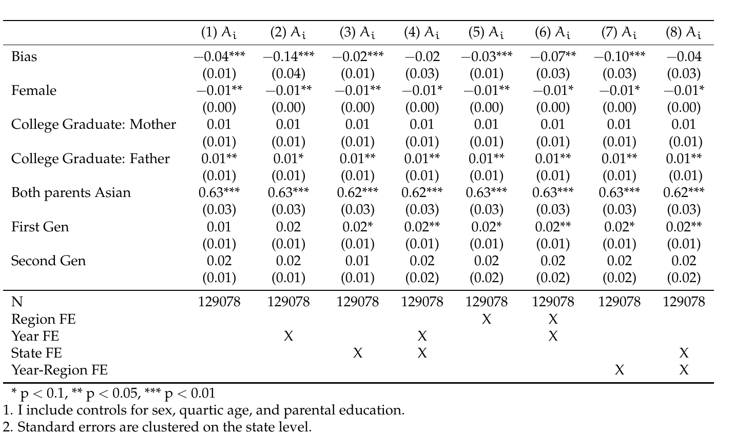

Table A.2. Logistic Regression Analysis of Bias and Interracial Marriages
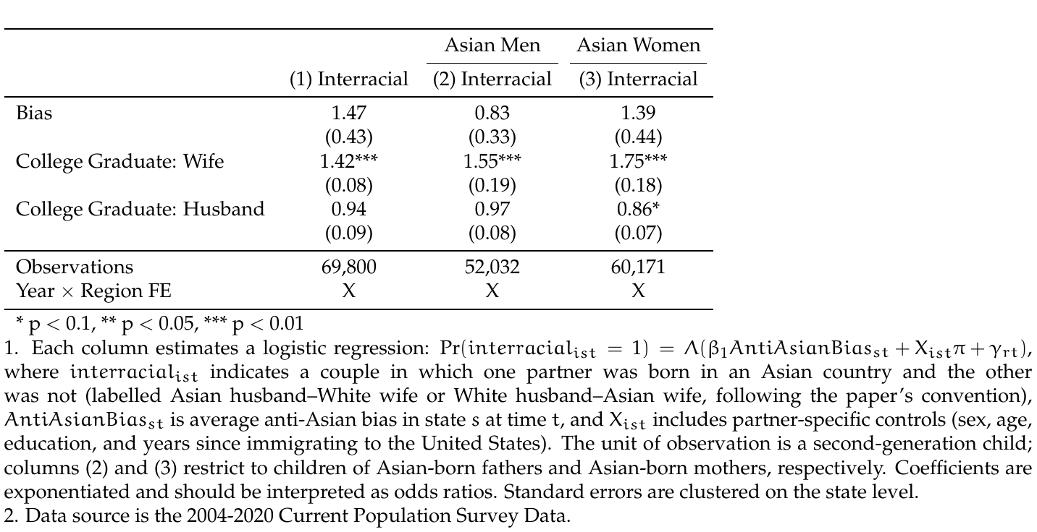

Table A.3. Between-Model Tests of Average Marginal Effects: Second-Generation AW vs. WA
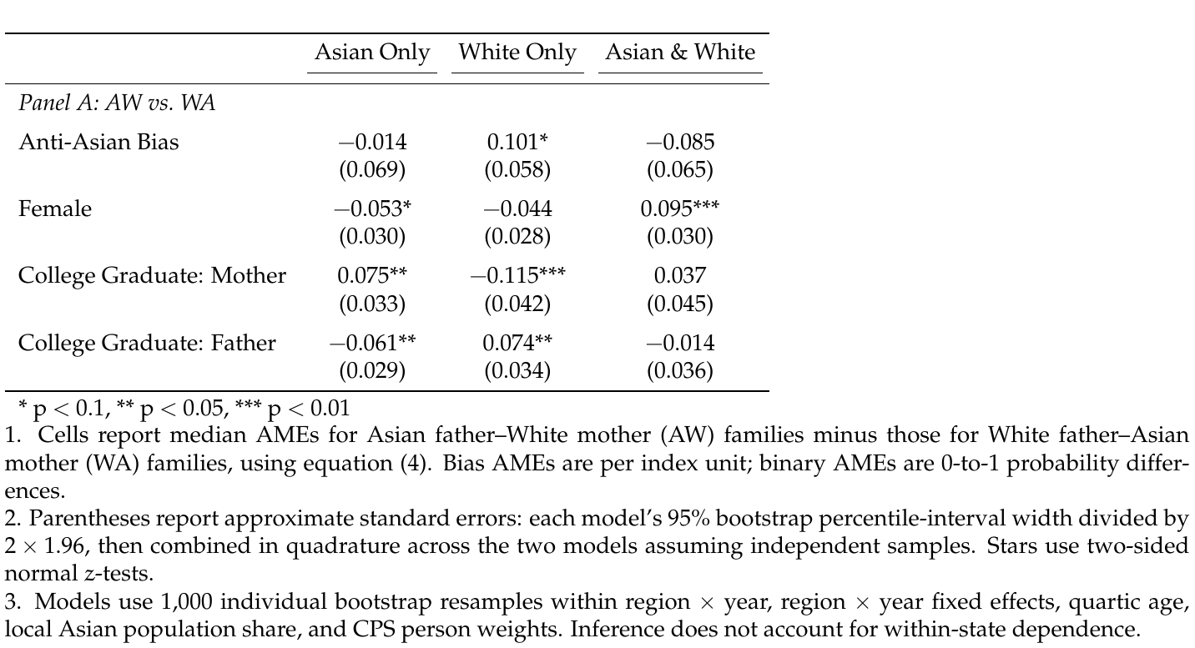

Table A.4. Between-Model Tests of Average Marginal Effects: Third-Generation by Asian Grandparent Count
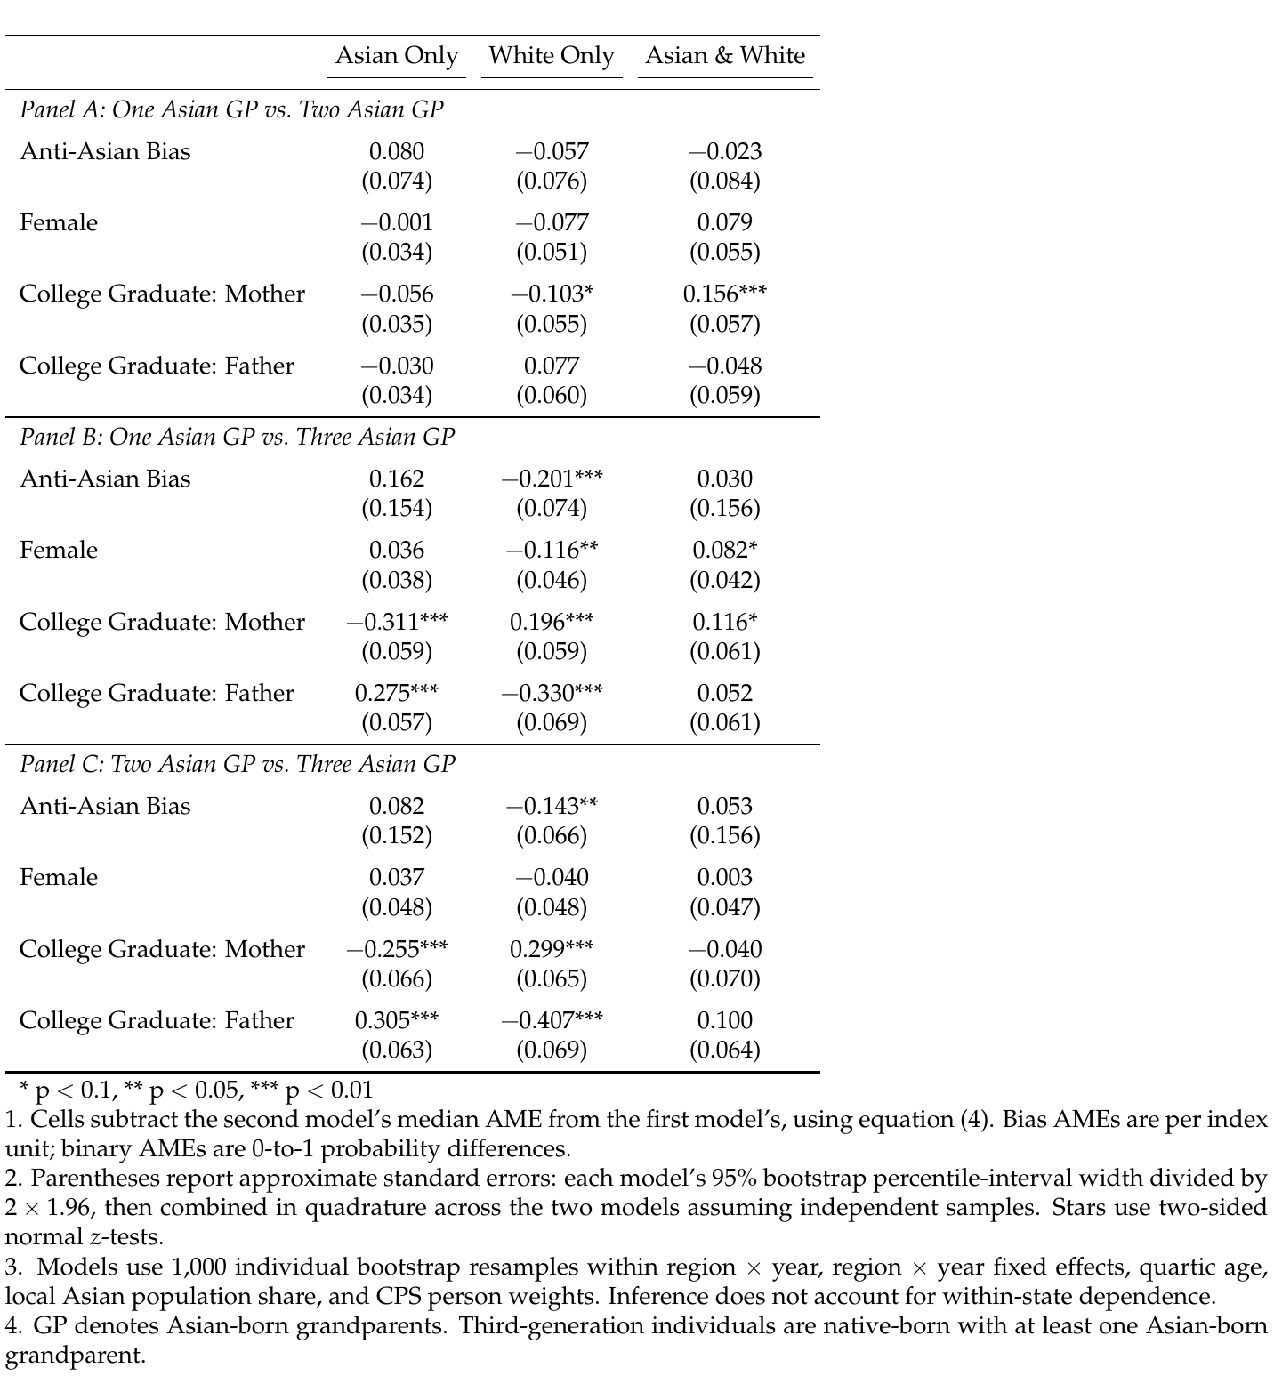

Table A.5. Pooled Multinomial Logit: Bias Interacted with Parental Configuration, Mixed-Race Second-Generation Children
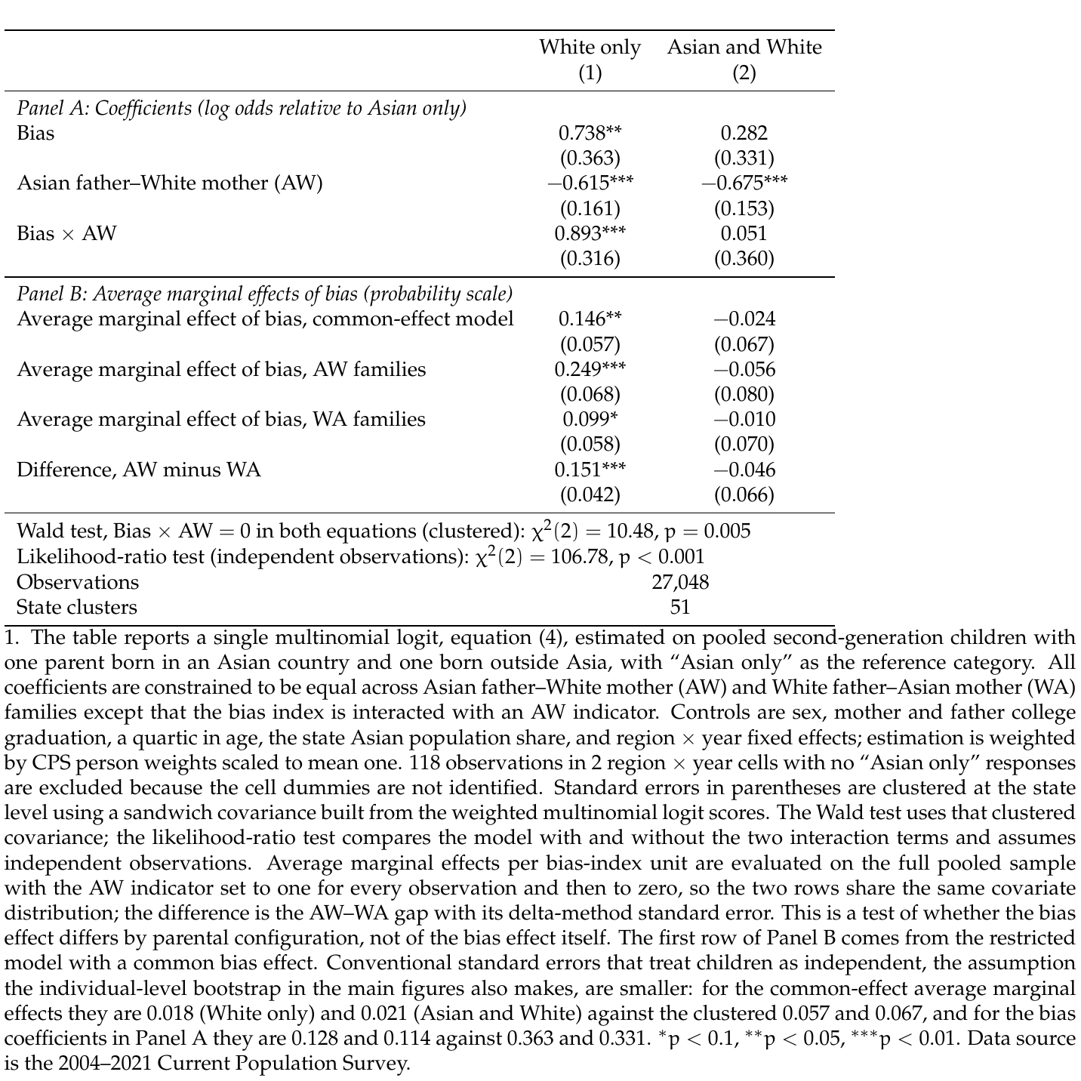

Figures

Figure A.8. Marginal Effects of Key Covariates on Racial Identity Choice by Parental Ancestry (Second-Generation Asian Americans)
(a) Asian Father-White Mother (AW)
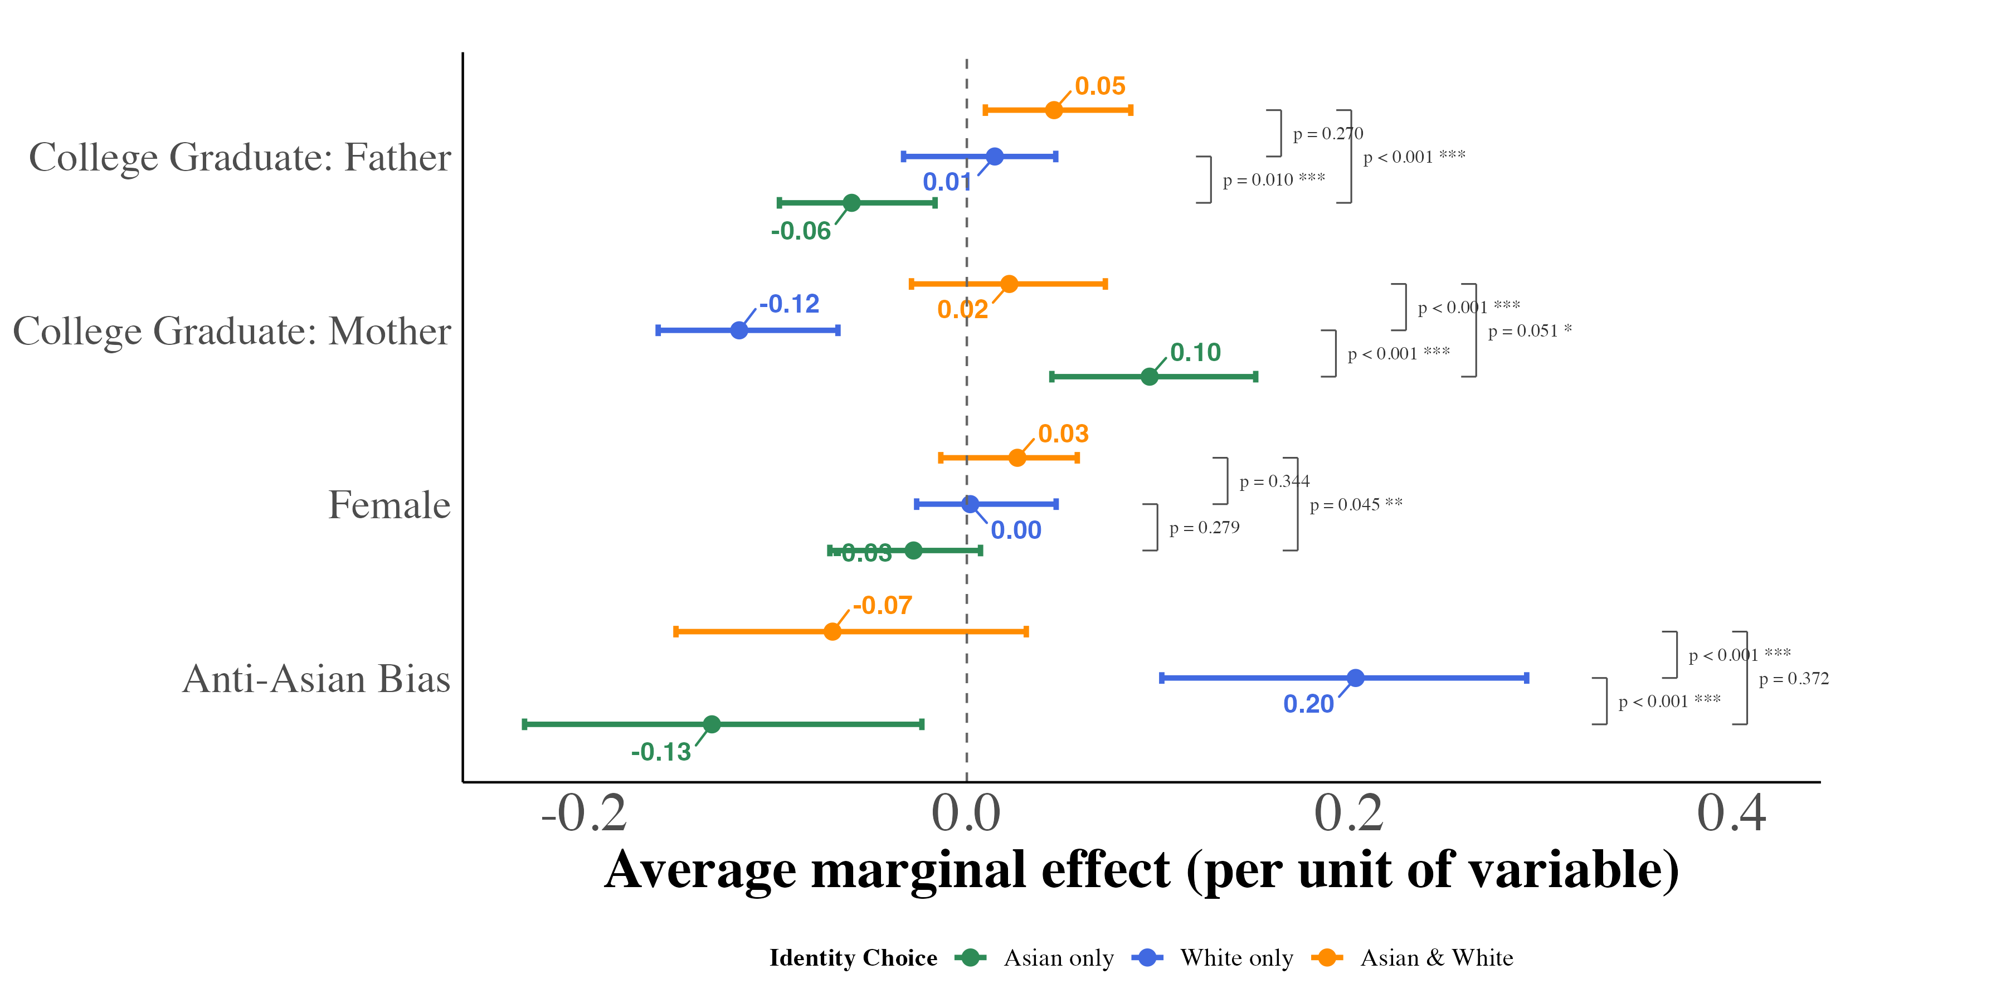
(b) White Father-Asian Mother (WA)
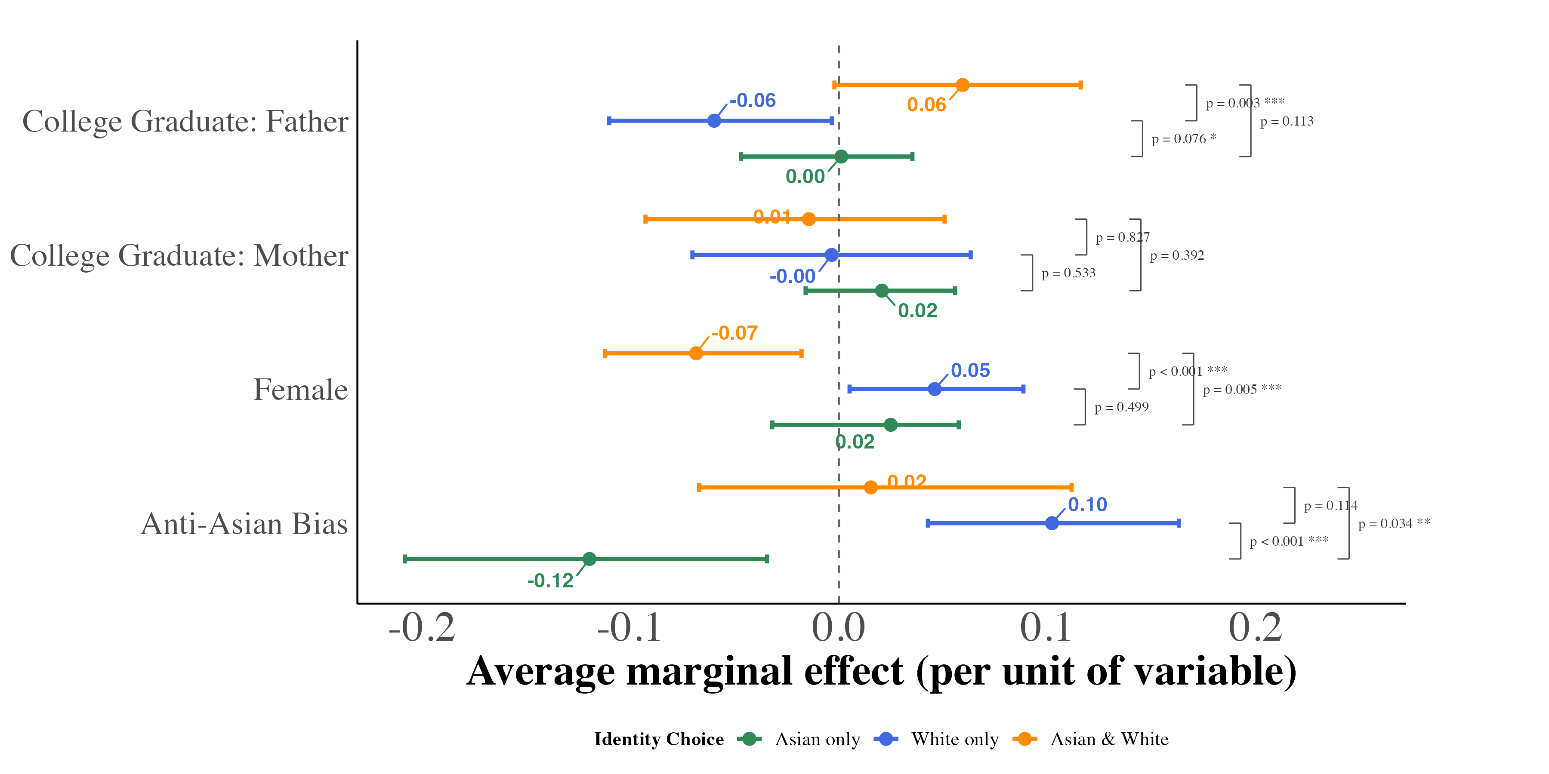
This figure displays average marginal effects of key covariates on the probability of each racial identity outcome, estimated from equation (4) separately for second-generation children with an Asian-born father and a mother born outside Asia (panel a) and with a father born outside Asia and an Asian-born mother (panel b). For anti-Asian bias, the marginal effect is the derivative of each predicted probability with respect to the bias index, evaluated for every child at that child’s own covariate values and averaged over the estimation sample, and is expressed per one-unit increase in the index; for the binary covariates, it is the average change in predicted probability from switching the indicator from 0 to 1 for every child. Models include region year fixed effects and controls for a quartic in age and the state Asian population share, and are weighted by CPS person weights. Each point is the median, across 1,000 bootstrap resamples of children drawn with replacement within region year cells, of the sample-average marginal effect; the bars span the 2.5th and 97.5th percentiles of the same resamples and do not account for dependence among children in the same state. Because the two panels come from separately estimated models, differences between them reflect both differences in coefficients and differences in the two groups’ covariate distributions; Appendix Table A.5 reports a pooled model that holds the covariate distribution fixed.

Figure A.9. Marginal Effects of Key Covariates on Racial Identity Choice (Pooled Mixed-Race Adult Second-Generation Asian Americans)
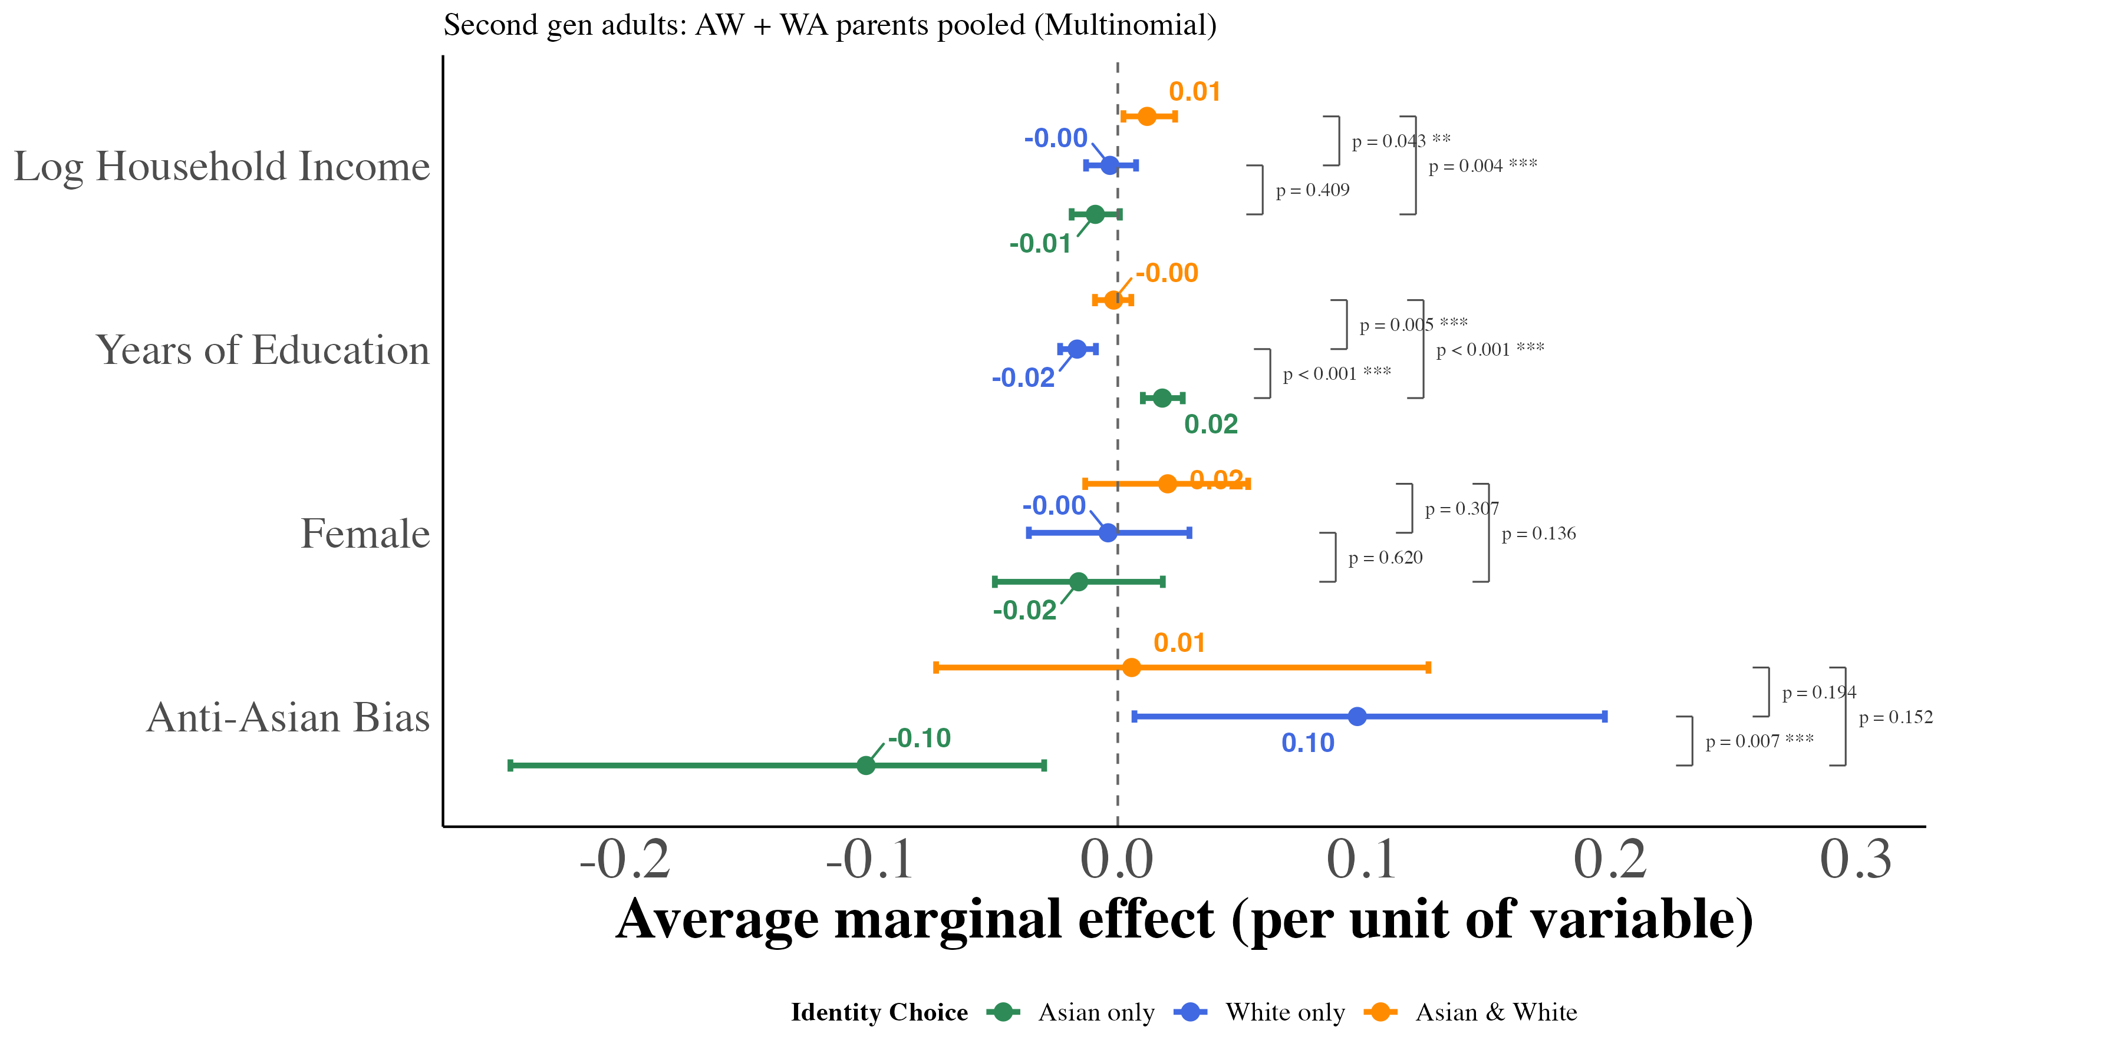
This figure displays average marginal effects of key covariates on the probability of each racial identity outcome, estimated from equation (4) for pooled second-generation adults (ages 18 and older) with one parent born in an Asian country and one parent born outside Asia. For anti-Asian bias, years of education, and log family income, the marginal effect is the derivative of each predicted probability with respect to the covariate, evaluated for every adult at that adult’s own covariate values and averaged over the estimation sample; the bias effect is expressed per one-unit increase in the index. For female, it is the average change in predicted probability from switching the indicator from 0 to 1 for every adult. Models include region year fixed effects and controls for a quartic in age and the state Asian population share, and are weighted by CPS person weights. Each point is the median, across 1,000 bootstrap resamples of adults drawn with replacement within region year cells, of the sample-average marginal effect; the bars span the 2.5th and 97.5th percentiles of the same resamples and do not account for dependence among adults in the same state.

Figure A.10. Marginal Effects of Key Covariates on Racial Identity Choice by Number of Asian Grandparents (Third-Generation Asian Americans)
(a) One Asian Grandparent
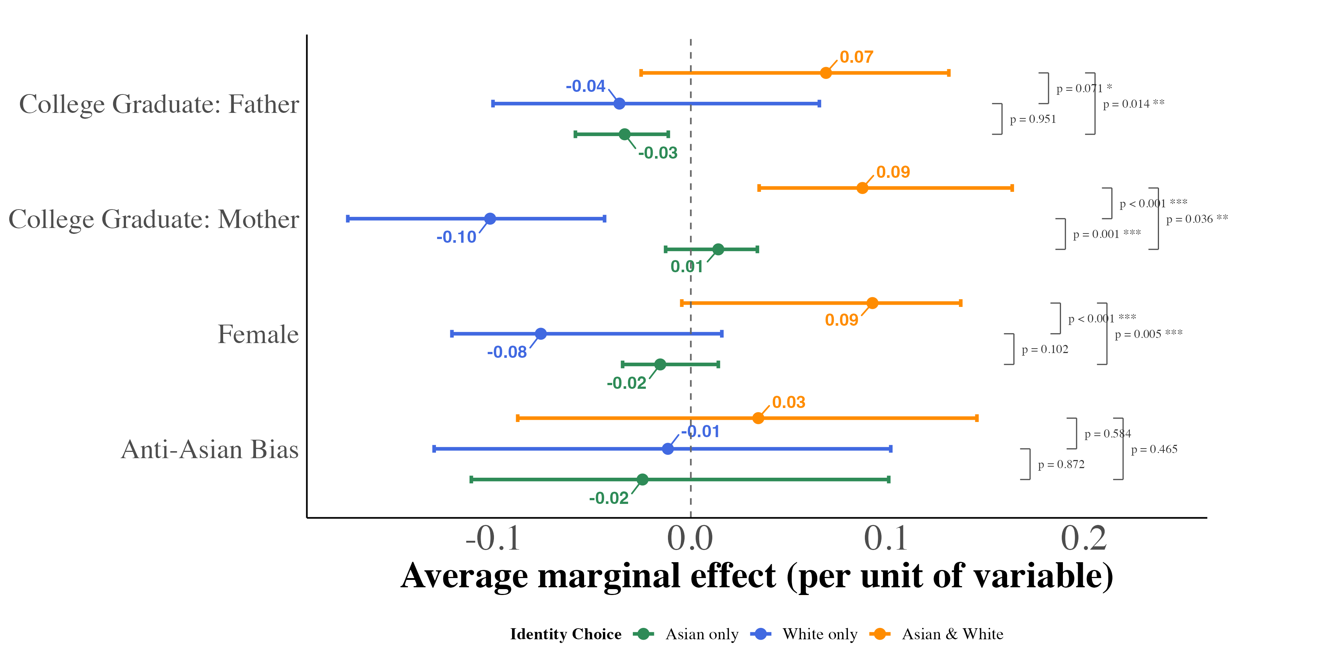
(b) Two Asian Grandparents
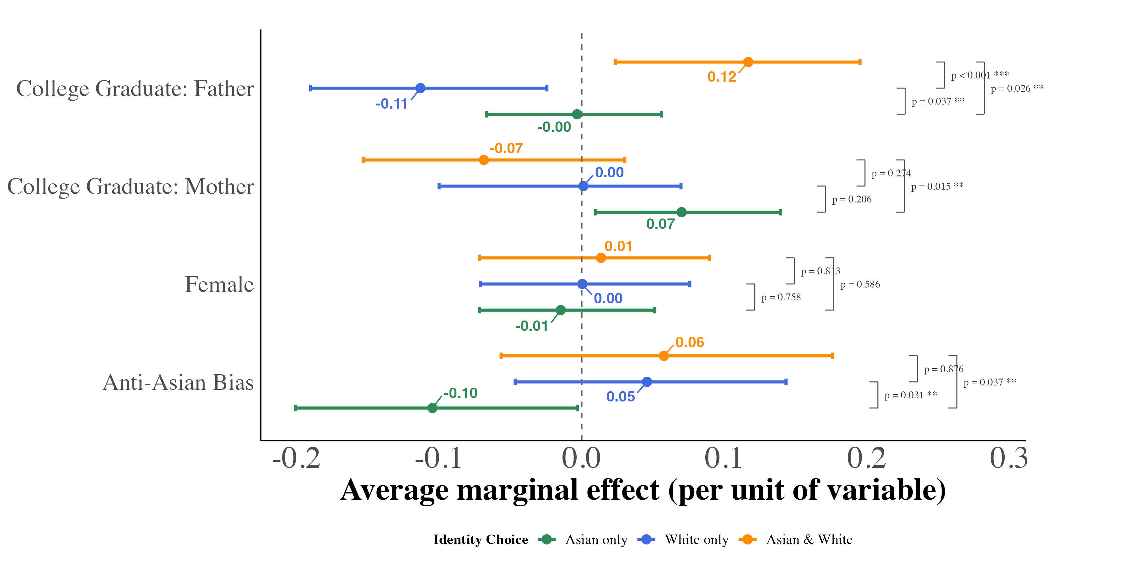
(c) Three Asian Grandparents
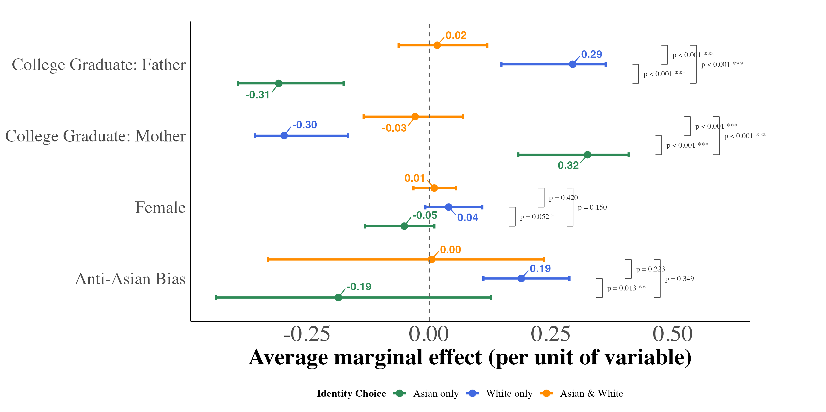
This figure displays average marginal effects of key covariates on the probability of each racial identity outcome, estimated from equation (4) separately for third-generation children with one, two, and three Asian-born grandparents. For anti-Asian bias, the marginal effect is the derivative of each predicted probability with respect to the bias index, evaluated for every child at that child’s own covariate values and averaged over the estimation sample, and is expressed per one-unit increase in the index; for the binary covariates, it is the average change in predicted probability from switching the indicator from 0 to 1 for every child. Models include region year fixed effects and controls for a quartic in age and the state Asian population share, and are weighted by CPS person weights. Each point is the median, across 1,000 bootstrap resamples of children drawn with replacement within region year cells, of the sample-average marginal effect; the bars span the 2.5th and 97.5th percentiles of the same resamples and do not account for dependence among children in the same state.

Figure A.11. Between-Model Differences in Average Marginal Effects: Second-Generation AW vs. WA
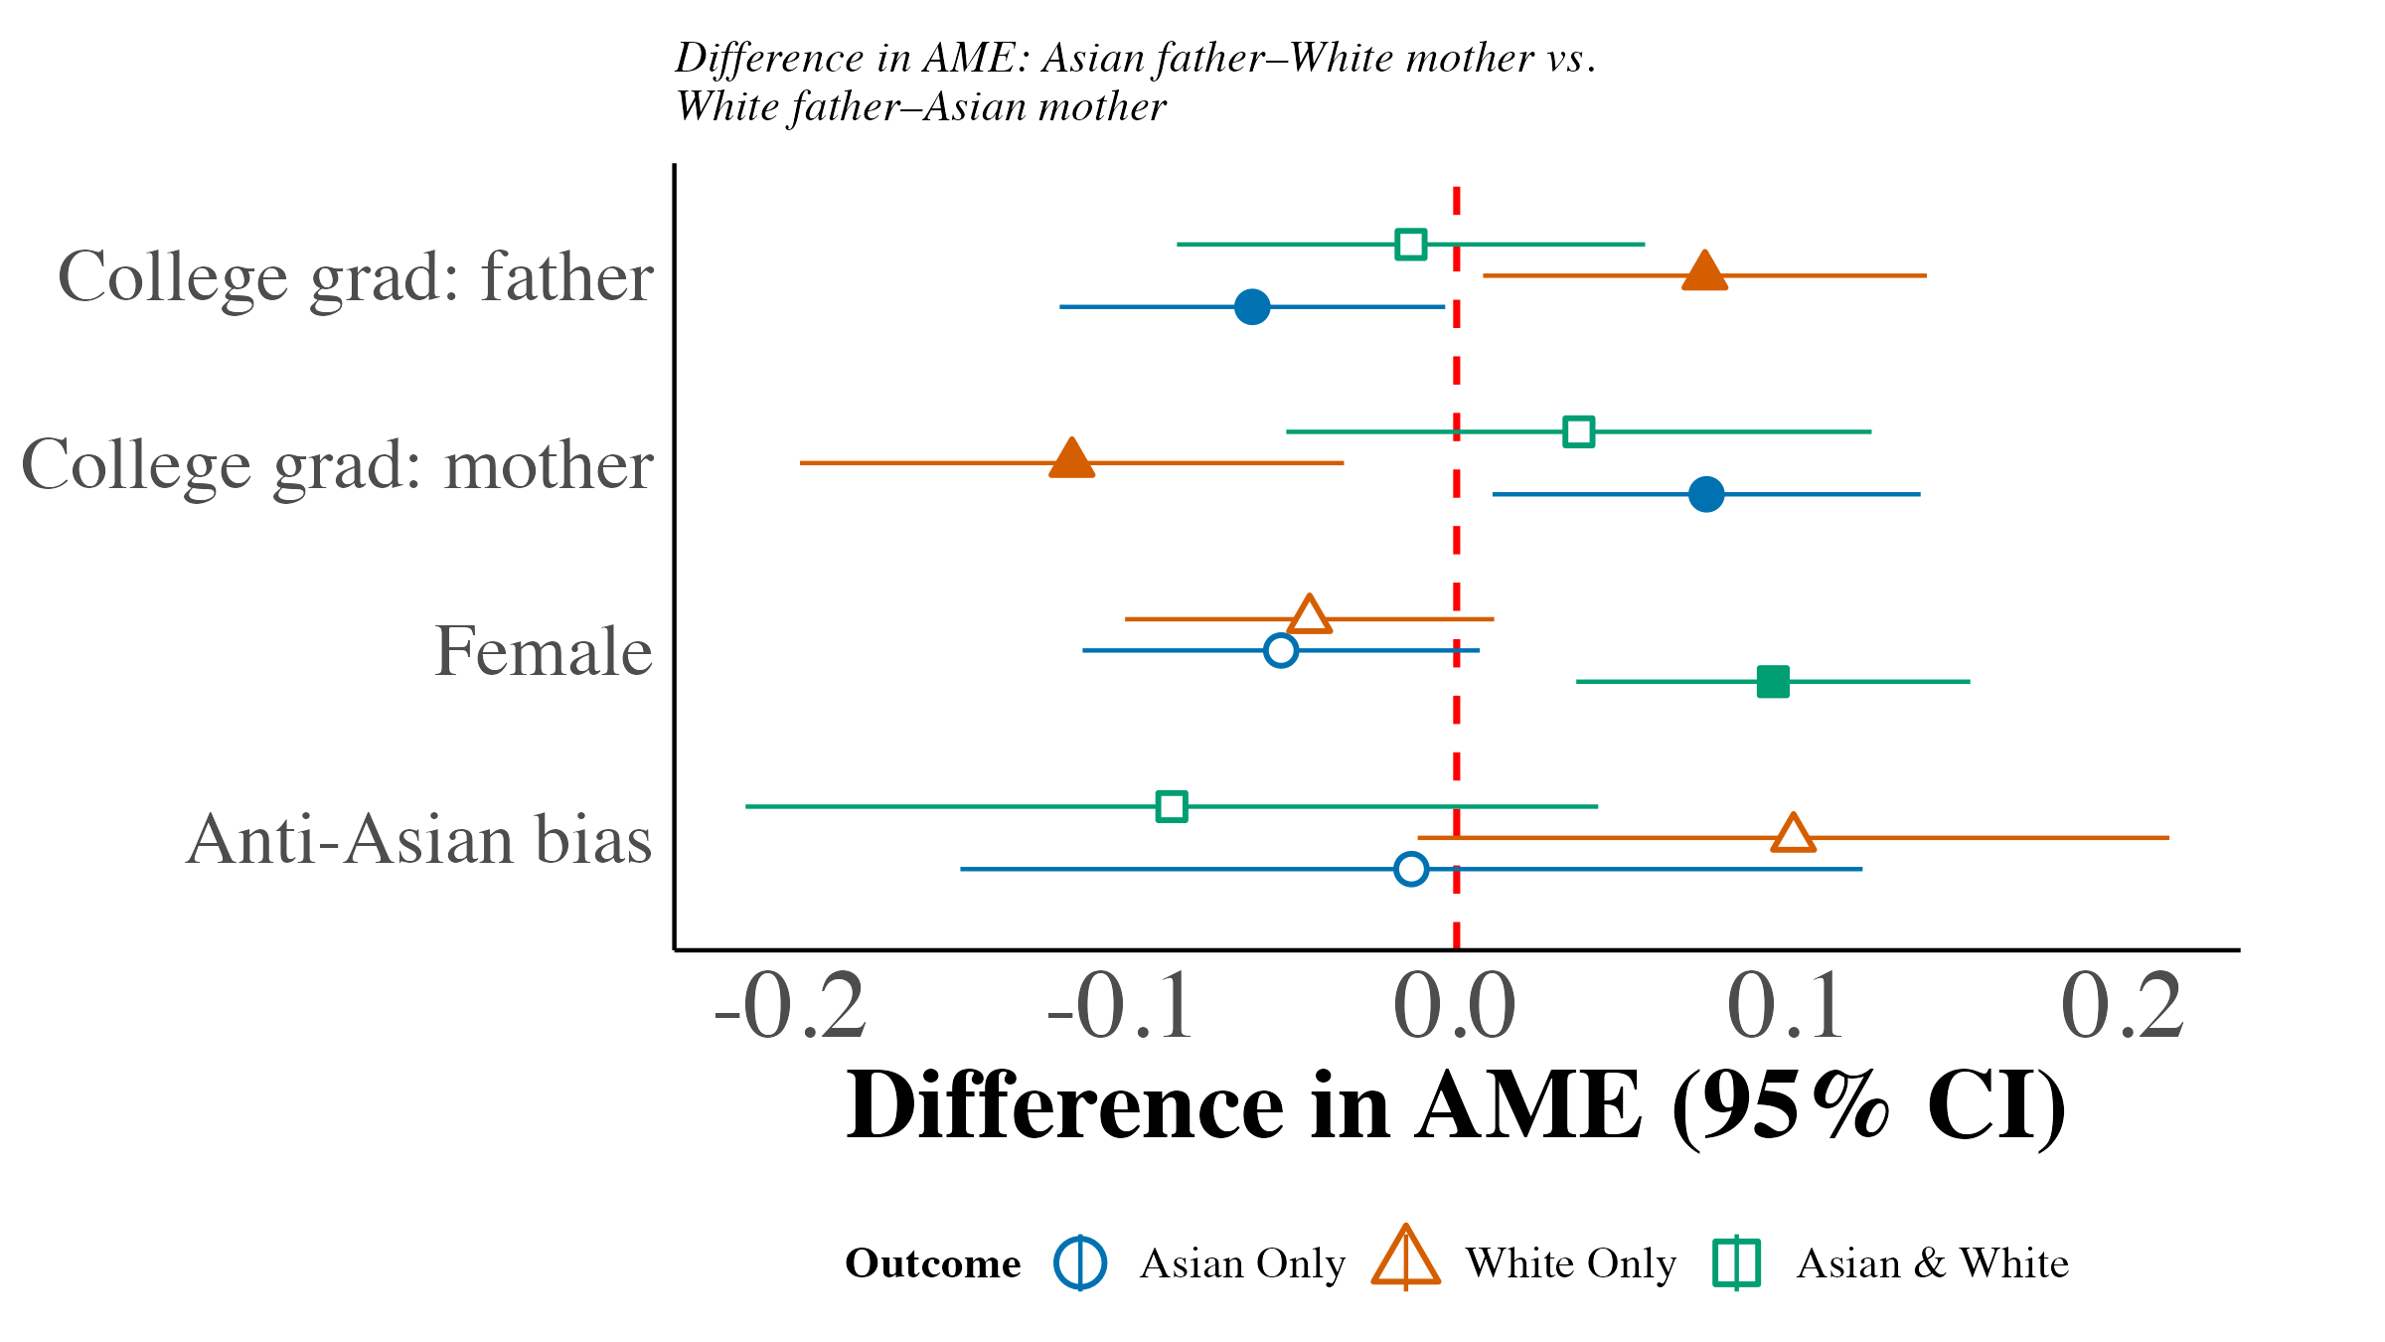
This figure plots differences in average marginal effects (AME) between the Asian father–White mother (AW) and White father–Asian mother (WA) multinomial logit models, estimated from equation (4). Each point subtracts the WA model’s median AME from the AW model’s; bias effects are per index unit. Each model’s summary uses 1,000 individual bootstrap resamples within region year cells. Its approximate standard error is the width of its 95% percentile interval divided by . The difference’s standard error combines the two model standard errors in quadrature, assuming independent samples. Bars show the difference plus or minus 1.96 standard errors; filled markers indicate 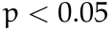 in a two-sided normal test. These intervals do not account for dependence among children in the same state; Appendix Table A.5 reports the bias contrast with state-clustered standard errors. Models include region year fixed effects, quartic age, and local Asian population share.

Figure A.12. Between-Model Differences in Average Marginal Effects: Third-Generation by Asian Grandparent Count
(a) One vs. Two Asian Grandparents
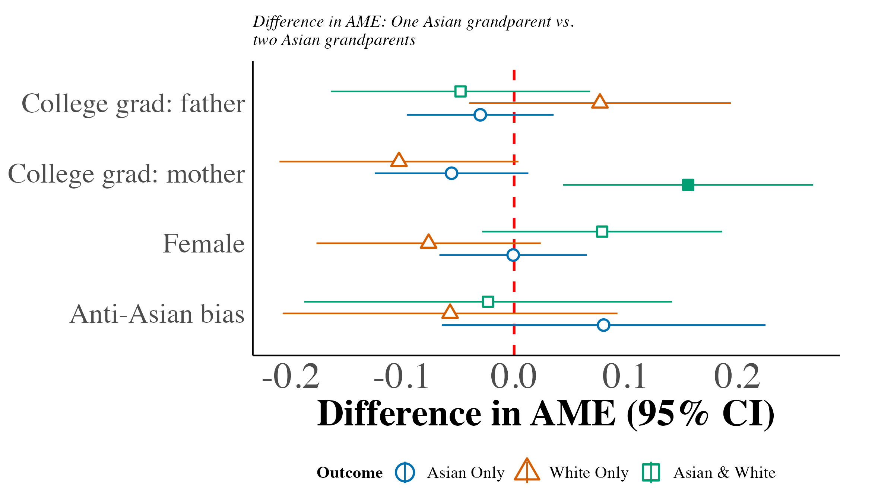
(b) One vs. Three Asian Grandparents
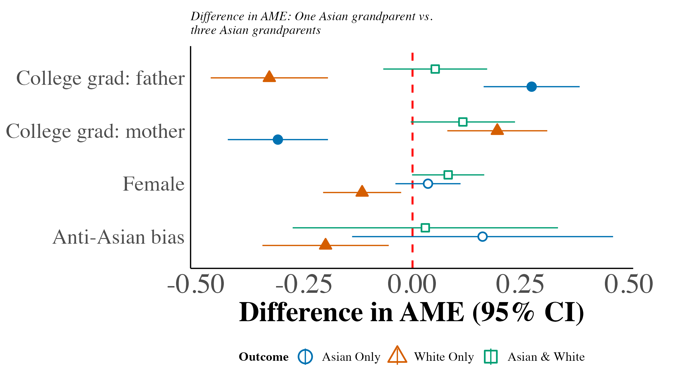
(c) Two vs. Three Asian Grandparents
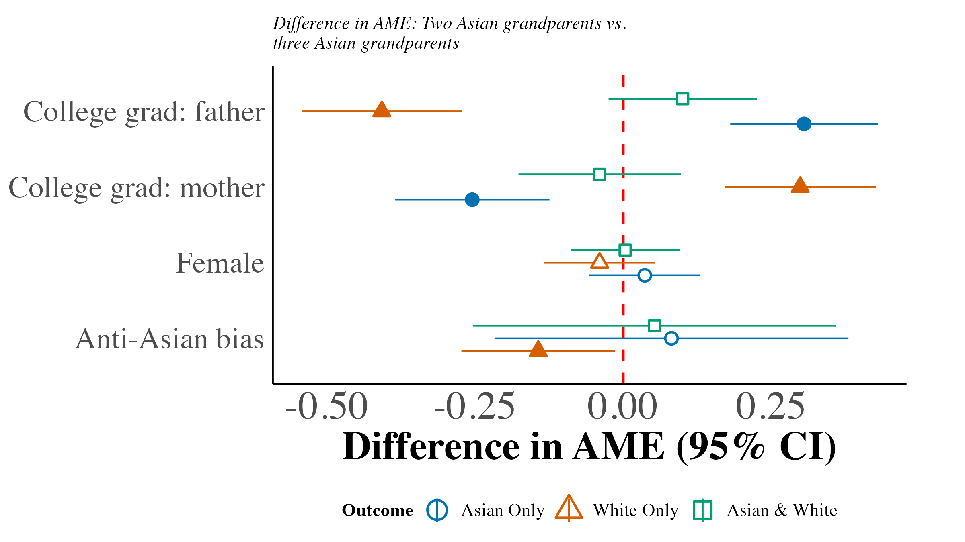
This figure plots differences in average marginal effects (AME) between third-generation multinomial logit models defined by the number of Asian grandparents. Each point subtracts the second group’s median AME from the first group’s; bias effects are per index unit. Each model’s summary uses 1,000 individual bootstrap resamples within region year cells. Its approximate standard error is the width of its 95% percentile interval divided by . The difference’s standard error combines the two model standard errors in quadrature, assuming independent samples. Bars show the difference plus or minus 1.96 standard errors; filled markers indicate in a two-sided normal test. These intervals do not account for dependence among children in the same state. Models include region year fixed effects, quartic age, and local Asian population share.

Figure A.13. Scatter Plot of Proportion Subjectively Asian on Bias
(a) Year < 2015
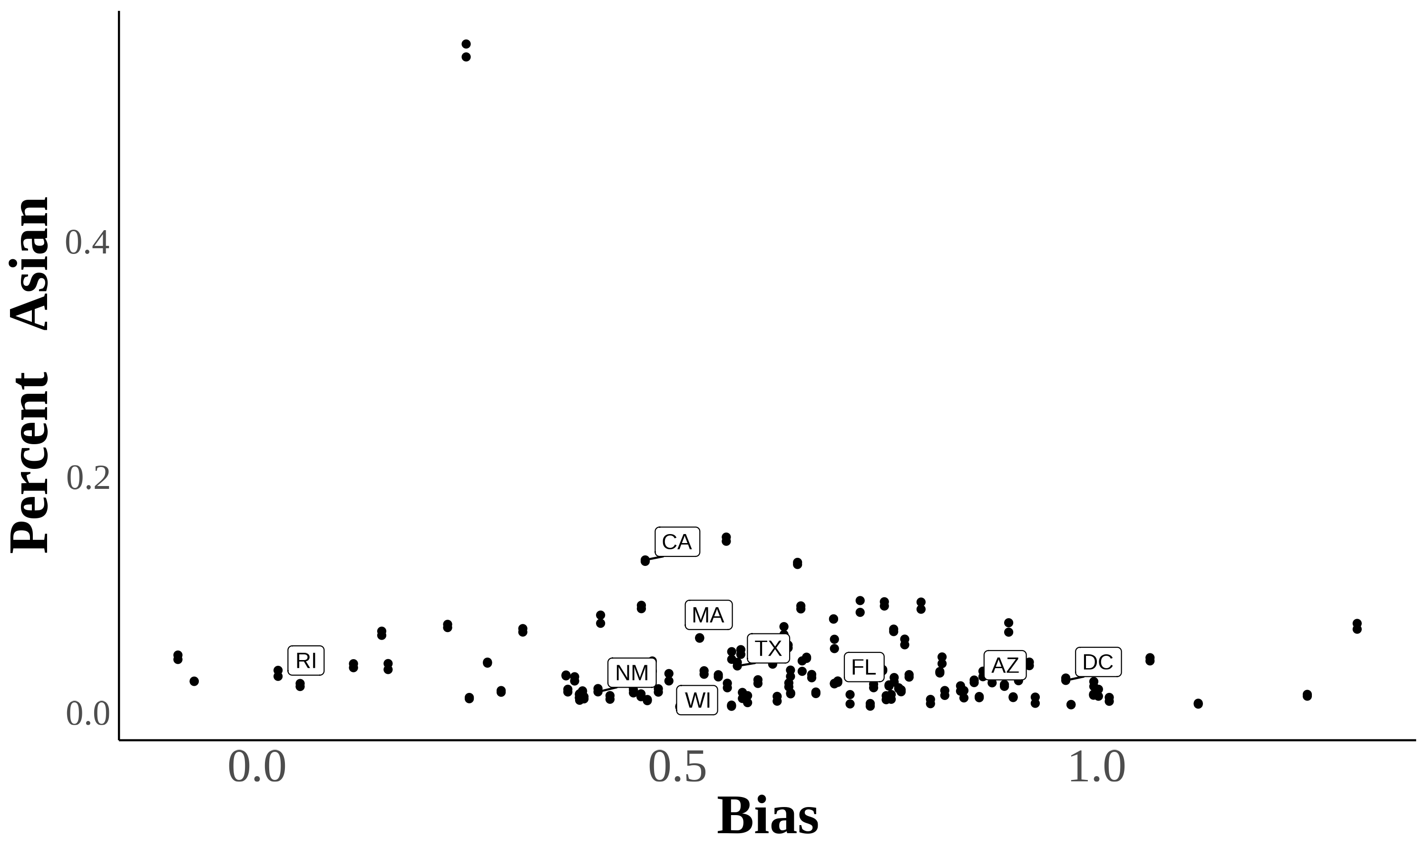
(b) Year 2015
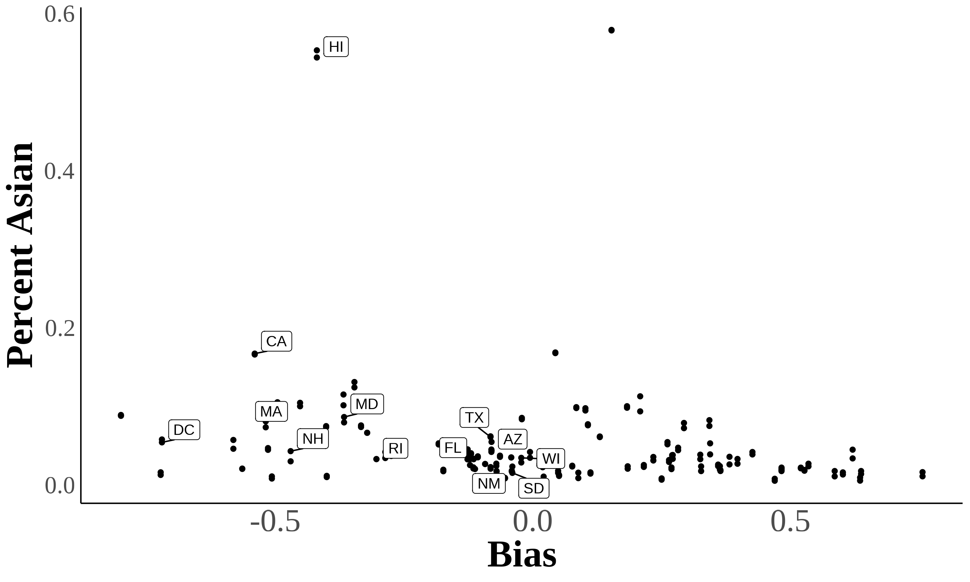
Here are two scatter plots showing the relationship between bias and subjective Asian population in a state. Each dot represents a state in a certain year. Percent subjectively Asian = 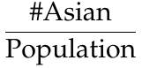
Source. 2004–2021 Current Population Survey.

Using Lubotsky & Wittenberg (2006) to Construct Bias Index
In Lubotsky & Wittenberg (2006), the authors propose a method to reduce measurement error in proxies by constructing a composite index. The Lubotsky-Wittenberg (henceforth LW) consider a model where a covariate is unobserved. Therefore, they use two proxies in its place, which will have measurement error. Thus, the LW method allows researchers to use two proxies that are error-ridden.
LW consider a setup with the following model:
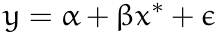
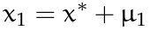
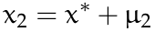
Where 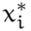 is the unobserved covariate, and are the proxies, and the measurement errors and are assumed to be classical and allowed to covary. The covariance matrix of the errors is given by:
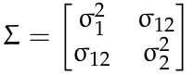
Replacing the unobserved with or yields the following expectations of the OLS estimates:
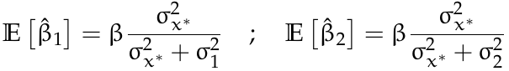
Both estimates are biased; the one with the smaller variance of the measurement error being less biased.
LW then propose defining a new proxy as a weighted average of and :
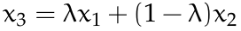
To minimize the attenuation bias in the OLS estimate of , they solve for the optimal value of :
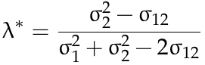
This optimal value of is not directly useful because the variances of the measurement errors and their covariance are unobserved. However, if you estimate a bivariate regression using OLS (i.e., regress on and ), then the expectation of the sum of the two coefficient estimates is identical to the expectation of the OLS coefficient estimate on in a univariate regression using the optimal choice of :
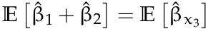
Thus, OLS produces an estimate of with the least bias by optimally combining the information in and .

References
Antman, F. M., Duncan, B., & Trejo, S. J. (2020). Ethnic attrition, assimilation, and the measured health outcomes of Mexican Americans. Journal of Population Economics, 33(4), 1499–1522. http://doi.org/https://doi-org.ezproxy.lib.uh.edu/10.1007/s00148-020-00772-8
Antman, F., Duncan, B., & Trejo, S. J. (2016). Ethnic Attrition and the Observed Health of Later-Generation Mexican Americans. The American Economic Review, 106(5), 467–471. Retrieved from http://www.jstor.org/stable/43861065
Lubotsky, D., & Wittenberg, M. (2006). Interpretation of Regressions with Multiple Proxies. The Review of Economics and Statistics, 88(3), 549–562. http://doi.org/10.1162/rest.88.3.549

