Online appendix: The Effect of Racial and Ethnic Attitudes on Asian Identity in the U.S

Data

Figure A.1. Examples of an Implicit Association Test
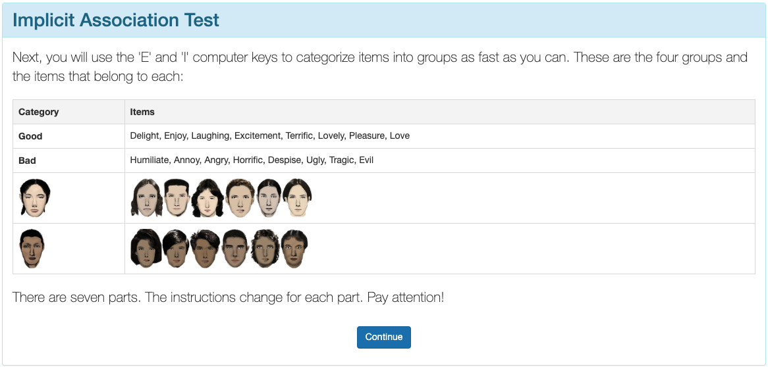
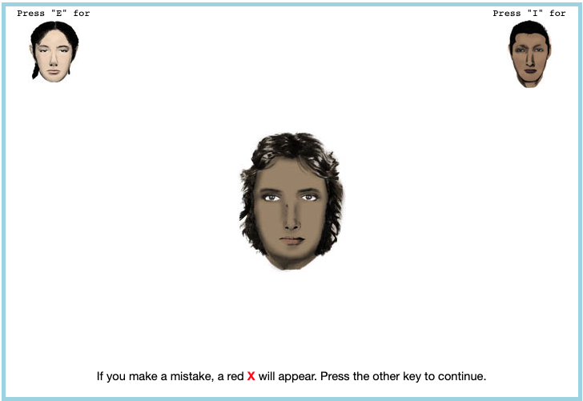



Here are a few examples of what a respondent would see on an implicit association test.

Tables

Table A.1. Subjective Asian Identity and Asian Bias
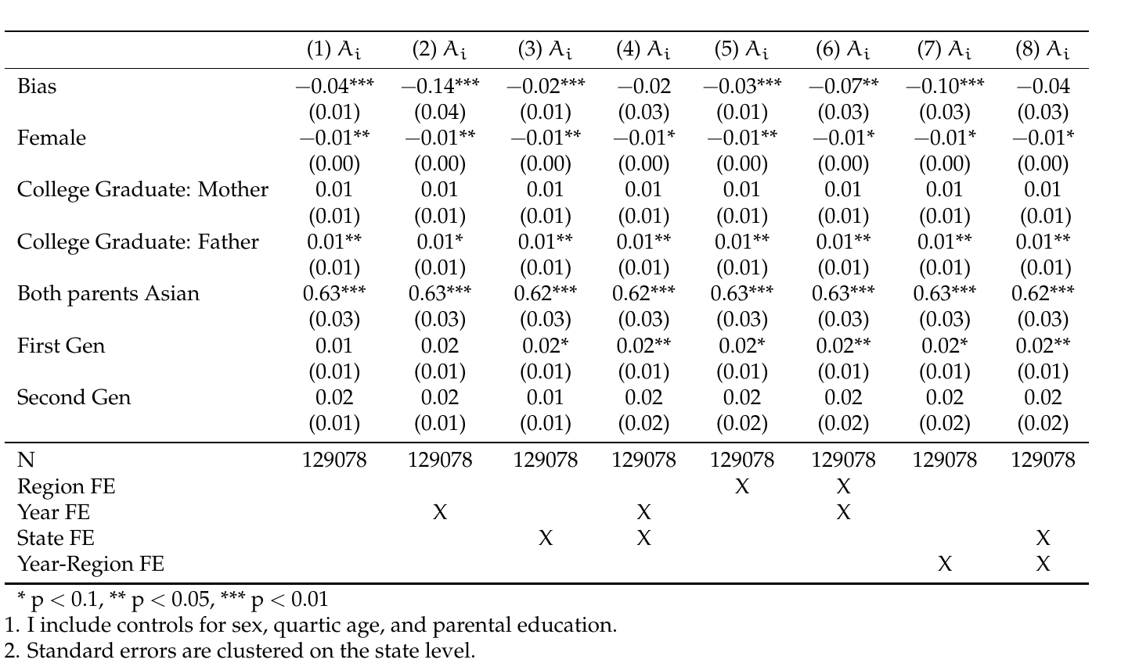

Table A.2. Logistic Regression Analysis of Bias and Interracial Marriages
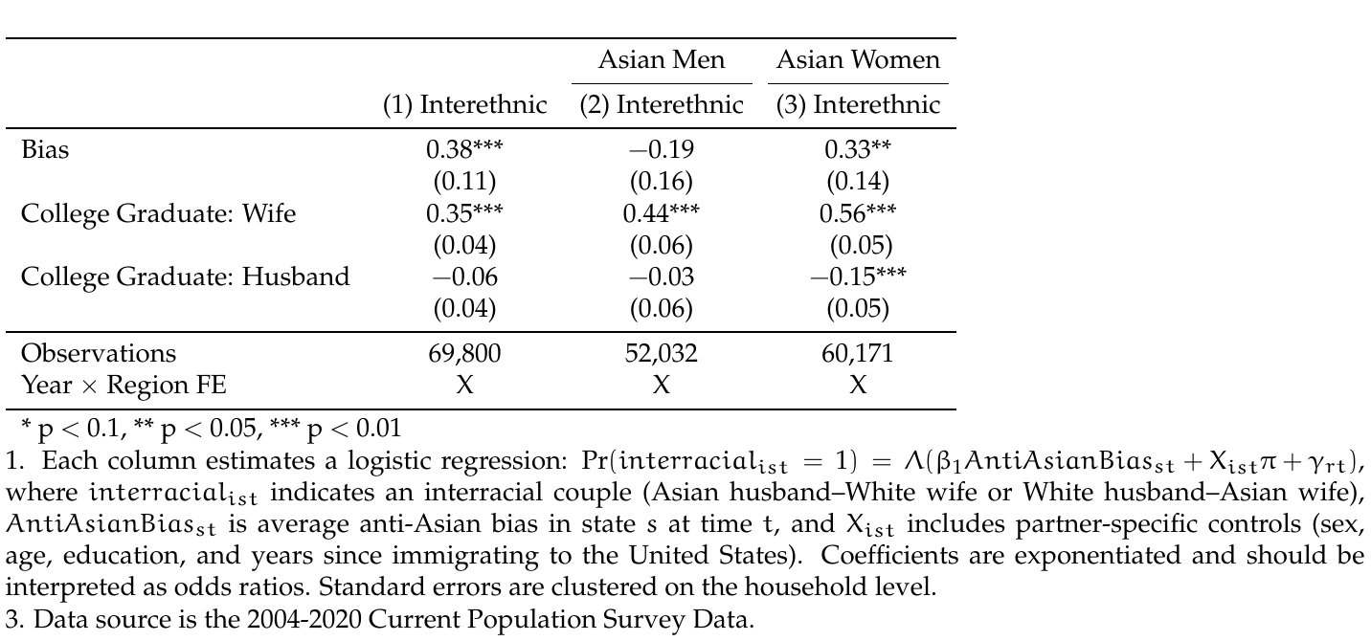

Table A.3. Between-Model Tests of Average Marginal Effects: Second-Generation AW vs. WA
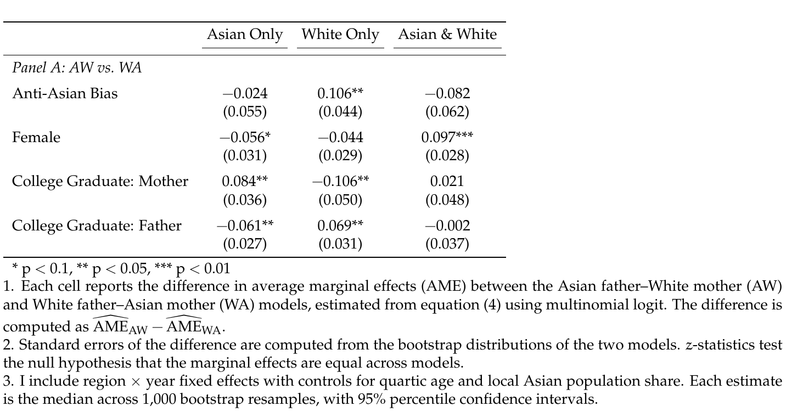

Table A.4. Between-Model Tests of Average Marginal Effects: Third-Generation by Asian Grandparent Count
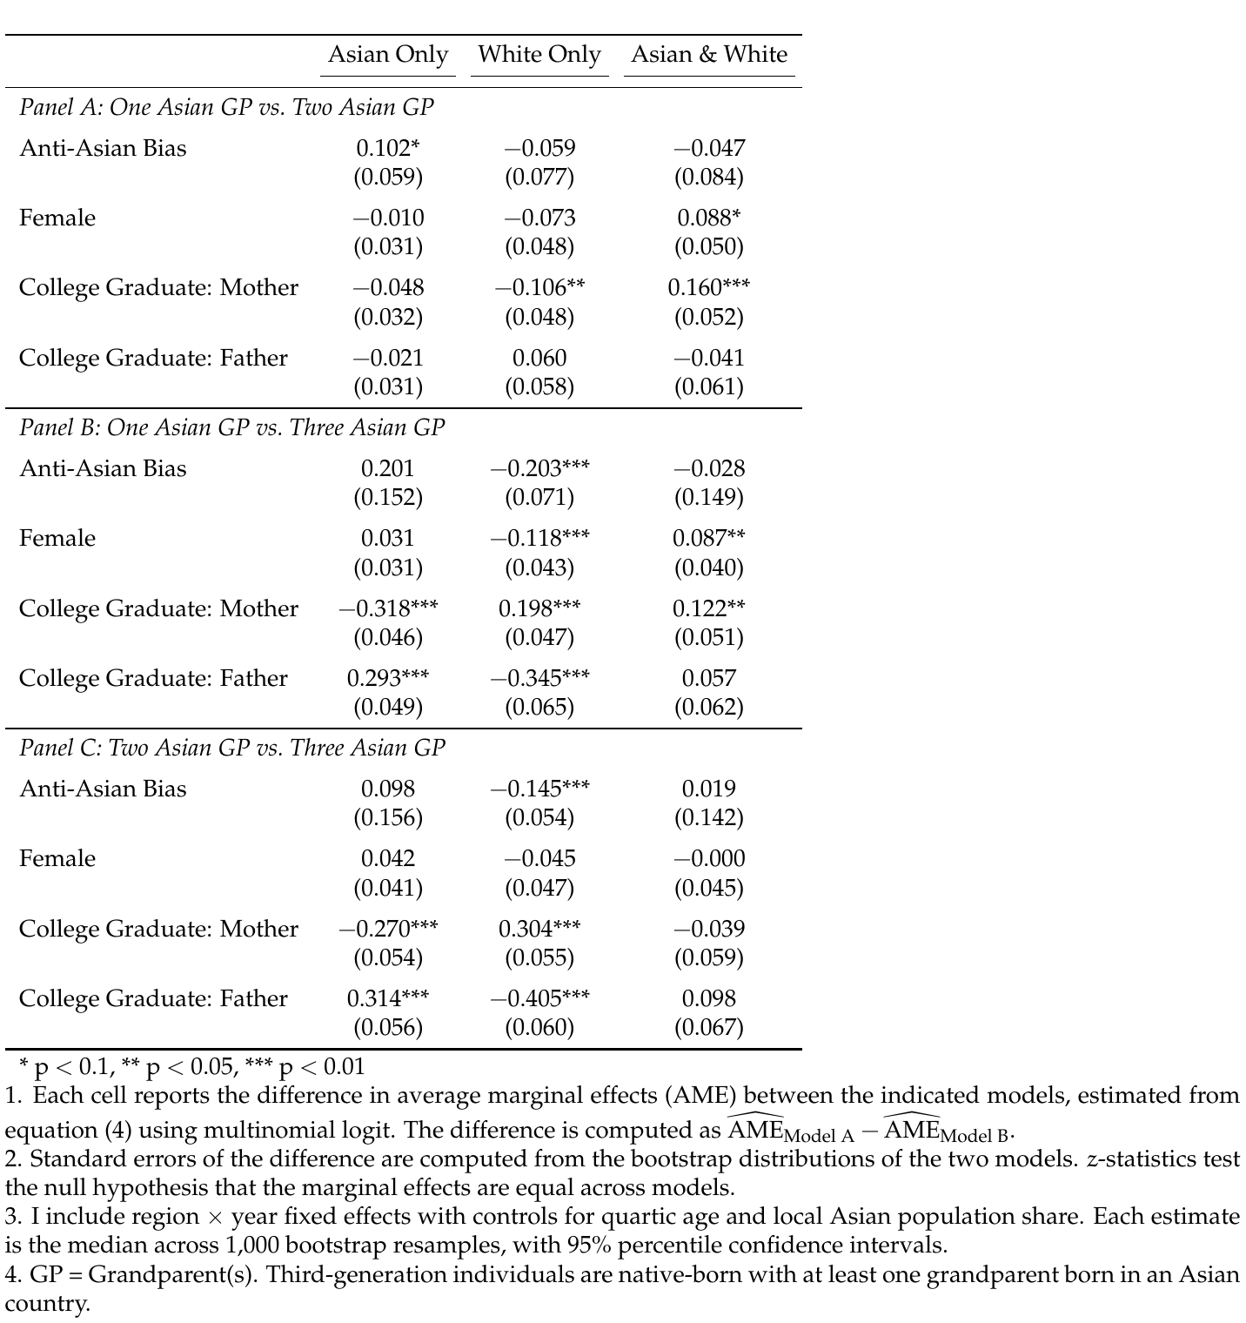

Figures

Figure A.2. Between-Model Differences in Average Marginal Effects: Second-Generation AW vs. WA
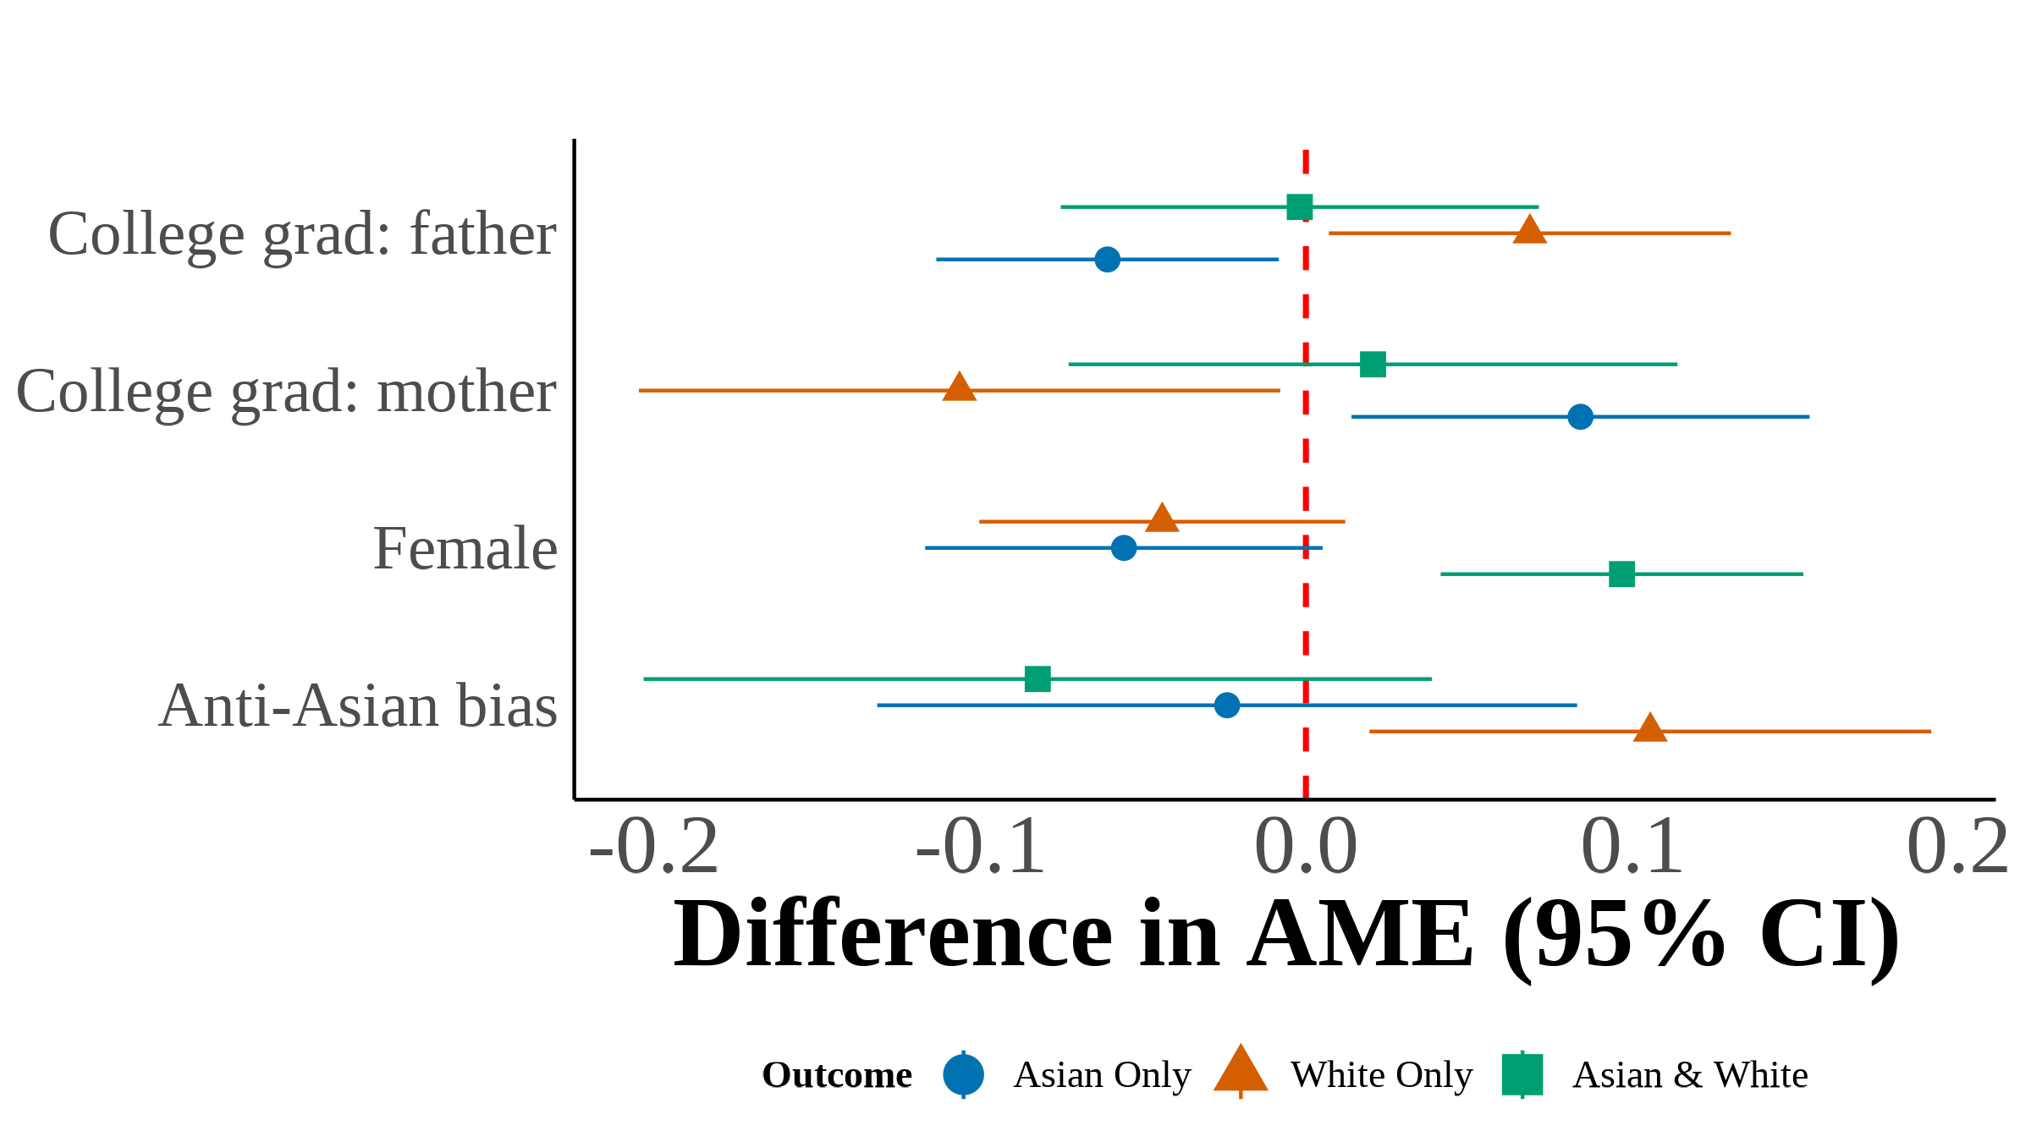
This figure plots the difference in average marginal effects (AME) between the Asian father–White mother (AW) and White father–Asian mother (WA) multinomial logit models, estimated from equation (4). Each point represents  for a given covariate and racial identity outcome. Filled markers indicate statistical significance at the 5% level. Error bars show 95% confidence intervals constructed from the bootstrap standard errors of the difference. I include region year fixed effects with controls for quartic age and local Asian population share. Each estimate is the median across 1,000 bootstrap resamples.

Figure A.3. Between-Model Differences in Average Marginal Effects: Third-Generation by Asian Grandparent Count
(a) One vs. Two Asian Grandparents
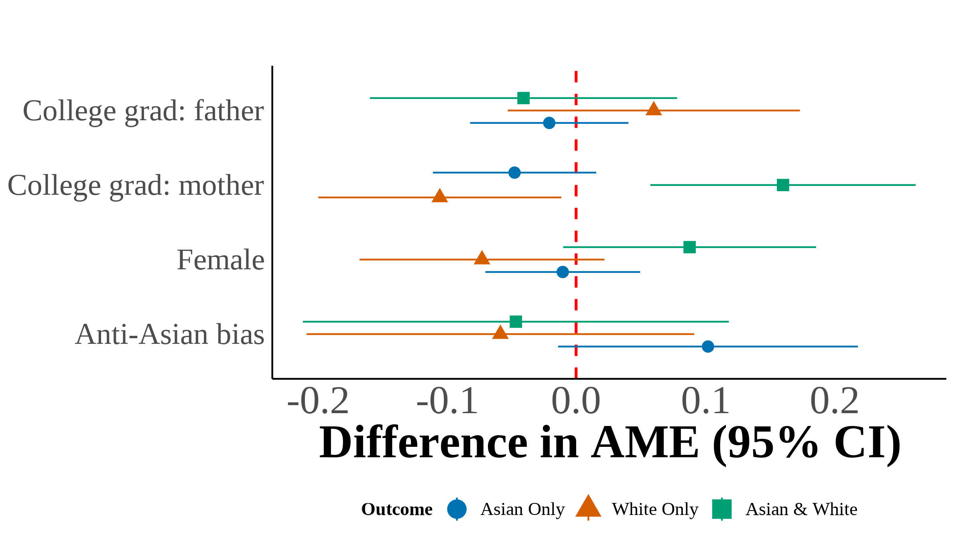
(b) One vs. Three Asian Grandparents
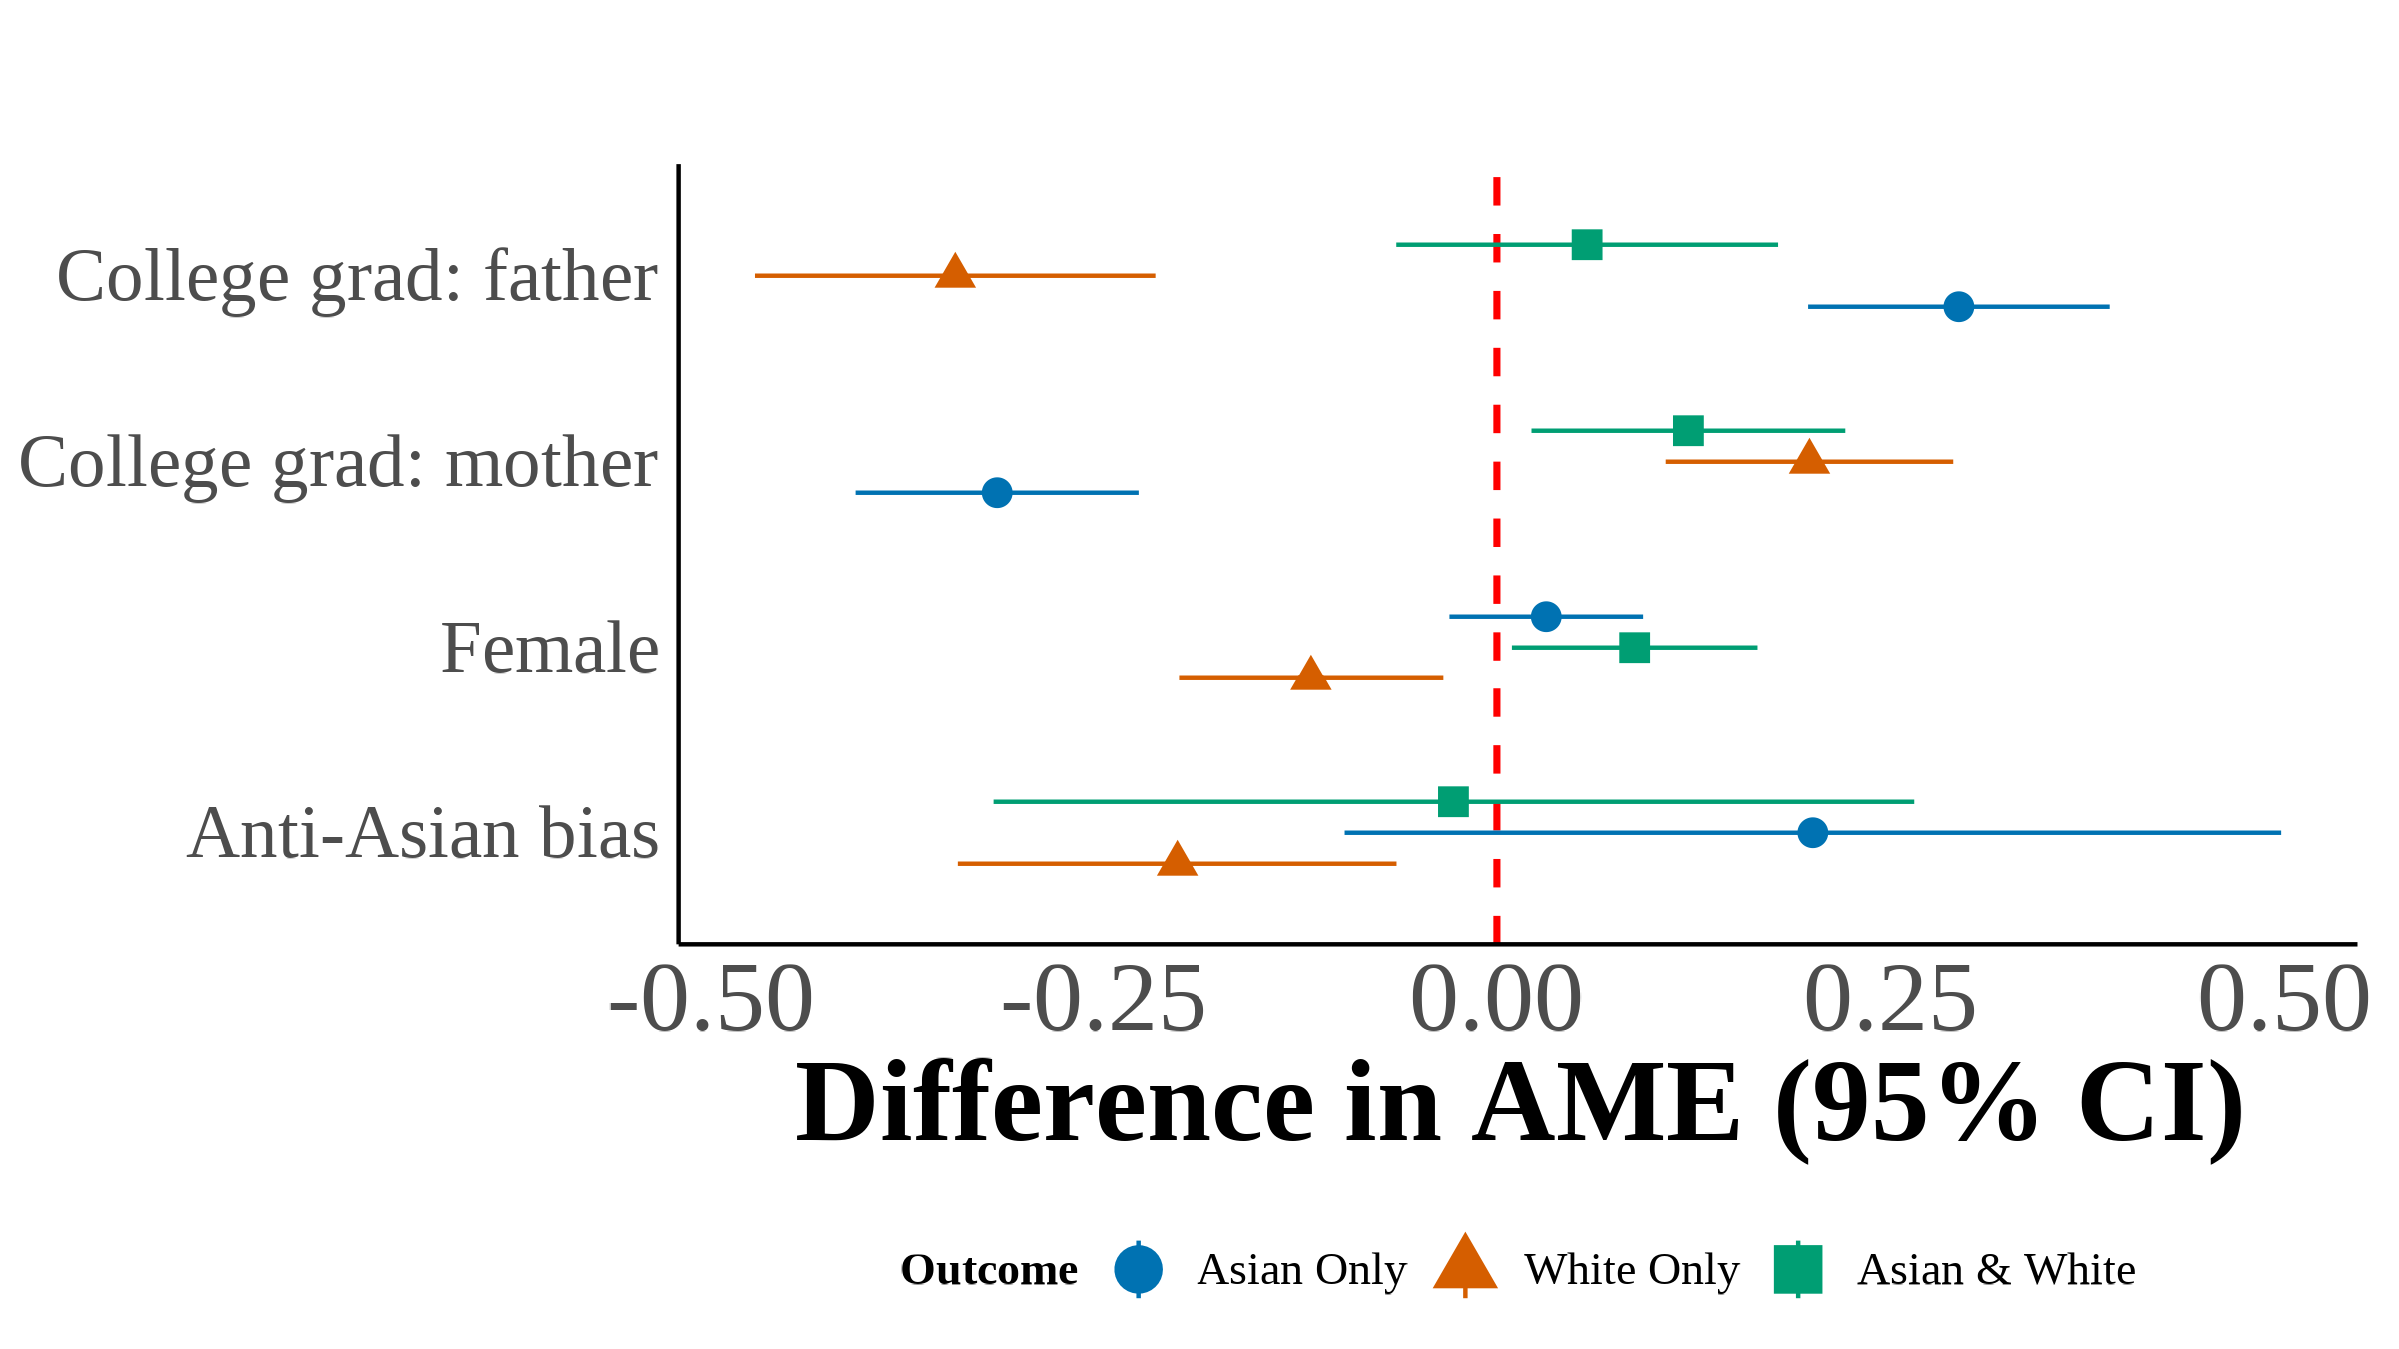
(c) Two vs. Three Asian Grandparents
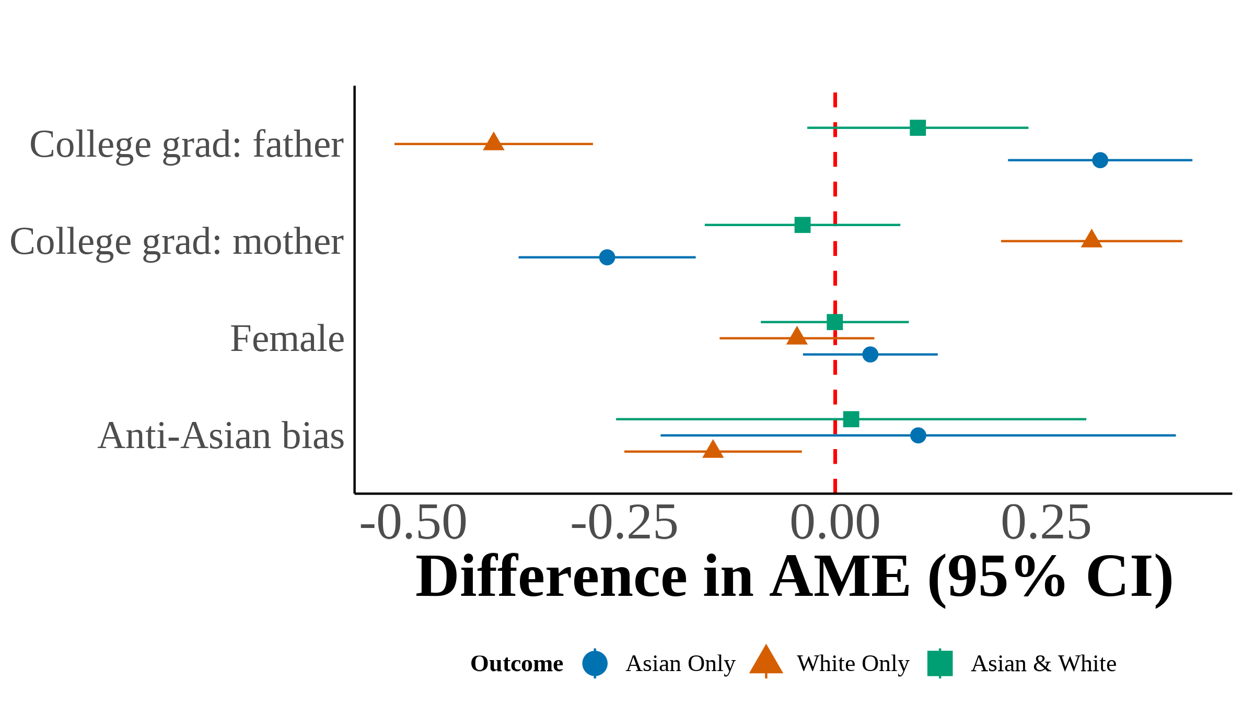
This figure plots the difference in average marginal effects (AME) between third-generation multinomial logit models estimated on samples defined by the number of Asian grandparents. Each point represents the difference in AME between the indicated models for a given covariate and racial identity outcome. Filled markers indicate statistical significance at the 5% level. Error bars show 95% confidence intervals constructed from the bootstrap standard errors of the difference. I include region year fixed effects with controls for quartic age and local Asian population share. Each estimate is the median across 1,000 bootstrap resamples.

Figure A.4. Scatter Plot of Proportion Subjectively Asian on Bias
(a) Year < 2015
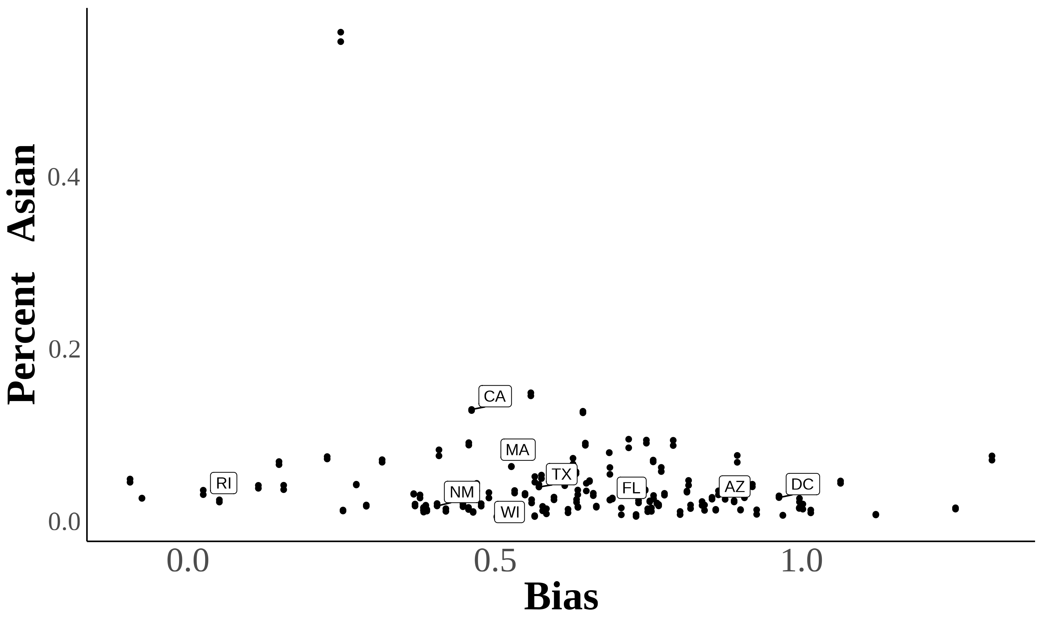
(b) Year 2015
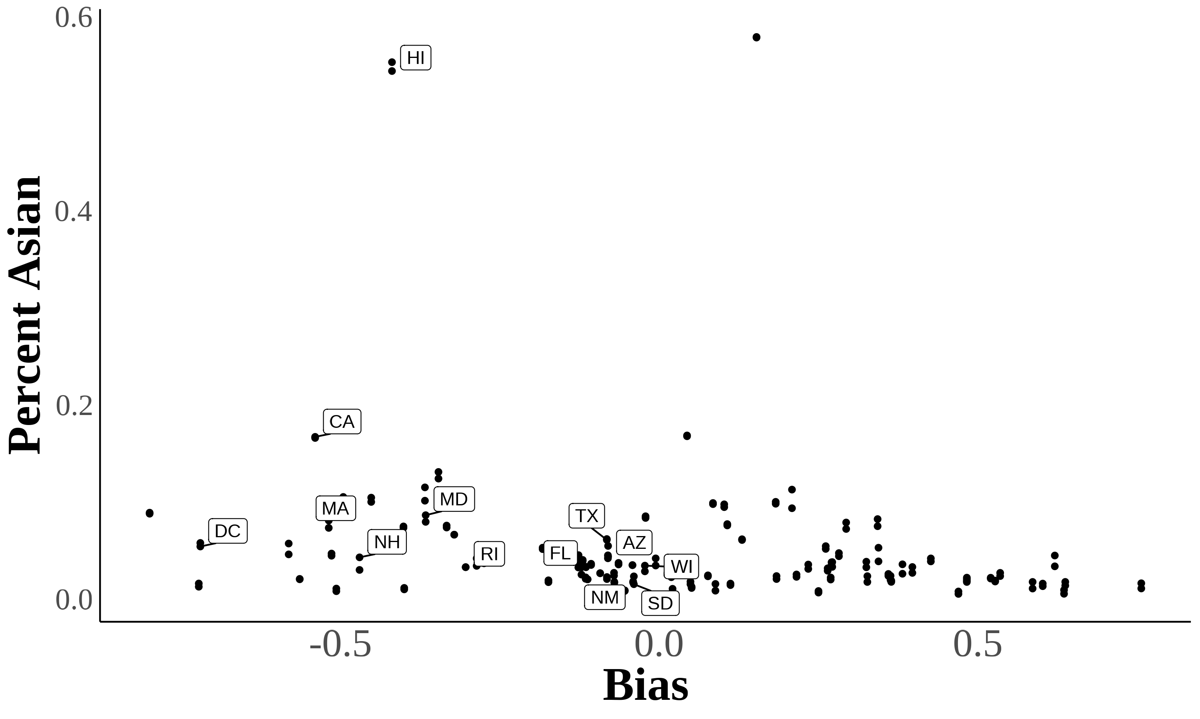
Here are two scatter plots showing the relationship between bias and subjective Asian population in a state. Each dot represents a state in a certain year. Percent subjectively Asian = 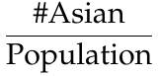
Source. 2004–2021 Current Population Survey.

Using Lubotsky & Wittenberg (2006) to Construct Bias Index
In Lubotsky & Wittenberg (2006), the authors propose a method to reduce measurement error in proxies by constructing a composite index. The Lubotsky-Wittenberg (henceforth LW) consider a model where a covariate is unobserved. Therefore, they use two proxies in its place, which will have measurement error. Thus, the LW method allows researchers to use two proxies that are error-ridden.
LW consider a setup with the following model:
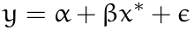
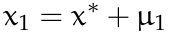
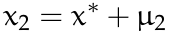
Where 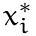 is the unobserved covariate, and are the proxies, and the measurement errors and are assumed to be classical and allowed to covary. The covariance matrix of the errors is given by:
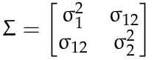
Replacing the unobserved with or yields the following expectations of the OLS estimates:
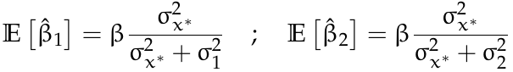
Both estimates are biased; the one with the smaller variance of the measurement error being less biased.
LW then propose defining a new proxy as a weighted average of and :
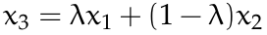
To minimize the attenuation bias in the OLS estimate of , they solve for the optimal value of :
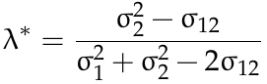
This optimal value of is not directly useful because the variances of the measurement errors and their covariance are unobserved. However, if you estimate a bivariate regression using OLS (i.e., regress on and ), then the expectation of the sum of the two coefficient estimates is identical to the expectation of the OLS coefficient estimate on in a univariate regression using the optimal choice of :
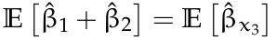
Thus, OLS produces an estimate of with the least bias by optimally combining the information in and .

References
Lubotsky, D., & Wittenberg, M. (2006). Interpretation of Regressions with Multiple Proxies. The Review of Economics and Statistics, 88(3), 549–562. http://doi.org/10.1162/rest.88.3.549

