ONLINE APPENDIX

The Effect of Racial and Ethnic Attitudes on

Asian Identity in the U.S
Hussain Hadah*

*. Hussain Hadah: The Murphy Institute and Department of Economics, Tulane University, Caroline Richardson Building, 62 Newcomb Place, Suite 118, New Orleans, LA 70118, United
States (e-mail: hhadah@tulane.edu, phone: +1-602-393-8077)

Data

Figure A.1: Examples of an Implicit Association Test
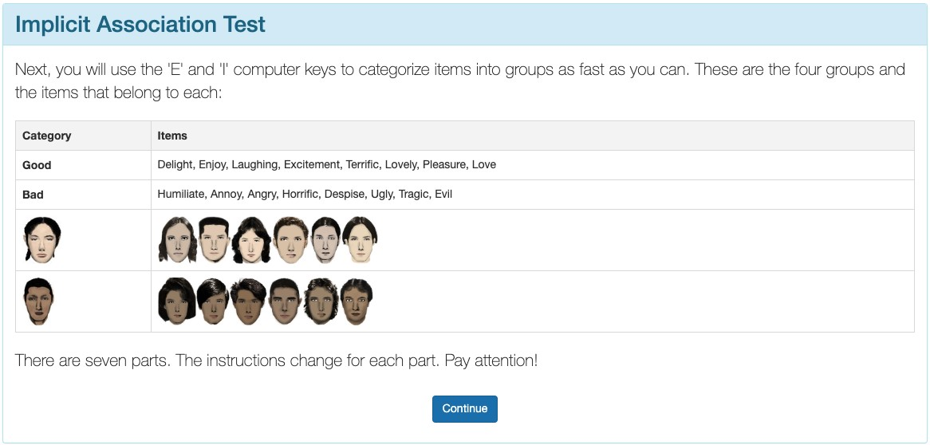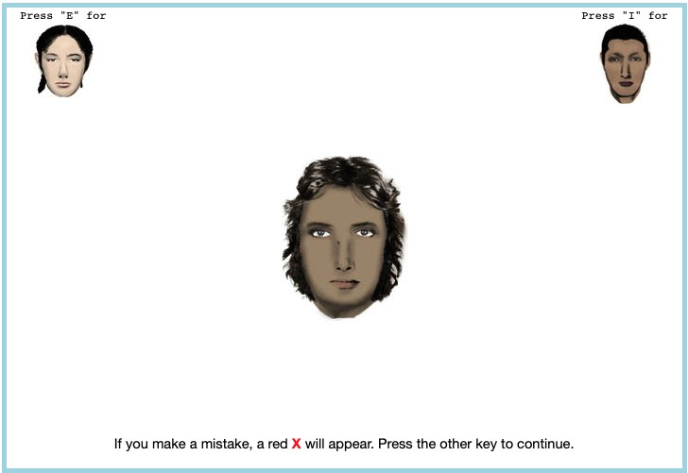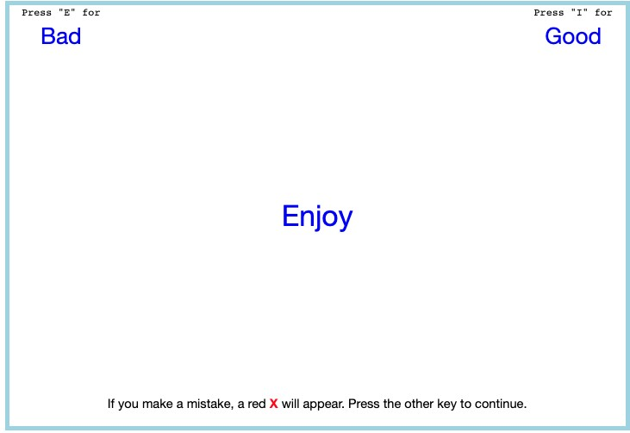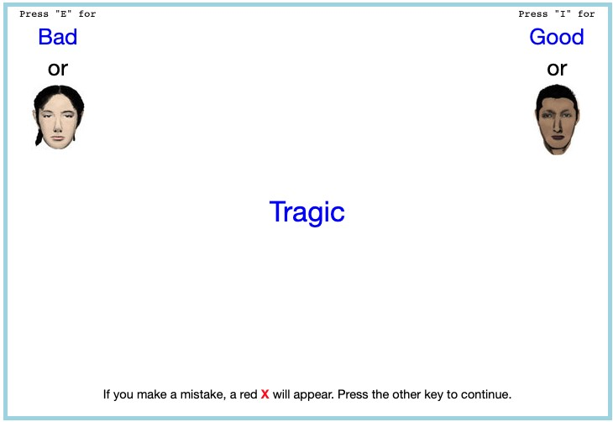

Here are a few examples of what a respondent would see on an implicit association test.
Figure A.2: Maps of State-level Association Test Bias Over Time Measure with
Census Division Regional Boundaries

(a) State-level Bias in 2004 (b) State-level Bias in 2008
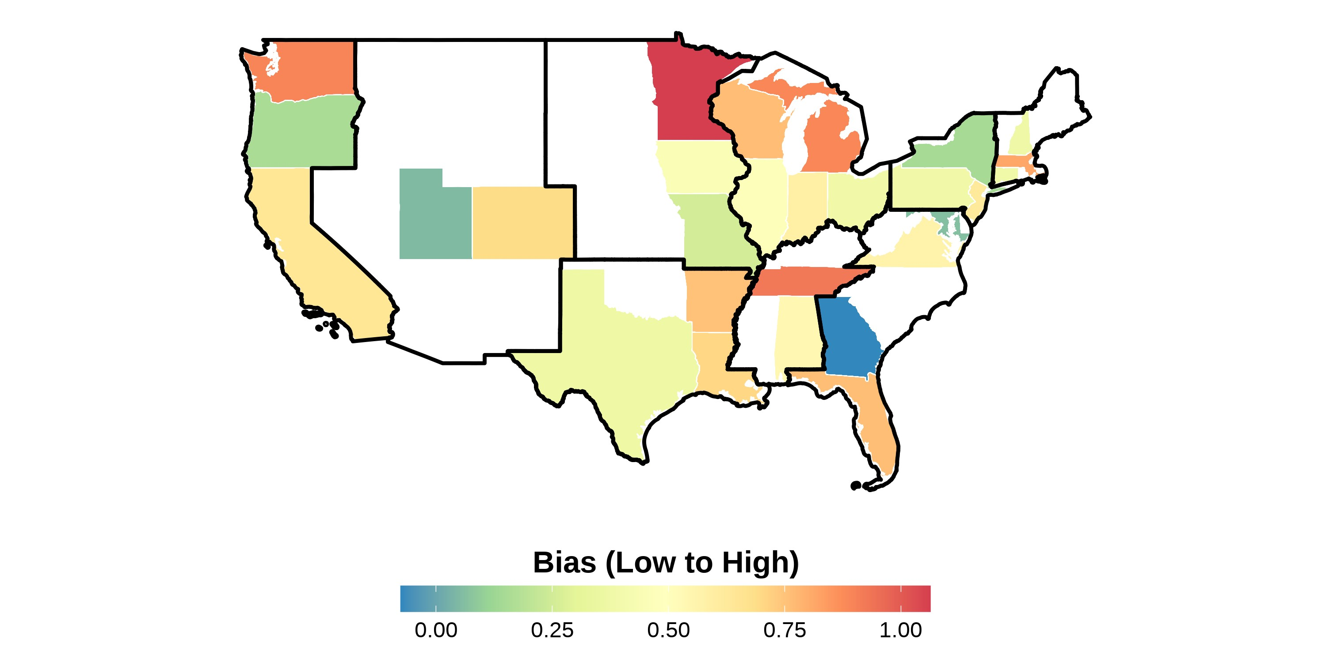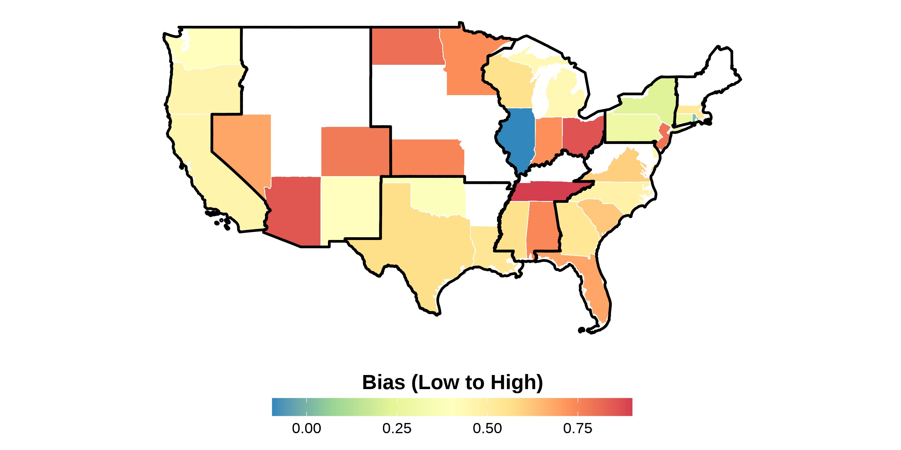

(c) State-level Bias in 2012 (d) State-level Bias in 2016
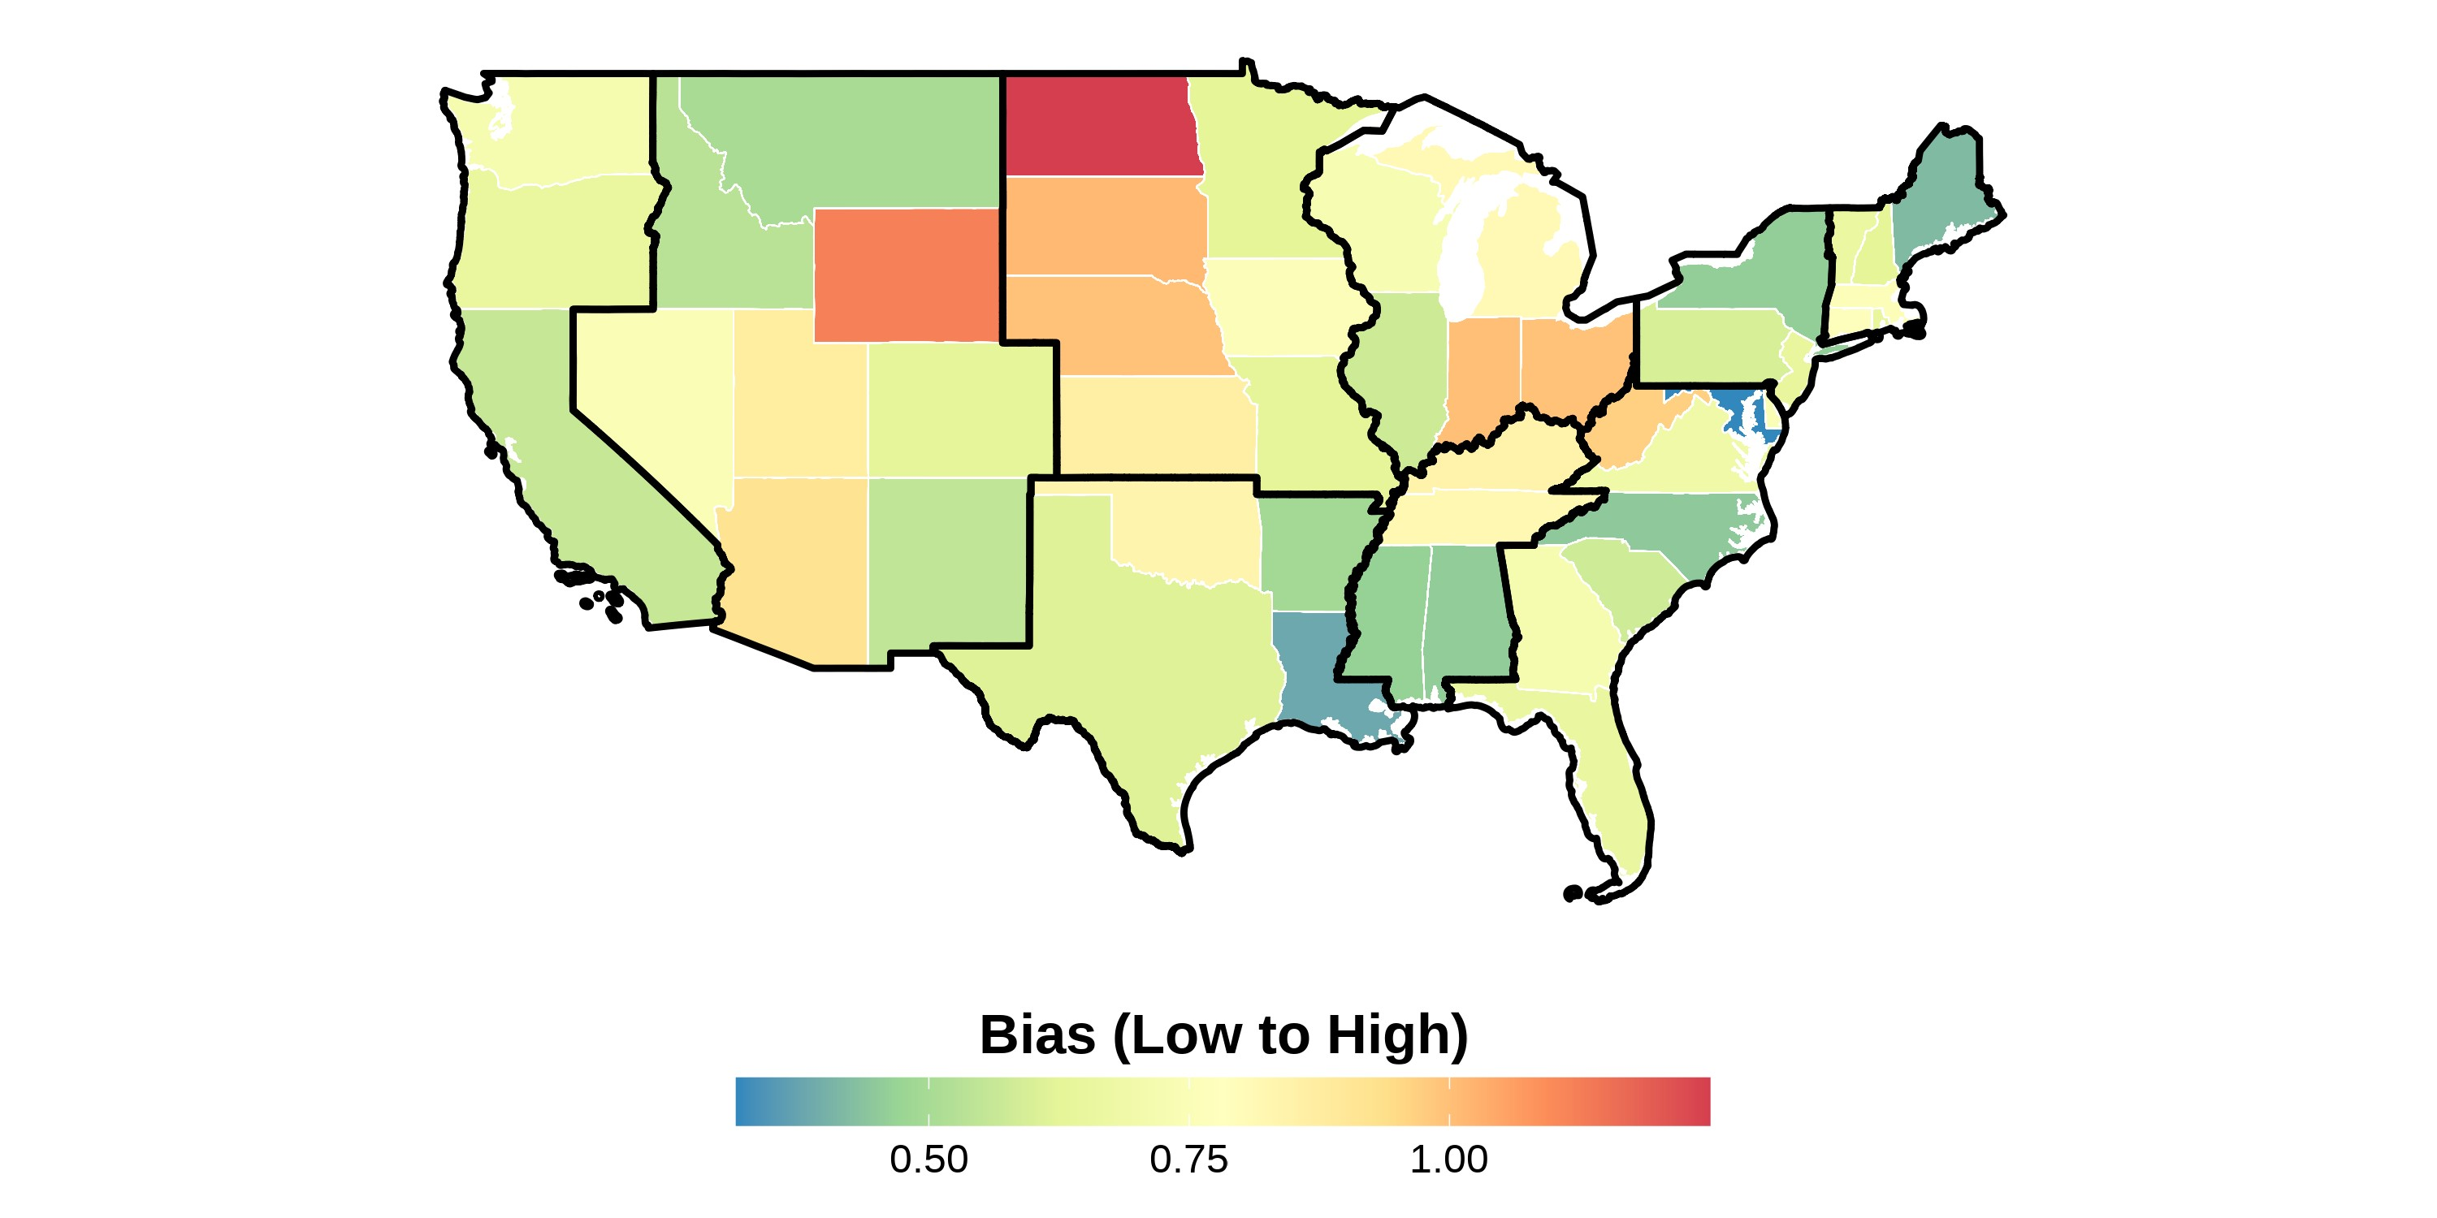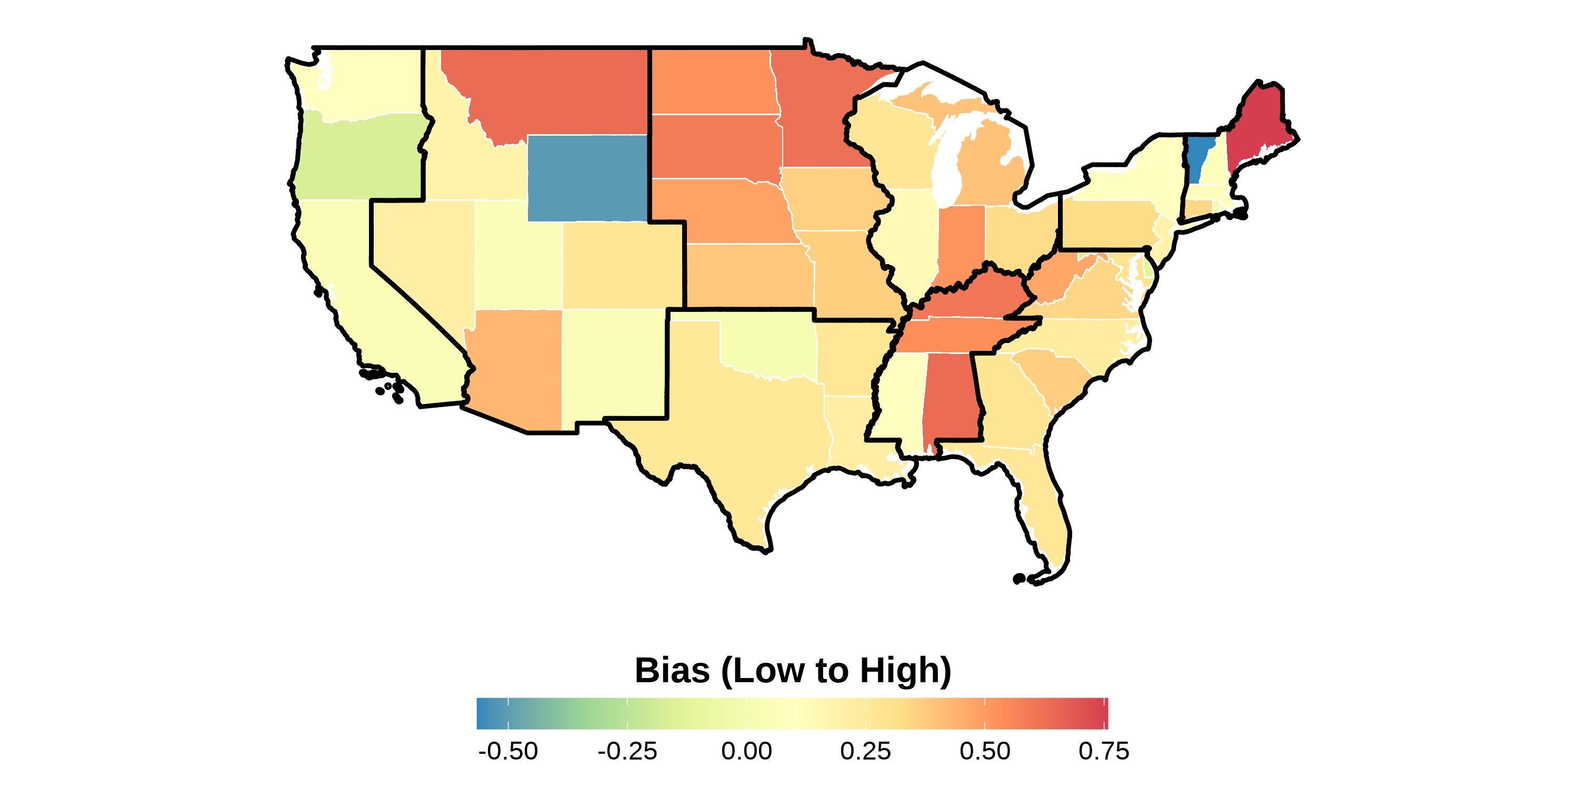
This figure shows the state-level bias index in different years in the sample. The bias units are in standard deviations and ranges from low to high bias. Bias index is constructed following Lubotsky and Wittenberg (2006). The data is from the 2004–2021 Harvard’s Project Implicit Association Test scores, American National Election Studies (ANES), and state-level hate crimes against Asians. Each panel presents state-level bias during a certain year. The boundaries in black represent the different Census divisions in the United States. Notice how there is a variation across states within a region.
Figure A.3: Maps of State-level Bias 2004–2021 Measure with Census Division Regional Boundaries
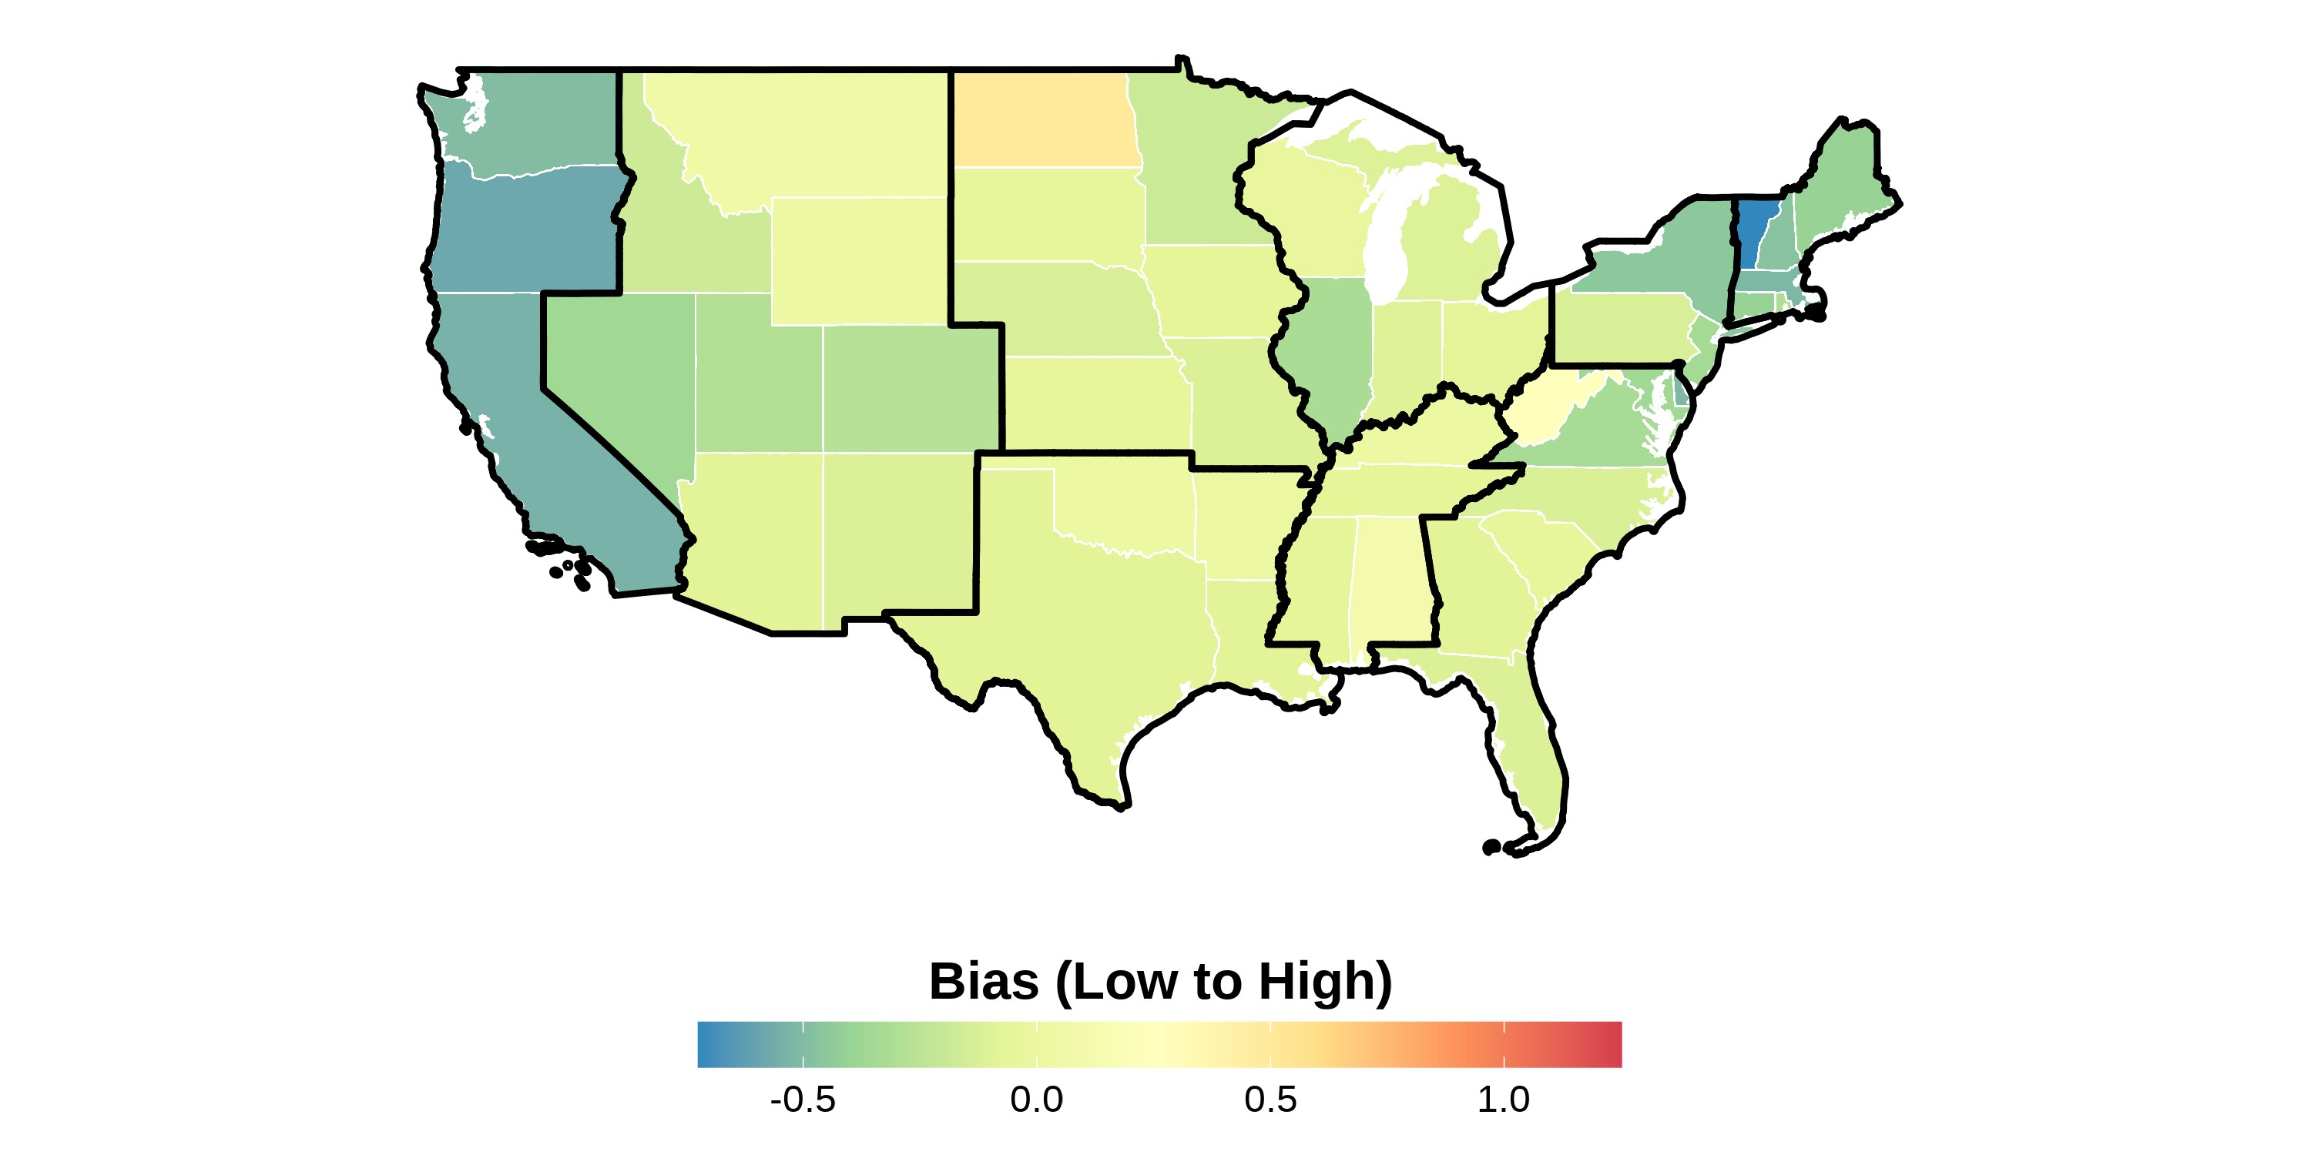
This figure shows the state-level bias index in the sample from 2004 to 2021. The bias units are in standard deviations and ranges from low to high bias. Bias index is constructed following Lubotsky and Wittenberg (2006). The data is from the 2004–2021 Harvard’s Project Implicit Association Test scores, American National Election Studies (ANES), and state-level hate crimes against Asians. The boundaries in black represent the different Census divisions in the United States. Notice how there is a variation across states within a region.

Figure A.4: Asian Racial Identity
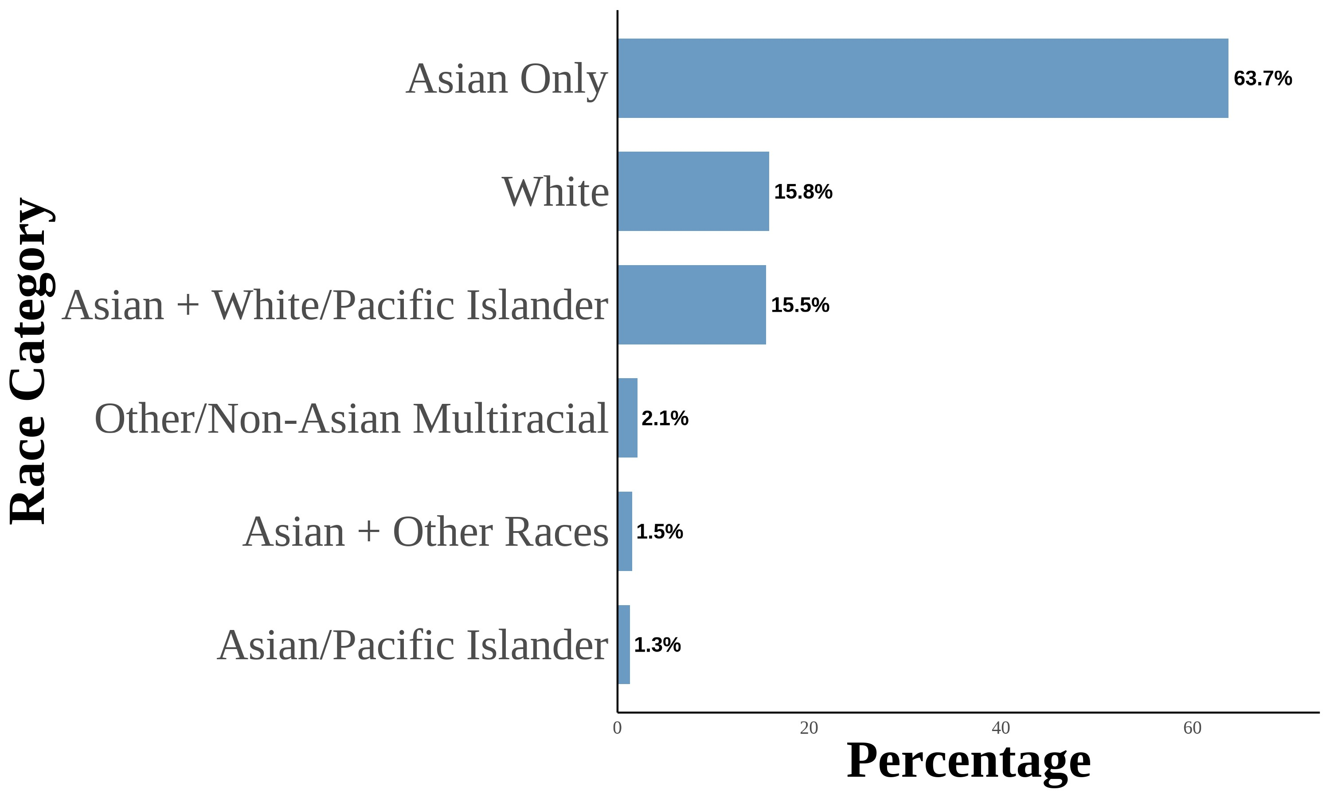
This figure shows the distribution of Asian racial identity among respondents. The data is aggregated from the 2004–2021 Current Population Survey (CPS). The sample includes first-, second-, and third-generation objectively Asian Americans. Following Antman, Duncan, and Trejo (2016) and Antman, Duncan, and Trejo (2020), I utilize birthplace information for individuals, parents, and grandparents to create objective Asian ancestry indicators.

Figure A.5: Asian Racial Identity: First Generation
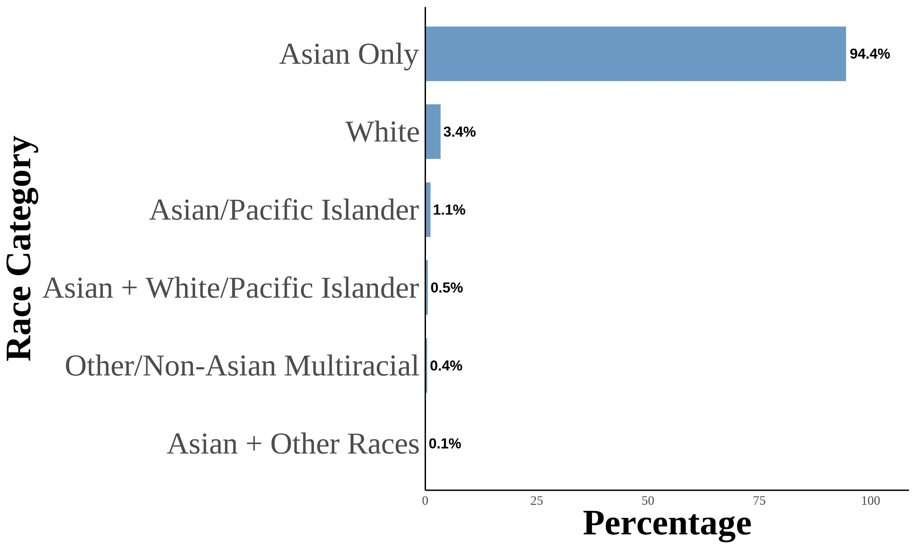
This figure shows the distribution of Asian racial identity among respondents. The data is aggregated from the 2004–2021 Current Population Survey (CPS). The sample includes first-generation objectively Asian Americans. Following Antman, Duncan, and Trejo (2016) and Antman, Duncan, and Trejo (2020), I utilize birthplace information for individuals, parents, and grandparents to create objective Asian ancestry indicators. A first-generation Asian American is defined as an individual born in an Asian country and is not a US citizen born to US citizen parents abroad.

Figure A.6: Asian Racial Identity: Second Generation
(a) All Second Generation (b) Second Generation: Asian Fathers-

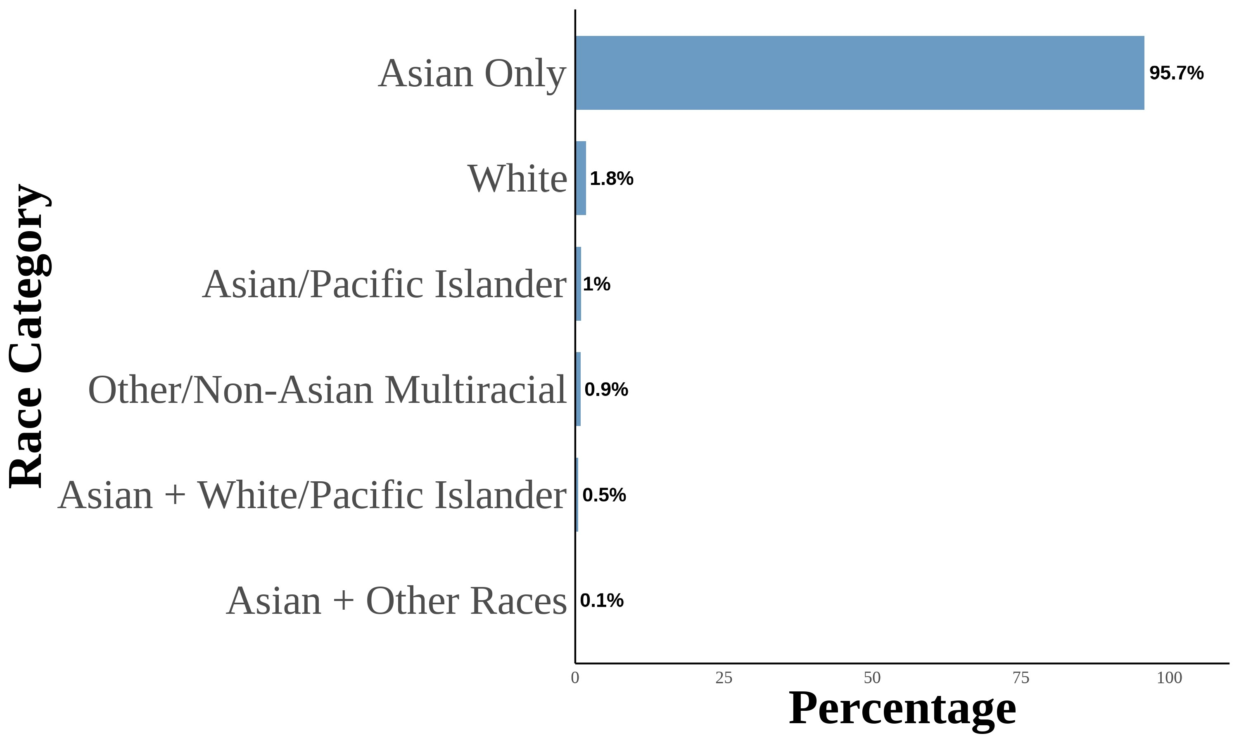
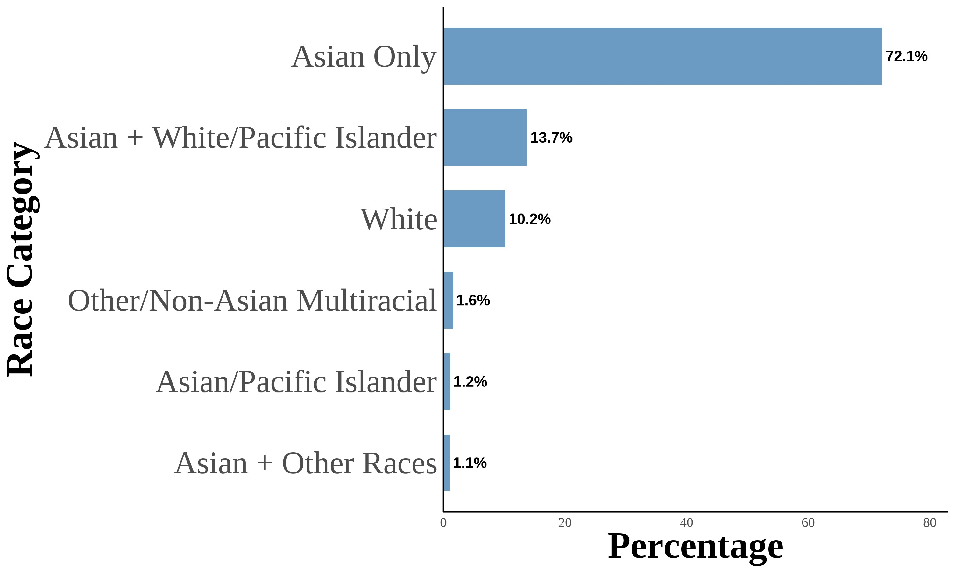 Asian Mothers
7
(c) Second Generation:  White Mothers | Asian Fathers- | (d) Second Generation:  Asian Mothers | White Fathers-
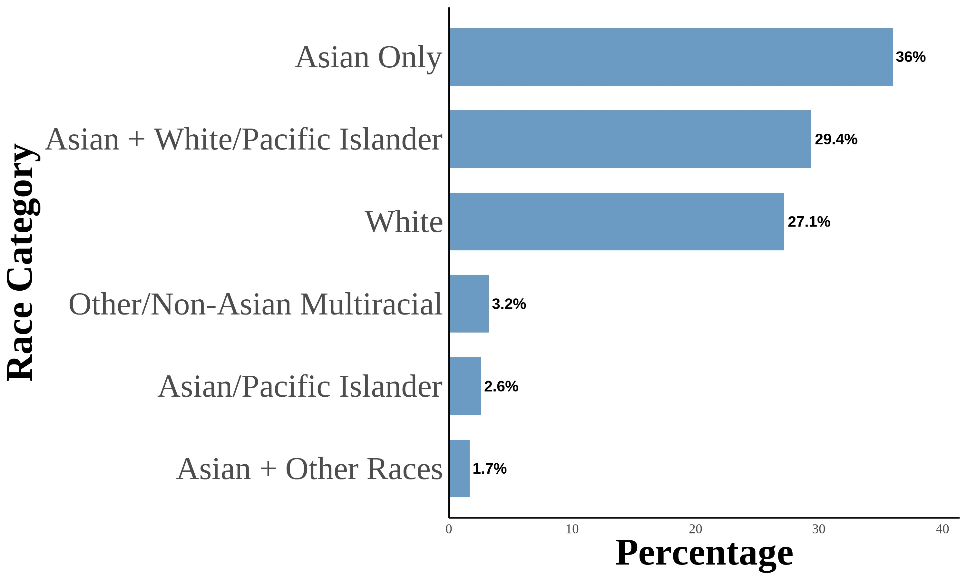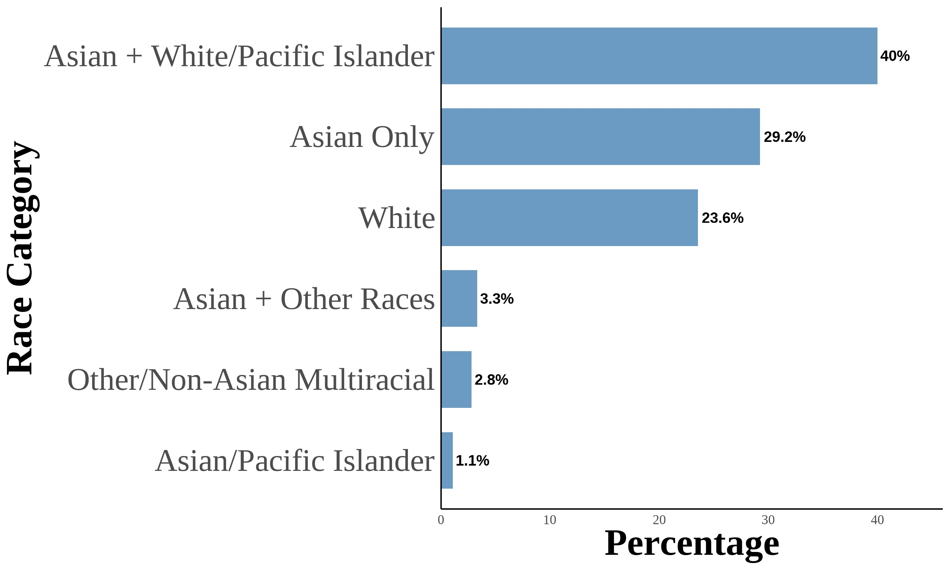
This figure shows the distribution of Asian racial identity among respondents. The data is aggregated from the 2004–2021
Current Population Survey (CPS). The sample includes second-generation objectively Asian Americans. Following Antman, Duncan, and Trejo (2016) and Antman, Duncan, and Trejo (2020), I utilize birthplace information for individuals, parents, and grandparents to create objective Asian ancestry indicators. A second-generation Asian American is defined as a native-born individual with at least one parent born in an Asian country. The first panel is for second-generation Asian Americans. The second panel is for second-generation Asian Americans with both parents born in an Asian country. The third panel is for second-generation Asian Americans with an Asian father and a White mother. The fourth panel is for second-generation Asian Americans with a White father and an Asian mother.

Figure A.7: Asian Racial Identity: Third Generation
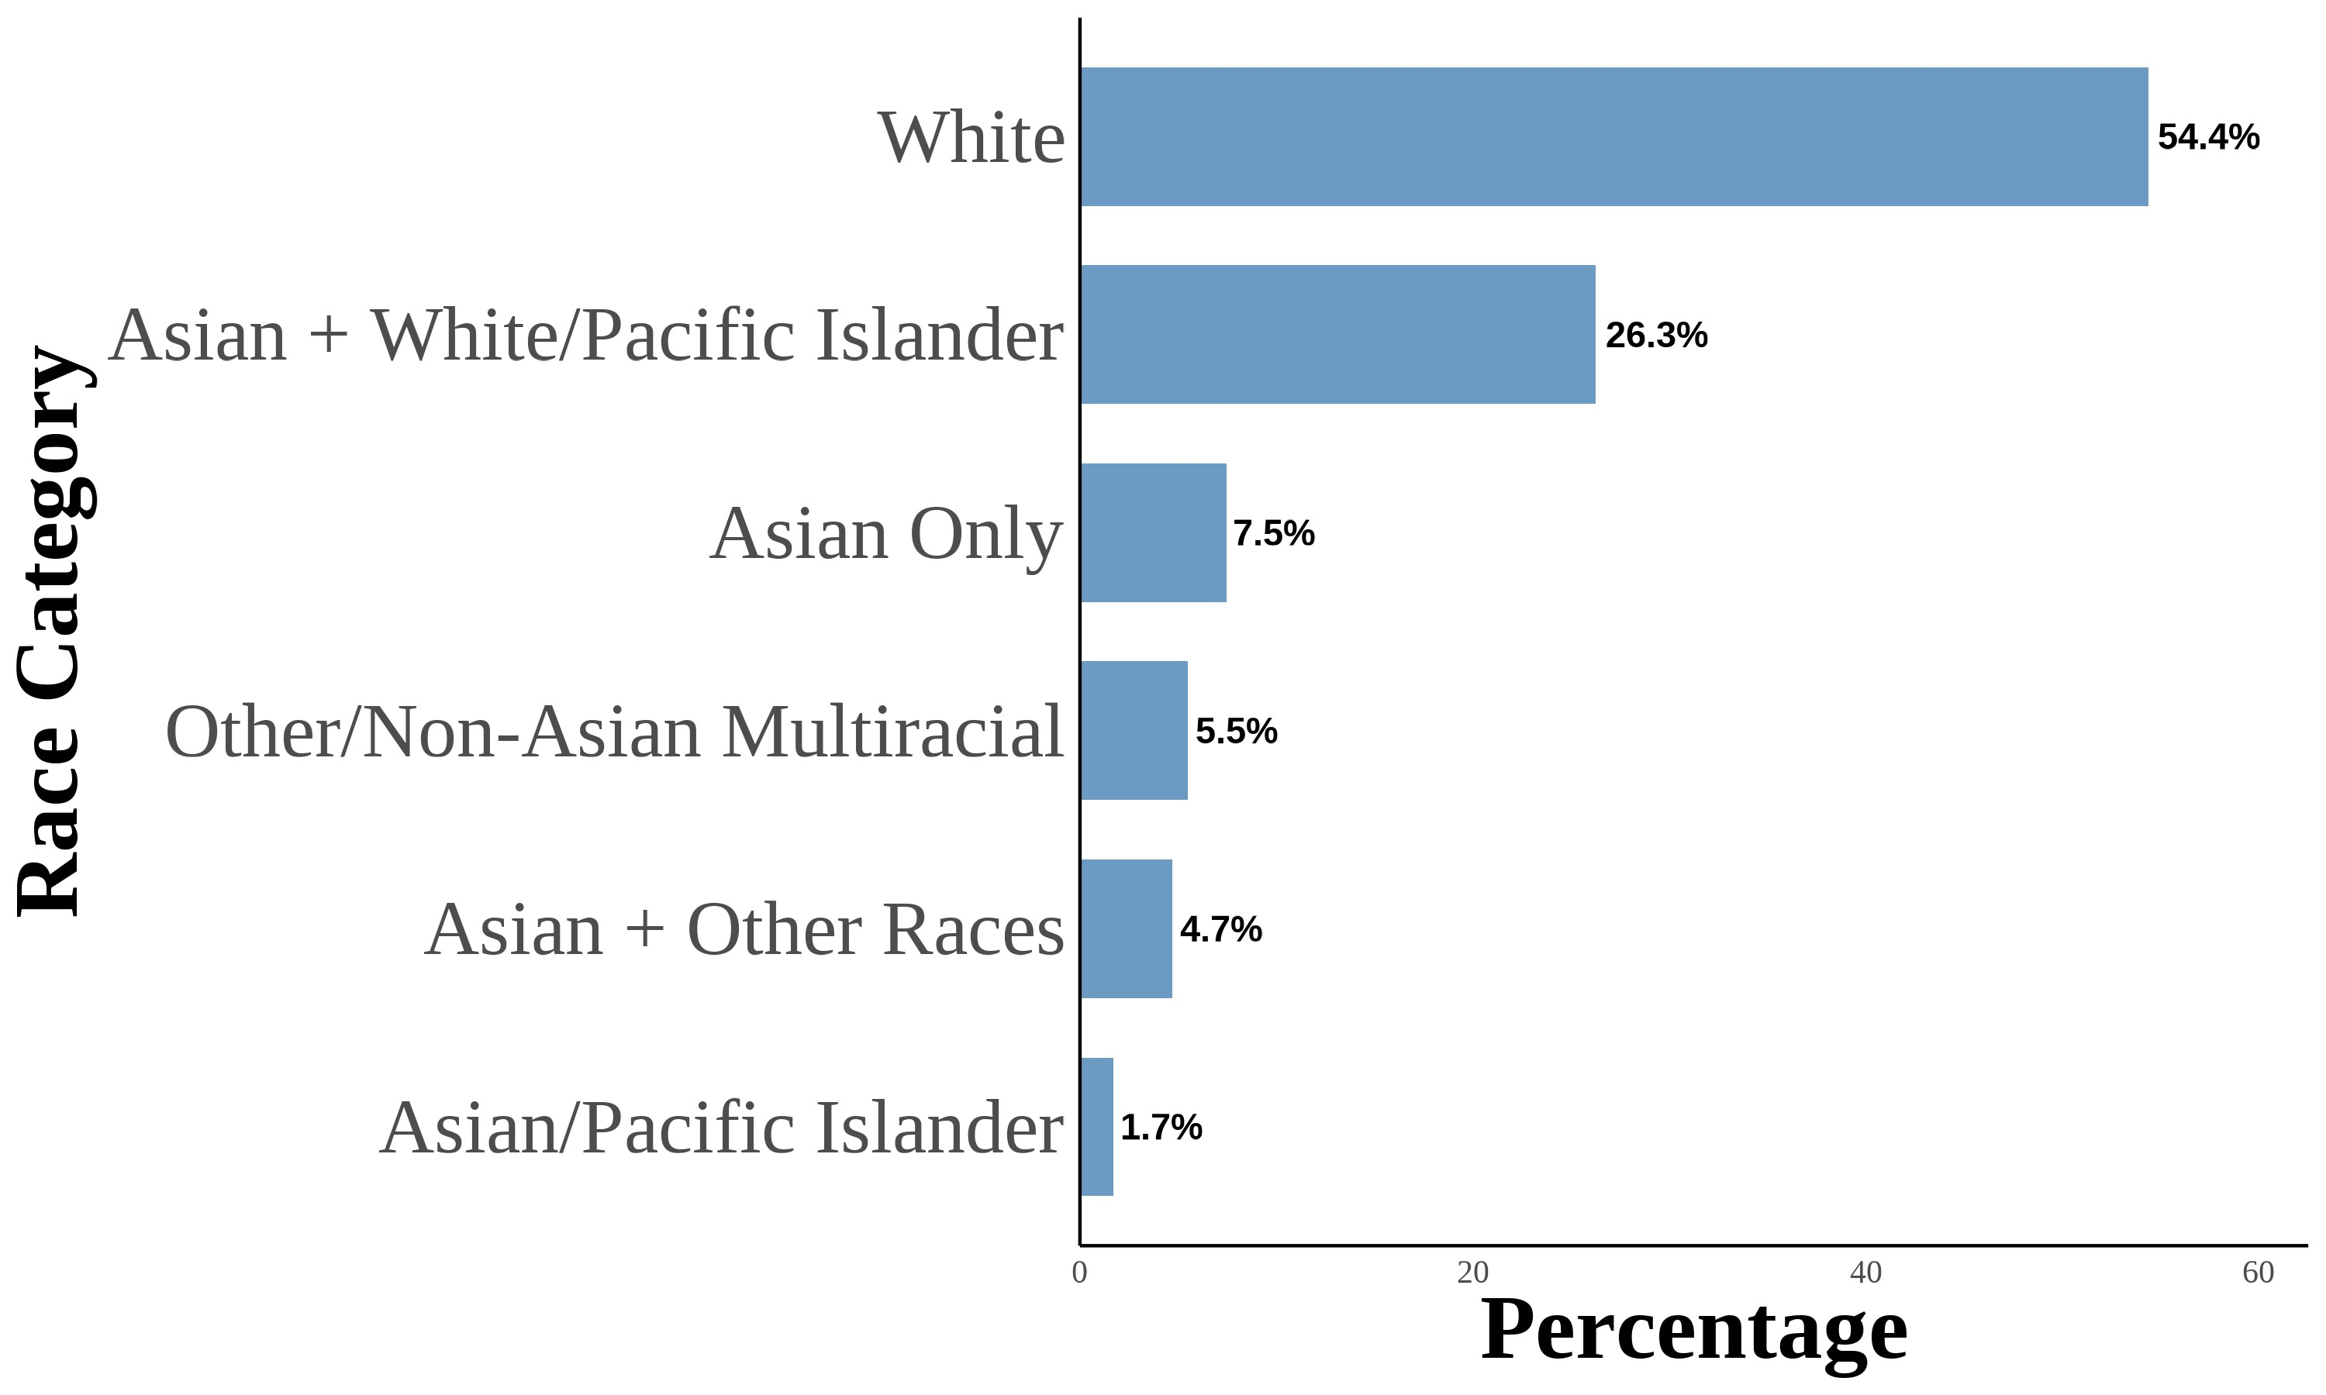
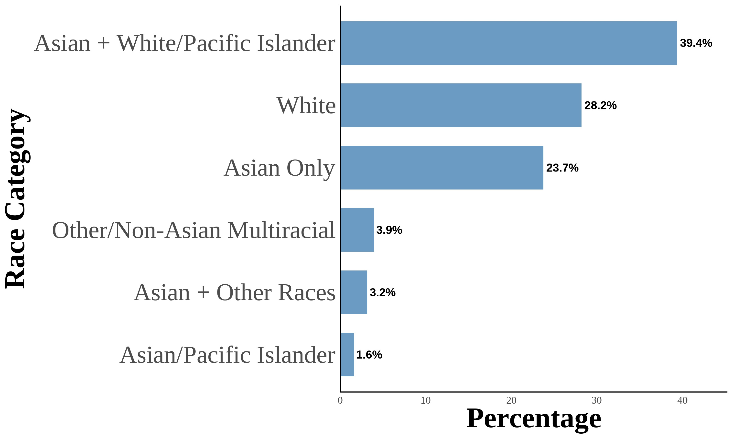
(a) All Third Generation (b) Third Generation: One (c) Third Generation: Two 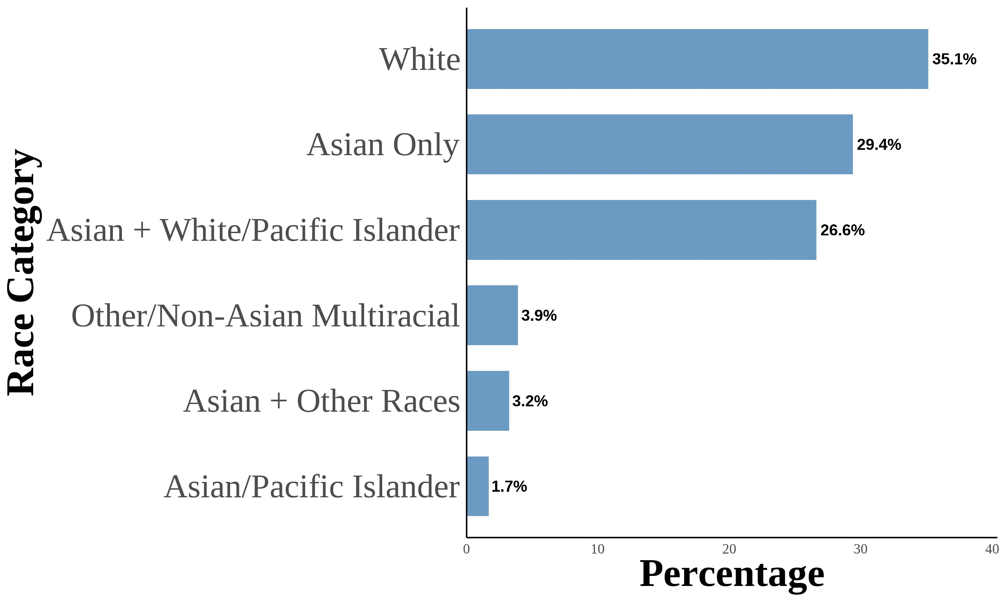 Asian Grandparent Asian Grandparents
8
(d) Third Generation: Three Asian  Grandparents | (e) Third Generation:  Grandparents | Four Asian
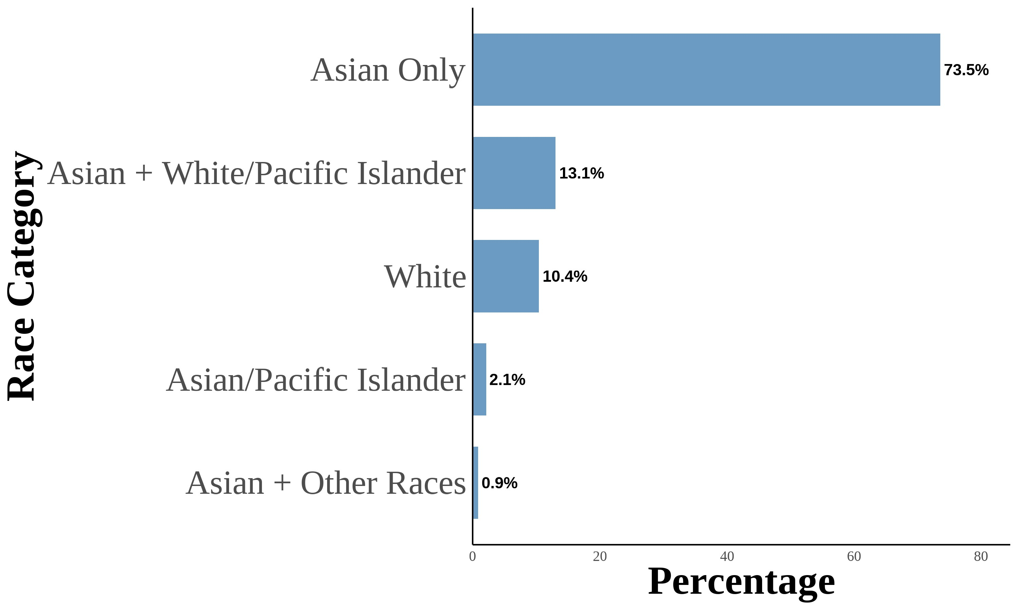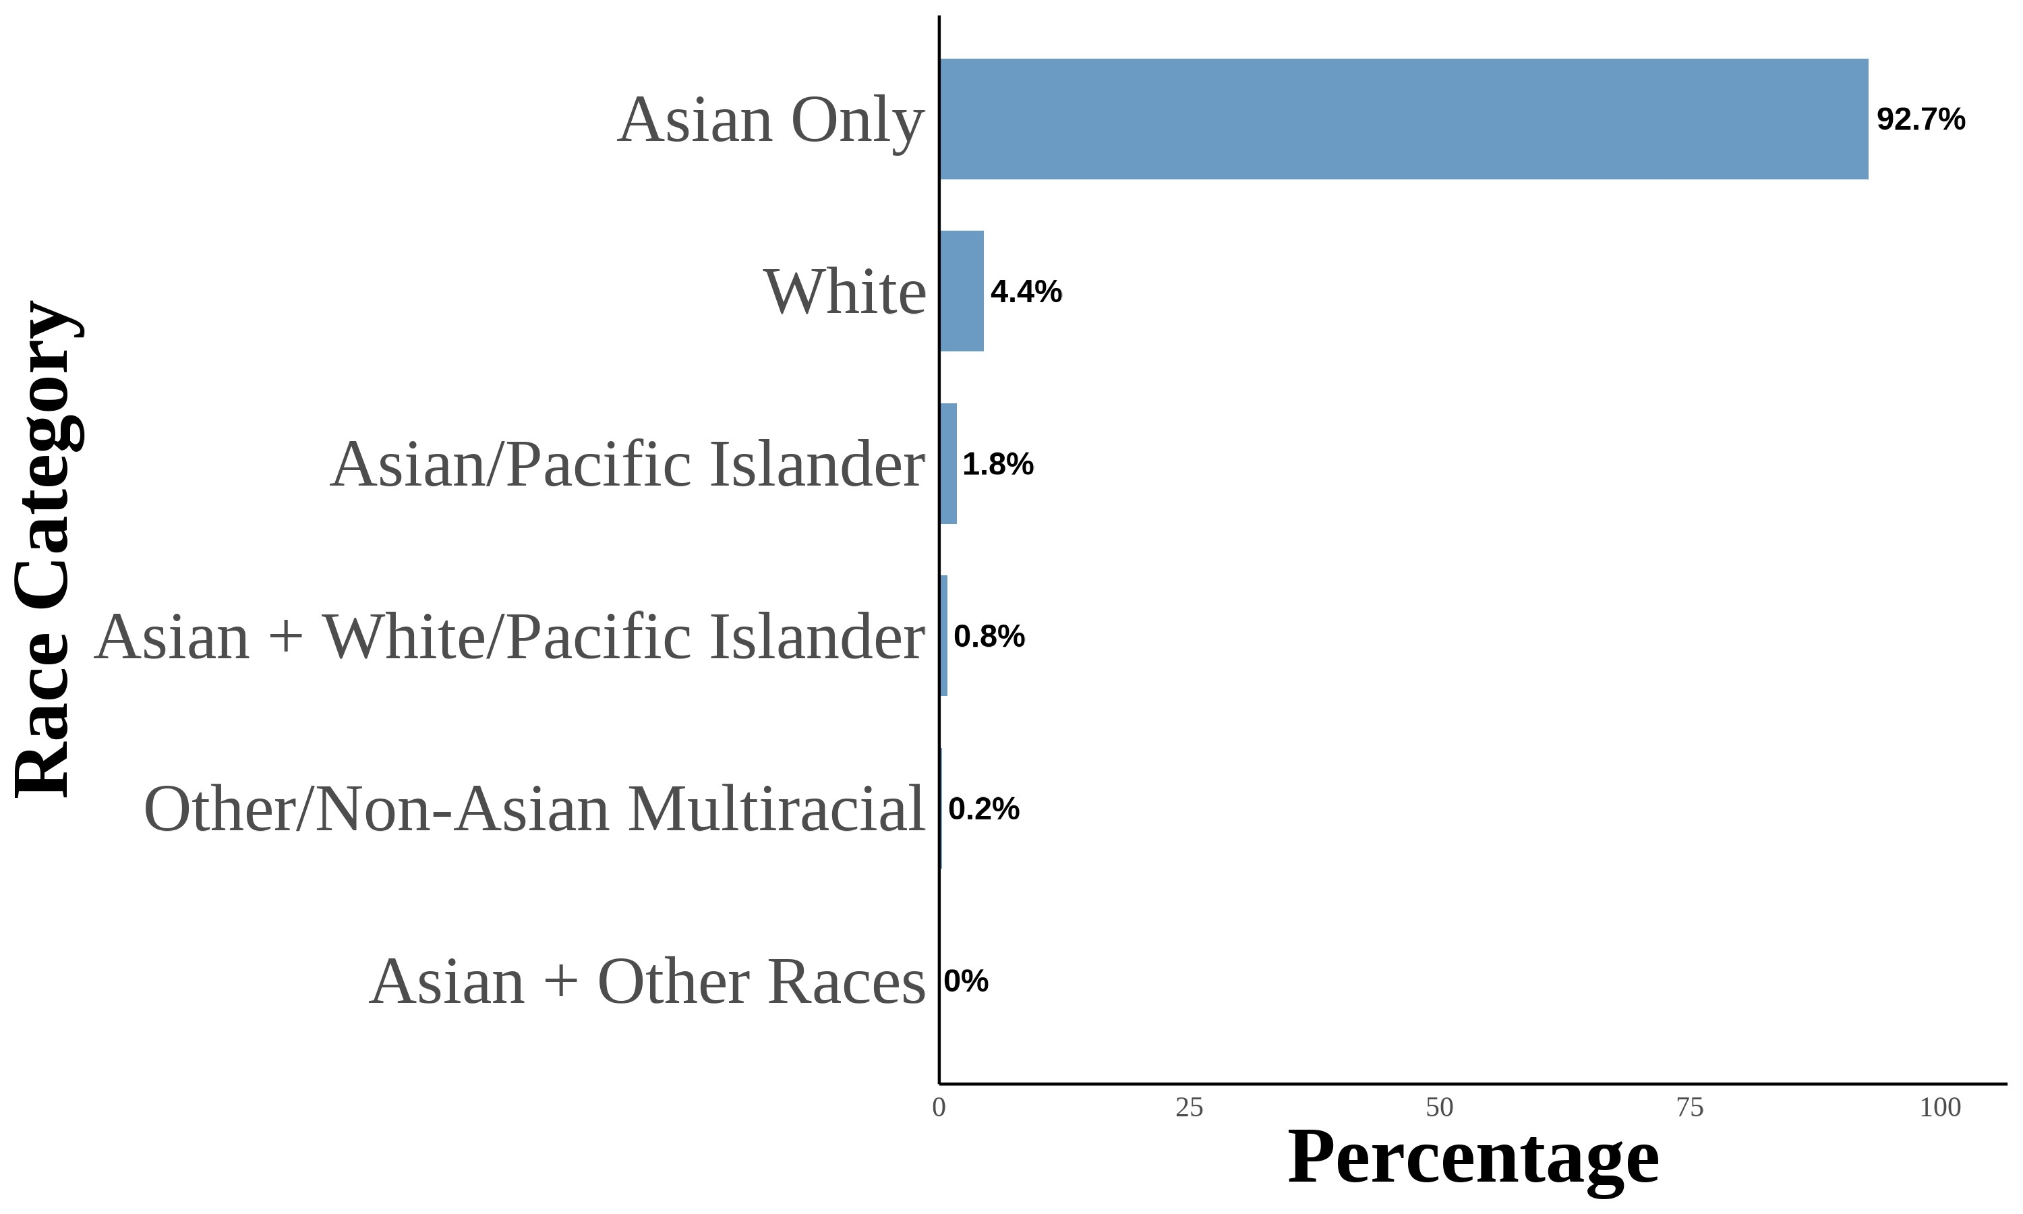
This figure shows the distribution of Asian racial identity among respondents. The data is aggregated from the 2004–2021
Current Population Survey (CPS). The sample includes second-generation objectively Asian Americans. Following Antman, Duncan, and Trejo (2016) and Antman, Duncan, and Trejo (2020), I utilize birthplace information for individuals, parents, and grandparents to create objective Asian ancestry indicators. A third-generation Asian American is defined as a nativeborn individual with native-born parents and at least one grandparent born in an Asian country. The first panel is for thirdgeneration Asian Americans. The second panel is for third-generation Asian Americans with one grandparent born in an Asian country. The third panel is for third-generation Asian Americans with two grandparents born in an Asian country. The fourth panel is for third-generation Asian Americans with three grandparents born in an Asian country. The fifth panel is for thirdgeneration Asian Americans with four grandparents born in an Asian country.

Tables

Table A.1: Subjective Asian Identity and Asian Bias

 | (1)  Ai | (2)  Ai | (3)  Ai | (4)  Ai | (5)  Ai | (6)  Ai | (7)  Ai | (8)  Ai
Bias | −0.04*** | −0.14*** | −0.02*** | −0.02 | −0.03*** | −0.07** | −0.10*** | −0.04
 | (0.01) | (0.04) | (0.01) | (0.03) | (0.01) | (0.03) | (0.03) | (0.03)
Female | −0.01** | −0.01** | −0.01** | −0.01* | −0.01** | −0.01* | −0.01* | −0.01*
 | (0.00) | (0.00) | (0.00) | (0.00) | (0.00) | (0.00) | (0.00) | (0.00)
College Graduate: Mother | 0.01 | 0.01 | 0.01 | 0.01 | 0.01 | 0.01 | 0.01 | 0.01
 | (0.01) | (0.01) | (0.01) | (0.01) | (0.01) | (0.01) | (0.01) | (0.01)
College Graduate: Father | 0.01** | 0.01* | 0.01** | 0.01** | 0.01** | 0.01** | 0.01** | 0.01**
 | (0.01) | (0.01) | (0.01) | (0.01) | (0.01) | (0.01) | (0.01) | (0.01)
Both parents Asian | 0.63*** | 0.63*** | 0.62*** | 0.62*** | 0.63*** | 0.63*** | 0.63*** | 0.62***
 | (0.03) | (0.03) | (0.03) | (0.03) | (0.03) | (0.03) | (0.03) | (0.03)
First Gen | 0.01 | 0.02 | 0.02* | 0.02** | 0.02* | 0.02** | 0.02* | 0.02**
 | (0.01) | (0.01) | (0.01) | (0.01) | (0.01) | (0.01) | (0.01) | (0.01)
Second Gen | 0.02 | 0.02 | 0.01 | 0.02 | 0.02 | 0.02 | 0.02 | 0.02
 | (0.01) | (0.01) | (0.01) | (0.02) | (0.02) | (0.02) | (0.02) | (0.02)
N | 129078 | 129078 | 129078 | 129078 | 129078 | 129078 | 129078 | 129078
Region FE |  |  |  |  | X | X
Year FE |  | X |  | X |  | X
State FE |  |  | X | X |  |  |  | X
Year-Region FE |  |  |  |  |  |  | X | X
* p < 0.1, ** p < 0.05, *** p < 0.01
I include controls for sex, quartic age, and parental education.
Standard errors are clustered on the state level.

Table A.2: Logistic Regression Analysis of Bias and Interracial Marriages

Asian Men Asian Women

 | (1)  Interracial | (2)  Interracial |  | (3)  Interracial
Bias |  | 1.47 |  | 0.83 | 1.39
 | (0.43) | (0.33) |  | (0.44)
College Graduate: Wife |  | 1.42*** | 1.55*** | 1.75***
 | (0.08) | (0.19) | (0.18)
College Graduate: Husband |  | 0.94 | 0.97 | 0.86*
 | (0.09) | (0.08) |  | (0.07)
Observations | 69, 800 | 52, 032 |  | 60, 171
Year × Region FE |  | X | X | X
* p < 0.1, ** p < 0.05, *** p < 0.01
- Each column estimates a logistic regression: Pr(interracial_{ist} = 1) =
Λ(β₁AntiAsianBias_{st} +X_{ist}π+γ_{rt}), where interracial_{ist} indicates a couple in which one partner was born in an Asian country and the other was not (labelled Asian husband–White wife or White husband–Asian wife, following the paper’s convention), AntiAsianBias_{st} is average anti-Asian bias in state s at time t, and X_{ist} includes partner-specific controls (sex, age, education, and years since immigrating to the United States). The unit of observation is a second-generation child; columns (2) and (3) restrict to children of Asian-born fathers and Asian-born mothers, respectively. Coefficients are exponentiated and should be interpreted as odds ratios. Standard errors are clustered on the state level.
Data source is the 2004-2020 Current Population Survey Data.

Table A.3: Between-Model Tests of Average Marginal Effects: Second-Generation
AW vs. WA
Asian Only
White Only
Asian & White

Panel A: AW vs. WA
 | Anti-Asian Bias | −0.024 | 0.106** | −0.082
 | (0.055) | (0.044) | (0.062)
Female | −0.056* | −0.044 | 0.097***
 | (0.031  ) |  | (0.029) |  | (0.028  )
College Graduate: Mother | 0.084** |  | −0.106** |  | 0.021
 | (0.036) |  | (0.050) |  | (0.048)
College Graduate: Father | −0.061** |  | 0.069** | −0.002
 | (0.027) |  | (0.031) |  | (0.037)

* p < 0.1, ** p < 0.05, *** p < 0.01
Each cell reports the difference in average marginal effects (AME) between the Asian father–White mother (AW) and White father–Asian mother (WA) models, estimated from equation (??) using multinomial
logit. The difference is computed as \ .
Standard errors of the difference are computed from the bootstrap distributions of the two models. z-statistics test the null hypothesis that the marginal effects are equal across models.
I include region × year fixed effects with controls for quartic age and
local Asian population share. Each estimate is the median across 1,000 bootstrap resamples, with 95% percentile confidence intervals.

Table A.4: Between-Model Tests of Average Marginal Effects: Third-Generation by Asian Grandparent Count
Asian Only
White Only
Asian & White
Panel A: One Asian GP vs. Two  Anti-Asian Bias |  | Asian GP  0.102* | −0.059 | −0.047
 | (0.059) | (0.077) | (0.084)
Female | −0.010 | −0.073 | 0.088*
 | (0.031) | (0.048) | (0.050)
College Graduate: Mother | −0.048 | −0.106** | 0.160***
 | (0.032) | (0.048) | (0.052)
College Graduate: Father | −0.021 | 0.060 |  | −0.041
 | (0.031) | (0.058) |  | (0.061)
Panel B: One Asian GP vs. Thre  Anti-Asian Bias |  | e Asian GP  0.201 | −0.203*** |  | −0.028
 | (0.152) | (0.071) |  | (0.149)
Female | 0.031 | −0.118*** |  | 0.087**
 | (0.031) | (0.043) |  | (0.040)
College Graduate: Mother | −0.318*** | 0.198*** |  | 0.122**
 | (0.046) | (0.047) | (0.051)
College Graduate: Father | 0.293*** | −0.345*** | 0.057
 | (0.049) | (0.065) | (0.062)
Panel C: Two Asian GP vs. Three Asian GP

Continued on next page

Table A.4 – continued from previous page
Asian Only
White Only
Asian & White
Anti-Asian Bias | 0.098 |  | −  0.145*** |  | 0.019
 | (0.156) |  | (0.054) |  | (0.142)
Female | 0.042 |  | −0.045 |  | −0.000
 | (0.041) |  | (0.047) |  | (0.045)
College Graduate: Mother | −0.270*** |  | 0.304*** |  | −0.039
 | (0.054) | (0.055) | (0.059)
College Graduate: Father | 0.314*** |  | −0.405*** |  | 0.098
 | (0.056) |  | (0.060) |  | (0.067)

* p < 0.1, ** p < 0.05, *** p < 0.01
Each cell reports the difference in average marginal effects (AME) between the indicated models, estimated from equation (??) using multinomial logit. The difference is computed as AME\_{Model A} − AME\_{Model} _{B}.
Standard errors of the difference are computed from the bootstrap distributions of the two models. z-statistics test the null hypothesis that the marginal effects are equal across models.
I include region × year fixed effects with controls for quartic age and
local Asian population share. Each estimate is the median across 1,000 bootstrap resamples, with 95% percentile confidence intervals.
GP = Grandparent(s). Third-generation individuals are native-born with
at least one grandparent born in an Asian country.

Table A.5: Pooled Multinomial Logit: Bias Interacted with Parental Configuration,
Mixed-Race Second-Generation Children
 | White only | Asian and White
 | (1) | (2)
Panel A: Coefficients (log odds relative to Asian only) Bias | 0.738** | 0.282
 | (0.363) | (0.331)
Asian father–White mother (AW) | −0.615*** | −0.675***
 | (0.161) | (0.153)
Bias × AW | 0.893*** | 0.051
 | (0.316) | (0.360)
Panel B: Average marginal effects of bias (probability scale)  Average marginal effect of bias, common-effect model | 0.146** | −0.024
 | (0.057) | (0.067)
Average marginal effect of bias, AW families | 0.249*** | −0.056
 | (0.068) | (0.080)
Average marginal effect of bias, WA families | 0.099* | −0.010
 | (0.058) | (0.070)
Difference, AW minus WA | 0.151*** | −0.046
 | (0.042) | (0.066)
Wald test, Bias × AW = 0 in both equations (clustered): χ²(2) = 10.48, p = 0.005
Likelihood-ratio test (independent observations): χ²(2) = 106.78, p< 0.001
Observations 27,048 State clusters 51

¹ The table reports a single multinomial logit, equation (??), estimated on pooled secondgeneration children with one parent born in an Asian country and one born outside Asia, with “Asian only” as the reference category. All coefficients are constrained to be equal across Asian father–White mother (AW) and White father–Asian mother (WA) families except that the bias index is interacted with an AW indicator. Controls are sex, mother and father college graduation, a quartic in age, the state Asian population share, and region × year fixed effects; estimation is weighted by CPS person weights scaled to mean one. 118 observations in 2 region × year cells with no “Asian only” responses are excluded because the cell dummies are not identified. Standard errors in parentheses are clustered at the state level using a sandwich covariance built from the weighted multinomial logit scores. The Wald test uses that clustered covariance; the likelihood-ratio test compares the model with and without the two interaction terms and assumes independent observations. Average marginal effects of a one standard deviation increase in bias are evaluated on the full pooled sample with the AW indicator set to one for every observation and then to zero, so the two rows share the same covariate distribution; the difference is the AW–WA gap with its delta-method standard error. This is a test of whether the bias effect differs by parental configuration, not of the bias effect itself. The first row of Panel B comes from the restricted model with a common bias effect. Conventional standard errors that treat children as independent, the assumption the individual-level bootstrap in the main figures also makes, are smaller: for the common-effect average marginal effects they14 are 0.018 (White only) and 0.021 (Asian and White) against the clustered 0.057 and 0.067, and for the bias coefficients in Panel A they are 0.128 and 0.114 against 0.363 and 0.331. ∗p < 0.1, ∗∗p < 0.05, ∗∗∗p < 0.01. Data source is the 2004–2021 Current Population Survey.

Figures

Figure A.8: Marginal Effects of Key Covariates on Racial Identity Choice by
Parental Ancestry (Second-Generation Asian Americans)

(a) Asian Father-White Mother (AW) (b) White Father-Asian Mother (WA)
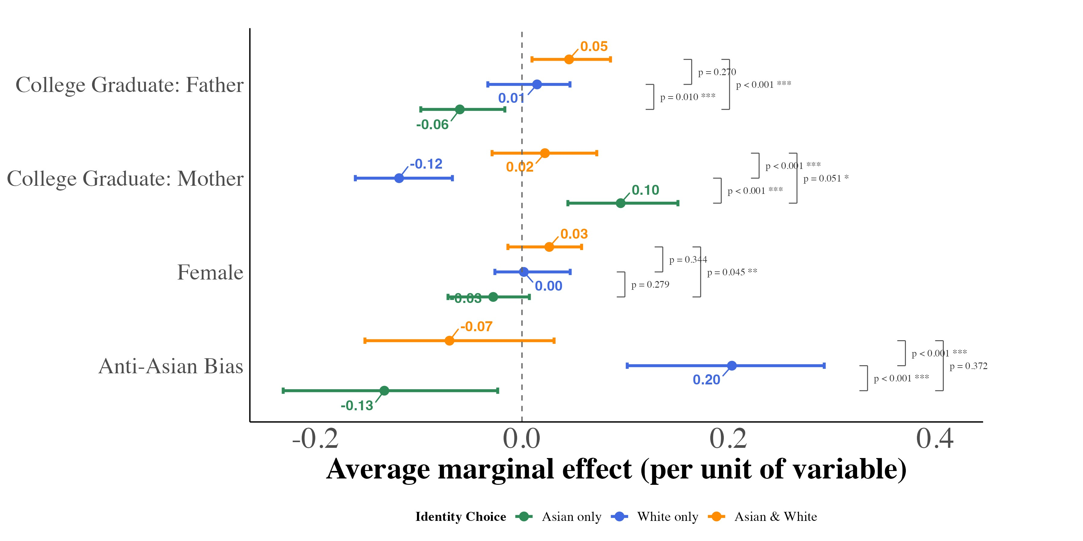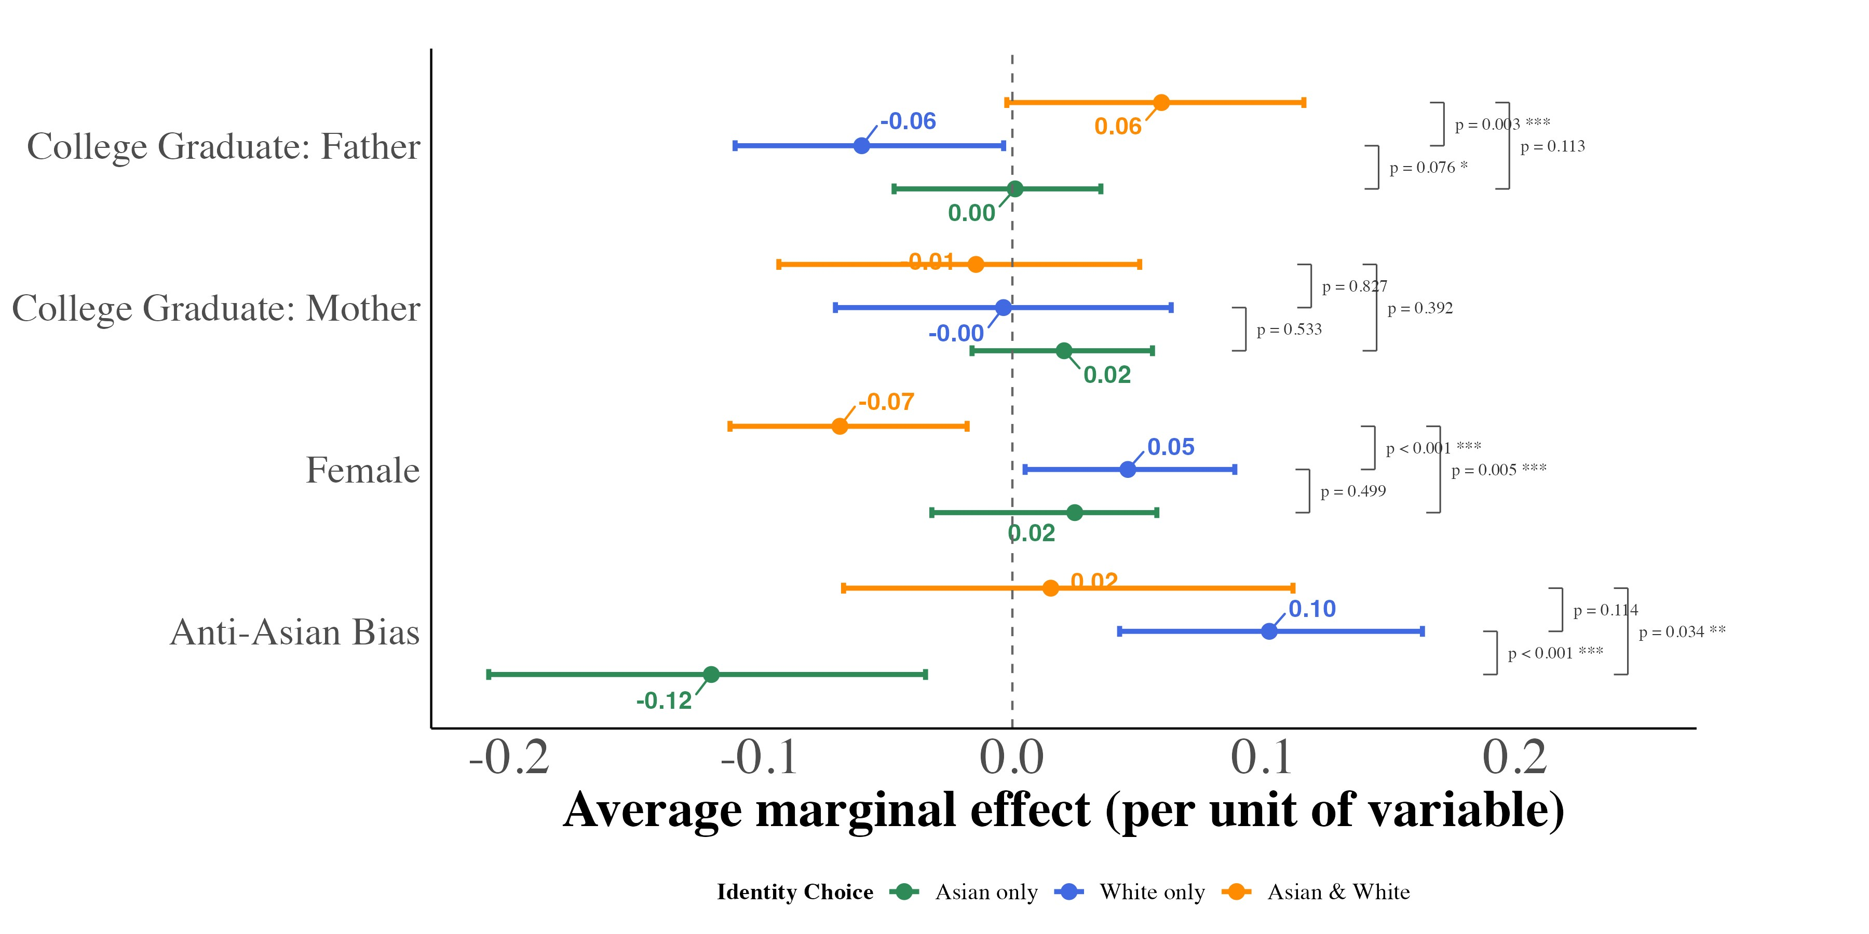
This figure displays average marginal effects of key covariates on the probability of each racial identity outcome, estimated from equation (??) separately for second-generation children with an Asian-born father and a mother born outside Asia (panel a) and with a father born outside Asia and an Asian-born mother (panel b). For anti-Asian bias, the marginal effect is the derivative of each predicted probability with respect to the bias index, evaluated for every child at that child’s own covariate values and averaged over the estimation sample; for the binary covariates, it is the average change in predicted probability from switching the indicator from 0 to 1 for every child. Models include region × year fixed effects and controls for a quartic in age and the state Asian population share, and are weighted by CPS person weights. Each point is the median of the average marginal effect across 1,000 bootstrap resamples of children, drawn with replacement within region × year cells; the bars span the 2.5th and 97.5th percentiles of the same resamples and do not account for dependence within state-year cells. Because the two panels come from separately estimated models, differences between them reflect both differences in coefficients and differences in the two groups’ covariate distributions; Appendix Table A.5 reports a pooled model that holds the covariate distribution fixed.
Figure A.9: Marginal Effects of Key Covariates on Racial Identity Choice (Pooled Mixed-Race Adult Second-Generation Asian Americans)
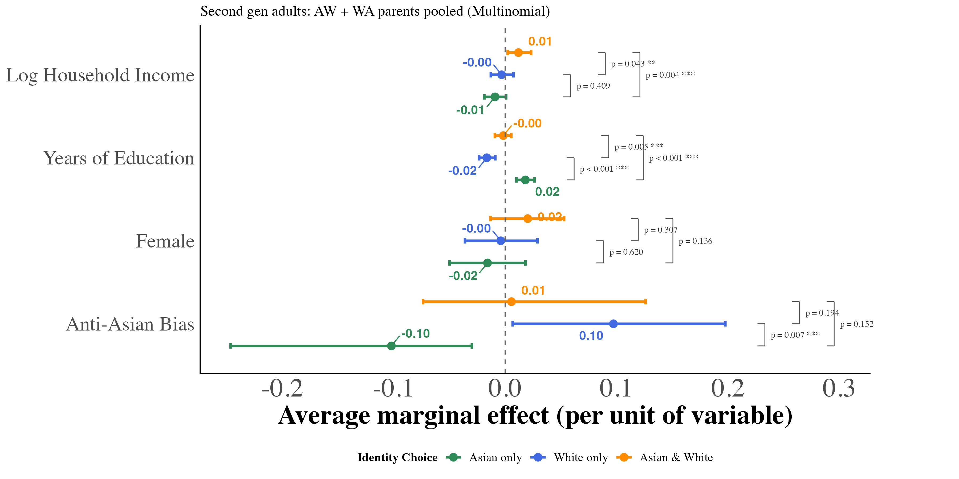
This figure displays average marginal effects of key covariates on the probability of each racial identity outcome, estimated from equation (??) for pooled second-generation adults (ages 18 and older) with one parent born in an Asian country and one parent born outside Asia. For antiAsian bias, years of education, and log family income, the marginal effect is the derivative of each predicted probability with respect to the covariate, evaluated for every adult at that adult’s own covariate values and averaged over the estimation sample; for female, it is the average change in predicted probability from switching the indicator from 0 to 1 for every adult. Models include region × year fixed effects and controls for a quartic in age and the state Asian population share, and are weighted by CPS person weights. Each point is the median of the average marginal effect across 1,000 bootstrap resamples of adults, drawn with replacement within region × year cells; the bars span the 2.5th and 97.5th percentiles of the same resamples and do not account for dependence within state-year cells.
Figure A.10: Marginal Effects of Key Covariates on Racial Identity Choice by Number of Asian Grandparents (Third-Generation Asian Americans)

(a) One Asian Grandparent (b) Two Asian Grandparents
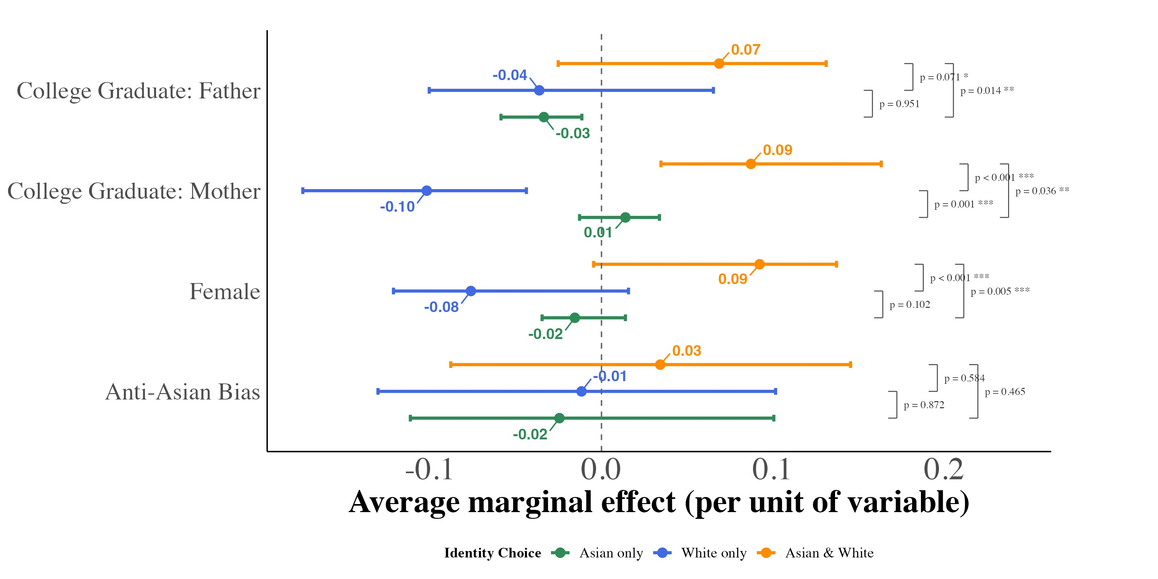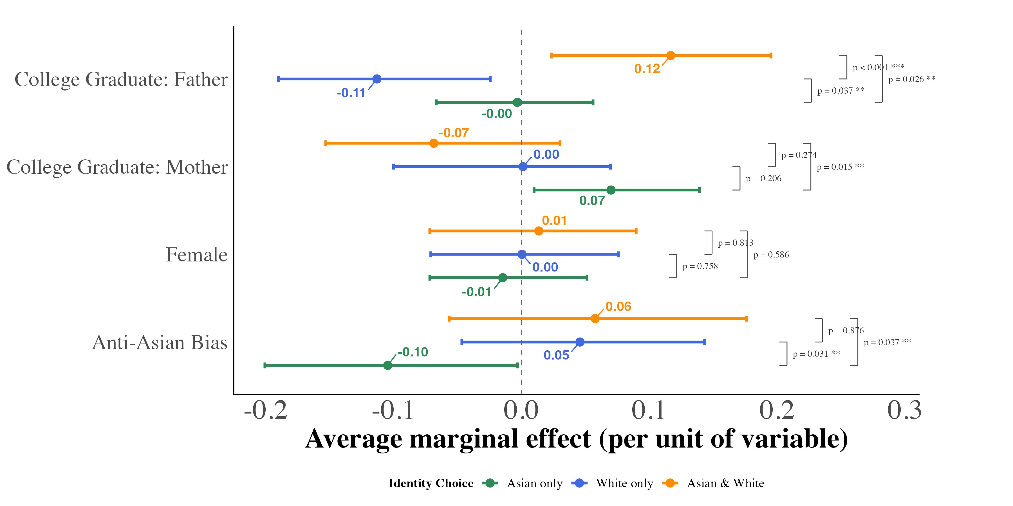

(c) Three Asian Grandparents
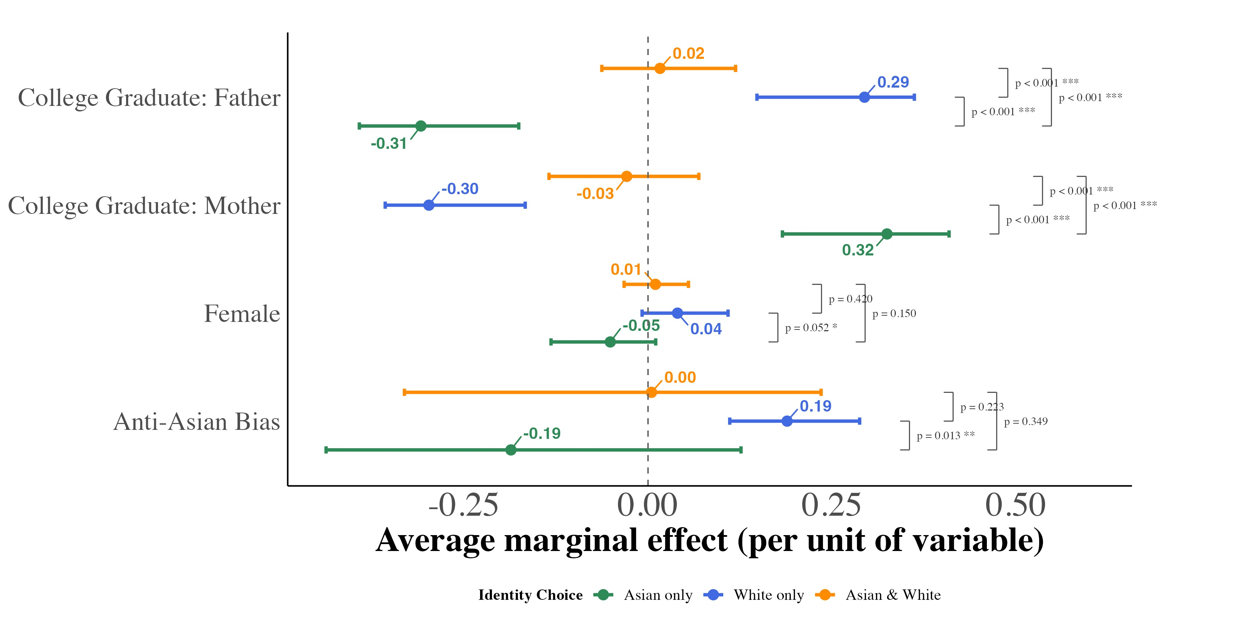
This figure displays average marginal effects of key covariates on the probability of each racial identity outcome, estimated from equation (??) separately for third-generation children with one, two, and three Asian-born grandparents. For anti-Asian bias, the marginal effect is the derivative of each predicted probability with respect to the bias index, evaluated for every child at that child’s own covariate values and averaged over the estimation sample; for the binary covariates, it is the average change in predicted probability from switching the indicator from 0 to 1 for every child. Models include region × year fixed effects and controls for a quartic in age and the state Asian population share, and are weighted by CPS person weights. Each point is the median of the average marginal effect across 1,000 bootstrap resamples of children, drawn with replacement within region × year cells; the bars span the 2.5th and 97.5th percentiles of the same resamples.
Figure A.11: Between-Model Differences in Average Marginal Effects: SecondGeneration AW vs. WA
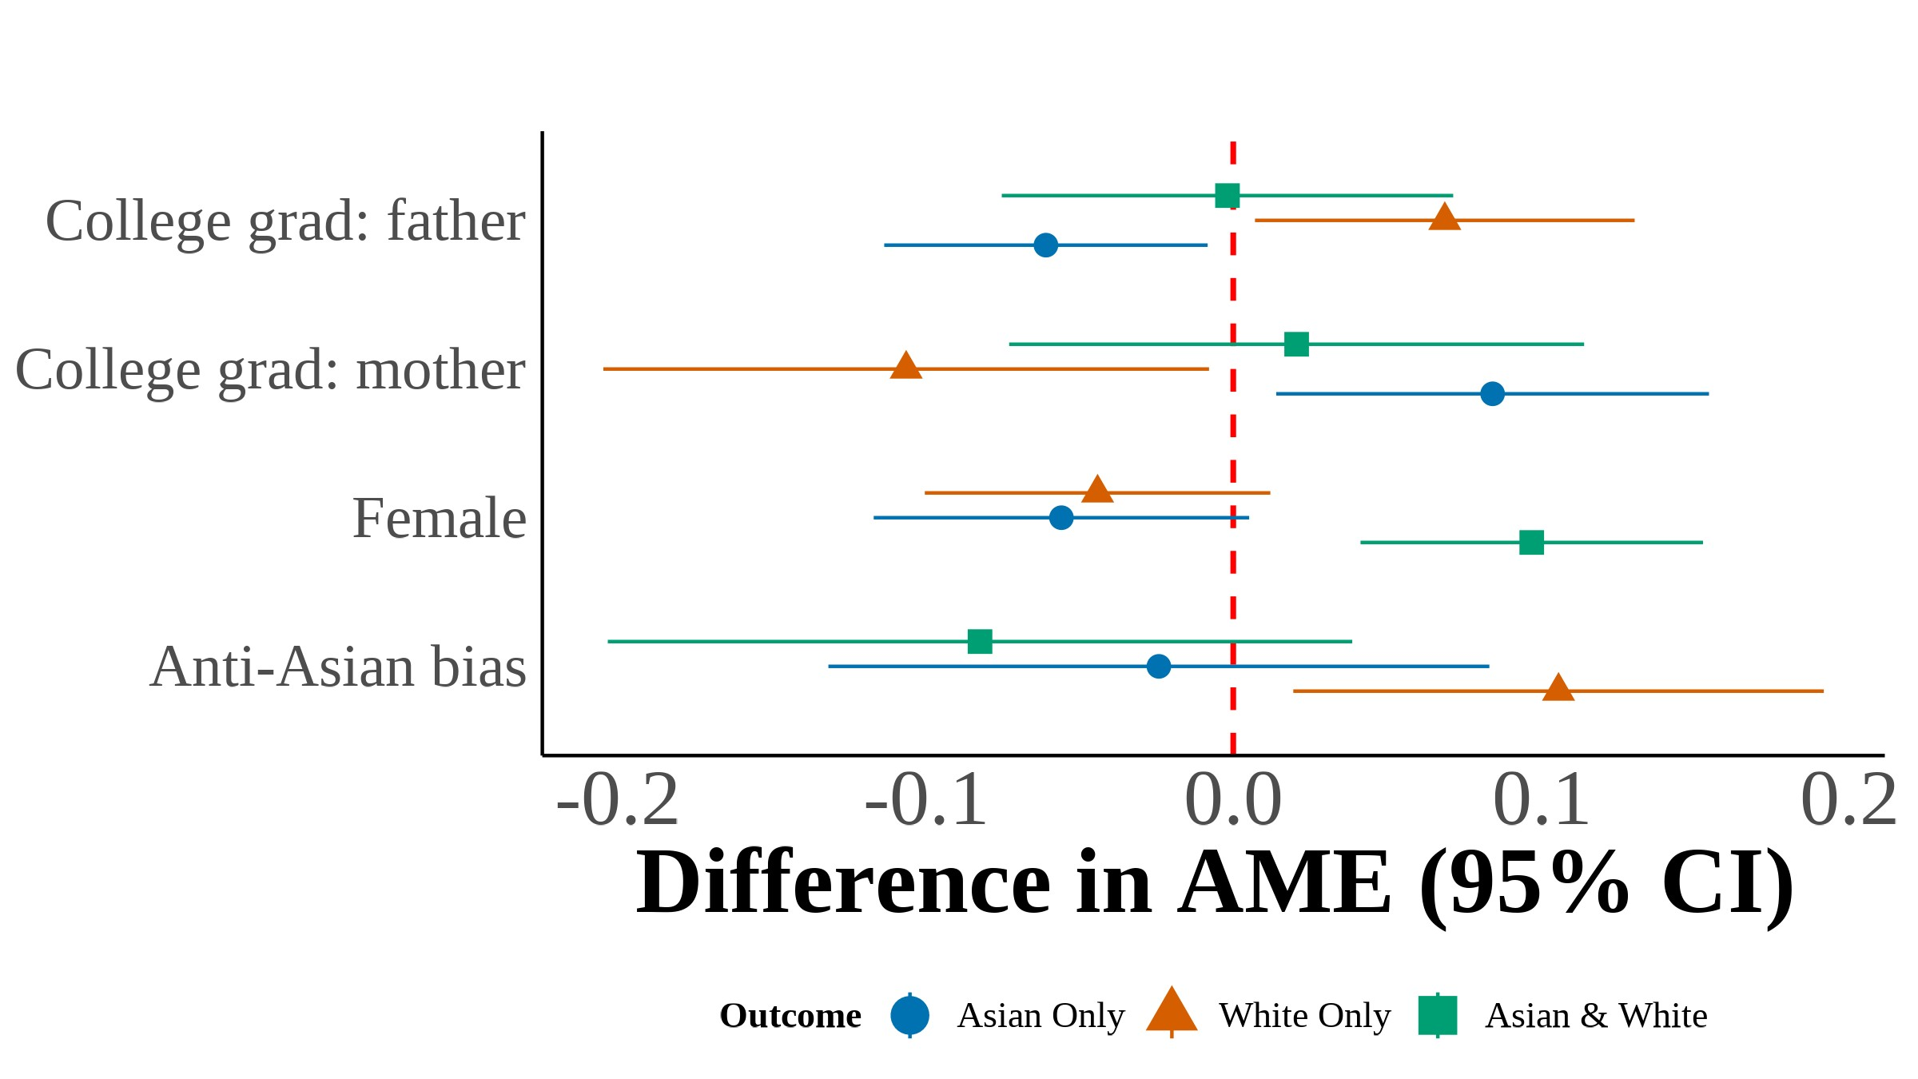

This figure plots the difference in average marginal effects (AME) between the Asian father–White mother (AW) and White father–Asian mother (WA) multinomial logit models, estimated from equation (??). Each point represents \_{WA} for a given covariate and racial identity outcome. Filled markers indicate statistical significance at the 5% level. Error bars show 95%
confidence intervals constructed from the bootstrap standard errors of the difference. I include region × year fixed effects with controls for quartic age and local Asian population share. Each estimate is the median across 1,000 bootstrap resamples.

Figure A.12: Between-Model Differences in Average Marginal Effects: Third-
Generation by Asian Grandparent Count

(a) One vs. Two Asian Grandparents (b) One vs. Three Asian Grandparents
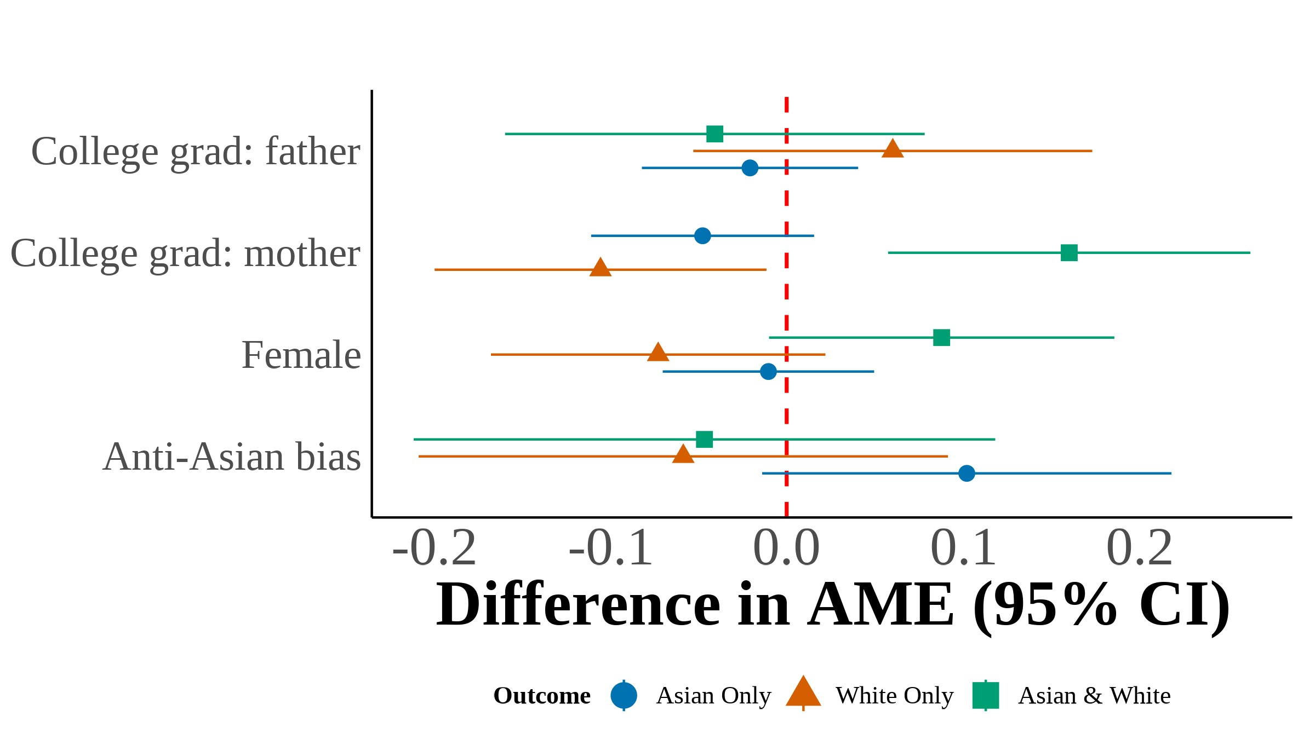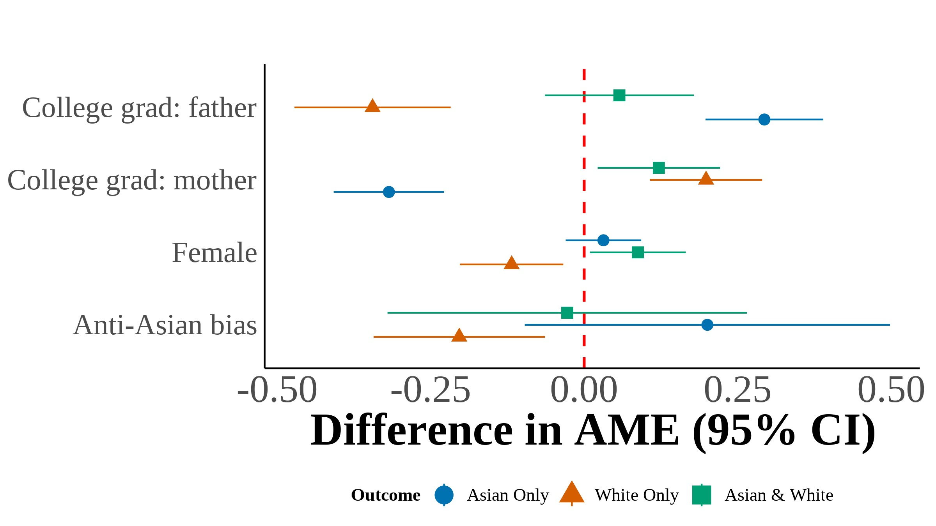
(c)

Two vs. Three Asian Grandparents
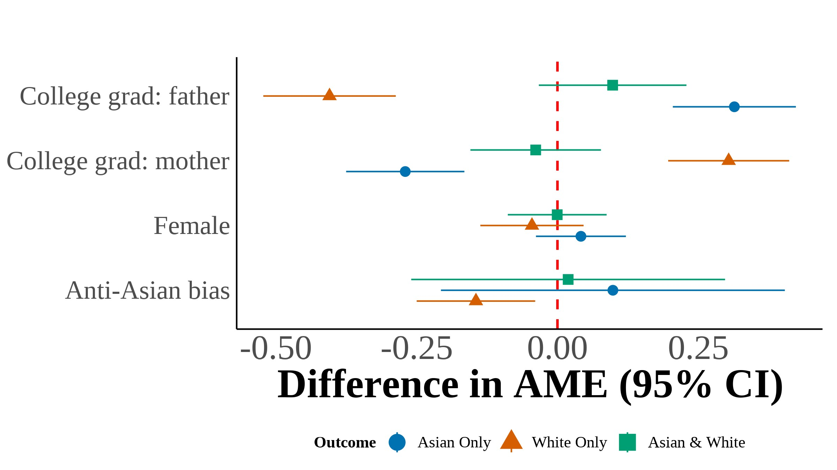

This figure plots the difference in average marginal effects (AME) between third-generation multinomial logit models estimated on samples defined by the number of Asian grandparents. Each point represents the difference in AME between the indicated models for a given covariate and racial identity outcome. Filled markers indicate statistical significance at the 5% level. Error bars show 95% confidence intervals constructed from the bootstrap standard errors of the difference. I include region × year fixed effects with controls for quartic age and local Asian population share. Each estimate is the median across 1,000 bootstrap resamples.

Figure A.13: Scatter Plot of Proportion Subjectively Asian on Bias (a)
  - Year < 2015
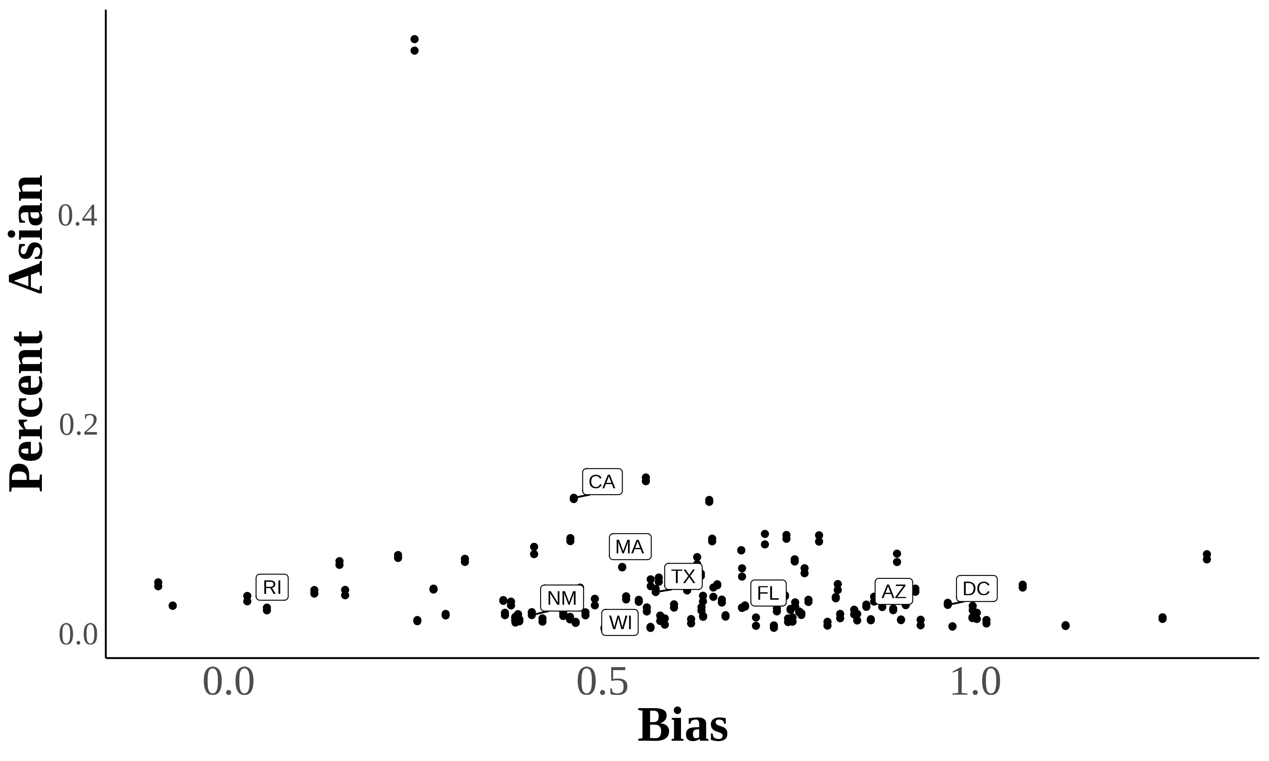
(b)
  - Year ⩾ 2015
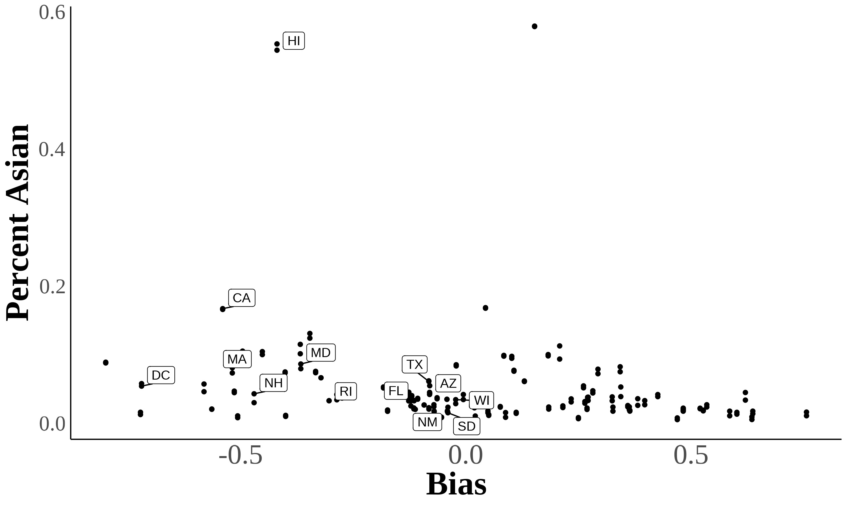

Here are two scatter plots showing the relationship between bias and subjective Asian population in a state. Each dot represents a state in a certain year. Percent subjectively Asian = _{Population}^{#Asian} Source. 2004–2021 Current Population Survey.

Using Lubotsky and Wittenberg (2006) to Construct Bias Index

In Lubotsky and Wittenberg (2006), the authors propose a method to reduce measurement error in proxies by constructing a composite index. The LubotskyWittenberg (henceforth LW) consider a model where a covariate is unobserved.
Therefore, they use two proxies in its place, which will have measurement error. Thus, the LW method allows researchers to use two proxies that are error-ridden.
LW consider a setup with the following model:

y = α+βx∗+ϵ
x₁ = x∗+µ₁ x₂ = x∗+µ₂

Where x∗_{i} is the unobserved covariate, x_{1i} and x_{2i} are the proxies, and the measurement errors µ₁ and µ₂ are assumed to be classical and allowed to covary. The
covariance matrix of the errors is given by:
  σ2₁  Σ =     σ12 |  σ12   σ2₂

Replacing the unobserved x∗ with x₁ or x₂ yields the following expectations of
the OLS estimates:
E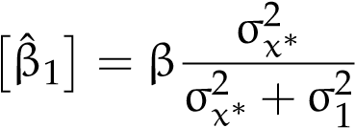 ; E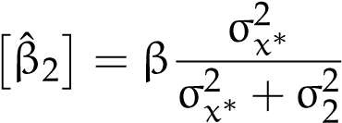

Both estimates are biased; the one with the smaller variance of the measurement error being less biased.
LW then propose defining a new proxy x₃ as a weighted average of x₁ and x₂:

x₃ = λx₁+(1 −λ)x₂

To minimize the attenuation bias in the OLS estimate of β, they solve for the optimal value of λ:
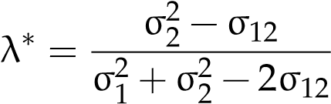

This optimal value of λ is not directly useful because the variances of the measurement errors and their covariance are unobserved. However, if you estimate a bivariate regression using OLS (i.e., regress y on x₁ and x₂), then the expectation of the sum of the two coefficient estimates is identical to the expectation of the OLS coefficient estimate on x₃ in a univariate regression using the optimal choice of λ:
E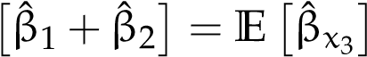

Thus, OLS produces an estimate of β with the least bias by optimally combining the information in x₁ and x₂.

References for Online Appendix
Antman, Francisca, Brian Duncan, and Stephen J. Trejo. 2016. “Ethnic Attrition and the Observed Health of Later-Generation Mexican Americans.” TheAmerican Economic Review 106 (5): 467–471. http://www.jstor.org/stable/4386106
5.
Antman, Francisca M., Brian Duncan, and Stephen J. Trejo. 2020. “Ethnic Attrition, Assimilation, and the Measured Health Outcomes of Mexican Americans.” Journal of Population Economics (Heidelberg, Netherlands) 33, no. 4 (October): 1499–1522. https://doi.org/https://doi-org.ezproxy.lib.uh.edu/10.1007/ s00148-020-00772-8.
Lubotsky, Darren, and Martin Wittenberg. 2006. “Interpretation of Regressions with Multiple Proxies.” The Review of Economics and Statistics 88, no. 3 (August 1, 2006): 549–562. https://doi.org/10.1162/rest.88.3.549.

